Personal Training Assignment 2

Programme Rationale
Introduction
This training programme has been carefully designed to meet the unique requirements and goals of a male client who wants to increase his level of endurance. With an emphasis on improving cardiovascular health and muscular endurance, the programme is designed to provide noticeable outcomes and promote long-term, sustainable improvement. This programme aims to enable the client to exceed his endurance goals while maintaining health and safety throughout the training process by combining evidence-based exercise science principles with customized training methods. By means of strategic exercise selection, regulation of intensity, and progressive adaptation, this programme aims to unlock the full potential of the client and enable a journey towards optimal endurance performance.
Exercise Selection and Order
All the exercises implemented in this training programme have been carefully selected to match the needs and goals of the client. As shown in Appendix C, all the resistance training exercises chosen are foundation movements; This is so that the training is efficient and will replicate real life so that the client will achieve optimal endurance (Tompsett, Burkett and McKean, 2014). Due to the client's lack of gym experience, the exercises chosen within the programme were all resistance machine exercises. This is because machines are safer and easier to use in a gym as there is only a fixed range of motion, on the contrary, exercises done with free weights are a lot more complex to do so this would not be suitable for the client (Aerenhouts, 2020). Every session includes a single leg movement as well as push and pull exercises, which effectively target the main muscle groups. Pull exercises work the back, biceps, and forearms; push movements work the chest, shoulders, and triceps. Leg exercises target the quads, glutes, hamstrings, and calves (Schuler, 2005). This streamlined method makes the most of the client's busy schedule while guaranteeing thorough full-body activation and efficiency throughout their time in the gym. Different exercises chosen throughout the programme are Chest Press, Shoulder Press, Lat Pulldown, Seated Row, Leg Press and Squats.
The resistance machine exercises follow a sequence of push, pull, then legs. Placing legs last allows for optimal recovery, as the client typically engages in cardiovascular exercises at the beginning of the session, leading to slight leg fatigue. By prioritizing upper body exercises first, the client ensures enough rest for their legs before engaging in leg-focused movements, maximizing performance, and minimizing fatigue-related risks (Nasiri et al., 2013).

Volume and Intensity Prescription
A key component of the programme is progressive overload, which allows for continual improvement and optimization of muscle endurance (Kraemer, Ratamess, & French, 2014). The key to attaining progressive overload is to increase the weight, repetitions, and sets. This will gradually push the body to adjust and become more resilient. The client begins the first three weeks of the programme with a comfortable weight of 30 kg for the Lat Pulldown and Chest Press, and 80 kg for the Leg Press. With this tailored approach, they can become familiar with the machines and improve their technique, which reduces the chance of injury (Kraemer and Ratamess, 2004). The client can confidently operate the equipment and set the stage for safe and efficient training progression by beginning with reasonable weights. 2 sets of 12 repetitions with 3 repetitions in reserve was set for the client in the first three weeks of the programme. In the gym, two sets are thought to be appropriate for beginners because studies have shown that novices can make significant progress with just one set; 12 repetitions each set is appropriate for the client's experience level and in line with suggestions for beginners looking to increase their general muscular fitness. Research recommends training for 8–12 repetitions at intensities between 60–70% of One Repetition Maximum (1–RM) to effectively advance towards fitness objectives (American College of Sports Medicine, 2021). The selected rest periods between each set range from 60 to 90 seconds (about 1 and a half minutes). This decision is based on the client performing each exercise with 3 repetitions in reserve, meaning they stop short of reaching fatigue. Consequently, shorter rest periods are deemed adequate, allowing for efficient recovery without risking muscle exhaustion (Hargens et al., 2022). As shown in Appendix B, over the 12-week program, the principle of progressive overload was systematically implemented across all aspects of resistance training. This strategic approach aimed to stimulate continuous improvements in the client's muscular strength and endurance, thereby facilitating efficient progress towards their desired fitness goals (Knapik et al., 2012).
Aerobic Exercise Prescription
In assessing the intensity of cardiovascular training sessions, the Rating of Perceived Exertion (RPE) was utilized. This method, though subjective, offers valuable insights as it adjusts depending on individual fitness levels (Kilpatrick et al., 2017). The RPE scale served as a tool to gauge perceived intensity levels, allowing for a personalized approach to training. For clarity and reference, Figure 1 provides a detailed example of the RPE scale.

Figure 1: Commonly used RPE scale (Aussie Coach Abroad, 2017)
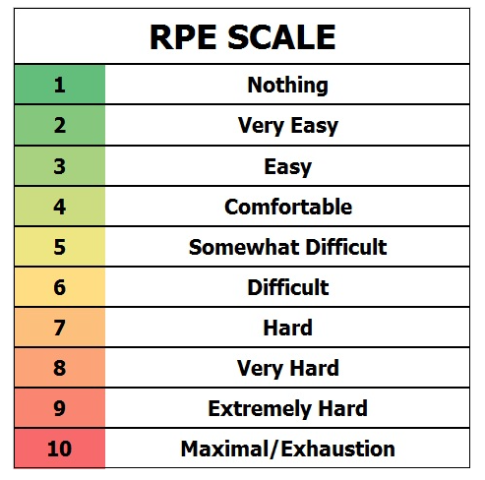

Throughout the course of the 12-week programme, progressive overload was continuously incorporated into the cardiovascular training routine. The first three weeks were spent emphasizing continuous training, with the client running on the treadmill for 10 minutes at an RPE 5. This approach, which is well known for being easy to follow and effective, is an excellent choice for the client because it is especially appropriate for novices who want to improve their cardiovascular endurance (Kumar, 2021). Between weeks 5 and 8, to further improve the client's knowledge and fitness, the training protocol shifted to interval training sessions on the treadmill, with session durations extended to 15 minutes, 1:30 minutes at RPE 5 followed by 1 minute at RPE 8. Extensive research shows the superior benefits of interval training for cardiovascular endurance improvement, making it a strategic addition to the programme (Wisløff, Ellingsen and Kemi, 2009). Between weeks 9 and 12, the cardiovascular training duration was extended to 20 minutes, 1 minute at RPE 5 followed by 1 minute RPE 8. This segment comprised 10 minutes on the treadmill followed by 10 minutes on the stationary bike, this is what is known as a ‘brick workout’ (Haworth, 2010). This adjustment stemmed from the client's expressed ambition to participate in a triathlon within the upcoming year, highlighting the program's adaptive nature in aligning with individual aspirations and goals.
Conclusion
In conclusion, this rationale outlines the thorough method used to create a 12-week training programme aimed at increasing the male client's endurance. Through the application of progressive overload principles and customized cardiovascular exercise, the programme aims to maximize results while putting efficacy and safety first. Each decision made, from thoughtful exercise selection to customized programme changes, shows a dedication to encouraging visible improvement and allowing the client to reach their fitness goals.

Reflections
Reflecting, working with the client has been highly informative. Each interaction has fostered ongoing progress throughout the project, serving as a lesson in and of itself. My client and I have worked together seamlessly, with their constant dedication to increasing the effectiveness of our sessions. It has been incredibly satisfying and educational to work through the entire process, from the first consultation to the training programme design and the one-on-one sessions. But after some thought, I see that there is room to improve much more. Going forward, I want to make sure that all the details from each session are recorded, including the client's development. By being thorough, I will be able to precisely adapt as needed, maximizing the training's effectiveness. Regarding the exercises, the client showed exceptional ability, quickly picking up the correct techniques under my supervision. In one case, however, adaptation was required since, even with proper form, the client felt uncomfortable during the shoulder press. As a result, I decided to choose a different workout to relieve any stress. Furthermore, I saw that the client's shoulders were elevating during the eccentric phase of the chest press exercise. I suggested lowering the weight and putting more emphasis on form correctness to fix this. The client's form significantly improved as a result of this correction, which proved to be successful. I made sure that the foundation of my client's programme was progressive overload during the training sessions. I carefully planned the program's progression, adding challenges and intensity one at a time. Each session attempted to push the limits of the client's abilities by carefully adjusting variables including weight, repetitions, and sets. Frequent evaluations made it possible to precisely track development and make necessary modifications to the training conditions. The client and I built a solid foundation of trust from our very first session together. Every session began with a positive attitude due to their persistent enthusiasm and motivation. I made it a point to check in with the client on a regular basis to make sure they were comfortable and to ask for feedback on the exercises. Our collaborative journey was tremendously facilitated by their desire to actively participate and offer constructive input. When I think back on my experience with my client, I have grown significantly, which I think will be quite helpful for my future clients. I have refined my professionalism since taking on the position of a professional for the first time, and I find it to be a valuable and satisfying skill set. It has been a fun experience that has allowed me to improve my adaptability and communication skills. Creating training programmes that are specifically tailored to the needs of my clients has broadened my knowledge base and improved my grasp of programme design, providing a solid foundation for potential career advancement.

Word Count: 1531

Client Profile and Programme Overview
Appendices
Appendix A –
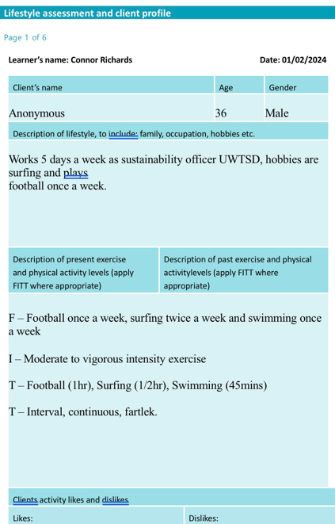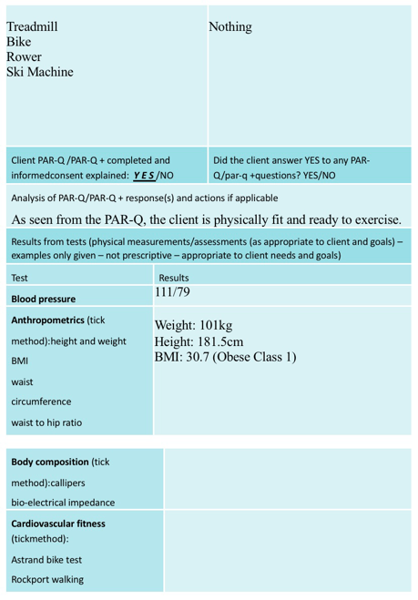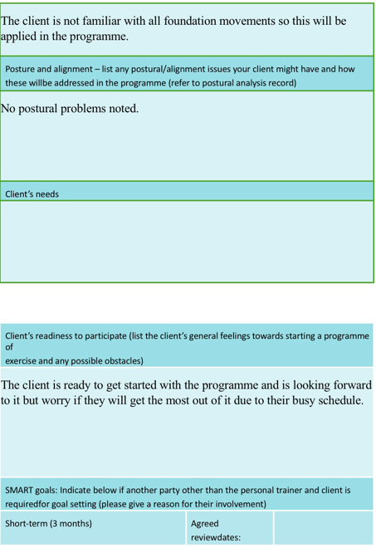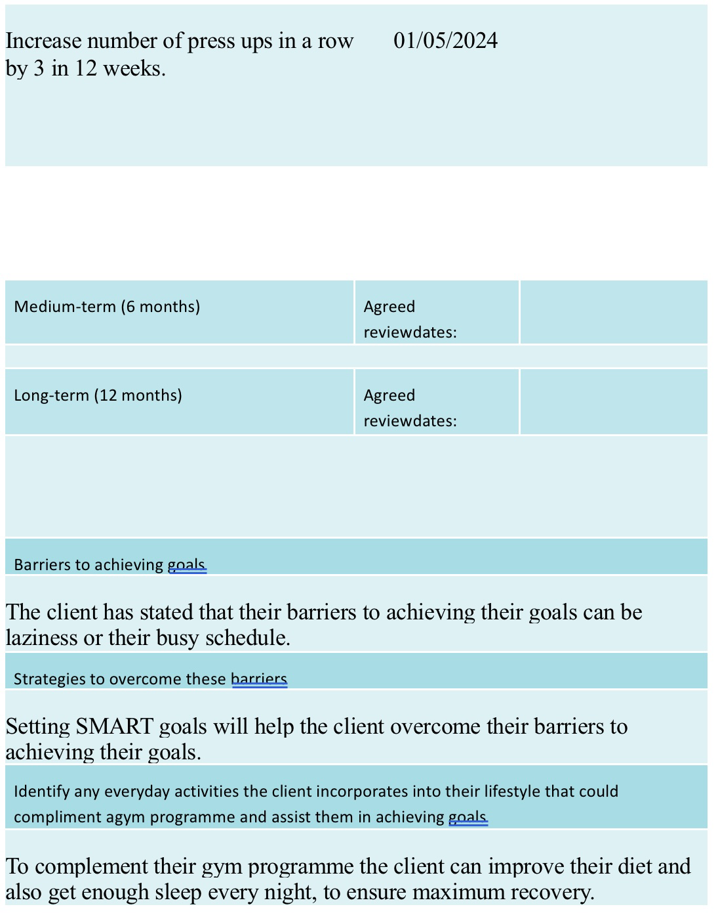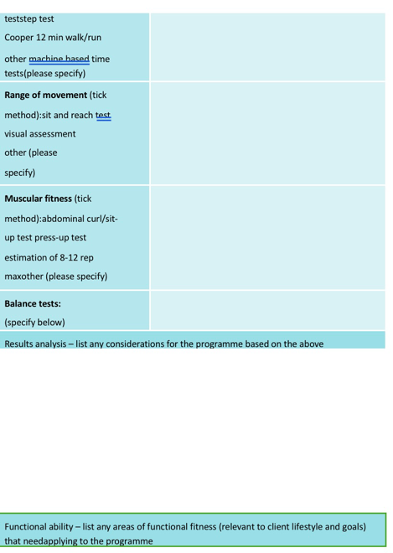

Appendix B -
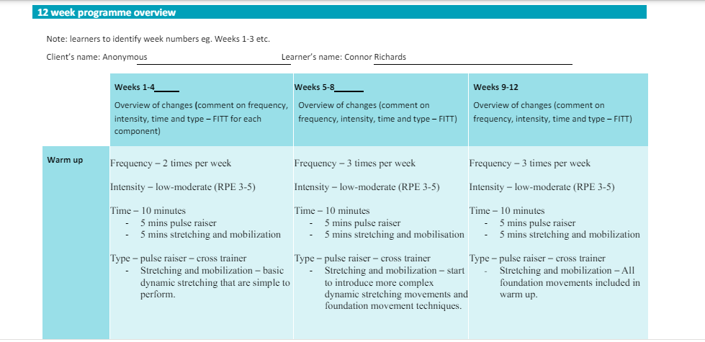

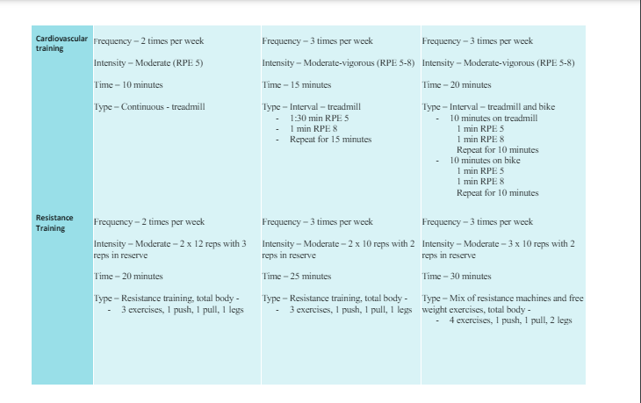

Appendix C -
Session Plan 1
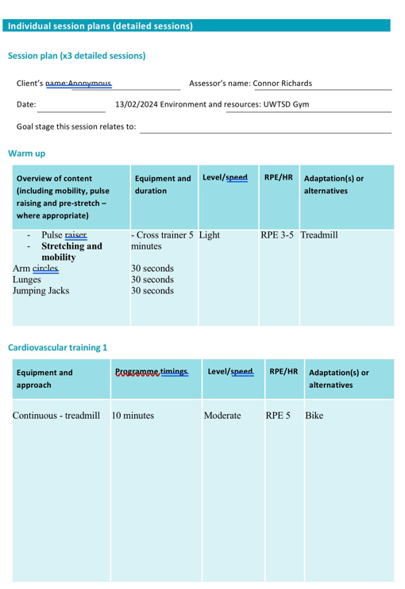
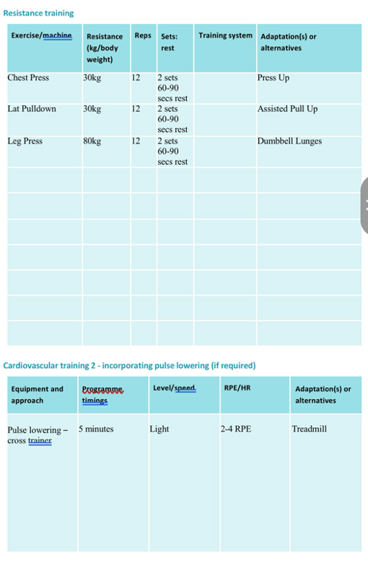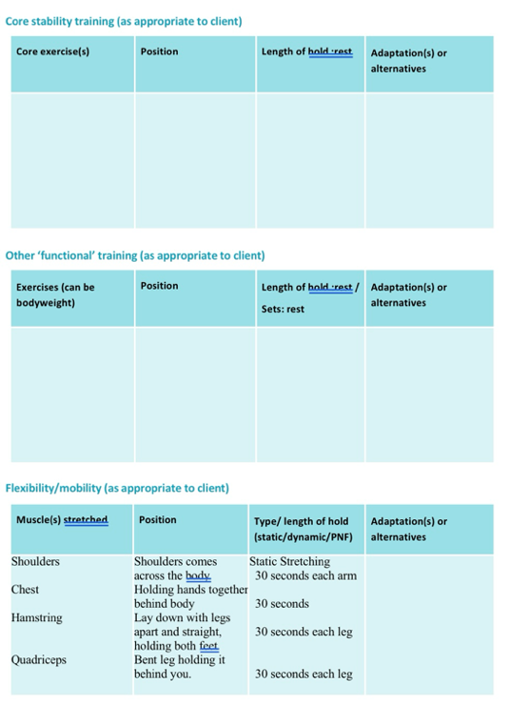

Session Plan 2
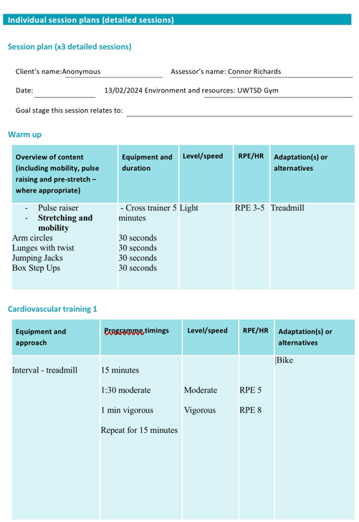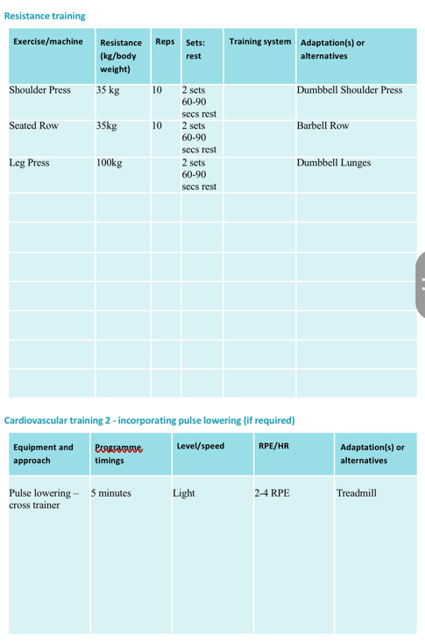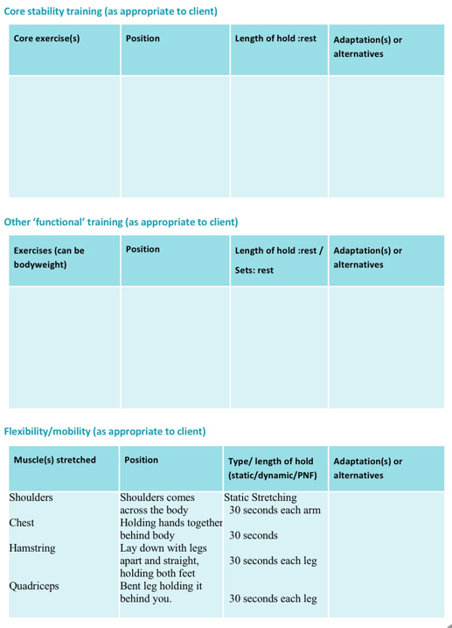

Session Plan 3
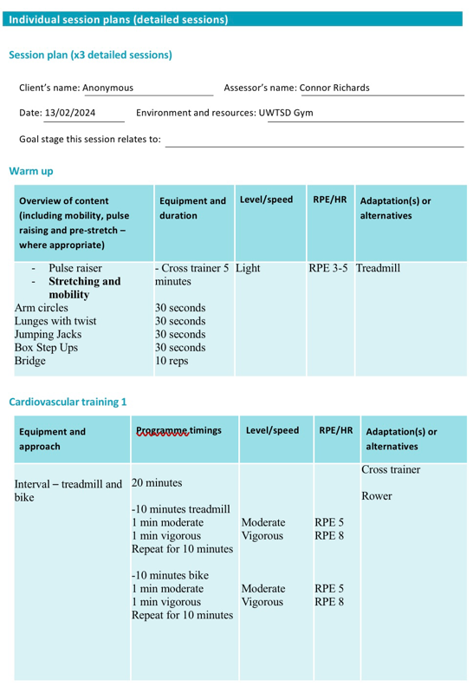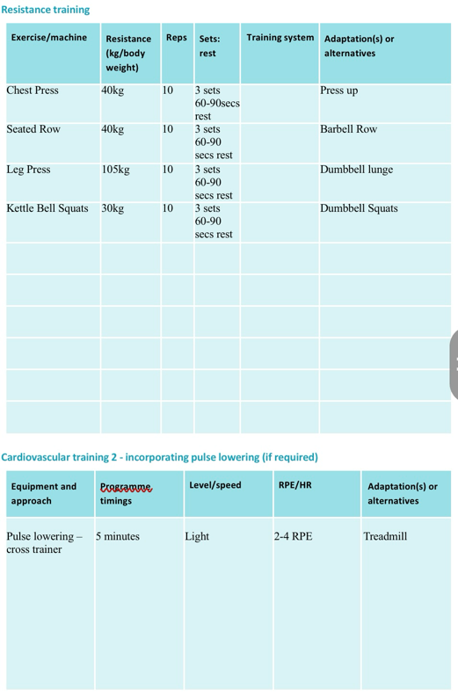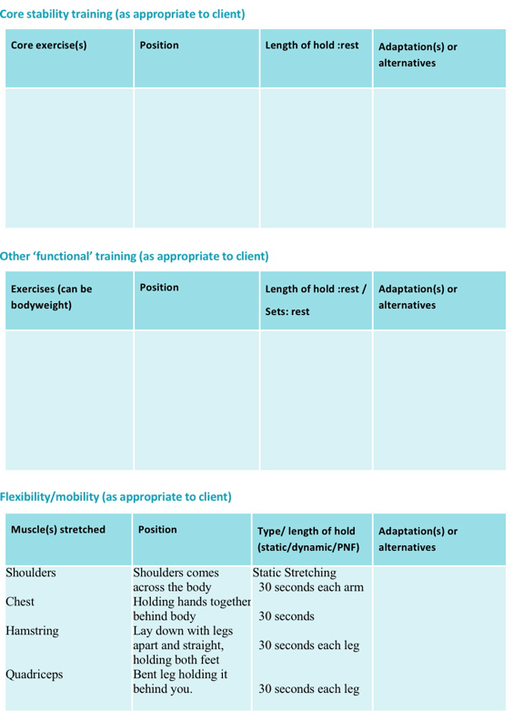

Appendix D –
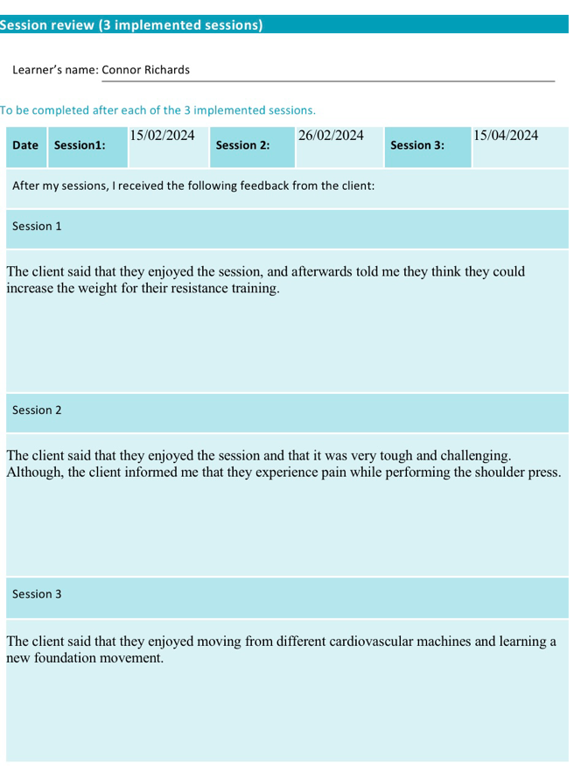
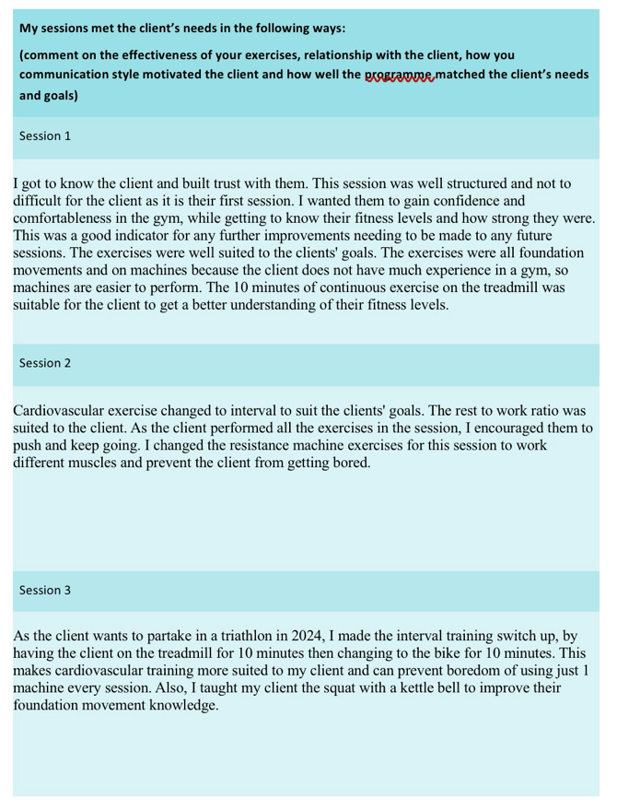

Appendix E -

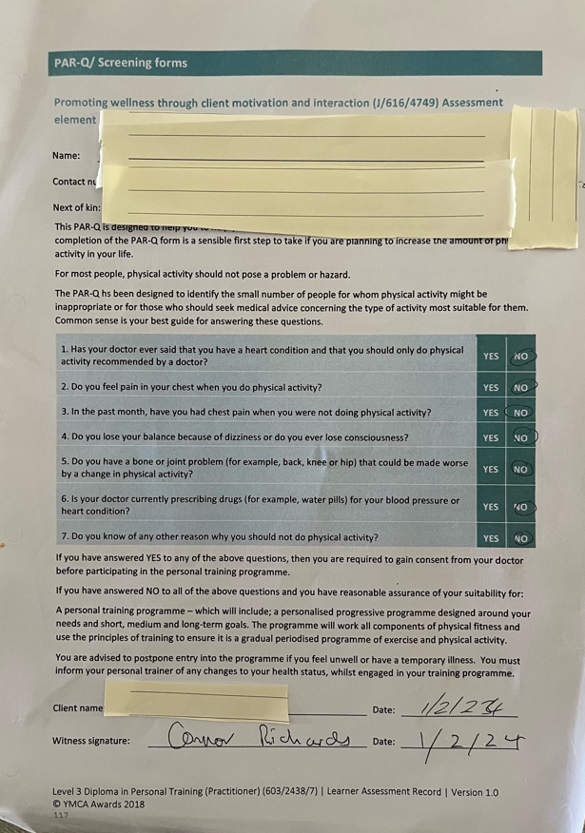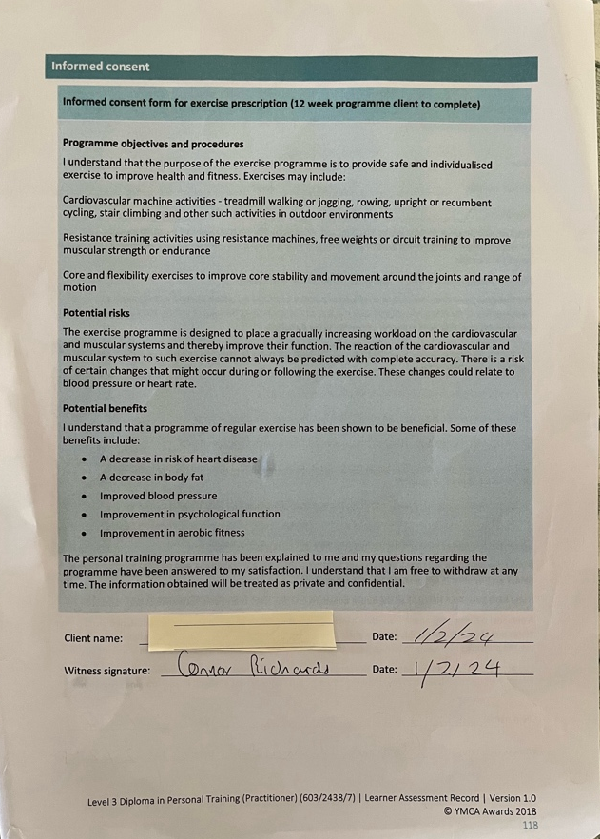

Reference List
Aerenhouts, D. and D’Hondt, E. (2020). Using Machines or Free Weights for Resistance Training in Novice Males? A Randomized Parallel Trial. International Journal of Environmental Research and Public Health, 17(21), p.7848. doi:https://doi.org/10.3390/ijerph17217848.
American College Of Sports Medicine (2021). ACSM’s guidelines for exercise testing and prescription. 11th ed. Philadelphia: Wolters Kluwer/Lippincott Williams & Wilkins Health.
Aussie Coach Abroad. (2017). Monitoring put simple. [online] Available at: https://www.aussiecoachabroad.com/blog/monitoring-put-simple [Accessed 25 Apr. 2024].
Hargens, T., Edwards, E.S., Musto, A.A., Piercy, K. and American College Of Sports Medicine (2022). ACSM’s resources for the personal trainer. Philadelphia: Wolters Kluwer.
Haworth, J., Walsh, M., Strang, A., Hohl, J., S. Spraets, Wilson, M. and Brown, C. (2010). TRAINING FOR THE BIKE TO RUN TRANSITION IN TRIATHLON. ISBS - Conference Proceedings Archive, 1(1).
Kilpatrick, M., Newsome, A., Foster, C., Robertson, R. and Green, M. (2020). Scientific Rationale for RPE Use in Fitness Assessment and Exercise Participation. ACSM’S Health & Fitness Journal, 24(4), pp.24–30. doi:https://doi.org/10.1249/fit.0000000000000587.
Knapik, J.J., Harman, E.A., Steelman, R.A. and Graham, B.S. (2012). A Systematic Review of the Effects of Physical Training on Load Carriage Performance. Journal of Strength and Conditioning Research, 26(2), pp.585–597. doi:https://doi.org/10.1519/jsc.0b013e3182429853.
Kraemer, W., Ratamess, N. and French, D. (2014). Resistance training for health and performance. Curr Sports Med Rep, 1, pp.165–171. doi:https://doi.org/10.1007/s11932-002-0017-7.
Kraemer, W.J. and Ratamess, N.A. (2004). Fundamentals of Resistance Training: Progression and Exercise Prescription. Medicine & Science in Sports & Exercise, 36(4), pp.674–688. doi:https://doi.org/10.1249/01.mss.0000121945.36635.61.
Kumar, R. (2021). Effect of Circuit Training and Continuous Training on the development of Selected Physical and Physiological Variables among Long Distance Runners. Ashok Yakkaldevi.
Nasiri, R., Damirchi, A., Mirzaei, B. and Jahanmahin, M. (2013). Comparison the effect of duration and type of rest intervals on sustainability of leg press repetitions in untrained men. International Journal of Sport Studies, 3(8), pp.886–892.
Schuler, L. and Cosgrove, A. (2008). The New Rules of Lifting. Penguin.
Tompsett, C., Burkett, B. and McKean, M.R. (2014). DEVELOPMENT OF PHYSICAL LITERACY AND MOVEMENT COMPETENCY: A LITERATURE REVIEW. Journal of Fitness Research, 3(2).
Wisløff, U., Ellingsen, Ø. and Kemi, O.J. (2009). High-Intensity Interval Training to Maximize Cardiac Benefits of Exercise Training? Exercise and Sport Sciences Reviews, 37(3), pp.139–146. doi:https://doi.org/10.1097/jes.0b013e3181aa65fc.

