
Skills for the Workplace
Module Assignment Submission
Student Name: | Waqar Ahmed Butt
Student Number: | 1711211
Module No: | BMSK4003_LON
Module Title: | Digital Skills and Research Methods
Lecturer: | Balendran Kandasamy

Statement of Confirmation of Authenticity
By the act of making this submission, the student declares that this is the work of the student named above. The work has not, in whole or in part, been knowingly presented elsewhere for assessment, or where assessment has been built on a previous assessment, this has been identified. Where materials have been used from other sources it has been properly acknowledged. If this statement is untrue, the student acknowledges that an assessment offence has been committed.
Attention is drawn to the plagiarism and unfair practice policies of both the University and of ILM.

Table of Contents
Introduction 3
How Brexit Emerged 3
Primary Research: 3
Primary Data 3
Research Method 4
Analysis of Data 4
Ethics in Data .................................................................................................................5
Secondary Research .................................................................................................................................5
Impact of Brexit 6
Conclusion ...............................................................................................................................................6
Bibliography .............................................................................................................................................7

Task: Students will write a report of 2,000 words, on a relevant and appropriate workplace topic showing evidence of a use of a range of research methodologies and an understanding of effective and ethical data collection and interpretation.
Introduction
In this report I will illustrate the various research methodologies utilised in collecting information for Brexit, the information I have collected is regarding how Brexit has impacted the UK and the residents living in the UK. In addition to this, I will also explain the importance of effective and ethical data collection and interpretation. Research methodologies are an important aspect of data collection as by using different research methodologies you are able to obtain the information you require correctly. Only using one research method to collect all forms of data is not rationale as the research method and data may not correlate. By collecting information we gain a better insight into a certain situation, in this case Brexit and how the situation has changed over a period of time either positively or negatively.
How Brexit Emerged
Brexit is essentially an abbreviation for the terms ‘British exit’. Brexit refers to the UK’s decision to leave the European Union (EU) in a referendum that took place June 2016. Brexit resurfaced when the Tory MPs were facing re-election. The results of the re-election looked not promising and they were afraid their seats would be taken by UKIP resulting in Labour winning. Therefore, the Prime Minister brought along the EU referendum, as it would have allow Conservative to go into 2015 assuring their anti- European voters that by voting Conservative they would be able to decide Britain’s future in Europe. Therefore, in January 2013, Mr David Cameron made a pledge of an in/out referendum if the Conservatives won the 2015 election.
Primary Research
In order to research how Brexit has affected the public, information must be collected from the public to gain a real perspective into the impact it has caused into their lives. Therefore, data will be personally collected from different locations to assure data is representative and not bias, if data is obtained from one location only that will not be a correct representative.
Primary Data
Data will be collected as it assists with decision-making. Once data has been obtained, it becomes an ease to make decisions as there is underlying robust information to work off. In this case, data will be retrieved from a primary source. Primary sources consist of individuals collecting information by asking or observing people. Data that previously exists will not be used so the use of a secondary source is not applicable here. Qualitative data will be collected from the public via a survey; the data will be qualitative as it will include words and opinions.
Research Method
The most suitable research method is a survey. Surveys are frequently used when collecting opinions and are the easiest research method to conduct as it is not time consuming for the respondent. In addition to this, surveys are an ease to produce and very affordable therefore, in monetary terms are suitable as well. Another advantage to using surveys is that you have full control over the survey and can so tailor the questions in order to obtain the information required.
Questions | Yes | Not Sure | No
Was leaving the EU the correct choice? | 43% | 16% | 41%
Do you think Brexit will make work difficult for the younger generation? | 62% | 8% | 30%
Is Brexit the result of irrational thinking? | 45% | 12% | 43%
Is Brexit going to impact us in a positive way? | 47% | 19% | 34%

When designing a survey it is highly vital that your questions must be short and easy to answer. Also, the font and font size should be simple making it easier for respondents to read but also so that it is accessible to people of all ages as in order to gain a real perspective of opinions it’s vital that all age groups participate in the survey. The easier the survey is to read the more people will complete it.
Analysis of Data
Once data has been collected the data must be manipulated in order for visual representation to identify any key patterns or trends.

The pie chart above shows the results of the key question asked to the public whether ‘leaving the EU was the correct choice or not’. It is rather evident that a greater percentage of the public are in favour of the UK leaving the EU however, this percentage includes the older generation which from the bar chart below is clear that they voted to leave. The percentage representing ‘no’ includes the younger generation who are to be most likely affected by the change that will occur as a result of Brexit. The data used in pie charts are often categorical data, with each pie slice showing a percentage of each category. The benefit of using pie charts to analyse data is that they allow the data to be presented side by side for comparative purposes making it much easier to identify patterns and trends and come to a conclusion.
Ethics in Data
According to the Data Protection Act 1998 principles, personal data shall only be collected for a specific or lawful purpose and be processed fairly and lawfully. Data should not be kept for longer that required and must be secure. The reason being is because personal data is valuable and collectors have responsibilities under this act. The respondent’s permission must firstly be acquired to use their data and their data must not be used for another purpose other than what has been specified to them. It is rather important to be ethical when collecting and interpreting data.
Secondary Research
To gain more information into the views of the people we viewed some statistics of previously collected data. The bar chart below depicts the distribution of the EU Referendum votes in the UK, by age and gender. This bar chart is part of our secondary research, and the data collected below is to be used for our specified research, which is that was leaving the EU the correct choice. The advantage of using secondary sources is that the data sets come from large, well-designed surveys that an individual may not be able to do individually. Therefore, the use of secondary sources helps to reinforce primary research and the findings found.
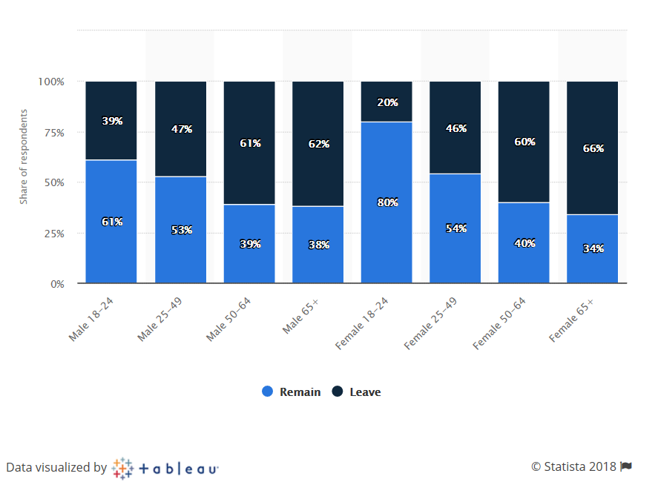
The bar chart below is a great way to depict data as you are able to clearly see the differences and similarities in the data and can identify any patterns or trends with great ease. From this bar chart we can conclude that, as the age of the respondents increase the more likely they are to vote ‘leave’. A stacked bar chart such as the one above allows many sets of related data to be aggregated to show individual and collective trends making them more convenient. The secondary research correlates with our primary research that a greater percentage of people thought it was the correct choice to leave the EU.

It is clearly visible that respondents who voted to remain are of the age group 18 – 24 whereas respondents who voted to leave are prominently of the age group 50 – 64 and 65 +. It is evident that due to the older generation mainly the UK has left the EU. The choice made by the older generation will affect the younger generation. Due to this choice, young people may become restricted in terms of their freedom of movement resulting in options to work and study abroad to not be available or accessible to them. This will increase the difficulty young people are already facing in terms of jobs due to the presence of high competition. Faced with such a circumstance it will be rather difficult for young people to gain experience of work.
Impact of Brexit
Brexit will result in many impacts which may not entirely be beneficial to the UK; however there will also be some impacts which will benefit the UK. I will be focusing on the negative impacts of Brexit.
The EU is a single market and there are no tariffs imposed on either imports or exports between the different member states. Britain being a member of the EU benefitted from this. With more than 50% of UK’s exports going to EU countries this was great as it prevented the UK having to face a great number of tariffs. However, now being outside the EU trading will decreased between the UK and its neighbours resulting in a reduction of the UK’s negotiating powers with the rest of the world.
Another huge aspect that will be impacted is immigration. According to the Official for National Statistics, there were 942,000 eastern Europeans working in the UK. The Official for National Statistics is a primary source showing data that has been individually collected for a specific purpose. Within the EU, Britain could not prevent anyone from coming to live in the UK from any other member state. This of course resulted in a huge increase in immigration evidently from eastern Europe. Those who voted ‘leave’ have the thought that immigration should be reduced and Britain should regain control of immigration. Theresa May has pledged to end freedom of movement resulting in a decline of immigration to occur vastly.
Jobs will be hugely impacted; a decrease in immigration will most definitely increase jobs for the people living in the UK however due to the temporary labour shortages the economy’s may remain stagnant with no potential growth. In some areas of the UK workforce there is a lack of skills resulting in a skill gap in different sectors. Candidates from outside the UK who possess these skills can only bridge these gaps, however with a restriction on freedom of movement this may not occur.
Conclusion
To conclude with, Brexit is favoured by many residents of the UK however, many are not in favour of Brexit either. Brexit was resurfaced and popular amongst the older generation who made up a majority of the ‘leave’ votes. On the other hand, the younger generation did not resonate with Brexit due to its negative consequences that would not only impact the younger generation but the country as a whole. After conducting the survey and viewing secondary research, it is evident that there is not a vast difference between the ‘leave’ and ‘remain’ votes and that many people are aware of their opinion. Visual representations e.g. pie chart is what works best with such data collection methods to view data well and precisely to identify the evident pattern. The only limitation is that due to restraints on time the study may not have been conducted as efficiently as it could have therefore by repeating the study once more we will receive more efficient results.
Bibliography
- https://www.independent.co.uk/news/uk/politics/what-is-brexit-why-is-there-an-eu-referendum-a7042791.html
- https://www.independent.co.uk/news/uk/politics/brexit-latest-news-young-people-eu-referendum-result-lse-reaction-bemused-angry-vote-leave-a8006226.html
- https://www.statista.com/statistics/567922/distribution-of-eu-referendum-votes-by-age-and-gender-uk/
- https://knowhownonprofit.org/organisation/impact/measuring-your-impact/questionnaires/layout-and-design-of-your-questionnaire
- http://www.theweek.co.uk/brexit-0
- https://www.sqa.org.uk/e-learning/ITLaw01CD/page_17.htm

