Changemakers: Creativity and Value Creation

Resurface of The Gravel Car Park by the Sports Hall

Ieuan Evans 2200476

Contents Page

Contents Page…………………………………………………………………………………2

Abstract……………………………………………………………………………………………3

Primary Research…………………………………………………………………………4-6

Secondary Research………………………………………………………………………7-8

Proposal……………………………………………………………………………………………9

Bibliography……………………………………………………………………………………10

Abstract

I have decided to explore into the gravel car park by the sports hall, and if it were possible to have a resurface of said car park due to its rough terrain. When I first started driving back in the summer of 2022, I was obviously very excited for many reasons. You gain an independence, more or less get to go wherever you want and personally for myself, have the ability to get too, and from university in a much more convenient way. But as a new driver and still today, I worry about the costs of owning a vehicle and what comes with having one. You have to make sure that you keep it in good condition. Otherwise you could find yourself in position where you’re spending a fortune just to keep it running.

So, when I found myself coming to university in my car for the first few times I started to notice a trend. There were no available parking spots anywhere by the flats or the student union. But there was one car park by the sports hall which was barren and unused from time to time. At first I saw it as a place to park but then I quickly realised why it was unused in the first place. The terrain of the car park was rough, gravelly and littered with pot holes. At first I saw it as an inconvenience but thought nothing of it. But when it became a reoccurring trend that I had to go back to that car park every day just to park because nowhere else was free, I started to get worried.

This now takes be back to the costs of owning a vehicle and how keeping it in good condition is important. But with a car park like that, it will be difficult to do so. It is simply not fair especially on students in university who are more or less struggling financially anyway and have to travel in when all other car parks are full. I aim to collect primary research in the form of surveys from the students of the university, to see if they agree and see what else they propose we do with the car park. Then I shall collect some secondary research to acknowledge what a car park like that can do to a vehicle and how to avoid it. My end goal is to simply have a smoother and more sustained car park. Allowing students to come in care free without worrying on if their car will get damaged or not.

Primary Research

Before going under way with my project, I needed to ensure that my opinions were being mimicked and that I wasn’t the only one that had a problem with the car park. To find this out I conducted an online survey and spread it amongst the many group chats and communities of the university itself. I needed to make sure that the survey itself would effectively dissect this said information so my key objective was to keep it short and sweet. Make the person who is taking the survey know what they are in for. To execute this I made sure that there weren’t many questions itself and that most of the questions would be short and closed for the person answering. This would then keep them interested and not give up on the survey. Considering that I’ve had 18 responses to my survey I feel like I could’ve done better but it was enough for me.

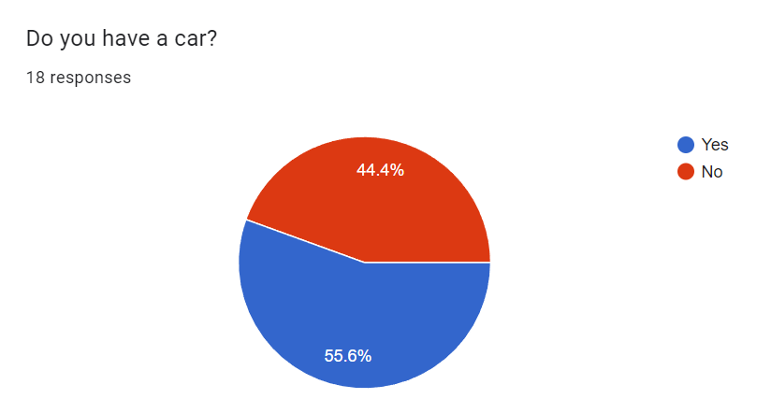
As you can tell my first question here isn’t rocket science. I simply wanted to know where I was standing with the person taking the survey. Also with a simple question such as this to start a survey, I do believe it would lure the person in and keep them interested to proceed.

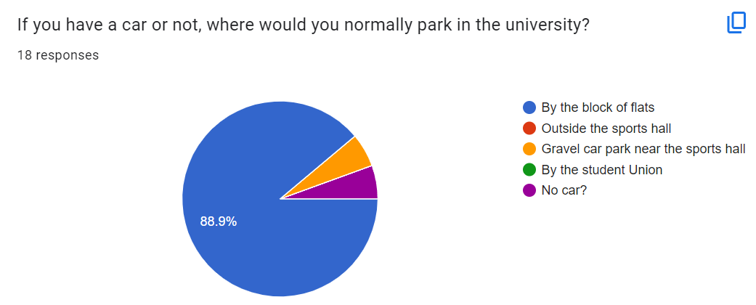
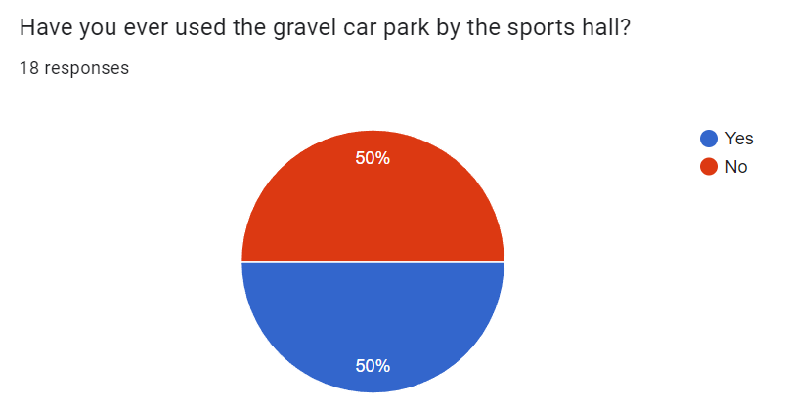

Now I started asking the questions which was going to give me my valuable information. What is nice to see about these two questions, is that the answers from both complement each other. I notice a trend in both that there is no desire to park in the gravel car park. Reason I see this is because, 88.9% of people stated that they would much rather park near the block of flats. Even though 50% stated that they have used the gravel car park before. So, that shows many have no interest in going back to that car park.

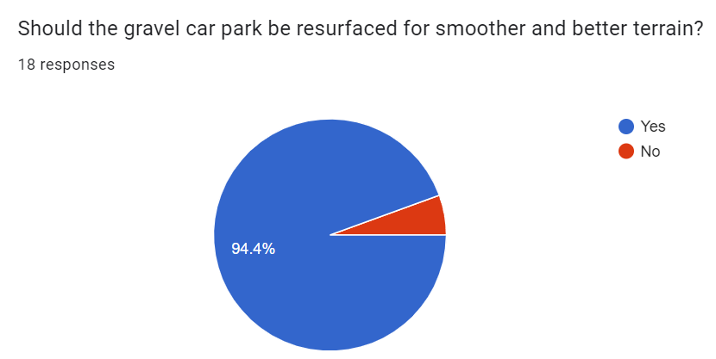
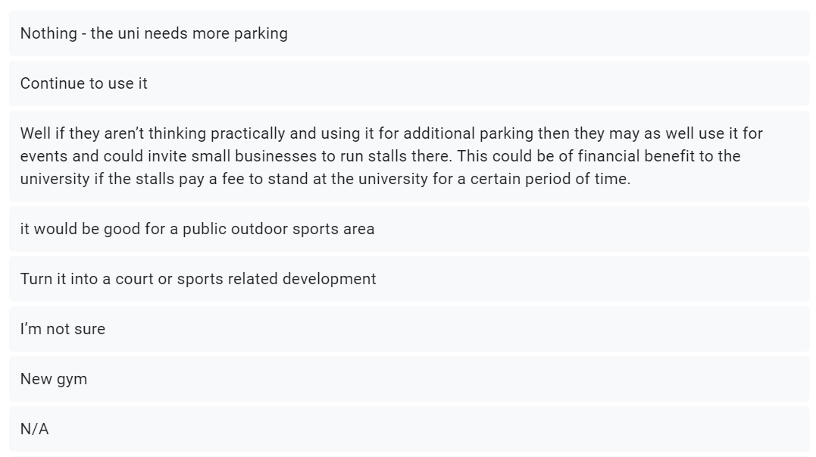
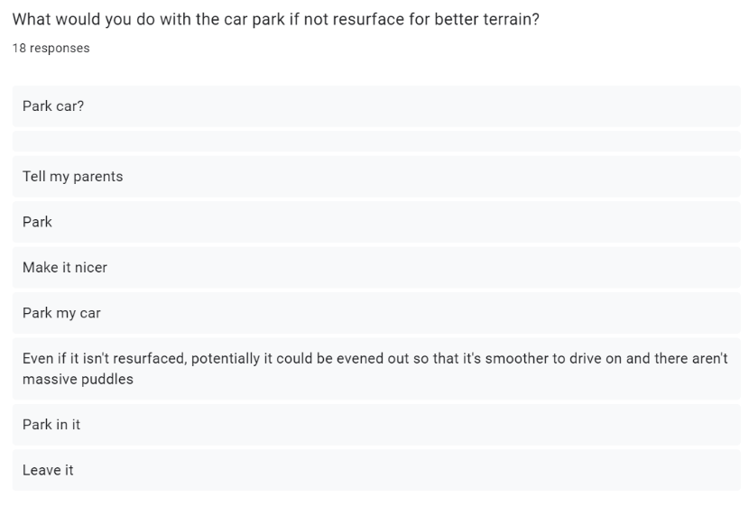
Now I asked the question that has been playing on my mind the most. Should the gravel car park be resurfaced for smoother and better terrain? As you can see, the answers speak for themselves. 94.4% of people agree with the fact that it should be resurfaced and that is exactly what I predicted to be the answer. It’s common sense if anything.

With my main question in essence being answered, I was interested to know what the people would do with the car park itself if not resurface it. Overall I am rather happy with the responses that I have gained from this question. Of course I realise that there are a few silly answers. But out of the reasonable ones I agree with every single suggestion. It’s nice to see that the students of the university have interesting ideas for what’s good for the university and how it can be improved. Because if it were to be resurfaced for better terrain, it could still be used for them small business to “run stalls” or for that “sports area” Hitting 2 birds with 1 stone.

Secondary Research

With my secondary research I wanted to investigate all the factors of what come with rough terrain and how it can affect you. Firstly, I found a blog online about how rough terrain such as the gravel car park can affect your car. Kris LeSueur states in a blog post that “Bad bumps may cause cracking or bending of wheels of substandard quality.” (Kris LeSueur, 2022, How To Minimize Damage When Driving On Bumpy Roads) Kris LeSueur also states that “A bump bad enough may result in tire bubbles due to pressure pinching the tire sidewall.” (Kris LeSueur, 2022, How To Minimize Damage When Driving On Bumpy Roads) Then finally Kris LeSueur mentions how “Metal fatigue may result in a lower car ride because of the suspension springs not returning to their correct position after a series of hard bumps.” (Kris LeSueur, 2022, How To Minimize Damage When Driving On Bumpy Roads) For me, that is way to many factors that can go wrong with a car when going over bumpy or uneven terrain. Of course I understand it’s natural as we are talking about bumpy and uneven terrain and those things would happen, but when you’re going over said uneven terrain on the daily just to park, you start to see how unfair it is. With that being said, unfortunately that is what we are working with in relation to the gravel car park. The car park is in no condition whatsoever for a vehicle to go over it on a daily basis. It will simply peel away at your vehicle and possibly in the end you will start to see the factors that Kris LeSueur mention start to creep up. It’s simply not right.

With all that being said, another set of factors come into play, and that is the costs of running a car. Jesse Cramer states in a blog that “The total cost of owning and operating the average car falls between 35 cents per mile and 65 cents per mile over the lifetime of the car.” (Jesse Cramer, 2020, The True Cost of Car Ownership) That as a statistic is heavy on large. With the average mileage of a car in its lifespan being 200,000 miles. With the math being applied that is £70,000 just for one single car. Obviously that’s over the average lifespan of a car but still expensive at the end of the day, especially for students of a university. Possibly as well you could see that statistic rise on possible additional repairs on the vehicle and that takes me to my second point on how that could easily be the case with our students and our car park. Students could be spending a small fortune on their cars just to repair the tires/suspension because of the nature of the gravel car park in the university. It's expensive as it is to run a car, students don’t need them additional repair costs.
With them factors in place the only thing at the moment you can do is simply try your best to avoid said uneven/bumpy terrain and if you can’t do that, be as careful as you can. Kris LeSueur states in her blog post again “knowing what to do and executing it with care and caution can always save your car from unnecessary damage or wear.” (Kris LeSueur, 2022, How To Minimize Damage When Driving On Bumpy Roads) This obviously being one of the most obvious solutions to work with. Yet, with that being said, even when going over the rough terrain carefully and slowly you are still, bit by bit, causing unnecessary damage to your car. That as a proposal may make it look like it’s a small nuisance, but I believe things can be put into place to solve the issue and get a rework of the car park.

With all that being said and done. The only thing left is to find a way to get it done. Unfortunately with where I stand in the university I can only do so much. Because at the end of the day it is down to them to get this idea off the ground. I’ll most certainly bring it up to them and hopefully they have the same opinions as me. It would only be right.

Proposal

With all the information I have collected within my primary and secondary research, I can confidently say my idea as a whole, has been boosted. If anything I see it as a much more beneficial project then when I first started the project as a whole. To see all my opinions and facts in a structure, and in an understanding format, it has given me a clear path on how to undertake this idea. It’s given me reason to complete this project. What I hope to do is to firstly get in contact with the university itself and fight for my idea to be put into place. With that being done, it’s simply down to the university if they wish to put it forward because it is such a big project and we would have to hire the council or a construction company to resurface the car park. I do hope that this project gets the green light. Because it would be incredibly beneficial to the university and especially the students. It would make life so much easier.

Bibliography

LeSueur, K. (2022) ‘How To Minimize Damage When Driving On Bumpy Roads’ Lesueur Car Company [Blog] 19 September. Available at: https://www.usedvwaudi.com/blog/2022/09/19/how-to-minimize-damage-when-driving-on-bumpy-roads#:~:text=Damage%20to%20suspension&text=The%20first%20to%20bear%20the,a%20series%20of%20hard%20bumps. (Accessed: 28 December 2023)

Cramer, J. (2020) ‘The True Cost of Car Ownership’ The Best Interest [Blog] 30 October. Available at: https://bestinterest.blog/cost-of-car-ownership/ (Accessed: 28 December 2023)

