Grazia Martone (1703121)
University of Wales Trinity Saint David
strategic management & Sustainablity report M3x9111

Contents
Executive summary 2
Introduction 3
Implementation of the strategy 11
References 16

Executive summary

This report will look at the competitive strategies from Lidl and how successful they are performed,
Lidl is the company looked at for the strategies which has brought Lidl to where it is today.
Whilst stating the advantages and disadvantages of the strategy chosen and what’s best for Lidl as a company.
Lidl is a company based in Germany which began in 1994, being around for 25 years and is one of Europe’s biggest food retailers with 760 stores their approach is ‘’low price for high quality’’ shows their differentiation. In the last year their market share has been gained to 6% by attracting competitors’ customers because of their low prices. Lidl has continued to show their success through their strategic decision making which allowed them to achieve high revenues, improved production processes and less kept inventory which has been the outcome of more in hand cash available for investing in more companies although as a company they may have to look at competitive downfalls based on their customers view on the products as can be seen as low quality because of the low prices as some parts of the country will not need low price products. Meaning if Lidl sticks to the strategic aim it will place Lidl into an era of economic constancy.
Introduction
Throughout this report an explanation on the company Lidl will be given also how it intends to investigate the competitive strategies applied by Lidl and how successful the strategies have been executed. Lidl’s profile is deliberately investigated for the implementation of the strategies that have made the organisation to what it is today. A critical analysis on the adopted strategies will be mentioned and stating the advantages and disadvantages of the organisation.
Report remit
in today’s world there is a lot of modernisation and economic pressures as things are rapidly changing. Organisations are competing and struggling in order to gain sustainability. Organisations are being placed in order to adapt according to the changing trends in the global market. To gain the maximum out of the market value, organisations will need to frame their strategies ahead of time for the non-stop change of the needs of the employees and the customers. Just like all other organisations competing to cope with increased changes in the global trends (Yoo & Chang, 2005). States that departmental stores will be faced with revolution in 1980 these department stores became very popular but, in some time, it was side-lined with discount stores and hypermarkets it is said that ‘’ discount stores are expected to be a leader in the future’’ this statement was proven true as the future was shaping more innovative stores were appearing. This report will show how Lidl has formulated its strategies that meet the needs of the globalisation while analysing the strategies and its effective struggling in order to compete globally as a chain.
Background of the organisation
Lidl stiftung & Co is a discount supermarket chain, the first Lidl stores opened in 1973 with small number of 3 employees and 500 product lines initially. By 1980 they became a household name in Germany, and within 10 years as a brand they ventured out to stores outside of Germany. Today Lidl are found all around Europe and now are contributing a huge network of 600+ stores just in the UK, Lidl was founded by the Schwarz family as wholesalers in1930 and then expanded into hypermarkets and discount stores as ‘kaufland’ (Lidl UK, 2017) Lidl’s like offers low prices for their products and enabling them to do so is the layout of their stores, it gives customers a hassle free shopping experience without having to keep with the modern ‘’look’’ (Bearden, 1977) says “consumers choose stores that they feel close to their self-image”.
Lidl has a mission statement aiming them to achieve outstanding customer fulfilment, to ensure the market leading quality and value while innovating and improving the processes that are driven by technology and people frequently, to work with business partners in sustainable relationships while contributing positively to local communities and to attain long-term success by investing in the recruitment, training and development of the employees of Lidl (Lidl UK, 2017).
(Marketline, 2017) shows that the market share of Lidl increased to 5.6 % from 5.2% this was shown through the statistics of market shares of grocery stores in the UK from august 2012 to august 2019. The figure below shows that Lidl has gained more market share every year compared to large grocery stores like Tesco which is shown that its shares is decreasing. This is happening because customers are shopping more locally, and their preferences have shifted from larger retailers to discounted stores to save money for essentially very similar products. Lidl plans to reach 2000 stores in the united states by 2020 the CEO of Lidl Us says "We are committed to long-term growth in the United States and always strive to locate in the most convenient locations for our shoppers, and these new stores are part of the next steps in our US expansion" (Peterson, 2019).
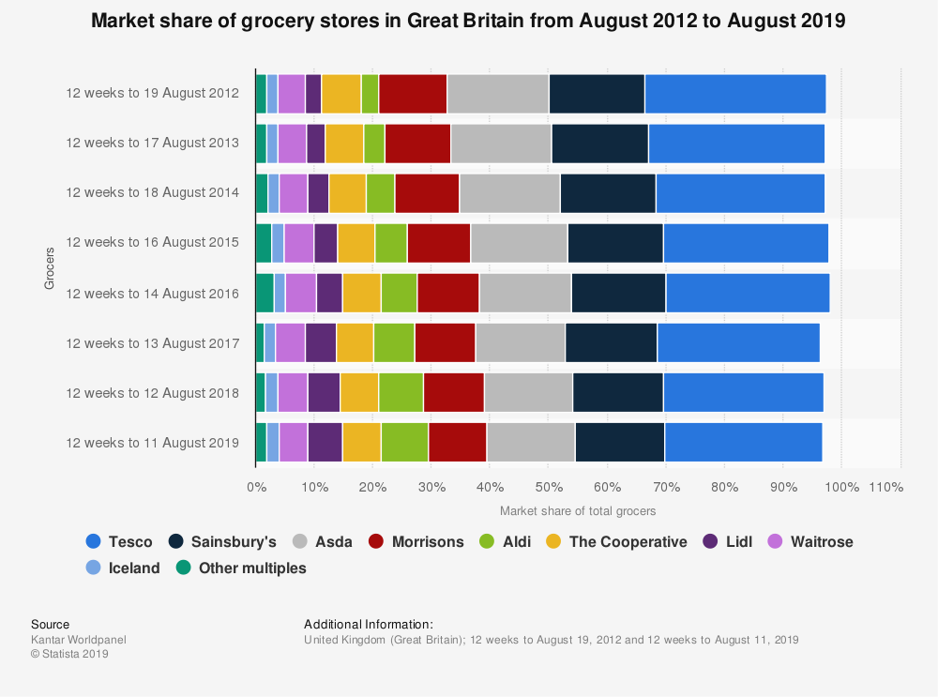
Figure 1: Market share of grocery stores in Great Britain from August 2012 to August 2019 (Statista, 2019).
Definitions of major concepts
There are main themes that will shape an understanding of main themes which are strategy, business level strategy and competitive advantage.
Strategy defined ‘’the science and art of employing the political, economic, psychological, and military forces of a nation or group of nations to afford the maximum support to adopted policies in peace or war’’ (Simply-strategic-planning.com, 2017).
Business level strategy defined ‘’Business strategy can be understood as the course of action or set of decisions which assist the entrepreneurs in achieving specific business objectives’’ (Pahwa, 2019).
Competitive advantage defined ‘’A competitive advantage is what makes an entity's goods or services superior to all of a customer's other choices. The term is commonly used for businesses. The strategies work for any organisation, country, or individual in a competitive environment’’ (Jurevicius, 2013).
Every organisation today needs some strategic knowledge in order to make the right choices, this is done through using business models or methods which can be defined by academics, models will clarify complex procedures enabling them to be understood better but, (Magretta, 2002) will argue that any business strategies and models are just the same as literature. Some researchers have different understandings on the definitions and others seem to believe that (Stähler, 2002) ‘everything that a business believes to give them a competitive advantage’ But (Campbell, Edgar, & Stonehouse, 2019) says that a strategy is a broad term used for different purposes an example is for military training. Professor chandler simplifies the definition as “Strategy can be defined as the determination of the basic long-term goals and objectives of an enterprise and the adoption of courses of action and allocation of resources necessary for carrying out these goals” (Baker, 1992).
To gain competitive advantage organisations will look at the strategic models this report will look at the Michael Porter’s Generic strategy. Organisations use this for better use of resources and competitive advantages Porter stated that “Competitive advantage grows out of value a firm is able to create for its buyers that exceeds the firm's cost of creating it. Value is what buyers are willing to pay, and superior value stems from offering lower prices than competitors for equivalent benefits or providing unique benefits that more than offset a higher price. There are two basic types of competitive advantage: cost leadership and differentiation.” (Tanwar, 2013).
There are four Porter’s Generic Strategies
Differentiation- being a unique product
Cost leadership- quality products at a cheaper cost
Differentiation focus- unique product which is offered in a more focused market
Cost focus- lower cost in a focused market
these four falls into two basic categories, the focus strategy will require concentration on a niche or a narrow segment, Porter states that success in the strategy can be done by either through cost leadership or differentiation therefore, cost leadership and differentiation are the most two basic strategies in Porter’s typology (Datta, 2010).
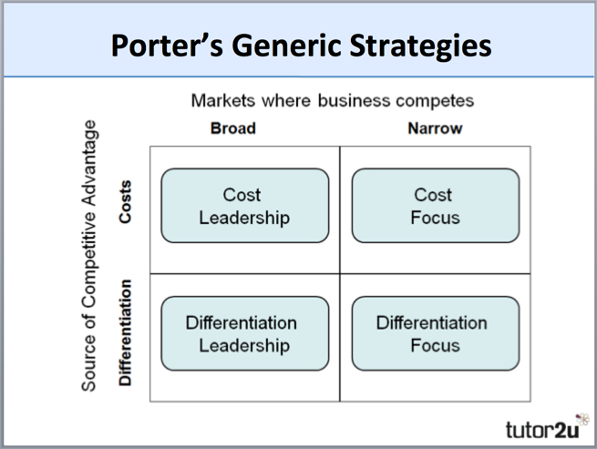
figure 2: Porter’s generic strategy (Riley, 2018)
Main body
By looking at Lidl and the way they operate, there is a clear understanding that they use cost leadership strategy as the main competitive strategy.
(Riley, 2018) says that the objective of this strategy is to be the lowest-cost producer in the industry. And in order to do this is by producing on a larger scale which gives the Lidl to investigate the economies of scale. Cost leadership is important because market segments within the same industry are provided with how important minimising costs. If the selling price is accomplished being at least very close enough the average for the market the lowest cost-producer will then have the benefit to enjoy the best profits. Cost leadership needs close cooperation with different functional areas of Lidl and for them wanting to be the lowest-cost producer several of the following they use
- High capacity utilisation
- Use of bargaining power to negotiate any lower prices for promotion inputs
- Lean production methods
- Effective use of technology in the production process.
- High level of productivity

companies will increase their market share by doing this they change the lowest possible prices through cutting off their production costs, this will help with achieving a sustainable advantage for the company, but other companies employing the cost leadership strategy can be seen at a bigger risk as other low-cost producers can join the market offering lower prices and this is why it can be seen impossible for the company to keep its competitive advantage.
Lidl for the sustainability of productions three aspects that are essential are the capital for an updated technology to reduce their costs, the efficient logistics and distribution also any factors that contribute towards low costs for example materiel or distribution and cheap labour.
by Lidl using this strategy rather than any others it also gives the cost reduction strategy by being more sustainable this will involve the no-frills method this decision was because they have placed themselves as discounted retailers but while there are more markets being entered a more durable strategy can be required for entering into the market for other grocers like Tesco, Asda etc (Morschett, Swoboda, & Klein, 2006).

Implementation of the strategy
(Hanbury, 2017) suggest that Lidl implement of a cost leadership strategy and how they manage to implement low prices examples show that how it is being used.
as a company they need to keep looking for ways to reduce their costs in order to maintain their strategic position Lidl recently have increased their market share through their business processes, it has aimed to keep increased shares by cutting out their competitors share from the market growth by lowering their processing costs (Doyle, 2000) says “All competitors can grow, which acts to reduce the destructive price competition and margin erosion”
(Timmermann, 2019) states that Lidl’s will display their goods in the boxes that they have been shipped in, this can speed up the restocking process and will require less people in order to get stock out efficiently, even their milk products are placed on carts which are mobile and have wheels, which again speeds up time from directly off the trucks straight onto the shop floor, they believe by spending less money on the overall instore look and its merchandising this is because as a company they do not stock many national brands. Rather than using cardboard cut-outs or any stacked pyramids they will stay using their simple displays and use baskets to place their products.
more examples show that their whole layout as a store is very different to others they take things slower than others, they have only now started to think about technology In the UK stores as a small minority offer the self- checkout option as this was launched some time ago but only in 2019 this has crossed their minds, before this they had people working at the tills with a ‘’fast scanning’’ approach this will enable to get customers in and out as quickly as possible without the store being overcrowded, as a company they do not offer loyalty cards or BOGOFs offers they use a special buy approach which uses the middle isle for seasonal trends and no staff discounts, these show that money is being spent elsewhere in order to deliver better prices than focusing more on these aspects (Chamberlain, 2018).
By having no megastores which will keep control of how many employers they retain in order to keep costs down. Lidl will sell 95% of their own stock, they say that they work with their suppliers to put their own label on their products, that are just as good and most popular branded products in other stores. They say that this is one of their biggest money saving aspects which contributes towards keeping costs low an having smaller choices enables bigger discounts saying that "Most of our stores will have a maximum of 2,000 carefully curated products depending on the time of year," (Chamberlain, 2018).
Lidl spent less on advertising they still use the brochure approach through doors with the weekly deals on offers. and by using this marketing approach which is ‘low price for a high quality’ will give them more time to be ‘’big on quality Lidl on price’’ this will attract budget conscious customers.
Advantages and disadvantages of the strategy
Advantages
1. it improves the sustainability of the business as when costs are lower a company, there will be fewer financial threats that can lead to Lidl dying out. Sustainability will be a big advantage when economic situations occur and take turn. And companies like Lidl with a low-price strategy will have a much better chance of survival.
2. there can be a decrease in production costs as it can lead to a faster turnaround time of your inventory by selling products faster meaning that they will not need to be stored for a long period, and once you can see a trend with higher volume of sales of a product higher more quantities of products can be ordered meaning more bulk buy will lead to promotions from suppliers (RooJet, 2019).

Disadvantages
1. It can reduce the importance of customer feedback as when organisations just look at the price of the goods it can be easy to ignore how market shifts in time. Consumers will always be changing their preferences and tastes in time and focusing more on products being at a low-cost consumer may shift to pay more for competitive products as it will meet their needs and wants more.
2. promotions are one of the biggest parts of marketing of a business, but with a low-cost strategy organisation they can find themselves in situations where sales cannot be conducted, for example losing sales at peak times like black Friday sales, boxing day sales and cyber Monday. And even when giving businesses can afford to give discounted prices some audiences may judge and take the sign as the business does not provide the lowest possible price out there (RooJet, 2019).
Conclusion
to conclude this report, it is shown that the success of Lidl needs to be a continuous aspect for them to become on top of all others but with keeping up with trends as well. Overall, they are very good with knowing the customers’ needs and wants, and how they deliver. It is said that the strategy showed improvements of the production and processing policy and their timely restocking helped them to exploit their profits within their stores.
It has shown that their approach is working well for their customers but they need to be more hands on when it comes to displaying their strategic choices to keep their growth as some consumers may take their low prices for low quality.
Recommendations
examples of other recommendations can be by expanding their regions will increase their market share, engaging more with consumers with loyalty schemes and more offers for regular customers and brand re positioning is useful as it will give more success this comes with changing the layouts of stores to modernise the look and more technology in areas where needed. The Japanese Kaizen is a good method to interpret which will give continuous improvement.
References
Doyle, P. (2000). Marketing Value-Based Marketing Strategies for Corporate Growth and Shareholder Value. USA: John Wiley & Sons Ltd.
Jurevicius, O. (2013). The Courageous Triumph of Competitive Advantage. [online] Strategic Management Insight. Available at: https://strategicmanagementinsight.com/topics/competitive-advantage.html [Accessed 18 Dec. 2019].
Simply-strategic-planning.com. (2017). What is strategy?. [online] Available at: http://www.simply-strategic-planning.com/what-is-strategy.html [Accessed 18 Dec. 2019].
Pahwa, A. (2019). Business Strategy: Definition, Levels, Components & Examples | Feedough. [online] Feedough. Available at: https://www.feedough.com/business-strategy-definition-levels-examples/ [Accessed 18 Dec. 2019].
Peterson, H. (2019). Lidl is opening 25 new stores and closing 2 — see if it's coming to your hometown. [online] Business Insider. Available at: https://www.businessinsider.com/lidl-new-stores-
list-2019-5 [Accessed 2 Dec. 2019].
Lidl UK. (2017). Our History. [online] Available at: https://careers.lidl.co.uk/en/our-history-1819.htm [Accessed 2 Dec. 2019].
Marketline. (2017). Aldi and Lidl US Expansion: US grocery retailers should be worried - Marketline. [online] Available at: https://www.marketline.com/blog/aldi-and-lidl-us-expansion-us-grocery-retailers-should-be-worried/ [Accessed 2 Dec. 2019].
Magretta, J. (2002, May). Why Business Models Matter. Harvard Business Review.
Campbell, D., Edgar, D., & Stonehouse, G. (2019). Business Strategy: An Introduction. https://books.google.com.pk/books/about/Business_Strategy.html?id=LqUcBQAAQBAJ&printsec=frontcover&source=kp_read_button&redir_esc=y#v=onepage&q&f=false: Red Globe Press.
Yoo, S. J., & Chang, Y. J. (2005). An Exploratory Research on the Store Image Attributes Affecting Its Store Loyalty. Seoul Journal of Business, Volume 11, 25.
Bearden, W. (1977). Determinant attributes of store patronage-downtown versus outlying shopping centres. Journal of Retailing, 53(2), 15.
Regoli, N. (2019). 14 Advantages and Disadvantages of Cost Leadership Styles. [online] FutureofWorking.com. Available at: https://futureofworking.com/14-advantages-and-disadvantages-of-cost-leadership-styles/ [Accessed 3 Dec. 2019].
Stähler, P. (2002, October). Business models as a unit of analysis for strategizing. In International workshop on business models, 45(7), 2990-2995.
Baker, M. J. (1992). Marketing Strategy and Management (2 ed.).
RooJet. (2019). Pros and Cons of Using Low Price Strategy in eCommerce - RooJet. [online] Available at: https://roojet.com/pros-and-cons-of-using-low-price-strategy-in-ecommerce/ [Accessed 17 Dec. 2019].
Tanwar, R. (2013). Porter’s Generic Competitive Strategies. IOSR Journal of Business and Management (IOSR-JBM), 15(1), 11-17.
Timmermann, M. (2019). 15 things to know before your first trip to Lidl - Clark Howard. [online] Clark Howard. Available at: https://clark.com/shopping-retail/lidl-grocery-store-tips-to-know-first-trip/ [Accessed 18 Dec. 2019].
Morschett, D., Swoboda, B., & Klein, H. S. (2006). Competitive strategies in retailing—an investigation of the applicability of Porter’s framework for food retailers. Journal of Retailing and Consumer Services, 13, 275–287.
Chamberlain, Z. (2018). Aldi insider reveals 12 reasons prices are so low. [online] walesonline. Available at: https://www.walesonline.co.uk/whats-on/shopping/how-aldi-cheap-insider-reveals-14800571 [Accessed 3 Dec. 2019].
Datta, Y. (2010). A critique of Porter’s cost leadership and differentiation strategies. [online] Davidpublisher.org. Available at: http://www.davidpublisher.org/Public/uploads/Contribute/5563f0411247b.pdf [Accessed 3 Dec. 2019].
Hanbury, M. (2017). A German grocery chain that's coming to America is already dominating Walmart on prices — here's why it's so cheap. [online] Business Insider. Available at: https://www.businessinsider.com/how-lidl-keeps-its-prices-down-2017-6?r=US&IR=T#2-it-has-a-limited-selection-of-products-2 [Accessed 3 Dec. 2019].
Riley, J. (2018). Porter's Model of Generic Strategies for Competitive Advantage | Business | tutor2u. [online] tutor2u. Available at: https://www.tutor2u.net/business/reference/porters-generic-strategies-for-competitive-advantage [Accessed 3 Dec. 2019].

