

Student Name : Ranjitkumar Jivabhai Keshvala
Student ID : 2532564
Master of Business Administration (MBA)
LCMB7003 - Strategic Management
Lecturer Name : Balendran Kandasamy
Chosen Company: “McDonald’s”

STRATEGIC MANAGEMENT EVALUATION: STRATEGIC ANALYSIS AND COMPETITIVE ADVANTAGE REPORT WAS WRITTEN AS A PART OF THE STRATEGIC MANAGEMENT
PROJECT

USE OF GENERATIVE AI IN ASSESSMENT
RESEARCH | For this assessment, you can use Generative AI to support you in research, including searching for bibliography, using tools to summarise, compare and  interrogate materials. | Yes ☒  No ☐
STRUCTURE | For this assessment, you can use Generative AI to support you in structuring your submission, including creating a draft argument structure, identifying parts  and headings, etc. | Yes ☐  No ☒
PROOFREADING | For this assessment, you can use Generative AI to check your own text/creation for grammatical and syntactical mistakes, including rephrasing of your  own work within specific standards. | Yes ☒  No ☐
WRITING | For this assessment, you can use Generative AI to create text for submission. | Yes ☐  No ☒
CREATIVE | For this assessment, you can use Generative AI to create creative materials, such as images. | Yes ☒  No ☐
PROGRAMING | For this assessment, you can use Generative AI to create and check code. | Yes ☐  No ☒
NONE | For this assessment, you are not allowed to use any type of Generative AI support. This includes research support, structure support, writing/proofreading  support and creative support. | ☐

Generative AI Acknowledgement
In accordance with the assessment guidelines, I recognize the use of Generative AI tools with this assignment.
Research: The use of Generative AI tools, such as Microsoft Copilot, to aid the research process, such as identifying, summarizing, comparing and questioning relevant content. Secondary sources used in the research process are McDonald's corporate publications and official publications such as Our Planet, About Us, the Annual Report, and Our Mission and Values. Appropriate references were made to relevant sources in the assignment. Using AI was restricted to supporting research, and the information I used was reviewed and evaluated by me before using it in creating work.
Proofreading: I have used Grammarly (https://www.grammarly.com/) proofread my own writing for grammatical, spelling, punctuation and syntactical errors and to improve the clarity and structure of my writing that I already have. Possible ideas, arguments, analysis, interpretation, and conclusions explained in this assignment are my own.
Creative materials: Where applicable, it was assisted using Generative AI to create creative materials allowed in the assessment guidelines.
I have independently produced the entire content of this assignment including with regard to the accuracy of information, analysis, referencing, arguments presented and conclusions reached. I have read the final version of the work and found it to be a clear and accurate presentation, which reflects my own knowledge, and meets the requirements for assessment and academic honesty.

Table of Contents
1. Organisational Context and Overview 6
2.1 PESTEL Analysis 8
2.2 Internal Environment Analysis (VRIO) 12
2.3 SWOT Analysis 14
3. View the organisation comprehensively and holistically 16
3.1 Corporate Social Responsibility (CSR) Strategy 16
3.2 Balanced Scorecard 18
Strategic Options and implementation 20
Business-Level Strategic Choices 20
Strategy Validation Using Ansoff Matrix 21
Strategy Implementation 23
Challenges and mitigation strategies in implementation 23
Section 2: Reflective Account 24
Summary 27
Reference List 28

1. Organisational Context and Overview
Company Background and History
McDonald's Corp. is the world's biggest quick-service restaurant (QSR) chain. It was founded in 1940 in San Bernardino, California, by brothers Richard and Maurice McDonald, before Ray Kroc bought the company in 1955 and launched its global franchising (LOC, 2026). There are currently 40,000 McDonald's restaurants in more than 100 countries and territories, serving some 70 million people each day (McDonalds, 2026). It is one of the largest companies among the world's food service businesses, with over 2 million employees in company-owned and franchised restaurants (McDonalds, 2026).
Mission and Vision
McDonald's vision is "Delicious feel good moments easy for everyone. The company's vision is to be customers' favourite place to eat and drink, always providing quality food, excellent customer service, convenience and value (McDonalds, 2026b). The statements reflect its long-term strategic goals of digital transformation, menu innovation, operational excellence and sustainable business growth.
Business Model
The business model of McDonald's is primarily based on franchising, where about 95% of the restaurants are independent franchisees (McDonalds, 2026a). The asset-light approach allows the company to profit from a variety of ways, such as franchise fees, royalties, rent revenue, and sales from restaurant locations operated by the company. The business model minimises risk of operations and facilitates a fast internationalisation and the maintenance of brand standards through centralised management of the supply chain, quality and marketing.
Industry Overview
The quick-service restaurant (QSR) sector is a part of a $1 trillion global sector that is growing due to trends like urbanisation, rising disposable income, digital ordering, and food delivery services (Fortunebusinessinsights, 2026). Despite this, the industry is still fiercely competitive, as companies have to adapt to meet the ever-increasing demands of consumers for healthier foods, sustainability efforts, customised experiences, and technological advancement.
Main Competitors
McDonald's faces competition from other huge international companies, such as Burger King, KFC, Subway, Wendy's, Domino's Pizza and Starbucks (Rani, 2023). Competition is heavy in all price, menu innovation, digital features, customer experience, and product quality and convenience areas, making the industry quite competitive.
Market Position
McDonald's has a strong control over the global QSR market, which is attributed to its global brand recognition, large restaurant footprint, and power of franchise and constant investments in technology. The company reported revenues of some US$25.9 billion in 2024 with one of the best operating margins in the industry (McDonalds, 2026a). Self-service kiosks, mobile apps, loyalty programs, artificial intelligence and delivery arrangements have also bolstered its competitive edge, making McDonald's one of the most valuable and influential brands in the restaurant industry worldwide.

2. External and Internal Analysis

2.1 PESTEL Analysis
PESTEL is a strategic management tool that is used to analyse the macro-environmental factors that affect an organisation's operations and long-term strategic decisions. The PESTEL analysis allows McDonald's to gain insight into the external environment of the company, identify potential risks, and formulate a strategy to bolster their competitive advantage in the fast-changing global quick-service restaurant market.
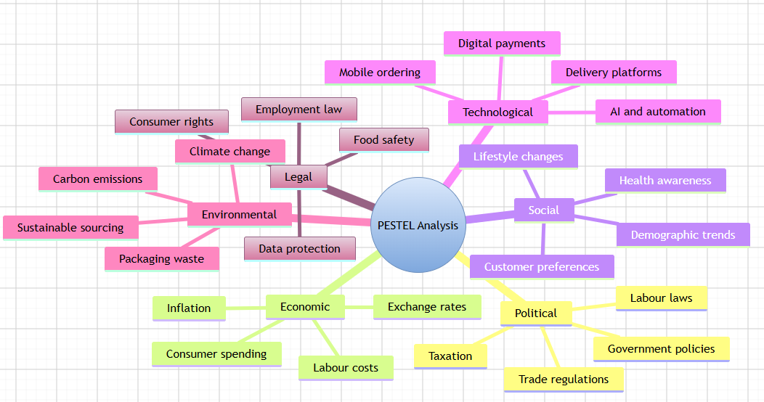
Figure 1: PESTLE Analysis
(Source: Self-created)
Political Factors
Politics plays a big role in the strategic decisions of McDonald's as it operates in over 100 countries, each with its own set of regulatory and policy frameworks. Food safety and labour regulations, taxation, and international trade regulations directly impact operating expenses and expansion for businesses (Gautam and Islam, 2022). In several countries, for instance, minimum wage legislation has forced up the costs of labour, leading McDonald's to invest even more in further automation, such as self-service kiosks and digital ordering systems, to increase efficiency. Furthermore, food safety laws have become stricter, which means that it is necessary to monitor suppliers and their production processes on a permanent basis, ensuring the quality of the products and protecting the reputation of the brand (Hong, 2025). However, international policies and geopolitical tensions may also be able to cause global supply chain disruptions and drive up costs of raw materials like beef, potatoes, and packaging.
Economic Factors
McDonald's is significantly affected by economic conditions, both in terms of its financial performance and its strategic priorities. Operating margins remain under pressure in all world markets due to rising inflation, rising interest rates, changing exchange rates and rising labour costs (Keyser et al. 2023). When the economy is uncertain, consumers' disposable income reduces, forcing them to be more price-sensitive and look for value for money. As a result, McDonald's has increased its value menu, promotions and digital loyalty initiatives to ensure demand is kept alive without compromising on profitability. A large share of the company's revenues comes from abroad, and exchange rate fluctuations have an impact on the company's international earnings. Meanwhile, emerging markets provide a growth path for the restaurant industry and more demand from customers (Daraojimba et al. 2023). Thus, McDonald's strategic emphasis on operational efficiency, franchising, price control, and value-based pricing allows the company to withstand difficult times in the economy or to exploit growth opportunities in developing economies.
Social Factors
Consumer preferences and lifestyles are still changing rapidly, which makes social factors important in the strategic decisions that McDonald's makes. The rising tide of health awareness has sparked a growing demand for healthier menu items, clear nutrition labels and sustainable ingredients (Das, 2025). McDonald's has responded by adding salads, fruit items, and plant-based items in certain markets, reducing calorie counts of drink items, and enhancing nutritional transparency. The rising demand for convenience, speed and personalisation have also been brought about by consumer lifestyles, particularly among the younger generation of consumers and working professionals. The company will meet these demands through a series of mobile ordering, drive-through and home delivery initiatives. Market expansion opportunities are also bolstered by demographic drivers, such as the rise of a growing middle class with more purchasing power in emerging markets and rising urbanisation (Kalinin et al. 2024). However, the company's brand is always in jeopardy because of people's concerns about obesity and unhealthy food consumption. Therefore, balancing consumer convenience and healthier product innovation will be a challenge for McDonald's to win the consumers' trust and stay competitive.
Technological Factors
The technological innovation has become one of the biggest platforms to help McDonald's attain operational efficiency and customer experience to improve the competitive strategy. The company has been spending a lot on kiosks, mobile apps, digital payment solutions, and data analysis, plus artificial intelligence (AI) technology that boosts customer engagement and better restaurant management (Patel, 2023). AI can be used to create personalized promotions for customers through recommendation systems and loyalty programs, which can result in higher customer satisfaction and increased repeat purchases for McDonald's. Beyond the growth of in-person dining, there's been a proliferation of strategic partnerships with food delivery services, such as Uber Eats and other local food delivery providers, enhancing market access for online food delivery. Furthermore, restaurant automation can reduce the need for manual staff and increase speed and efficiency in the kitchen and restaurant.Additionally, restaurant automation can improve efficiency and speed of the restaurant, and reduce reliance on manual staff in the kitchen (Arias, 2023). While all these benefits are great, it can be a costly investment and a risk to the company in the areas of cyber security and data privacy if there is a continuous investment in technology.
Environmental Factors
With rising expectations from consumers and a commitment to the global climate, environmental sustainability is becoming a key strategic consideration for McDonald's. Organisations are expected to be more responsible in reducing their environmental footprint by using responsible sourcing, waste minimisation and managing carbon emissions, all of which are becoming increasingly expected by consumers, governments and investors. In turn, McDonald's has made strides to be more sustainable, including the use of certified sustainable beef, coffee, palm oil and fish, and an increase in using recyclable and renewable packaging (Mcdonalds, 2026a). The company also pledged to cut GHGs from restaurants and the supply chain by implementing energy efficiency and investing in renewable energy. Despite all this, McDonald's is still under attack for packaging waste, the amount of plastic used, and its impact on livestock. These challenges demand constant innovation and working with suppliers to deliver sustainability goals whilst maintaining operational efficiencies.
Legal Factors
There are legal aspects that have a significant impact on the operation of McDonald's because it has to be able to abide by different types of regulatory frameworks in its different markets. Food safety rules, employment laws, consumer protection laws and data privacy laws have a direct impact on everyday business operations and business decisions (Widiarty and Tehupeiory, 2024). Food safety is a key element in complying with food hygiene standards that must be adhered to to safeguard the health of customers and preserve the company's international brand image. Similarly, changes in employment legislation regarding minimum wage, employee benefits and workplace safety have an impact on operational costs, but also drive improvements in HR practice and workforce management. With the rise of digital ordering and loyalty systems, the need to adhere to data protection laws, including the General Data Protection Regulation (GDPR), has grown even more crucial to protect customer information and keep consumer trust (Celestin, 2024).
Strategic challenges and success factors
The PESTEL analysis shows how important it is for McDonald's to be able to adapt to the fast-changing external environment yet operate with operational excellence in the long run. Its globally recognised brand, high efficiency in its franchising model, efficient supply chain, constant innovation in the digital sector and its dedication to sustainability are critical success factors (Mulyo, 2023). The features enable the company to adjust to the evolving requirements of its customers, regulatory bodies and technological solutions so that it can continue to deliver the best possible service to customers in various countries. However, McDonald's has several strategic issues to contend with, as well. Labour and raw material expenses, regulatory demands, the heightened awareness of health and environmental issues, and tougher competition in the quick-service restaurant arena remain challenges to profits and market share.

2.2 Internal Environment Analysis (VRIO)
The VRIO framework is a strategic analysis tool that is employed to analyse an organisation's resources and capabilities and find out if these resources and capabilities give it a sustainable competitive advantage (Saloko et al. 2023). By using the VRIO framework, McDonald's can assess the importance of each of its resources in helping it become more successful and competitive in the global quick service restaurant industry.
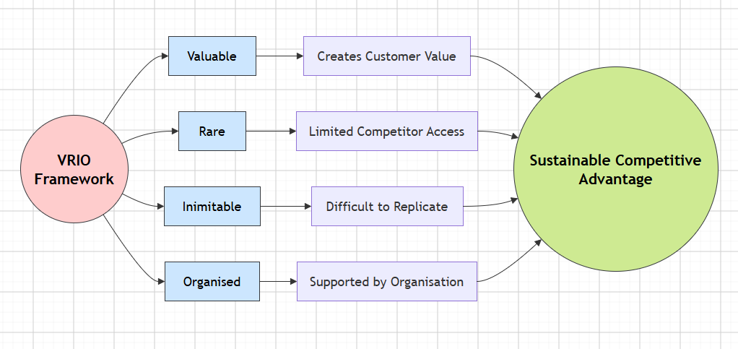
Figure2: VRIO Framework
(Source: Self-created)
Analysis
The VRIO analysis shows that McDonald's has a few strategic resources and capabilities that can help it to have competitive advantages in the long run. Its global brand reputation is the most valuable strategic asset amongst these. The brand has been developed over many years and is known globally for its uniformity, ease and customer service. This is a sustainable competitive advantage as it is difficult for competitors to match the brand's reputation and customer loyalty (Blankson et al. 2026). In the same way, McDonald's large worldwide franchise is another source of competitive advantage. By using a franchising model, the company can expand fast in the international market, and minimise capital investment and operational risks. It is backed by effective operating practices, training programs and quality control systems that enable McDonald's to achieve economies of scale that are difficult to match by many of its competitors.
Resources and Capabilities | Valuable | Rare | Inimitable | Organised | Competitive Implication
Brand Reputaion | ✔ | ✔ | ✔ | ✔ | Sustained competitive advantage
Franchise Network | ✔ | ✔ | ✔ | ✔ | Sustained competitive advantage
Supply Chain | ✔ | ⛌ | ⛌ | ✔ | Competitive parity
Digitalisation | ✔ | ✔ | Partly | ✔ | From temporary to sustained competitive advantage.
Finance | ✔ | ⛌ | ⛌ | ✔ | Competitive parity
Innovation | ✔ | ✔ | Partly | ✔ | Temporary competitive advantage
Table 1: VRIO Analysis
(Source: Self-created)
The company's digital ecosystem, which encompasses the company's mobile application, loyalty programme, artificial intelligence, and self-service kiosks, further enhances the company's strategic capabilities. While other brands have tried to implement similar digital solutions, McDonald's has the advantage of rolling out these systems throughout its extensive global restaurant footprint and leveraging customer data to improve personalisation of its service. Therefore, for the time being, digital innovation offers a short-term to long-term competitive advantage, as long as the organisation keeps on investing in technology (Cuthbertson and Furseth, 2022). McDonald's efficient supply chain, as well as its financial resources, is still a valuable organisational asset to serve in enhancing operational efficiency, purchasing power and business resilience. Nevertheless, they are not exactly hard to come by: several large multinational restaurant chains have similar capabilities. Therefore, they do not provide any competitive edge, but only contribute to maintaining competitive parity.
Based on the VRIO analysis, McDonald's has many competitive advantages, which are notably its global brand recognition, well-established franchise system, and the ability of its organisation to effectively coordinate its strategic resources. It will be crucial to stay competitive in the ever-changing and tech-savvy business world through continuous innovation and good resource management.

2.3 SWOT Analysis
Strength | Weaknesses
- Globally recognised brand  - Global extendable network  - Strong financial performance  - Advanced digital capabilities  - Optimised worldwide supply chain | - A strong reliance on franchise operations  - Unhealthy food products are perceived across the country  - Increase in labour and operating expenses  - Criticism of packaging and emissions in the environment  - Relying heavily upon adult markets for a large proportion of sales
Opportunity | Threats
- Growth in developing countries  - Increasingly more people want healthier menu items in school food service  - Digital innovation and AI  - Conservation of packaging and sourcing  - Increase in online food deliveries | - High level of rivalry in the QSR sector.  - The economic situation and inflation  - Changing consumer preferences towards healthier lifestyles  - Increasing government regulations and labour costs  - Disruptions in the supply chain and geopolitical uncertainty
Table 2: SWOT Analysis
(Source: Self-created)
The SWOT analysis is a combination of the results of the PESTEL analysis and the VRIO analysis to give an overall assessment of McDonald's strategic position. The company's well-known and recognised brand, a franchise network, financial strength and digital capabilities give it a good platform to take advantage of opportunities, including entering new markets, technological developments and rising interest in sustainable business (Rani, 2023). Although the issues of dependence on franchises, and continuing complaints about health risks and environmental damage need to be solved. Failing to cope with the external pressures such as rising operational costs, changing consumer preferences, and stiff competition in the industry may have a negative impact on profitability. In other words, McDonald's must continue to capitalize on its current advantages and take necessary measures to give itself the strongest competitive position and market leadership such as investing in better product innovation in the healthy and sustainable products category, and digital transformation.

3. View the organisation comprehensively and holistically
Assessing an organisation's strategic position is only one part of the full picture - the other part is assessing the long-term value that the business practices are adding to stakeholders (Annesi et al. 2025). Corporate Social Responsibility (CSR): It reflects society's expectation of the organisation to take responsibility and act ethically, socially and environmentally (Awa et al. 2024). The Balanced Scorecard is a tool that allows the strategic performance of the organisation to be measured by using both financial and non-financial measures (Al-Hosaini et al. 2023). These strategies work together to ensure McDonald's sustainability efforts, operations and future business goals can be aligned and help give the company a competitive edge.

3.1 Corporate Social Responsibility (CSR) Strategy
Corporate Social Responsibility (CSR) is a key part of the corporate strategy of McDonald's because the company realises that its success in the end requires value creation for customers, employees, suppliers, communities and the environment. McDonald's does not see CSR as a stand-alone program, but one that is embedded in the company's operations and strategy (McDonald, 2024). This helps the company achieve its purpose with profitable growth, and it will be aligned with the business's strategy and priorities. The strategy of McDonald's CSR has five main areas, namely sustainable sourcing, environmental responsibility, community development, employee well-being and responsible governance (Rathnayake, 2025). The company's sustainability initiatives around the world include certified sustainable ingredients like coffee, fish, palm oil and beef, and working with suppliers to enhance animal welfare, food quality and supply chain transparency. These efforts contribute to lowering environmental risks and enhancing the brand reputation among customers.
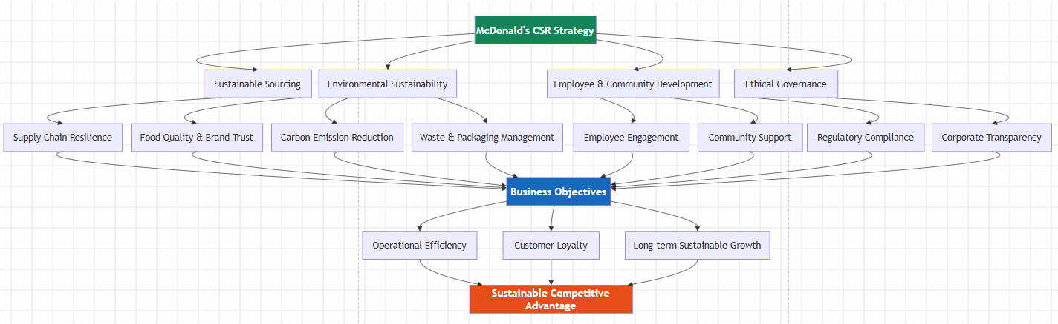
Figure 3: CSR Strategy
(Source: Self-created)
Environmental sustainability is yet another area that is crucial for McDonald's CSR efforts. The company has committed to reducing GHG emissions in its restaurants and supply chain, aiming at optimizing its energy usage and transition to renewable energy, and increase recycling and the use of renewable packaging materials. The initiatives are contributing to the global climate targets and meeting the growing expectations of consumers for a more sustainable way of doing business (Bhandari, 2025). Further, waste reduction initiatives and sustainable packaging practices help optimise resources and minimise operating expenses. However, another company pays a lot to its employees and local communities: McDonald's. The company's social responsibility is reflected in the training and development programmes, diversity and inclusion at work, wellbeing and support for Ronald McDonald House Charities (Rathnayake, 2025). The programmes foster employee engagement, build corporate image, and help to manage community relationships in its international markets.
The company's CSR policy is well aligned to the business operations. Responsible sourcing helps build a resilient supply chain, environmental measures help improve operational efficiency, and community participation boosts trust and loyalty among stakeholders and customers. However, there is a worry about the health of some of McDonald's products, the waste of packaging and the carbon dioxide released by raising animals (Fredson et al. 2025). So, the company must continue to invest more in healthier menu innovation, step up sustainability investments, and increase transparency to be credible and sustainable as part of its CSR efforts to create long-term competitive advantage.

3.2 Balanced Scorecard
Perspective | Objectives | KPIs | Targets | Initiatives
Financial | Boost profits and growth in revenue. | Revenue Growth, Operating Margin, ROI. | Enhance business revenues and operating efficiency. | Improve cost efficiency, optimise pricing strategies, and expand franchising.
Customer | Enhance customer satisfaction and loyalty. | Customer satisfaction score, repeat purchase rate, growth of loyalty membership. | Increase customer retention and digital engagement. | Strengthen loyalty programmes, menu innovation, and improve the digital ordering experience.
Business Processes | Increase operational efficiency and product quality. | Deliver and maintain order accuracy, fast service times, food safety compliance, and supply chain efficiency. | Minimise turnaround times and ensure uniform quality. | Develop AI, kitchen automation, supplier relationships, and quality management.
Learning and Growth | Build employee skills and promote creativity. | Hours spent training employees, employee retention, innovation projects, and employee participation. | Enhance the skills of the workforce and organisational innovation. | Leadership development, digital skills training, diversity, and technology investment.
Table 3: Balanced Scorecard
(Source: Self-created)
The Balanced Scorecard illustrates the measurable organisation's performance that reflects McDonald's corporate strategy. The company prioritises financial growth, realised through profitable expansion, high efficiency and good cost management, primarily based on the franchise concept (Mulyo, 2023). These goals help to create shareholder value and ensure financial agility in a very competitive market. The customer perspective is an expression of McDonald's dedication to providing the best customer value by innovating menus, leveraging digital convenience and personalising experiences. The company's commitment to loyalty programs, mobile apps, and delivery collaborations fortifies customer relationships and enhances retention, aligning with its mission to be the preferred dining spot for customers.
The internal business process dimension is employed to enhance the business process. McDonald's continues to invest in AI, automation, supplier relationships and quality assurance, which is helping to improve food safety, product uniformity and ‘restaurant service delivery speed’ globally. The enhancements boost the company's competitiveness and its operational efficiency. Finally yet importantly, the learning and growth dimension emphasises the significance of employee development and innovation (Omoseebi et al. 2023). Workforce training, leadership development, digital skills and organisational learning are investment areas, which enable employees to perform better and create innovative solutions within the organisation. These four views demonstrate that McDonald's has been successful in aligning its strategic vision with success measures, and has enabled the company to expand and maintain its position in the international fast-food market.

Strategic Options and implementation
Organisations make decisions to meet changing market conditions and to maintain their competitive edge. Given the high level of competition, consumer tastes, technological advancements, and rising sustainability requirements in the quick-service restaurant sector, McDonald's must choose the correct business approach. Based on the previous PESTEL, VRIO, and SWOT analysis, McDonald's should keep on going with a differentiation strategy with market development and product development strategies (Adewusi et al. 2024). This will allow the firm to reinforce its customer value, enter new markets and stay competitive in the long term.

Business-Level Strategic Choices
Porter's Generic Strategies are three basic ways to achieve competitive advantage: cost leadership, differentiation, and focus (Bhat et al. 2024). McDonald's has always made a point of operating efficiently and differentiating its product. While the company enjoys economies of scale and cost-efficient operations due to its franchise model, it has more advantages than this, and it is a competitive advantage. Rather, McDonald's distinguishes itself with the strength of their brand recognition, innovation in menu offerings, digital technologies, convenience for customers, and the quality of their service delivery.
The company's investments in artificial intelligence, self-service kiosks, mobile apps, customised loyalty schemes and delivery collaborations are evidence of its focus on delivering customer experiences, not just the best prices (Guo, 2025). In addition, the constant development of new menu items, such as healthier meat and non-meat items, higher quality beverages, and new localised items, helps McDonald's adjust to consumer changes in various countries around the world. Hence, the most appropriate business level strategy would be differentiation as it provides more value to customers and less direct competition.

Strategy Validation Using Ansoff Matrix
The Ansoff Matrix is a valuable tool for analysing strategic growth opportunities as it looks at existing products and new products with existing markets and new markets (Ferreira and de, 2024). Of these, product development and market development are the most suitable growth strategies for McDonald's to use in order to maintain their advantage in the future.
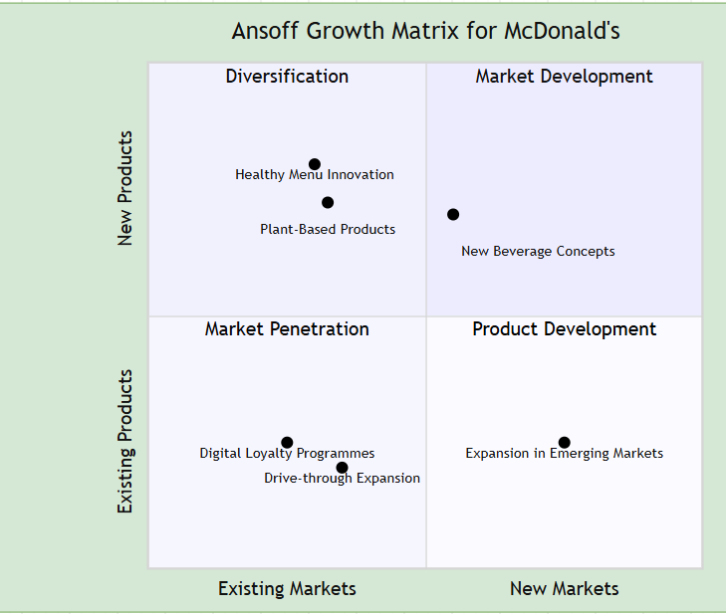
Figure 4: Ansoff Matrix
(Source: Self-created)
Digital marketing, loyalty schemes and better customer engagement are key points for retaining customers in the Ansoff Matrix. Product development and market development strategies are more likely to bring about greater long-term growth, though (Sudirjo, 2023). Product development allows McDonald's to meet rising demands from consumers for healthier foods, higher quality menu items and sustainable food products. Concurrently, market development is helping the growth of high-growth emerging economies, in which urbanisation, growing disposable income, and an evolving lifestyle are driving continued growth in demand for quick-service restaurants. Through these strategies, McDonald's can deepen its loyalty, also diversify its revenue, and eliminate its reliance on well-established markets (Ciaburri et al. 2026). Given the above, the Ansoff Matrix backs the suggestion that the company needs to continue to focus on product innovation and international expansion for its future growth plan.

Strategy Implementation
For McDonald's to be successful with its differentiation strategy, it must make sure all functions are coordinated, including operations, technology, HR, marketing, and supply chain management. First, the business needs to invest more in healthy menu innovation, including more low-calorie, plant-based and locally adapted foods that meet consumers' expectations (Yildirim, 2024). Continuous product innovation will help McDonald's improve customer satisfaction and differentiate itself from its rivals. Second, McDonald's needs to speed up their digital transformation by improving their AI, mobile app, self-service kiosks, and data analytics. These can help to enhance operational efficiency, streamline customer interactions, manage inventory, and boost customer loyalty by personalising promotions (Siddique et al. 2026). At the same time, greater partnerships between digital ordering and delivery will enhance the convenience and market availability for customers.
Expansion internationally should continue to be considered as a strategic objective, especially in the emerging economies where urbanisation, population growth and rising disposable income are a convincing market opportunity (Rodrik and Stiglitz, 2025). However, to be successful, menus, prices and marketing campaigns must be customised to local tastes, while preserving the global brand. Improving relationships with suppliers and investing in sustainable sourcing will also enhance the resilience of supply chains and help the organisation's environmental commitments. Training of employees is yet another critical implementation need (Bagherian et al. 2022). Leadership development, digital capability training and customer service skills will be continued to ensure employees can meet technological innovation demands whilst delivering the restaurant's high service standards, throughout the McDonald's restaurant network worldwide.

Challenges and mitigation strategies in implementation
There are several challenges that McDonald's might face in implementing it. Short-term financial impacts could be caused by increasing investment costs of digital technologies, restaurant modernisation and sustainability measures (Rasulov, 2024). In addition, franchisees and employees might also be reluctant to adopt new technologies and processes within their franchise. Competition from some major QSR brands and new fast-casual restaurants will also demand ongoing innovation to stay competitive (Hossen and Sheshir, 2025). McDonald's will need to take a gradual approach to implementation, focusing on key launches and ensuring investment costs are managed, in order to address these challenges. The implementation of complete training courses and ongoing communication with franchisees will help to increase the likelihood of organisational commitment and minimise resistance to change. Furthermore, further strengthening strategic partnerships with technology providers and sustainable suppliers can drive innovation and limit operational risks (Nasir and Butt, 2025). To measure the progress of implementation and take strategic decisions when needed, regular monitoring will be done by following clearly defined key performance indicators.

Section 2: Reflective Account
This is a reflective account showing the use of Gibbs' Reflective Cycle to reflect on the research, analysis and preparation of a strategic management report about McDonald's. Reflection includes what has been learned, the difficulties faced, and the skills acquired during the assignment, as well as what could have been improved.
Description
This assignment involved playing the role of a strategic management consultant and critically analysing the strategic position of McDonald's. Analysed both the external and internal business environment using recognised strategic management frameworks – PESTEL, VRIO, SWOT, Balanced Scorecard and Ansoff Matrix. Accessed academic journal articles, company reports and industry publications to formulate evidence-based arguments and recommendations. In this report, the models have not been described in detail but related to the concepts and practical application in the business. This helped me to gain an appreciation of the interdependencies of various strategic management tools in relation to organisational decision-making.
Feelings
Initially, it was difficult to select the number of strategic frameworks due to the fact that each model focuses on a different aspect of the organisation's performance. At first, I was not sure how to bring these together into a single consultancy report instead of separate analyses. As I dug deeper into my research, my confidence grew as I got a better grasp of the influence of external opportunities and threats on internal capabilities and strategic decisions. Finally, I was fascinated by the thought of a huge global brand like McDonald's constantly evolving as technology, sustainability requirements and consumer habits evolve. The creation of the report made me more confident in the use of strategic management theories on actual business problems.
Evaluation
A significant strength of my work was the high level of academic literature and up-to-date company information that was used throughout the process of strategic analysis. This allowed me to have evidence-based conversations, not based on my opinion. In addition, using more than one strategic framework helped me to think critically as I needed to compare information from a variety of sources to create recommendations. Moreover, analysing McDonald's has shown the significance of strategic choices in relation to organisational resources, customers' wants, and environmental changes.
I encountered a couple of difficulties in the research process, however. Gathering the most recent and reliable data from a variety of academic and business sources took a lot of time. There was some repetition of information in some strategic frameworks, which made it hard to avoid repetition and maintain logical flow between sections. Careful planning and prioritisation of the most relevant evidence were also needed to comply with the word limit in the assignment, while maintaining a level of detail.
Analysis
This assignment was a learning experience in the aspects of strategic management, which demand that organisations should constantly adjust to the changes occurring in the environment around them and be able to use internal resources and capabilities effectively. Having different strategic frameworks enabled me to see that, there is no one framework, which could give a full assessment of organisational performance. In contrast, the use of PESTEL, VRIO, SWOT, the Balanced Scorecard and Ansoff Matrix gave the organisation a broader idea of McDonald's strategic position. For instance, while the PESTEL analysis provided external opportunities and threats, the VRIO analysis detailed how the internal resources help the organisation achieve sustainable competitive advantage. The linking of these findings to the SWOT analysis enhanced the overall strategic assessment and helped to ensure that the final recommendations were evidence-based.
While this experience also helped me to evaluate the strategies of the organisation, it was not solely in terms of business activities. Furthermore, I knew that my strategic recommendations should be based on timely academic research, company reports and analyses to ensure that it will provide a sound basis for my recommendations. All of these have played a significant and positive role in my thinking skills, research and problem-solving skills, which are essential for my postgraduate study and for management in the real world.

Conclusion
Overall, it has led to a deeper insight into the role strategic analysis can play in supporting organisational decision-making and, in the long term, in gaining an organisation a competitive advantage. The assignment enhanced my ability to use theory in practice in business situations, and helped to sharpen my critical evaluation and problem-solving skills. It also demonstrated the need to combine various strategic models to generate robust recommendations, and not simply use individual analysis tools. The biggest lesson I learned from this experience was to gain confidence in being able to use academic and industry research to make professional recommendations and provide a strategic analysis on my own.
Action Plan
In the future, I intend to strengthen my analytical skills in the process of writing strategic management projects by using a wider range of the latest scientific literature and reports from industry. I will also be working on being able to combine information from several strategic frameworks without repeating information. I will also become more confident in my data-interpretation skills, particularly when interpreting indicators of organisation performance, which will continue to promote the quality of my strategic evaluation. Finally, I will be continuously improving my academic writing, critical thinking and the presentation of reports in the professional context in order to produce more impactful consultancy reports to aid managers in decision-making in complex business scenarios.

Summary
External and internal analysis of McDonald's was used to analyse thoroughly and effectively the strategic position of the company and to apply a strategic management practical framework. The findings showed that the company has a strong brand reputation, a well-established franchise, digital competence, and sustainability initiatives, providing a solid foundation for maintaining its competitive position in the evolving market landscape and environmental challenges. As a basis for differentiation, product innovation and development of international markets are suitable, and the proposed differentiation approach has high potential for sustainable development. The reflective statement further highlighted the importance of applying strategic management theory in an actual business context and gave basic knowledge of the development of critical thinking, research and decision-making skills, which will be relevant in future academic and business contexts.

Reference List
Adewusi, A.O., Okoli, U.I., Adaga, E., Olorunsogo, T., Asuzu, O.F. and Daraojimba, D.O., 2024. Business intelligence in the era of big data: A review of analytical tools and competitive advantage. Computer Science & IT Research Journal, 5(2), pp.415-431. https://www.researchgate.net/profile/Adebunmi-Adewusi/publication/378208076_BUSINESS_INTELLIGENCE_IN_THE_ERA_OF_BIG_DATA_A_REVIEW_OF_ANALYTICAL_TOOLS_AND_COMPETITIVE_ADVANTAGE/links/65cd3b9f1e1ec12eff9bea3f/BUSINESS-INTELLIGENCE-IN-THE-ERA-OF-BIG-DATA-A-REVIEW-OF-ANALYTICAL-TOOLS-AND-COMPETITIVE-ADVANTAGE.pdf
Al-Hosaini, F.F., Ali, B.J., Baadhem, A.M., Jawabreh, O., Atta, A.A.B. and Ali, A., 2023. The impact of the Balanced Scorecard (BSC) non-financial perspectives on the financial performance of private universities. Information Sciences Letters, 12(9), pp.2903-2913. https://www.naturalspublishing.com/files/published/975uz7qi255y5d.pdf
Annesi, N., Battaglia, M., Ceglia, I. and Mercuri, F., 2025. Navigating paradoxes: building a sustainable strategy for an integrated ESG corporate governance. Management Decision, 63(2), pp.531-559. https://www.emerald.com/md/article-pdf/63/2/531/9675610/md-10-2023-2006.pdf
Arias, L., 2023. Automation for All? A Historical Analysis of the Automation of the Food Service Industry. https://www.ideals.illinois.edu/items/137945/bitstreams/448805/data.pdf
Awa, H.O., Etim, W. and Ogbonda, E., 2024. Stakeholders, stakeholder theory and corporate social responsibility (CSR). International journal of corporate social responsibility, 9(1), p.11. https://link.springer.com/content/pdf/10.1186/s40991-024-00094-y.pdf
Bagherian, A., Gershon, M. and Swarnakar, V., 2022. Role of employee training on Six Sigma implementation's success: an empirical study. International Journal of Six Sigma and Competitive Advantage, 14(2), pp.247-278. https://www.researchgate.net/profile/Vikas-Swarnakar/publication/362829184_Role_of_employee_training_on_Six_Sigma_implementation%27s_success_an_empirical_study/links/63316ead6063772afd92bfb5/Role-of-employee-training-on-Six-Sigma-implementations-success-an-empirical-study.pdf
Bhandari, N., 2025. Analysis of Circular Economy Practices at McDonald's. https://www.theseus.fi/bitstream/handle/10024/888228/Bhandari_Nawaraj.pdf?sequence=3
Bhat, M., Agrawal, A. and Barmpas, M.V., 2024. Differentiation, cost leadership, or ending up in the middle?: a reflection on the viability of Porter's generic strategies through a case study comparison of McDonalds and Starbucks. Athens journal of business & economics, 10(3), pp.217-238. https://savearchive.zbw.eu/bitstream/11159/653919/1/1892097567_0.pdf
Blankson, C., Boakye, K.G., Prybutok, V.R., Mahmoud, M.A. and Opare, G., 2026. Brands in crisis: customer loyalty and corporate reputation. Marketing Intelligence & Planning, 44(5), pp.997-1021. https://www.researchgate.net/profile/Charles-Blankson/publication/398624219_Brands_in_crisis_customer_loyalty_and_corporate_reputation/links/69dfb52eb1056332819c773b/Brands-in-crisis-customer-loyalty-and-corporate-reputation.pdf
Celestin, P., 2024. How Emerging Data Protection Laws Are Reshaping Digital Marketing and Consumer Privacy Policies. https://papers.ssrn.com/sol3/Delivery.cfm?abstractid=5188091
Ciaburri, M., Savio, R., Ferri, S. and Tiscini, R., 2026. E-commerce platform dependence: a double-edged sword for born global firms?. International Entrepreneurship and Management Journal, 22(2), p.76. https://link.springer.com/content/pdf/10.1007/s11365-026-01205-w.pdf
Cuthbertson, R.W. and Furseth, P.I., 2022. Digital services and competitive advantage: Strengthening the links between RBV, KBV, and innovation. Journal of Business Research, 152, pp.168-176. https://ora.ox.ac.uk/objects/uuid:63f6668c-7128-4bfe-9119-6163c1d6f831/files/rhh63sw55n
Daraojimba, C., Kolade, A.O., Nwankwo, T.C., Agho, M.O. and Okafor, C.M., 2023. A review of business development strategies in emerging markets: economic impacts and growth evaluation. International Journal of Research and Scientific Innovation, 10(9), pp.195-206. https://www.researchgate.net/profile/Chiedozie-Okafor-2/publication/374691820_A_Review_of_Business_Development_Strategies_in_Emerging_Markets_Economic_Impacts_and_Growth_Evaluation/links/652a40411a05311a23fbecb3/A-Review-of-Business-Development-Strategies-in-Emerging-Markets-Economic-Impacts-and-Growth-Evaluation.pdf
Das, J., 2025. Health and Wellness Foods: Trends, Consumer Behavior, and Market Evolution. Consumer Behavior, and Market Evolution (November 27, 2025). https://papers.ssrn.com/sol3/Delivery.cfm?abstractid=5814702
Ferreira, A.P.P.F.S. and de Sá, M.M.B.P., 2024. The importance of the Ansoff matrix for the study of the information services market. The Canadian Journal of Information and Library Science, 47(2), pp.78-84. https://ojs.lib.uwo.ca/index.php/cjils/article/download/17432/15874
Fortunebusinessinsights, 2026. Quick Service Restaurants Market Size, Share & Industry Analysis, By Service Type https://www.fortunebusinessinsights.com/quick-service-restaurants-market-103236
Fredson, G., Adebisi, B., Ayorinde, O.B., Cynthia, E., Onukwulu, O.A. and Ihechere, A.O., 2025. Building resilient supply chains in emerging markets: sustainable procurement and stakeholder engagement strategies. World Scientific News, 201, pp.57-95. https://worldscientificnews.com/wp-content/uploads/2025/03/WSN-201-2025-57-95.pdf
Gautam, Y. and Islam, M.S., 2022. International Business Operations in the Quick Service Restaurants and the need for Reformed HR Practices in Finland. https://www.theseus.fi/bitstream/handle/10024/752996/Islam_Gautam.pdf?sequence=2
Guo, Y., 2025. Successful stories on the usage of technologies in service industries. In Technological innovations in the food service industry (pp. 197-230). IGI Global Scientific Publishing. https://www.academia.edu/download/125132642/Full_Book.pdf#page=217
Hong, T.K., 2025. Developing a Risk Management and Business Continuity Plan for McDonald's: Addressing Food Poisoning Incidents. https://www.researchgate.net/profile/Kwan-Hong-Tan/publication/391122334_Developing_a_Risk_Management_and_Business_Continuity_Plan_for_McDonald's_Addressing_Food_Poisoning_Incidents/links/680b1a47bfbe974b23baf273/Developing-a-Risk-Management-and-Business-Continuity-Plan-for-McDonalds-Addressing-Food-Poisoning-Incidents.pdf
Hossen, A.A.M. and Sheshir, M.H., 2025. Marketing strategies in fast food industries: a study of McDonald’s in Pietarsaari. https://www.theseus.fi/bitstream/handle/10024/890165/Hossen_Sheshir.pdf?sequence=2
Kalinin, A., Rudnik, R., Tsvetov, A., Bondarenko, K. and Shuranova, A., 2024. Emerging markets decoded 2024. Available at SSRN 4862785. https://papers.ssrn.com/sol3/Delivery.cfm?abstractid=4862785
Keyser, T.D., Langenus, G. and Walraven, L., 2023. The development of corporate profit margins and inflation. NBB economic review, (8), pp.1-28. https://savearchive.zbw.eu/bitstream/11159/654039/1/1892806444_0.pdf
LOC, 2026. McDonald's Founded in 1940. https://guides.loc.gov/this-month-in-business-history/may/mcdonalds-founded
McDonald, T., 2024. Do generative artificial intelligence company strategies of ‘moving fast and breaking things’ in civil society cancel their social licence to operate? A nurse’s evaluation of chatbot impacts. Pacific Rim International Journal of Nursing Research, 28(4), pp.689-706. https://he02.tci-thaijo.org/index.php/PRIJNR/article/download/268964/184562
Mcdonalds, (2026c). Our Planet https://corporate.mcdonalds.com/corpmcd/our-purpose-and-impact/our-planet.html
Mcdonalds, 2026. About Us. https://www.mcdonalds.com.my/company
Mcdonalds, 2026a. Annual Report. https://corporate.mcdonalds.com/content/dam/sites/corp/nfl/pdf/McD%20-%202024%20Annual%20Report%20to%20Shareholders.pdf
Mcdonalds, 2026b. Our Mission and Values https://www.mcdonalds.com.my/company/mission-values
Mulyo, I.A., 2023. Value chain analysis of McDonald. Jurnal Ekonomi, 12(02), pp.908-913. https://ejournal.seaninstitute.or.id/index.php/Ekonomi/article/download/1815/1438
Mulyo, I.A., 2023. Value chain analysis of McDonald. Jurnal Ekonomi, 12(02), pp.908-913. https://ejournal.seaninstitute.or.id/index.php/Ekonomi/article/download/1815/1438
Nasir, M.S. and Butt, S.A., 2025. The Role of Supplier Relationship Management in Reducing Operational Risks. Economic Trends and Business Review, 3(1), pp.34-49. https://etbrjournal.com/index.php/journal/article/download/48/48
Omoseebi, A., Jayson, A. and Winston, W., 2023. Skill Development: Training Programs to Equip Employees with Digital Skills [online] https://www.researchgate.net/profile/Adetoyese-Omoseebi/publication/389691208_Skill_Development_Training_Programs_to_Equip_Employees_with_Digital_Skills/links/67cde60abab3d32d84405d53/Skill-Development-Training-Programs-to-Equip-Employees-with-Digital-Skills.pdf
Patel, A., 2023. An evaluation of modern methods of delivering customer service and the role of AI: Case study of McDonald’s (ITIS) Finland. https://www.theseus.fi/bitstream/handle/10024/801197/Patel_Ameet.pdf?seque
Rani, J., 2023. Exploring McDonald', adaotation to changing consumer preferences and trends. https://www.theseus.fi/bitstream/handle/10024/800374/Rani_Jyoti.pdf?sequence=2
Rani, J., 2023. Exploring McDonald', adaotation to changing consumer preferences and trends. https://www.theseus.fi/bitstream/handle/10024/800374/Rani_Jyoti.pdf?sequence=2
Rasulov, R., 2024. Economic substantiation of innovative solutions for direct cooperation between manufacturers and restaurants. Futurity Economics&Law, 4(4), pp.121-136. http://www.futurity-econlaw.com/index.php/FEL/article/download/291/170
Rathnayake, C., 2025. Corporate social responsibility and consumer trust: A case study of McDonalds Finland. https://www.theseus.fi/bitstream/handle/10024/904582/Rathnayake_Channa.pdf?sequence=2
Rodrik, D. and Stiglitz, J.E., 2025. A new growth strategy for developing nations. In The new global economic order (pp. 89-107). Routledge. https://library.oapen.org/bitstream/handle/20.500.12657/104259/1/9781040400159.pdf#page=102
Saloko, S.A., SP, M., Elfatma, O., SP, S.G., MP, I., Santi, I.S. and Prasetya, B., 2023, August. Analysis of sustainable competitive advantage at PT. X: Application of the VRIO approach. In Proceeding of International Conference on Innovations in Social Sciences Education and Engineering (Vol. 3, pp. 078-078). http://conference.loupiasconference.org/index.php/icoissee3/article/download/421/386
Siddique, M.E., Shahzad, M.K., Amjad, S.I., Hussain, S.Z. and Adil, F., 2026. An Artificial Intelligence–Driven Framework for Integrating Personalized Marketing, Demand Forecasting, and Supply Chain Optimization in E-Commerce Platforms to Enhance Customer Experience and Operational Efficiency. Journal of Management Science Research Review, 5(2), pp.1612-1636. https://www.jmsrr.com/index.php/Journal/article/download/690/663
Sudirjo, F., 2023. Marketing strategy in improving product competitiveness in the global market. Journal of Contemporary Administration and Management (ADMAN), 1(2), pp.63-69. http://journal.literasisainsnusantara.com/index.php/adman/article/download/24/39
Widiarty, W.S. and Tehupeiory, A., 2024. The role of business law in improving consumer protection in the digital age. Journal of Law and Sustainable Development, 12(2), pp.1-12. http://repository.uki.ac.id/13892/1/TheRoleOfBusinessLaw.pdf
Yildirim, M., 2024. Changing Nutrition Trends and McDonald’s Product Strategies: The Rise of Plant-Based Products and Their Impact on Consumer Behaviour. https://arc.cct.ie/cgi/viewcontent.cgi?article=1042&context=business

