The Professional Practitioner (ECEY4009/C)
I confirm that I have not used any AI tools in the research and creation of this assignment. I confirm that I have not presented any AI-generated materials as my own work. I confirm I have copies of my drafts, notes, and other resources I used, which I may be asked to provide in evidence.
Sarah Seim: 2500546

- Create a reflective personal development plan (PDP) that includes personal and professional aims to help develop your professional practitioner skills, including a personal reflection (500 words)
Word count: 495

Objective | Actions (How will I achieve this objective/ what needs to be done?) | Resources (What support and resources are needed to achieve this objective?) | Target Date for achieving objective. | Success criteria (How will I know I have achieved this goal; how will I review this?)
Improve my Japanese skills to a conversational level. | I will dedicate around thirty minutes three times a week to studying Japanese using structured online lessons and language-learning apps such as Pimsleur. I will also use flashcards to build vocabulary, practice writing simple sentences, and watch Japanese media with subtitles to develop listening and comprehension skills. | I currently use a language learning app subscription (Pimsleur) and have the ‘Basic Japanese’ textbooks for vocabulary. Furthermore, online resources, such as grammar guides, and viewing Japanese films or podcasts for immersion practice daily, have been benefitting me. | This is an ongoing objective, but I aim to reach conversational level within one year with progress reviews every three months. | I will know I have achieved this goal when I can hold a short conversation in Japanese and understand basic phrases without subtitles. I will review progress by testing myself monthly through speaking exercises and vocabulary recalls
Obtain my driving license | I have already completed my theory test and will now focus on building my practical driving skills through regular lessons with a qualified instructor. I plan to attend at least one to two lessons per week to develop my confidence, control, and awareness on the road. I will also review key areas after each session, such as parking manoeuvres and hazard perceptions to track improvement and identify what needs further practice. | I have a provisional license already and booked a qualified driving instructor with access to a suitable car for lessons and practice. I have sufficient funds to cover the cost of lessons and the practical test. Alongside this, my theory books and online tests, for precaution and road safety, are necessary tools to keep my memory refreshed. | As I am starting lessons this month, hopefully, I am looking at a time frame within the next six months, depending on progress and practical test availability. | I will know I have achieved this goal when I successfully pass my practical driving test and receive my full driver’s license. I will review my progress after each lesson with feedback from my instructor, noting any improvements in confidence, observation, and independent decision making.
Develop stronger organisation and time management habits during my degree | I will be using a physical calendar to record assignment deadlines, lectures, and plan for upcoming assignments. I will also create a structured routine that balances study, rest, and personal time to reduce stress and improve productivity. | I have a planner app and a physical calendar for deadlines and any ongoing events. I use my accommodations quiet study space for concentration and have digital tools such as reminders to keep me on track. | This is ongoing goal that I will continue to develop throughout my degree. However, I aim to establish consistent organisational habits within each academic term. | I will know I have achieved this goal when I consistently submit assignments on time feel less stressed about deadlines and can maintain a balanced study routine.  I will review my progress by checking my calendar weekly reflecting on how well I managed my workload and noting any improvements in focus or academic performance.

- Design a briefing paper that explores the importance of reflective practise within the early years and analyses different reflective models. (1000 words) Word count: 993

What is reflection and reflective practise?  Reflection is the process of learning from previous experiences by examining how we and others viewed a situation and using that understanding to inform future decisions (Tarrant 2013). Tarrant Further explains that reflective practise involves opening our actions to scrutiny both our own and that others involved to develop greater self-awareness and professional growth.  Similarly, Hargreaves and Page (2013) describe Reflective practise is a complex process grounded in ethical principles relevant to 1's professional context it goes beyond theoretical knowledge from textbooks, encompassing learning through personal experience and the ability to integrate that learning into professional practise. Even Thomas and Lewis (2016), claim that effective reflection requires emotional intuition to enable a deeper understanding of one’s actions.  This essentially describes reflective practise as a way to develop reflective skills by integrating both practical and emotional approaches to enhance he child's learning as well as our own professional growth | Why is reflective practise important to EY practise?  Reflective practise is important in early years education because it enables practitioners to evaluate their own teaching methods ensuring that every child receives high quality care and learning opportunities. Lindon and Trodd (2016) Emphasise the continuous importance of reflection on its direct impact on the children practitioners work with they suggest that through reflection practitioners can model positive behaviour and shape children's actions by leading through example a practitioners first-hand interactions and approaches play a crucial role in shaping a child's early learning experiences influencing their behaviour both in the present and potentially into adulthood. For instance, Ourvy and Furtado (2020) highlights the significance of play in developing children's understanding of the world and how they form social connections. By reflecting on each child's individuality and learning needs practitioners can adapt their teaching approaches to best support development. This thoughtful practise not only enriches the child's learning journey but also lays a solid foundation for the emotional and social growth in later life.  Reflective practise also holds deep value for practitioners themselves. It becomes an ongoing journey of personal and professional learning encouraging the development of self-awareness skills and confidence to support children more effectively (Lindon & Trodd 2016). While recognising the weight of that influence can be feel daunting practitioners can also find great fulfilment in seeing the positive lasting impact that actions have on a child's life.
The theory of reflective practise:

The theory of reflective practise explains how professionals can learn from their own experiences as well as from the perspectives of influential theorists to improve their practise. It provides a framework for applying reflection in real life professional situations (Lindon&Trodd, 2016).
A key figure in reflective practise is Donald a Schon, who distinguishes between reflection in action (reflecting during an activity) and reflection on action (reflecting after the activity). Schon describes reflection as an art not just as a mechanical process. He uses historical examples such as Slovakian Shawl makers to illustrate how humans develop a form of practical ‘knowing.’ This shows that judgement is not limited to explicit knowledge or physical experience but also involves an instinctive understanding of what works well and how to improve. In other words, practitioners can learn from experience in ways that are intuitive as well as deliberate using reflection to enhance decision making and outcomes.
For example, in an early years setting a practitioner might notice that a child becomes withdrawn during group activities. using reflection in action the practitioner could adjust their approach immediately. By gently engaging the child in a smaller group or offering comfort through one-to-one interaction. Later through reflection on action they might consider what triggered the child's response and plan strategies to better support social inclusion in future sessions this demonstrates Schons theory in practise showing how reflective thinking directly informs and improves the quality of care and learning in early years education.

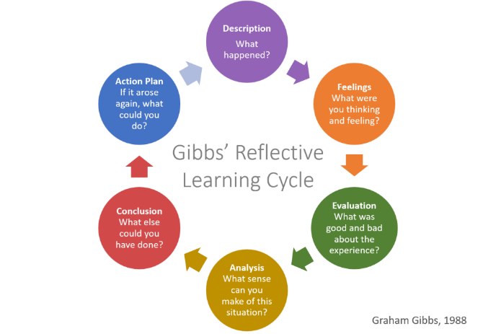  Figure 1:  Gibbs’ model | 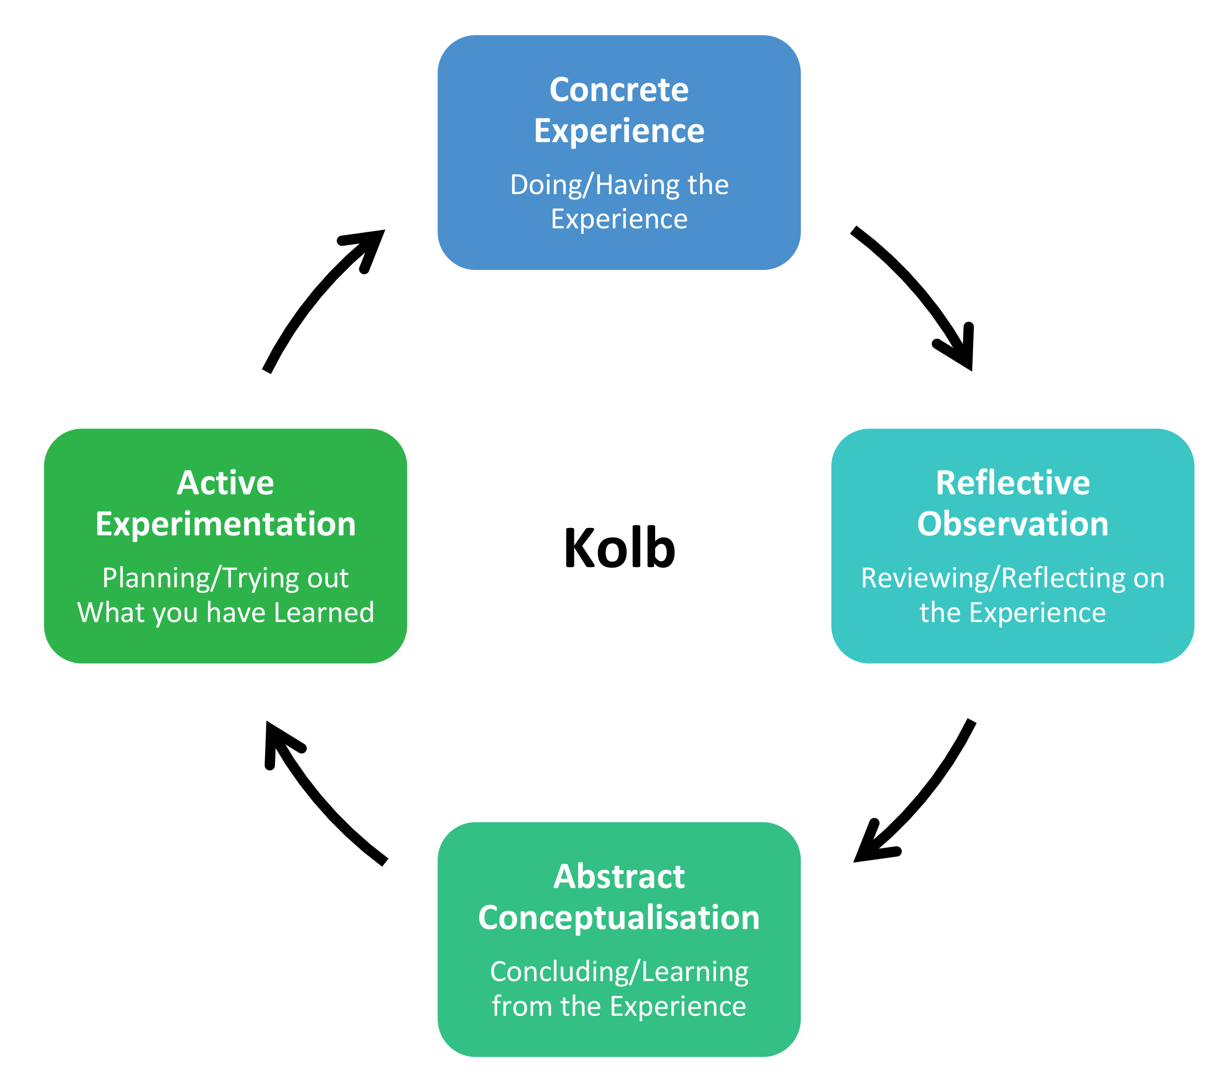  Figure 2:  Kolb’s model
Analysis of models – compare/contrast/pros/cons:

Both Gibbs’ (1988) reflective cycle and Kolb’s (1984) experimental learning cycle aim to Help individuals learn from experience. They shared the belief that reflection is a continuous process, but they differ in how they guide a person through that process.
Kolb’s model focuses on how people turn experience into learning and understanding. It includes 4 stages concrete experience reflective observation abstract conceptualization and active experimentation. These stages form a repeating cycle that shows how we experience something think about it form conclusions and then evaluate those conclusions in future scenarios. Kolb theory is particularly useful for understanding how individuals learn best and how reflection supports personal development.
Gibbs’ model builds on Kolb’s idea but provides a clearer more detailed structure. It includes 6 stages description feelings, evaluation, analysis, conclusion, and action plan. Gibbs’ cycle is more emotionally focused and encourages people to explore their personal responses to experiences as part of their learning. This makes it especially helpful in professions like early years education, why reflection often involves understanding emotional reactions, relationships, and communication with children.
While both models encourage ongoing learning, they serve slightly different purposes. Kolb’s Cycle helps practitioners understand how learning happens wild gifts gives practical steps for reflecting on specific experiences. Gibbs model can be easier for beginners because of its clear structure but it may become repetitive if used too rigidly. Colds on the other hand offers more flexibility but less emotional depth.
In an early years setting a practitioner might use Gibbs model to reflect on challenging situations such as managing a child's behaviour Paul using Kolb’s to understand how that experience contributes to the overall learning and development as a professional. Together both models support thoughtful effective reflective practise.

Conclusion
In conclusion reflection and reflective practise are essential for continuous growth and improvement in early years education. Through reflection practitioners can adapt their approaches, meet each child's individual needs, and strengthen the quality of care they provide. Theories such as Schons reflection as an active process of learning through experience, while models like Kolb’s and Gibbs offer structured ways to apply it. Overall, reflective practise allows earliest professionals to remain thoughtful responsive and dedicated to the ongoing development to both themselves on the children they support.

References:
Hargreaves, J. and Page, L. (2018). Reflective practice. Cambridge, Uk ; Malden, Ma: Polity.
Lindon, J. and Trodd, L. (2016). Reflective practice and early years professionalism. 3rd ed. London: Hodder Education.
Martin, H. (2021). Gibbs’ Reflective Learning Cycle. [online] HELEN MARTIN BLOG. Available at: https://helendenheld.com/tag/gibbs-reflective-learning-cycle/. (Accessed 17/10/2025)
Ouvry, M. and Furtado, A. (2019). Exercising muscles and minds : outdoor play and the early years curriculum. London ; Philadelphia: Jessica Kingsley Publishers.
Schön, D.A. (1983). The Reflective Practitioner: How Professionals Think in action. London: Temple Smith.
Tarrant, P. (2013). Reflective practice and professional development. London: Sage.
The complete Medic (2021). Self-Development: Learn to Reflect Effectively. [online] theCompleteMedic. Available at: https://thecompletemedic.com/self-development/reflection.
Thomas, A. and Lewis, A. (2016). An introduction to the foundation phase : early years curriculum in Wales. London ; New York: Bloomsbury Academic.

‌

‌
‌

‌
‌
‌

- Written Piece: Recognise and analyse the significance of different aspects of professional practise and why these are important in meeting the individual and inclusive needs of children - including professional values, communication, multiagency work, observations, planning and the UNCRC. (1500 words) Wordcount: 1443

Professional practise in early years settings involves a combination of knowledge, skills, and ethical values that enable practitioners to meet the individual needs of children effectively. Understanding and applying professional values, clear communication, multi-agency collaboration, careful observation, and thoughtful planning a role essential to ensuring high quality care and learning. Additionally, adhering to frameworks such as the United Nations Convention on the Rights of the Child (UNCRC) supports practitioners in promoting children's rights, well-being, and participation. This essay will recognise and analyse the significance of these aspects of professional practise, demonstrating how they contribute to responsive, inclusive, and effective support for every child in early years settings.
Professional values form the foundation of ethical and effective early years practise. They guide how practitioners interact with children, families, and colleagues, ensuring that every child's welfare, rights, and individuality are prioritised. These values include respect, honesty, quality, and a commitment to safeguarding and professional integrity. Atwal (2022) Explain stop professionalism can be difficult to define precisely as it depends on the context of each profession. However, all professions share a rule of thumb demonstrating consistent behaviours, ethical judgement, and a strong knowledge base that reflect the principles of one’s field. She further highlights that being professional goes beyond simply knowing the standards of practise it involves embodying them daily through moral and altruistic decision making, even when personal beliefs may conflict with professional expectations. In the context of early years, this means upholding children's rights and well-being above personal bias or preference, following safeguarding procedures, and maintaining confidentiality and fairness in all actions. This aligns with the United Nations Convention on the Rights of the Child (UNCRC), adopted in 1989 and entering falls in 1990, which establishes that a ‘child's best interest must always be the primary consideration’ (article 3). By reflecting on their own values and ensuring they act in accordance with these legal and ethical frameworks, practitioners can provide care that supports both the child's learning and their fundamental rights to safety, respect, and inclusion.
Another important aspect of professional practise is communication. Communication plays a crucial role in supporting children's emotional, social, and behavioural development within early years settings. According to the United Nations Convention on the Rights of the Child (UNCRC, 1989), Article 8, highlights everyday child's rights to ‘preserve their identity, including their name, nationality, and family relations, without unlawful interference,’ This emphasises the importance of communicating with children in a way that respects their individuality, cultural background, and personal boundaries. Practitioners must therefore approach each child with sensitivity and awareness, ensuring that their words and tone reflect respect and inclusivity. O’Toole and Hayes (2020) Explore the impact of communication in the context of managing children's behaviour. They note the way practitioners deliver messages can deeply influence how children respond and engage. As cited by Toshalis (2010), “Authoritarian educators tend to focus more on discouraging misbehaviour than promoting learning” or inspiring engagement” (O’Toole and Hayes, 2020, p.405). However, they also explained that being overly lenient can be equally harmful, as it limits children's educational and behavioural growth. This balance highlights how positive, consistent communication enables children to understand boundaries while still feeling supported and motivated. For instance, when addressing conflict between children, practitioners can correct the misbehaviour while also asking the child why they acted in that way. This approach helps identify unmet needs and promotes reflection and emotional understanding. Furthermore, communication among colleagues is equally essential, as sharing observations about children's behaviour ensures consistency and helps meet individual needs more effectively.
In addition to communication within the setting, collaboration beyond it is equally vital. Multi agency work is a vital element of professional practise within early years, as it ensures that children's individual needs are met through collaboration between professionals and agencies. Wate and Boulton (2015) highlights several key laws designed to strengthen this cooperation, such as the Children Act 2004 and the United Nations Convention on the Rights of the Child 1989. Section 11 of the Children Act 2004 states that “each statutory organisation and person has a duty to safeguard and promote the welfare of children”, reinforcing that protecting and supporting children is a shared responsibility across all services. Furthermore, section 25, Part 3 of the act explains that authorities must work together to “care for” and improve the “well-being” of children, while parts 11 defines well-being as including emotional physical financial and educational support this legal framework forms the foundation for effective multi agency collaboration, ensuring that practitioners, local authorities, and safeguarding professionals work in harmony to meet every aspect of a child's development and safety. Wate and Boulton (2015) Also discusses the importance of designated safeguarding leads (DSL), emphasising that their ability to identify potential vulnerabilities early on and refer concerns to local authorities is essential to a child's protection. This links closely to the importance of communication, as previously discussed, since multi agency work relies heavily on the ability of different services to exchange information clearly and consistently. Whether it be between frontline practitioners, schools, or charities such as UNICEF UK, effective communication ensures that children's welfare remains at the centre of every decision. Additionally, multi-agency work does not only involve professionals and statutory organisations but also includes collaboration with parents and carers. Buckler (2023) Highlights the importance of practitioners forming trusting relationships and maintaining open communication with parents to prevent “disguised compliance,” will apparent appears cooperative but fails to make real changes. This links closely to the earlier discussion on communication as the way practitioners share information, both with other professionals and with families, must always be managed respectfully and professionally. Effective multi agency practise ensures that all parties work towards a common goal, promoting the child's well-being and safeguarding them from potential harm through this shared responsibility children receive consistent support across different areas of their lives.
Observation is a fundamental aspect of professional practise in early years, directly linking to multi agency work as it allows practitioners to identify and respond to children's needs at the earliest stage. Wate and Boulton (2015) describe the importance of vigilance in safeguarding, noting the forming types of abuse described in working together to safeguard children 2015 physical, emotional, sexual, and neglect. Practitioners must be able to notice signs of these abuses, as early identification allows for timely intervention through tools such as Common Assessment Framework (CAF) or Early Help, which help monitor and address emerging issues. According to Wate and Boulton (2015) CAF is used when a practitioner has concerns about the child's well-being this may include issues related to “health, development, welfare, behaviour, or progress in learning.” It can also be initiated when a child, parent, or carer raises a concern, or when a practitioner identifies needs but is unsure of the most suitable support to offer. Importantly, CAF is not a risk assessment, but a voluntary, early intervention tool designed to promote collaboration between agencies and ensure that children receive coordinated support. Because its used depends on the practitioner's own judgement, strong observational skills are essential. While this responsibility can place pressure on the practitioner, recognising and acting upon early signs of concern can ultimately safeguard a child's life and long-term well-being. As observing children is not limited to physical science but also includes listening to what children say about their home life, peers, and relationships. Fitzgerald 2022, p.26) explains that abuse can result from multiple factors, including parental mental illness financial hardship emotional stress and physical burdens. Often a single observation can reveal multiple underlying issues, highlighting the interconnected nature of safeguarding concerns. For example, a child experiencing sexual exploitation may describe a “boyfriend" in their life, reviewing grooming behaviour that could otherwise go unnoticed. By carefully observing and documenting such behaviours, practitioners can ensure that appropriate support and intervention are provided, often involving collaboration with other agencies to fully safeguard the child.
In summary, professional practise in early years settings is fundamental to meeting the individual and inclusive needs of children. By embracing core professional values, practitioners create ethical, safe, and respectful environments in which children can thrive. Clear and thoughtful communication ensures that each child's identity, culture, and voice are valued and heard. Collaborative multi-agency work brings together the expertise of different services so that children receive holistic support, especially when complex needs are present. Rigorous observation enables early detection of concerns on the development of well informed, initiative-taking interventions. When all these elements are together, they are not only upholding children's rights and well-being but also offer every child the opportunity to reach their full potential. In the constantly changing ways of early years education, maintaining this integrated approach is a key to effective, inclusive, and reflective practise.

References:
Atwal, A. (2022). Preparing for Professional Practice in Health and Social Care. John Wiley & Sons.
Buckler, R. (2023). Developing Child-Centred Practice for Safeguarding and Child Protection. Routledge.
Department for education (2025). Keeping children safe in education 2025 Statutory guidance for schools and colleges. [online] Available at: https://assets.publishing.service.gov.uk/media/68add931969253904d155860/Keeping_children_safe_in_education_from_1_September_2025.pdf. (Accessed 21/10/25)
Legislation.gov.uk. (2012). Children Act 2004. [online] Available at: https://www.legislation.gov.uk/ukpga/2004/31/section/25.
O’Toole, L. and Hayes, N. (2019). Supporting Positive Behaviour in Early Childhood Settings and Primary Schools. Routledge.
UNICEF (n.d.). UN convention on the rights of the child (UNCRC). [online] UNICEF. Available at: https://www.unicef.org.uk/what-we-do/un-convention-child-rights/. (Accessed 19/10/25)
Wate, R. and Boulton, N. (2015). Multi-agency safeguarding in a public protection world: a handbook for protecting children and vulnerable adults. Hove: Pavillion Publishing.
‌
‌
‌

