Sustainable architecture
Lampeter building - Natural and artificial light.

Introduction.
A small team of surveyors from Swansea UWTSD were sent to Lampeter UWTSD university campus where they have a grade 2* listed building where a church and library is situated. Solely the east block of the building was surveyed on this occasion. At the time of the survey, the east side of the building was empty, but had previously been used as student housing. The building is to be renovated to house foreign students and will be expected to be modern, homely and sustainable.
An initial survey of the Lampeter listed accommodation was undertaken by the team from UWTSD Swansea. Each member of the team surveyed a different aspect of the building, including water, light, energy efficiency and thermal bridging. This document is based on the current use of light in the building and the changes that will be made. The team looked at each room taking note of the types of light fittings and how far away from the ground they are situated, the sizes of the rooms and the sizes and number of windows in each room. This information will be used to calculate the lumen for each room. A lighting design will be created for the building, which will ensure that adequate layout of lighting is provided for all work surfaces in each room.
The current condition of the building is fairly poor and the energy efficiency of the building is extremely poor. The building has damp issues, cold bridging, drafts and single paned windows. Therefore, this document will identify the current problems with the building so that action can be taken in terms of lighting. The aim of the document is to set out a plan to put the building right and bring it up to 21st century standards. The property is required to meet current building regulations and must have a modern internal finish in order to meet the potential client’s specification.

Natural light.
Natural light is a consideration when discussing how to most efficiently set out the lighting system for a building. Natural light can be utilized in a building by positioning windows to effectively spread light throughout the building, and reduce the need for artificial light during the day. Using natural light correctly can completely change the internal environment of a building, making it bright and warm. Due to the difficulty of the calculation and the fact it does not impact the use of artificial light at night time, natural light won’t be taken into consideration. Due to the fact the building is listed there won’t be any option to change the positioning of the windows but natural light could still be improved upon using light refraction from external sources. Using light coloured paving slabs outside the windows would reflect light into the building and there is the possibility to have a working water feature in the centre of the courtyard which would also reflect light into the building.
There is the opportunity to implement manual light control into the building. Dimmer switches would be an option to allow for variation in internal light level to fit the needs of the occupant, for example in the student bedroom the space will need to be used for doing work, relaxing and sleeping and being able to reduce the light from working level to relaxing level would be a good feature. Dimmer switches would also be affordable to the development team being only slightly more expensive than standard switches.

Method
Step one of the survey was to assess the condition and collect measurements of the building. On entry to the building via the front door, you are greeted with the hallway and stairs. Off the hallway is two bedrooms at the front and two at the back. Upstairs, there are two bedrooms at the back and two at the front and a bathroom positioned at the front of building in the centre between the two front bedrooms. The windows are singled glazed.
The building is currently in poor condition. The carpets are heavily worn, and internal water damage is present on the external wall in the front downstairs bedroom. (on the left). The left hand upstairs front rooms floor boards are broken and pulled up. The remaining rooms were run down and in need of refurbishment.
The brief states that the renovation must primarily be designed in a sustainable manner and defy expectations of a listed building. The major limiting factors are the budget and CADW (The Welsh governing body for listed buildings and monuments).
Once the data is collected the calculations can begin. Using the lumen calculation, the number of bulbs needed for each room can be calculated. To start, the area of all the rooms will be calculated, using the following method: width x length= area. Next using the internet, the required illuminance will be found for each room. It must be specific for the type of room due to the need for different light levels for different activities which take place in each room. The lumens given off by the bulbs specified can be found on the manufacturer’s websites. The maintenance factor is next and is based upon the room and how dirty it may become. If the rooms become dirty it could reduce the light being reflected around the room making it become dim, this is most important for tiles in the kitchen and bathroom and surfaces in the kitchen. The last figure that is needed before the data can be put into the formula and the number of bulbs can be found out is the utilization factor. Utilization factor can be calculated using all reflection factors for each room.
Once all the data is found out each rooms lumen method calculation can be completed and the lighting system can be laid out.
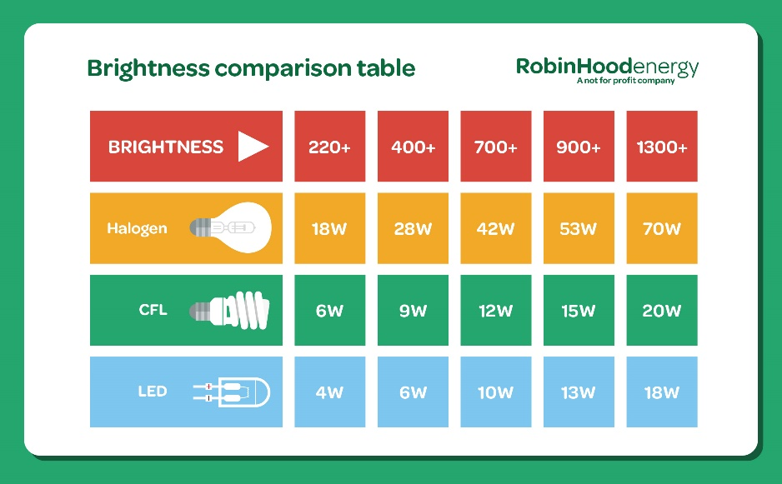
(robin hood energy, 2018).

Calculation/results.
Firstly, the area of each room will be calculated. Then using the lumens emitted from the chosen lamp, the number of lamps needed for each room will be calculated, and at what distance from the intended work. In the bedrooms the calculation will be estimated to desk level so that students have sufficient lighting within their work space. However, in the kitchen the calculation will be based on counter top level and at floor level in the hallway and stairs area. This will ensure that the level of lighting is sufficient in order for the areas to be used safely.
The following calculation will be used predominantly: N=E x Area(m2) / F x UF X MF, the lumen method. The lumen method is used to design a lighting system which equally distributes the luminaires in a space in conjunction with the strength of the lamps. (Corona,2014).
N= number.
E= required illuminance.
A= area (m2).
L= lumens of each luminaires.
UF= utilisation factor.
MF= maintenance factor.
Each of these fields must be completed filled before working out the final equation. Below is the require lux for different types of rooms which will be used in the equations for each separate room.
The room index will be a secondary calculation used to find the utilisation factor needed for the lumen method.

Activity | Footcandles | Lux
Hallways | 5-7 | 55-75
Entertaining | 10-20 | 110-215
Dining | 10-20 | 110-215
Easy reading | 20-50 | 215-540
Bathroom | 20-50 | 215-540
Kitchen—basic lighting | 20-50 | 215-540
Kitchen—food prep | 50-100 | 540-1075
Difficult reading or writing | 50-100 | 540-1075
General workshop lighting | 50-100 | 540-1075
Fine or detailed work | 100-200 | 1075-2150
(CIBSE, 2015).

Different LUX readings will be used for each room. The reason for doing this is because each room will have a different purpose, such as a work space, food preparation or recreation. As shown in the table, a place of work needs brighter lights as to not strain the eyes while working.

The bulb used in lighting system will be an Osram E27 GLS LED Bulb 11.5 W(75W), 2700K, Warm White, GLS shape. The bulb is a low energy consuming 1055lm bulb which cost £7.24 with 15,000-hour life span and has an A+ energy rating. The bulb has been chosen due to its high quality and life span along with its impressive energy efficiency rating. (RS,2019).

Ground floor/1st floor.

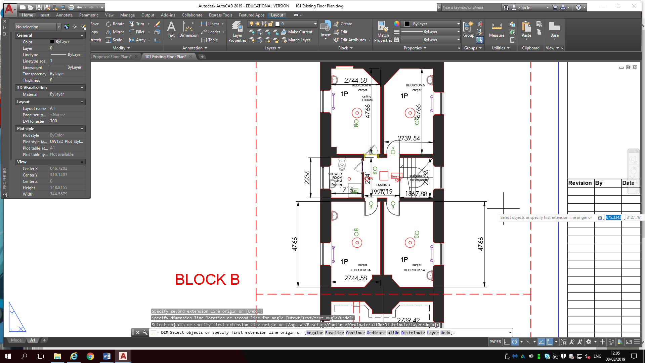
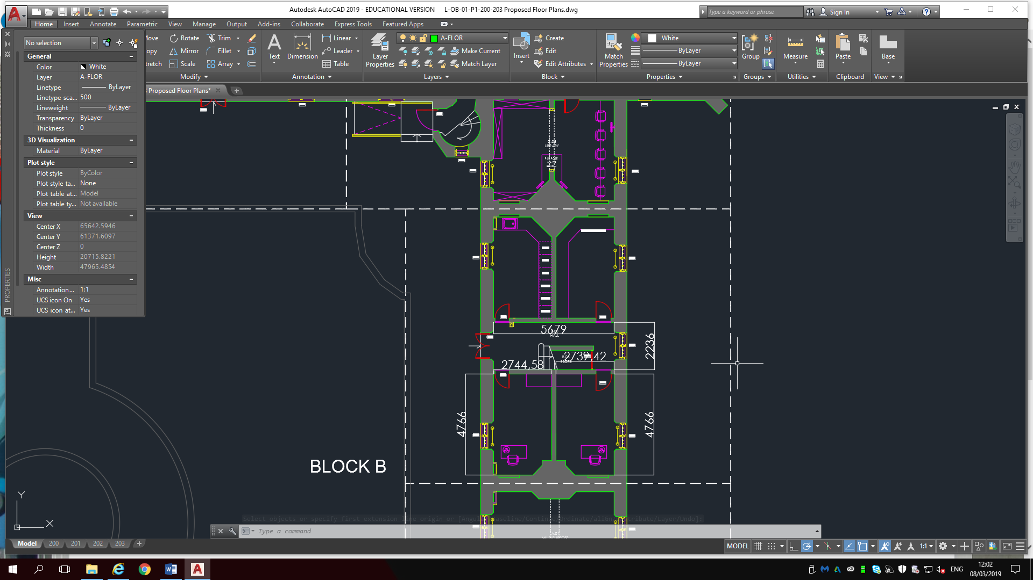
4
4
3
1
1
1
1
2
1
1
1

Each room is marked with a number corresponding to the list below which shows what each room will be used for once the renovation is complete.
- Bedroom
- Kitchen
- Bathroom
- Hallway
The bedrooms are all the same dimensions, along with the kitchen being the same size as the bedrooms. The dimensions of the bathroom and hallways are shown above. The dimensions shown above are used for the area M2 element of the lumen method calculation.
The result of the equation will be rounded up to create a whole number which will be marked as lamps, and this will be the result used to form the layout design of the lighting system. For example, if the answer of the lumen method is 4.3 the required number of lamps will be 5.
The circle with a cross through it is an icon which represents the luminaire.

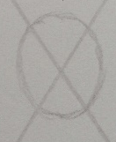
The position of all the luminaires in each room have been calculated using the Pythagorean theorem to find the centre of the room.

Bedroom.
Lumen method calculation = 215 x 13.08 / 1055 x 0.8 x 0.8
= 1.7
Lamps (bulbs) = 2
In the bedrooms the artificial lighting design will consist of 2 lamps housed in one luminaire. The luminaires will be set out in a uniform illuminance as this is required. The design of the lighting system will be shown below:
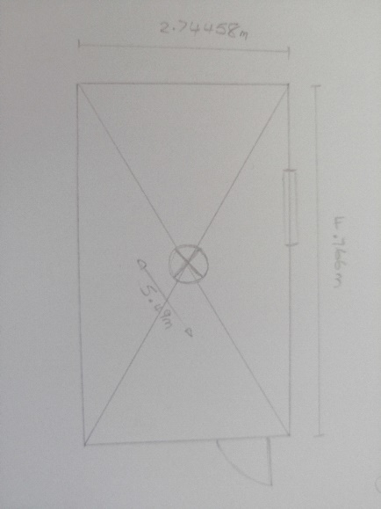
Here the lighting design shows the luminaire positioned in the centre of the room. The position of the luminaire has been calculated using the Pythagorean theorem to find the centre of the room. The luminaire is positioned in the centre of the room to provide an equal light distribution.

Kitchen.
Lumen method calculation = 215 x 13.08 / 1055 x 0.8 x 0.8
= 1.7
Lamps (bulbs) = 2
In the kitchen the artificial lighting design will consist of 2 lamps housed within one luminaire. The luminaires will be set out in a uniform illuminance as this is required. The design of the lighting system will be shown below:
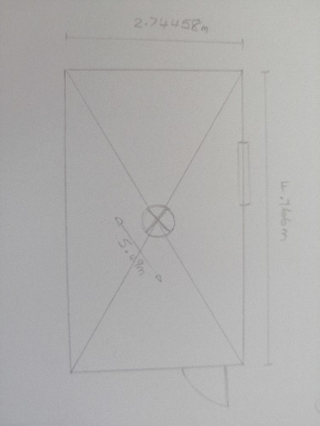
Here the lighting design shows the luminaire positioned in the centre of the room and is the same as the kitchen due to the rooms being the same dimensions. The luminaire is positioned in the centre of the room to give an equal light distribution. In the kitchen, if the work surfaces are not blocked from the luminaire the lighting at the kitchen surface level will be correct. However, if they are blocked under cabinet luminaires may be required.

Bathroom.
Lumen method calculation = 215 x 3.82 / 1055 x 0.8 x 0.8
= 0.4
Lamps (bulbs) = 1
In the bath room the artificial lighting design will consist of 1 lamp housed in 1 luminaire. The lighting design will be shown below:
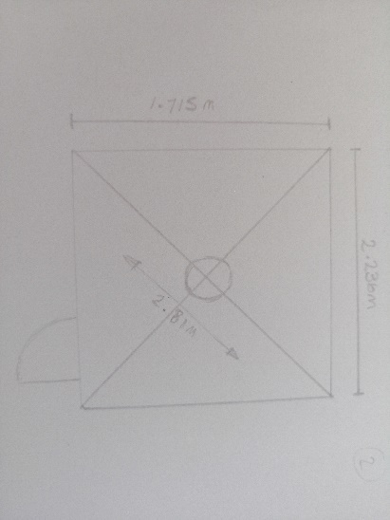
Here the lighting design shows the luminaire positioned in the centre of the room. The luminaire is positioned in the centre of the room to give an equal light distribution. Lighting in the bath room is debatably less important than other rooms. The mirror in the bath room will need its own specific light to improve its use for the occupants.

Hallway.
The downstairs and 1st floor hallways are different sizes therefore two lumen calculations will be used to accurately calculate the lighting required for each area.
(Ground floor hallway).
Lumen method calculation = 55 x 12.69 / 1055 x 0.38 x 0.8
= 0.4
Lamps (bulbs). = 1
Although the lumen method calculation states that 1 lamp is required, due to the obstruction of the stairs, 2 lamps will be necessary at each end of the hallway. The lighting design is show below:
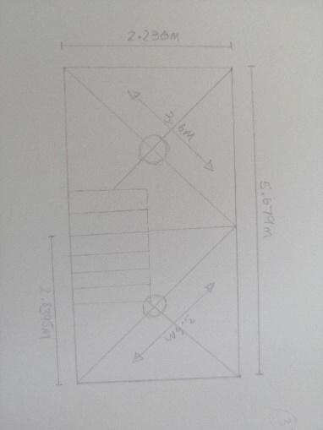
The stairs in the ground floor hallway drastically block light from properly illuminating the area. The lumen calculation indicates that only 1 luminaire is required, however this does not take into account potential obstacles within the room. For example, there would be shadows in the corners of the room. To resolve this issue, the room has been split in two and the centre of each half has a luminaire which will drastically improve the lighting coverage in the area.

(1st floor hallway).
Lumen method calculation = 55 x 8.6 / 1055 x 0.8 x 0.8
= 0.28
Lamps (bulbs) = 1

The 1st floor hallways artificial lighting design will consist of 1 lamp housed within 1 luminaire. The lighting design for the 1st floor hallway will be shown below:
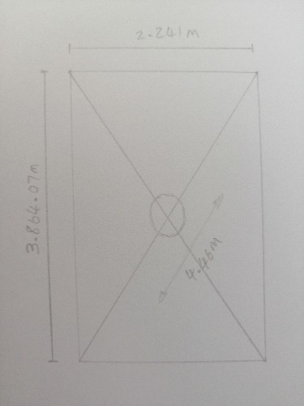
The 1st floor hallway is less complex than the ground floor as there are no obstructions. Due to this the results of the number of luminaires from the lumen calculation can be used. There will be 1 luminaire in the centre of the room. (Cibse, 2002).
As part of the design, the lighting lay out for each room will use the corresponding lumen method results to calculate the most suitable number of luminaires. This will create the perfect lighting for each working environment and the different rooms and uses. It is important to create lighting that best suits the uses for each particular room. This is significant as unsuitable lighting could cause straining of occupant’s eyes and further damage could also occur after longer term exposure.
A possible limitation of the lighting design being proposed is that natural light pollution has not been taken into consideration. This could potentially be an issue in day time use but as for night time use of the internal spaces it will not be a concern, as the lighting calculated using the lumen method will create sufficient light for each room at night.

The overall cost for the redesign of the lighting shouldn’t be an issue for the design team as it should only take up a small percentage of the budget. There are no real expensive elements to the project with the more expensive components such as the fuse box is required by building regs so would be needed in any system. With the correct light it should make the internal spaces much more comfortable for the occupant and with the edition of dimmer switches all occupants should be happy whatever the circumstance. By using UPVC wire covers rather than drilling into the walls this also reduces the cost by not needing heavy machinery.

Conclusion.
In conclusion, a lighting layout has been designed for each room, which best suites and illuminates the room. The designs were backed up using the lumen method which calculated the number of lamps(bulbs) required per room. The Pythagorean theorem was used to work out the centre of each room, and where the luminaires were to be positioned. These calculations were used in conjunction in order to create the most appropriate levels of lighting for the future occupants. LED bulbs were used, as they are more energy efficient and sustainable. The new wiring in the block was externally wired and covered by PVC cable covers to reduce the effect of the new wiring work on the building due to it being a grade 2* listed building. It was important to externally wire rather than insert the new wires into the old walls due to potential objections from CADW. Additionally, it was not possible to modify the original windows due to restriction from CADW. Therefore, increasing natural light penetration into the building by increasing the size of the windows was not an option. Due to these limitations it was decided to internally add secondary glazing to increase the energy efficiency of the single glazed unit currently in place and focus on artificial lighting in order to improve the quality of the internal lighting.
The correct lighting can completely change a room and will create a comfortable living environment and an enjoyable atmosphere for its occupants, which was one of the client’s main objectives. The block will be used primarily by university students, therefore the lighting in the rooms must be correct so that university work can be completed effectively. This has been achieved through using the correct calculation methods as shown in this document. Cost was also a consideration to the client and the recommendations made within this document are not cost intensive with minimal outlay required.

References.

Efficiency Manie (2019) Lighting solutions [website].
Available at: https://www.efficiencymaine.com/at-home/lighting-solutions/
(Accessed 3rd February 2019).

Marlin aluminium glazing systems (2017) What is a listed building? [website].
Available at:
https://www.marlinwindows.co.uk/replace-listed-building-windows.html.
(Accessed 1st February 2019).

Historic England (2019). Energy Efficiency and Historic Buildings: Secondary glazing for windows. [website].
Available at:
https://historicengland.org.uk/images-books/publications/eehb-secondary-glazing-windows/.
(Accessed 1st February 2019).

Corona (2014)Topic: list of reflectance. [website].
Available at: https://corona-renderer.com/forum/index.php?topic=2359.0.
(Accessed 27th February 2019).

RS (2019) Osram E27 GLS LED Bulb 11.5 W(75W), 2700K, Warm White, GLS shape. [webdite].
Available at url:https://uk.rs-online.com/web/p/gls-led-lamps/1262169/.
(Accessed 7th march 2019).

Cibse (2002) The installer’s guide to lighting design. [website].
Available at url: https://www.cibse.org/getmedia/0276ac78-dc41-4694-9378-8f984ef924f2/GPG300-The-Installers-Guide-to-Lighting-Design.pdf.aspx
(Accessed on 2nd march 2019).

Liteharbor (2014). How many lights do I need? [website].
Available at url: http://www.liteharbor.com/resources/light-knowledge/60_How-Many-Lights-Need-for-Your-Home.html
(Accessed 10th March 2019).

CIBSE (2015) lighting for residential buildings [table].
Available at: http://www.cibse.org/getmedia/e86f244c-2ad8-4503-bbd9-3646055cd940/151015-Lighting-for-Residential-Buildings-(LG9)_2015_IET.pdf.aspx
(Accessed on 27th April 2019).

Robin hood energy (2018) energy saving light bulbs [image].
Available at: https://robinhoodenergy.co.uk/news/energy-saving-light-bulbs/
(accessed on 3rd of May 2019).

