Effective Team
Working and
Communication

Contents

- Introduction

- Types of Communication

- Models of Communication

- Communication In My Workplace

- How We Can Improve The Communication In My Workplace

- Conclusion

- References

INTRODUCTION

What this report about is about the types of communication (verbal, nonverbal, written) and the meaning of each. He also talks about communication models (Berlo, Shannon-Weaver Model and Schramm) about their methods, meanings and their respective graphic models with a clearer perspective on each one.
I also add information about my workplace and how is the communication in it, both between employees and between employer and employees, what types of communication are in each case and situation, and the problems that we can find in our day to day instead busy to be able to make good communication. I also talk about the principles of communication that are 7 (Clarity, Attention, Feedback, Informality, Consistency, Timeliness and Adequacy) explanation of each one and how they are attributed in my workplace. Then, I proceed to talk about the barriers of communication that can be found in my workplace and some ideas that could help improve communication.
This report also includes some in-class exercises that we have done during the course and I have added the references of all the researches I have done to complete this work.

TYPES OF
COMMUNICATION

There are three kind of communication:

- Verbal
- Non-Verbal
- Written

Verbal: It is a type of oral communication where the message is transmitted through the spoken words. The sender gives words in the form of speeches, discussions, presentations or conversations.
Non-Verbal: It is the process of conveying meaning without the use of words either written or spoken. It is any communication between two or more people through the use of facial expressions, hand movements, body language, postures and gestures.
Written: It refers to the process of conveying a message through the written symbols. It is any message exchanged between two or more people that make use of written words.
MODELS OF
COMMUNICATION

There are three models of communication:

- Shannon and Weaver Communication
- Berlo
- Schramm

Shannon and Weaver Communication: It is a linear model of communication that provides a framework for analyzing how messages are sent and received. It is known for its ability to explain how messages can be mixed up and misinterpreted in the process between sending and receiving the message.

Noise

Feedback

Berlo: This model focuses on encoding and decoding which happens before sender sends the message and before receiver receives the message respectively. This model has four components to describe the communication process.
(Sender, Message, Channel and Receiver)
Each of the component is affected by many factors.

Communication skill
Hearing
Content

Elements

Treatment

Structure

Code
Culture
Social System
Knowledge
Attitudes
Tasting
Smelling
Touching
Seeing

Schramm: It is a model of communication defined as a circular model that shows the message go in two directions. It has four principles keys. 1- Communication is circular not linear, 2- Communication is usually equal and reciprocal, 3- Messages require interpretation, 4- There are three steps for communicating: Encoding, Decoding and Interpreting.

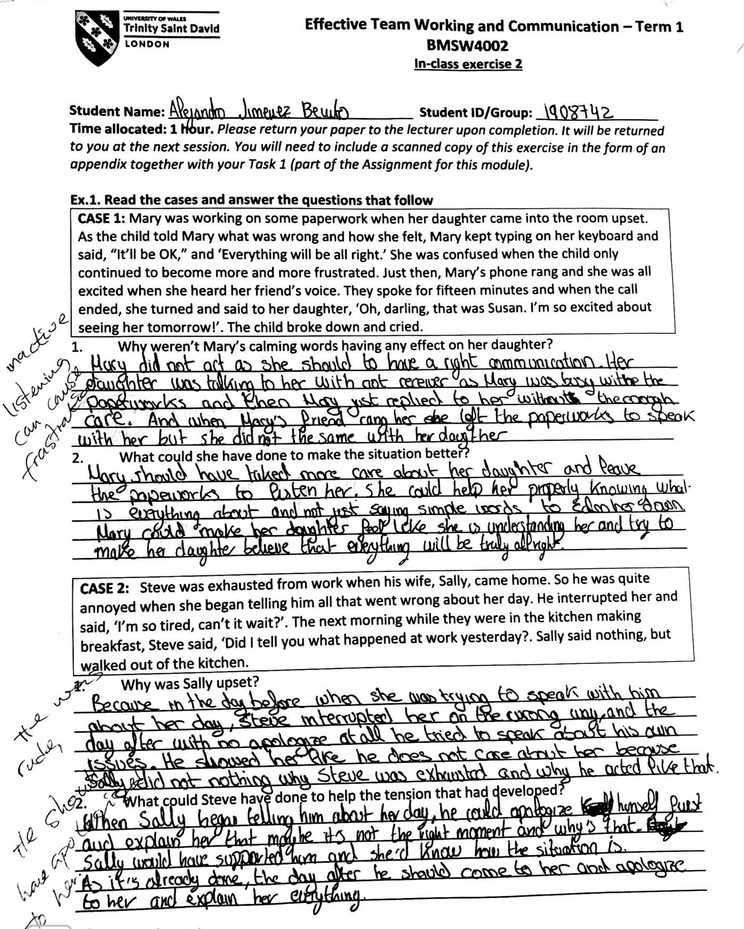
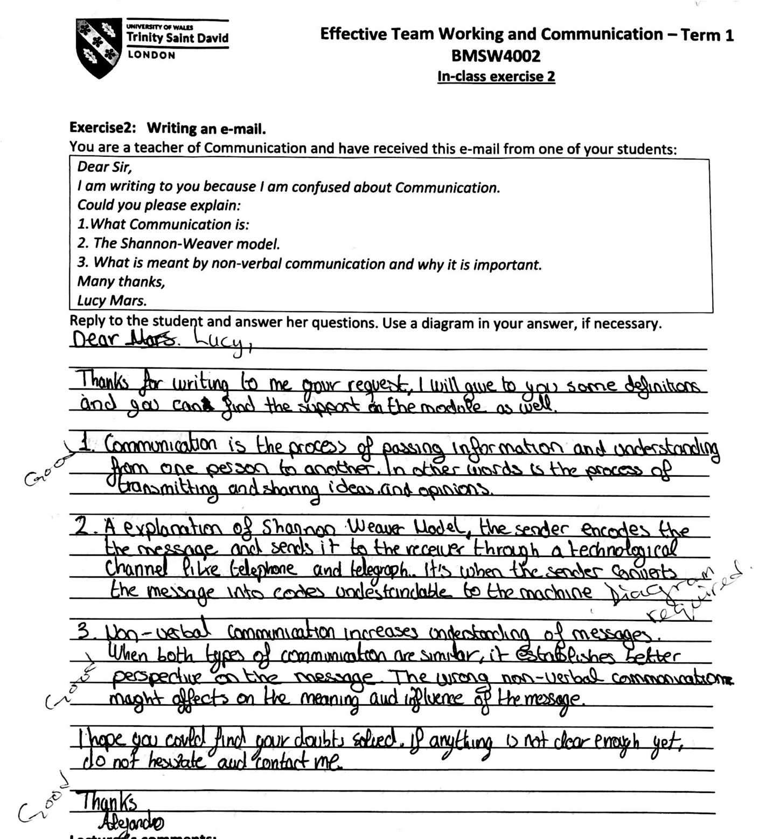

COMMMUNICATION
IN MY WORKPLACE

There are four points to speak about:

- Between employees
- Employer-employees
- Principles of communication
- Barriers of communication

Between employees: My current job is located in the center of London, just a few minutes walk from Oxford Circus, it is a coffee shop in an area surrounded by offices and businesses which makes this site a very busy workplace every day. I am working there as a supervisor and my job is to have the whole team organized, do interviews and order the orders of both food and the necessary materials. To do my job correctly I always need good communication with my team, speak verbally with them at all times to organize any type of need at the time, to organize breaks and to know how each one is and keep a team together as sometimes such a busy job site can create stressful moments among workers and times when everyone has to run and work hard and that can cause mistakes, misunderstandings or even conflicts which I have to avoid. I also need to have a good and clear verbal communication while I am doing interviews because I need to show that person who does not know us and does not know this place yet that we have an amazing environment and we are a professional company and I need to identify or find by speaking the right person to hire as it is my responsibility. I also need a type of written communication since when I pick up an order from a customer, I proceed to write the order in the till which sends a ticket to the person in charge of the coffee machine to know what coffee or drink has to do and another ticket is sent to the kitchen in which the chefs receive the order and process the food. I also use communication written by WhatsApp, where I communicate with the team to let them know the schedule of the following week or any type of change and for which they ask me for days off that they need or let me know in case they are sick and they can't go to work. To make orders for food or materials I have to make them written or on the Ipad of the store or on papers which I have to send to the different suppliers.

Between employers and employees: In this case, the store owners have a person, who is me, who acts as an intermediary. The owners only occasionally pass by the store to make sure everything goes correctly and there is no problem, but in the case that they want to communicate something to the employees, they discuss it first with me or they transmit the message they want to project and then I am the person in charge of making that message reach the recipient. In the event that the owners receive any complaint of any kind, they will contact me immediately as well as by phone call or by email depending on the urgency of the matter. Also, we have a WhatsApp group between employers and all employees, in which they send written communications to let us know the periods in which the store will be closed as Christmas or to congratulate holidays or some type of event in particular.
At the end of each week I have to count each employee's hours, write them and send them to the owners in word format by WhatsApp. They calculate and process the respective payments to each one and then create the payslips and send them by email to each one.
In case I decided to dispense with the service of any of the employees, I would let you know and they would come to talk to that person and fill out the paperwork for leaving work. In the moments when they decide to appear in the store and take a look at how everything is going, especially in those moments I have to make sure that any type of communication is clear and correct, both verbal, written and non-verbal. that we have to show them a correct attitude with our body language and any type of gesture made since we are facing the public offering constant customer service and non-verbal communication is very important.

Principles of communication:
There are 7 principles of communication:

- Clarity: The fact of clear communication at all times is very important, especially in the busiest moments. Either because the language spoken among the workers is not their main language for some of them, due to the fact that there is a lot of noise by the coffee machine, by the orders, and by all the clients without stopping and entering and leaving and without stopping If you talk, you can create misunderstandings. So you always have to take care of the clarity of our communication
- Attention: For effective communication we have to capture the attention of the recipient and we strive to pay attention to what others tell us.
- Feedback: It is important to give and receive feedback when we are communicating with others to confirm the understanding of the message
- Informality: It is essential to use a formal communication in the work area, both between employees and towards the management team or owners. Being a customer service job, employees have to speak formally at all times to show professionalism and make a good impression.
- Consistency: This principle establishes that communication must always be consistent with the policies, plans, programs and objectives of the owners and not conflict with them. If the messages and communications are in conflict with the policies and programs, then there will be confusion in the minds of the employees and they may not implement them correctly. Such situation will be detrimental to the interests of the organization.
- Timeliness: Make each statement at its appropriate time in very important to solve problems and avoid major misunderstandings
- Adequacy: The information communicated should be adequate and complete in all respects. Inadequate information may delay action and create confusion. Inadequate information also affects efficiency of the receiver

Barriers of communication: Sometimes due to the large number of people in busy moments, the noise of those people talking to each other, the sound of the coffee machine, of the door opening and closing make that at certain times a great noise is created with which the communication is can be affected and the speed and stress with which employees are working makes proper communication difficult

HOW CAN WE CAN IMPROVE THE COMMUNICATION IN MY WORKPLACE
Some ideas that could improve communication in my work area are, for example, adding one more till and hiring someone else to take care of the till would help better communication with customers since at busy moments there would not be that pressure to attend to customers fast so as not to form queues. That would make the employees more relaxed and the communication between the people in the kitchen and the people in the coffee machine could be clearer and without having to shout. Solving the noise caused by the coffee machine and the door would help a sharper communication without so much noise in the channel. Also that the owners were sometimes clearer in the emailes sent and came to speak the discussions they have scheduled would avoid some misunderstandings that written communication can cause. The tickets that are sent from the till to the kitchen and the coffee machine sometimes fail and are not sent correctly and produces misunderstandings since the communication has not been very good, so an improvement of the electronic devices of the store would help a lot to the communication.

CONCLUSION

In conclusion with this report we discover the possible types of communication and the differences between them, the different communication models and the factors that influence each of them so that communication is possible. I have also analyzed what types of communication are used in my workplace, as they are used between each one, we find the principles of communication with a brief explanation and what relationship with them there is in the communication in my work and what are the barriers of communication that we can face every day instead of working so busy. After all the explanation I offer some ideas with which you could improve the types of communication used in my coffee shop and be able to get a clearer communication, and achieve better performance in general thanks to good communication. In conclusion, we see how truly important communication is and how necessary it is to have good communication at all times, so it would be helpful to work on it and always get proper communication.
To this report I add the references of the sources of information in which I have done my researches to obtain more knowledge about everything that corresponds to the communication.

REFERENCES

- Jargons, B. (2018) Verbal Communication. Available at: https://businessjargons.com/verbal-communication.html (Accessed: 15/12/2019)
- Jargons, B (2018) Non-Verbal Communication. Available at: https://businessjargons.com/non-verbal-communication.html (Accessed: 15/12/2019)
- Jargons, B (2018) Written Communication. Available at: https://businessjargons.com/written-communication.html (Accessed: 15/12/2019)
- Drew, C (2020) Shannon-Weaver Model of Communication / 7 Key Concepts. Available at: https://helpfulprofessor.com/shannon-weaver-model/ (Accessed: 02/01/2020)
- Businesstopia (2018) Berlo’s SMCR Model of Communication. Available at: https://www.businesstopia.net/communication/berlo-model-communication (Accessed: 16/12/2019)
- Drew, C (2020) 4 key Principles / Osgood-Schramm Model of Communication. Available at: https://helpfulprofessor.com/osgood-schramm/ (Accessed: 02/01/2020)

- Venkatesh (2017) 7 Principles of Communication – Explained! Available at: http://www.yourarticlelibrary.com/management/communication/7-principles-of-communication-explained/53333
(Accessed: 20/12/2019)

