Name- Dalton Brown

Student number- 1908063

Course- HND Quantity Surveying

Module- Material Science and Building Services

Assignment Title- Construction Materials

Tutor- Allan Nantel

Contents Page
Concrete Frame Building
- Design
- Construction
- Environmental Impact
- Durability
- Material Production Process
- Climatic Resistance
- Materials of Adaptation
Steel Frame Building
- Design
- Construction
- Environmental Impact
- Durability
- Climatic Resistance
- Materials Process
- Materials of Adaptation
Comparison Between Steel and Concrete
- Positives
- Negatives

Material Science and Building Services.
Construction Materials
Introduction
The aim of this assignment I will be talking about two existing habitable buildings from around the world. One will be a steel framed building and one will be a concrete framed building reporting on the detail of their original design planning, construction and their potential impact with consideration to sustainability at the site of the build. I will be then comparing and contrasting the framing material of each of the buildings in the following areas.
- Their likely durability and climatic resistance, given the environmental conditions they are exposed to at the site.
- The likely impact of the frame materials original production process on the environment.
- The frames ease of assembly and the potential ease of its adaptation to different building shape and use, within the life cycle of the building.
Concrete Framed Building- The shard
Design
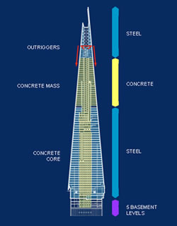
The Shard is located on the south side of the River Thames in the heart of the newly created London Bridge quarter. It was built to revitalise the surrounding area this has been a massive plus as its increased jobs and investment. It’s at a height of 306m also the tallest building in western Europe and made up of 25 storeys of offices, 8000 workers, three levels of restaurants, 18 storeys of hotel and 13 storeys of apartments. It also has a viewing gallery at the top which looks out of the views of London. The design came from an architect named Renzo Piano who wanted a building which would stand out in the London skyline. A lot of planning and preparation went into this before anything was even built due to the significance of the job.

Construction.
Construction of the Shard took over 3 years to built with a cost of up to 450 million. Construction started in March 2009 where there was a site excavation took place to remove an old office block where the Shard was going to be located. Due to the sheer size of the building concrete piles were used and extended down 53m below the earth’s surface with steel plunge columns were then put on top of the piles. The concrete foundations used a total of 5,500m3 of concrete with estimated 700 truckloads using three pumps and taking a time period of 36 hours. Once this was complete the build up of 310m began. The main feature is the glass of the building with its sloping walls which game the building its name. A total of 11,000 glass panels were used this covered a total of 56,000 sq. meters. The glass and corners of the build are open to allow the building to breathe as the shards do not touch.
Environmental Impact
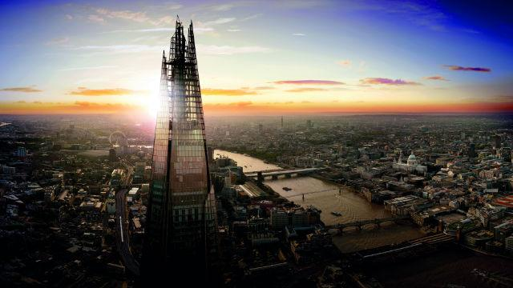
This place a huge part as nearly 5,500m3 of concrete was used in the foundations alone which would have made an increase in air pollution as it took over 700 truckloads. Also, the amount of glass shards that was brought to site would have meant this job would have had an enormous amount of air pollution.
Durability.
The durability of the concrete has been aged back to the Roman times which would mean it would have a long life and its properties would be a massive positive for the building. Concrete can also have problems when it breaks down as unlike steel concrete can not be recycled as easy. Concrete if at all may not be able to be recycled as it will have to have the reinforced steel separated from the concrete. This would be very cost affective but very beneficial as by doing this it can get used into hardcore and be re used being a positive impact of the environment. But if not recycled it will just be used as landfill and will have a negative impact.
Material Production Process.
The material process for the Shard was very beneficial as 95% of the construction materials were recycled. But with the concrete it used a huge energy consumption as there was such a high volume of it gave off high vehicle pollution. Concrete is formed between paste and aggregate with the paste being mainly cement and water. The paste hardens it with strength to form the concrete. But forming concrete with the cement causes problems in our environment as it produces carbon dioxide cement which gives out CO2 emissions. This is a negative impact on the job due to the amount of concrete used.
Climatic Resistance.
With the building being over 300m high the main factor to look out for would be the wind which may cause the building to sway. Winds up of up to 100mph have been recorded at the shard with the building swaying but to prevent this heavy concrete section were installed between 41-69 this was to increase the stiffness. To increase the stiffness even more on level 66 hat truss was installed to rise the perimeter columns to the central core making the building stiffer with less sway.
Materials of Adaptation.
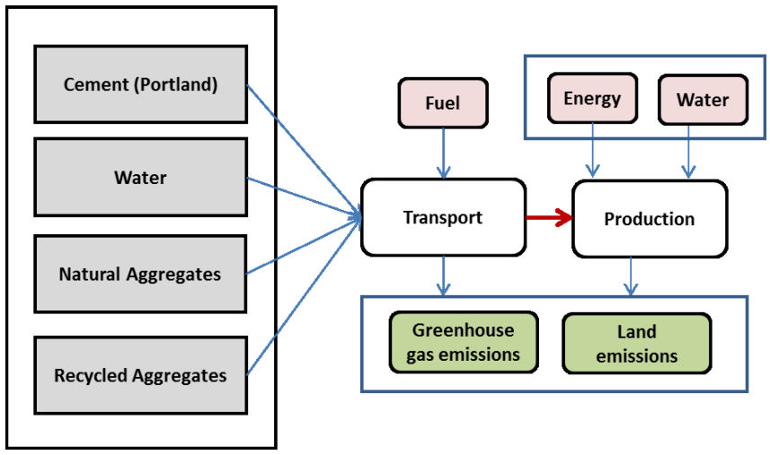
Concrete can be formed in any way which it is required as it is poured with a correct specification and the right consistency. Concrete is made off site which would then be transported onto site and pumped into wherever it is needed. Concrete can be either be slow setting or a fast setting it all depends on how much of the retardants is used. Gypsum will slow the concrete down and calcium chloride will quicken up the process and setting rate. Concrete can also be controlled by its water content with a high-water content it will provide more workable but with less water it will increase strength for standard moulds. The rise of workability is probably the most important part of the concrete as it controls how easy it can be shaped and adapted into where the concrete needs to go.
Steel Framed Building- The Burj Khalifa
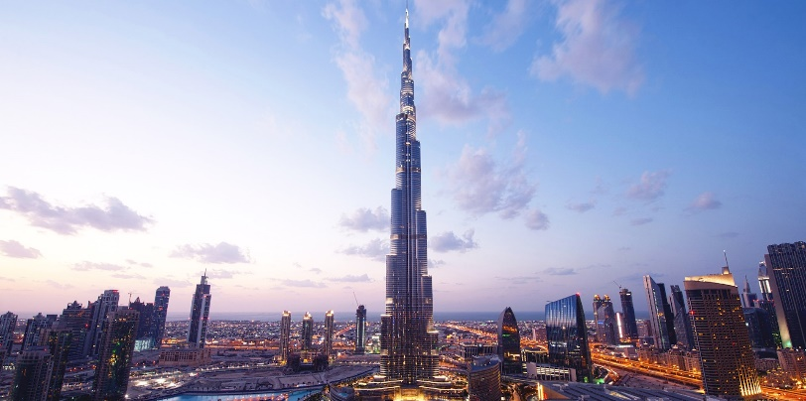
Design.
The design of the Burj was done by Adrian Smith who is the global leader in creating ultra-tall structures. The Burj is known as the worlds tallest tower with a unique design which has attracted the world’s most famous designers to an invited design competition. The design is made up of three main elements around a central core. The building is in a Y shaped structure with all wings being evenly setback which would then provide good floor plates for people staying there. The main core of the building will emerge at the top with the Y shaped plan which increases views of Dubai. Many factors were taken into consideration for this job like Wind Tunnel Testing. Over 40 tests were taken to examine the tests to verify its wind climate in Dubai.

Construction.
Excavation of the job took place in January 2004 with piling starting in the February. Over 192 piles were put 50m beneath ground level. 12,500 cubic meters of concrete was used at this point with a high-density low permeability concrete used for the foundations with a protection system under the mat. This was to stop any chemicals in the local ground water. The construction of the Burj will take 22 million-man hours using a total of 333,000 of concrete and 39,000 of steel rebar. Another big part of this job was the exterior cladding which began in May 2007 and was completed in September 2009. At the stage of installation, I took 380 men to complete the job. With at first it was 20 to 30 panels a day but with times and programmes to the job the task was going behind so eventually the works per putting on up to 175 panels per day. The installation of the tower at 512 metres become a world record with a height of more than 293 Eifel Towers. November 2007 was the highest reinforced concrete core walls pumped using 80MPA concrete from ground level. The finished product used a total of 31,400 tons of rebar.
Environmental Impact.
The main and most important part to this job was the Steel which was the main material used to develop the world’s tallest tower. To complete the job 31,400 tons of rebar was used which was all prefabricated away from site and delivered. A lot of planning would have gone into this to get the steel made and delivered to site in a safe manner. This would be a negative for the job as it would have taken a lot of transportation to complete which would give off a lot of air pollution. Once delivered to site a crane system would have been put in place to put the steel up.
Durability.
Steel Structures are better than most materials as they don’t age, or ware and it is very durable till any repair is needed. Structures around the world that can be adapted effectively and kept away from high costs and environmental demolition. Steel is a much more adaptable in a way that it can be completed with significant interruption and much less of a cost. This is not like concrete which is much harder to do but could be done.
Climatic Resistance.
Being the tallest tower in the world one of the main threats to the building would be the wind with over 40 wind tunnelling tests being done to see the affect that it would have on the tower. The tests ranged from original tests just looking at Dubai too large structural analysis models and pressure around the building. As the building gets taller the wind levels will rise so special studies were carried out to determine changes that would be dealt with the design of the building.
Materials Process.
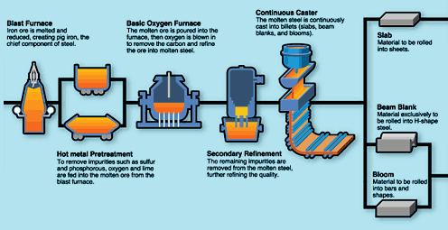
The material process of steel is made up of three factors limestone, iron core and coal which is then heated into a blast furnace. It is then converted to carbon monoxide which in turn reduces the iron oxide to iron. The iron then collects at the bottom of the furnace which then forms into a limestone slag which floats on top. Impurities are then formed from the iron and absorbed by the slag and removed. Iron is then drawn into ladles and then taken to the oxygen vessel. Approximately two tons of ore are used one ton of coke and half of tone of limestone which would then produce a ton of iron.
Materials of Adaptation.
Steel is normally produced off site and fabricated to what is needed on site which is then transported to site and bolted. Which then a crane will be used to put the steel in to the right position where it is required. A use of a crane will be involved when the steel is located on site to lift it into place but may have a high cost of the use of the crane. Adaptation of steel is quite easy it can be cut or added relatively easy using a MEWPS system on site.
Compare on Contrast of Steel and Concrete.
Concrete is known to be durable but only when it is reinforced with steel, but steel is always more durable due to it not rusting and it is easily to replace as you can add more steel to steel whereas concrete you can’t. An advantage of concrete is that it is implied to reduce the sway of buildings but then it will be reinforced by the steel however steel can reduce the sway too if designed properly. However, concrete can last longer in certain climates, but this is vital that the correct additives are used. But then steel will also have a long life but can rust easy and make it unsafe. Concrete is quicker method to use on site as it can be used there and then whereas steel is fabricated to the design but then brought to site. Concrete is much cheaper than steel, but the price could increase if reinforcement is required but steel could be cheaper on a much bigger project. But then a much smaller project concrete could be more beneficial using concrete and cheaper. Concrete can also stick to mould provided it can be more intricate when required. Concretes original process produces high amounts of CO2 and has a lot of water waste where steel only produces a lot of CO2.
Bibliography.
- The shard Design and Construction - https://www.theguardian.com/uk/2012/jul/05/23-facts-about-the-shard
- The Material Production Process- http://www.engineersjournal.ie/2016/01/26/engineering-the-shard/
- Construction of the Burj- https://www.burjkhalifa.ae/en/the-tower/design-construction/
- Material process of steel- https://science.jrank.org/pages/6483/Steel-Raw-materials.html
- https://www.google.com/search?q=material+production+of+steel&rlz=1C1PRFI_enGB768GB768&source=lnms&tbm=isch&sa=X&ved=2ahUKEwjY7K7j_4LnAhWKRMAKHSthBqIQ_AUoAXoECA8QAw&biw=1600&bih=789#imgrc=jylvuUTA-CpdeM:
- Adaptation of Concrete- https://www.google.com/search?rlz=1C1PRFI_enGB768GB768&biw=1600&bih=789&tbm=isch&sa=1&ei=dqcdXtKDG5aQ1fAP5emu-Ak&q=material+production+of+concrete&oq=material+production+of+concrete&gs_l=img.3...93720.97362..97911...0.0..0.71.653.15......0....1..gws-wiz-img.HA6e_zsRkmU&ved=0ahUKEwjSlpzk_4LnAhUWSBUIHeW0C58Q4dUDCAc&uact=5#imgrc=47TfNsGzkmJuUM:
- The Burj Khalifa- https://www.google.com/search?q=the+burj&rlz=1C1PRFI_enGB768GB768&source=lnms&tbm=isch&sa=X&ved=2ahUKEwiMxN7F1YDnAhXVThUIHcA3DmAQ_AUoAXoECBMQAw&biw=1920&bih=969#imgrc=hrs2iEG4eciJQM:
- The Shard- https://www.google.com/search?q=the+shard&rlz=1C1PRFI_enGB768GB768&source=lnms&tbm=isch&sa=X&ved=2ahUKEwj-6_S2uIDnAhUOGsAKHW06AfYQ_AUoAXoECA4QAw&biw=1920&bih=969#imgrc=wnwK9wEokONYQM:

