

Changemakers: Creativity and Value Creation
Professions (BMHP5014)

Component 1: Online portfolio of set exercises
Student name: Jessica Waters
Student number: 2335157
Lecturer’s name: Dr. Laila Surani.

Table of contents
Introduction 3
Task 1- Defining Key Concepts in Practice 4
Task 2 - Mind Map 5
Task 3 - Self-Reflection of Group Activity 6
Task 4 - Case Study Analysis of a UK Innovation 7
Task 5 - Research Task 8
Task 6 - Exploring Digital Innovation in Health and Social Care 9
Task 7 - Understanding the NHS Leadership Framework 10
Task 8 - Self-Reflection Journal Entry 12

Introduction
During this assignment i will be going over all different tasks that i have learnt during this module, key concepts in practice, mind mapping, and explaining what it is, i will also be doing some self reflection on some of the tasks that i did during my classes on this module, I will be discussing innovative technologies and how they have improved patients health and how they have pathed the way for a much easier better quality of care. And at the end of this assignment I will be reflecting on this assignment and the entire module, explaining what I have learnt and whether or not it has changed my way of looking at innovative technology.

Task 1- Defining Key Concepts in Practice
Innovation, I believe, is immensely important in health and social care, it's creating new technologies that will or can save lives, new ways that can help people live longer with diseases that would have most likely killed us 50 or more years ago. Thinking of new ways that we can deliver better quality of care, and even making sure that all patients' information is kept safe. All the things that I have mentioned above have been improved by innovation, xray machines are now different to how they were 20 years ago. We keep patients' information safe on a computer now instead of in a filing cabinet. If a patient has more than 2 different consultants for different reasons, they can easily communicate and access their patients files, all because of the concept, innovation. (Care Quality Commission, 2022).
Creativity in health and social care and be used in many different ways, helping people express themselves with art, music, dancing, whatever makes anthem feel good, in health and social care it's not all about the technologies or the medicines, it's about finding all different ways that can help our patients, creativity in health and social care, may help people that suffer with anxiety, autism, and even dementia, in a recent research study, it showed that creative activities can actually help with our cognitive decline. (Care Management Matters, 2025)
Value creation is mainly focused on the outcomes of the patients, making sure they are positive and meaningful, building good relationships between patient and caregiver. Providing quality care, including the patient and getting good end results. (National Library Of Medicine, 2022)
The NHS is changing constantly, The #Health and Social Care services always need change. We need to change with the world, when COVID happened, everything overnight had to be done differently, to be able to save peoples lives, no more face to face appointments, unless in critical need, we had to wear masks, we had to stay in our homes. Change needs to happen in order to save more lives. (NHS England, 2023).

Task 2 - Mind Map
Mind mapping is basically visualising what is in your brain when you have a certain topic or subject you're trying to solve or trying to visualise or explain. It brings your ideas to life, It's a way to bring what's going on in your brain and turn it into a colourful diagram so you can see the whole picture. You can use it for brainstorming, simplifying tasks or as a graphic organiser. Once you have got your mind map you will find it much easier to recall the data that was once in your brain. (Mind Mapping, 2025)
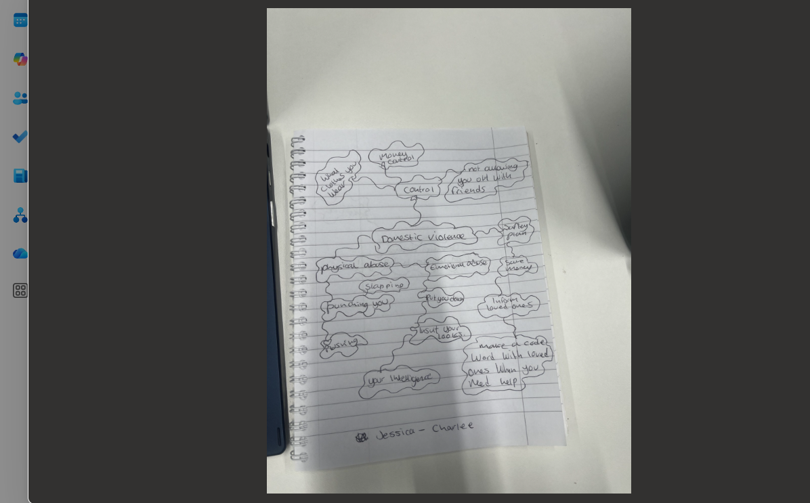

Task 3 - Self-Reflection of Group Activity
Divergent thinking and convergent thinking are completely different, divergent thinking is being open to endless solutions and possibilities, you open your mind much more to possibilities and options than what someone that uses convergent thinking would. Convergent thinkers would see a problem and think of the easiest possible way to solve the situation and have no more other options, they want the situation resolved quickly and easily. (Asana, 2025)
During our group activity, myself and my partner chose to focus on divergent thinking, instead of coming up with just one solution, we came up with multiple ways that Stanley could solve his problems or to make them easier, we thought he could seek help from charities for both more vaccines and help with extra people to help him administer the vaccinations, we also thought about him using recruitment agencies for extra help and also asking other hospitals for extra help.
For myself, while I was doing this task, I realised that the way I think is divergent. I'm always thinking of different ways that I may be able to fix things that have broken or solve problems that I have.
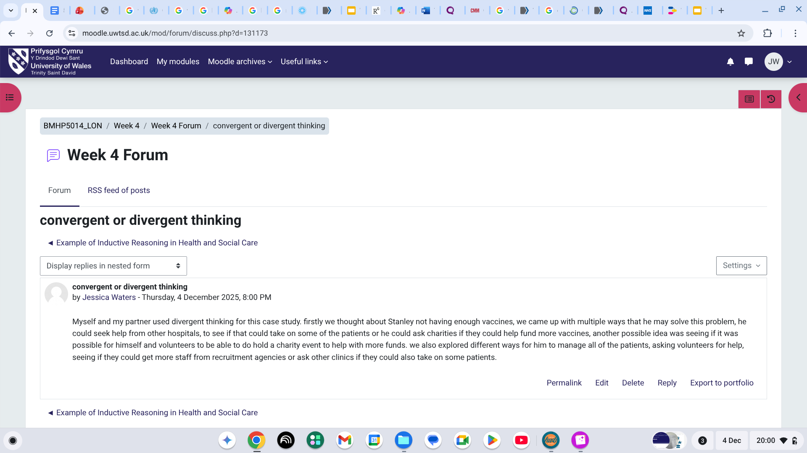

Task 4 - Case Study Analysis of a UK Innovation
The innovative digital health tool that I chose to base my case study on was a, continuous glucose monitor (CGM) which is a small device that diabetics have places just under their skin on their arm, and it keeps track of their blood sugar levels, this little device can help prevent hypoglycemic episodes, it can help patients make better choices, when it comes to the food they eat, the drinks that they have and also what exercises they take part in or if they need to exercise more.
Back in the early 1900’s healthcare professionals use to try measure blood sugar levels via the urine, after that was the finger pricks, now we have such a small device created for diabetic patients, that continuously tracks your levels, you don't have to remember to prick your finger, it's just there hardly visible on your arm, tracking your health and warning you if your health is at risk, this is such a creative innovated health care tool, and I truly believe that when it was made, they did want to make the life of a diabetic much more easier and safe. (London Medical, 2021)
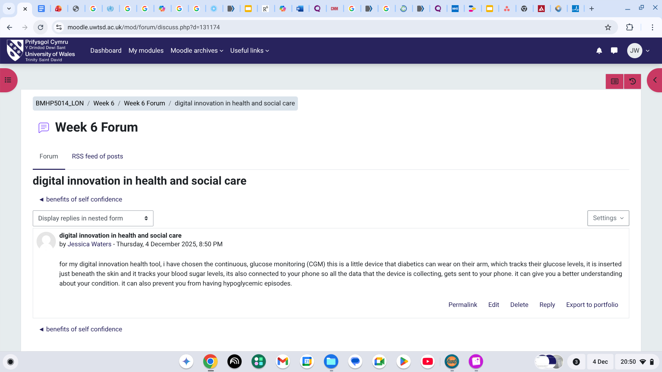

Task 5 - Research Task
The current issue that i have been researching, is the waiting times for patients in hospitals across the uk, it has got worse over the years, but “between the months of July and September of this year, that being only 3 months, over 300,000 patients left a&e without being treated”, due to the waiting times being so bad. (Bawden, A. 2025)
Whilst i have been researching this current issue, i have found that there could be several reasons for the waiting times to be so bad, the 2 main reasons that i have come across is, one being that people are really struggling to be able to get an appointment with their GPs, so they are going to a&e instead, as a last resort, the second reason that i have found is that, people coming into a&e are more sick than what they previously was, so waiting times increase because hospitals are not able to discharge patients as quick as they usually would because the case is more complex, and they have to find more patients more beds and allocate them to different wards, which takes up more time. (Sansum. J. 2023)
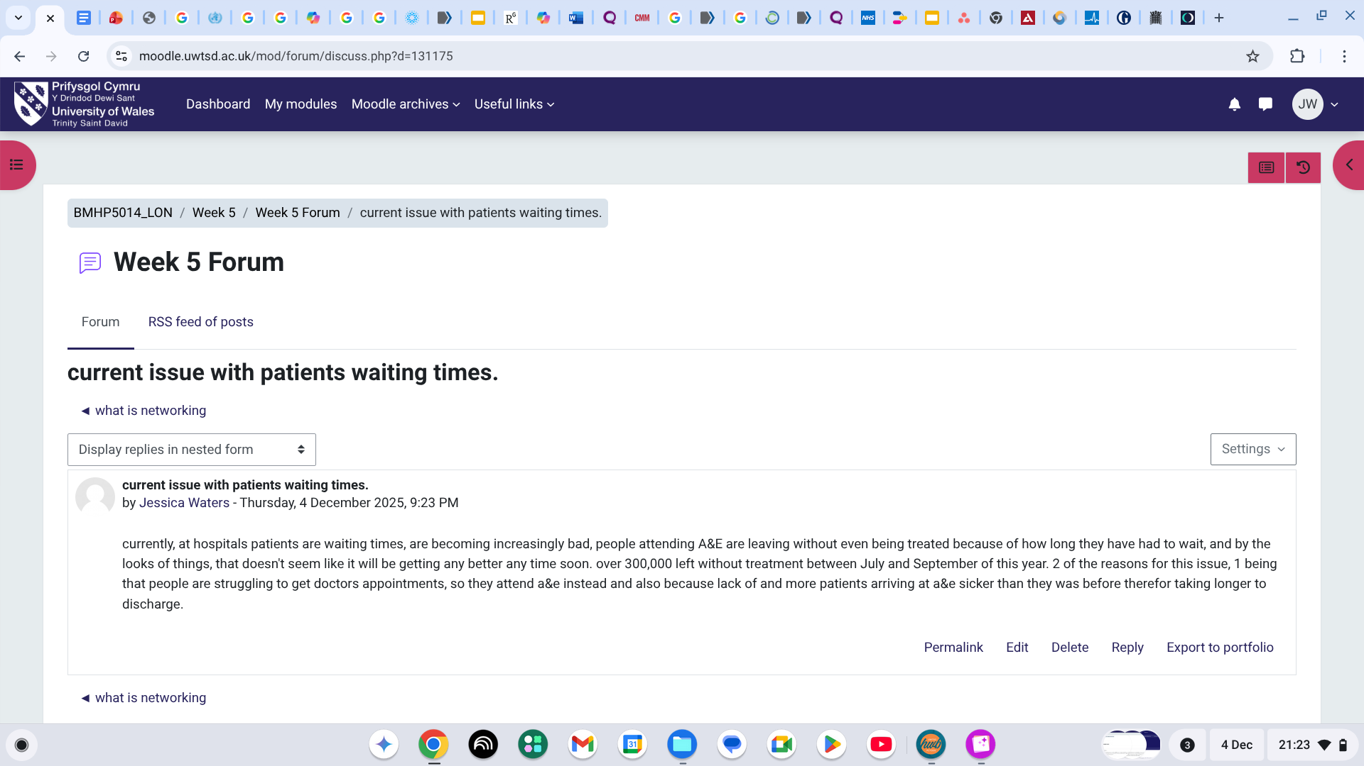

Task 6 - Exploring Digital Innovation in Health and Social Care
Wearing innovative health technologies can be beneficial in many different ways. With wearable technologies it can be used any time, and anywhere that you are, which is beneficial for patients, who have a busy lifestyle, it can make people who once felt powerless to their condition actually feel like they now have some control back in their life, and lastly one more beneficial that i have found is that with the wearable technologies that we have today in health and social care, they can reach more patients than face to face appointments. So overall innovative health technologies are very beneficial, for patients and healthcare workers, it makes the patients lives much easier when it comes to living with their condition and also taking stress off the work load of health care professionals. (NIHR, 2022). The EHRs have made communications between all different healthcare providers run much more smoothly, it has allowed them to be able to communicate and collaborate much easier than ever before, all important data about the patient is stored on one place which all relevant health care teams can access, it has improved patients quality of care, their out comes and it has also enabled patients to be able to play a more active role in their own care. Patients now have access to their own medical information at a click of a button, so overall it has made both patients and health care professionals lives much easier. They can make more informed decisions about their patients' care and it makes less space for clinical errors. (Careful, 2025). Digital technology can help support preventative care and health promotion, with elderly patients if they become unsteady on their feet, whether they live in a care home or are still in their own homes, they can be given a watch that they wear, at all times, it also comes with a device, which is like a phone, with this watch it can detect falls, so if the elderly patient falls it sends a signal straight to the box that it came with and then someone will instantly start speaking from it, if they do not get a reply they will send out help. (Telecare24. 2025)

Task 7 - Understanding the NHS Leadership Framework
The NHS Leadership Framework, is a set of principles, that are typically there for every staff member to follow, not just those that are in a leadership role, its goals set out for all staff to follow to provide the best care, and be the best health professionals that they can be, regardless of their roles, some of the key principles are, accountability which means, holding themselves accountable for their work and their actions, and also holding others to accountability when needed.
Collaboration, which means collaboration with other health care professionals and also patients, ensuring that all patients experience the people-centered care, listening to everyone's voice and opinions, not just going with what you think is best. It's making sure you're putting patients' best interests first.
Inclusion, making sure that everyone feels safe, making sure that everyone feels like they belong, actively advocating for diversity, fairness, and ethical practice.
Compassion, making sure not just your patients but co-workers feel respected, heard and valued, let them know that you want them to thrive, you want them to be the best that they can be and also let them know they can trust you.
Integrity, always ensure you act with integrity, honesty and transparency, with all those that they work with and also all those that they treat. (NHS England, 2025)
I think when in a leadership role leading with integrity and compassion is so important, the compassion will really inspire, not only the people that you work with but the patients that you treat, compassion I believe has a lasting impact on people and it also helps build up trust with the people around you, integrity is key, it makes people respect you, truthful and transparent, people will always respect a leader that is honest and transparent because again, they will know, good or bad that you will be honest and behave in a professional manor. (Care Quality Commission, 2024)
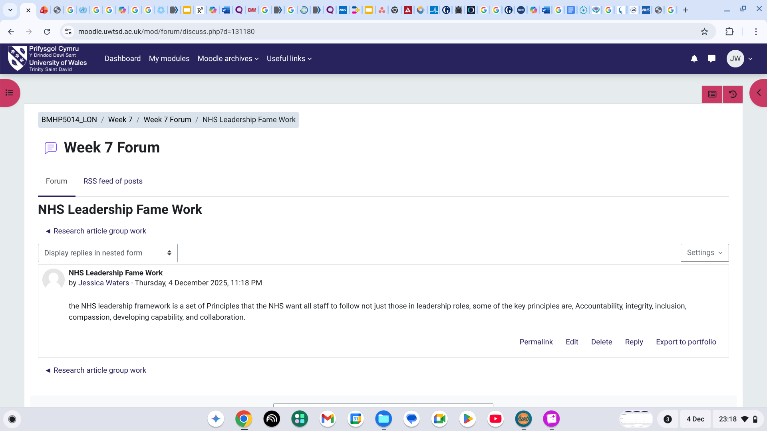

Task 8 - Self-Reflection Journal Entry
During this module my outlook on innovative technologies have completely changed, i believed that technology was getting out of control, we didn't need all this technology, but since doing this module and doing my research on all the different innovative technologies in health and social care, and how they help people with all different conditions, has completely changed my mind. I think they are doing amazing things for people and completely changing people's lives. I'm excited to see what the future brings, with innovative technology in health and social care, the possibilities seem endless.
The moment i knew i had changed my outlook on innovative technology was when i was researching the endoscopy camera, because that was also one of the reasons i was sceptical about it as well, as my son has been offered this and i didnt like the sound of it until my research during this assignment, im actually relieved that he will be having this instead of being put to sleep again and having it the usual way. I still am hoping to be a midwife, just a midwife that would like an innovative technology to work with.

References
Care Quality Commission. (2022). Innovation and why it is important. Available at: https://www.cqc.org.uk/publications/themes-care/innovation-why-it-important (Accessed on, 4 December, 2025)
Care Managment Matters, (2025). The benefits Of Creative Approaches and Activities In Care Services. Available at: https://www.caremanagementmatters.co.uk/feature/creative-health-reviewing-the-benefits-of-creative-approaches-and-activities-in-care-services/ (Accessed on, 4 December, 2025)
National Library Of Medicine, (2022). How It Has Influenced Medical Practice. Available at: https://pmc.ncbi.nlm.nih.gov/articles/PMC5367583/#:~:text=Conclusion,when%20they%20are%20fully%20empowered. Accessed on, 4 December, 2025)
NHS England, (2023). Evolving to meet a changing world. Available at: https://www.england.nhs.uk/future-of-human-resources-and-organisational-development/the-future-of-nhs-human-resources-and-organisational-development-report/evolving-to-meet-a-changing-world/
Mind Mapping, (2025). The Concept of Mind Mapping. Available at: https://www.mindmapping.com/mind-map (Accessed on, 4 December, 2025)
Asana, (2025). Convergent Vs Divergent Thinking. Available at: https://asana.com/resources/convergent-vs-divergent (Accessed on, 4 December, 2025)
London Medical, (2021). CGM A Revolution in The Making. Available at: https://londondiabetes.com/news-and-events/continuous-glucose-monitoring-a-revolution-in-the-making/ (Accessed on, 4 December, 2025)
Bawden. A. (2025). The Guardian. Available at: https://www.theguardian.com/society/2025/dec/03/numbers-leaving-ae-without-treatment-triples-in-six-years (Accessed on, 4 December, 2025)
J. Sansum. (2023). NHS Confederation. Available at: https://www.nhsconfed.org/articles/are-ae-waiting-times-bad-because-too-many-people-are-going-there-who-dont-need (Accessed on, 4 December, 2025)
NIHR, (2022). What is Digital Health Technology And What Can It Do For Me? Available at: https://evidence.nihr.ac.uk/collection/what-is-digital-health-technology/ (Accessed on, 4 December, 2025)
CareFul, (2025). The Impact Of EHRs on interprofessional collaboration in UK Healthcare. Available at: https://careful.online/the-impact-of-ehrs-on-interprofessional-collaboration-in-uk-healthcare/ (Accessed on, 4 December, 2025)
TeleCare24, (2025). Fall Alarms For The Elderly. Available at: https://www.telecare24.co.uk/features/fall-alarms/?srsltid=AfmBOooG0LXSidtTG1ljg2_MXYq7ATxNOAkp1T10G_ygM3SJCFEHZ5cD (Accessed on, 4 December, 2025)
NHS England, (2025). Explore The Healthcare Leadership Model. Available at: https://www.leadershipacademy.nhs.uk/healthcare-leadership-model/explore-the-healthcare-leadership-model/ (Accessed on, 4 December, 2025)
Care Quality Commission, (2024). Capable, Compassionate, And Inclusive Leaders. Available at: https://www.cqc.org.uk/guidance-regulation-nhs-key-question-well-led-leaders (Accessed on, 4 December 2024)

