Daisy Hay
1703178
Tribal Art London
Project initiation document

Content page
- Project justification……………………………….2
  - Background…………………………………………..2
  - Project aim……………………………………………2
  - Project objectives…………………………….……2
  - Project scope and excursions………………..2
  - Project constraints and assumptions………2
  - Stakeholders…………………………………………..3
  - Rationale………………………………………………..3
2. Business case approach……………………………3
  - Potential benefits and outcomes………3
  - Risks and risk management strategy...3
  - Project costs……………………………………..4
- Proposed research strategy……………………4
- Project management team structure……..5
- Quality management strategy………………..6
- Communication strategy………………………...6
- Project plan………………………………………….…6
- Project Gantt Chart………………………………...7
- Project controls………………………………………7
- Project reporting……………………………………7
- Reference list…………………………………………8

- Project justification
1.1 Background
Tribal Art London launched in 2007. The organisation first started off in a single gallery space in Notting Hill. Within a few years it relocated to a larger gallery in Cork street. There was an increase in numbers at Tribal Art dealers that took part including a large number from overseas. This resulted in an increase of visitors attending and recognition of the fair at an international level. By 2014, the event had grown even larger which led to a second relocation to the Mall galleries, offering a much larger space. The organisations aim is to provide a friendly and knowledgeable atmosphere for potential customers interested in tribal art.
1.2 Project Aim
The aim of this project is to identify and evaluate ways to improve marketing at Tribal Art London.
1.3 Project objectives
- Communicate with management at Tribal Art London to discuss the organisations current marketing strategies.
- Evaluate the marketing strategies to discover the strengths and weaknesses.
- To make recommendations on how the organisation can make improvement.
1.4 Project scope and excursion
The project intends to provide the organisation with a greater insight into the constant change in marketing strategies and trends and how the organisation can stay consistent in order to keep engaging with customers. The project also intends to identify, anticipate and satisfy customer needs.
1.5 Project constraints and assumptions
One of the major constraints when undertaking this project is time as there will be a numerous number of tasks to be completed to finalise the project. Each task could potentially take longer to complete than anticipated. To overcome this constraint, a Gantt chart (P.7) has been created which displays the tasks that need to be completed throughout the project and the deadlines they need to be completed.
An assumption when having completed the project is that the organisation will be willing to take the project suggestions and recommendations onboard.

1.6 Stakeholders
- The management and staff are the main stakeholders who have a massive contribution into the event and are the people who make the event as successful as it is.
- The exhibitors are one of the organisations stakeholders. They showcase their artwork making them the heart and soul of the event.
- The Mall galleries own the building where the event takes place.
- The visitors are a key component for the organisation. The event has grown and expanded over the years due to its increase of visitors.
- The organisations have partnerships with the brands; Tribal art magazine, EduKaid, Tribal Art Fair Amsterdam, IMO Dara and San Francisco Tribal textural art show.
1.7 Rationale
The client stated interest for the consultant to explore ways to increase visitor numbers. The project’s aim was selected as marketing is a key component for an organisation to gain visitors and a wider audience which meets the clients brief.
- Business case and approach
2.1 Potential benefits and outcomes
The overall outcome of this consultancy project is to be able to contribute an increase of visitors’ numbers and a higher customer retention for the organisation. Another desired outcome is to be able to reach a wider audience from discovering different marketing strategies.
  - Risks and Risk Management strategy
When undertaking a project, there is bound to be risks. Risks can be handled if there has been a large contribution of planning completed beforehand.
A potential risk that could occur could be that the recommendations might not lead to the intended outcome and leads to negative consequences. To prevent this, primary and secondary research will be conducted to achieve the desired outcome.
The client may not be free to communicate with client due to a busy schedule. This can be dealt with as the consultant will allow plenty of time for the client’s schedule.

  - Project costs
The project will require the consultants time and knowledge in order to provide a detailed report which will aim to have an outcome of adding value to the organisation. The project will not require any financial cost, but instead it will require an exchange of knowledge between the consultant and the client.
- Proposed research Strategy
Throughout this project, a variety of different research methods will be undertaken to be able to form conclusions. By undertaking research methods, it provides practical skills that will enable the researcher to produce and consume facts, findings and information which will arrive at a solid conclusion (Watkins, D. C. 2012).
There are two approaches when gathering and evaluating data, this includes qualitative and quantitative research. Quantitative research focuses primarily on numbers and statistics. It can be used to assess or confirm assumptions and theories. The use of qualitative research is to comprehend concepts, experiences and thoughts which are expressed in words (Streefkerk, R. 2019).
The project’s main type of research that will be included is secondary. This type of research is cost effective and less time consuming than primary research. Data will be collected from available sources on the internet, libraries and commercial information sources and report and studies from trade or industry organisations (Bhat, A. 2020).
Primary research is a form of research which is data gathered directly, opposed to depending on data that has been already collected from research that has previously been done (Bhat, A. 2020). A questionnaire will be undertaken during the project and completed using google forms which is cost free and will be shared across a variety of different social media platforms to gain responses. Primary research is important to conduct during the report as it provides fresh unedited data, which is a lot more accurate compared to secondary research (Valcheva. S. 2019).

- Project management team structure
For this project to be successful, it is vital for the project to have clear roles and responsibilities for all taking part. The client will need to agree to the project and approve to the research the consultant will undertake. However, the client will not be required to be too involved in the project. The client could be needed to provide information the consultant might require.
Although the organisation has many different stakeholders, only a few will be involved in the project. The consultant is the individual who had initiated the want for the project and will be the person undertaking the project until the 13th May 2020.
The management will need to have continuous level of communication with the consultant throughout the project. The management and the consultant are the key members of the project team structure.
Although the chart below displays ‘staff’ and ‘customers’, these stakeholders will not be directly involved in the project, but their opinions and views will be useful in the project.

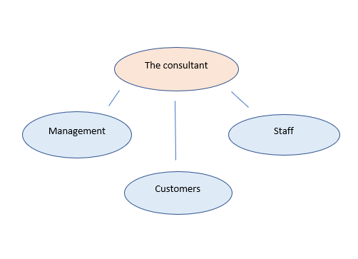

- Quality management strategy
A quality management strategy is needed to exemplify the quality standards and techniques applied and the responsibilities to reach the correct quality levels throughout a project (Greycampus, 202). This strategy is used to keep all parties satisfied with the progress of the project. The consultant must apply a high level of professionalism, high standards of service and consistency from start to finish.
- Communication management strategy
A communication plan is a key component for the project as it will allow engagement from the stakeholders, benefitting all forms of research being undertaken throughout the project. The consultant is accountable for providing an effective level of communication from the start and end of the project. The methods used for consultant-stakeholder communication are emailing, phone calls and meetings. These methods will be applied on a weekly and monthly basis.
- Project Plan
To be able to complete a successful project and meet task deadlines, it is important to have a clear and concise plan. The project plan begins with having presented the BID pitch on 11th February 2020 to submitting the final report on the 12th May 2020.
The steps of the project:
- Communicate with organisation to discuss the current marketing strategies and the social media platforms used to promote the organisation. Once these have been discussed, the consultant will investigate how effective they are and then display the results into a SWOT.
- Undertake a competitor analysis. This will require looking at other competitors and how they market themselves. The competitor will then be compared to the organisation.
- Investigate and analyse online reviews on the organisation which will then be evaluated in the report.
- Complete and share a questionnaire which the responses will then be converted into graphs and evaluated in the report.
- Conclude the report. The conclusion will include recommendations and improvements to benefit the organisation. The organisation will be sent a copy of the final report as well as the university.

- Project Gantt chart
The project Gantt chart has been created to be able to assist the planning and scheduling of each task (Mindtool, 2019).
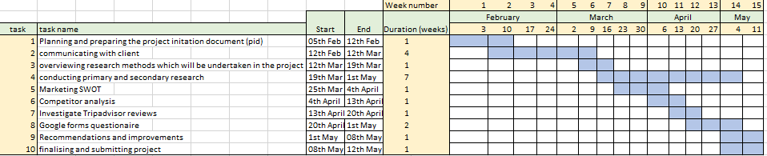

- Project controls
When undertaking each task in the project, there will be a use of controls to help establish project progress and time management. The tasks and deadlines are displayed in the Gantt chart but there is a possibility tasks may over run. If a task were to overrun, a 3-day time allowance can be used but the overall project deadline will still be on the 12th May.
For a successful project, it will be controlled and monitored and reviewed on a weekly basis by the consultant making sure it meets the Gantt charts criteria.
- Projecting reporting
Due to the client being based in London and occasionally visiting Carmarthen, emails will be the main point of contact to discuss project details. Meetings will take place but may not be as frequent opposed to emails.
All forms of communication between the consultant and client will be logged. Emails will be recorded and displayed in the report. If meetings take place, a brief summary will be typed up highlighting key discussions and decisions. The client will be kept up to date with all project findings.

Reference list
Bhat, A. (2020). Secondary Research- Definition, Methods and Examples. Available: https://www.questionpro.com/blog/secondary-research/. Last accessed 29th Feb 2020.
greycampus. (2020). Quality Management Strategy. Available: https://www.greycampus.com/opencampus/prince-2-foundation/quality-management-strategy-in-prince2. Last accessed 1st March 2020.
mindtools. (2020). Gantt charts. Available: https://www.mindtools.com/pages/article/newPPM_03.htm. Last accessed 29th Feb 2020.
Streefkerk, R. (2019). Qualitative vs. quantitative research. Available: https://www.scribbr.com/methodology/qualitative-quantitative-research/. Last accessed 29th Feb 2020.
Valcheva. S. (2019). Primary Data VS Secondary Data. Available: http://intellspot.com/primary-data-vs-secondary-data/. Last accessed 29th Feb 2020.
Watkins, D.C., 2012. Qualitative research: The importance of conducting research that doesn’t “count”. Health promotion practice, 13(2), pp.153-158.

