

  - CLOUD COMPUTING TECHNOLOGIES
MARIN ZAHARIDOV | Course Title: ACCC5000 | 1814694

TABLE OF CONTENT

The report is connected with Cloud Computing and mostly creating SaaS to help on a small business – London Bikes Ltd. The company want to improve the business process and to help their customers to make fast and easy purchase.
- Background and terminology of Cloud Computing
- Main characteristics and benefits
- Service model and real-time service
- Suggested model and deployments
- Virtualisation an how to connected with the Cloud
- Cloud Computing migration strategy
- Security and how to protect the information
- Software as a Serveice implementation for the company
The Beginning of Cloud Computing
In 1963, MIT create innovation permitting for a “computer to be utilized by two or more individuals, simultaneously.” In this case, one of those tremendous, bygone computers utilizing reels of attractive tape for memory and was the antecedent to what has presently gotten to be collectively known as Cloud Computing. It acted as a primitive Cloud with two or three individuals getting to it. The word “Virtualization” was utilized to portray this circumstance, in spite of the fact that the word’s meaning afterward extended.
In 1969, J. C. R. Licklider made a difference create the ARPANET, a “very” primitive form of the Web. JCR, or “Lick” was both a clinician and a computer researcher, and advanced a vision called the “Intergalactic Computer Network,” in which everybody on the planet would be interconnected by way of computers, and able to get to data from any place. Like the Interglacial Computer Organize, something else known as the Web, is vital for get to the Cloud.

The Cloud picked up notoriety as companies picked up understanding of its administrations and value.
In 2002, Amazon presented its web-based retail administrations. It was the primary major commerce to think of utilizing as it were 10% of their capacity as a issue to be unraveled. The Cloud Computing Foundation Demonstrate gave them the adaptability to utilize their computer’s capacity much more effectively.
In 2011, IBM presented the IBM SmartCloud system, in bolster of More intelligent Planet (a social considering venture). At that point, Apple propelled the ICloud, which centers on putting away more individual data (photographs, music, recordings, etc.). Moreover, amid this year, Microsoft started publicizing the Cloud on radio and TV
, making the common open mindful of its capacity to store photographs, or video, with simple access. Oracle presented the Prophet Cloud in 2012, advertising the three essentials for trade, IaaS (Infrastructure-as-a-Service), PaaS (Platform-as-a-Service), and SAAS (Software-as-a-Service).

To begin with, customers the administrations, rather than acquiring equipment and program to achieve the same objective. Moment, the merchant is mindful for all the organization, upkeep, capacity arranging, reinforcements, and investigating. And at long last, for numerous trade ventures, it is essentially quicker and less demanding to utilize the Cloud. It comes with gigantic sums of capacity, the capacity to handle different ventures, and more accessibility to a assortment of clients, at the same time.
The service are separate on three basic categories:
- IaaS (Infrastructure-as-a-Service) bargains with crude computing capacity. IaaS is the foremost fundamental benefit, and gives a server, or servers, within the cloud, along side capacity. IaaS clients are regularly tech companies that regularly have a incredible bargain of IT ability. The objective is to have get to to computing control, without the obligations of establishment or maintenance.
- PaaS (Platform-as-a-Service) underpins composing program for computer frameworks that require it. This Cloud-based benefit lets businesses compose program for coordination existing applications, or create custom applications. PaaS situations are prepared with program improvement innovations, such as .NET, Python, Ruby on Rails, and Java. When the code is wrapped up, the benefit supplier will have it, making it accessible to other web clients. Right now, PaaS is the littlest portion of the Cloud Computing showcase, and has been utilized by businesses needing to outsource portion of their infrastructure.
- SAAS (Software-as-a-Service) gives program. This portion of the Cloud is the biggest and most created. It may be a program, or a suite of applications, accessible inside the Cloud, instead of a computer’s difficult drive.
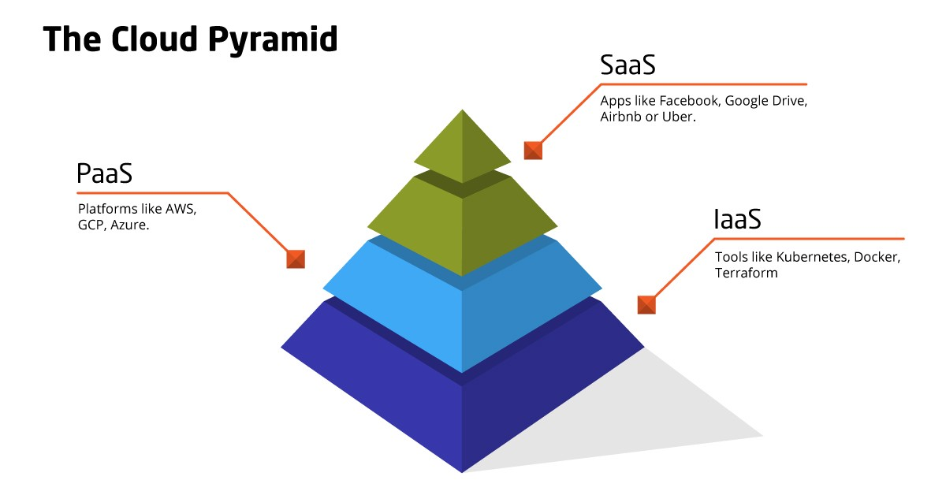

Concept and understanding for the CLOUD.
Major key difference is that clouds do not need to be Web-based, even though they are generally based on Internet protocols and technologies. Protocols refer to standards and methods that allow computers to communicate in a pre-defined and standardised manner with each other. A cloud can be built on using any protocol that enables its IT resources to be accessed remotely.

From the IT resource we define two types of scaling:
- Horizontal - transfer of resources is called scaling out, and the horizontal release of resources is called scaling in. Horizontal scaling is one common method of cloud scaling.
- Vertical - Specifically, the replacement of an IT resource with a higher capacity resource is referred to as scaling up and the replacement of an IT resource with a lower capacity resource is known to be scaling down. In cloud environments, vertical scaling is less common due to the downtime needed while the replacement takes place.
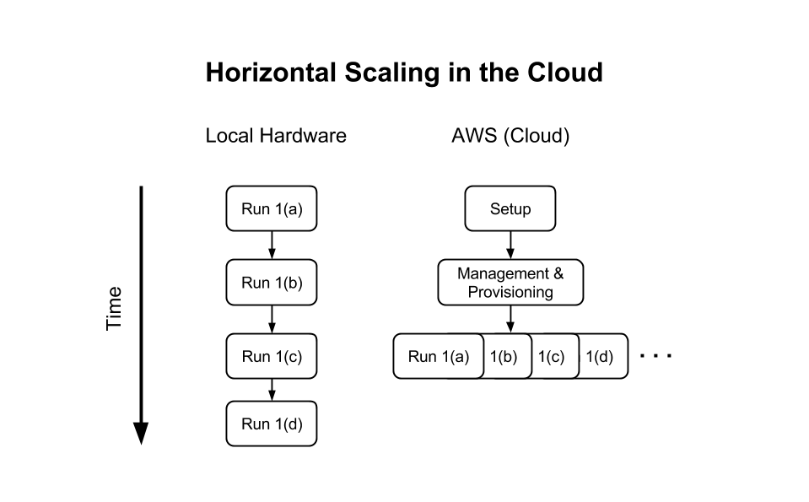
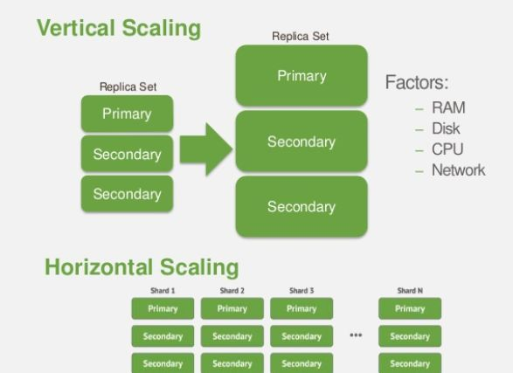

There is some difference :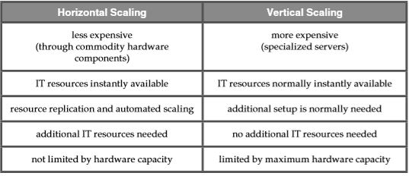

Cloud service or cloud is an infrastructure which can be accessed remotely. For example, only other IT resources within the same cloud can access a database or a physical server which is installed in a cloud. You can specifically deploy a software programme with a published API to allow remote user access. Cloud computing is driving the provision of IT resources as services.
Cloud computing systems also provide the benefit of being elastic, which ensures that you are not only able to access additional resources exactly where you need them, but you are also paying only for the systems you use, so there is no need to purchase extra hardware for more redundancy.

Characteristics and benefits of Cloud Computing

Reduced and proportional costs.
Major reason for investing in cloud-based IT services is to minimise or remove outright upfront IT expenses, namely acquisitions of hardware and software and ownership costs.
• Short-term access to pay-as-you-go computing resources (such as hourly processors), and the opportunity to unlock such computer services when they are no longer required.
• Capability of attaching or deleting IT services.
In this case for London Bikes Ltd The decision to continue with a plan for implementing cloud computing would require far more than a straightforward contrast between the lease costs and the buying costs. For example, account must also be taken of the ﬁnancial benefits of dynamic scaling and the risk transfer of both over-supply (under-use) and under-supply (over-use).

Scalability – Increased
By offering collections of IT resources, along with tools and technology engineered to collectively optimise them, clouds can instantly and dynamically assign IT resources to cloud consumers, on demand, or through the direct trust configuration of the cloud users. This enables cloud users to scale up their cloud-based IT services to automatically or manually manage processing variations and peaks. (Erl, 2013)

Availability and Reliability is increased
IT resources' availability and reliability are directly related to tangible business benefits. Outages restrict the time it takes for an Online resource to be "open to business" for its clients, thereby reducing its capacity for use and generating revenues. During high-volume use, runtime errors that are not immediately fixed may have a more severe effect.
Very Important Characteristics are:
- Self-service on-demand: A customer can automatically have computing resources independently, such as server time and network storage, without requiring human interaction with each service provider as necessary.
- Wide access to the network: features are accessible across the network and accessed across common frameworks that facilitate the use of heterogeneous thin or thick client devices ( e.g. cell phones , tablets , laptops and workstations).
- Resource pooling: The computing resources of the provider are pooled to support multiple users using a multi-tenant model, dynamically assigning and reassigning different physical and virtual resources according to customer demand.
- Rapid elasticity
- Measured service - cloud systems automatically monitor and optimise resource
It is critical that businesses, when evaluating leasing cloud-based services and IT infrastructure, carefully evaluate the SLAs provided by cloud providers. Despite the fact that many cloud environments are capable of providing exceptionally high standards of availability and reliability, the SLA guarantees usually reflect their actual contractual obligations are the outcome. (Chabrow, 2011)

Service Models And Real – Time Services
Cloud-based tools, such as emailing software or social media platforms, open up new collaboration and connection. Ultimately, this means you don’t need to channel all work communication through a single, stationary desktop.
In that case for the London Bikes Ltd is very important to keep up-to - date with the latest technologies and to ensure that their data are safe and retrievable at any time.
Security is one of the most important examples of cloud computing that London Bikes company can embrace. It shouldn't be a option to back up your data and invest in a recovery strategy: it is a requirement.

Cloud Deployment Models
Cloud computing refers to the provision of on-demand computing resources, including storage, hosting, databases, analytics, applications, and servers, over the Internet. It helps businesses to rent access from a cloud service provider to a range of services and pay for it on the go – without wasting their money on costly IT infrastructure and maintenance.
Various cloud deployment models exist: private, public, and hybrid. Every model has its own peculiarities and while some are more common than others, the one you select depends on your business's unique needs.
A private cloud refers to a cloud computing model that is run solely by a single entity, whether it is physically installed at the on-site data centre of the business, or is controlled and hosted by a third party. Resources are not shared with other companies in a private cloud, but this also ensures that the entity that uses them is solely responsible for its management, operation and maintenance with often updates.
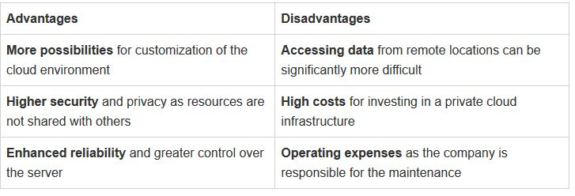

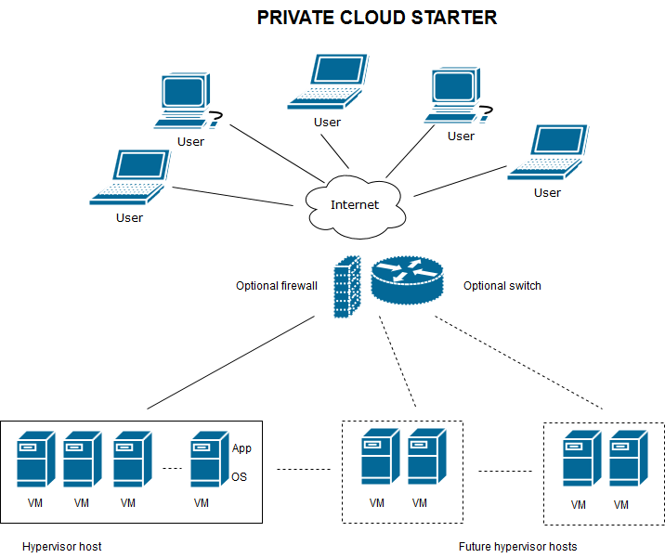
A cloud is considered public when services are made by third-party providers over a network that is available for public use, meaning you use the same infrastructure, software and network devices with other users of the same company (for example, other companies).
The responsibility for the storage and maintenance of the cloud is another significant differentiator between a public and a private cloud. Since you're just "renting" a storage space from a third party vendor in a public cloud, he'll be the one who bears the costs and maintenance of the entire system. You do not have any obligations as a customer who pays for this service with no responsibility and only use to store data by pay as you go.
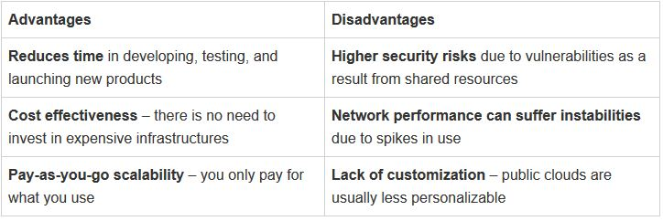
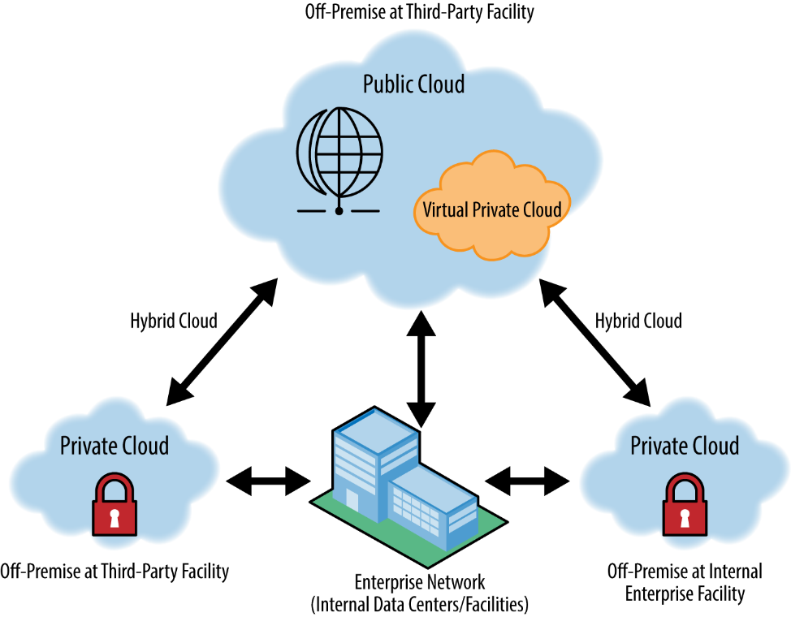

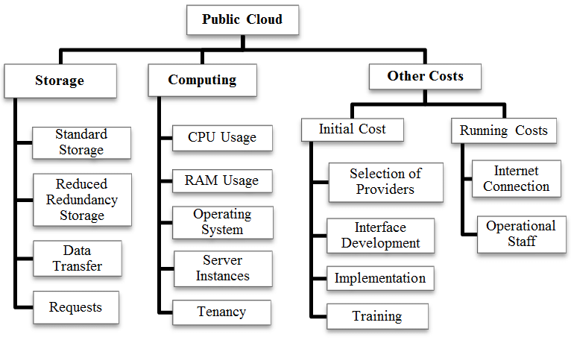
Between all models there is some differences:
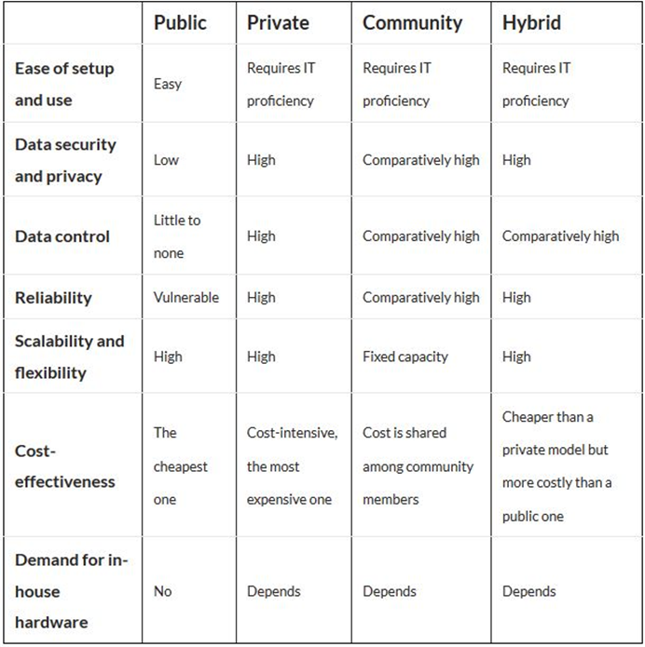
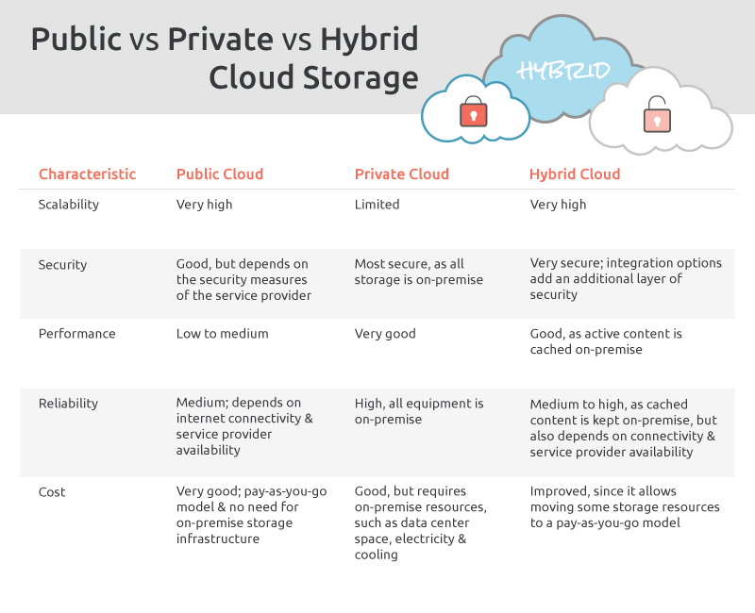

Best option when we are choosing the right Cloud for this business is the Hybrid Cloud.
A hybrid cloud is a mix of a private cloud combined with the use of public cloud services where one or more inter-environmental touchpoints exist. The aim is to integrate resources and data from a number of cloud models to create a computing system that is centralised, automated and well controlled. The modern concept of computing is integrating public networks with private clouds and the data centre as a hybrid. Not every organisation using some public and some private cloud services has a hybrid cloud. Like a hybrid cloud is an area where value is generated by the use of private and public resources together.
A hybrid cloud - If a company uses a software development platform that transfers data to a private cloud or an application built on a data centre. When a organisation leverages many SaaS (Software as a Service) applications and transfers data between the resources of the private or data centre. When a business process is structured as a service allowing it to communicate with environments as if they were a service in a single system. (Judith Hurwitz, 2010)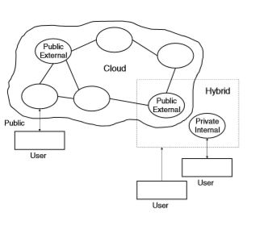

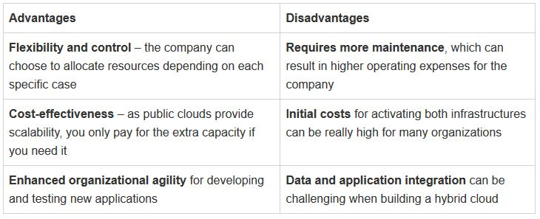
Hybrid Cloud Benefits
- Scalability and Versatility -The biggest benefit of the hybrid cloud is without question its versatility. Managing the in-house IT infrastructure takes time and money, and the addition of resources requires advance planning.
- Highest speed access
- Savings in Price -The hybrid cloud's public cloud portion offers cost-effective IT services without incurring both capital and labour costs.IT professionals will define the best configuration, service provider and location for each project, thus minimising costs by matching the resource with the role that best suits it.

According to 451 Report, 69 percent of enterprises will be working in hybrid cloud environments by 2019, and 60 percent of workloads will be running in some form of hosted cloud service (up from 45 percent by 2017).Which suggests the advantages of the hybrid cloud appeal to a wide range of businesses. (Bauer, 2018)
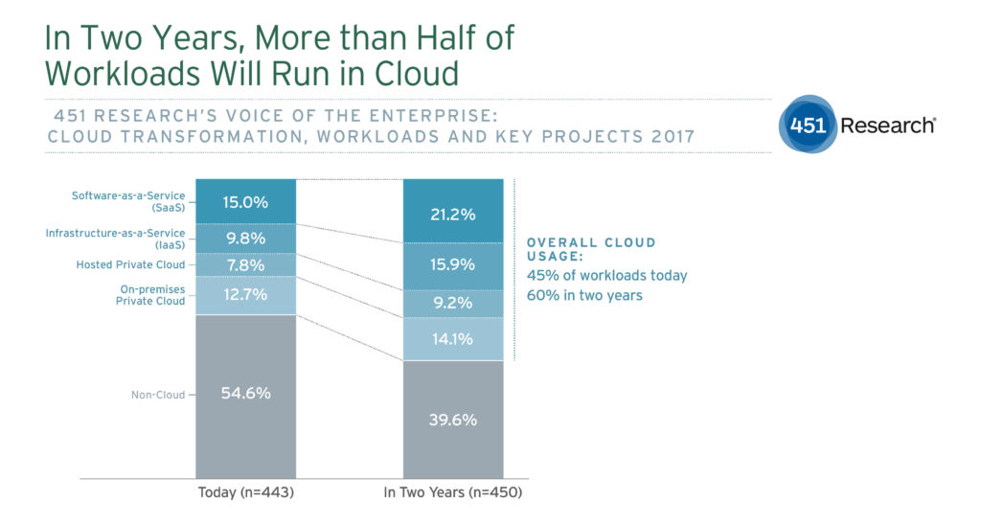

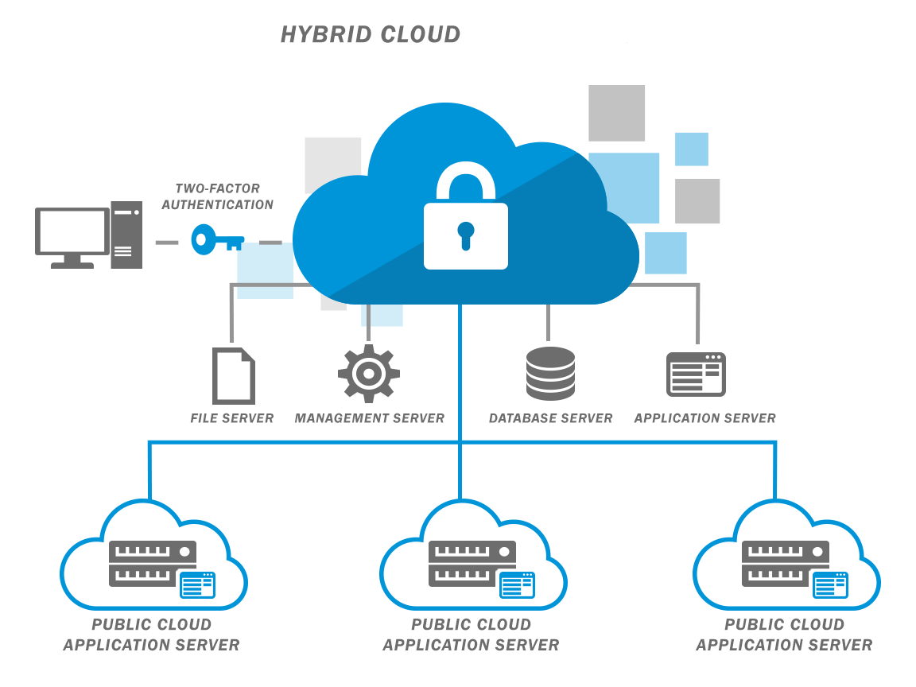

Virtualization Concepts in Cloud Computing
Virtualisation technology splits one physical server into several virtual machines that are separated.
This reduce the price for service.

Three separate systems operate in non-cloud computing for three distinct applications that run on their own server. Since you need to endorse several different operating environments in cloud computing the hypervisor becomes an ideal framework for delivery. The hypervisor allows you to view the same application on several devices despite having to copy the application physically to each device.
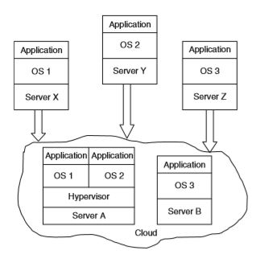
Organising virtualization requires an abstraction layer between the physical storage subsystems which hides and manages stuff. The virtualization programme needs to view the entire storage asset as a single, sharable resource for the virtualized system. The process can be harder than it does look.

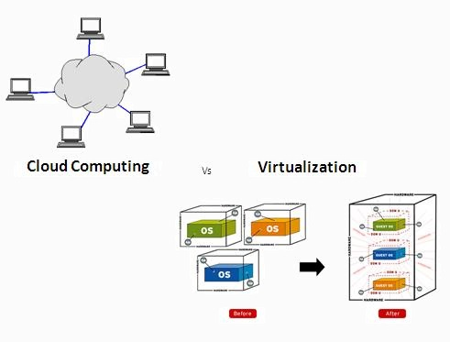

Present network protections are physical network dependent. The network is no longer physical in the virtualized environment - its configuration will in fact change dynamically, making control of the network difficult.
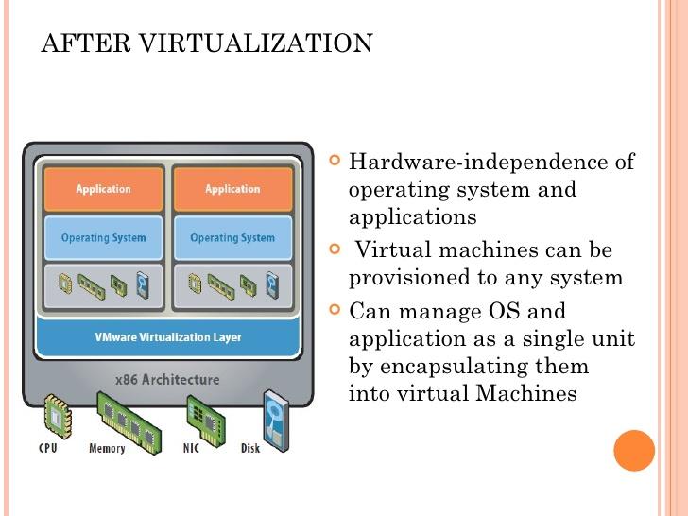 Virtualisation of servers

Basically, you are running multiple tasks from one server instead of assigning one computing task to one server (and leaving loads of underused resources there). In the case of AWS it sells services from one server to many companies.
The virtualisation of networks
You can build several individual networks from one local area network ( LAN) using network virtualisation. You 're looking at building a 'remote' network without linking to the public internet (i.e. virtual private server) in terms of the server.

Virtualisation Data storage
Virtualization for storage means 'grouping' or 'pooling' several physical data storage devices into one view, even if those devices come from various manufacturers, data place. By virtualizing, the diverse computing assets can be analysed as if they were one single resource.
Virtualisation on the desktop
Among the first stuff that people virtualized are desktops. The basic idea is that without the hardware, you can give someone a whole forum for computing.
Virtualisation of Software
You run an application on a computer with device virtualisation, but without relying on the hardware or software of the machine.
Virtualisation Benefits
Cutting down the reliance on the underlying hardware is the common thread for both of these virtualization principles. You do need the hardware, to be honest! With cloud and virtualization, however, if one server goes down, it doesn't mean that all of your application goes down with it. (Lund, 2019)
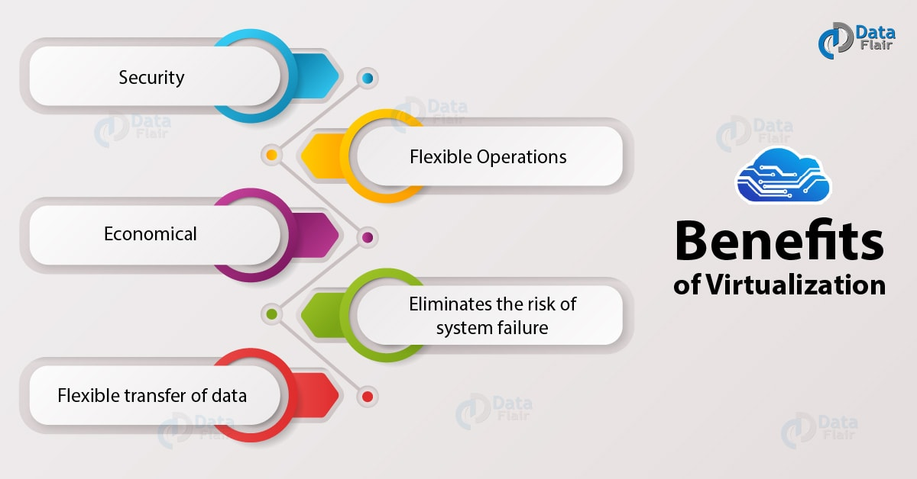

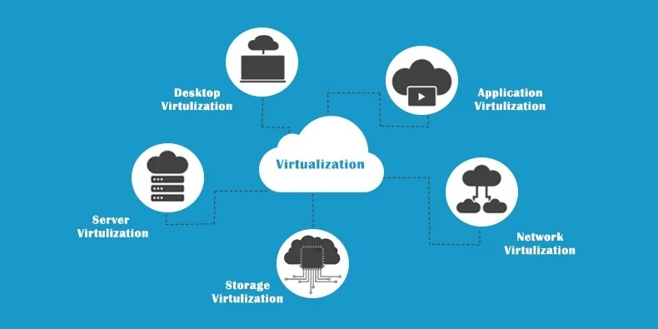
Migration strategies of Cloud Computing
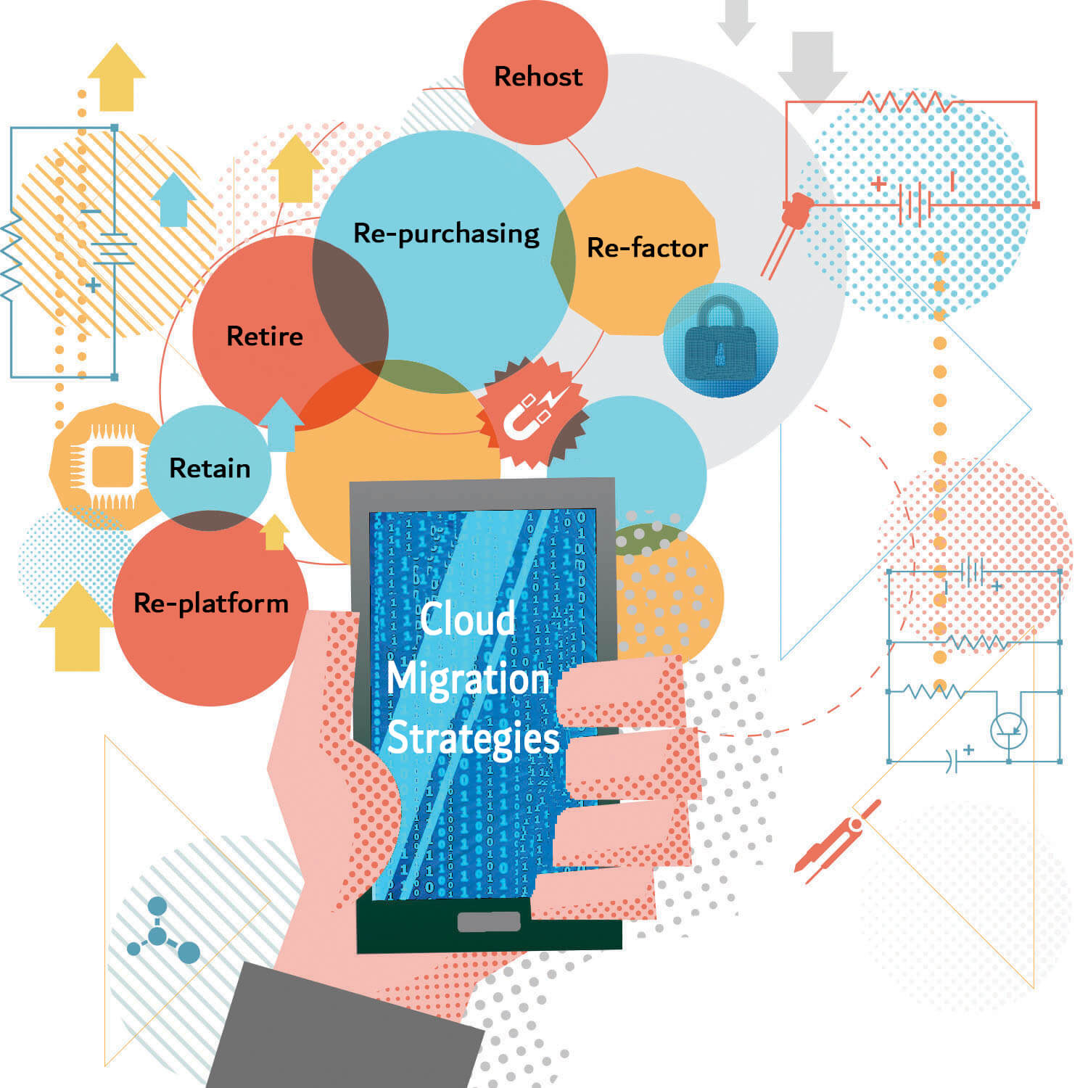

These are the six most popular migrations:
- Rehosting ('shift and lift')
- Re platforming
- Repurchasing
- Refactoring (or rearchitecting) involves reconstructing the software from the ground up.
- Retaining - cloud adoption is still not sensible for some organisations. Should you not take data off premises for purposes of compliance.
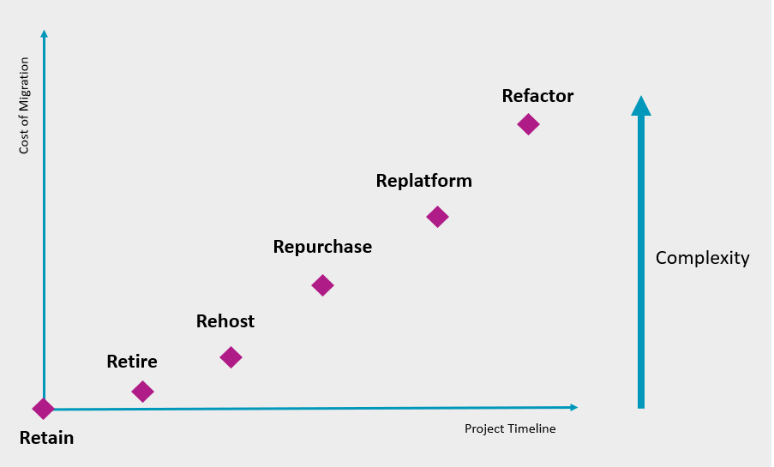

Benefits from Migration Strategy
Reduced storage costs and agility and scalability - cloud-based services not only automatically increase power, but also enable teams to work on application changes. Reduced footprint and Disaster recovery: for smaller businesses it is traditionally costly.
Today, the cloud is helping more companies adopt strategies for backup and recovery that require less time and up front investment.
Safety: By centrally saving your confidential data and software, the cloud provides better protection than data centres.
With the benefits there is some risk also. One of them is happened when the process is offline – it is called downtime. There is also possibility of some data loss or problems with resource management.

Software as a Service for London Bikes
Today, cloud computing is the most advanced field of SaaS.
There is some characteristics of Software as a Service:
- The SaaS framework needs to be generic enough to attract lots of customers in the service. Examples of these types of applications are given here: accounting, partnership, project management.
- SaaS implementations require sophisticated navigation.
- The SaaS need to be flexible and without this decentralised approach, making third-party independent companies join the ecosystem would be hard to modify and hard to get.
- SaaS need developed interfaces and a partner environment that can extend the company's customer base and hit the market.
- SaaS must ensure that the data and unique configurations of each client are distinct and safe from the data and configurations of other customers.
- SaaS systems need to give customers sophisticated business process configurators. Under the structured SaaS framework, each customer will adjust the procedure. For example, a business may choose to implement a procedure, so that a manager needs to approve a new customer's price. An integrated configuration tool allows this to be achieved ad design, without programming.
- SaaS systems need to protect the customer data privacy. This involves providing techniques to allow data to either move within the firewall to a private database or to storage facilities of third parties.

SaaS business dynamics is distinct from conventional perpetual licencing and you have to pay extra fee each year to cover maintenance and support. (Bloor, 2009)
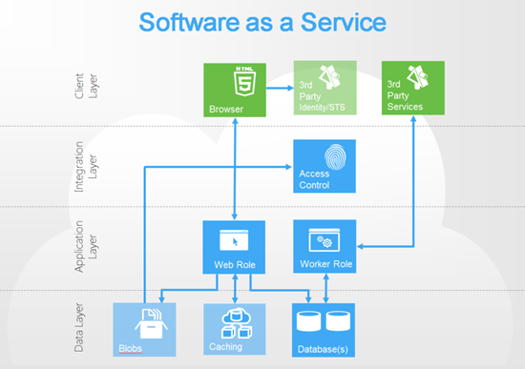

For your business we can not give you an absolute figure while we compare all the running software aspects before deciding which solution is best for you.
Prices can differ widely from an open-source version which provides vendors with the software plus full integration services with support for a price.
You may be looking at an open-source CRM product for example. Even though the basic product is free, you don't get any support or software updates, and you must rely on the community to find patches and bug fixes. If you are very professional, it could be a good option, but many consumers choose to pay for help in order to prevent a lot of headaches.

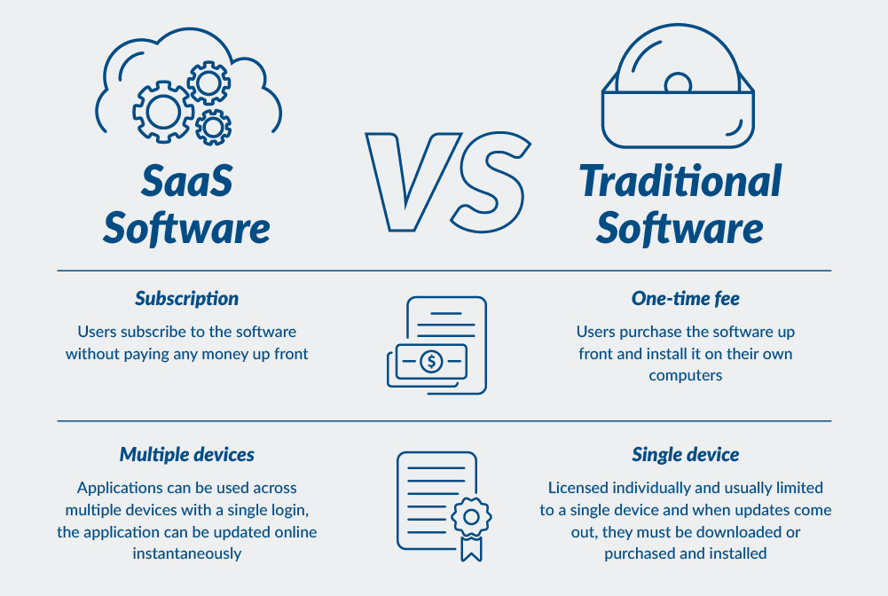
To help London Bikes to make the right choice we are separating Software as a Service on 3 parts.

Packaged software: This is the SaaS market 's biggest sector. They 're built with unique business processes that can be changed by customers. They migrated to the cloud in large numbers, because consumers considered the networks too difficult to handle.
Collaborative software: This is for a software of all kind of services.
Tools for activating and managing: Think about the programming resources developers need to build and design a SaaS platform or think about evaluating, tracking and assessing the needs of a customer and developer.

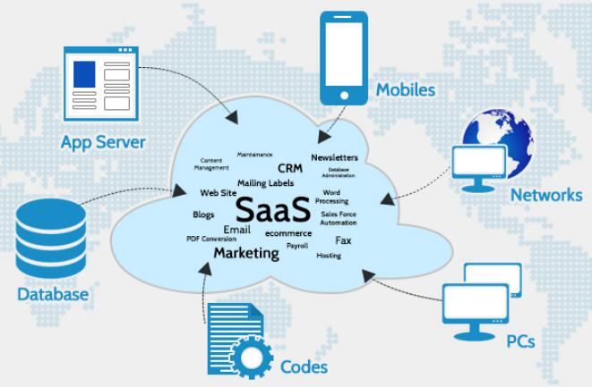

Security as a product. For most of the software there is antivirus programs to secure and check the system. Most of the antivirus protection is with free trial version and after that you have to subscribe to use the full options.
Cloud Computing Security
Cyber-safety - The transition to cloud computing opens up businesses to higher cyber-attack threats. As such the demand for all forms of protection services is expected to increase. Three protection innovations are expected to drive the growth: third - party risk prevention, robotics, and virtual protection.
Increased Security Vulnerabilities
Another result of covering believe boundaries relates to the cloud provider’s to get cloud customer information. The degree to which the information is secure is presently constrained to the security controls and approaches connected by both the cloud buyer and cloud supplier. Moreover, there can be covering believe boundaries from diverse cloud shoppers due to the reality that cloud-based IT assets are commonly shared.
Organisations, as well as cloud service providers, security is a very complex field. A lot of companies would have hybrid systems that have both private and public clouds. Internal systems are wired into cloud environments. Modern boundaries bring uncertainty and risk to this.
When hosted by a third party cloud provider, the geographic location of data and IT resources may be out of the reach of a cloud user. This may raise numerous questions regarding compliance with the laws and regulations.

Cloud storage providers' protection standards commence with the same strategies and technologies as traditional data centres, which requires implementing a strong security network. But physical classification and hardware-based protection between virtual machines can not protect against attacks on the same server. Cloud computing services use the same operating systems as online location computers and physical servers, for software platforms. This means that bugs in certain systems and software can be remotely exploited by an attacker.

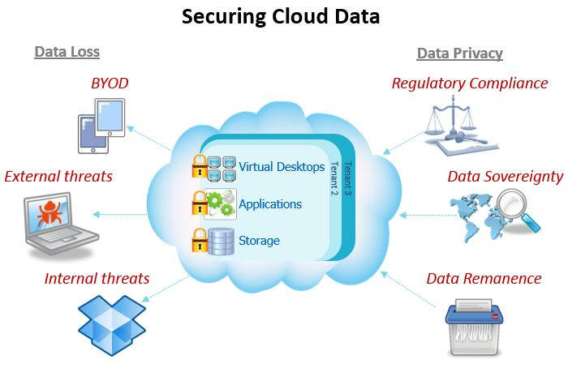

Cloud security is important. But data stored in the cloud could be safer as cloud service providers have superior security policies, and they are experts in security.
Protection fears
A main issue for cloud storage providers is cloud protection. Not only do they have to please their customers, they also have to meet certain regulatory criteria to store confidential data, such as credit card numbers and health records. Third party assessments of the security systems and processes of a cloud provider help ensure data is secure for users.
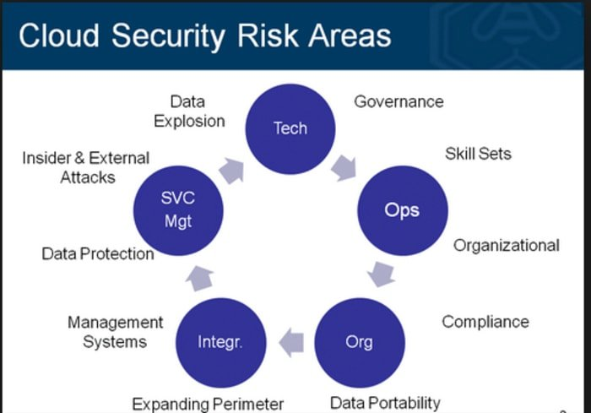

Significant risks to cloud security include data breaches, data loss, hijacking of accounts, hijacking of service traffic, unsafe application programme interfaces (APIs), poor choice of cloud storage providers, and shared infrastructure that could compromise cloud security. (Frankefield, 2020)

Distributed access denial (DDoS ) attacks are yet another challenge to cloud security. These attacks shut down a service by flooding it with data such that users, such as bank accounts or email accounts, can not access their accounts.
CONCLUSION
In addition to these traditional services, cloud computing solutions are far more complex, and are rapidly growing. Popular people use cloud services to store valuable images or videos from their mobile devices. Cloud computing is clearly poised to characterise the future in the next few decades.
Cloud computing has improved the cost-effectiveness of many IT-based companies by maintaining consistency in the infrastructure. Cloud services also allowed companies to expand as they were able to participate in big data analysis and better understand the consumers. Applications for cloud computing, which are implemented correctly, could create a new road for the digital world.

References
Bauer, R. (2018, 04 19). Hybrid Cloud. Retrieved from BackBlaze: https://www.backblaze.com
Bloor, R. (2009). Cloud Computing and Service Management. UK: Wiley.
Chabrow, E. (2011, 10 25). Characteristic of Cloud. Retrieved from InfoRisk: https://www.inforisktoday.com/
Erl, T. (2013). Cloud Computing Concepts,technology and Architecture. In Z. M. Thomas Erl, Cloud Computing Concepts,technology and Architecture (pp. 40-80). United States: Arcitura Education Inc.
Frankefield, J. (2020, 05 07). Cloud Security. Retrieved from Investopedia: https://www.investopedia.com
Judith Hurwitz, R. B. (2010). Cloud Computing for Dummies. USA: Wiley Publishing.
Lund, C. (2019, 08 14). Understanding of Cloud Computing . Retrieved from Techolution: https://techolution.com/

