

UNIVERSITY OF WALES TRINITY SAINT DAVID

MASTER OF BUSINESS ADMINISTRATION (MBA)

Dissertation Proposal

Title: The Impact of F1 Hybrid Engine Technology on Global Sustainability

Submitted by: Vladimir Krasimirov Totev
Student ID: 2024467

Supervisors: Dr. Hoang Nguyen and Vasilios Tavlaridis

Internal Verifier: Dr. Suresh George

Module Code: LCMB7035

Date of Submission: 8th November 2024 by 2PM

Table of Contents

Chapter 1: Introduction 2
Chapter 2: Literature Review 4
2.1 Definition of F1 Hybrid Engine Technology 4
2.2 Characteristics of F1 Hybrid Engines 4
2.3 Importance of F1 Hybrid Engine Technology in Global Sustainability 4
2.4 Models of Sustainability in Automotive Engineering 4
2.5 Theories Related to Technological Innovation and Sustainability 4
2.6 Advantages and Disadvantages of Hybrid Engine Technology in F1 4
2.7 Challenges Associated with F1 Hybrid Engine Technology Adoption 5
Chapter 3: Research Methods and Methodology 5
3.1 Research Philosophy and Justification 5
3.2 Research Paradigm and Justification 5
3.3 Research Approach and Justification 5
3.4 Research Methodology and Justification 5
3.5 Research Strategy and Justification 5
3.6 Sampling Methods and Justification 5
3.7 Data Collection Methods/Tools 5
3.8 Data Interpretation Methods 6
Limitations 6
Ethical Considerations 7
Chapter 4: Conclusion 7

Chapter 1: Introduction

1.1 Overview of the Topic

For years, F1 has operated as an incubator for automotive evolution and deployment saplings of technologies that would at some stage find their way to road cars. There has been a more recent introduction during the last few years, hybrid engine technology linking up traditional ICE powertrains with electric motors to boost performance without hiking emissions or expanding environmental footprints (Moss and Turner 2021; Smith and Patel 2022). This work will study the role of F1 hybrid drive technology to achieve global sustainability and reduce carbon footprints, improve energy efficiency, as well as general consequences on broader sustainability for the automotive industry at a world scale (S. Lehmann, K.M Becker & S Müller 2021).

1.2 Significance of the Topic

The increasing focus on the sustainable nature of development across globally mean that industries, in particular automotive industry have been investing a large amount into modern technologies which are being developed to reduce their environmental impact (Jones and Lewis 2022). The implementation of hybrid engine technology in F1, looking at the case study for high-performance sustainable engineering (Dyer et al., 2020). This is a significant economic advantage for F1 by being at the cutting edge of technology and innovation with global implications, specifically relating to increasing fuel economy and decreasing emissions (Miller & Davis 2021). Considering the new environmental regulations, perhaps F1's sustainability focus on hybrid engines can be replicated in bulk commercial vehicle production to help achieve global sustainability goals and thereby mitigate potential greenhouse gas emissions (Li & Zhang 2020).

1.3 Purpose of the Research

Higher focus on global sustainability has resulted in industries, especially automotive a lot to primp up and introduce the new technologies required for moving towards lower carbon footprint (Jones and Lewis 2022). The development of the electric and combustion engine hybrid powertrains in F1 serves as an example to study (Dean, 2020) another area how high-performance sustainable engineering could be beneficial for society. F1 has long been one of the most innovative industries and so by hybrid technology being an adopted process in F1, its success can spill over to other sectors particularly beneficial for automotive advancement which spans across virtually all economies in terms of fuel efficiency and emissions on a global scale (Miller & Davis 2021). In the face of increasingly stringent environmental regulations, F1's sustainable hybrid engines could almost certainly be adopted by commercial vehicle production to meet global sustainability goals (especially on lowering greenhouse gases) The example here is how an innovation in a passenger car category then spilled onto another and even trainable industry.

1.4 Proposed Aim, Objectives, and Research Questions
Aim:
Researching the potential roles of F1 hybrid engine technology for global environmental conservation, including its capabilities to decrease carbon emissions, and whether it can be applied into consumer-automotive vehicles.
Objectives:
- To analyse the components and technology features in F1 hybrid engine systems
- To assess the carbon-saving mileage abilities of hybrid engines
- To determine the environmental and financial drawbacks associated with hybrid engine technology in commercial vehicles
- To suggest steps to use F1 hybrid technology for the sake of sustainability in automotive industry.
Research Questions:
- What sustainability-related technologies are unique to F1 hybrid engines?
- Why the new hybrid engines in F1 reduce carbon emissions and are more energy efficient than the old ones?
- The environmental and economic challenges of scaling F1 hybrid technology for commercial exploitation.
- What role can F1 play in driving sustainability best practice across the global automotive industry?

Chapter 2: Literature Review

2.1 Definition of F1 Hybrid Engine Technology

F1 hybrid engines are described by including a combination of ICE and electric motors recovering energy during races, notably through systems such as the Energy Recovery System (ERS) or Kinetic Energy Regeneration Systems KERS (Moss & Turner, 2021). They allow for energy to be saved and give a big surge of power, saving on fuel (Dyer, 2020).

2.2 Characteristics of F1 Hybrid Engines

The primary features of an F1 hybrid engine are ability to capture energy from braking (KERS) and thermal energy found in exhaust gases (ERS). Engine technology, using these technologies to improve the energy output as well as reducing both power lose and fuel consumption while driving contributes towards reduced CO2 emissions from high performance vehicles (Lehmann, Becker & Müller. 2021).

2.3 Importance of F1 Hybrid Engine Technology in Global Sustainability

The F1 hybrid engines indicate a transition, albeit profound in helping manufacturers adopt more sustainable technologies towards greener motorsport because historically motor racing is represented as environmentally unfriendly due to the high fuel consumption and emissions (Li & Zhang, 2020). F1 is acknowledging its need to adopt hybrid technology and commitment for decreasing the carbon footprint in line with global ambitions towards sustainability (Jones & Lewis, 2022; Refer Miller & Davis, 2021), highlighting this mandate could be setting a path how each of such automotive industry can turn back.

2.4 Models of Sustainability in Automotive Engineering

Several models, such as the Triple Bottom Line (TBL) and Life Cycle Assessment (LCA), have been used to evaluate the sustainability of automotive technologies (Miller & Davis 2021). These will form the basis for assessing the entire environmental impact, like hybrid engine technology and its translation into mass production automotive (Lehmann et al., 2021).

2.5 Theories Related to Technological Innovation and Sustainability

Theories such as the innovation diffusion theory (Rogers, 2003) and disruptive innovation theories can help us understand how new technologies or innovations explain can change entire industries as hybrid engines might disrupt current ones (Li & Zhang, 2020). (Jones and Lewis, 2022) uses these theories to analyse the potential consequences of F1 hybrid technology for global automotive industry sustainability.

2.6 Advantages and Disadvantages of Hybrid Engine Technology in F1

Though hybrid technology does provide some environmental benefits like lower emissions and better fuel efficiency, it also has its negative aspects. These challenges can be particularly difficult due to high costs of development, complexity in technical design and limitations when implemented into real-world scenarios (Dyer 2020; Jones & Lewis, 2022). This section will analyse into detail the pros & cons.

2.7 Challenges Associated with F1 Hybrid Engine Technology Adoption

Making the current F1 hybrid technology ubiquitous will not be an easy task, though. There are mainly technical restrictions and regulatory roadblocks as well as enormous research-and-development costs (Miller & Davis, 2021). Furthermore, the question of scalability (i.e., whether hybrid technology is transferrable to consumer markets) remains a major hurdle as well (Tomić and Kempton 2021).

Chapter 3: Research Methods and Methodology

3.1 Research Philosophy and Justification

This study follows a pragmatic view, targeting effects in practice and actual applications. To research this, a pragmatist approach is especially suitable because of its combinatory use quantitative methods to study the effect of F1 hybrid engine technology in global sustainability (Creswell & Plano Clark 2017; Morgan: 2014).

3.2 Research Paradigm and Justification

To investigate the complex phenomena of technological innovation and sustainability, a quantitative research paradigm is adopted. The study must explore thoroughly how F1 hybrid engine technology impacts on sustainability and commercialization in the car market which points at use of both quantitative (Bryman, 2015).

3.3 Research Approach and Justification

An inductive research design would be employed to allow patterns and theories from the data outweighing any pre-set hypothesis (Bryman, 2015). This is especially useful in emerging technology research with real-world consequences (Creswell & Plano Clark, 2017).

3.4 Research Methodology and Justification

This approach is encapsulated within a quantitative research study to formally test the sustainability impact and scalability of Formula 1 (F1) hybrid engine technology to the consumer automotive space. Only emphasis on quantitative methods is in line with the purpose of this research: to provide as much objective, measurable information as possible, while for comparing and summarising all quantitative information systematic comparison would be possible only through numerical analysis. This would also work well with the technical nature of the subject, where exact information on fuel efficiency and emissions decrease and energy recovery are needed to assess any possible advantages F1 hybrid technology can provide.

3.5 Research Strategy and Justification

The research strategy will concentrate on F1 hybrid engine technology, to enable thorough analysis of its sustainability concerns. This strategy will offer lessons that can be used for other industries (Yin, 2014). The quantitative data gives a good basis for comparison and the research can evaluate if F1 hybrid technology is saleable to mass-market. This allows the study to quantify potential advantages or disadvantages in factors that affect commercial viability by comparing performance metrics from F1 technology with those typically achieved through conventional consumer hybrid systems.

3.6 Sampling Methods and Justification

This study aims quantitative purposive sampling of secondary data concerning the sustainability consequences of Formula 1 (F1) hybrid engine technology. Purposive sampling is suitable for this study since it can help identify data sources that best inform the specific objectives of evaluating environmental benefits and scalability potential (Bryman 2015). This methodology minimizes inclusion of local technical specifications not directly related to sustainability performance enhancing the valid scope and applicability of findings within the context of F1 technology.

3.7 Data Collection Methods/Tools

Document Analysis:

Technical and Sustainability Documentation: will analyse data from F1 sustainability reports, various F1 technical specifications as well as industrial publications for hybrid engines around emissions decrease, fuel efficiency and energy recovery.

Journal of Automotive and Environmental Research: The studies published will provide automotive benchmark data in comparison of F1 technology with consumer hybrid vehicles on emissions and fuel economy.

Publicly Available Databases:

Automotive and Environmental Databases: Various recognized sources such as the International Council on Clean Transportation (ICCT) and European Environment Agency (EEA) will be used for environment standards, technical performances data.

Comparative Analysis:

Consumer Hybrid Vehicle Data: Data from industry authors will act as a reference point to assess the scalability of F1 technology and performance benefits relative to consumer hybrid systems.

Data Collection Tools

Uniform templates for data extraction: This is going in the right direction as a uniform template will ensure that numbers such as emissions and fuel economy are collected consistently across all stakeholders.

Statistical Software (Excel or SPSS) to organize and analyse data to do comparative analysis and statistical assessments.

All these methods will help in deriving quantitative as well as technical insights to achieve the goals of research (Morgan, 2014).

3.8 Data Interpretation Methods
Key methods to be employed for analysing the quantitative data regarding sustainability and scale of F1 hybrid engine technology are as follows (Bryman, 2015; Field, 2013):

- The descriptive statistics summarize the important metrics such as emissions reduction and fuel efficiency to discern patterns and trends in sustainability impact of F1 technology (Field, 2013).

- Comparative Analysis: Points out that consumer hybrid engine architecture cannot scale up and is losing ground by comparing F1 hybrid technology with consumer engines in terms of both merits and demerits. (Yin, 2014)

- Correlation Analysis: explores the relationships between fuel efficiency and emissions reduction, conservation show the potential environmental benefitsF1 technology (Bryman) 2015.

- Graphical Representation: Visualization of data through charts and graphs that makes complex data easier to interpret and compare (Field, 2013).

This approach provides a transparent, systematic and quantitative assessment of the promise of F1 hybrid technology for sustainable automotive use (Bryman, 2015).

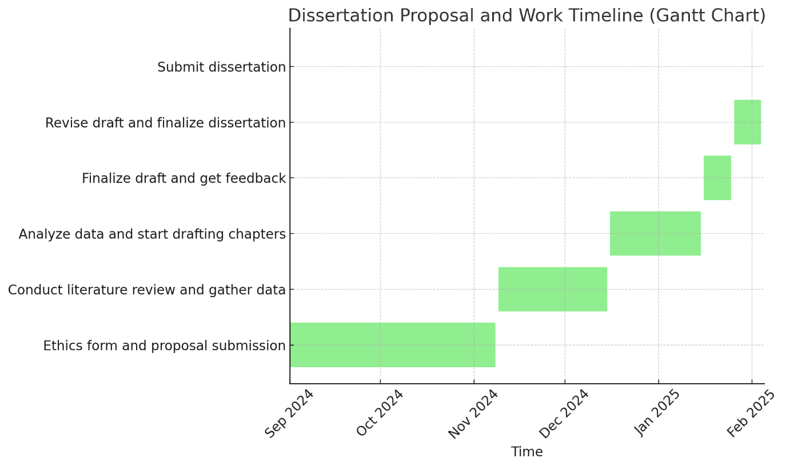

Figure 1: Gantt chart.

Limitations
This research seeks to provide a thorough environmental footprint of F1 hybrid technology on the sustainability worldwide, although it is important to be aware that there are some limitations. This is a multiple-case study that only used one case: The Formula 1, which reduces the external validity of results to other automotive (Yin, 2014) and motorsport industries. The technological advancements in F1 are extremely specific and substantial hurdles may exist for their scaling into consumer markets (Tomić & Kempton, 2021). Additionally, the research is time and resource limited which may curtail examination of downstream environmental (and economic) impacts (Jones & Lewis 2022)

Ethical Considerations
This research project will be focusing mainly on the ethical considerations. All interview participants will provide informed consent and be made aware of the purpose for which their responses are sought, as well as their right to withdraw at any time. Due to the proprietary nature of this information, confidentiality and anonymity will be preserved. In addition, the study will comply with ethical principles of research as determined by its Institutional Review Board (IRB). The data will not be collected until approval from the appropriate ethics committees has been obtained.

Chapter 4: Conclusion
This dissertation shall seek to provide an understanding of what role the technology behind F1 hybrid engines has in global sustainability. Exploring the core elements of F1 hybrid engines and their role in lowering carbon output and the journey it will offer new understanding into how innovative high-performance engineering is influencing sustainable action. These results will demonstrate the possibility of transferring F1 hybrid technology to cars that consumer can buy, answering a key question on an automotive sector path towards lowering its environmental impact.
Additionally, this study will identify the potential of scalability into hybrid from motorsport to automotive and the barrier in terms of opportunities for enabling it. Although F1 has proved that hybrid engines can work effectively in a high-performance setting, the cost and environmental considerations of applying it to mass-market cars will have to be weighed up more carefully. With the high costs of development, technical complexity and regulatory factors that have potential to prohibit execution at mass scale.
To sum up, the thesis aims to underline that F1-Hybrid-Engine Technology is a big step towards sustainability and can be used in more fields than just motorsport. Granted that there are limitations, hurdles to clear and a whole host of other ways in which F1 could be further improved upon but if these areas can be looked at as the first step or signpost along this path then maybe it will mean something more meaningful for global ground transport into longer-term sustainability aspirations. It concludes that this work will be a building block for further study on the downstream effects of hybrid technology in consumer markets and its part to play as automakers seek greater compliance with environmental stewardship. Finally, the potential effectiveness of such technologies could have big consequences on carbon emissions and sustainable development in transport generally.

References.
Bryman, A. (2015) Social Research Methods. 5th ed. Oxford: Oxford University Press.
Creswell, J. W. and Plano Clark, V. L. (2017) Designing and Conducting Mixed Methods Research. Sage.
Dyer, R. (2020) "Technological Advancements in Sustainable Motorsports: A Focus on Hybrid Engine Technology." Automotive Engineering Review, 28(2), pp. 67-82.
Field, A. (2013) Discovering Statistics Using IBM SPSS Statistics. 4th ed. Sage.
Jones, H. and Lewis, P. (2022) "The Evolution of Hybrid Powertrains in Formula 1: Environmental Impacts and Performance Benefits." International Journal of Automotive Technology and Management, 21(1), pp. 25-38.
Lehmann, P., Becker, T., and Müller, J. (2021) "Hybrid Engines in High-Performance Motorsports: Sustainable Development in Motorsport Engineering." Journal of Sustainable Engineering, 12(3), pp. 45-58.
Li, Z. and Zhang, W. (2020) "Energy Efficiency and Environmental Impact of Hybrid Vehicles in High-Performance Motorsports." Journal of Environmental Management, 267, Article 110572.
Miller, R. and Davis, T. (2021) "Assessing the Carbon Footprint of Hybrid Racing Cars: A Life Cycle Perspective." Sustainability Science and Engineering, 19(2), pp. 140-158.
Morgan, D. L. (2014) Integrating Qualitative and Quantitative Methods: A Pragmatic Approach. Sage.
Moss, T. and Turner, L. (2021) Hybrid Power and Sustainability in Motorsports. Oxford University Press.
Saunders, M. (2019) Research Methods for Business Students. 8th ed. Pearson.
Smith, A. and Patel, R. (2022) Technological Innovation in Formula 1: Balancing Performance and Sustainability. Cambridge University Press.
Tomić, J. and Kempton, W. (2021) "Using Fleets of Electric-Drive Vehicles for Grid Support: Economic and Environmental Considerations." Journal of Energy Systems, 36(4), pp. 99-118.
Yin, R. K. (2014) Case Study Research: Design and Methods. 5th ed. Sage.
Bryman, A. (2015) Social Research Methods. 5th ed. Oxford: Oxford University Press.
Field, A. (2013) Discovering Statistics Using IBM SPSS Statistics. 4th ed. London: Sage.
Yin, R.K. (2014) Case Study Research: Design and Methods. 5th ed. London: Sage.

