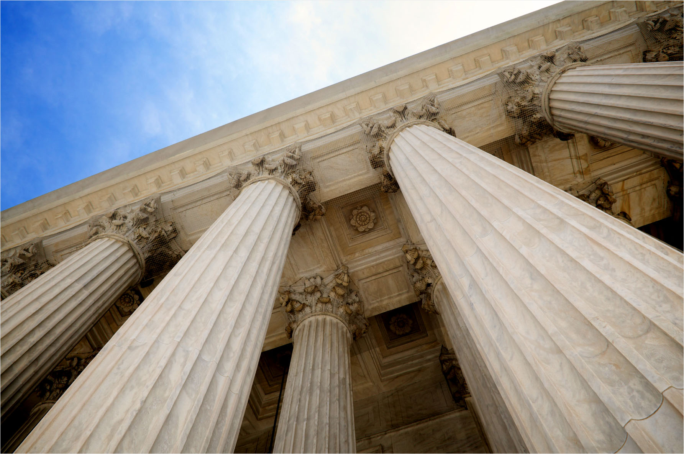

Health, wellbeing and Sustainable Development

Nikole Atkinson 1910236 | BSC Health and social care | BMHP6021
Written report
Robert Nartowski
Content page
Page 3
Introduction
what is sustainable city
what is health
what is wellbeing
Page 4
1.0 Sustainability development goal 3
1.1 Sustainability development goal 3 Strategy 1
Page 5
1.2 Sustainability development goal 3 Programme 1
1.3 Sustainability development goal 3 Evaluation 1
Page 6
1.4 Measuring index
1.5 Sustainability development goal 3 Strategy 2
1.6 Sustainability development goal 3 Programme 2

Page 7
1.7 evaluation and recommendation
2.0 Sustainability development goal 11

Page 8
2.1 Sustainability development goal 11 strategy 1
2.2 Sustainability development goal 11 strategy 1
2.3 Sustainability development goal 11 programme 1

Page 9
2.4 Sustainability development goal 11 strategy 2
2.5 Sustainability development goal 11 programme 2

Page 10
2.6 evaluation and recommendation

3.0 sustainable development goal 17

Page 11
3.0 sustainable development goal 17 strategy 1
3.1 sustainable development goal 17 Programme 1
3..2 sustainable development goal 17 strategy 2
3.3 sustainable development goal 17 programme 2

Page 12
3.4 sustainable development goal 17 starter 2
3.5 evaluation and recommendation

4.0 conclusion

Page 13
4.0 conclusions

Page 14
Reference

Page 15
References

Page 16
Reference

Page 17
Appendix

Introduction
This report will summarise and give definition of SDG (sustainable development goals) health and wellbeing, the focus will be on three main SDG goals SDG 3: Good Health and Wellbeing; SDG 11: Sustainable Cities and Communities; and SDG 17 Partnerships. Two strategies will be included in each of the three SDGs chosen, providing a breakdown of how each goal and programme will be achieved, how they are implemented, and the progress that the UK government has made so far in carrying them out, a critical evaluation will also be included giving recommendations on how to make the UK more sustainable.

Sustainability development
Sustainable development goals, or SDGs, are expressed as developments that take on the requirements of the cause without harming the future. There are 17 sustainable goals, each of which supports the others in some way. Pradhan et al., (2017) suggests that its is “In contrast to conventional growth plans that initially emphasis on a partial number of criteria, the SDGs present a comprehensive and multifaceted concept of improvement Policies and legislation play a big part in the SDG moment such as the Care Act 2014 that works alongside Health, for example a lack of health jeopardises children's right to an education, which is a basic human right and a major determinant of sustainable development and it restricts men's and women's economic opportunities and worsens poverty in communities and nations around the world.
Health
Western treatment was originated in the nineteenth and early twentieth periods on a reductionist definition of wellbeing based on the privation of infections or infirmities and described by physical criteria. According to Leonardi (2018), "the Heliocentric theory revolution came later, as a result of the World Health Organization (WHO), and since then health has been portrayed as a condition of comprehensive physical, mental, and social well-being, not just the non-existence of sickness or indisposition."
Wellbeing
Wellbeing is widely acknowledged that the concept of wellbeing is inextricably linked to both health and quality of life. According to Sfeatcu, Cernuşcă-Miţariu2, and Ionescu, (2014), "there are two dimensions to well-being: a subjective dimension and an objective dimension." This includes an individual's life experience as well as a comparison of their current situation to social norms and values. Well-being is linked to health and vice versa it influences but also benefits from health. Wellbeing also corresponds to the 2014 Care Act. Society's sovereignty and well-being are promoted by the Care Act. According to the Care Act: Assessment and Eligibility, (2022), "local governments obligations is to deliver or classify programmes that help avert people from attaining care and support wants or delay, people from worsening to the point where they would need enduring care and support”.

1.0 Health and wellbeing SDG3
SDG3 Health and wellbeing is protected by the care act (Implementing the Sustainable Development Goals (n.d) Suggest “the local authorities have to Focus their assessment on the individual's desires and how they affect their well-being as well as the outcomes they wish to reach”, not only that but also to conduct an examination of anybody who seems to require care and support, irrespective of their probable entitlement for public-funded care. So, what is SDG3 health and wellbeing? This is one of the 17 Sustainable Development Goals set by the United Nations in 2015, SDG 3, which focuses on "Good Health and Well-Being" does not just focus on health it has many contributing factors such as a person’s physical and mental state, the aim of SDG3 is to focus on healthy lives and promote well-being for all people of all ages. SDG3 includes and focuses on a variety of components of healthy living and lifestyles. SDG3 is endorsed by nine targets that mainly fall into split but corresponding groups, according to Capon et al. (n.d.). Providing universal health coverage, falling transmissible and non-communicable illnesses, plummeting risk factors (tobacco, substance abuse, road traffic injuries, hazardous chemicals, and pollution), and reducing morbidity and mortality for vulnerable groups such as mothers, newborns, the elderly, and children are all part of providing sustainable health.
One of the goals to promote SDG3 is "sexual and reproductive health" (3.7), as stated by Voluntary National Review of Progress Towards the Sustainable Development Goals, (2019), the UK's strategy for managing sexual health is 1. Build your knowledge and resilience. Priorities and prevention 3. Make high-quality services available quickly. 4 Maintain sexual health in accordance with Health promotion for sexual and reproductive health and HIV, (n.d.).
1.1 Strategies
The public health service (PHE) has implemented the following strategies to reduce the rate of sexual infections which has been stated by (Selbie, 2019)
- Reduce the burden of HIV infection by lowering morbidity and mortality rates among those most vulnerable to new infections and reducing late and undiagnosed HIV prevalence within the most disadvantaged communities.
PHE will work with state and local collaborators to increase HIV testing in high-prevalence areas (> 2: 1000) and among HIV-prone populations.
- - Assist in the development and implementation of novel HIV prevention technologies and mediations.
- - Evaluate performance in terms of new HIV diagnoses, CD4 amount at period of HIV identification, HIV testing rates, and condom use.
- (PHE) will accomplish both of its objectives of lowering HIV and STIs.
PHE will: a) contribute to the development and implementation of novel HIV prevention technologies and involvements; and b) assess implementation through surveillance and exposure of new HIV diagnoses, CD4 amount at the point of HIV diagnosis, HIV testing rates, and condom use.
- - PHE will achieve both of its HIV and STI reduction goals by encouraging safer sexual behaviours and risk-reduction techniques such as regular condom use.

1.2 Programmes
One of the programmes in place to support the SDG3 Strategy, and they are as follows.
Sexwise is a sexual health and reproductive health information programme that aims to deliver strong, balanced, and up-to-date information to the general public and healthcare experts in order to encourage informed sexual health choices and healthier sexual behaviour. In 2017, Public Health England launched the Protect Against STIs, use a Condom sexual health campaign to encourage condom use among young adults aged 16 to 24 years in order to reduce STI rates. Its goal is to improve perception about the serious concerns of STIs while also normalising and encouraging the use of condoms. Examine the various campaign advertisements and images.
UK Government have stated that the progress that has been made so far Health Secretary announces goal to end HIV transmissions by 2030, (2019) From 2013 to 2017, HIV testing in sexual health services in England grew by 15%. HIV testing is a crucial aspect of putting a stop to the epidemic. It reduces the proportion of HIV-positive people who are unaware of their infection and may spread the virus. Work to end HIV is also being done outside of the UK. The government has contributed £1.2 billion to the Global Fund to combat AIDS, tuberculosis, and malaria, and UK Aid is increasing access to life-saving HIV treatment.

1.3 Evaluation and recommendation
As you can see from the strategy that they are attempting to implement above, they are only attempting to manage the short-term methods, which is the here and now, rather than attempting to implement strategies for those who are and will be suffering from long-term effects. Those struggling with HIV are more likely to endure long-term medical complications as they grow older (co-morbidities). Services that deliver critical illnesses associated with substantial immunosuppression should start working in partnership with GPs, nursing homes, and others to provide long-term disease management. The demographic shift is clear, and HIV services must become a part of today's broader approaches to caring for people with chronic illnesses. Yes, even though prevention is better than cure and installing HIV and STis programmes is a wonderful indicator, ensuring they are in the correct geographical areas (impoverished, limited NHS resources) will help this plan become sustainable. Looking at the programmes that they have put into the sdg3, such as sexwise, as shown in Appendix 1.1, there are around 12 clinics in Birmingham, which does not appear to be enough hubs in relation to the Birmingham population, According to Cassell (2003), “even though there are fewer interactions with sexual health clinics, STD's (sexual transmitted diseases) are still on the rise, with "more than 1 million STIs acquired every day." WHO estimates 374 million new infections in 2020, implying that current programmes are not as effective as they should be and a better support system needs to be implemented. Hubs like Umbrella are overworked because all appointments must be booked via them this was to help lessen the burden on primary care system but in result have put pressure on the healthcare system so was this a sustainable plan? The limitation of this is that people may not be comfortable going beyond reluctant to do so To make this a more sustainable outcome I recommend that they Implement a wider range of hubs targeting those areas that it is effected the most, I also feel that they should intergrade this with technology such as advertising, booking through apps, social media and create more awareness to society, also put in interventions for long term care.

1.4 How it is measured
SDG3 indicators can be measured with The Human Development Index (HDI) is a summary assessment of average accomplishment in important areas of human development Nations, (2022) brings forward that this may include living a long and healthy life, being knowledgeable, and having a good standard of living. The HDI is the geometric mean of the normalised indices for each dimension. The health dimension is measured by life expectancy at birth, while the education dimension is measured by the average number of years of schooling for individuals aged 25 and up, as well as the predicted number of years of schooling for school-age children. See appendix 1.2
Another indicator that the UK has implemented in relation to the SDG3 health and wellbeing is 3.5. Strengthen substance abuse prevention and treatment, particularly narcotic drug abuse and hazardous alcohol use; their main goals are to reduce this by: Demand reduction, A dedicated resource for drugs and alcohol, and a tailored approach to vulnerable groups’
  - Strategies
Regulating alcoholic beverage marketing particularly to young people, restraining and limiting alcohol accessibility, adopting suitable drink -driving policies, lowering demand via taxation and pricing methods; Direct alcohol tax income to preventative health activities (with a focus on alcohol-related harm) and alcohol and other drug treatment programmes are strategies that have been and will be implemented in the UK to support SDG3 Provided by WHO, (2022), NATIONAL ALCOHOL STRATEGY, (2019) includes that "the Approach also represents Australia's assistance to the World Health Organisation's Global Direction to Decrease Damaging Use of Alcohol" including strong alignment between this Strategy's overarching aim, goals, and strategic initiatives and the Global Strategy's aspirations and intervention regions corresponding to the United Nations 2030 Agenda for Sustainable Development Goals.
Levitation awareness of public health difficulties instigated by damaging use of alcohol and guaranteeing provision for actual alcohol policies, delivering available and inexpensive action for people with alcohol-use conditions; and applying transmission and rapid-lived intercessions programmes for dangerous and harmful drinking in health services are also apart of the UK’S strategy to strengthen drug and abuse prevention.
1.6 Programmes
Aquarius is a Birmingham-based charity dedicated to assisting individuals, families, and communities who have been negatively impacted by the adverse impacts of alcohol, drugs, and gambling. In addition to treatment, family support, education, and training, Aquarius undertakes research on best practises and what works successfully.
Swanswell is a non-profit trust that is a pioneer in providing community-based services. Swanswell offers several services to assist people, their families, caregivers, and 'affected others' in dealing with drug and/or alcohol issues.
The Norman Imlah Day Centre is for people who require long-term alcohol treatment and support. The centre, which is in Birmingham's Duddeston neighbourhood, offers a variety of therapy interventions in an alcohol-free setting, with a particular emphasis on relapse prevention work.

1.7 Evaluation and recommendation
The strategies that have been put in place such as taxes for alcohol misuses is a good idea rises in alcohol taxes are used as a public health policy measure to discourage excessive drinking and the social ills associated with it. Wilson et al., (2021) puts forward that “In over a hundred research worldwide, tax and price hikes have been found to be effective in lowering alcohol consumption and alcohol-related problems.” Having proven facts that this will have a positive impact on the long-term effects on society will help towards a promising sustainable future. UK programmes have also been effective, such as BAADT (Birmingham alcohol and drugs team), which created a wider network to support those with substance misuse. Not only do these agencies support the individuals, but they also help their families. Despite the proven success of these programmes, there are many limitations, which include social determinants that may influence alcohol consumption, which has the potential to result in homelessness, a reaction to homelessness, or a reaction to homelessness. "Individuals dealing with AUD and precarious housing are vulnerable to a multitude of acute consequences." "This may include excessive alcohol consumption and seizures; chronic health illnesses such as liver disease and cancer; premature death; poor mental health; assault and injury; and, almost always, social exclusion." Interventions that include the social aspects will have a better impact on society and this should also assist in maintaining and obtaining housing, as well as teaching life skills so they are secure and have a long-term positive outcome.
2.0 Sustainable cities SDG11
The goal of SDG11 is to make cities and human settlements more inclusive, safe, resilient, and sustainable. Cities in the UK and their partners believe that problems can be solved in ways that support their growth and development while maximising resource efficiency, lowering pollution levels, and alleviating poverty. Future cities of opportunity will give access to critical services such as energy, housing, transportation, and other essentials. Vaidya and Chatterji, (2019) imposes that SDG11 is not only to attain long-term development goals, but also to provide real, tangible improvements to people's quality of life. As more people move to cities, the world is steadily becoming more urban. "Cities contain 55 percent of the world's population, cause 85 percent of global GDP, but also account for 75 percent of greenhouse gas emissions." This suggests that global sustainability challenges cannot be addressed without a clear focus on urban sustainability.
2.1 Strategies
One of the indicators for SDG11 is for the UK to achieve net zero greenhouse gas emissions by 2050. To assist sustainable cities and reduce emissions consumption, Birmingham council has established a clean air zone, the objective of which is described by (Scotford, 2020) "A Clean Air Zone is a location where targeted achievement is engaged to expand air quality, specifically by disheartening polluting vehicles from inflowing the zone." No cars are prohibited in the zone, however individuals who do not have good engines must pay a daily fee if they enter there.
Around £500 million will be connected to the UK-wide Clean Air Strategy to assist the growth of regional plans, some of which consist of the implementation of Clean Air Charges. As of April 2019, 12 local plans have been approved in England and £200 million of funding disbursed (Stewart, 2019)
An additional £620 million has been committed to help with the change to plug-in vehicles.
The funding will go toward charging infrastructure development, with a particular emphasis on local on-street residential charging and targeted plug-in vehicle grants.
• Establish a globally economical nil-emission vehicle supply chain to ensure our success. The automotive industry is at the forefront of the net zero transition.

• Set a good example by making 25% of the government car task force ultra-low emission by December 2022, the entire government car and van fleet will be zero-emissions.

• Take steps to increase average road vehicle occupancy by 2030 while decreasing emissions.

The government has stated that Birmingham need a Clean Air Zone and that NO2 levels in the air must be reduced to a maximum average of 40g/m3 as soon as practicable. Once we attain that goal, we want to keep lowering the amount of NO2 and particulate matter in the air as much as possible.
2.2 Programmes
The Birmingham City Council's Air Quality management Zone Vehicle Scrappage and Travel Credit Scheme has been formally launched. The £10 million scheme aims to give people earning less than £30,000 per year who work in the Clean Air Zone the option of discarding a car that would otherwise be subject to the daily levy. Qualified candidates receive a £2,000 payout in exchange for scrapping a vehicle, which can be used as a "travel credit" or to purchase a vehicle that meets the Clean Air Zone pollution criteria. Green Paper on a New Road Vehicle CO2 Emissions Regulatory Framework for the United Kingdom, (2021), states that "we have made out our plan to phase out the sale of new petrol and diesel cars and vans by 2030, and for all new cars and vans to be 100% zero emission at the tailpipe by 2035".
According to (Selbie, 2019), the UK has effectively created beneficial, ecologically sociable cities, which is a priority across the country. Since 2010, air quality has improved: by 2017, sulphur dioxide emissions have decreased by 62%, nitrogen oxide by 29%, and PM2.5 (fine .particulate matter) by 10%. 375 The initiatives outlined in the UK-wide Clean Air Strategy are expected to reduce the cost of air pollution by £1.7 billion per year by 2020, rising to £5.3 billion per year by 2030.

2.3 Evaluation
The clean air zone is one of the sdg11 initiatives and programmes in place for sustainable cities. In my opinion, clean air zones can be advantageous because they immediately operate as a deterrent for many non-essential journeys, resulting in some cars avoiding big regions with high emissions and significant build-up. This could help to minimise congestion in city centres and make public transportation more efficient, but on the other hand it is not a feasible strategy since certain cars from a specific year are not permitted to enter the clean air zone without incurring costs. People who need to commute to work, I believe, will continue to enter this zone. Cities having CAZs (clean air zones) may find that the restrictions imposed aggravate their pollution problem. Many travellers and transportation businesses may use alternate routes to avoid paying the higher tariffs, accruing more miles and increasing pollution in the process. Discouragement of motorists from the area is likely to influence the situation elsewhere in the zone, increasing out-of-city traffic as well as fuel consumption due to the additional miles driven to avoid the CAZ. Looking into this and its limitations, it will cause more pollution in deprived areas, causing ill health in those areas that already struggle with health care, causing more issues for those who are already struggling, even though this programme has its disadvantages to this idea I feel that they should create a more realistic approach and what I mean by this scale of weening out older modelled cars, ensuring car manufactures are following the UK emission guidelines and are involved in sustainable development, having better transportation making it safer and cleaner so society feel more comfortable in catching public transport.
2.4 Sdg3 11 sustainable cities strategy
They have imposed the following indication in support of SDG 11: they intend to provide more, higher-quality, safer, greener, and more affordable housing. According to (Jenrick and Pocklington, 2021) is "that by the end of this Parliament, the UK will have ended poverty and homelessness, building on the amazing advances made during the epidemic to protect society's most vulnerable segment." In addition, the UK will spend more than £750 million this year to address homelessness and rough sleeping, building on more than £700 million invested in 2020–21. We will boost our efforts to prevent homelessness by providing assistance to local governments through the Homelessness Prevention Grant. We will continue to grow the flagship Rough Sleeping Initiative driving down rough sleeping in local communities, allowing local partners to help those in need get off the streets
So far, the UK has said by Wilcox, S, Perry, J, Stephens, M & Williams, P (2016) "In 2017-18, England added 222,190 new dwellings, including 19,290 new buildings, a 17 percent increase over 2015/16.377." This takes the total number of extra homes completed since April 2015 to more than 629,000, putting the country on track to reach ambitions of delivering a million homes by the end of 2020" they also hope to build another half a million by the end of 2022. A number of measures are being introduced and developed to enable England to build an unprecedented 300,000 new homes per year by the mid-2020s.
2.5 Programmes
Birmingham Municipal Housing Trust (BMHT) is in charge of creating affordable social housing in the city. Under the current initiative, the BMHT Building Specification for new construction includes energy and water-saving measures, and the BMHT is also studying options for utilising more sustainable construction methods to reduce environmental effects. (n.d., climate emergency) It is also developing long-term housing, such as wheelchair-accessible housing There is currently no planning policy requirement in the Emerging Core Strategy for market housing developers to build houses specifically designed for people who use wheelchairs or that can be readily modified for wheelchair usage, as well as life satisfaction.
A pleasant living environment is essential for developing sustainable communities where people want to live. In their design and access statement, developers must describe how they adhered to excellent urban design principles. The Council has set great urban design criteria that developers must implement into their buildings Places for the Future - Detailed SPD Guidance, (2012):
• Locating mixed-use developments in areas with good accessibility
• Connecting the development to existing route networks - for further details, see layout and design and sense of place.
• Creating environments that are simple to understand, safe, and accessible - for additional information, see layout and design, sense of place, and ‘safe and secure communities.'
2.6 Evaluation
The strategies that have been put in place creating more funding to support the rising populations is a start to helping to create a more sustainable city, the only thing is with aging populations I feel that funding should also be invested in the social aspects of things such as care homes making them more appealing for the older generations, investing into programmes such as life long homes will help more families stay in their family homes as it will facilitate all their need for now and the future but with the growing population will it help manage the process of families waiting for homes, or can this balance the number of homes needed, I feel the UK government should start with the basic understanding of homelessness. Does the statistics include all homelessness or only what is considered to be homelessness people still in temporary accommodations the growing population and those also living on the streets is this include in their financial investments, can the government create all these homes without effecting the plans that are required for more green space which is also apart the SDG11 sustainable plans Inside this global scenario, (Bailey, 2020) states the case of London and the United Kingdom is symptomatic: one in every three low-rent homes is unhealthy, and renters spend an average of 41 percent of their earnings on rent. In 2017, there were 1,155,285 households on social housing waiting lists in English local councils. A national borrowing cap and the national Right-to-Buy scheme have reduced councils' ability to provide social housing significantly: out of 326 UK local authorities, 166 have sold off their social housing assets, so I think that’s starting from the bottom will then provide the right figures and strengthening Policies and programmes aimed at avoiding homelessness must be inventive and adaptable. One of the consequences of the more sophisticated conception of homelessness is that interventions to homelessness must consider the diversity of a relevant target group. Good practise programmes and policies are those that respond effectively and sufficiently to a homeless population that we now know is not homogeneous. Good practise policies and programmes combine preventive, early involvement, disaster intervention, and long-term support techniques to promote independence. Minnery and Greenhalgh, (2007)

3.0 Partnership SDG17
SDG 17: Partnerships aims to "revitalise the global collaboration for sustainable development." It is an overarching aim to publicise partnership engagements as a means of achieving the other 16 goals of the 2030 Agenda. This aim recognises that the 2030 Agenda will be unreachable without global, geographic, governmental, and regional collaborations. levels' Terzakis and Klei, (n.d.).
AAAA agender is an agenda that has been put in place by the United Nations to support the Sustainable Development Goals 17 The Addis Ababa Action Agenda (AAAA) of the recently settled Third International Conference on Financing for Development (Addis Ababa, 13-16 July 2015) acknowledges that “together community and isolated investment consume key roles to play in organisation funding, contained through public private partnerships (ppp’s) (Jomo, K.S., Chowdhury, A., Sharma, K. and Platz, D., (2016)

3.1 Strategies
The approach to trade of the Department of International Development will be centred on poverty reduction. The United Kingdom's (UK) exit from the European Union (EU) presents a once-in-a-lifetime chance to put together a complete package combining UK trade policy, aid to remove trade obstacles, and venture capital campaign to alleviate poverty. We will assist partner countries in making the most of global trade talks in order to profit from trade access and decrease trade expenses Economic Progress Strategy: prosperity, poverty and meeting global challenges, (2017). DFID will employ Development Capital to create jobs, catalyse private region investment, and construct markets in difficult environments. Extended-term persistent capital can demonstrate the financial sustainability of financing in the world's deprived countries, lowering private investors' costs and risk. As a result, DFID-supported investments can attract multiples of the funds invested.
3.2 Programme
The Nicaraguan Network of Community Commerce (RENICC) is a national network comprising 62 organisations, including cooperatives, networks of rural women and female entrepreneurs, consumer networks, and non-governmental organisations (NGOs) focused on agriculture and crafts.RENICC seeks to generate political and economic lobbying opportunities in order to advocate the passage of legislation and the incorporation of alternative commercialization channels into public policy Schiller, K., Godek, W., Klerkx, L. and Poortvliet, P.M., (2020).
3.3 Strategy
Improving North-South, South-South, and triangular local and world-wide collaboration on and admission to science, technology, and revolution, as well as acquaintance division on equally agreed footings, with improved coordination among existing mechanisms, particularly at the UN level, and through a global technology facilitation mechanism.
Promoting the development, transfer, dissemination, and diffusion of environmentally sound technologies to developing nations on advantageous terms, including rebates and special consideration as discussed and agreed upon.
The technology bank and the capacity-building mechanism for LDCs in science, technology, and innovation will be fully operational by 2017, and the use of enabling technology, notably information and communications technology, will be enhanced.
3.4 Programme
The Blue Belt Programme is implementing monitoring equipment and conducting systematic fieldwork around Pitcairn Island in order to gain a better understanding of these unique marine ecosystems. Whomersley, P., Clingham, E., Collins, M.A., Feary, D.A., Weber, S.B., Bell, J. and Stockill, J. eds., (2022). “The information gathered during these voyages will eventually help the Pitcairn community protect these aquatic habitats. Photographer: Luke Hosty for Protect Blue”. In order to create future economic, security, and technical ties, we will continue to prioritise shared global issues in our approach to low- and middle-income countries: as a accountable transnational actor and a trusted strategic partner. We will translate our unprecedented global leadership at COP26 and throughout the COVID-19 epidemic into long-term progress for our friends and partners, as well as the British people. In addition, under the Prime Minister's Clean Green Initiative, we will collaborate with low-income communities.
compensation for adjustment costs associated with multilateral (and indeed regional) trade liberalisation (IMF and World Bank, 2005).
In response to these concerns, the WTO Ministerial Meeting in Hong Kong in December 2005 called on donors to increase Aid for Trade resources to "assist developing countries, particularly LDCs, in building the supply-side capacity and trade-related infrastructure that they require to assist them in implementing and benefiting from WTO Agreements and, more broadly, to expand their trade.
3.5 Evaluation
the two strategies that have been imposed by the UK and their partners in relation to the SDG17 examining the financial aspect I think that with the pandemic it set aside financial difficulties for the world financially, socially and economically Mwoka et al., (2021) suggests that “The COVID-19 pandemic has highlighted the significance of adequate housing for people's health and well-being. populations. Lockdowns, curfews, and mandatory restrictions were implemented to varying degrees around the world at the start of the crisis, disproportionately impact low-income and already vulnerable populations” . Not only do some of these populations face homelessness, financial difficulties in paying rent, and insecure tenure, but they are also hampered by a lack of safe, dependable water, sanitation, and adequate space to comply with COVID-19 safety precautions. Homeless people are especially vulnerable access to basic facilities such as healthcare and sanitation, as well as existing comorbidities such as chronic mental and physical conditions worldwide, the governments are trying build back up their economy Debt risks are rising, creating fears of a new round of debt crises and economic turmoil. Developing nations are under pressure to increase public investments in the SDGs at a time when restrictions on further debt funding are set to tighten, so I do not know how sustainable their imposed strategies are, having a plan in actions is recommended this is to see how much damage covid 19 has done globally financially economically and socially, ensuring that they have enough resources to accommodate regionally and globally.

4.0 Conclusion
Looking at SDGs 3, 11, and 17, you can see that there are efforts to make the UK and the world more sustainable. They have implemented good ideas and strategies such as long-life homes, sexual health programmes, and other plans to help with health, poverty, and partnerships. However, even though plans have been in place for a few years, not much has been done, and due to COVID-19, which put a halt to the world, targets have not been met, which has slowed down the implementations. of these initiatives, which are already moving slowly I also believe that, while their overarching goals and intentions may make the world a better place, doing so has to be more realistic to society, with more community input from those who are really living through it and better timeframes. The United Kingdom should also consider the expanding population and long-term strategies to accommodate it. SDG17 partnerships programmes are effective as everyone worldwide deserves social justice but I feel that limited supply and resources will also hinder the progress in making this sustainable, trying to implement financial strategies were countries are already struggling will result in recessions and other social aspects

References

- Assets.publishing.service.gov.uk. (2017). Economic Development Strategy: prosperity, poverty and meeting global challenges. [online] Available at: <https://assets.publishing.service.gov.uk/government/uploads/system/uploads/attachment_data/file/587374/DFID-Economic-Development-Strategy-2017.pdf> [Accessed 1 August 2022].
- Bailey, N., (2020). Poverty and the re-growth of private renting in the UK, 1994-2018. PLOS ONE, [online] 15(2), p.e0228273. Available at: <https://journals.plos.org/plosone/article?id=10.1371/journal.pone.0228273> [Accessed 29 July 2022].
- Birmingham city council. (n.d). climate emergencies. [online] Available at: <https://www.birmingham.gov.uk/info/20015/environment/2026/climate_emergency/7> [Accessed 28 July 2022].
- Capon, A., Howden-Chapman, P., Siri, J., Chisholm, E., Chapman, R. and Doll, C., (n.d). SDG 3 good health and wellbeing. [ebook] council science, p.84. Available at: <https://council.science/wp-content/uploads/2017/03/SDGs-interactions-3-healthy-lives.pdf> [Accessed 4 July 2022].
- Carver, H., Parkes, T., Browne, T., Matheson, C. and Pauly, B., (2020)
- . Investigating the need for alcohol harm reduction and managed alcohol programs for people experiencing homelessness and alcohol use disorders in Scotland. Drug and Alcohol Review, [online] 40(2), pp.220-230. Available at: <https://onlinelibrary.wiley.com/doi/full/10.1111/dar.13178> [Accessed 27 July 2022].
- Cassell, J., (2003). Treating sexually transmitted infections in primary care: a missed opportunity?. Sexually Transmitted Infections, [online] 79(2), pp.134-136. Available at: <https://sti.bmj.com/content/79/2/134>
- GOV.UK. (2019). Health Secretary announces goal to end HIV transmissions by 2030. [online] Available at: <https://www.gov.uk/government/news/health-secretary-announces-goal-to-end-hiv-transmissions-by-2030> [Accessed 4 August 2022].
- GOV.UK. (2022). Implementing the Sustainable Development Goals. [online] Available at: <https://www.gov.uk/government/publications/implementing-the-sustainable-development-goals/implementing-the-sustainable-development-goals--2> [Accessed 24 July 2022].
- Jenrick, R. and Pocklington, J., (2021). MHCLG Outcome Delivery Plan: 2021 to 2022. [online] GOV.UK. Available at: <https://www.gov.uk/government/publications/ministry-of-housing-communities-and-local-government-outcome-delivery-plan/mhclg-outcome-delivery-plan-2021-to-2022> [Accessed 30 July 2022].
- Leonardi, F., (2018). The Definition of Health: Towards New Perspectives. International Journal of Health Services, [online] 48(4), pp.735-748. Available at: <https://journals.sagepub.com/doi/full/10.1177/0020731418782653 [Accessed 4 July 2022].
- Jomo, K.S., Chowdhury, A., Sharma, K. and Platz, D., (2016). Public-private partnerships and the 2030 Agenda for Sustainable Development: fit for purpose?.
- Minnery, J. and Greenhalgh, E., (2007). Approaches to Homelessness Policy in Europe, the United States, and Australia. Journal of Social Issues, [online] 63(3), pp.641-655. Available at: <https://spssi.onlinelibrary.wiley.com/doi/epdf/10.1111/j.1540-4560.2007.00528.x> [Accessed 2 August 2022].
- Mwoka, M., Biermann, O., Ettman, C., Abdalla, S., Ambuko, J., Pearson, M., Rashid, S., Zeinali, Z., Galea, S., Valladares, L. and Mberu, B., (2021). Housing as a Social Determinant of Health: Evidence from Singapore, the UK, and Kenya: the 3-D Commission. Journal of Urban Health, [online] 98(S1), pp.15-30. Available at: <https://link.springer.com/content/pdf/10.1007/s11524-021-00557-8.pdf> [Accessed 29 July 2022].
- Nations, U., (2022). Human Development Index. [online] Hdr.undp.org. Available at: <https://hdr.undp.org/data-center/human-development-index#/indicies/HDI> [Accessed 12 July 2022].
- (n.d). Health promotion for sexual and reproductive health and HIV. [ebook] UK: PHE, p.`4. Available at: <https://assets.publishing.service.gov.uk/government/uploads/system/uploads/attachment_data/file/488090/SRHandHIVStrategicPlan_211215.pdf> [Accessed 25 July 2022].
- Nhs.uk. (2022). Sexual health clinics near Birmingham - NHS. [online] Available at: <https://www.nhs.uk/service-search/sexual-health/find-a-sexual-health-clinic/results/Birmingham?postcode=Birmingham> [Accessed 27 July 2022].
- Our World in Data. (n.d). Goal 11: Sustainable Cities and Communities - SDG Tracker. [online] Available at: <https://sdg-tracker.org/cities> [Accessed 8 July 2022].
- Pradhan, P., Costa, L., Rybski, D., Lucht, W. and Kropp, J., (2017). A Systematic Study of Sustainable Development Goal (SDG) Interactions. Earth's Future, [online] 5(11), pp.1169-1179. Available at: <https://agupubs.onlinelibrary.wiley.com/doi/full/10.1002/2017EF000632>.
- Schiller, K., Godek, W., Klerkx, L. and Poortvliet, P.M., (2020). Nicaragua’s agroecological transition: Transformation or reconfiguration of the agri-food regime?. Agroecology and Sustainable Food Systems, 44(5), pp.611-628.
- Stewart, R., (2019). Voluntary National Review of progress towards the Sustainable Development Goals. [ebook] UK: hm government, p.141. Available at: <https://assets.publishing.service.gov.uk/government/uploads/system/uploads/attachment_data/file/818212/UKVNR-web-accessible1.pdf> [Accessed 27 July 2022].
- Selbie, D., (2019). PHE Strategy 2020-25. [ebook] LONDON: Public Health England, pp.20-21. Available at: <https://assets.publishing.service.gov.uk/government/uploads/system/uploads/attachment_data/file/831562/PHE_Strategy_2020-25.pdf> [Accessed 1 August 2022].
- Scie.org.uk. (2022). The Care Act: Assessment and eligibility. [online] Available at: <https://www.scie.org.uk/care-act-2014/assessment-and-eligibility/> [Accessed 25 July 2022].
- Scotford, E., (2020). Rethinking Clean Air: Air Quality Law and COVID-19. Journal of Environmental Law, [online] 32(3), pp.349-353. Available at: <https://academic.oup.com/jel/article/32/3/349/5989812> [Accessed 2 August 2022].
- Sfeatcu, R., Cernuşcă-Miţariu2, M. and Ionescu, C., (2014). THE CONCEPT OF WELLBEING IN RELATION TO HEALTH AND QUALITY OF LIFE. [online] Ejst.tuiasi.ro. Available at: <http://www.ejst.tuiasi.ro/Files/46/12_Sfeatcu%20et%20al.pdf>.
- Terzakis, K. and Klei, D., (n.d). sustainable development goal. [online] Sustainabledevelopment.un.org. Available at: <https://sustainabledevelopment.un.org/content/documents/211617%20Goals%2017%20Partnerships.pdf> [Accessed 1 August 2022].
- Who.int. (2022). Target 3.5: Strengthen the prevention and treatment of substance abuse, including narcotic drug abuse and harmful use of alcohol. [online] Available at: <https://www.who.int/data/gho/data/themes/topics/topic-details/GHO/target-3-5-strengthen-the-prevention-and-treatment-of-substance-abuse-including-narcotic-drug-abuse-and-harmful-use-of-alcohol> [Accessed 27 July 2022].
- Vaidya, H. and Chatterji, T., 2019. SDG 11 Sustainable Cities and Communities. Science for Sustainable Societies, [online] pp.173-185. Available at: <https://link.springer.com/chapter/10.1007/978-981-32-9927-6_12#citeas> [Accessed 2 August 2022].
- Who.int. (2022). 10 areas governments could work with to reduce the harmful use of alcohol. [online] Available at: <https://www.who.int/news-room/feature-stories/detail/10-areas-for-national-action-on-alcohol> [Accessed 27 July 2022].
- Wilson, L., Pryce, R., Angus, C., Hiscock, R., Brennan, A. and Gillespie, D., (2021). The effect of alcohol tax changes on retail prices: how do on-trade alcohol retailers pass through tax changes to consumers?. The European Journal of Health Economics, [online] 22(3), pp.381-392. Available at: <https://link.springer.com/article/10.1007/s10198-020-01261-1> [Accessed 1 August 2022].
- Wilcox, S, Perry, J, Stephens, M & Williams, P 2016, UK Housing Review (2016) Briefing Paper. Chartered Institute of Housing pp.7
- Whomersley, P., Clingham, E., Collins, M.A., Feary, D.A., Weber, S.B., Bell, J. and Stockill, J. eds., 2022. Working towards a blue future: Promoting sustainability, environmental protection and marine management: Examples from the UK Government Blue Belt Programme and current international initiatives. Frontiers Media SA.
- (2012). Places for the Future - Detailed SPD Guidance. [online] Available at: <https://www.birmingham.gov.uk/download/downloads/id/941/places_for_the_future_draft_detailed_policy_guidance.pdf> [Accessed 2 August 2022].
- (2019). Voluntary National Review of progress towards the Sustainable Development Goals. [ebook] united kingdom: Hm government, p.60. Available at: <https://assets.publishing.service.gov.uk/government/uploads/system/uploads/attachment_data/file/818212/UKVNR-web-accessible1.pdf> [Accessed 25 July 2022].
- (2021). Green Paper on a New Road Vehicle CO2 Emissions Regulatory Framework for the United Kingdom. [ebook] UK: Department of transport, p.10. Available at: <https://assets.publishing.service.gov.uk/government/uploads/system/uploads/attachment_data/file/1007466/green-paper-on-a-new-road-vehicle-CO2-emissions-regulatory-framework-for-the-United-Kingdom-web-version.pdf> [Accessed 28 July 2022].

Appendix
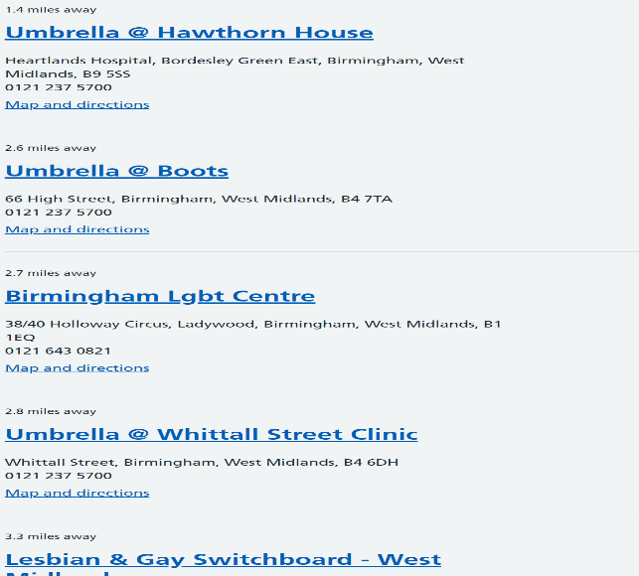
1.1 (Sexual health clinics near Birmingham - NHS, 2022)

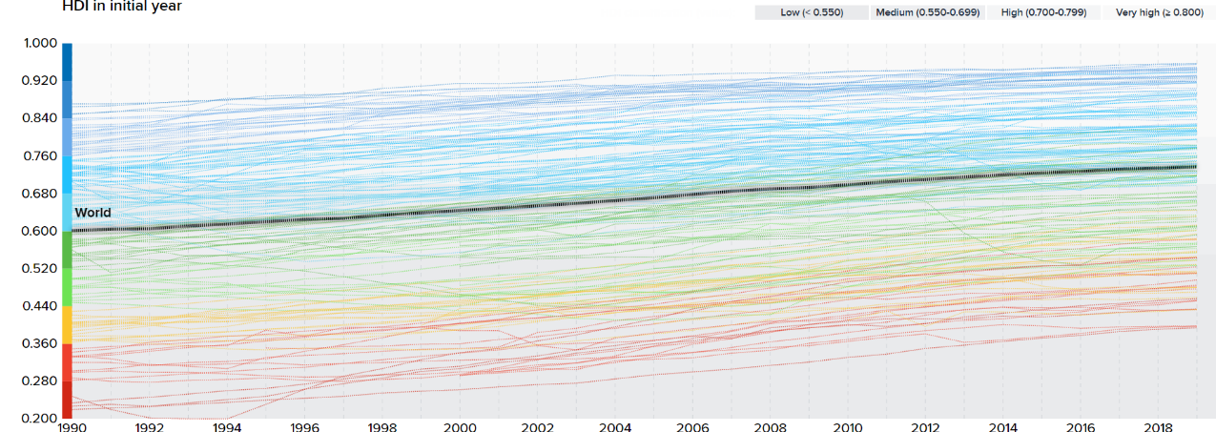
(Nations, 2022) h

