University of Wales Trinity St David

Investigation into Resonant Circuits

ACDB4002 – Engineering Science 1

BEng Energy & Environment Engineering
Steve Mosey

by Antony Wingate (1904205)

Table of Contents
2. Table of Contents 2
3. Table of Figures 2
Abstract 3
Introduction 4
Simulation setups 5
Series RLC circuit 5
Parallel RLC circuit 6
Results 7
Discussion 10
Series RLC circuit 11
Parallel RLC circuit 14
Conclusion 17
Bibliography 18

Table of Figures

Figure 1 Series RLC setup 5
Figure 2 Parallel RLC setup 6
Figure 3 Voltage, current and phase vs Frequency in the parallel circuit 7
Figure 4 Attenuation graph for the parallel circuit 7
Figure 5 Actual parallel Current vs Time 8
Figure 6 Actual series voltage vs frequency 8
Figure 7 Actual series VLC vs frequency 9
Figure 8 Actual Series attenuation vs Frequency 9
Figure 9 Reactance vs frequency (Aspencore,2020) 10
Figure 10 RLC reactance 11
Figure 11 Calculated Series output voltage vs frequency 12
Figure 12 Calculated Series attenuation vs frequency 13
Figure 13 Calculated series current vs frequency 14
Figure 14 Calculated parallel attenuation vs frequency 15
Figure 15 calculated parallel current vs frequency 15
Figure 16 calculated output voltage vs frequency 16

Abstract

In this report the behaviour of resonant circuits is investigated using the programme Proteus to simulate a series RLC circuit and parallel RLC circuit. Graphs of various characteristics were produced and compared between the circuits. Using various formulas from basic theory, the circuit values were used to calculate multiple values, such as impedance, reactance and output voltages. Once plotted on graphs, they were compared to those produced in Proteus to see if their behaviour matched that of the theory.

Introduction

AC stands for alternating current and consists of a voltage or current where the signal changes between positive and negative, completing one cycle with one half-cycle positive and the other half-cycle negative. In these circuits the current and voltages are represented by magnitude and direction. Depending on various parameters, such as resistance, inductance and capacitance, the alternating quantity will change in and out of phase with each other. In AC Circuits impedance is the opposition to current flow. Alternating current is found in most modern-day infrastructure (Addohms, 2013).
An RLC circuit is an electrical circuit that consists of a resistor, an inductor and a capacitor. They can be connected in various ways but are usually in series or in parallel. All these components are passive, consuming energy rather than producing it (RLC Circuit Analysis (Series and Parallel), 2021). These circuits form a harmonic oscillator for current and resonate in a similar way to that of an LC circuit. In RLC circuits, the energy is stored in two ways. When current flows in an inductor, energy is stored in a magnetic field, and when a capacitor is charged, energy is stored in a static electric field (Horowitz and Hill, 2015). RLC circuits have multiple applications. They can be used as radio receivers and in televisions to select a narrow frequency range from radio waves.
The Quality or “Q” factor of a resonant circuit is a way of measuring the quality of a circuit. The Q factor relates the maximum peak energy stored to the energy dissipated during each cycle of oscillation. This means that it is a ratio of resonant frequency to bandwidth. Therefore, the higher the circuit Q factor, the smaller the bandwidth, and the sharper the peak of resonance. The Q factor works slightly differently in series RLC circuits and parallel RLC circuits. In series circuits, the Q factor gives the voltage magnification of the circuit, whereas in parallel circuits it gives the current magnification (Yoshida, 2021).
This report will investigate the behaviour of resonant circuits and, more specifically, series and parallel RLC circuits and the differences between them.

Simulation Set-ups

Both circuits were simulated in the programme Proteus, with component values of 19 ohms for the resistor, 205 milli Henries for the inductor, 4 micro Farads for the capacitor, and a sine generator with a 1 Volt peak-peak voltage.

Series RLC Circuit

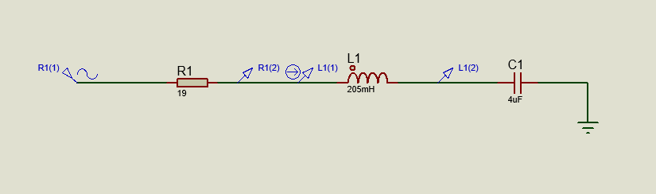
For this circuit the sine generator was placed, followed by the resistor, the inductor, the capacitor and finally a ground terminal. Two voltage probes were placed, one between the resistor and inductor, and the second between the inductor and capacitor. See Figure 1 for the complete circuit.
Figure 1 Series RLC setup

A frequency response graph, shown in Figure 6, was used to plot the voltages across the components, including the resistor voltage, capacitor voltage and inductor voltage.
Figure 7 shows both the inductor voltage and the capacitor voltage added together and plotted on a frequency response graph, allowing the bandwidth and Q factor to be calculated.
Figure 8 shows the attenuation of the circuit by plotting the voltage against frequency in dB.

Parallel RLC Circuit

This circuit was set up in a similar way to the series circuit, but the inductor and capacitor were placed in parallel. A voltage probe was placed on the net before it split to the capacitor and inductor. Two current probes were places just before the inductor and capacitor. The main graph, shown in Figure 3, was set up using a frequency response graph, with the frequency set between 1Hz and 20kHz, with 1000 steps per interval. The reference was set as the sine generator and set to show Volts rather than dBs.
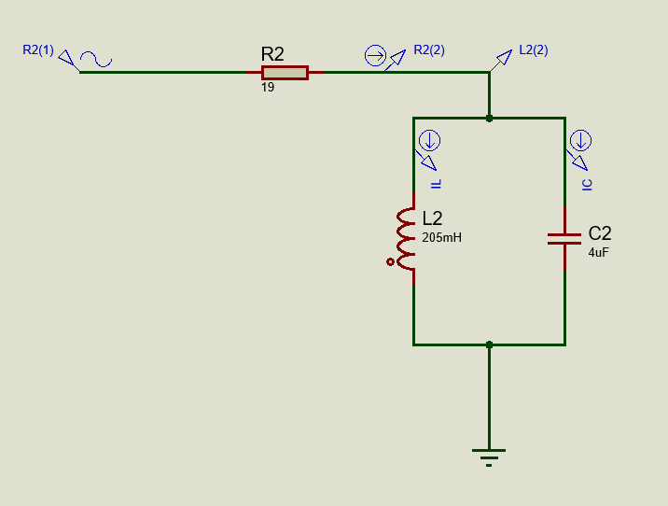
Figure 2 Parallel RLC setup
An analogue graph was used with the current probes IL and IC, showing the difference in current in the inductor and capacitor. The stop time was set to 28.4ms to show 5 full cycles.

Figure 4 shows attenuation vs frequency, using the voltage probe as reference. The graph was set up in dBs with a frequency of 100Hz-10kHz with 1000 steps per interval, referencing the sine generator (R2(1)).

Results

The results of the simulated experiment are displayed below.
Figure 3 Voltage, current and phase vs Frequency in the parallel circuit

Figure 4 Attenuation graph for the parallel circuit

Figure 5 Actual parallel Current vs Time
Figure 6 Actual series voltage vs frequency

Figure 7 Actual series VLC vs frequency
Figure 8 Actual Series attenuation vs Frequency

Discussion

The Q factor was calculated by $Q=\frac{F}{BW}$ , where F is the resonant frequency and BW is the bandwidth. The bandwidth was calculated by recording the frequencies at 70.7% either side of the maximum voltage; these were labelled as F_{L} and F_{H}. Once these were found, the larger frequency F_{H} was subtracted from F_{L}. This gave the bandwidth. These frequencies are also the cut-off frequencies for the circuit and match the -3dB points on the attenuation graph, Figure 8.
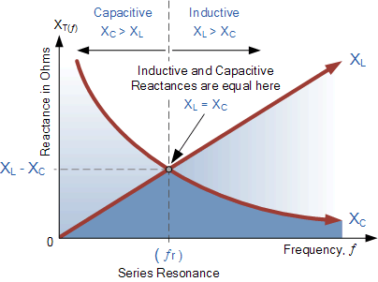
The resonant frequency was calculated by $F=\frac{1}{2π√LC}$ , where L is the inductor value and C is the capacitor value.
Figure 9 Reactance vs frequency (Aspencore,2020)

Figure 9 shows that electrical resonance occurs in an AC circuit when capacitive and inductive reactance (X_{L} and X_{C}) are equal and cancel each other out. This results in the circuit acting as a short circuit, with the only resistance in the circuit being the resistor (Yoshida, 2020).

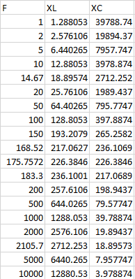
Figure 10 RLC reactance
Figure 10 shows the calculated reactance values for the capacitor and inductor within the circuit.
XT is the total reactance (X_{C}- X_{L}). XT will be zero at resonance (175.757Hz), as the inductor and capacitor reactance values will be equal and, looking at Figure 10, this appears to be true.
The capacitive reactance was calculated by $XC=\frac{1}{2πfC}$ , where f is the frequency and C is the capacitor value.
The inductive reactance was calculated by $XL=2πfL$, where f is the frequency and L is the inductor value.

Series RLC Circuit

As displayed in Figure 6, when the circuit is at resonant frequency, the voltage reaches its highest point. Through the resistor, this maximum is the supply voltage of 1 volt. However, looking at the voltage for the inductor and capacitor, the voltage is much higher, reaching almost 12 volts. This is called voltage magnification and only occurs in series RLC circuits. An example of voltage magnification is when a radio is tuned to receive a broadcast. When the dial is turned, the value of the tuning capacitor is changed, and when the circuit reaches a resonance frequency that corresponds to the frequency of the radio wave, the voltage is increased and processed to produce sound (Electricity - Alternating-current circuits, 1998).

Figure 11 Calculated Series output voltage vs frequency
The series attenuation graph Figure 8 shows the attenuation vs frequency. The graph shows that, as the circuit reaches resonance, there is a sharp drop in voltage which then returns to the input voltage. This is called a band-stop filter and is a combination of a high-pass filter and low-pass filter. It is a second-order filter due to having two cut-off frequencies. It will block any frequencies between the two cut-off points, 168Hz and 183Hz. Due to the small range of frequencies being blocked and the pointy appearance of the graph, this can also be called a notch filter (Horowitz and Hill, 2015).
To compare with common theory the voltage divider equation, $V_{Out}=V_{in}\frac{Z_{B}}{Z_{A}+Z_{B}}$ was used, where ZA and ZB are the top and bottom impedances of the divider. For this calculation the impedance and current must be known. To calculate impedance, the formula $Z=R+j\left(X_{L}-X_{C}\right)$ was used.
In this case, ZB is the combination of the capacitor and inductor in series, and ZA is the resistor. Once this calculation is done, the absolute value of V-out can be calculated for the circuit and plotted against frequency, shown in Figure 11. Comparing Figure 11 to the series attenuation graph Figure 8, both graphs are very similar, and it can be assumed that the workings of this circuit are supported by the literature.
The Q factor for the series circuit was found by finding the frequencies at the 70.7% points of the maximum voltage. Looking at the VL+VC graph Figure 7, the cut-off frequencies for this circuit were 168.51Hz and 183.3 Hz, giving a bandwidth of 14.81Hz. Using the equation $Q=\frac{F}{BW}$ , the circuit Q factor was found to be 11.87.
Figure 12 Calculated Series attenuation vs frequency

Looking at the phase angle, for frequencies below the resonant frequency the angle is positive, and for frequencies above it is negative. However, at resonant frequency, the phase angle is 0. This is because, at resonance, the impedance of the circuit is equal to the resistance, and therefore the phase angle is 0.
Figure 13 Calculated series current vs frequency

Parallel RLC Circuit

Looking at Figure 3, as the circuit approaches resonance, the drop in voltage reduces to 0 and the voltage (VLC) increases to the supply voltage.
As resonance is approached, less current is drawn by the inductor (IL on the graph) and the current in the capacitor starts to increase (IC on the graph). When resonance is achieved, the two currents are equal.

The parallel attenuation graph Figure 4 shows characteristics of an active band-pass filter. Like the band-stop filter in the series circuit, it is a combination of a low-pass filter and high-pass filter. The two cut-off frequencies are 14.63Hz and 2112.3Hz, giving a bandwidth of 2097.67Hz and a Q factor of just 0.0837. This low Q factor creates a wide pass band, allowing a large range of frequencies within the two cut-off points (F_{L,}F_{H}) to pass, and blocking signals outside of the range (Active Band Pass Filter, 2021)

Figure 15 calculated parallel current vs frequency
Figure 14 Calculated parallel attenuation vs frequency
Figure 16 calculated output voltage vs frequency

Looking at the two phase lines in Figure 3, for the capacitor and inductor currents (IL and IC), it appears that they are 180° out of phase with each other. This is because the voltage across a pure inductor “leads” the current by 90°, and in a pure capacitor it “lags” the current by 90°. Therefore, IL and IC are out of phase and in opposition to each other (Warnes, 1994). The current vs time graph Figure 5 also shows this. As the currents oscillate, the inductor current (IL) is at its peak and the capacitor current (IC) is at its lowest.

As with the series circuit, the Impedance must be known. However, the formula must be adjusted, using $Z=R+\frac{jX_{L}×-jX_{C}}{jX_{L}-jX_{C}}$ . Once the impedance was calculated, the same formulas used in the series circuit were used to calculate V-out, and produce graphs of attenuation, circuit current and output voltage vs frequency.

Conclusion

In this experiment, it has been determined that RLC circuits show unique behaviour compared with other electrical circuits. Moreover, depending on their configuration, RLC circuits can behave in very different ways themselves. It can be determined that as frequency increases, so does current, and therefore these two values are directly proportional. Looking at the Q factor figures, they compare well with the literature which states that a higher Q factor, seen in the series circuit, will have a smaller band width and a sharper peak. In contrast, a lower Q factor will have a wider band width and therefore not have as sharp a peak. Depending on configuration, RLC circuits can be used as varying types of filters, by blocking or allowing certain frequencies.
Overall, the calculated graphs appear very similar to those of the graphs produced in Proteus, indicating that the experiment was successful.

Bibliography

Addohms, 2013. Difference between AC and DC Current Explained | AddOhms #5. [video] Available at: <http://addohms.com/ac-vs-dc> [Accessed 20 April 2021].
Aspencore, 2020. Series Reactance. [image] Available at: <https://www.electronics-tutorials.ws/wp-content/uploads/2018/05/accircuits-acp204.gif> [Accessed 8 April 2021].
Cliffsnotes.com. 2021. Alternating Current Circuits. [online] Available at: <https://www.cliffsnotes.com/study-guides/physics/electricity-and-magnetism/alternating-current-circuits> [Accessed 11 April 2021].
Electrical4u. 2021. RLC Circuit Analysis (Series And Parallel). [online] Available at: <https://www.electrical4u.com/rlc-circuit/> [Accessed 24 April 2021].
Electronics-tutorials. 2019. Active Band Pass Filter. [online] Available at: <https://www.electronics-tutorials.ws/filter/filter_7.html> [Accessed 16 April 2021].
Encyclopedia Britannica. 1998. Electricity - Alternating-current circuits. [online] Available at: <https://www.britannica.com/science/electricity/Alternating-current-circuits#ref71573> [Accessed 17 April 2021].
Horowitz, P. and Hill, W., 2015. The Art of Electronics. 3rd ed. Cambridge: Cambridge University Press, pp.1-55.
Warnes, L., 1994. Electronic and electrical engineering. Basingstoke, Hampshire: Macmillan, pp.38-59.
Yoshida, J., 2020. Series-resonance. [online] electronics-tutorials. Available at: <https://www.electronics-tutorials.ws/accircuits/series-resonance.html> [Accessed 8 April 2021].

