Student’s Name: Elena Deprez
Student Number: 2021159
Module Code: BMSW4006
Module Title: Managing Enterprises in the 21st Century
Lecturer’s Name: Afzal Munna

Assignment Title: Managing Enterprises in the 21st Century

Executive Summary
The Look is a beauty salon that offers personal beauty care services for women using natural ingredients of products, which eventually with reach and growth will do the same for men.
The Look will be located in London at first, and secondly in Manchester and with time more outlets will be organized all around the UK and hopefully worldwide.
The main mission and value proposition of The Look is to offer personal care using chemical-free products and safe for the skin. This is also one of their competitive advantages, the need for these services lies in a too little coverage of such salons currently operating in London.
Due to the novelty brought by the use of natural products only, The Look offers an all-inclusive salon experience with unique services that our competition is unable to offer. This gives us a leg-up on the competition and allows us to service our customer’s unique wants and needs just like we are planning it, to ensure our customers have the best salon experience.
The mission of the enterprise would be to enhance someone’s inner beauty in a way to define their overall outer look and lifestyle in a healthier, confident, and lively version while ensuring comfort and relaxation for the customers avoiding chemical products.
The target market of the business would be young and middle-aged people concerned about personal care. To satisfy the needs of these customers, the main features of the service are innovation (The Look will produce their own products from natural ingredients), technology advancement (the business will focus on better technology-based service to make it more convenient for the customer).
Also, for a proper market analysis, SWOT and Porter’s five forces analysis have been conducted to find out the current market position of the industry, and lastly, PEST analysis has been conducted to evaluate the outer environmental factors so that The Look can be well prepared with the target market and promotional strategy in that region.

Table of Contents

Executive Summary 2
Introduction 4
Market Analysis 5
Conclusion 10
References 11

Introduction
In the 21st century, managing enterprises depends on using knowledge and understanding at its best to utilize people and processes in the business’s favor so that the goal and mission can be met smoothly in a sustainable approach. And with time the approach of managing enterprises has changed its ways and strategies by the advancement of technology, leveraging of knowledge, development in market research areas, etc. (Hatten, 2015).
In this report, a business plan regarding “The look”, a beauty salon will be demonstrated from scratch to give an overview of how to manage an enterprise in the 21st century. Here, evaluating the business idea for The Look, a business plan would be prepared accordingly conducting related researches and understanding the business type and scenario. The demonstration will focus on market analysis.

Market Analysis
Market analysis is the procedure to research the current market to identify its feasibilities, pros, and cons for entering with a new business plan in the competitive industry. Firstly, the market analysis should be done to understand the customers’ demands, and how to conduct the business (Hair et al., 2019).
SWOT Analysis
The internal factors of The Look have been addressed to identify the competitive advantage and goal of marketing strategy. Here, a SWOT analysis has been conducted to identify the business’s potential strengths, weaknesses, opportunities, and threats.
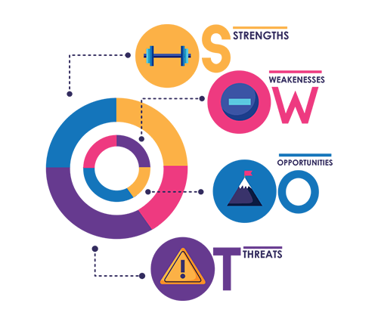
Figure 2: SWOT Analysis (Malhotra et al., 2017).
Strengths
- Provides service using natural ingredients
- Formulates its own products to use
- Have a good upcoming plan to expand services for men as well
- Technology-based service (Saptura et al., 2020).
- Concentrates on different values than the competitors
Weaknesses
- Acceptability could be tough initially with the natural products
- The impact of the service through natural ingredients takes more time than chemical ones (Malhotra et al., 2017).
- Limited service initially
- Would be a bit costly comparatively for the use of natural ingredients (Saptura et al., 2020)
Opportunities
- The business plan might be a kick-start as a good market potential believe in natural substances of skincare rather than chemical ones
- With fast fashion, new trends can be introduced for expanding the service (Hair et al., 2019)
- Introducing a brand of The Look’s natural personal care products could be a chance to expand in future
Threats
- Changing customer’s demand from the beauty salon industry
- The economic impact of the pandemic can affect the people’s life standard to think of personal care as a luxury (Jarnagin, 2019)
Having a unique value proposition, The Look has quite a few options to expand the business in the future if the threats and weaknesses are dealt with effectively.

Porter’s Five factors
To define the business’s market position and potential, Porter’s Five Forces have been conducted. Porter’s Five Forces method helps look at the ‘balance of power’ in the market we intend to penetrate on a global level, and it helps to analyze the attractiveness and potential profitability of the industry sector we are interested in by opening the salon.
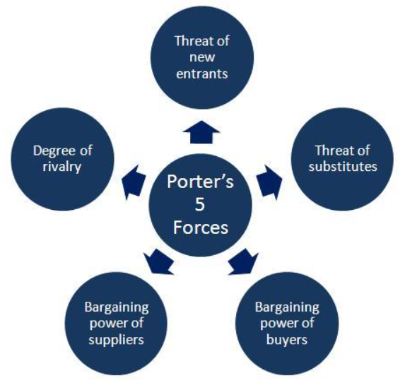
Figure 3: Porter's Five Forces (Berry and Wilson, 2016).
Bargaining Power of Suppliers: The bargaining power of the suppliers is low as The Look will be making their service products, so they will only need natural ingredients for the products.
Bargaining Power of Buyers: The bargaining power of buyers will be moderate as the beauty salon industry is quite growing (Hair et al., 2019). But the value proposition of this business is different which would be a reason for the buyers to offer more value in return for the service.
The Threats of New Entrants: The threat of new entrants is high, as people do consider beauty salons as a good start-up option but having the same value proposition might not be regular (Hair et al., 2019).
The Threats of New Substitutes: The threat of new substitutes would be moderate, as The Look will offer services with natural products. But in the UK market quality service of natural beauty care is not quite common in the current market (Jarnagin, 2019).
Competitive Rivalry: Competitive rivalry is moderate, for the different value propositions of The Look. This type of USP would be a game ahead if the business plan works out and grabs the market.
PEST Analysis
Research the outer environmental factors is important in the case of starting up a new business, with the goal being to identify potential threats and opportunities for the business.
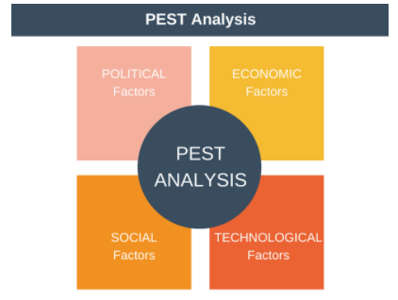
Figure 4: PEST Analysis (Abrams, 2013).
Political Factors: The UK is politically moderately stable, in 2019 it was 0.52 (United Kingdom Political stability - data, chart | TheGlobalEconomy.com, 2021). To ensure product safety the FDA is strictly followed in the country (Malhotra et al., 2017). Here, The Look has already planned to conduct the FDA research of the products they would use for the services. The Brexit can hinder the regulations and business procedure of The Look in that geographical area.
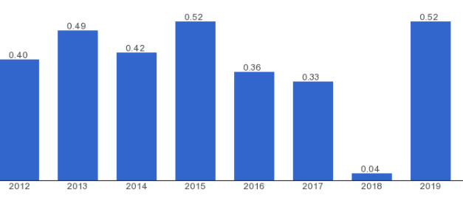
Figure 5: Political stability index of the UK (United Kingdom Political stability - data, chart | TheGlobalEconomy.com, 2021).
Economic Factors: The beauty industry is quite resistant to economic recessions. The UK has a good life standard to have a luxury life to available personal care services which is a plus point. In 2018, around 1.3% of GDP was generated by beauty industry service in the UK which is around 28.4 billion dollars (Jeon, 2018). This is an advantage for The Look to be hopeful about the business. But the tax rate is quite high in this region which might be a problematic issue for this industry.
Social factors: The UK has a good influence on fashion and sense of beauty, so the consumers of beauty care are quite consistent which is a hit for the industry (Berry and Wilson, 2016). Also, the importance of using natural ingredients has been popular in the area recently, which could be a turn for The Look.
Technological Factors: In 2020, the technological advancement of the country was in 4th position in innovation GII, it is the 4th leading technologically advanced country in the world (Saputra, 2020). Consequently, that improves the communication and service procedure in the country for The Look to function better.
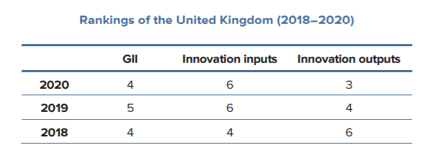
Figure 6: The UK's Rank in Global Innovation Index (Saputra, 2020).
Target Market
The Look’s target market is quite a niche, mainly young and middle-aged people as they are mostly concerned about personal beauty care. The age is between 16 to 30 for the young target market and 30 to 45 for the middle-aged people. The functions and services are customize-able for the same reason so that potential customers can find the services convenient. Also, recently the UK has a great change in the perception of beauty care which shifted the value of natural ingredients positively (Hair et al., 2019). So, a potential consumer would be that certain people who are concerned about skin but in an environment-friendly and chemical-free approach.
Market Positioning & Promotional Strategy
The market positioning of The Look is “Natural Substances for enhancing the personal beauty to make you look better”. This is the value proposition of the business, to provide chemical-free, safe, and self-made products to treat the customers while giving the utmost satisfaction and relaxation of personal care. Currently, market positioning is an important factor to draw customers’ attention to any organization making a perspective in their head (Emerald et al., 2016).
The Look has planned some promotional strategies:
- Will develop a strong online presence through all the social media
- Use digital marketing to reach the target customers
- Focus on customize-able services, and regular upgrades with time
- Promotion the salon focusing on the unique value proposition

Conclusion
The business plan of The Look has demonstrated how to start up a beauty salon business from scratch, and what are the components that should be considered before planning anything for the business, focusing on the market analysis.
The Look has different types of unique selling points which might be a lead to make the business more sustainable and prosperous in near future, the value proposition of natural products would be a hit if the opportunities are utilized and threats are dealt with significance. The report shows a brief overview of the market analysis of the business, providing that there is a niche in the market that „The Look” can exploit. This analysis provides the foundation on which our marketing and sales plan will rest.

References
- Abrams, R.M. (2013). The successful business plan: secrets & strategies. The Planning Shop.
- Berry, T. and Wilson, D. (2016). On Target: The Book on Marketing Plans: how to Develop and Implement a Successful Marketing Plan. Palo Alto Software, Inc.
- Emerald, M., Emerald, A., Emerald, L. and Kumar, V. (2016). Perspective of natural products in skincare. Pharm Pharmacol Int J, 4(3), p.00072.
- Hair Jr, J.F., Bush, R.P. and Ortinau, D.J. (2019). Marketing research. McGraw-Hill/Irwin.
- Hatten, T.S. and Hatten, T.S. (2015). Small business management: Entrepreneurship and beyond (p. 528). Boston: Houghton Mifflin.
- Jarnagin, R.A. (2019). BEAUTY SALON ESTABLISHMENT IN THE TWENTY-FIRST CENTURY.
- Jeon, H. (2018). The effect of experiential marketing on customer satisfaction and revisit intention of beauty salon franchise stores. Journal of Fashion Business, 17(3), pp.109-121.
- Malhotra, N.K., Nunan, D. and Birks, D.F. (2017). Marketing research: An applied approach. Pearson Education Limited.
- Reuvid, J. (2011). Start Up and Run Your Own Business: The Essential Guide to Planning Funding and Growing Your New Enterprise. Kogan Page Publishers.
- Saputra, V., Eng, K.I., Purnama, J. and Galinium, M. (2020) September. Business Analysis and Design of Online Marketplace for Beauty Care Services. In Proceedings of the International Conference on Engineering and Information Technology for Sustainable Industry (pp. 1-6).
- Shankararaman, V. ed. (2012). Business Enterprise, Process, and Technology Management: Models and Applications: Models and Applications. IGI Global.
- TheGlobalEconomy.com. 2021. United Kingdom Political stability - data, chart | TheGlobalEconomy.com. [online] Available at: <https://www.theglobaleconomy.com/United-Kingdom/wb_political_stability/> [Accessed 13 July 2021].
- https://www.wolterskluwer.com/en/expert-insights/market-analysis-for-your-business-plan, accessed 13 July 2021.
- https://www.thebalancesmb.com/how-to-write-the-market-analysis-section-2951562, accessed 13 July 2021.

