
- Student name: Amina noor
- Student ID:2421445
- Module title: Principles of Health and Social Care Practice (BMHP5016)
- Module code: (BMHP5016)
- Assignment title (Component 1: Reflective Report)
- Lecturer name: Kennedy Obohwemu
- Word count:2350

Table of Contents
Introduction 3
Task 1: Reflection on Importance of Principles 3
Task 2: Practical Example in Practice 5
Task 3: Self-reflection 6
Conclusion 9
References 10

Introduction
Health and social care practice is built on three principles that together support safe, compassionate, and effective care: person-centred care, partnership working, and ethical practice. Evidence shows that person-centred approaches improve outcomes; research links them to up to 30% fewer avoidable hospital admissions and higher satisfaction, reported by over 85% of service users (The King’s Fund, 2024; NHS England, 2022).
This report examines the meaning, legal basis, and practical importance of each principle, showing how they work together to support high-quality care for service users, practitioners, and communities. It considers how each principle works on its own and how applying them together can improve outcomes, drawing on legislation, theory, and real-world evidence. Maslow’s Hierarchy of Needs (Maslow, 1943) illustrates how meeting basic, emotional, and aspirational needs supports wellbeing. Task two applies these principles to Robyn’s experience of regaining independence with a Personal Health Budget. Task 3 uses Gibbs’ Reflective Cycle (Gibbs, 1988) to examine professional strengths, learning needs, and development plans. The report concludes by summarising how consistent application of the principles strengthens professional practice.

Task 1: Reflection on Importance of Principles
The following sections examine each principle in detail, starting with person-centred care. PCC involves individuals as active participants in their care, with support shaped around their preferences, strengths, and aspirations rather than organisational routines (NHS England, 2022). The Care Act 2014 establishes this in law, requiring local authorities to make an individual’s wellbeing, including dignity, autonomy, and control, the primary consideration in all decisions (Department of Health and Social Care, 2014). This matters because it recognises service users as experts in their own lives. Evidence shows that person-centred care improves satisfaction, safety, and outcomes while reducing unnecessary service use (The King’s Fund, 2024).
Aligned with Maslow’s Hierarchy of Needs (Maslow, 1943), person-centred practice meets physical needs at the most fundamental level while also supporting safety, belonging, esteem, and purpose, creating the conditions for self-actualisation. However, staffing shortages, time pressures, and inflexible systems that prioritise tasks over individuals can disempower people and prevent their needs from being met holistically (SCIE, 2025).
Partnership or collaborative practice brings together health, social care, and community organisations to provide integrated, seamless support. The Health and Care Act 2022 strengthens this framework by establishing Integrated Care Boards and Integrated Care Partnerships and legally requiring partners to collaborate and involve service users in planning (Department of Health and Social Care, 2022).
For people with complex or long-term needs, effective partnership reduces duplication, prevents gaps, and supports continuity at critical points, such as hospital discharge (NICE, 2018). From a Maslovian perspective, coordinated, reliable support provides the safety and security needed before higher-order needs can be met (Maslow, 1943). Benefits include shared knowledge, joint problem-solving, and stronger trust. However, conflicting organisational priorities, unclear roles, and communication barriers can hinder progress (Department of Health and Social Care, 2013).
Ethical practice is the moral and professional foundation of all care, guided by five core values: autonomy, beneficence, non‑maleficence, justice, and dignity. The Care Quality Commission’s Fundamental Standards establish the legal minimum, requiring providers to treat people respectfully, involve them in decisions, and protect them from harm (CQC, 2017). NICE guidance further states that personalised care planning must be transparent, fair, and based on informed choice (NICE, 2021). Ethical practice maintains professional integrity and helps ensure decisions can be justified, even in difficult circumstances. In Maslow’s terms, fair, respectful, and empowering treatment supports self‑esteem and confidence, enabling people to participate fully in their care (Maslow, 1943). Conflicts may arise, such as balancing an individual’s right to make choices with concerns about their safety, or distributing limited resources fairly (SCIE, 2025). Together, these three principles address needs across Maslow’s hierarchy, helping people feel safe, respected, connected, and empowered to live meaningful lives.

Task 2: Practical Example in Practice
Application of Person‑Centred Care, Partnership Working and Ethical Practice in Robyn’s Story
Robyn’s experience shows how person-centred care, partnership working, and ethical practice can transform lives. At 21, a spinal injury left her tetraplegic and reliant on 24-hour care. Initially, a home care agency supported her through joint funding from NHS Continuing Healthcare and her local authority. As the agency grew, recruitment and retention worsened; in 2014, her final year with the agency, she had 36 different Personal Assistants (PAs). Many did not know her routines, were allergic to or afraid of her animals, or could not drive, making visits to her ponies impossible. Although her basic physical needs were met, her preferences, identity, and aspirations were overlooked, contrary to the principle that care should reflect what matters to the individual, not service convenience (NHS England, 2022). This compromised even the foundations of wellbeing: she felt unsafe and uncertain, and could not plan, limiting social connection and personal growth (Maslow, 1943).
In May 2014, Robyn approached her social care and Continuing Healthcare teams to ask to manage her own support. They discussed a Personal Health Budget (PHB), and in November 2015 she began directly employing her own PAs. By her third year, she had just five PAs over the year: two regulars on a rota, who had collaborated with her for 18 months and two years, and three who covered leave. This continuity transformed her life. She now runs her own animal business, competes in carriage driving, and contributes to national policy as part of NHS England’s Co‑Production Group. She describes the PHB as having “given her life back” (NHS England, 2019).
The PHB gave Robyn decisive control, allowing her to choose PAs who shared her interests and understood her priorities. This aligns with the Care Act 2014 duty to place individual wellbeing, including choice and control, at the centre of all decisions (Department of Health and Social Care, 2014). It also reflects NICE guidance that personalised planning must respect people’s preferences and empower them to pursue fulfilling lives (NICE, 2021). As she rebuilt her life, Robyn progressed through Maslow’s hierarchy: safety and security → social belonging → self‑esteem → self‑actualisation through work, sport, and advocacy (Maslow, 1943; NHS England, 2019).
Success depended on collaboration among teams: her PHB Nurse, social care professionals, and the Personal Budget Support Service worked together to assess her needs, set an indicative budget, develop a care plan, and support her through recruitment and employment. This reflects the Health and Care Act 2022 requirement for integrated systems and shared decision-making (Department of Health and Social Care, 2022). Challenges included an 18-month process marked by periods of poor communication and an initial plan that did not reflect Robyn’s true priorities. These challenges were addressed through persistence, honest dialogue, and professionals demonstrating the 6Cs: Care, Compassion, Competence, Communication, Courage, and Commitment (Department of Health, 2012). As her confidence grew, Robyn rewrote her care plan, offering a powerful example of co-production in practice.
The agency model had fallen short of the CQC Fundamental Standards, which require dignity, involvement in decisions, and protection from avoidable harm (CQC, 2017). The PHB restored Robyn’s autonomy: she chose who entered her home and how care was delivered. Throughout the process, her PHB Nurse maintained open, compassionate communication, preserving professional integrity even during delays. This upheld the ethical principles of autonomy and dignity and ensured decisions were transparent, fair, and fully informed (NICE, 2021).
Robyn’s journey shows how person-centred approaches can restore identity and purpose, partnership working can provide dependable, coordinated support, and ethical practice can protect dignity and respect. Together, these principles helped her move from simply surviving to thriving.

Task 3: Self-reflection
This reflection uses Gibbs’ Reflective Cycle (Gibbs, 1988) to assess my developing practice against the three principles, identify strengths and areas for growth, and outline a professional development plan. Reflective practice is essential in health and social care because it deepens learning, supports better decision-making, and promotes safety and compassion (NHS England, n.d.). I will use Gibbs’s reflective cycle to reflect on my experience (Figure 1).

Gibbs’s reflective cycle diagram (Figure 1)

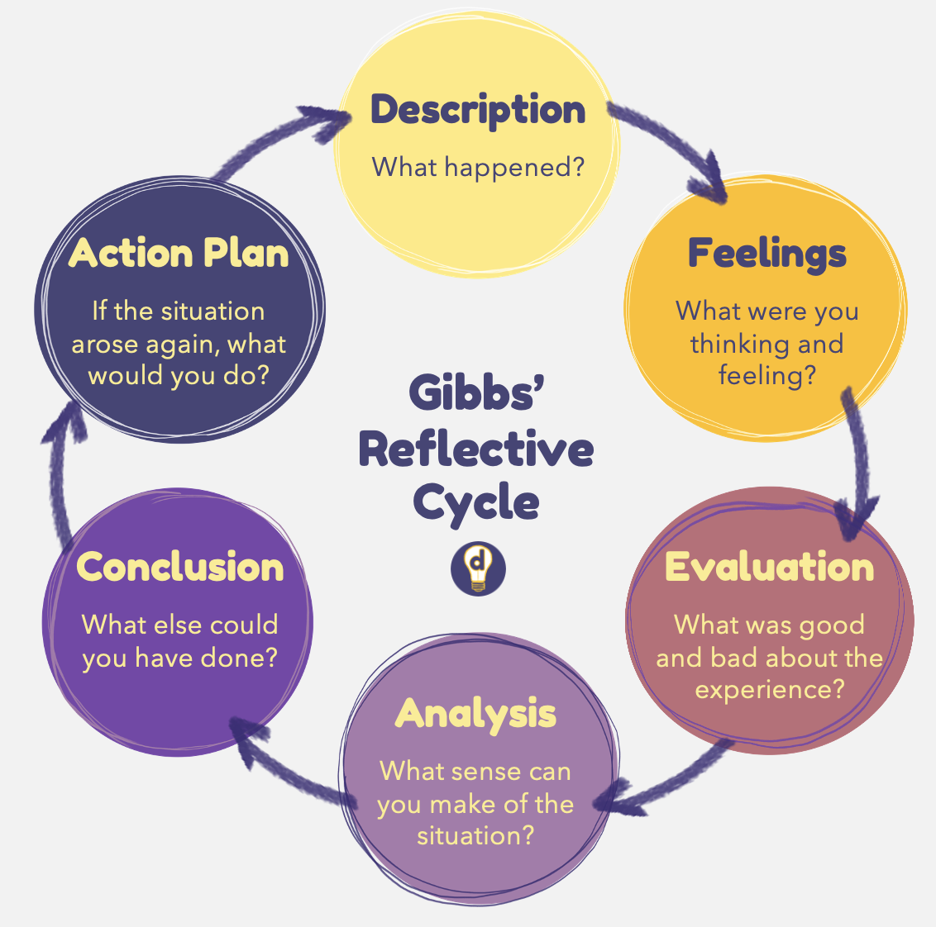
Storage.googleapis.com

Description
Before starting this course, I worked in a customer-facing role, supporting people with a range of needs. One situation has stayed with me: an older woman seemed confused and distressed as she worked through a complex form. She told me she was afraid of making mistakes and was close to tears. Although this was not a formal health setting, I recognised that she needed patience, reassurance, and clear, accessible support. I took the time to explain each section and check her understanding at every stage. She completed the form independently and thanked me, saying she could not have managed otherwise.

Feelings
I was acutely aware that she might feel embarrassed or undervalued, so my priority was to help her feel safe and respected. I now see this as aligning with the ethical duty to uphold dignity and autonomy (CQC, 2017). I was pleased that she succeeded but also recognised a limitation: I chose what support to offer instead of asking what she found most helpful. I felt momentarily unsure when she became distressed a natural reaction, but one I want to build confidence in managing.
Evaluation
Strengths: I demonstrated empathy, patience, active listening, and adapted my communication, key aspects of compassionate, person-centred practice (NHS England, 2022). I treated her with respect and upheld her dignity, in line with ethical standards. Areas for improvement: I did not explicitly ask about her preferences or involve her in deciding how to proceed. Shared decision-making is central to personalised care planning in health and social care (NICE, 2021). I also need to build my confidence in supporting visibly distressed people.
Analysis
Connecting this to the three principles and Maslow’s framework, person-centred practice means recognising the individual as the expert on their own life (NHS England, 2022). Although I offered dedicated support, I retained control instead of asking, “What matters most to you?” the essence of genuine partnership. Meeting her need for r safety addressed a basic level, but true autonomy builds the esteem and confidence needed for self-determination (Maslow, 1943). The Care Act 2014 places a legal duty on practitioners to promote choice and control (Department of Health and Social Care, 2014). I supported her dignity but could have done more to let her lead. My hesitation stems from inexperience, a gap that reflective practice and supported experience can address (SCIE, 2025).
Conclusion (Gibbs’ model)
My strengths include empathy, patience, respect, and a commitment to doing my best, which align with the 6Cs values (Department of Health, 2012). However, I need to build confidence in asking open questions, supporting shared decision-making, and staying calm when helping someone distressed. These skills develop with practice; they are not personality traits that I either have or lack.
Action plan
To develop these skills and consistently embed the three principles, I will seek voluntary or part-time care roles and apply person-centred approaches alongside experienced practitioners (NHS England, n.d.). I will build my knowledge by completing CPD courses in communication, safeguarding, and personalised care planning, aligned with the Care Act 2014 and NICE guidance (Department of Health and Social Care, 2014; NICE, 2021). I will reflect systematically by applying Gibbs’ Reflective Cycle to review experiences, track progress, and address gaps (SCIE, 2025). I will also seek mentorship from a practice supervisor to build confidence in ethical decision-making. These steps will turn understanding into consistent, compassionate, person-centred care.

Conclusion
Person-centred care, partnership working, and ethical practice are not abstract concepts; they are the essential legal and professional foundations of safe, compassionate, and effective health and social care. Set out in the Care Act 2014 and the Health and Care Act 2022, and supported by NICE guidance and CQC standards, they help ensure that services are respectful, well-coordinated, and properly accountable (DHSC, 2014; DHSC, 2022; CQC, 2017). Robyn’s powerful case demonstrates their real impact: people’s lives improve when they are at the centre of care and supported by integrated teams that act with integrity. Through careful self-reflection, I recognise that I already hold the core values of the 6Cs, while also acknowledging meaningful areas for growth. With experience, ongoing learning, and regular reflection, I will build my confidence and competence to ensure my future practice is genuinely person-centred, collaborative, and ethical.

References
Care Quality Commission (2017). The fundamental standards | Care Quality Commission. Cqc.org.uk. Available at: https://www.cqc.org.uk/what-we-do/how-we-do-our-job/fundamental-standards [Accessed 14 Oct. 2026].
Department of Health (2012). Compassion in Practice. NHS England. Department of Health. Available at: https://www.england.nhs.uk/wp-content/uploads/2012/12/compassion-in-practice.pdf [Accessed 14 Oct. 2026].
Department of Health and Social Care (2013). Integrated care: Our shared commitment. GOV.UK. Available at: https://www.gov.uk/government/publications/integrated-care [Accessed 14 Oct. 2026].
Care Act (2014). Care Act 2014. [online] Legislation.gov.uk. Available at: https://www.legislation.gov.uk/ukpga/2014/23/contents [Accessed 14 Oct. 2026].
Health and Care Act (2022). Health and care act 2022. [online] Legislation.gov.uk. Available at: https://www.legislation.gov.uk/ukpga/2022/31/contents [Accessed 14 Oct. 2026].
Gibbs, G. (1988). Learning by doing: A guide to teaching and learning methods. Programmed Learning & Educational Technology, 25(2).
Maslow, A.H. (1943). A theory of human motivation. Lanham: Start Publishing LLC, pp.370–396.
NICE (2018). Overview | people’s experience in adult social care services: Improving the experience of care and support for people using adult social care services | guidance | NICE. www.nice.org.uk. Available at: https://www.nice.org.uk/guidance/ng86 [Accessed 14 Oct. 2026].
National Institute for Health and Care Excellence (2021). Overview | shared decision making | guidance | NICE. www.nice.org.uk. Available at: https://www.nice.org.uk/guidance/ng197 [Accessed 14 Oct. 2026].
NHS England (2019). NHS England » Personal health budgets (PHBs). England.nhs.uk. Available at: https://www.england.nhs.uk/personal-health-budgets/ [Accessed 14 Oct. 2026].
NHS England (2022). Personalised care. England.nhs.uk. Available at: https://www.england.nhs.uk/personalisedcare/ [Accessed 14 Oct. 2026].
NHS England (n.d.) PNAs and reflective practice in mental health services. Available at: https://www.england.nhs.uk/nursingmidwifery/delivering-the-nhs-ltp/professional-nurse-advocate/case-studies/pnas-and-reflective-practice-in-mental-health-services/ (Accessed: 21 September 2026).
Social Care Institute for Excellence (2025) Ethical practice in social care. London: Social Care Institute for Excellence. Available at: https://www.scie.org.uk/ (Accessed: 21 September 2026).
The King's Fund (2024) Mental health 360: quality and patient experience. Available at: https://www.kingsfund.org.uk/insight-and-analysis/long-reads/mental-health-360-quality-patient-experience (Accessed: 21 September 2026).

