Info Skills Unit Evidence:

Info Skills: Finding Information: Unit 1 Types of Information

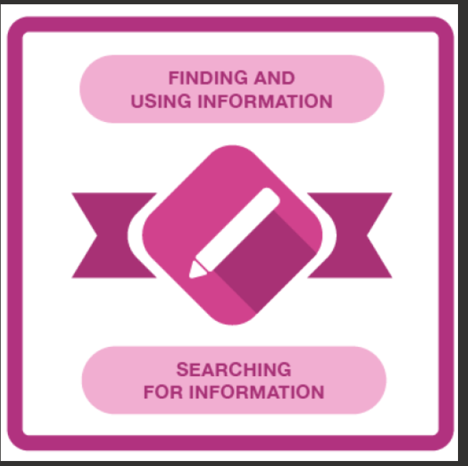

Info Skills: Finding Information: Unit 4, Section 1 (Critical Awareness)
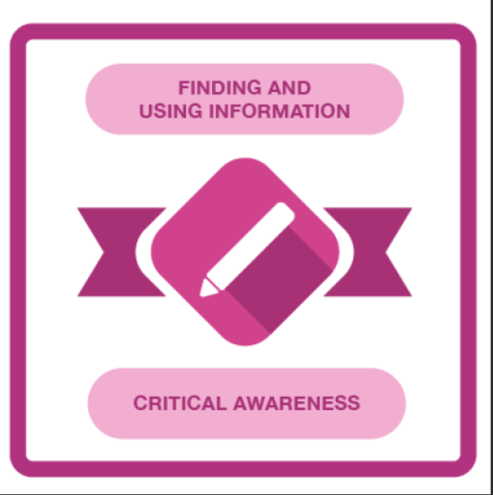

Info Skills: Referencing Basics

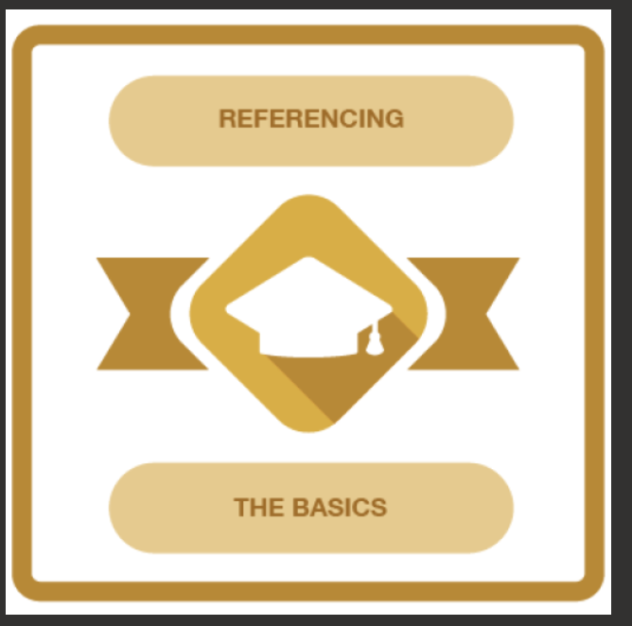

Info Skills: Academic Integrity
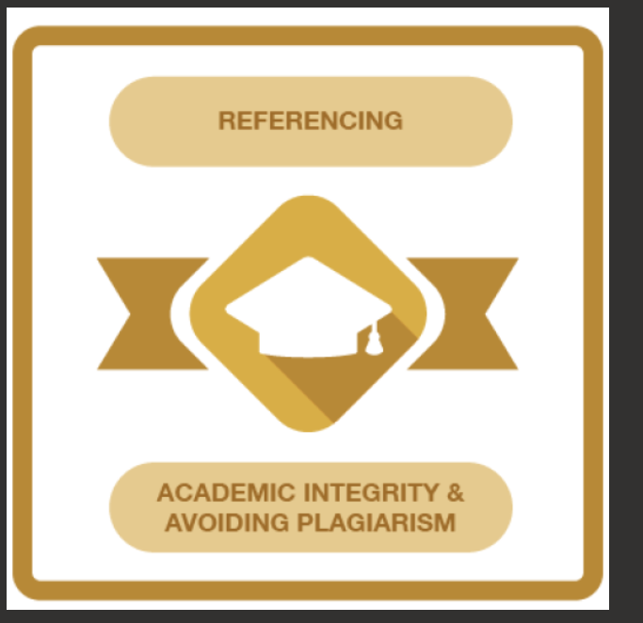

Info Skills: Evaluating Information


