DECLARATION

This work has not previously been accepted in substance for any degree and is not being concurrently submitted in candidature for any degree

Signed……Qi Zhang…………………………………

Date……12 May 2021……………………………………
…

STATEMENT 1

This dissertation is being submitted in partial fulfilment of the requirements for the degree of BA International Finance
Signed……………Qi Zhang………………………………….

Date……………12 May 2021…………………………………

Title
The Internet financial concept problems of single period people on Internet financial

Qi Zhang

STATEMENT 2

This dissertation is the result of my own independent work, except where otherwise stated.

Other sources are acknowledged by footnotes giving explicit references. A bibliography is appended.

Signed……………Qi Zhang………………………………

Date……………12 May 2021…………………………………

Abstract
In 2013, Yu’E Bao raises the trend of Internet financial. It affects the traditional financial and Internet financial market deeply. This research studies the famous Internet financial market, the objectives of this research is the concepts of single period people. The aim of this research is concluding the problems of Internet finance for single period people and provide some suggestions for them. This research adopts the research onion of Saunders to design the research processes. This research combines the Internet financial and family life cycle finance theory to investigate the problems of Internet financial concepts of single period people. It adopts the questionnaires to collect information about single period people.

Most of single period people lack education and learning about financial and Internet financial products. So, they need more guidance on the Internet financial platform. People can adopt the consulting part of Alipay to achieve the investment suggestions and products recommdation. The management efficiency of free and scattered money is low. People can adopt Yu’E Bao to mange free and scattered money. People should choose famous and normal Internet financial platform to invest to avoid financial fraud. The suggestion can help single period people to invest on the Internet and reduce the risks of financial fraud.

Table of content
Abstract 6
Chapter 1 Introduction 12
1.1 Background 12
1.2 Rationale and meaning 14
1.4 The aim of this research 16
1.4 Conclusion 16
Chapter 2 Literature review 17
2.1 Introduction 17
2.2 The financial service 18
2.3 The Internet personal financial service 19
2.4 The financial service products 21
2.5 Theory of family life cycle finance 22
2.6 Conclusion 26
Chapter 3 Research methods 28
3.1 Research methodology 28
3.1.1 Philosophies 29
3.1.2 Approach 30
3.1.3 Strategies 31
3.1.4 Choices 31
3.1.5 Time horizon 31
3.1.6 Data Collection and Analysis 32
3.2 Research processes 32
3.3 Research methods 33
3.3.1 Questionnaires 33
3.4 Limitation and ethics problems 34
Chapter 4 35
4.1 The information of Alipay 35
4.2 learning degree analysis about Internet financial service 36
4.3 Learning degree analysis about Internet financial service 38
4.4 Finance willing analysis 41
4.5 Barriers of financial 44
4.6 Financial service expectation 47
4.7 Assist of Internet financial service platform 50
4.8 Conclusion 52
Chapter 5 Conclusion 53
5.1 The review of this research 53
5.2 Suggestions for single period people 54
5.3 The influence of conclusion 55
Chapter 6 the limitation of this research and future development 56
Reference 58
Appendix 66
Appendix1 The service of Alipay 66
Appendix 2 the consulting service of Alipay 67
Appendix 3 Questionnaire 69
Appendix 4 Answers 71
Figure
figure 1 the research onion 15
figure 2 Have you ever learned about Internet financial service products 19
figure 3What do you think of the necessity of financing 20
figure 4Attitude of single period people for Internet financial 21
figure 5 crosstab analysis 22
figure 6Free money investment ratio 23
figure 7crosstab analysis 24
figure 8 Risks toleration 25
Figure 9Factors of effecting people to purchase financial service products 26
figure 10Financial service expectations 27
figure 11What services do you want from Internet financial service platform 28
Figure 12 crosstab analysis 28
Figure 13 Accept pay for the service 29
Figure 14Attend group purchase activities 30

Chapter 1 Introduction

1.1 Background
The quality of lifestyle of people improves obviously at recently years. Based on the data of National Bureau of Statistics of China (2021), in 2018 and 2019, the per capita urban disposable income is 39251yuan and 42359 yuan. So, people in China have much free money and have more chances to allocate the money and achieve assets gain. The demands of personal finance increase and the personal financial plans are attended by people. However, the barriers of traditional finance are difficult to overcome for most of Chinese. Based on the survey of Fu (2014), the traditional financial products require higher investment capital which generally is more than 50 thousand Yuan. The redemption term is close and length, which is about 113 days. Those cause to low liquidity of assets. It is not suitable for most of Chinese to finance and it is not satisfy the financial demands of most Chinese.

In 2013, Alipay launched the Internet financial product, Yu’E Bao, which is popular with most of Chinese. It possesses low financial requires, which can be invested from 1 Yuan, can redeem within one day, possess low risks and can use money of Yu’E Bao at any time. After 7 months, the assets of Yu’E Bao is over 250 billion Yuan, the users are over 49 million (Fu, 2014). Yu’E Bao concentrates the scattered free money of people to invest, which satisfy the demands of people who are rejects by traditional finance.

With the development of technology, especially the Internet, it provides more benefits for the financial market. Economides (1996, quoted in Dai, 2017) considers the Internet as the medium which connects with the seller and buyer of financial products or supplier and demander of fund becoming the fictitious financial market. There are more financial companies transfer or design the financial products on the Internet platforms, such as the apps on the phones and the software on the computers. Based on The Analysis Report about the Bank Financial Market of Rong360, which is the financial institution, the Chinese banks issue 13820 financial products November 2017 (Rong360, 2017). That just is the data of banks, so there are more financial products at other financial institutions. So many financial products can bring more chooses and benefits for people to allocate the disposable income.

The technology of smart phone development promotes the Internet financial platform generation. Many Internet financial platforms were built by different corporations, such as Alipay, Wechat, online banks. The most customers of different Internet financial platforms are common people, which mean they not equip or have not enough the financial knowledge and experience. So, the most of Internet financial platform launch many new services for them. For example, the Internet financial platform of Ailpay recommends different financial products based on the future benefits of financial products and demands of customers (Appendix 1). It also launches a new Internet financial product, Yu’E Bao, to meet the people who want finance on the Internet but are not equipping financial knowledge and have no free time. So the Internet financial platform generates large influence for the lifestyle of people. People can finance at anywhere and whenever, people who have not financial knowledge or experience also can finance on the Internet.

1.2 Rationale and meaning
Comparing with the tradition finance, the Internet finance possesses lower requires, more convenient and flexible, more products choices. Those advantages attract people to purchase the Internet financial products, which caused to more financial companies to design more new Internet financial products. So there are so many Internet products in the market. In additional, the Internet safety problems, Internet fraud and immorality behaviours of financial platform also cause many people suffer capital loss. In 2020, the 360 Safety Brain (2020) analyze the 15505 fraud events in 2019 from Hunting Net platform databases, it shows the financial frauds is the largest part whose amount are up to 3314. It shows many people have not correct financial concepts and do not know the financial methods. So it is important to build correct financial concepts for people to identify the fraud and reduce the capital loss.

The Internet financial platform is an importance part to finance online, because Internet financial platform large customers group and large scale potential customers. The most famous Internet financial platforms are Alipay and Wechat. Alipay is the Internet pay tool and Wechat is the Internet communication tool. There are 600 million people use Alipay present, so Internet financial platform possesses large impacts for people (Alipay, 2021). Wechat have 1.21 billion users in 2020 (Southmoney, 2020). That is large users group, which include most of Chinese. There are large amount of users cannot equip the financial knowledge and experience. So, the Internet financial platform provides many news services for them. For example, it will recommend financial products, simplify the processes of Internet finance and provide the professional consulting and analysis for use. Those behaviours generate large influence for personal financial. It reduces the barriers of financial for common people, and use the free and scattered money of people.

The correct Internet financial concepts building requires people understand the characteristics and operation form of Internet financial products. However, there are seldom scholars to analyze Internet financial products to give some suggestions for people. Chen (2018), Wu (2017), Yang and Wang (2015) and Deng (2018) just study and analyze the influence and risks of Internet financial products and give suggestion for government or banks, there is not systematic suggestions for people. Zhou (2008) just analyzed different advantages, disadvantages, risks of Internet financial products. There are not any suggestions for people. Shi et al. (2018) just analyzed the influence one Internet financial products for people. In additional, Internet financial platform possesses the large impacts for people to finance on the Internet.

There are not enough suggestions to guidance young people finance on the Internet. This research studies the characteristics of Internet financial and the financial demands of young people to make some suggestions. The outcomes of analysis about characteristics of Internet financial can help people to learn the Internet financial future. The suggestions can help young people to finance on the Internet financial platform and reduce the risks of financial.

1.4 The structure and aim of this research
The aim of this research is giving suggestions for young people to finance in the Internet financial platform. First, this research should learn the demands of young people in finance through studying the family life cycle finance. It is an importance precondition to do this research, because it guidance the questionnaire design and data collection. Second, it will collect information to learn the demands and concept of young people through questionnaires. Third, it will analyze the advantages and disadvantages of Internet financial platform. Last, it will combine the data of questionnaires to conclude the suggestions for young people.

1.4 Conclusion
The traditional financial possesses high threshold for people, so most of Chinese cannot finance in traditional financial market. Yu’E Bao remedies financial demands of most of Chinese. The low threshold, flexible purchase and redeem and higher benefits attract large amount of people to purchase it. It generates large impacts for financial market of China and the financial concept of Chinese. This final aim of research is not analyze the Internet financial. It is concluding some suggestions for young people to finance on the Internet.

Chapter 2 Literature review

2.1 Introduction
In this part, it will show the previous study about personal financial plans from different literatures. Then, it will critically analyze the previous studies and choose the study direction based the weakness of previous studies. In this chapter, it will study the Internet financial service, the family life cycle finance theory. The aim is to learn the Internet financial service and the strategies of make financial plans. Then, it finds the weaknesses of Internet financial services and determines the research objectives and aim.

2.2 The financial service
There are many studies about the personal financial service in China because the financial services are more popularly. Yi (2005) points out the personal financial service concept were first appeared at 300BC in the Oeconomicus of Xenophon, which is family economics book. So, the first concept of personal financial service is a part of family economics. That means this theory is served for family.

Jack, Les and Robert (1996, quoted in Dai, 2017) said the financial service are the processes that to achieve the aims of person financial plans through family assets. The teachers of Henan University, Gao and Guo (2020), said the financial is not only the investment, but also that is the long term plan about cash, custom, expenditure, investment, risks management, education, retirement based on the assets and liabilities of different stages of family. Above definitions discuss personal financial service based on the family, it is not comprehensive. The Financial Planning Standards Board (China) (FPSB China) gives a definition about financial services. This service means the professional financial workers make the appropriate financial plans under analysis and evaluation for the financial position of customer to achieve the free and independent in financial and satisfy different financial objectives in different life steps for customers. The purpose of financial service is the goals of customers (Hu, 2015). This definition of FPSB (China) increase the working of financial workers in the definition, it is more suitable for the personal financial service at present. It is not a single person behavior, who includes more than 2 parts, family members, financial workers and companies who sale personal financial service products.

2.3 The Internet personal financial service
The Internet Information technology update rapidly promotes the personal financial service development. The news channels and methods of personal financial service are appeared and bring large effect for people. The Internet technology development promotes the Internet financial service market development, the Internet financial service market of China was raised in 2007 and it develops rapidly from 2016 to present (Li, Yu and Wu, 2018). Gai (2014) said the Internet financial service achieves the financial service activities through the Internet under the traditional financial service background, which possesses two types of media that are the third-party platform and e-commerce platform. Actually, the Internet media plays more importance roles in Internet financial service activities, rather than just as the media of two parts. Liu (2017) considers the Internet financial service means the traditional financial service depends on the Internet to adopt the Big Data Analysis System to develop service and provide the financial service plans and products for customers.

There are many scholars studied the Internet personal financial service and analyze the products or risks or both. Yang and Wang (2015) said the Internet financial service gathers large amount of customers through the e-commerce platform and social media, which can satisfy requirements of diversification investment for people, however it also increases the financial risks and cause the excessive competition between Internet financial institutions and traditional institutions. Yang and Wang just discuss advantages and advantages of Internet financing, the types of Internet financial products also need to be discuss future.

Chen (2018) studies the barriers of financial service products development in China and gives some suggestions to deal with it. Chen points out the Internet financial service are low cost, large range and high efficiency, however the types of financial service products are similar and the supervision system is not perfect and the financial service products possess many risks. Chen also suggests the government should improve the supervision for Internet and enhance the risks management. Wu (2017) analyzed the Internet financial service products and the influence factors. Wu raised there are three types of main finance which are currency, stock investment and public placement fund. The Internet financial service possesses low requires and operation cost and diversification functions. Wu also lists the affect factors of financial service products to adopt, which are function value, perceptible cost and risks, emotion and social value. Deng (2018) studied the development trend and analyze the operation model of the Internet financial service products, and then Deng raise the Internet financial service threats the traditional financial service market serious. Deng analyzes the questionnaires data and case study and points out the Internet financial service as an importance part in the financial market, however the laws and supervision lacking cause many risks for investors.

2.4 The financial service products
There are also some articles to analyze personal financial service products. Zhou (2008) analyzes the personal financial service products which include details, risks and problems. Zhou raise different personal financial service products possess different advantages and disadvantages, the investors should purchase personal financial service products according different personal demands. Only the appropriate personal financial service plan can achieve the aims of financial. Chen (2014) investigated citizen of Xuzhou city about the factors to purchase personal financial service products for people, who show the education backgrounds, risks preference and difficulty to achieve the information about products for people possess negative correlation with the purchase behaviors in the banks. It shows positive correlation with the gender, income, the learning about personal financial service products in banks, the reliance for the personal financial service products in banks and the professional of workers of banks. Shi et al. (2018) study the Internet personal financial service products through analyzing the advantages, disadvantages, operation characteristics of Yu'E Bao. Yu'E Bao makes full use of the large scattered money to achieve the value increase and creates connection between financial and payment tools. Shi et al. raise the Internet financial service products possess lower requires for customers and large users range.

2.5 Theory of family life cycle finance
Family life cycle finance theory plays the importance role in the personal financial, there are many scholars study the influence and practices in the personal financial. In 1927, Huebner raised the basal concept of financial life cycle in the book of The Economics of Life Insurance (Cai, 2006). The life can be divided by are five parts, which are single period, family formative period, growth period, mature period and senescence period. The single period means people have working, but people do not marry the financial aim is improve the income and purchase high return products. The family formative period means married without feeding children, which needs high return financial products. Growth period means couple feeding children period, which needs lower risks and lower return investment than before two periods, such as bonds. Mature period means children are independent and couples are not retirement, the financial aim is conservative investment to increase the income steadily and pension. Senescence period means couple is retirement, the financial aim is enjoying the retirement life and they will invest low risks financial products (Liu and Zhang, 2008).

Modigliani raised the Family life cycle finance theory firstly in 1954, which can be divided by before retirement that is the step of wealth accumulation and after retirement that is the steps of payment over income (Xu, 2007). Zhang and Li (2008, p51) consider personal financial service is continuity and systematic and associate with the family life cycle, which possesses important meaning to study the personal financial service based on the life cycle.

However, the period of family life cycle can be divided by other ways. Xu (2009) studies the literatures of Merton, Boide, Samuelson, Detemple, Garcia and Rindisbacher about the financial life cycle and achieve an outcome. The financial life cycle can be divided by the financial model of lasting time, the selectable works can be increased, the increase of habits development, information achievement and investment choice. Xu raises different life steps needs different investment strategies because different life steps possess different demands and risk tolerance. Zou and Zhang (2007, p51) study the influence of the life cycle theory, Modern Portfolio Theory and Capital Asset Pricing Model for personal financial. The conclusion shows the theories can guide the financial institutions to design the financial service products and people to purchase appropriation financial service products.

There are many literature studying the demands different period. Liu and Zhang (2008) studied and analyze different financial service demands of different life periods and different financial service products based on the financial life cycle. Liu and Zhang found the single period and family formative period people need accumulating wealth and improve the life level, they can achieve the help from financial service counselors, diversified invest. Growth period people needs building education plans for children, accumulating wealth, improving the life level and building pension schedules. They should assess the financial position and achieve the help from financial service counselors with face to face. Mature period and senescence period people need complete pension schedules, setting up the contingency reserve and improve the life levels.

Wang and Wang (2007) study the advantages and disadvantages of financial service products and analyze the demands and risks tolerate based on the Family life cycle finance theory. They point out single period and family formative period people want achieve high return with high risks. Growth period people want middle return with middle risks. Mature period and senescence period people need low return and low risks financial service products.

However, Yun and Wang (2014) study the Family life cycle finance theory of United Bank of Switzerland and raise different periods. It increases a period of financial, which is a university period of children. They consider in this period, the education cost of children is large burden for financial position. So, they advice people should adopt the loan to pay the expense of university. In additional, they consider single period people should reduce the high risks investment and choose more steadily investment than single period.

Zhang (2018) studies optimizing strategy of family asset allocation based on the financial life cycle. Zhang analyzes the family life cycle firstly, and then Zhang also studies the asset allocation position. The outcomes show the bank saving is the largest part in the single period, mature period and senescence period of Chinese family. The stocks and futures investment is increase obviously in Growth period and family formative period. Zhang also points out the main reasons why cause this phenomenon. First, Chinese lacking the systematic financial service education and enough knowledge of financial, so the main financial plan method is saving. Second, the lower development levels and shortly development time of personal financial service market in China lead to people lacking chances and channel to finance.

Zhu (2017) investigates family financial service status of the middle class family in Hang Zhou City based on the family life cycle finance theory. Zhu hands out questionnaires to sample survey middle class family in Hang Zhou City. Then Zhu concludes some strategies of financial plan for people. For single period people, they should invest 20% in saving, insurances, 80% invest in risky financial service products, which include 60% high risk financial service products and 40% low risk financial service products. The financial service products should over three types. For family formative period, people should invest risky financial service products under 70% and invest saving and insurances over 25%. The financial service products should over three types. For growth period people, they should not invest risky financial service products over 65% and the saving and insurance cannot low than 35%. Risky financial service products include 60% high risks investment and 40% low risks investment. Mature period people should invest 50% risky products and 50% insurance and saving. In risky investment, high risks investment should not over 20% and low risks investment should over 80%. The senescence period people investment structure is 30% risky investment and 70% saving and insurances investment. They should not invest high risks products, such as stocks.

2.6 Conclusion
In conclusion, the Internet financial service plays important roles for the financial service industry which also possesses threats for traditional financial. The Internet financial service possesses many advantages which are low cost, large ranges of customer, diversification functions and more convenient for people and less requirements. However, the disadvantages also are obviously, which are the management risks, Internet safety and crime of swindling. The most of articles study the characteristics, advantages, disadvantages and improvement for bank to design and sale the Internet financial service products. There are not people to study influence of different types Internet financial service products for people and give some suggestions for people.

This research study the family life cycle finance theory to conclude the appropriation Internet financial plans for single period people. Based on the family life cycle finance theory, the demands of single period are income increase and wealth accumulation. Single period people can undertake the high risk and they also can purchase large ratio high return products. The family formative period people possess similarly demands, risk toleration and financial service products plans with single period people. However, they have more burdens on family, so the ratio of high risk investment is reduced. The growth period people will pay for more cost of feeding children, house, health care, in additional they also need high return products. So, they should reduce the high risks financial service products future, and increase the low risk financial service products. Mature period people do not pay for the cost of feeding and educating children, so the demand of income increase and the risk toleration is lower than before periods. So those people should reduce the high risks financial service products deeply, most of investment products are low risks financial service products. Senescence period people loss the work, the income reduces deeply, risks toleration also are lowest levels. So they cannot invest the high risks financial service products and reduce the low risks investment.

This research reviews some literature and finds the most of suggestions discussing the strategies of financing on the Internet. However, it is vague and it is not according with real environment of Internet financial and real demands and concept of people. So, it cannot clearly guidance single people to finance on the Internet.

Chapter 3 Research methods
In this part, this dissertation will show the processes of research and thought. It will explain research methods and reasons why adopt the research methodology, qualitative analysis, products life cycle. And then, it will point out limitation of research methods and solution.

3.1 Research methodology
This research adopts research onion to determine the processes of study. In the view of Jankowicz (1995), research means systematic investigation to collect more information or knowledge. It is importance for the dissertation to be guidance by correct research Methodology. Sun (2016) raises the research methodology is the processes to analyze and choose for research methods, thought, angle and units based on research objects and specific problems. This dissertation adopts research onion of Saunders to guidance the research procedures. Bryman (2012, quoted in Thesismind, 2019) describes different onion layers can provide more details for research steps in research process and promote the research methodology designed. In order to understand the research methodology, this dissertation will show the Research Onion of Saunders..

figure 1 the research onion
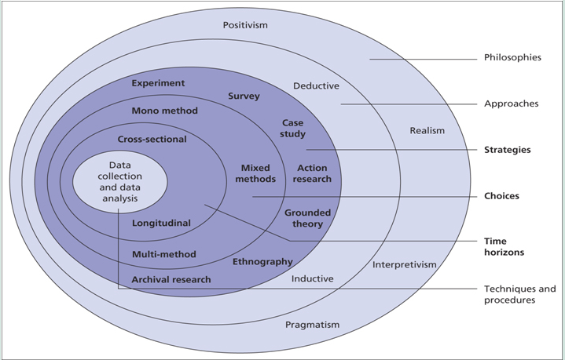
(Saunders et al., 2012)

3.1.1 Philosophies
This research will adopt positivism to confirm research methods. The positivism considers people must collect different information. And then people should scientific, objective and neutral analyze and handle the information to achieve the knowledge for the world (Zhang, 1996). The context of this research is to analyze Internet financial service products and the concept of Internet financial, so it needs scientific, objective and neutral to analyze and evaluate. Then, it can learn the correct knowledge about Internet finance and conclude the suggestions for single period people future. So, this dissertation adopts the philosophies of positivism.

3.1.2 Approach
This research will adopt deduction to analyze the date. Deductive means deduce a specifics conclusion based on a generally principle (Shi, 2016). This dissertation will give some suggestions for single period people through analyzes Internet financial service products and the concept of Internet financial service products of youth. The analysis will based on existing theories or definition, such as the definition of funds, Internet financial, to deduce the new concludes about Internet finance and the new suggestions for young people. So, this research chooses deductive to do next processes.

The deductive is based on the outcomes is qualitative and quantitative analysis. Quantitative analysis analyzes quantitative characteristics, quantitative relations and quantitative changes (UKESSAYS, 2018). This research adopts questionnaires to collect quantitative date, and then it will analyze to achieve quantitative date and achieve the outcomes. So, this research will adopt quantitative analysis.

Sun (2005, p2) considers qualitative analysis is the studying and analysis for essence of items, it is often used to study development trend and characters of items. This research will analyze the outcomes of quantitative analysis for questionnaires and give some suggestions for people. The suggestion is describable language. So, it is suitable for qualitative.

3.1.3 Strategies
This research will adopt survey to collect date. Survey means adopting interview, questionnaires, symposium and other ways to systematic and considerable learn history, development, problems and experience of a activity. And then, it will analyze the information that was collected through survey. This research hands out questionnaires to collect the information about Internet financial service of young people. Then, it will analyze the information to learn the concept of Internet finance for single period peopleand combine some theory to make some suggestions for young people. So, it chooses the survey methods.

3.1.4 Choices
Mixed methods means choose two or more research methods to analyze information, usually it refer to qualitative and a quantitative analysis (UKESSAYS, 2018). This research collects information through questionnaires, so it analyzes the date adopting quantitative analysis. However, the aim of this research is to make some suggestions for young people, so it will adopt the qualitative analysis to analyze the outcomes of quantitative analysis. So this research chooses the mixed methods.

3.1.5 Time horizon
The cross sectional time horizon means collecting the date within an established time range (UKESSAYS, 2018). The time range of this research is one year, which is fixed. So, the date collects, analyzes must be completed within one year. In addition, this research just studies the financial service concepts of single period people at present time. So, this research just collects the information once time. This research adopt cross sectional time horizon to manage time.

3.1.6 Data Collection and Analysis
This research will adopt the primary data from questionnaires and secondary data from Internet. This research will hand out questionnaires to collect information about the financial service concept of single period people. So the data of questionnaires is primary data. This research will collect the information about theory and similarly research from the previous study and the information from Alipay, which are the secondary information. So, this research will collect the primary and secondary information.

3.2 Research processes
First, this dissertation searches the pervious literatures about Internet finance to explain the development of Internet financial. Then, this research study the family life cycle finance theory to learn the financial plan strategies.

Second, it will collect the information about the Internet financial service concept of single period people through questionnaires. Then it will analyze the data of questionnaires by quantitative analysis and combine family life cycle finance theory to research the financial service demands and barriers. It will conclude the financial plan strategies of single period people based on the family life cycle finance theory and outcomes of quantitative analysis.

Third, this research will collect the information of Alipay, which includes the service information, products information and company information. It will analyze the information based on the Internet financial service research.

Fourth, it will combine the financial service strategies of single period people and the characteristics of Internet financial service to conclude some suggestions for single people to finance on the Internet.

3.3 Research methods

3.3.1 Questionnaires
Zhen (2014) considers the questionnaires design and hand out questionnaires to relation people and collect to information, then it statistic analyze the date and achieve the outcomes. This dissertation adopts questionnaires to collect the information of concept of people for Internet finance. In order to increase the accuracy, it will hand out and collect 150 questionnaires. Then it uses quantitative analysis to analyze the date of questionnaires by the SSPS software and summary opinions of people for Internet financial service through the qualitative analysis for the outcomes of quantitative.

It chooses the single period people as the sample. Single period people have more free time to complete the questionnaires. Comparing with older people, they have more learning for Internet.

The problems of questionnaires are the quality and recycle rate cannot be controlled (Zhong and Li, 2012). It will result in the date and analysis inaccuracy. So this dissertation will hand out and more questionnaires and recycle and filtrate questionnaires.

3.4 Limitation and ethics problems
First, this dissertation collect 150 samples, it cannot represent all Chinese concept in Internet financial. It will cause to the conclusions existing little deviation with truth.

Second, due to the limitations of research methods, the analysis cannot consider all parts. So, it lead to the conclusions are not extreme accuracy.

Third, questions of questionnaires refer to privacy problems which lead to the ethics problems. The investment objectives and willing will be required completed, it is privacy information.

Chapter 4

4.1 The information of Alipay
Alipay is the subsidiary company of Ant Financial Services Group and built in 2004. Alipay has corporate with over 200 financial institutions, whose services include payment, personal financial, insurances and charity activities (Alipay, 2021). This research will investigate the personal financial service, so it just collects the information about personal service.

The personal financial services include funds, stocks, golden, loan, insurances, pensions and financial service profiles (Appendix1). In additional, it also provides the consulting services to guidance people finance (Appendix 2). The most famous Internet financial service product is Yu’E Bao of Alipay in China. Yu’E Bao is asset management service, the asset of Yu’E Bao was bought currency funds and people can achieve the benefits each day (Alipay, 2021). It also can be as the payment tool, because it supports many types of trade that include guarantee transaction, instant to account transactions, consolidated payment, Insurance and finance transactions, transfer transaction, personal withholding, general withholding and repayment (Alipay, 2021). The minimum transfer amount is 1 Yuan. It provides the quickly receive services, which people can withdraw and receive the money of Yu’E Bao within 2 hours (Alipay, 2021).

4.2 learning degree analysis about Internet financial service
This research handed out Internet questionnaires to collect the information about the learning and attitude for Internet financial. It collects 158 questionnaires answers. This research will analyze the 158 respondent to research the attitude and view about Internet financial service and search the weakness view and give some suggestions.

This research will analyze learning degree for Internet financial service and the Internet financial service products.

figure 2 Have you ever learned about Internet financial service products
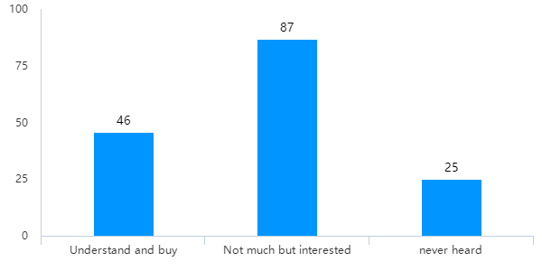
(Source from appendix 4)

This chart shows the people who learned the Internet financial service products. There are 46 people learned and purchased the financial service products. There are 87 people learned not much but they were interesting for Internet products. 25 people are never heard Internet financial service products. 133 people know or brought the Internet financial service products, which means the Internet financial service is popular and playing an important role in personal financial service behaviors.

There are many reasons leading to this phenomenon, which include the life quality improvement, the more free and scattered money, Internet technology advance and the large users of Internet financial service platform. So, people have the awareness of financial service. For understanding the attenuated of financial service for single period people future, this research surveys the necessity of financing for young people.

figure 3What do you think of the necessity of financing
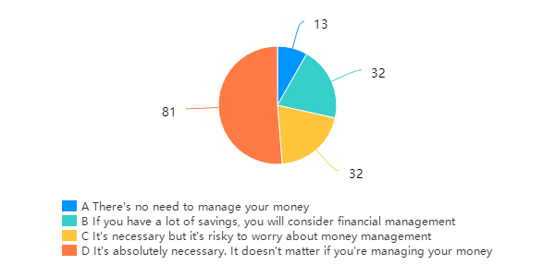
(Source from appendix 4)

This pie chart shows the necessary of financing for young people. In this chart, 81 single period people consider it is necessary to finance, 32 single period people consider financing is necessary, however the risks will affect financing, 32 single period people consider financing when they have redundant savings and 13 single period people consider it is not necessary to finance. This data present 145 single period people possess the awareness of finance, although 64 single period people will be influenced by other factors.

Based on the personal financial service theory, financial service cannot only help people to against inflation, increase the value of asset, but also it can improve the life levels and reduce the financial risks. So, it is necessary and importance for people to make a financial plan. However, 13 people consider it is not necessary to finance and, which means some people lacking the financial education. It is not according with family life cycle finance theory for 32 people who invest Internet financial service when they have large saving. Because single period people want achieve wealth increase rather than capital steadily in this theory. So, there are some conflictions between theory and really environment. The main reason is that people lacking enough learning for financial service, because more than 112 people lacking enough understanding for financial service at above survey.

4.3 Learning degree analysis about Internet financial service
Although most of people learn the financial service, the learning degree of Internet financial is unclearly. This research hands out questionnaires to study this problem.

figure 4Attitude of single period people for Internet financial
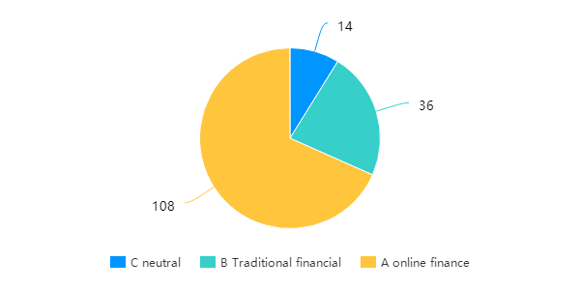
(Source from appendix 4)

This pie chart shows the preference of single period people for Internet financial service and traditional financial service. It shows 108 people are prefer to Internet finance, 36 people are prefer to traditional finance and 14 people are neutral. It presents most of people prefer to Internet finance, which means the Internet financial service are popularly for people and most of people learn the benefits and advantages of Internet financial service and support it.

Based on the first question, there are 133 people learning the financial. However, it is not all people can accept the Internet financial service. For studying learning degree of Internet financial service products people who prefer to Internet finance, this research adopts the crosstab analysis of SPSS to analyze this relations between two areas.

figure 5 crosstab analysis
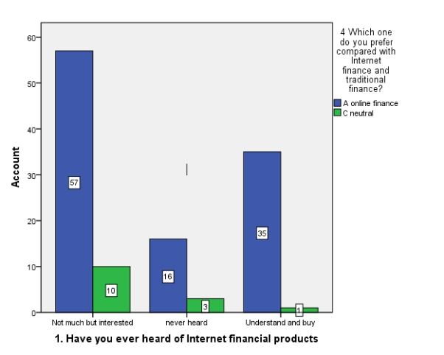
(Source from appendix 4)

This bar chart shows the relations between the people who understand of Internet financial service products and people who prefer to finance on the Internet or neutral. It removes people who prefer to traditional finance, because it cannot present the Internet financial service concepts. 36 people learned well and brought the Internet financial service products, 67 people learned little but not brought and 19 people are not learning it. Comparing with the ratio of Internet supporting for people between understand and buy and not much more interested, the support ratio of understand and buy is higher than not much but interesting, which is 35:1 and 5.7:1. It means people who learn more the Internet financial service will choose Internet financial service more. Oppositely, the little understanding of Internet financial service prevents people to choose Internet financial service. Although the amount of people who neutral are not much in this research, it is so large amount in whole single period people in Chine.

4.4 Finance willing analysis
Above research show the many people lacking enough learning for Internet financial service. This part investigates the invest rate of free money to learn the concepts of single period people future.

figure 6Free money investment ratio
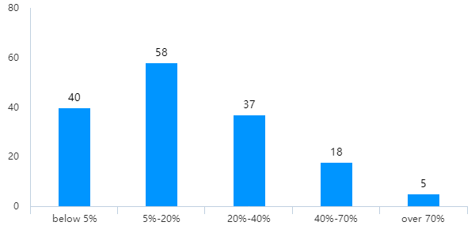
(Source from appendix 4)

This bar chart shows the free money investment rate of young people. 40 single period people invest 5% free money to finance, 58 single period people invest 5%-20% free money to finance, 37 single period people invest 20%-40% to finance, 18 single period people invest 40%-70% free money to finance and 5 single period people invest over 70% free money to finance. 135 single period people just invest below 40% free money on Internet financial, just 23 people want invest large money on Internet financial. It presents most of people unwillingness invest large free money to finance. It means there are large free money cannot be used, the financial plan cannot achieve the financial aim, which are income increase and wealth increase.

For understand the invest rate of people who prefer to Internet finance, this research adopts the crosstab analysis through SPSS.

figure 7crosstab analysis
(Source from appendix 4)

This bar chart shows the invest rate of single period people who prefer to invest Internet financial. It presents 95 single period people prefer to invest below 40% frees money to invest. Although most of single period people support investment on the Internet, the use ratio of free money is low.

Based on the Internet financial service study, the Internet financial plans can make use of the free and scattered money and help people to increase wealth. In family life cycle finance theory, the single period people cannot support family, so they have high rate of free and scattered money. Actually, most of single period people just invest low 40% free and scattered money. According with the study of Fu (2014), the traditional financial service affects the financial concept a lot. Due to the high capital requires of traditional financial, most of people cannot purchase the traditional financial service products. The redemption period also is so long which lead to people cannot redeem the capital within investment period, or cannot achieve the benefits to redeem capital. So, they are used to save more money in the bank and unwilling invest more money to financial.

4.5 Barriers of financial
Last research shows the phenomenon of low investment ratio about free and scattered money. This part will investigate the factors of influence of Internet financial investment, which include risks toleration and factors of effecting people to purchase financial service products.

figure 8 Risks toleration
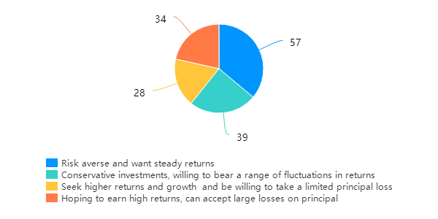
(Source from appendix 4)

This pie chart shows the risks toleration and of young people. 57 single period people disgust risk and want achieve steady returns, 39 single period people can tolerate low risks and want achieve slight high return, 28 people can tolerate middle risk and achieve middle return, and 34 people can tolerate high risks and want achieve high return. 62 people can tolerate middle and high risks and want achieve higher return. Overall, 96 people cannot tolerate middle and high risks, which is not according with the family life cycle financial theory.

Based on the family life cycle finance theory, single period people do not pay for supporting family, children feeding and education expenditure. So, they can tolerate high risks in financial. In additional, single period people have strong consume desire. So they want increase income to satisfy the desire. They want achieve high return and can tolerate high risks in financial service activities. However, over half of people want invest low risks financial service products. It means people have large misgiving in Internet finance.

For learning the reasons why people have large misgiving in purchasing financial service products, this research collects the data of the factors of effecting people to purchase financial service products.

Figure 9Factors of effecting people to purchase financial service products
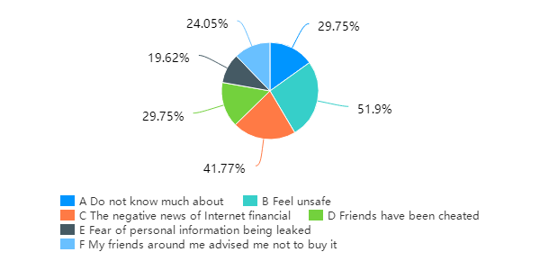
(Source from appendix 4)

Based on the investigation about the factors which effect people to purchase financial service products, the largest factor is people feeling unsafe, 51.9% people feel unsafe to finance on the Internet. 41.7% people are influence by the negative news of financial, 29.7% people reject investment on the financial service product due to be cheated experience of friends or do not know how to invest. 24% people were advised by friends and 19.6% people worry about personal information safety. Most of people are influence by the negative factors of financial.

Based on the 360 Safety Brain statistics (2020), there are 3314 financial frauds in 2019. It caused large negative influence in the social. It causes too many people do not trust the financial service products. In additional, most of people lack the systematic financial education. It also aggravated the possibly of people being cheated. So, there are 51% people feeling unsafe in Internet personal financial service, 41.77% people are influence by negative news of Internet financial.

The main barriers which prevent people investing Internet financial service is Internet safety problems.

4.6 Financial service expectation
After learning the barriers of people finance on the Internet, it researches financial service expectations for single period people to finance to make the suggestions comprehensive.

figure 10Financial service expectations
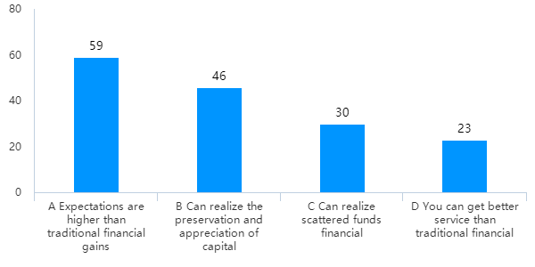(Source from appendix 4)

This bar chart shows the financial service expectations for young people. 59 single period people want achieve higher benefits, 46 single period people want achieve value increase in assets, 30 single period people want use free money to finance and 23 single period people want enjoy better service than traditional financial. So, most of people want achieve wealth increase through finance.

Based on the family life cycle finance theory, the single period people belong high consumption people. They need earn more money to support high consumption. So, the main purpose of personal finance service is increase the income and wealth. It is according with the really environment.

Then, this research investigates the expectations of people who invest Internet financial service. It is directly guidance for this research to make suggestions for single period people.

figure 11What services do you want from Internet financial service platform
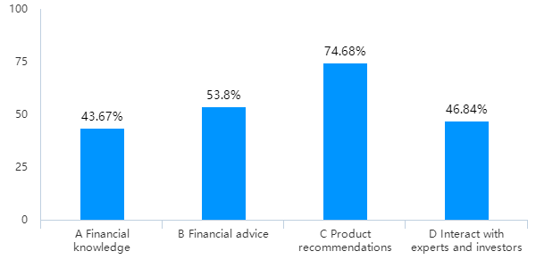
(Source from appendix 4)

In this bar chart, the largest demand of service is products recommendation which have 74.68% people choose it. the second demand is financial service advice which possess 53.8% people choice, the third demand is communication with experts and investors which possess 46.84% people choice and the fourth is financial service knowledge which possess 43.67% people want achieve. Most of people want achieve products recommendation, which means people cannot find satisfaction Internet financial service products by themselves. In other words, most of people need the professional guidance on Internet financial.

4.7 Assist of Internet financial service platform
Last investigation surveys expectation of people who support Internet financial service. This part investigates satisfaction with the Internet financial service consulting service for single period people combining with the first question.

Figure 12 crosstab analysis
Satisfaction of Internet financial service platform consulting service |  | 12 How helpful do you think the online financial service consulting service is to you |  |  |  | Total
 |  | It's very helpful | general | little | nothing help | Total
1. Have you ever heard of Internet financial service products | Understand and buy | 13 | 17 | 11 | 5 | 46
 | Not much but interested | 30 | 29 | 23 | 5 | 87
Total |  | 43 | 46 | 34 | 10 | 133

This chart shows the satisfaction of Internet financial service platform consulting service for single period people who have brought or interesting in Internet financial service products. 43 people consider it is helpful, 46 people consider it is general, 34 people consider it has little help and 10 people consider it cannot provide any help. Most of single period people consider it can help them to purchase the Internet financial service products. It means the consulting service is an important part for Internet financial service platform. However, it is not free for valuable suggestions, so this research investigates the willing to pay for the valuable consulting for young people.

Figure 13 Accept pay for the service
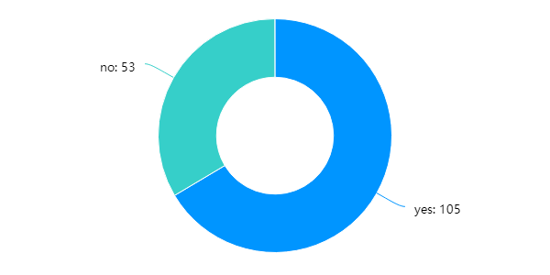
(Source from appendix 4)

This chart shows the attitude of paying for consulting services of young people. 105 people can accept pay for it, 53 people cannot accept it. Two third people can accept the cost of consulting, which means they crave to finance to achieve wealth increase. For satisfying this demands of people, the Internet financial platform, the Internet financial service platform launches many activities, such as financial profiles and group purchase activities. This research investigates willing of people who want attend group purchase activities.

Figure 14Attend group purchase activities
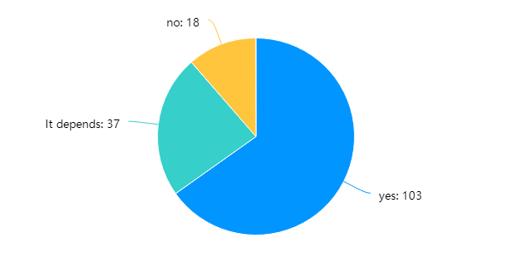
(Source from appendix 4)

This pie chart shows single period people who will attend group purchase activities in the Internet financial service platform. 103 people will attend group purchase activities, 37 people will attend group purchase activities based on different conditions, and 18 people will not attend group purchase activities. Most of single period people will attend group purchase activities of Internet financial service platform, which means marketing of Internet financial service platform possesses large impacts for people.

4.8 Conclusion
This research analyzes the financial service concept of single period people through the quantitative analysis for questionnaires. It also adopts Alipay as the example of Internet financial service platform. Based on the analysis, there are some problems for single period people to finance on the Internet.

First, the single period people lack the learning for Internet financial. Second, most of people who invest or want invest Internet financial service lack enough learning for Internet financial service products. Third, most of people cannot use Internet financial service platform to management free and scattered money. Fourth, most of people lack the systematic education about financial. Sixth, most of people need professional guidance of Internet financial. Last, Internet financial service platform possesses large impacts for people.

Chapter 5 Conclusion

5.1 The review of this research
Since Yu’E Bao built in 2013, the Internet financial service is forced all time and caused large impact for society. So, this research investigates the Internet financial service concept of single period people to conclude some suggestions. This research design adopts research onion of Saunders. The information of this research includes primary data and secondary data. It adopts questionnaires to collect the primary data. The secondary include the relation theory, information about Internet financial service and the information about Alipay. This research main adopts the family life cycle finance theory to analyze the data of questionnaires and conclude the suggestions for single period people. It also studies the Internet financial service and personal financial service.

After analyzing the data of questionnaires, there are some problems for single period people on Internet finance. The problems include lacking education and learning about Internet financial service and Internet financial service products, cannot manage free and scattered money efficiency, needing professional guidance on Internet finance. Those questions will be solved in this chapter.

5.2 Suggestions for single period people
Internet financial service possesses many disadvantages, which include higher benefits, low requires, fixable redemption and investment. People can buy and sale financial service products at anytime and anywhere. The cost of Internet financial service is lower traditional financial service for sellers.

Based on the family life cycle finance theory, the family can be divided by five parts which are singe period, family formative period, growth period, mature period and senescence period. The single period people have not large burden on live and family, they also are high consume group. So, they have large demands of increase wealth through financial. In additional, they also can undertake high risks. So, they can purchase high return and high risks financial service products.

However, based on the financial position of China, most of single period people are not according with requires of traditional financial. So, people will save money in the bank. It caused large free and scattered money cannot be used. The Internet financial service products of Alipay, Yu’E Bao, can solve this problem. It can help people to manage the free and scattered money, because the money of Yu’E Bao can be used to invest funds and the minimum investment amount is 1 Yuan. In additional, the money in Yu’E Bao can be withdrawn at any time and the benefits also can be achieved by people (Alipay, 2021). So, people can invest more free and scattered money in Yu’E Bao.

Most of single period people lacking systematic financial education and the learning for Internet financial service and Internet financial service products. So, they need professional guidance on Internet finance. There is consulting part in the Alipay, which can help people make four financial plans. So, people can find help on the Internet financial service platform to reduce the difficult of Internet financial.

There are many financial fraud events in recently years, it cause negative impacts for Internet financial. When people purchase Internet financial service products, they should choose famous and can ensure the capital safety. So, people can invest Alipay can ensure capital safety and reduce the chances of being cheated.

5.3 The influence of conclusion
It is famous for people to finance on the Internet. Due to the advantages of Internet financial, more and more people are attracted by Internet financial. Most of people lack a guidance and education of Internet financial. When people achieve a guidance from Internet financial service platform, the free and scattered can be use to create people value. In addition, it also can help people avoid invalid investment.

It also can help people to reduce the risks of cheat. Due to the financial fraud were often happened, this research suggest people invest in famous and assets. It can avoid cheat events and ensure asset safely.

Chapter 6 the limitation of this research and future development
There are many disadvantages in this research.

First, the amount sample is 150 which cannot show all the Internet financial service concept of single period people of China. So the outcome is not perfect.

Second, due to the limitation of account, this research cannot analyze all services the Alipay. It cannot provide more detail suggestions for single period people finance on the Internet.

Third, the Internet financial service market often changes, the theory of Internet financial service exist some disadvantages.

So, in the future, this research will update the news theory about family life cycle finance theory to ensure the analysis is right. It also follows the Internet financial service market to improve this research.

Reference

Alipay 支付宝 (2021) Enterprise Profile [online] 企业简介, available at https://about.alipay.com/ (accessed at 3 May 2021)

Alipay 支付宝 (2021) Introduction of Yu’E Bao [online] 余额宝介绍, available at https://cshall.alipay.com/lab/help_detail.htm?help_id=257914&catId=237770 (accessed at 3 May 2021)

Alipay 支付宝 (2021) Yu’E Bao consumption [online] 余额宝消费, available at https://cshall.alipay.com/lab/help_detail.htm?help_id=258083&catId=237772 (accessed at 3 May 2021)

Cai, F.M. 蔡逢敏 (2006) The application of life cycle finance theory in personal finance business 生命周期理财理论在个人理财业务中的应用， Beijing: University of International Business and Economics

Chen, X. 陈旭 (2018) ‘Bottleneck Analysis and Countermeasure Discussion of Internet Financial Products Development in China 我国互联网金融理财产品发展瓶颈分析及对策探讨’ Modern Marketing, 2018(09) pp47-48

Chen, L. 陈琳 (2014) Analysis on influencing factors of residents' behavior of purchasing bank personal finance products居民购买银行个人理财产品行为影响因素分析, Nanjing: Nanjing Agricultural University

Deng, W 邓薇 (2018) Analysis of the influence of Internet finance on residents' investment and financial management 互联网金融对居民投资理财的影响探析, Wuhan: Huazhong University of Science and Technology

Dai, D. 戴丹(2016) Research on the Impact of Internet Finance development on household wealth management互联网金融发展对家庭财富管理影响研究, Zhejiang: Zhejiang University

Fu, J. 傅婕, (2014) Influencing factors and empirical research on consumers' willingness to adopt Internet financial products: Taking Yu 'ebao as an example 消费者互联网理财产品采纳意愿的影响因素及实证研究 ——以余额宝为例, Chendu: Southwestern University of Finance andEconomics

Gai, H. 盖宏 (2014), ‘Risk analysis and legal consideration of Internet financial products互联网金融理财产品的风险分析及法律思考’ Financial View, 2014(06) PP55-56.

Gao, S. and Guo, Y.Q. 高爽; 郭熠倩, (2020) ‘Research on Family Financial Planning in the Context of Internet Finance互联网金融背景下家庭理财规划研究’ Journal of Beijing Vocational College of Economics and Management, 35(03) pp 14-19

Hu, Y. 胡怡 ‘Reflection on the development trend of China's financial planning market 对我国金融理财市场发展趋势的思考’Modern Marketing, 2015(07) pp90-91

Jankowicz, A.D. (1995) Business Research Projects, 4th ed, London : Business Press Thomson Learning

Li, H.Q. Yu, S.N. and Wu, M.X. 李瀚祺, 余胜男, 吴美萱 ‘Analysis on the development status and trend of China's investment and financial management market 我国投资理财市场发展现状及趋势探析’ Chinese market, 2018(20), PP 91-92

Liu, J. 刘佳 (2017) ‘Chinese Internet financial risk analysis and countermeasure research我国互联网金融理财风险分析及对策研究’ Modern Marketing, 2017(08) pp159-156

Liu, G.L. and Zhang, L. 刘光岭 张雷 (2008) ‘Personal finance demand pattern analysis based on life cycle基于生命周期的个人理财需求模式分析’ Economic Problem 2008(03) pp111-113

National Bureau of Statistics国家统计局, (2021) Per Capita Urban Disposable Income城镇居民人均可支配收入, Available at https://data.stats.gov.cn/search.htm?s=城镇居民人均可支配收入 (accessed at 19th February 2021)

Rajasekar, S. Phinlominathan, P. and Chinnathambi, V. (2006) Research Methodology [online], available at https://www.doc88.com/p-0788747684585.html (accessed at 25 February 2021)

Rong360 融360 (2021) The Analysis Report about the Bank Financial Market 银行理财市场分析报告, available at https://static.rong360.com/upload/pdf/32/e8/32e87056621e0c43a3d61380c57988a6.pdf (accessed at 21 February 2021)

Shi, Y.Y. et al. (2018) ‘Analysis of the current situation of Internet financial products Take Yu 'ebao as an example互联网金融理财产品现状分析——以余额宝为例’ Business theory of China中国商论, 2018(05) pp 24-26

Southmoney 南方财富, (2020) What are the hundreds of millions of WeChat users now?
Tencent third-quarter financial results released new data in 2020现在微信用户数量多少亿?2020腾讯三季度财报公布新数据， available at http://www.southmoney.com/caijing/caijingyaowen/202011/7590302.html (accessed at 29 April 2021)

Sun, L.L. 孙丽丽 (2016)The development course and methodology of educational anthropology in Germany since 1960s 20世纪60年代以来德国教育人类学的发展历程及其方法论探究, East China Normal University

Shi, N. Z. 史宁中 (2016) ‘On the Logic of the Process of Mathematical Reasoning What is Logical Reasoning试论数学推理过程的逻辑性——兼论什么是有逻辑的推理’ Journal of Mathematical Education, 25(04), PP1-16

UKEssays. (2018). Research Onion - Explanation of the Concept [online]. Available from: https://www.ukessays.com/essays/psychology/explanation-of-the-concept-of-research-onion-psychology-essay.php?vref=1 [Accessed 25 April 2021]

Wu, X. 吴潇 (2016) ‘Analysis of Internet financial products互联网金融理财产品分析’ Popular Financing, 2016(9) pp124-125

Wang, Y. and Wang, D.M. 王珏 王瑞梅 (2007) ‘Personal finance strategy analysis based on life cycle theory基于生命周期理论的个人理财策略分析’ Consume Guide, 2007(09) P58

Xu, H. 许恒 (2007) Personal financial planning based on life cycle 基于生命周期的个人理财规划, Beijing: University of Science and Technology

Xu, F. 徐凡 (2009) Personal finance investment strategy research based on life cycle finance theory基于生命周期理财理论的个人理财投资策略研究, Xian: Xi’an University of Science and Technology

Yang, Y. and Wang, L.J. 杨莹，王利景 (2015) ‘Analysis of the influence of Internet financial management on financial development互联网理财对金融发展的影响分析’ Foreign Trade, 2015(3), PP107-108

Yun, H. and Wang, X.R. 云虹 王喜荣 (2014) ‘Personal finance strategy research based on life cycle theory基于生命周期理论的个人理财策略研究’ Friends of Accounting, 2009(05), PP47-48

Yi, J. 易娟 （2005）Research on Personal Finance 个人理财研究， Chengdu: Southwestern University of Finance and Economics

Zhou, Q. 周琦 (2008) Analysis of personal finance investment products 个人理财投资产品分析, Chengdu: Southwestern University of Finance and Economics

Zhang, Y. and Li, Q, 张云，李晴 (2008) ‘Personal finance research based on life cycle theory 基于生命周期理论的个人理财研究’ Journal of Jiangxi Finance College, 21(04), pp51-53

Zou, Y.S. and Zhang, Y. 邹亚生，张颖 (2007) ‘Personal finance: analysis based on life cycle theory and modern finance theory个人理财:基于生命周期理论和现代理财理论的分析’ International Business (Journal of University of International Business and Economics, 2007(04), pp48-51

Zhu, J. 朱洁 (2017) Analysis of financial management status of middle class families in Hangzhou and research on financial management strategies杭州市中产阶层家庭理财现状分析及理财策略研究, Hangzhou： Zhejiang University of Technology

Zhong, B.C. and Li, Y. 钟柏昌 李艺 (2012) ‘An analysis of the application of questionnaire survey in the field of education research 问卷调查方法在教育研究领域的应用状况分析’ Open Education Research, 18(06), pp74-79

Zheng, J.J. 郑晶晶 (2014) ‘A review of research on questionnaire survey问卷调查法研究综述’ Theory of observation, 2014(10), pp102-103

Zhang, X.S. 张小山 (1996), ‘Comte on the principle of positivism 孔德实证主义原则论略’ Jianghan BBS, 1996(06), PP33-36

360 Safety Brain 360安全大脑 (2020) A report on online fraud trends in 2019 2019年网络诈骗趋势研究报告, available at http://zt.360.cn/1101061855.php?dtid=1101062366&did=610412125 (accessed at 24 February 2021)

Appendix

Appendix1 The service of Alipay
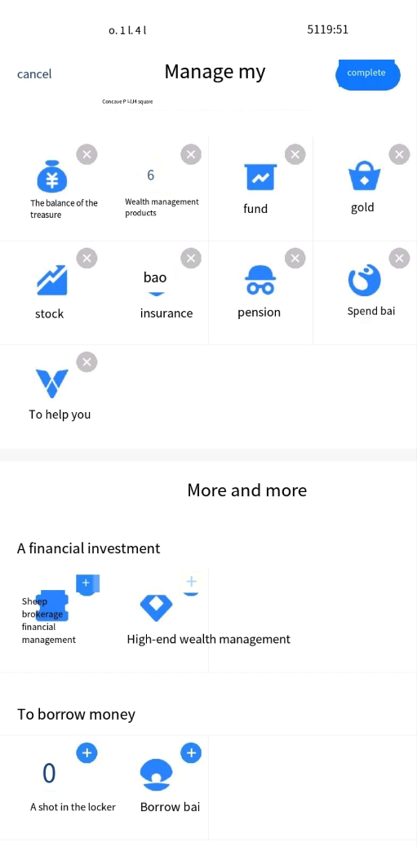

Appendix 2 the consulting service of Alipay

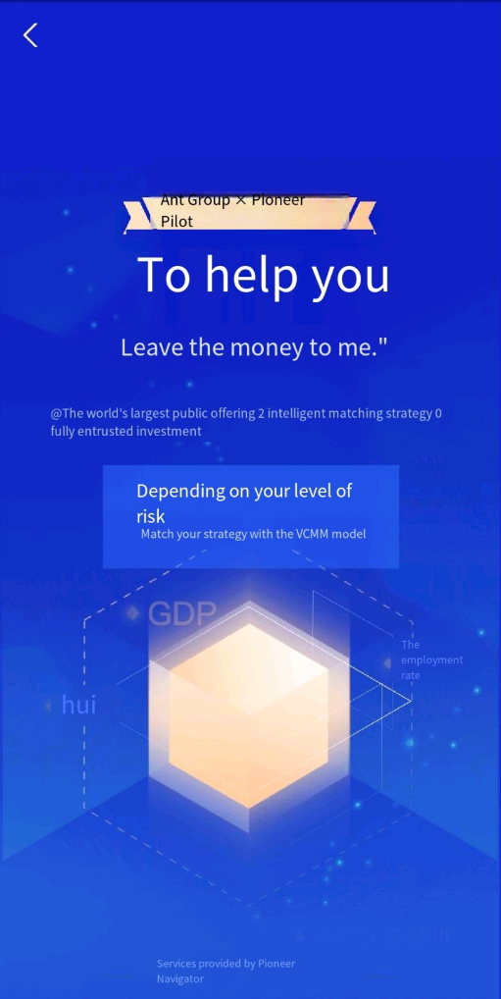

Appendix 3 Questionnaire

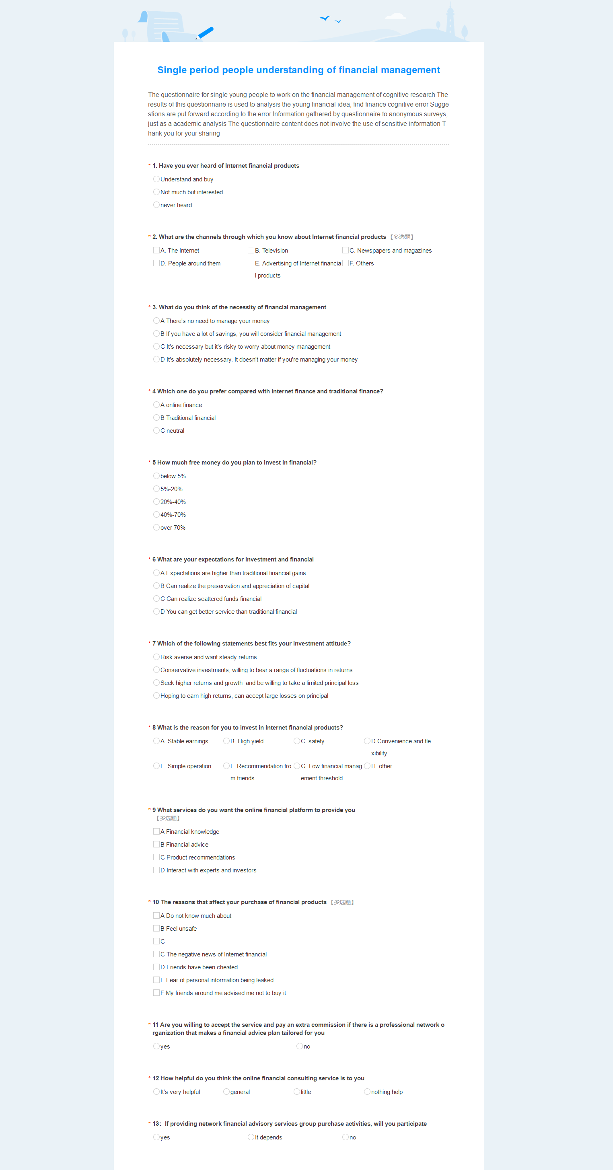

Appendix 4 Answers

Number | 1. Have you ever heard of Internet financial products | 2. What are the channels through which you know about Internet financial products
1 | Understand and buy | A. The Internet┋C. Newspapers and magazines┋E. Advertising of Internet financial products
2 | Not much but interested | A. The Internet┋E. Advertising of Internet financial products
3 | Understand and buy | A. The Internet┋E. Advertising of Internet financial products
4 | never heard | A. The Internet┋B. Television┋D. People around them
5 | Not much but interested | A. The Internet┋B. Television┋D. People around them
6 | Not much but interested | A. The Internet┋E. Advertising of Internet financial products
7 | Understand and buy | C. Newspapers and magazines┋D. People around them┋E. Advertising of Internet financial products
8 | Understand and buy | A. The Internet┋E. Advertising of Internet financial products
9 | Not much but interested | A. The Internet┋E. Advertising of Internet financial products
10 | Understand and buy | A. The Internet┋D. People around them┋E. Advertising of Internet financial products
11 | Understand and buy | A. The Internet┋E. Advertising of Internet financial products
12 | Understand and buy | A. The Internet┋C. Newspapers and magazines
13 | never heard | B. Television┋C. Newspapers and magazines┋D. People around them
14 | Not much but interested | A. The Internet┋E. Advertising of Internet financial products
15 | Understand and buy | A. The Internet┋E. Advertising of Internet financial products
16 | Not much but interested | A. The Internet┋D. People around them┋E. Advertising of Internet financial products
17 | Not much but interested | A. The Internet┋E. Advertising of Internet financial products
18 | Not much but interested | A. The Internet┋E. Advertising of Internet financial products
19 | Not much but interested | A. The Internet┋E. Advertising of Internet financial products
20 | Not much but interested | A. The Internet┋B. Television┋D. People around them
21 | Understand and buy | B. Television┋C. Newspapers and magazines
22 | Understand and buy | B. Television┋C. Newspapers and magazines┋E. Advertising of Internet financial products
23 | never heard | B. Television┋C. Newspapers and magazines┋E. Advertising of Internet financial products
24 | Not much but interested | A. The Internet┋E. Advertising of Internet financial products
25 | Not much but interested | B. Television┋C. Newspapers and magazines
26 | Not much but interested | A. The Internet┋E. Advertising of Internet financial products
27 | Understand and buy | C. Newspapers and magazines┋D. People around them┋E. Advertising of Internet financial products
28 | Not much but interested | A. The Internet┋E. Advertising of Internet financial products
29 | Not much but interested | A. The Internet┋B. Television
30 | Understand and buy | C. Newspapers and magazines┋D. People around them┋E. Advertising of Internet financial products
31 | Not much but interested | B. Television┋C. Newspapers and magazines┋E. Advertising of Internet financial products
32 | Not much but interested | A. The Internet┋E. Advertising of Internet financial products
33 | Not much but interested | B. Television┋C. Newspapers and magazines┋E. Advertising of Internet financial products
34 | never heard | B. Television┋C. Newspapers and magazines
35 | never heard | C. Newspapers and magazines┋D. People around them
36 | Understand and buy | A. The Internet┋E. Advertising of Internet financial products
37 | Understand and buy | A. The Internet┋E. Advertising of Internet financial products
38 | never heard | A. The Internet┋E. Advertising of Internet financial products
39 | Understand and buy | B. Television┋C. Newspapers and magazines┋E. Advertising of Internet financial products
40 | never heard | A. The Internet┋D. People around them┋E. Advertising of Internet financial products
41 | never heard | A. The Internet┋E. Advertising of Internet financial products
42 | Understand and buy | A. The Internet┋E. Advertising of Internet financial products
43 | Not much but interested | B. Television┋C. Newspapers and magazines
44 | Understand and buy | A. The Internet┋D. People around them┋E. Advertising of Internet financial products
45 | Not much but interested | A. The Internet┋D. People around them┋E. Advertising of Internet financial products
46 | never heard | A. The Internet┋E. Advertising of Internet financial products
47 | never heard | B. Television┋C. Newspapers and magazines┋E. Advertising of Internet financial products
48 | Not much but interested | B. Television┋C. Newspapers and magazines┋E. Advertising of Internet financial products
49 | Not much but interested | A. The Internet┋E. Advertising of Internet financial products
50 | never heard | A. The Internet┋E. Advertising of Internet financial products
51 | Not much but interested | A. The Internet┋E. Advertising of Internet financial products
52 | Not much but interested | C. Newspapers and magazines┋D. People around them
53 | never heard | B. Television┋C. Newspapers and magazines┋E. Advertising of Internet financial products
54 | Not much but interested | A. The Internet┋D. People around them┋E. Advertising of Internet financial products
55 | Not much but interested | A. The Internet┋E. Advertising of Internet financial products
56 | Not much but interested | D. People around them┋E. Advertising of Internet financial products
57 | Not much but interested | A. The Internet┋E. Advertising of Internet financial products
58 | never heard | A. The Internet┋D. People around them┋E. Advertising of Internet financial products
59 | Not much but interested | A. The Internet┋E. Advertising of Internet financial products
60 | Not much but interested | A. The Internet┋D. People around them┋E. Advertising of Internet financial products
61 | Not much but interested | A. The Internet┋D. People around them┋E. Advertising of Internet financial products
62 | Understand and buy | A. The Internet┋B. Television┋D. People around them
63 | Not much but interested | B. Television┋C. Newspapers and magazines
64 | Understand and buy | B. Television┋C. Newspapers and magazines
65 | Understand and buy | A. The Internet┋E. Advertising of Internet financial products
66 | Understand and buy | A. The Internet┋B. Television
67 | Understand and buy | A. The Internet┋D. People around them┋E. Advertising of Internet financial products
68 | Not much but interested | A. The Internet┋E. Advertising of Internet financial products
69 | Understand and buy | B. Television┋D. People around them
70 | never heard | A. The Internet┋E. Advertising of Internet financial products
71 | Understand and buy | A. The Internet┋E. Advertising of Internet financial products
72 | Understand and buy | A. The Internet┋D. People around them┋E. Advertising of Internet financial products
73 | Understand and buy | B. Television┋C. Newspapers and magazines
74 | Understand and buy | A. The Internet┋B. Television┋D. People around them
75 | Not much but interested | A. The Internet┋E. Advertising of Internet financial products
76 | Not much but interested | A. The Internet┋D. People around them┋E. Advertising of Internet financial products
77 | Understand and buy | B. Television┋C. Newspapers and magazines
78 | Not much but interested | C. Newspapers and magazines┋D. People around them
79 | Not much but interested | B. Television┋C. Newspapers and magazines
80 | Not much but interested | A. The Internet┋E. Advertising of Internet financial products
81 | never heard | A. The Internet┋D. People around them┋E. Advertising of Internet financial products
82 | Understand and buy | A. The Internet┋C. Newspapers and magazines┋E. Advertising of Internet financial products
83 | Not much but interested | A. The Internet┋C. Newspapers and magazines┋E. Advertising of Internet financial products
84 | Not much but interested | A. The Internet┋E. Advertising of Internet financial products
85 | Not much but interested | A. The Internet┋E. Advertising of Internet financial products
86 | Not much but interested | A. The Internet┋E. Advertising of Internet financial products
87 | Not much but interested | A. The Internet┋D. People around them┋E. Advertising of Internet financial products
88 | never heard | A. The Internet┋C. Newspapers and magazines┋E. Advertising of Internet financial products
89 | Not much but interested | A. The Internet┋D. People around them┋E. Advertising of Internet financial products
90 | never heard | A. The Internet┋E. Advertising of Internet financial products
91 | Not much but interested | A. The Internet┋B. Television┋D. People around them
92 | Not much but interested | B. Television┋C. Newspapers and magazines
93 | Not much but interested | A. The Internet┋E. Advertising of Internet financial products
94 | Understand and buy | B. Television┋C. Newspapers and magazines┋E. Advertising of Internet financial products
95 | Not much but interested | D. People around them┋E. Advertising of Internet financial products
96 | Understand and buy | A. The Internet┋D. People around them┋E. Advertising of Internet financial products
97 | Not much but interested | A. The Internet┋E. Advertising of Internet financial products
98 | Understand and buy | A. The Internet┋D. People around them┋E. Advertising of Internet financial products
99 | Understand and buy | A. The Internet┋D. People around them┋E. Advertising of Internet financial products
100 | Understand and buy | A. The Internet┋E. Advertising of Internet financial products
101 | Not much but interested | A. The Internet┋E. Advertising of Internet financial products
102 | Not much but interested | A. The Internet┋C. Newspapers and magazines
103 | Not much but interested | A. The Internet┋E. Advertising of Internet financial products
104 | Understand and buy | A. The Internet┋E. Advertising of Internet financial products
105 | Understand and buy | A. The Internet┋D. People around them┋E. Advertising of Internet financial products
106 | Not much but interested | B. Television┋C. Newspapers and magazines┋E. Advertising of Internet financial products
107 | Not much but interested | A. The Internet┋D. People around them┋E. Advertising of Internet financial products
108 | Not much but interested | A. The Internet┋C. Newspapers and magazines┋E. Advertising of Internet financial products
109 | Not much but interested | A. The Internet┋E. Advertising of Internet financial products
110 | Not much but interested | A. The Internet┋E. Advertising of Internet financial products
111 | Understand and buy | C. Newspapers and magazines┋D. People around them
112 | Not much but interested | C. Newspapers and magazines┋D. People around them┋E. Advertising of Internet financial products
113 | never heard | A. The Internet┋E. Advertising of Internet financial products
114 | Not much but interested | A. The Internet┋B. Television
115 | never heard | A. The Internet┋E. Advertising of Internet financial products
116 | never heard | A. The Internet┋E. Advertising of Internet financial products
117 | Not much but interested | A. The Internet┋D. People around them┋E. Advertising of Internet financial products
118 | Understand and buy | D. People around them┋E. Advertising of Internet financial products
119 | Not much but interested | A. The Internet┋E. Advertising of Internet financial products
120 | Not much but interested | A. The Internet┋E. Advertising of Internet financial products
121 | Not much but interested | B. Television┋C. Newspapers and magazines
122 | Understand and buy | C. Newspapers and magazines┋D. People around them┋E. Advertising of Internet financial products
123 | Not much but interested | B. Television┋C. Newspapers and magazines
124 | Not much but interested | A. The Internet┋D. People around them┋E. Advertising of Internet financial products
125 | Not much but interested | A. The Internet┋C. Newspapers and magazines
126 | Not much but interested | B. Television┋C. Newspapers and magazines
127 | never heard | C. Newspapers and magazines┋D. People around them┋E. Advertising of Internet financial products
128 | Not much but interested | A. The Internet┋E. Advertising of Internet financial products
129 | Not much but interested | A. The Internet┋C. Newspapers and magazines
130 | Understand and buy | A. The Internet┋E. Advertising of Internet financial products
131 | never heard | A. The Internet┋D. People around them┋E. Advertising of Internet financial products
132 | Not much but interested | A. The Internet┋D. People around them┋E. Advertising of Internet financial products
133 | Understand and buy | A. The Internet┋E. Advertising of Internet financial products
134 | Not much but interested | A. The Internet┋D. People around them┋E. Advertising of Internet financial products
135 | Not much but interested | A. The Internet┋E. Advertising of Internet financial products
136 | never heard | A. The Internet┋E. Advertising of Internet financial products
137 | Not much but interested | A. The Internet┋D. People around them┋E. Advertising of Internet financial products
138 | Not much but interested | A. The Internet┋E. Advertising of Internet financial products
139 | Understand and buy | A. The Internet┋E. Advertising of Internet financial products
140 | Not much but interested | A. The Internet┋E. Advertising of Internet financial products
141 | Not much but interested | A. The Internet┋E. Advertising of Internet financial products
142 | Not much but interested | B. Television┋C. Newspapers and magazines┋D. People around them
143 | Understand and buy | A. The Internet┋E. Advertising of Internet financial products
144 | Not much but interested | A. The Internet┋D. People around them┋E. Advertising of Internet financial products
145 | Not much but interested | A. The Internet┋E. Advertising of Internet financial products
146 | Not much but interested | A. The Internet┋E. Advertising of Internet financial products
147 | Not much but interested | A. The Internet┋D. People around them┋E. Advertising of Internet financial products
148 | Not much but interested | A. The Internet┋D. People around them┋E. Advertising of Internet financial products
149 | Not much but interested | A. The Internet┋E. Advertising of Internet financial products
150 | never heard | A. The Internet┋C. Newspapers and magazines
151 | Understand and buy | C. Newspapers and magazines┋D. People around them┋E. Advertising of Internet financial products
152 | Not much but interested | A. The Internet┋E. Advertising of Internet financial products
153 | Not much but interested | A. The Internet┋E. Advertising of Internet financial products
154 | Understand and buy | B. Television┋C. Newspapers and magazines┋E. Advertising of Internet financial products
155 | Not much but interested | A. The Internet┋C. Newspapers and magazines
156 | never heard | D. People around them┋E. Advertising of Internet financial products
157 | Understand and buy | A. The Internet┋D. People around them┋E. Advertising of Internet financial products
158 | Not much but interested | B. Television┋C. Newspapers and magazines┋E. Advertising of Internet financial products

3. What do you think of the necessity of financial management | 4 Which one do you prefer compared with Internet finance and traditional finance?
D It's absolutely necessary. It doesn't matter if you're managing your money | A online finance
C It's necessary but it's risky to worry about money management | B Traditional financial
D It's absolutely necessary. It doesn't matter if you're managing your money | A online finance
D It's absolutely necessary. It doesn't matter if you're managing your money | C neutral
C It's necessary but it's risky to worry about money management | A online finance
D It's absolutely necessary. It doesn't matter if you're managing your money | A online finance
D It's absolutely necessary. It doesn't matter if you're managing your money | A online finance
D It's absolutely necessary. It doesn't matter if you're managing your money | A online finance
A There's no need to manage your money | A online finance
D It's absolutely necessary. It doesn't matter if you're managing your money | B Traditional financial
B If you have a lot of savings, you will consider financial management | A online finance
B If you have a lot of savings, you will consider financial management | A online finance
D It's absolutely necessary. It doesn't matter if you're managing your money | B Traditional financial
B If you have a lot of savings, you will consider financial management | A online finance
C It's necessary but it's risky to worry about money management | A online finance
B If you have a lot of savings, you will consider financial management | A online finance
D It's absolutely necessary. It doesn't matter if you're managing your money | C neutral
D It's absolutely necessary. It doesn't matter if you're managing your money | A online finance
D It's absolutely necessary. It doesn't matter if you're managing your money | C neutral
D It's absolutely necessary. It doesn't matter if you're managing your money | C neutral
C It's necessary but it's risky to worry about money management | A online finance
C It's necessary but it's risky to worry about money management | A online finance
C It's necessary but it's risky to worry about money management | A online finance
D It's absolutely necessary. It doesn't matter if you're managing your money | A online finance
C It's necessary but it's risky to worry about money management | B Traditional financial
C It's necessary but it's risky to worry about money management | A online finance
D It's absolutely necessary. It doesn't matter if you're managing your money | B Traditional financial
A There's no need to manage your money | A online finance
A There's no need to manage your money | A online finance
D It's absolutely necessary. It doesn't matter if you're managing your money | A online finance
D It's absolutely necessary. It doesn't matter if you're managing your money | A online finance
D It's absolutely necessary. It doesn't matter if you're managing your money | B Traditional financial
B If you have a lot of savings, you will consider financial management | B Traditional financial
B If you have a lot of savings, you will consider financial management | A online finance
D It's absolutely necessary. It doesn't matter if you're managing your money | A online finance
D It's absolutely necessary. It doesn't matter if you're managing your money | A online finance
D It's absolutely necessary. It doesn't matter if you're managing your money | A online finance
D It's absolutely necessary. It doesn't matter if you're managing your money | A online finance
D It's absolutely necessary. It doesn't matter if you're managing your money | A online finance
D It's absolutely necessary. It doesn't matter if you're managing your money | B Traditional financial
D It's absolutely necessary. It doesn't matter if you're managing your money | A online finance
C It's necessary but it's risky to worry about money management | C neutral
D It's absolutely necessary. It doesn't matter if you're managing your money | A online finance
B If you have a lot of savings, you will consider financial management | B Traditional financial
D It's absolutely necessary. It doesn't matter if you're managing your money | B Traditional financial
B If you have a lot of savings, you will consider financial management | A online finance
D It's absolutely necessary. It doesn't matter if you're managing your money | B Traditional financial
B If you have a lot of savings, you will consider financial management | A online finance
A There's no need to manage your money | B Traditional financial
A There's no need to manage your money | B Traditional financial
B If you have a lot of savings, you will consider financial management | A online finance
D It's absolutely necessary. It doesn't matter if you're managing your money | A online finance
C It's necessary but it's risky to worry about money management | A online finance
B If you have a lot of savings, you will consider financial management | A online finance
D It's absolutely necessary. It doesn't matter if you're managing your money | A online finance
D It's absolutely necessary. It doesn't matter if you're managing your money | B Traditional financial
C It's necessary but it's risky to worry about money management | B Traditional financial
D It's absolutely necessary. It doesn't matter if you're managing your money | B Traditional financial
D It's absolutely necessary. It doesn't matter if you're managing your money | C neutral
D It's absolutely necessary. It doesn't matter if you're managing your money | B Traditional financial
D It's absolutely necessary. It doesn't matter if you're managing your money | A online finance
D It's absolutely necessary. It doesn't matter if you're managing your money | B Traditional financial
B If you have a lot of savings, you will consider financial management | C neutral
D It's absolutely necessary. It doesn't matter if you're managing your money | A online finance
D It's absolutely necessary. It doesn't matter if you're managing your money | A online finance
C It's necessary but it's risky to worry about money management | A online finance
C It's necessary but it's risky to worry about money management | B Traditional financial
C It's necessary but it's risky to worry about money management | A online finance
A There's no need to manage your money | A online finance
D It's absolutely necessary. It doesn't matter if you're managing your money | A online finance
C It's necessary but it's risky to worry about money management | A online finance
D It's absolutely necessary. It doesn't matter if you're managing your money | B Traditional financial
D It's absolutely necessary. It doesn't matter if you're managing your money | B Traditional financial
C It's necessary but it's risky to worry about money management | A online finance
D It's absolutely necessary. It doesn't matter if you're managing your money | C neutral
D It's absolutely necessary. It doesn't matter if you're managing your money | A online finance
B If you have a lot of savings, you will consider financial management | A online finance
D It's absolutely necessary. It doesn't matter if you're managing your money | C neutral
C It's necessary but it's risky to worry about money management | B Traditional financial
C It's necessary but it's risky to worry about money management | A online finance
D It's absolutely necessary. It doesn't matter if you're managing your money | A online finance
A There's no need to manage your money | B Traditional financial
D It's absolutely necessary. It doesn't matter if you're managing your money | A online finance
B If you have a lot of savings, you will consider financial management | B Traditional financial
D It's absolutely necessary. It doesn't matter if you're managing your money | B Traditional financial
C It's necessary but it's risky to worry about money management | A online finance
D It's absolutely necessary. It doesn't matter if you're managing your money | A online finance
B If you have a lot of savings, you will consider financial management | C neutral
D It's absolutely necessary. It doesn't matter if you're managing your money | A online finance
D It's absolutely necessary. It doesn't matter if you're managing your money | A online finance
D It's absolutely necessary. It doesn't matter if you're managing your money | A online finance
D It's absolutely necessary. It doesn't matter if you're managing your money | A online finance
D It's absolutely necessary. It doesn't matter if you're managing your money | A online finance
C It's necessary but it's risky to worry about money management | A online finance
D It's absolutely necessary. It doesn't matter if you're managing your money | A online finance
D It's absolutely necessary. It doesn't matter if you're managing your money | A online finance
C It's necessary but it's risky to worry about money management | A online finance
D It's absolutely necessary. It doesn't matter if you're managing your money | A online finance
D It's absolutely necessary. It doesn't matter if you're managing your money | A online finance
A There's no need to manage your money | A online finance
D It's absolutely necessary. It doesn't matter if you're managing your money | A online finance
D It's absolutely necessary. It doesn't matter if you're managing your money | B Traditional financial
D It's absolutely necessary. It doesn't matter if you're managing your money | B Traditional financial
D It's absolutely necessary. It doesn't matter if you're managing your money | B Traditional financial
C It's necessary but it's risky to worry about money management | A online finance
D It's absolutely necessary. It doesn't matter if you're managing your money | A online finance
D It's absolutely necessary. It doesn't matter if you're managing your money | A online finance
B If you have a lot of savings, you will consider financial management | C neutral
B If you have a lot of savings, you will consider financial management | A online finance
D It's absolutely necessary. It doesn't matter if you're managing your money | A online finance
D It's absolutely necessary. It doesn't matter if you're managing your money | A online finance
D It's absolutely necessary. It doesn't matter if you're managing your money | A online finance
C It's necessary but it's risky to worry about money management | A online finance
D It's absolutely necessary. It doesn't matter if you're managing your money | A online finance
D It's absolutely necessary. It doesn't matter if you're managing your money | A online finance
B If you have a lot of savings, you will consider financial management | A online finance
C It's necessary but it's risky to worry about money management | A online finance
D It's absolutely necessary. It doesn't matter if you're managing your money | A online finance
B If you have a lot of savings, you will consider financial management | B Traditional financial
D It's absolutely necessary. It doesn't matter if you're managing your money | B Traditional financial
D It's absolutely necessary. It doesn't matter if you're managing your money | A online finance
D It's absolutely necessary. It doesn't matter if you're managing your money | A online finance
B If you have a lot of savings, you will consider financial management | B Traditional financial
D It's absolutely necessary. It doesn't matter if you're managing your money | C neutral
D It's absolutely necessary. It doesn't matter if you're managing your money | A online finance
B If you have a lot of savings, you will consider financial management | A online finance
B If you have a lot of savings, you will consider financial management | C neutral
B If you have a lot of savings, you will consider financial management | C neutral
D It's absolutely necessary. It doesn't matter if you're managing your money | A online finance
D It's absolutely necessary. It doesn't matter if you're managing your money | B Traditional financial
C It's necessary but it's risky to worry about money management | A online finance
C It's necessary but it's risky to worry about money management | A online finance
B If you have a lot of savings, you will consider financial management | A online finance
B If you have a lot of savings, you will consider financial management | A online finance
B If you have a lot of savings, you will consider financial management | B Traditional financial
D It's absolutely necessary. It doesn't matter if you're managing your money | A online finance
C It's necessary but it's risky to worry about money management | A online finance
A There's no need to manage your money | A online finance
D It's absolutely necessary. It doesn't matter if you're managing your money | A online finance
B If you have a lot of savings, you will consider financial management | A online finance
B If you have a lot of savings, you will consider financial management | A online finance
D It's absolutely necessary. It doesn't matter if you're managing your money | A online finance
B If you have a lot of savings, you will consider financial management | A online finance
C It's necessary but it's risky to worry about money management | A online finance
C It's necessary but it's risky to worry about money management | B Traditional financial
B If you have a lot of savings, you will consider financial management | A online finance
A There's no need to manage your money | B Traditional financial
D It's absolutely necessary. It doesn't matter if you're managing your money | A online finance
C It's necessary but it's risky to worry about money management | A online finance
B If you have a lot of savings, you will consider financial management | B Traditional financial
A There's no need to manage your money | A online finance
D It's absolutely necessary. It doesn't matter if you're managing your money | A online finance
A There's no need to manage your money | A online finance
C It's necessary but it's risky to worry about money management | A online finance
D It's absolutely necessary. It doesn't matter if you're managing your money | A online finance
B If you have a lot of savings, you will consider financial management | A online finance
A There's no need to manage your money | A online finance
C It's necessary but it's risky to worry about money management | A online finance
5 How much free money do you plan to invest in financial? | 6 What are your expectations for investment and financial
5%-20% | A Expectations are higher than traditional financial gains
over 70% | B Can realize the preservation and appreciation of capital
below 5% | A Expectations are higher than traditional financial gains
20%-40% | C Can realize scattered funds financial
5%-20% | D You can get better service than traditional financial
20%-40% | C Can realize scattered funds financial
40%-70% | A Expectations are higher than traditional financial gains
20%-40% | A Expectations are higher than traditional financial gains
below 5% | C Can realize scattered funds financial
20%-40% | A Expectations are higher than traditional financial gains
below 5% | B Can realize the preservation and appreciation of capital
5%-20% | B Can realize the preservation and appreciation of capital
5%-20% | D You can get better service than traditional financial
5%-20% | D You can get better service than traditional financial
below 5% | C Can realize scattered funds financial
below 5% | C Can realize scattered funds financial
40%-70% | B Can realize the preservation and appreciation of capital
below 5% | A Expectations are higher than traditional financial gains
20%-40% | A Expectations are higher than traditional financial gains
5%-20% | C Can realize scattered funds financial
5%-20% | D You can get better service than traditional financial
20%-40% | A Expectations are higher than traditional financial gains
5%-20% | A Expectations are higher than traditional financial gains
20%-40% | D You can get better service than traditional financial
5%-20% | B Can realize the preservation and appreciation of capital
20%-40% | B Can realize the preservation and appreciation of capital
20%-40% | A Expectations are higher than traditional financial gains
5%-20% | A Expectations are higher than traditional financial gains
below 5% | A Expectations are higher than traditional financial gains
5%-20% | B Can realize the preservation and appreciation of capital
below 5% | A Expectations are higher than traditional financial gains
below 5% | A Expectations are higher than traditional financial gains
below 5% | A Expectations are higher than traditional financial gains
5%-20% | D You can get better service than traditional financial
below 5% | A Expectations are higher than traditional financial gains
20%-40% | A Expectations are higher than traditional financial gains
5%-20% | B Can realize the preservation and appreciation of capital
5%-20% | A Expectations are higher than traditional financial gains
5%-20% | B Can realize the preservation and appreciation of capital
below 5% | A Expectations are higher than traditional financial gains
20%-40% | B Can realize the preservation and appreciation of capital
5%-20% | B Can realize the preservation and appreciation of capital
5%-20% | D You can get better service than traditional financial
20%-40% | B Can realize the preservation and appreciation of capital
20%-40% | A Expectations are higher than traditional financial gains
5%-20% | D You can get better service than traditional financial
over 70% | A Expectations are higher than traditional financial gains
5%-20% | B Can realize the preservation and appreciation of capital
5%-20% | B Can realize the preservation and appreciation of capital
5%-20% | C Can realize scattered funds financial
20%-40% | B Can realize the preservation and appreciation of capital
below 5% | D You can get better service than traditional financial
40%-70% | C Can realize scattered funds financial
20%-40% | C Can realize scattered funds financial
20%-40% | C Can realize scattered funds financial
40%-70% | C Can realize scattered funds financial
20%-40% | C Can realize scattered funds financial
20%-40% | A Expectations are higher than traditional financial gains
40%-70% | D You can get better service than traditional financial
5%-20% | D You can get better service than traditional financial
below 5% | D You can get better service than traditional financial
20%-40% | D You can get better service than traditional financial
20%-40% | B Can realize the preservation and appreciation of capital
20%-40% | A Expectations are higher than traditional financial gains
40%-70% | A Expectations are higher than traditional financial gains
5%-20% | B Can realize the preservation and appreciation of capital
below 5% | B Can realize the preservation and appreciation of capital
5%-20% | A Expectations are higher than traditional financial gains
5%-20% | C Can realize scattered funds financial
5%-20% | B Can realize the preservation and appreciation of capital
5%-20% | A Expectations are higher than traditional financial gains
20%-40% | C Can realize scattered funds financial
40%-70% | A Expectations are higher than traditional financial gains
below 5% | A Expectations are higher than traditional financial gains
below 5% | A Expectations are higher than traditional financial gains
5%-20% | C Can realize scattered funds financial
5%-20% | B Can realize the preservation and appreciation of capital
below 5% | B Can realize the preservation and appreciation of capital
below 5% | B Can realize the preservation and appreciation of capital
20%-40% | D You can get better service than traditional financial
20%-40% | A Expectations are higher than traditional financial gains
5%-20% | A Expectations are higher than traditional financial gains
40%-70% | C Can realize scattered funds financial
40%-70% | B Can realize the preservation and appreciation of capital
5%-20% | C Can realize scattered funds financial
below 5% | C Can realize scattered funds financial
5%-20% | D You can get better service than traditional financial
5%-20% | C Can realize scattered funds financial
5%-20% | C Can realize scattered funds financial
5%-20% | C Can realize scattered funds financial
below 5% | B Can realize the preservation and appreciation of capital
20%-40% | C Can realize scattered funds financial
5%-20% | A Expectations are higher than traditional financial gains
5%-20% | D You can get better service than traditional financial
5%-20% | B Can realize the preservation and appreciation of capital
5%-20% | C Can realize scattered funds financial
5%-20% | C Can realize scattered funds financial
5%-20% | D You can get better service than traditional financial
below 5% | D You can get better service than traditional financial
below 5% | D You can get better service than traditional financial
below 5% | A Expectations are higher than traditional financial gains
5%-20% | A Expectations are higher than traditional financial gains
20%-40% | A Expectations are higher than traditional financial gains
below 5% | A Expectations are higher than traditional financial gains
5%-20% | D You can get better service than traditional financial
40%-70% | B Can realize the preservation and appreciation of capital
5%-20% | B Can realize the preservation and appreciation of capital
below 5% | A Expectations are higher than traditional financial gains
below 5% | A Expectations are higher than traditional financial gains
20%-40% | B Can realize the preservation and appreciation of capital
20%-40% | A Expectations are higher than traditional financial gains
5%-20% | B Can realize the preservation and appreciation of capital
20%-40% | B Can realize the preservation and appreciation of capital
over 70% | A Expectations are higher than traditional financial gains
40%-70% | A Expectations are higher than traditional financial gains
20%-40% | B Can realize the preservation and appreciation of capital
5%-20% | C Can realize scattered funds financial
5%-20% | C Can realize scattered funds financial
5%-20% | B Can realize the preservation and appreciation of capital
40%-70% | A Expectations are higher than traditional financial gains
below 5% | A Expectations are higher than traditional financial gains
5%-20% | A Expectations are higher than traditional financial gains
20%-40% | B Can realize the preservation and appreciation of capital
over 70% | B Can realize the preservation and appreciation of capital
below 5% | B Can realize the preservation and appreciation of capital
40%-70% | C Can realize scattered funds financial
5%-20% | A Expectations are higher than traditional financial gains
5%-20% | B Can realize the preservation and appreciation of capital
5%-20% | C Can realize scattered funds financial
below 5% | A Expectations are higher than traditional financial gains
5%-20% | B Can realize the preservation and appreciation of capital
below 5% | A Expectations are higher than traditional financial gains
40%-70% | B Can realize the preservation and appreciation of capital
20%-40% | A Expectations are higher than traditional financial gains
40%-70% | B Can realize the preservation and appreciation of capital
over 70% | D You can get better service than traditional financial
20%-40% | B Can realize the preservation and appreciation of capital
below 5% | B Can realize the preservation and appreciation of capital
5%-20% | A Expectations are higher than traditional financial gains
40%-70% | C Can realize scattered funds financial
5%-20% | D You can get better service than traditional financial
20%-40% | A Expectations are higher than traditional financial gains
below 5% | B Can realize the preservation and appreciation of capital
below 5% | C Can realize scattered funds financial
5%-20% | A Expectations are higher than traditional financial gains
below 5% | B Can realize the preservation and appreciation of capital
20%-40% | D You can get better service than traditional financial
40%-70% | A Expectations are higher than traditional financial gains
20%-40% | A Expectations are higher than traditional financial gains
5%-20% | A Expectations are higher than traditional financial gains
below 5% | B Can realize the preservation and appreciation of capital
20%-40% | A Expectations are higher than traditional financial gains
below 5% | A Expectations are higher than traditional financial gains
below 5% | A Expectations are higher than traditional financial gains
40%-70% | A Expectations are higher than traditional financial gains
5%-20% | A Expectations are higher than traditional financial gains
below 5% | B Can realize the preservation and appreciation of capital
below 5% | B Can realize the preservation and appreciation of capital

7 Which of the following statements best fits your investment attitude? | 8 What is the reason for you to invest in Internet financial products?
Seek higher returns and growth and be willing to take a limited principal loss | C. safety
Hoping to earn high returns, can accept large losses on principal | G. Low financial management threshold
Hoping to earn high returns, can accept large losses on principal | C. safety
Risk averse and want steady returns | E. Simple operation
Conservative investments, willing to bear a range of fluctuations in returns | E. Simple operation
Hoping to earn high returns, can accept large losses on principal | A. Stable earnings
Risk averse and want steady returns | C. safety
Hoping to earn high returns, can accept large losses on principal | A. Stable earnings
Hoping to earn high returns, can accept large losses on principal | F. Recommendation from friends
Hoping to earn high returns, can accept large losses on principal | A. Stable earnings
Seek higher returns and growth and be willing to take a limited principal loss | E. Simple operation
Seek higher returns and growth and be willing to take a limited principal loss | C. safety
Conservative investments, willing to bear a range of fluctuations in returns | B. High yield
Hoping to earn high returns, can accept large losses on principal | D Convenience and flexibility
Conservative investments, willing to bear a range of fluctuations in returns | A. Stable earnings
Seek higher returns and growth and be willing to take a limited principal loss | D Convenience and flexibility
Conservative investments, willing to bear a range of fluctuations in returns | A. Stable earnings
Risk averse and want steady returns | C. safety
Hoping to earn high returns, can accept large losses on principal | A. Stable earnings
Seek higher returns and growth and be willing to take a limited principal loss | C. safety
Conservative investments, willing to bear a range of fluctuations in returns | A. Stable earnings
Conservative investments, willing to bear a range of fluctuations in returns | C. safety
Hoping to earn high returns, can accept large losses on principal | B. High yield
Hoping to earn high returns, can accept large losses on principal | D Convenience and flexibility
Conservative investments, willing to bear a range of fluctuations in returns | E. Simple operation
Risk averse and want steady returns | B. High yield
Hoping to earn high returns, can accept large losses on principal | A. Stable earnings
Seek higher returns and growth and be willing to take a limited principal loss | G. Low financial management threshold
Hoping to earn high returns, can accept large losses on principal | B. High yield
Seek higher returns and growth and be willing to take a limited principal loss | D Convenience and flexibility
Risk averse and want steady returns | G. Low financial management threshold
Hoping to earn high returns, can accept large losses on principal | C. safety
Risk averse and want steady returns | C. safety
Conservative investments, willing to bear a range of fluctuations in returns | G. Low financial management threshold
Hoping to earn high returns, can accept large losses on principal | A. Stable earnings
Seek higher returns and growth and be willing to take a limited principal loss | C. safety
Hoping to earn high returns, can accept large losses on principal | A. Stable earnings
Risk averse and want steady returns | C. safety
Hoping to earn high returns, can accept large losses on principal | B. High yield
Risk averse and want steady returns | B. High yield
Risk averse and want steady returns | D Convenience and flexibility
Conservative investments, willing to bear a range of fluctuations in returns | B. High yield
Seek higher returns and growth and be willing to take a limited principal loss | B. High yield
Risk averse and want steady returns | A. Stable earnings
Conservative investments, willing to bear a range of fluctuations in returns | D Convenience and flexibility
Risk averse and want steady returns | D Convenience and flexibility
Conservative investments, willing to bear a range of fluctuations in returns | A. Stable earnings
Risk averse and want steady returns | D Convenience and flexibility
Conservative investments, willing to bear a range of fluctuations in returns | B. High yield
Seek higher returns and growth and be willing to take a limited principal loss | D Convenience and flexibility
Conservative investments, willing to bear a range of fluctuations in returns | H. other
Seek higher returns and growth and be willing to take a limited principal loss | D Convenience and flexibility
Risk averse and want steady returns | A. Stable earnings
Conservative investments, willing to bear a range of fluctuations in returns | C. safety
Conservative investments, willing to bear a range of fluctuations in returns | G. Low financial management threshold
Risk averse and want steady returns | H. other
Risk averse and want steady returns | B. High yield
Hoping to earn high returns, can accept large losses on principal | B. High yield
Conservative investments, willing to bear a range of fluctuations in returns | D Convenience and flexibility
Risk averse and want steady returns | G. Low financial management threshold
Risk averse and want steady returns | E. Simple operation
Conservative investments, willing to bear a range of fluctuations in returns | C. safety
Hoping to earn high returns, can accept large losses on principal | B. High yield
Conservative investments, willing to bear a range of fluctuations in returns | D Convenience and flexibility
Risk averse and want steady returns | C. safety
Seek higher returns and growth and be willing to take a limited principal loss | E. Simple operation
Risk averse and want steady returns | D Convenience and flexibility
Conservative investments, willing to bear a range of fluctuations in returns | A. Stable earnings
Hoping to earn high returns, can accept large losses on principal | D Convenience and flexibility
Seek higher returns and growth and be willing to take a limited principal loss | A. Stable earnings
Risk averse and want steady returns | F. Recommendation from friends
Conservative investments, willing to bear a range of fluctuations in returns | A. Stable earnings
Conservative investments, willing to bear a range of fluctuations in returns | B. High yield
Hoping to earn high returns, can accept large losses on principal | F. Recommendation from friends
Seek higher returns and growth and be willing to take a limited principal loss | G. Low financial management threshold
Risk averse and want steady returns | H. other
Conservative investments, willing to bear a range of fluctuations in returns | A. Stable earnings
Conservative investments, willing to bear a range of fluctuations in returns | G. Low financial management threshold
Hoping to earn high returns, can accept large losses on principal | C. safety
Conservative investments, willing to bear a range of fluctuations in returns | A. Stable earnings
Seek higher returns and growth and be willing to take a limited principal loss | A. Stable earnings
Risk averse and want steady returns | C. safety
Seek higher returns and growth and be willing to take a limited principal loss | E. Simple operation
Conservative investments, willing to bear a range of fluctuations in returns | G. Low financial management threshold
Risk averse and want steady returns | A. Stable earnings
Risk averse and want steady returns | B. High yield
Hoping to earn high returns, can accept large losses on principal | A. Stable earnings
Hoping to earn high returns, can accept large losses on principal | C. safety
Seek higher returns and growth and be willing to take a limited principal loss | B. High yield
Risk averse and want steady returns | D Convenience and flexibility
Risk averse and want steady returns | B. High yield
Hoping to earn high returns, can accept large losses on principal | C. safety
Risk averse and want steady returns | D Convenience and flexibility
Risk averse and want steady returns | A. Stable earnings
Risk averse and want steady returns | G. Low financial management threshold
Conservative investments, willing to bear a range of fluctuations in returns | C. safety
Risk averse and want steady returns | A. Stable earnings
Risk averse and want steady returns | E. Simple operation
Risk averse and want steady returns | F. Recommendation from friends
Hoping to earn high returns, can accept large losses on principal | F. Recommendation from friends
Risk averse and want steady returns | D Convenience and flexibility
Hoping to earn high returns, can accept large losses on principal | F. Recommendation from friends
Risk averse and want steady returns | B. High yield
Conservative investments, willing to bear a range of fluctuations in returns | B. High yield
Risk averse and want steady returns | B. High yield
Conservative investments, willing to bear a range of fluctuations in returns | B. High yield
Risk averse and want steady returns | E. Simple operation
Conservative investments, willing to bear a range of fluctuations in returns | C. safety
Seek higher returns and growth and be willing to take a limited principal loss | A. Stable earnings
Conservative investments, willing to bear a range of fluctuations in returns | A. Stable earnings
Conservative investments, willing to bear a range of fluctuations in returns | C. safety
Seek higher returns and growth and be willing to take a limited principal loss | D Convenience and flexibility
Hoping to earn high returns, can accept large losses on principal | C. safety
Risk averse and want steady returns | B. High yield
Risk averse and want steady returns | A. Stable earnings
Seek higher returns and growth and be willing to take a limited principal loss | A. Stable earnings
Risk averse and want steady returns | H. other
Conservative investments, willing to bear a range of fluctuations in returns | B. High yield
Hoping to earn high returns, can accept large losses on principal | G. Low financial management threshold
Risk averse and want steady returns | D Convenience and flexibility
Risk averse and want steady returns | A. Stable earnings
Risk averse and want steady returns | F. Recommendation from friends
Hoping to earn high returns, can accept large losses on principal | B. High yield
Hoping to earn high returns, can accept large losses on principal | A. Stable earnings
Seek higher returns and growth and be willing to take a limited principal loss | B. High yield
Risk averse and want steady returns | D Convenience and flexibility
Seek higher returns and growth and be willing to take a limited principal loss | E. Simple operation
Risk averse and want steady returns | E. Simple operation
Risk averse and want steady returns | C. safety
Risk averse and want steady returns | G. Low financial management threshold
Conservative investments, willing to bear a range of fluctuations in returns | E. Simple operation
Risk averse and want steady returns | B. High yield
Risk averse and want steady returns | C. safety
Seek higher returns and growth and be willing to take a limited principal loss | A. Stable earnings
Risk averse and want steady returns | E. Simple operation
Conservative investments, willing to bear a range of fluctuations in returns | B. High yield
Risk averse and want steady returns | G. Low financial management threshold
Hoping to earn high returns, can accept large losses on principal | G. Low financial management threshold
Hoping to earn high returns, can accept large losses on principal | F. Recommendation from friends
Risk averse and want steady returns | A. Stable earnings
Seek higher returns and growth and be willing to take a limited principal loss | E. Simple operation
Risk averse and want steady returns | B. High yield
Risk averse and want steady returns | A. Stable earnings
Risk averse and want steady returns | B. High yield
Risk averse and want steady returns | G. Low financial management threshold
Seek higher returns and growth and be willing to take a limited principal loss | C. safety
Hoping to earn high returns, can accept large losses on principal | D Convenience and flexibility
Hoping to earn high returns, can accept large losses on principal | E. Simple operation
Seek higher returns and growth and be willing to take a limited principal loss | G. Low financial management threshold
Conservative investments, willing to bear a range of fluctuations in returns | G. Low financial management threshold
Risk averse and want steady returns | A. Stable earnings
Risk averse and want steady returns | H. other
Seek higher returns and growth and be willing to take a limited principal loss | A. Stable earnings
Conservative investments, willing to bear a range of fluctuations in returns | A. Stable earnings
Conservative investments, willing to bear a range of fluctuations in returns | D Convenience and flexibility
Seek higher returns and growth and be willing to take a limited principal loss | A. Stable earnings
Conservative investments, willing to bear a range of fluctuations in returns | B. High yield
Conservative investments, willing to bear a range of fluctuations in returns | B. High yield

9What services do you want the online financial platform to provide you | 10 The reasons that affect your purchase of financial products
B Financial advice┋C Product recommendations┋D Interact with experts and investors | C The negative news of Internet financial┋D Friends have been cheated
A Financial knowledge┋B Financial advice | C┋F My friends around me advised me not to buy it
C Product recommendations┋D Interact with experts and investors | B Feel unsafe┋C The negative news of Internet financial┋F My friends around me advised me not to buy it
B Financial advice┋C Product recommendations | C The negative news of Internet financial┋E Fear of personal information being leaked┋F My friends around me advised me not to buy it
B Financial advice┋C Product recommendations | C┋E Fear of personal information being leaked
B Financial advice┋C Product recommendations | A Do not know much about┋B Feel unsafe
A Financial knowledge┋B Financial advice | C The negative news of Internet financial┋D Friends have been cheated
B Financial advice┋C Product recommendations | B Feel unsafe┋D Friends have been cheated
A Financial knowledge┋C Product recommendations | B Feel unsafe┋C The negative news of Internet financial┋F My friends around me advised me not to buy it
C Product recommendations┋D Interact with experts and investors | B Feel unsafe
C Product recommendations┋D Interact with experts and investors | C The negative news of Internet financial
A Financial knowledge┋B Financial advice┋C Product recommendations | A Do not know much about
A Financial knowledge┋C Product recommendations | C The negative news of Internet financial┋E Fear of personal information being leaked┋F My friends around me advised me not to buy it
A Financial knowledge┋C Product recommendations | C The negative news of Internet financial┋D Friends have been cheated
A Financial knowledge┋D Interact with experts and investors | B Feel unsafe┋C The negative news of Internet financial┋F My friends around me advised me not to buy it
C Product recommendations┋D Interact with experts and investors | B Feel unsafe┋D Friends have been cheated
B Financial advice┋D Interact with experts and investors | B Feel unsafe┋E Fear of personal information being leaked
B Financial advice┋C Product recommendations┋D Interact with experts and investors | B Feel unsafe┋C The negative news of Internet financial
B Financial advice┋C Product recommendations | C The negative news of Internet financial┋D Friends have been cheated
B Financial advice┋C Product recommendations┋D Interact with experts and investors | A Do not know much about┋B Feel unsafe┋C The negative news of Internet financial
A Financial knowledge┋B Financial advice┋D Interact with experts and investors | C The negative news of Internet financial┋E Fear of personal information being leaked┋F My friends around me advised me not to buy it
A Financial knowledge┋D Interact with experts and investors | C The negative news of Internet financial
B Financial advice┋C Product recommendations | B Feel unsafe┋F My friends around me advised me not to buy it
A Financial knowledge┋B Financial advice┋C Product recommendations | B Feel unsafe┋C The negative news of Internet financial
B Financial advice┋C Product recommendations | B Feel unsafe┋C The negative news of Internet financial
A Financial knowledge┋D Interact with experts and investors | C┋E Fear of personal information being leaked
A Financial knowledge┋B Financial advice┋D Interact with experts and investors | B Feel unsafe┋D Friends have been cheated
A Financial knowledge┋D Interact with experts and investors | A Do not know much about
A Financial knowledge┋C Product recommendations | B Feel unsafe┋E Fear of personal information being leaked
C Product recommendations┋D Interact with experts and investors | A Do not know much about┋B Feel unsafe
B Financial advice┋C Product recommendations | C The negative news of Internet financial┋E Fear of personal information being leaked┋F My friends around me advised me not to buy it
A Financial knowledge┋C Product recommendations | B Feel unsafe┋C The negative news of Internet financial┋F My friends around me advised me not to buy it
B Financial advice┋C Product recommendations┋D Interact with experts and investors | C The negative news of Internet financial
C Product recommendations┋D Interact with experts and investors | C┋F My friends around me advised me not to buy it
B Financial advice┋C Product recommendations | C The negative news of Internet financial┋D Friends have been cheated┋E Fear of personal information being leaked
C Product recommendations┋D Interact with experts and investors | B Feel unsafe
B Financial advice┋C Product recommendations┋D Interact with experts and investors | B Feel unsafe┋D Friends have been cheated
C Product recommendations┋D Interact with experts and investors | A Do not know much about┋B Feel unsafe
B Financial advice┋C Product recommendations | A Do not know much about
A Financial knowledge┋B Financial advice┋C Product recommendations | A Do not know much about┋B Feel unsafe
A Financial knowledge┋D Interact with experts and investors | C The negative news of Internet financial┋D Friends have been cheated┋E Fear of personal information being leaked
A Financial knowledge┋D Interact with experts and investors | F My friends around me advised me not to buy it
A Financial knowledge┋C Product recommendations | C The negative news of Internet financial┋D Friends have been cheated
B Financial advice┋C Product recommendations┋D Interact with experts and investors | A Do not know much about
A Financial knowledge┋B Financial advice | B Feel unsafe┋D Friends have been cheated
A Financial knowledge┋B Financial advice | C The negative news of Internet financial┋E Fear of personal information being leaked┋F My friends around me advised me not to buy it
C Product recommendations┋D Interact with experts and investors | C The negative news of Internet financial┋E Fear of personal information being leaked┋F My friends around me advised me not to buy it
A Financial knowledge┋B Financial advice | B Feel unsafe┋E Fear of personal information being leaked
B Financial advice┋C Product recommendations | B Feel unsafe┋D Friends have been cheated
A Financial knowledge┋C Product recommendations | A Do not know much about┋D Friends have been cheated
C Product recommendations┋D Interact with experts and investors | A Do not know much about┋B Feel unsafe┋E Fear of personal information being leaked
B Financial advice┋C Product recommendations | A Do not know much about
A Financial knowledge┋C Product recommendations | B Feel unsafe┋D Friends have been cheated
B Financial advice┋C Product recommendations | C The negative news of Internet financial┋E Fear of personal information being leaked┋F My friends around me advised me not to buy it
A Financial knowledge┋B Financial advice┋C Product recommendations | F My friends around me advised me not to buy it
A Financial knowledge┋C Product recommendations | C The negative news of Internet financial
A Financial knowledge┋B Financial advice┋C Product recommendations | B Feel unsafe┋C┋D Friends have been cheated
A Financial knowledge┋D Interact with experts and investors | A Do not know much about┋B Feel unsafe
B Financial advice┋C Product recommendations | A Do not know much about┋B Feel unsafe
C Product recommendations┋D Interact with experts and investors | C The negative news of Internet financial┋D Friends have been cheated
B Financial advice┋C Product recommendations | C The negative news of Internet financial┋D Friends have been cheated┋E Fear of personal information being leaked
B Financial advice┋C Product recommendations | A Do not know much about┋B Feel unsafe┋E Fear of personal information being leaked
C Product recommendations┋D Interact with experts and investors | C The negative news of Internet financial┋D Friends have been cheated
A Financial knowledge┋B Financial advice┋C Product recommendations | B Feel unsafe┋F My friends around me advised me not to buy it
C Product recommendations┋D Interact with experts and investors | A Do not know much about┋B Feel unsafe
A Financial knowledge┋D Interact with experts and investors | A Do not know much about┋B Feel unsafe
B Financial advice┋C Product recommendations | C The negative news of Internet financial┋D Friends have been cheated
B Financial advice┋C Product recommendations | B Feel unsafe
A Financial knowledge┋C Product recommendations | B Feel unsafe┋C The negative news of Internet financial┋F My friends around me advised me not to buy it
B Financial advice┋C Product recommendations | B Feel unsafe┋D Friends have been cheated
B Financial advice┋C Product recommendations | A Do not know much about┋B Feel unsafe
A Financial knowledge┋C Product recommendations | C┋F My friends around me advised me not to buy it
A Financial knowledge┋B Financial advice┋D Interact with experts and investors | C The negative news of Internet financial┋D Friends have been cheated
B Financial advice┋D Interact with experts and investors | B Feel unsafe┋F My friends around me advised me not to buy it
C Product recommendations┋D Interact with experts and investors | A Do not know much about┋B Feel unsafe
B Financial advice┋C Product recommendations | D Friends have been cheated┋F My friends around me advised me not to buy it
B Financial advice┋C Product recommendations | A Do not know much about┋C The negative news of Internet financial
B Financial advice┋C Product recommendations┋D Interact with experts and investors | C The negative news of Internet financial┋D Friends have been cheated
A Financial knowledge┋C Product recommendations | C┋F My friends around me advised me not to buy it
A Financial knowledge┋C Product recommendations | B Feel unsafe┋D Friends have been cheated
B Financial advice┋C Product recommendations┋D Interact with experts and investors | B Feel unsafe┋D Friends have been cheated
C Product recommendations┋D Interact with experts and investors | B Feel unsafe┋D Friends have been cheated
C Product recommendations┋D Interact with experts and investors | A Do not know much about┋C The negative news of Internet financial
A Financial knowledge┋C Product recommendations | A Do not know much about┋B Feel unsafe
B Financial advice┋D Interact with experts and investors | B Feel unsafe┋F My friends around me advised me not to buy it
A Financial knowledge┋C Product recommendations | D Friends have been cheated┋F My friends around me advised me not to buy it
B Financial advice┋C Product recommendations | B Feel unsafe┋D Friends have been cheated
C Product recommendations┋D Interact with experts and investors | B Feel unsafe┋C The negative news of Internet financial
C Product recommendations┋D Interact with experts and investors | B Feel unsafe┋E Fear of personal information being leaked
A Financial knowledge┋D Interact with experts and investors | C The negative news of Internet financial┋D Friends have been cheated
C Product recommendations┋D Interact with experts and investors | B Feel unsafe┋C The negative news of Internet financial┋F My friends around me advised me not to buy it
C Product recommendations┋D Interact with experts and investors | A Do not know much about┋C The negative news of Internet financial
C Product recommendations┋D Interact with experts and investors | A Do not know much about┋C The negative news of Internet financial
C Product recommendations┋D Interact with experts and investors | B Feel unsafe┋E Fear of personal information being leaked
C Product recommendations┋D Interact with experts and investors | B Feel unsafe┋C The negative news of Internet financial┋F My friends around me advised me not to buy it
B Financial advice┋C Product recommendations | B Feel unsafe┋C The negative news of Internet financial┋F My friends around me advised me not to buy it
A Financial knowledge┋B Financial advice | B Feel unsafe┋E Fear of personal information being leaked
B Financial advice┋C Product recommendations┋D Interact with experts and investors | A Do not know much about
B Financial advice┋C Product recommendations | B Feel unsafe┋D Friends have been cheated
C Product recommendations┋D Interact with experts and investors | B Feel unsafe
A Financial knowledge┋B Financial advice┋D Interact with experts and investors | B Feel unsafe
B Financial advice┋C Product recommendations | A Do not know much about┋D Friends have been cheated
A Financial knowledge┋C Product recommendations | A Do not know much about┋B Feel unsafe
A Financial knowledge┋B Financial advice┋D Interact with experts and investors | C The negative news of Internet financial┋D Friends have been cheated
A Financial knowledge┋D Interact with experts and investors | E Fear of personal information being leaked
A Financial knowledge┋D Interact with experts and investors | A Do not know much about┋B Feel unsafe
B Financial advice┋D Interact with experts and investors | A Do not know much about┋B Feel unsafe
A Financial knowledge┋B Financial advice┋C Product recommendations | C The negative news of Internet financial
B Financial advice┋C Product recommendations | A Do not know much about┋B Feel unsafe┋C The negative news of Internet financial
C Product recommendations┋D Interact with experts and investors | C The negative news of Internet financial
A Financial knowledge┋B Financial advice┋D Interact with experts and investors | C The negative news of Internet financial┋E Fear of personal information being leaked┋F My friends around me advised me not to buy it
A Financial knowledge┋B Financial advice┋D Interact with experts and investors | B Feel unsafe
A Financial knowledge┋D Interact with experts and investors | A Do not know much about
B Financial advice┋C Product recommendations | C The negative news of Internet financial┋E Fear of personal information being leaked┋F My friends around me advised me not to buy it
A Financial knowledge┋B Financial advice | A Do not know much about┋B Feel unsafe┋E Fear of personal information being leaked
B Financial advice┋C Product recommendations┋D Interact with experts and investors | C The negative news of Internet financial┋D Friends have been cheated
A Financial knowledge┋C Product recommendations | A Do not know much about┋B Feel unsafe
B Financial advice┋D Interact with experts and investors | B Feel unsafe┋D Friends have been cheated
B Financial advice┋C Product recommendations | B Feel unsafe┋C The negative news of Internet financial┋F My friends around me advised me not to buy it
B Financial advice┋C Product recommendations┋D Interact with experts and investors | C┋E Fear of personal information being leaked
B Financial advice┋C Product recommendations | A Do not know much about┋C The negative news of Internet financial
A Financial knowledge┋C Product recommendations | C┋F My friends around me advised me not to buy it
A Financial knowledge┋B Financial advice┋D Interact with experts and investors | C The negative news of Internet financial┋D Friends have been cheated
C Product recommendations┋D Interact with experts and investors | B Feel unsafe┋C The negative news of Internet financial
B Financial advice┋C Product recommendations | B Feel unsafe┋C┋D Friends have been cheated
A Financial knowledge┋C Product recommendations | A Do not know much about┋C The negative news of Internet financial
C Product recommendations┋D Interact with experts and investors | B Feel unsafe┋C The negative news of Internet financial
A Financial knowledge┋C Product recommendations | B Feel unsafe┋C The negative news of Internet financial┋F My friends around me advised me not to buy it
B Financial advice┋C Product recommendations | B Feel unsafe┋C┋D Friends have been cheated
B Financial advice┋C Product recommendations | A Do not know much about┋C The negative news of Internet financial
B Financial advice┋D Interact with experts and investors | B Feel unsafe┋C The negative news of Internet financial┋F My friends around me advised me not to buy it
A Financial knowledge┋D Interact with experts and investors | B Feel unsafe
C Product recommendations┋D Interact with experts and investors | C┋C The negative news of Internet financial
A Financial knowledge┋B Financial advice┋C Product recommendations | A Do not know much about┋B Feel unsafe┋E Fear of personal information being leaked
A Financial knowledge┋C Product recommendations | B Feel unsafe┋C The negative news of Internet financial
A Financial knowledge┋C Product recommendations | C The negative news of Internet financial┋E Fear of personal information being leaked┋F My friends around me advised me not to buy it
A Financial knowledge┋B Financial advice┋D Interact with experts and investors | C┋E Fear of personal information being leaked
A Financial knowledge┋B Financial advice | A Do not know much about
C Product recommendations┋D Interact with experts and investors | B Feel unsafe┋F My friends around me advised me not to buy it
B Financial advice┋D Interact with experts and investors | B Feel unsafe
A Financial knowledge┋C Product recommendations | A Do not know much about┋D Friends have been cheated
C Product recommendations┋D Interact with experts and investors | C The negative news of Internet financial┋D Friends have been cheated
A Financial knowledge┋D Interact with experts and investors | C The negative news of Internet financial┋D Friends have been cheated
B Financial advice┋C Product recommendations | A Do not know much about┋B Feel unsafe
B Financial advice┋C Product recommendations | C The negative news of Internet financial┋E Fear of personal information being leaked┋F My friends around me advised me not to buy it
A Financial knowledge┋C Product recommendations | A Do not know much about┋D Friends have been cheated
A Financial knowledge┋C Product recommendations | A Do not know much about┋B Feel unsafe┋E Fear of personal information being leaked
A Financial knowledge┋C Product recommendations | B Feel unsafe
A Financial knowledge┋B Financial advice┋D Interact with experts and investors | A Do not know much about┋B Feel unsafe
C Product recommendations┋D Interact with experts and investors | B Feel unsafe┋D Friends have been cheated
B Financial advice┋C Product recommendations | A Do not know much about┋C The negative news of Internet financial
A Financial knowledge┋C Product recommendations | B Feel unsafe┋E Fear of personal information being leaked
A Financial knowledge┋B Financial advice | B Feel unsafe┋D Friends have been cheated
B Financial advice┋C Product recommendations | A Do not know much about┋D Friends have been cheated
B Financial advice┋C Product recommendations | D Friends have been cheated┋F My friends around me advised me not to buy it
C Product recommendations┋D Interact with experts and investors | A Do not know much about┋D Friends have been cheated
A Financial knowledge┋B Financial advice┋C Product recommendations | A Do not know much about┋C The negative news of Internet financial
B Financial advice┋C Product recommendations | C┋F My friends around me advised me not to buy it

11 Are you willing to accept the service and pay an extra commission if there is a professional network organization that makes a financial advice plan tailored for you | 12 How helpful do you think the online financial consulting service is to you | 13：If providing network financial advisory services group purchase activities, will you participate
yes | general | no
yes | little | yes
yes | little | It depends
yes | general | no
yes | general | yes
yes | It's very helpful | yes
yes | It's very helpful | yes
yes | little | no
yes | It's very helpful | yes
yes | general | yes
no | little | yes
yes | little | It depends
yes | little | yes
yes | It's very helpful | It depends
yes | nothing help | no
no | general | yes
yes | little | yes
yes | general | yes
yes | It's very helpful | It depends
no | It's very helpful | yes
no | general | yes
yes | It's very helpful | yes
no | It's very helpful | yes
no | general | yes
yes | It's very helpful | no
yes | It's very helpful | It depends
no | general | yes
yes | general | yes
yes | general | yes
yes | little | yes
no | little | no
yes | nothing help | yes
yes | little | yes
yes | general | yes
yes | It's very helpful | yes
yes | general | It depends
yes | It's very helpful | It depends
yes | It's very helpful | yes
yes | It's very helpful | It depends
yes | general | yes
no | little | yes
no | general | yes
yes | nothing help | yes
yes | general | yes
yes | little | It depends
yes | It's very helpful | yes
no | general | yes
yes | little | yes
no | little | It depends
yes | little | yes
yes | general | It depends
yes | general | yes
yes | little | yes
yes | little | It depends
yes | nothing help | no
yes | It's very helpful | It depends
no | little | yes
no | It's very helpful | yes
yes | little | It depends
no | little | It depends
no | It's very helpful | no
yes | It's very helpful | no
yes | general | yes
no | general | yes
no | general | no
yes | It's very helpful | yes
no | nothing help | yes
yes | general | It depends
no | It's very helpful | yes
yes | general | It depends
yes | little | yes
yes | general | yes
no | It's very helpful | It depends
yes | nothing help | yes
no | nothing help | yes
no | little | yes
no | general | no
no | little | yes
yes | general | yes
yes | general | yes
yes | It's very helpful | yes
no | general | yes
no | It's very helpful | yes
yes | It's very helpful | It depends
yes | It's very helpful | yes
no | general | It depends
yes | little | yes
yes | little | It depends
yes | general | It depends
no | little | no
yes | general | It depends
no | It's very helpful | yes
yes | general | yes
yes | little | yes
no | little | yes
no | nothing help | It depends
yes | little | yes
no | little | yes
yes | little | It depends
yes | general | yes
no | It's very helpful | yes
no | It's very helpful | yes
yes | general | yes
yes | general | no
yes | little | yes
yes | It's very helpful | yes
yes | little | yes
yes | It's very helpful | It depends
no | little | yes
yes | general | It depends
yes | general | It depends
no | general | yes
yes | It's very helpful | yes
yes | general | It depends
yes | It's very helpful | no
yes | little | It depends
no | It's very helpful | no
yes | It's very helpful | yes
yes | little | yes
yes | It's very helpful | yes
yes | nothing help | It depends
yes | It's very helpful | yes
no | It's very helpful | yes
yes | general | yes
yes | It's very helpful | yes
yes | general | It depends
yes | It's very helpful | It depends
no | It's very helpful | yes
no | general | no
yes | general | yes
yes | little | yes
yes | general | yes
yes | nothing help | yes
yes | It's very helpful | no
yes | It's very helpful | yes
no | general | It depends
no | It's very helpful | yes
yes | little | yes
no | little | yes
no | It's very helpful | yes
no | little | yes
yes | general | yes
yes | It's very helpful | It depends
yes | It's very helpful | It depends
yes | general | yes
no | little | yes
no | It's very helpful | no
no | general | yes
no | It's very helpful | yes
no | general | yes
no | It's very helpful | yes
no | little | yes
yes | general | It depends
yes | It's very helpful | yes
yes | It's very helpful | yes
yes | It's very helpful | yes
yes | general | yes
yes | general | yes

