University of Wales Trinity Saint David

Wales Institute of Science & Art

BEng Manufacturing Systems Engineering

Module: Manufacturing, Innovation and Sustainability (ACMA5007)
Assignment Title: Approaches to Innovation and Organisational Changes
Name: Mathew Soroka
Student ID: 2406846
Date: May 2025

1. Executive Summary
This report analyses Amazon’s implementation of ultrasound technology within its condition-based maintenance (CBM) strategy, designed to enhance operational efficiency and reduce downtime. By examining the organisational change through structured models, the report highlights how technical improvements required both cultural and behavioural shifts across the business.
Lewin’s Forcefield Analysis identifies the key driving forces (cost savings, operational reliability, data insights) and resisting forces (employee reluctance, skills gaps, upfront costs) that shaped the project’s success. Kotter’s 8 Step Change Model is applied to evaluate how Amazon built urgency, empowered employees, and embedded the change sustainably. Herzberg’s Two Factor Theory further assesses how motivation was managed during the transition, balancing hygiene factors and intrinsic rewards.
Findings show that Amazon’s strong leadership, structured communication, and investment in training were essential for overcoming resistance and building adoption. However, challenges such as inconsistent rollout speeds and change fatigue slightly weakened momentum.
Overall, the report concludes that while the transition was successful, future initiatives could be improved through earlier employee engagement, phased rollouts, and more consistent feedback loops, offering broader lessons for managing large scale technological change.

Table of Contents
1. Executive Summary 1
Table of Figures 2
2. Introduction 3
3. Main Findings 4
3.1 What is Change 4
3.2 Background and Context 4
3.3 Lewin’s Forcefield Analysis 5
3.4 Kotter’s 8-Step Change Model 8
3.5 Herzberg’s Motivational Theory 10
4. Conclusion 13
5. Reference List 15

Table of Figures
Figure 1 - Ultrasound Probe (UE Systems, 2023) 5
Figure 2 - Lewin’s Force Field Analysis (Judge, 2023) (O'Donovan, 2024) 5
Figure 3 - Ultrasound Fault detection P-F Curve (UE Systems, 2023) 6
Figure 4 - Kotter's 8 Step Change Model (Expert Program Management, 2022) 8
Figure 5 - Herzberg's Two Factor of Motivation Theory 1959 (Clark, 2016) 11

2. Introduction
Amazon, founded in 1994, is a global technology company specialising in e-commerce, cloud computing, digital streaming, and Artificial Intelligence (Amazon, 2025). In the fast-paced e-commerce sector, operational efficiency and innovation are crucial. Known for rapid fulfilment and a vast logistics network, Amazon relies on the optimal performance of its equipment to meet delivery standards and ensure customer satisfaction.
To maintain this high level of service, Amazon focuses heavily on its sortation systems, conveyance equipment, and infrastructure. Traditionally, maintenance was either reactive or scheduled preventively, both of which often resulted in unplanned downtime and inefficiencies. To address these challenges, Amazon introduced a condition-based maintenance (CBM) strategy. CBM tracks equipment health to detect early failures, enabling timely repairs that enhance reliability, reduce downtime, and prevent serious issues (Nithin S.K et al., 2022).
A key advancement in this transition has been the implementation of ultrasound technology, which identifies early-stage faults like bearing wear, air leaks, and electrical discharges. However, adopting this technology also required a cultural shift within the organisation.
For organisations like Amazon, managing such significant changes effectively is crucial. Change management plays a vital role in ensuring that new technologies and processes are smoothly integrated. Using models like Lewin’s Force Field Analysis or Kotter’s Eight-Step Model, companies can assess readiness, address challenges, and sustain momentum, ultimately increasing the likelihood of successful, long-term transformation. (Kotter, 2012).

3. Main Findings

What is Change
Change is an ongoing process involving transformation in people, circumstances and systems. As early as 500 BC, the Greek philosopher Heraclitus observed, “The only thing that is constant is change” (Giesecke, 2015). Despite its inevitability, change is often met with discomfort, uncertainty, and resistance; reactions rooted in a natural human preference for stability. However, when approached with intention and self-awareness, change can serve as a powerful catalyst for growth. By reframing discomfort as a necessary component of progress and recognising fear as a prompt for adaptation, individuals and organisations can shift their perspective. In this way, change becomes not a disruption, but an opportunity. (Crayne, 2023)

Background and Context
Amazon has redefined e-commerce with a vast fulfilment network that processes over 1.6 million orders daily (Buck, 2025). As same-day delivery becomes normality, system reliability is essential. To avoid costly disruptions, Amazon has shifted from reactive to predictive maintenance, using condition-based maintenance (CBM) to monitor equipment in real time. This enables early fault detection, reducing downtime and extending machinery lifespan. Ultrasound technology plays a crucial role by identifying issues like bearing wear and air leaks before failure. These proactive strategies ensure operational efficiency and high customer satisfaction, particularly during peak demand (Amazon Web Services, 2023).
Human hearing ranges from 20 Hz to 20,000 Hz, gradually declining with age (Sarow, 2024). Ultrasound testing uses frequencies above 20 kHz, typically between 20 kHz and 40 kHz. The ultrasound probe converts these high-frequency signals into audible sounds, allowing maintenance teams to detect issues beyond the range of human hearing. (Kim et al., 2008) (Figure 1).

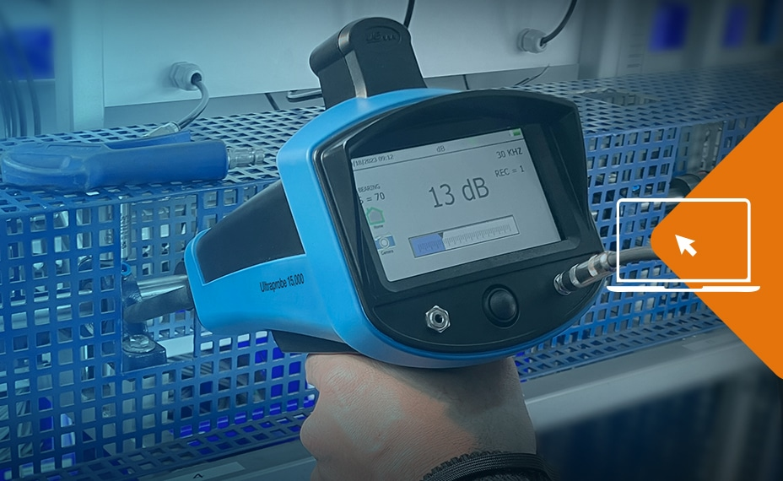
Figure 1 - Ultrasound Probe (UE Systems, 2023)

Lewin’s Forcefield Analysis
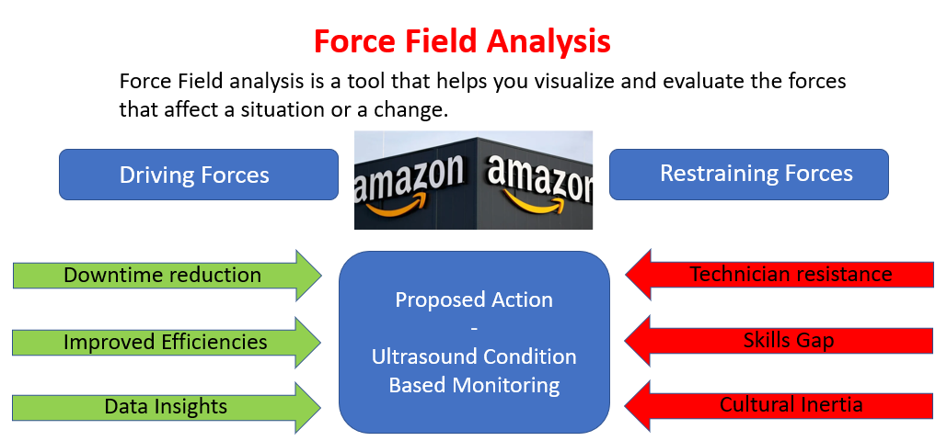
Kurt Lewin’s Force Field Analysis identifies and evaluates the driving and restraining forces influencing change (Judge, 2023) (Figure 2). It helps Amazon balance these forces, guiding the successful adoption of ultrasound technology by strengthening the positives and minimizing obstacles.
Figure 2 - Lewin’s Force Field Analysis (Judge, 2023) (O'Donovan, 2024)

Amazon faced strong driving forces for change, including the need to reduce downtime, extend equipment lifespan, and improve operational efficiency. Cost savings and access to real-time data supported this drive, but resistance emerged. Maintenance technicians favoured traditional methods, and the high upfront cost of equipment, extensive training, and a skills gap in ultrasound diagnostics posed challenges. Additionally, cultural inertia and reluctance to shift from reactive to proactive maintenance slowed adoption. To address these issues, Amazon leveraged strong leadership, which communicated the long-term benefits and linked success to employee growth and recognition. Hands-on training, pilot programs, and early successes helped ease the transition and build confidence in the new system. The ability to identify faults earlier in the maintenance cycle, as demonstrated by the P-F curve, was a key selling point. Ultimately, Amazon overcame resistance by reinforcing driving forces and addressing concerns, though a more phased rollout and earlier involvement of frontline employees could have eased the process further (Burnes and Cooke, 2013).
The P-F curve highlights the technology’s ability to detect faults early, preventing severe breakdowns (UE Systems, 2023) (Figure 3).
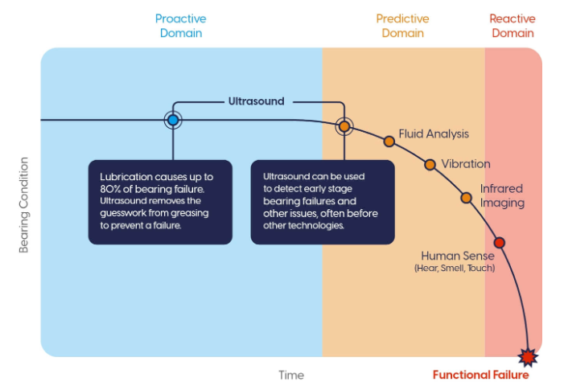

Figure 3 - Ultrasound Fault detection P-F Curve (UE Systems, 2023)

Balancing these forces was critical. While Amazon managed the transition well by providing resources and support, the change process could have been further improved by involving frontline employees earlier, addressing fears more transparently, and introducing ultrasound technology in smaller, phased stages to build momentum.
Overall, Lewin’s model highlights that the ultrasound project succeeded because the driving forces, such as cost savings, reduced downtime, and technological advantage, ultimately outweighed the resisting forces, leading to sustainable change and strengthening Amazon’s competitive edge.
Lewin's model is particularly valuable in its simplicity and clarity. According to McPheat (2023), the model's psychological foundation is a key strength. It focuses on understanding individuals’ responses to change, enabling managers to address resistance, design transition plans, and minimize stress, ensuring a smoother change process. The model’s straightforward framework also provides clear stages that can be easily communicated to all levels of the organization, fostering alignment and shared understanding. This makes it accessible and applicable across diverse teams. However, Malik (2022) identifies significant weaknesses, such as its time-consuming nature, oversimplification of change processes, and assumption of linear progression. In fast-paced, technology-driven environments like Amazon, the model’s rigid structure may hinder responsiveness, fail to capture the complexity, and struggle with the unpredictable nature of organizational change. Additionally, Lewin's approach may not sufficiently address the need for continuous, iterative changes, often required in dynamic sectors like e-commerce, where constant adaptation is key. This limitation underscores the need for more flexible and adaptive change management strategies.

Kotter’s 8-Step Change Model
Change can be a difficult process, and according to Kotter (2012) only 30% of organisational change is successful. Kotter's 8-Step Change Model is by organisations as a framework for effectively implementing organisational change (Expert Program Management, 2022) (Figure 4).
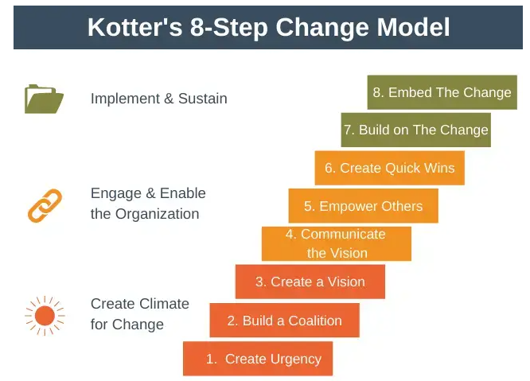
Figure 4 - Kotter's 8 Step Change Model (Expert Program Management, 2022)

Applying Kotter’s 8-Step Model to a project like the Ultrasound Project at Amazon ensures strategic change management, minimized resistance, and maximized long-term success. The model’s structured, people-centered approach aligns with Amazon’s commitment to operational excellence and continuous improvement. Leveraging the existing leadership hierarchy (Project Owner, Pillar POCs – Cluster of 6 sites, and Site Champions) ensures strong ownership and project buy-in.
The first step, according to Kotter (2012), is to create a sense of urgency because it drives immediate action and prevents complacency. Amazon RME Central Reliability created urgency by presenting data on past equipment failures and demonstrating how ultrasound CBM could prevent costly downtime, building momentum for change across the RME network.
The second step of Kotter’s model is to build a coalition because lasting change requires strong leadership and committed stakeholders to guide, support, and drive the initiative. A structure of Project Owner, Pillar Owners, and Site Ultrasound Champions formed an empowered coalition that removed barriers and advocated across all levels (Kotter, 2012).
The third step of Kotter’s model is to create a vision because it provides direction, aligns stakeholders, and motivates action. Amazon’s vision to revolutionize reliability through data-driven innovation offered a clear purpose, guiding the rollout from pilot sites to full CMMS integration and enabling consistent execution across all fulfilment centers (Kotter, 2012).
The fourth step, according to Kotter (2012), is to communicate the vision because clear, ongoing communication reinforces alignment and commitment. Amazon used weekly office hours, success stories, and recognition incentives to engage the RME team, from managers to technicians, building grassroots support and sustaining project visibility and momentum.
The fifth step, Kotter (2012) suggests, is to empower others because removing obstacles and building confidence enables employees to act on the vision. Amazon supported this through hands-on training, SOPs, certification, mentoring, and a technician support group, fostering adoption and overcoming barriers like unfamiliarity with ultrasound technology.
The sixth step, as Kotter (2012) notes, is to create quick wins because visible, short-term successes build trust, prove the change is working, and encourage continued effort. Amazon’s pilot programs demonstrated reduced downtime and cost savings, boosting confidence and accelerating adoption across the fulfilment centre network.
The seventh step, according to Kotter, is to build on the change because sustained progress requires reinforcement and continuous improvement (Kotter, 2012). Amazon expanded the project with live dashboards and Weekly Business Reviews, enabling performance tracking, celebrating success, addressing challenges, and keeping the initiative aligned with leadership priorities and long-term goals.
The eighth step of Kotter’s model is to embed the change because lasting transformation requires the new approach to become part of the culture (Kotter, 2012). At Amazon, ultrasound CBM is fully integrated into operations via routine CMMS workflows, empowering technicians and making proactive maintenance the standard practice.
According to Kirwin (2020), Kotter’s 8-Step Model is praised for its simplicity, people-focused approach, and emphasis on building momentum through short-term wins. This model prepares organizations for lasting cultural change by reducing resistance and promoting continuous improvement beyond initial implementation. However, the main challenge in Kotter's eight-stage model is changing people's behaviour, not strategy, systems, or culture, as behaviour is the key to successful transformation (Pawar, 2017). As Grayson (2016) notes, Kotter’s model faces challenges such as employee resistance, lack of flexibility, difficulty in establishing urgency, and its time-consuming nature. Given Amazon's fast-paced environment, where change often requires quick decisions, Kotter’s model may not be the best fit for immediate or time-sensitive changes, as it is more suited to long-term strategic shifts. The core issue in all eight stages proposed by Kotter is changing people's behaviour, not strategy, systems, or culture. These elements are important, but the central issue is the behaviour what people do, and that is how they need to be changed.

Herzberg’s Motivational Theory
Motivation is the inner force that inspires individuals to pursue goals in order to meet their needs or fulfill personal expectations. Herzberg’s Two-Factor Theory is a motivational model that identifies two sets of factors influencing job satisfaction. Hygiene factors, such as salary and working conditions, prevent dissatisfaction but don’t motivate. Motivators, like recognition and achievement, inspire higher performance and job satisfaction. The model emphasizes that while hygiene factors are necessary, true motivation comes from meaningful work and growth opportunities (Mullins, 2016).
In managing change, it’s vital to guide employees, addressing both satisfaction and dissatisfaction, which are separate entities, not opposites, to maintain motivation and reduce resistance (Clark, 2016) (Figure 5).
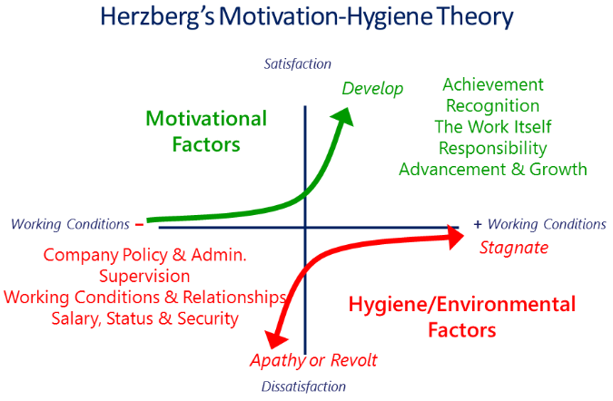
Figure 5 - Herzberg's Two Factor of Motivation Theory 1959 (Clark, 2016)

In applying Herzberg’s Two Factor Theory to the Ultrasound CBM project rollout at Amazon, the importance of balancing hygiene factors and motivators is clear. According to Pilat (2021), even highly motivated employees may disengage if hygiene factors are overlooked, highlighting that hygiene forms the necessary foundation for individuals to fully respond to motivators.
Hygiene factors Amazon supplied the team with included:
- Working conditions: Access to $21,995 ultrasound testing equipment and comprehensive training, from a 3-day induction to CAT 2 certification, with equal opportunity for all.
- Supervision: The workload was fairly distributed and opened up to everyone, with consistent communication throughout the project.
- Policies and rules: Visual Standard Operating Procedures (VSOP’s) were created for safe technology use, reviewed by the team, and revised to empower employees.

Motivators Amazon provided the team with included:
- Achievement: Recognition for identifying potential failures and associated cost savings. Including templated success stories to share with the network.
- Personal Growth: Opportunities for skill development and career advancement within the reliability teams or network.
- Responsibility: Increased ownership of in-depth project work.
- Job Interest: Work became meaningful by impacting operational efficiency and cost reduction.
Despite these efforts and being critical of the process, motivation could have been better maintained. Frequent changes to the project rollout team and a slow rollout hindered motivation. Changing teams disrupted cohesion, created confusion and impacted the overall buy in at times. The slow pace of rollout frustrated employees and reduced excitement. Also, the training was phased, leaving some technicians ahead while others waited for technology to arrive, creating knowledge gaps and weakening momentum.
Herzberg’s Two-Factor Theory provides valuable insights into employee motivation. The strength of Herzberg's model lies in its ability to identify satisfaction drivers, uncover motivators and hygiene factors, and support employee empowerment (Iyer, 2024). This understanding helps reduce turnover, absenteeism, and conflict, fostering a culture of excellence, innovation, and collaboration. However, Dr. Yew (2012) cautions that Herzberg's theory can disadvantage managers if employees with low motivation needs are misidentified. Elements traditionally categorised as hygiene factors, such as salary, can, in practice, act as strong motivators, driving employees to work harder to achieve recognition, promotions, or pay increases. Furthermore, Herzberg’s model fails to account for varying individual preferences and work contexts, suggesting that motivation is more complex than the binary distinction between hygiene and motivators. This oversight can lead to a one-size-fits-all approach, potentially hindering personalized motivation strategies.

4. Conclusion
Amazon’s adoption of ultrasound technology within its predictive maintenance strategy highlights the power of proactive change management and innovation. By shifting from reactive and scheduled maintenance to a condition-based maintenance (CBM) model, Amazon successfully utilised ultrasound technology to detect early stage equipment faults, enhancing operational efficiency (Amazon Web Services, 2023). Through a structured change management approach, Amazon overcame employee resistance, minimized disruptions, and improved system reliability.
While each project brings its own challenges, the real value lies in the lessons we carry forward. According to Martins (2024), capturing lessons learned is essential for transferring knowledge. It empowers future teams to build on successes, avoid repeating mistakes, and drive more efficient project execution.
The application of Lewin’s Forcefield Analysis, Kotter’s 8 Step Change Model, and Herzberg’s Two Factor Theory emphasizes the importance of balancing driving and resisting forces, fostering employee motivation, and ensuring a people centered approach to change. Strong leadership, effective communication, extensive training, and employee empowerment were pivotal to the widespread adoption of ultrasound technology (Mullins, 2016).
However, opportunities for improvement were identified. Involving employees earlier and addressing concerns more transparently would have eased the transition. A phased rollout could have minimised resistance and built momentum. Issues arose from having one person per shift to implement the technology, leading to consistency problems. A two-person team, as a result of lessons learned, was a more effective approach. Additionally, standardisation of test points, which were manufactured via 3D printing, should have been established upfront to prevent delays and confusion across different sites.
Future technological rollouts should prioritise innovation, operational excellence, and clear communication. Addressing resistance with targeted training and early stage employee involvement will minimise disruptions and ensure Amazon’s long-term success in technological advancements.

5. Reference List
Amazon Web Services, 2023. Amazon Customer Fulfillment Increased Productivity and Reduced Unplanned Equipment Downtime Using Amazon Monitron. [Online]
Available at: https://aws.amazon.com/solutions/case-studies/amazon-customer-fulfillment-case-study/
[Accessed 06 05 2025].
Amazon, 2025. About Amazon. [Online]
Available at: https://www.aboutamazon.com/what-we-do
[Accessed 05 05 2025].
Buck, A., 2025. 37 Amazon Statistics for 2025 (Order Volume, Market Share, Amazon Prime). [Online]
Available at: https://www.mobiloud.com/blog/amazon-statistics
[Accessed 27 04 2025].
Burnes, B. and Cooke, B. (2013). Kurt Lewin’s Field Theory: a Review and Re-evaluation. International Journal of Management Reviews, 15(4), pp.408–425. doi:https://doi.org/10.1111/j.1468-2370.2012.00348.x. [Accessed 09 05 2025].
Clark, A., 2016. Incentive Work, right?. [Online]
Available at: https://www.keybiz.com/blog/2016/9/6/incentives-work-right
[Accessed 18 04 2025].
Crayne, T., 2023. Disruption as an Opportunity: Navigating Industry Changes with Agility.. [Online]
Available at: https://qat.com/disruption-opportunity-navigating-agility/
[Accessed 05 05 2025].
Expert Program Management, 2022. Kotter’s 8-Step Change Model. [Online]
Available at: https://expertprogrammanagement.com/2021/02/kotters-8-step-change-model/
[Accessed 21 04 2025].
Giesecke, N.M. (2015). ‘The Only Thing That is Constant is Change’ – Heraclitus, circa 500 B.C.E.. ASA Monitor, 79(9), pp.4–5. doi:https://doi.org/10.1097/01.asm.0001073432.28695.b9. [Accessed 09 05 2025]
Grayson, E., 2016. Kotter's 8-Step Change Model: Advantages, Challenges and Potential Alternatives. [Online]
Available at: https://vocal.media/education/kotter-s-8-step-change-model-advantages-challenges-and-potential-alternatives
[Accessed 21 04 2025].
Iyer, Y., 2024. Herzberg’s two-factor theory in project management. [Online]
Available at: https://www.wrike.com/blog/what-is-herzbergs-two-factor-theory/
[Accessed 21 04 2025].
Judge, J., 2023. How to Use Force Field Analysis to Manage Change and Improve Performance. [Online]
Available at: https://www.certaintysoftware.com/how-to-use-force-field-analysis-to-manage-change-and-improve-performance/
[Accessed 27 04 2025].
Kim, E.Y., Tan, A.C.C., Mathew, J. and Yang, B.S. (2008). Condition monitoring of low speed bearings: A comparative study of the ultrasound technique versus vibration measurements. Australian Journal of Mechanical Engineering, 5(2), pp.177–189. doi:https://doi.org/10.1080/14484846.2008.11464546. [Accessed 09 05 2025]

Kirwin, M., 2020. Kotter's Change Model. [Online]
Available at: https://www.morethan1answer.com/kotters-change-model/
[Accessed 21 04 2025].

Kotter, J., 2012. In: Leading Change. Boston: Harvard Business Review Press, pp. 25-26.
Malik, P., 2022. Change Management: Lewin’s 3-Stage Model of Change Theory: Overview. [Online]
Available at: https://whatfix.com/blog/lewins-change-model/
[Accessed 23 04 2025].
Martins, J., 2024. How to capture lessons learned in project management. [Online]
Available at: https://asana.com/resources/lessons-learned
[Accessed 18 04 2025].
McPheat, S., 2023. Advantages and Disadvantages of Lewin’s Change Model. [Online]
Available at: https://www.mtdtraining.com/blog/advantages-disadvantages-lewins-change-model.htm
[Accessed 23 04 2025].
Mullins, L. J., 2016. Management & Organisational Behaviour. Eleventh ed. New York: Pearson Education Limited.
Nithin, S.K., Hemanth, K., Shamanth, V., Shrinivas Mahale, R., Sharath, P.C. and Patil, A. (2022). Importance of condition monitoring in mechanical domain. Materials Today: Proceedings, 54, pp.234–239. doi:https://doi.org/10.1016/j.matpr.2021.08.299. [Accessed 06 05 2025].
O'Donovan, B., 2024. Amazon says it has invested more than €22 billion in Ireland. [Online]
Available at: https://www.rte.ie/news/business/2024/0919/1470765-amazon-ireland/
[Accessed 06 05 2025].
Pawar, A. a. C. K., 2017. Research Revolution International Journal of Social Science and Management,. Study on adaptability of change management: review of Kurt Lewins and Kotter model of change, 5(4), pp. 79-83.
Pilat, D., 2021. Herzberg’s Motivation Theory. [Online]
Available at: https://thedecisionlab.com/reference-guide/management/herzbergs-motivation-theory
[Accessed 18 04 2025].
Sarow, A., 2024. What Can Humans Hear? Exploring the World of Auditory Perception. [Online]
Available at: https://www.soundly.com/blog/humans-hear-auditory-perception
[Accessed 2025 04 27].
UE Systems, 2023. Your equipment is trying to tell you something. [Online]
Available at: https://www.uesystems.com/en-gb/ultrasound-technology/?srsltid=AfmBOoq_L3mfRvn_VeIOcQRtxCs9nCvF7D0WFkW9oxz1121N-NT8iYvF
[Accessed 27 04 2025].
Yew, D. L. T., 2012. A critical assessment of Herzberg’s theory of motivation. [Online]
Available at: https://www.theborneopost.com/2012/10/23/a-critical-assessment-of-herzbergs-theory-of-motivation/
[Accessed 21 04 2025].

