The Material Culture of Death
The Tomb titled TT99 is situated in the necropolis of Sheikh Abd el-Qurna, and it is a part of the wider mortuary landscape of western Thebes, modern Luxor. It is carved into the limestone cliffs that overlook the fertile Nile valley. TT99 belonged to Sennefari, who was a high official of the early 18th dynasty, who served under Thutmose III c. 1479-1425BCE.
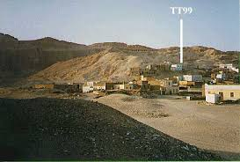

Figure 1: A picture with annotation showing the location of TT99 (Strudwick, 2016)

Knowledge of the tomb derives primarily from the modern excavation and publication led by Nigel Strudwick whose detailed study and associated project website present the architecture, decoration, stratigraphy, and finds in careful archaeological context. This material gives historians the ability to not only reconstruct the tomb’s physical form but also to analyse how its architecture and contents expressed Sennefari’s identity and social position within New Kingdom Egyptian society.
This study will examine the architectural layout and development of TT99, its decorative and textual program, the assemblage of material culture recovered from its shafts and chambers and the long-term reuse of the monument. It shall then assess how this material evidence reflects Sennefari’s status as a senior official in the expanding imperial state of Thutmose III.

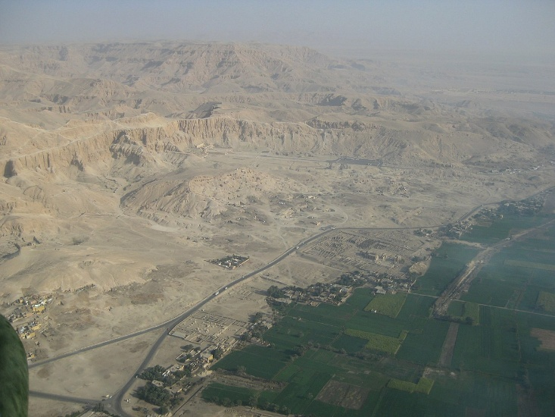

Figure 2: A photo showing an aerial view of the Theban Necropolis (Cameron, 2010)

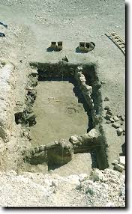
The tomb opens with a large courtyard carved into the slope of the hillside. This forecourt would not have been just a simple access point but would have been an integral ritual space. Similarly to other elite Theban tombs of the early 18th Dynasty, the courtyard would serve as the location for funerary ceremonies, including offerings and potentially aspects of the burial procession.
The excavations lead by Strudwick, revealed numerous shafts cut into the courtyard’s floor. One of these appears to have been the principal burial shaft for Sennefari, while others represent either subsidiary burials or later reuse phases. The presence of several shafts indicates both the complexity of the burial program and the tomb’s later history.
Although now heavily eroded, the façade would have originally framed the entrance to the chapel. With similar Theban tombs the façade often featured niches for statues or stelae, which would allow the deceased to symbolically participate in offerings performed in the courtyard. The scale and elaboration of TT99 was far greater than anything attainable of a low-ranking individual, yet still more reserved than that that of royalty. The act of carving such a courtyard and entrance into the cliff face would have required very skilled labour, administrative authority and financial resources, making this a carefully planned elite monument as opposed to a modest family burial.
Figure 3: A picture showing the courtyard from TT99 (Strudwick, 2016)
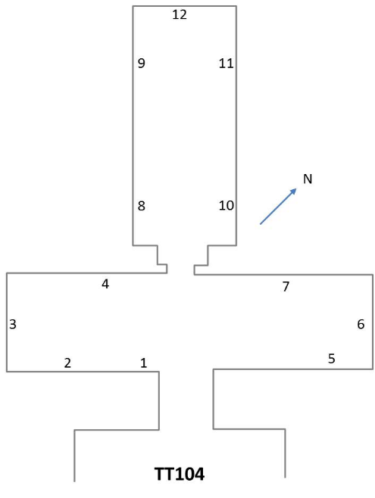
Behind the entrance a chapel is to be found, carved in the standard T shaped plan that was characteristic of early 18th Dynasty elite tombs (Australian Museum). This comprised of a broad transfer hall, an axial corridor and a rear chamber or shrine space. This plan was to reflect architectural convention and symbolic logic. The transverse hall provided a space for offerings and gatherings, where cultic rites could be performed (Goodman, 2020). The axial hall would move visitors inwards towards the rear chamber, reinforcing the sense of sacred progression from public to intimate ritual space.
Figure 4: A plan of a similar tomb, showing the iconic T shape (Hotepibre, 2018)
TT99 features rock cut-pillars separating interior spaces; these provide structural support and symbolic uses. Structurally they give the ceiling critical support to help it stay up and symbolically they create a hypostyle environment that echoes temple architecture, subtly associating the tomb owner with the monumental spaces of state cult.
The investment of a fully articulated T chapel indicates that Sennefari belonged to the upper administrative elite. Simpler shaft burials, without decorated chapels were often for lower officials (University College London, 2001). The chapel of TT99 signals access to wealth, artisans, and state sanctioned prestige.
Below the courtyard and chapel, lies multiple shafts descending to burial chambers. The principal shaft, known as shaft 1, leads to a series of underground rooms where significant ceramic and other funerary material was discovered. These shafts are deep and were carefully cut, reflecting a concern for both protection and ritual separation. In Egyptian belief, burial to the west symbolised rebirth, the descent into the earth paralleled the sun’s nightly journey through the underworld (Mark, 2013). This architecture encoded a cosmological meaning.
The presence of multiple burial contexts, some original and some intrusive, indicates that TT99 was a durable and desirable monument. The architectural solidarity ensured its reuse in later centuries, further testifying to its original quality.
Despite only some of the decorations in TT99 surviving, the recorded scenes can be revealing. Various inscriptions found within the chamber record aspects of Sennefari’s career. He bore several titles, including ‘Chancellor of the King of Lower Egypt’ and ‘Overseer of Seal Bearers’. These would not have been minor positions: the chancellor operated at the heart of royal administration, dealing with documentation, seals, and potentially oversight of economic transactions.
One notable scene refers to a cedar expedition to Lebanon. Under Thutmose III, Egypt was expanding militarily and economically into the Levant. Cedar from Lebanon was crucial for ship building, monumental construction and coffins for the elite (Allen, 2024). Participation in such expeditions underscores Sennefari’s involvement in state sponsored, international enterprise. His tomb walls acted as a public resume carved into stone; through biography Sennefari presented himself as indispensable to the Pharaohs projects.
Several scenes depict Sennefari in front of tables piled with food, drink and luxury goods. The purpose of these scenes was to magically ensure eternal sustenance and to display wealth and abundance. Lists of offerings often include bread, beer, cattle, fowl, oils and textiles, symbols of prosperity. This imagery reinforces the theory that Sennefari expected an afterlife commensurate with his earthly rank (Assmann, 2005).
Hymnic references to Osiris and other deities found align him with orthodox mortuary theology. In the 18th Dynasty personal piety and official religion were intertwined. In associating himself with Osiris, Sennefari claimed the promise of resurrection and justified status among the blessed dead (Smith, 2013).
Potentially some of the most important contributions in Strudwick’s work lies in the systematic excavation of the burial shafts, which housed an unusually large ceramic assemblage and other artifacts. The ceramic material includes marl clay storage jars, amphorae, fine tableware and blue painted pottery typical of the 18th Dynasty. This large scale indicates mass scale provisioning. In Egyptian funerary beliefs, ceramics symbolised sustenance. However, the diversity of forms suggests more than just symbolic necessity, but access to trade networks and elite consumption patterns. Imported amphorae may indicate Levantine connections, consistent with Sennefari’s role in foreign expeditions. Therefore, even humble pottery becomes evidence of high administrative reach (Taylor, 2001).
Several fragments of wooden coffins and painted cartonnage have been recovered from the shafts. Lots of this belonged to later intrusive burials, however most likely some material will date back to the original burial. Coffins of a high quality often required imported timber, usually cedar; if Sennefari did indeed oversee cedar procurement then the symbolic resonance could be powerful. The administrator of royal timber being buried in the same precious material would have been a powerful message. The tomb also housed numerous ritual implements including ivory adzes used during the ‘opening of the mouth’ ceremony. This rite would animate the senses of the deceased, enabling speech, sight and sustenance in the afterlife. The presence of these specialised ritual tools confirms that sennefari’s burial followed elaborate elite procedures.
A selection of stone vessels for oils and perfumes were among the findings within the tomb. These items would have been seen as luxury goods and would have been associated with purity and transformation. Oils, such as those that would have been stored in these vessels, played a central role in mummification and ritual anointing. Later burials introduced shabti figures, small servant statues intended to perform agricultural labour in the afterlife. Although they do not all date back to Sennefari’s lifetime their presence indicates the prestige and desirability of the tomb.
Stratigraphic evidence proves that TT99 had been reused during the third intermediate period, including burials of the 22nd Dynasty. Various coffin fragments and intrusive shafts attest to multiple phases of activity. TT99 remained structurally sound and symbolically potent for centuries. In a necropolis with many monuments, reuse of a tomb would imply the recognition of it as a high-status burial site. The extended lifespan of the tomb also amplifies its original prestige, as the architecture was robust enough to invite continued occupation, embedding Sennefari’s memory in Theban mortuary tradition.
The cumulative evidence from TT99 indicates Sennefari’s position in ancient Egyptian society in several interrelated ways, and tells historians about him. The first thing that it tells historians is about Sennefari’s administrative rank, the titles recorded in the tomb confirm his proximity to royal authority. The chancellor’s office required literacy, bureaucratic skills and trust; only a small number of individuals would have attained such positions. The second thing that historians can learn from this is the economic reach: ceramic imports and references to cedar expeditions indicate involvement with imperial trade networks. Sennefari operated in a time when Egypt was becoming a territorial empire; his reflects this globalising context. The next thing that historians can learn from this tomb is about the religious orthodoxy, the decorative program within TT99 aligns perfectly with state religion. The afterlife hopes of Sennefari were expressed through conventional iconography, demonstrating adherence to official theology rather than heterodox belief. The final aspect that historians can gain insight into is architectural investment, as the scale and complexity of TT99 far surpasses the tombs of more minor officials. Sennefari’s tomb stands among the more substantial tombs of early 18th Dynasty Thebes. The monumental rock cut chapels were a privilege of the wealthy and powerful.
TT99 is more than just a burial place, it is a physical statement of a man’s identity. Through the mediums of architecture, decoration and artifacts, Sennefari was able to portray an image of loyalty, piety and competence. The tomb’s T shaped chapel, deep shafts, extensive ceramic assemblages, ritual implements and autobiographical inscriptions all converge to demonstrate the owner’s elite standing in the expanding state of Thutmose III.
The excavations and studies conducted by Nigel Strudwick have transformed TT99 from a simple name on a topographical list into a richly contextualised monument. The material culture found within illustrates how power was expressed in stone and clay, how bureaucracy intersected with belief and how one official sought eternal remembrance in the cliffs of western Thebes. In TT99 historians see the intersection of administration, empire, religion and memory, an enduring testament to the social world of the early New Kingdom of Egypt.

Bibliography
Allen S (2024), A Categorisation of Ancient Egyptian Watercraft, from the Predynastic Petroglyphs to the Khufu Boats, Oxford: BAR Publishing
Assmann, J (2005), Death and Salvation in Ancient Egypt, Ithaca: Cornell University Press
Cameron S (2010), Aerial View of the Theban Necropolis, available at https://commons.wikimedia.org/wiki/File:SFEC_AEH_-ThebesNecropolis-2010-FULL-Overview-039.jpg, accessed 04/03/2026
Goodman P (2020), Funerary Rites, Burial, and the Afterlife of the Ancient Egyptians, available https://www.worldhistory.org/collection/104/funerary-rites-burial-and-the-afterlife-of-the-anc/, Accessed 12/03/2026
Hotepride (2018), Planimetria schematica della tomba TT104, available at https://commons.wikimedia.org/wiki/File:TT104.jpg , accessed 05/03/2026
Mark J (2013), Ancient Egyptian Burial, Available at https://www.worldhistory.org/Egyptian_Burial/, accessed 12/03/2026
Smith M (2013), ‘Osiris and the Deceased in Ancient Egypt: Perspectives from Four Millenia’, Sciences Religieuses
Strudwick N (2016), The Tomb of Sennefari, available at https://tt99.fitz.ms/architecture.html, accessed 04/03/2026
Taylor JH (2001), Death and the Afterlife in Ancient Egypt, London: British Museum Press
The Australian Museum, Tombs in Ancient Egypt, available at https://australian.museum/learn/cultures/international-collection/ancient-egyptian/tombs-in-ancient-egypt/, accessed 12/03/2024
University College London, Thebes Some Tombs of The New Kingdom, available https://www.ucl.ac.uk/museums-static/digitalegypt/thebes/tombs/index.html, accessed 12/03/2026

