Digital Skills Task 3 Completed Paper – Digital Portfolio

This digital portfolio showcases examples of my work completed during this module using Microsoft Word, PowerPoint, and Excel. The portfolio demonstrates the digital skills I have developed, the progress I have made throughout the module, and areas where I have improved in confidence and competence.

Microsoft Word
MS Word
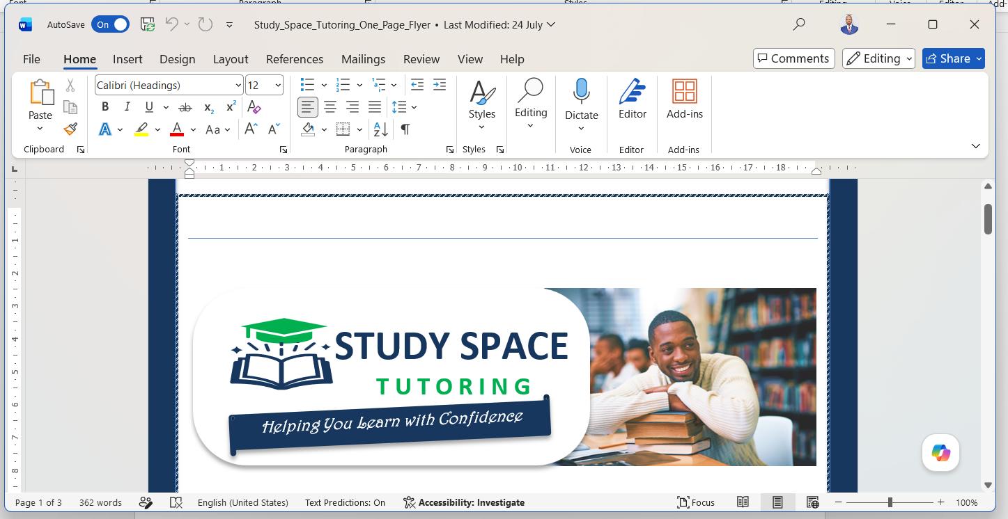
Skills I learnt using word
I have learned how to do the following tasks
- Creating and formatting professional documents
- Using headings and styles
- Inserting tables and images
- Adjusting page layout and margins
- Insert citation and references

Progress I made;
This task helped me understand how to create well-structured documents and present information clearly.
At the beginning of the module, I only used basic typing and formatting features. By the end, I was able to create professional documents using styles and tables. I practised using word to design the study space image and flyer as displayed in the picture above.

PowerPoint
PowerPoint App
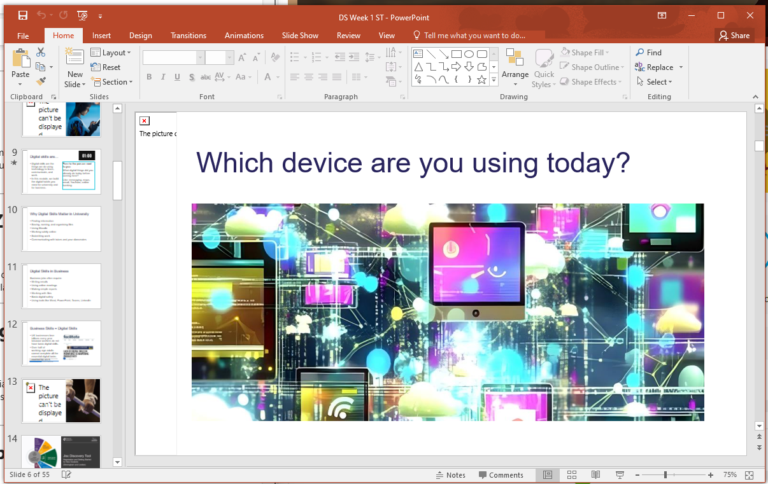
Skills I learnt using powerpoint
Using Microsoft PowerPoint, I developed skills in presentation design, visual communication, slide organisation, and audience engagement. I learned how to create presentations that communicate ideas effectively. I achieved this by carrying out the following tasks;
• Creating presentation slides
• Applying themes and layouts
• Inserting images, charts, and SmartArt
• Using transitions and animations
• Presenting information visually

What Was Hard at the Start
At first, I found it difficult to create visually appealing slides without overcrowding them with information. I also struggled with balancing text and visuals to keep presentations engaging.

Progress I made and what I can do confidently now
I can confidently explain how to create an effective presentation by using clear slide layouts, consistent design themes, and visual elements that support the content without overcrowding the slides.

My early presentations contained too much text. As I progressed through the module, I learned how to create more engaging presentations using visuals and concise information. I also learned how to use PowerPoint to make video presentations for my assessment.
I am now confident that I can go into the professional world of work with these skills I have learnt and can make good success in my chosen career path.

Excel
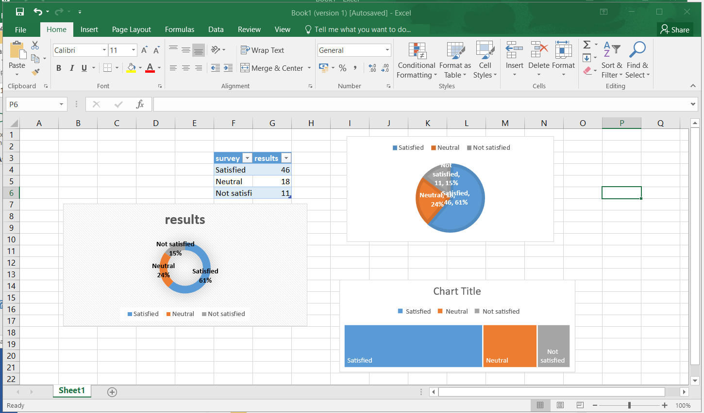

Skills I learnt using Excel
In the past 10 weeks during my digital skills learning journey, I developed a range of Microsoft Excel skills that improved my ability to organise, analyse, and present data effectively. They include;
- Creating and formatting spreadsheets professionally
- Entering, editing, and organising data in rows and columns.
- Using basic formulas and functions such as SUM, AVERAGE, MIN, MAX, and COUNT.
- Applying cell formatting, including fonts, colours, borders, and number formats.
- Sorting and filtering data to find specific information quickly.
- Creating charts and graphs to present data visually.
- Using tables to organise datasets and improve readability.
- Performing simple calculations and data analysis.
- Saving, sharing, and collaborating on Excel workbooks.

These skills have helped me become more confident in managing data and using Excel effectively for both academic and professional purposes.

Example of tasks I Found Difficult at First
Initially, I found using formulas and functions challenging, especially understanding how different formulas work and how to apply them correctly.

How I Improved
Through practice and completing assessment activities, I became more comfortable using formulas such as SUM, AVERAGE, and other basic functions.

An example of what I can now do confidently includes;
- Sorting and filtering data to find specific information quickly.
- Creating charts and graphs to present data visually.
- Using tables to organise datasets and improve readability.
- Performing simple calculations and data analysis.
- Saving, sharing, and collaborating on Excel workbooks.

Conclusion
I am now confident that I can go into the professional world of work with these skills I have learnt and can make good success in my chosen career path.

​
Reflection
Through using Microsoft Word, Excel, and PowerPoint, I have developed strong digital skills that have improved my confidence, productivity, and ability to communicate professionally. These tools have provided me with practical skills that are directly applicable to academic work and future business environments.

References
Joshua A. Jackman, D. A. G. &. Y. P., 2021. Addressing the digital skills gap for future education. Nature Human Behaviour.
Society, D. S. -. U. t. I., 2014. Digital Skills - Unlocking the Information Society. Palgrave Macmillan, a division of Nature America Inc. 2014.

