Question 1 Screen Dump
Circuit Design and Layout
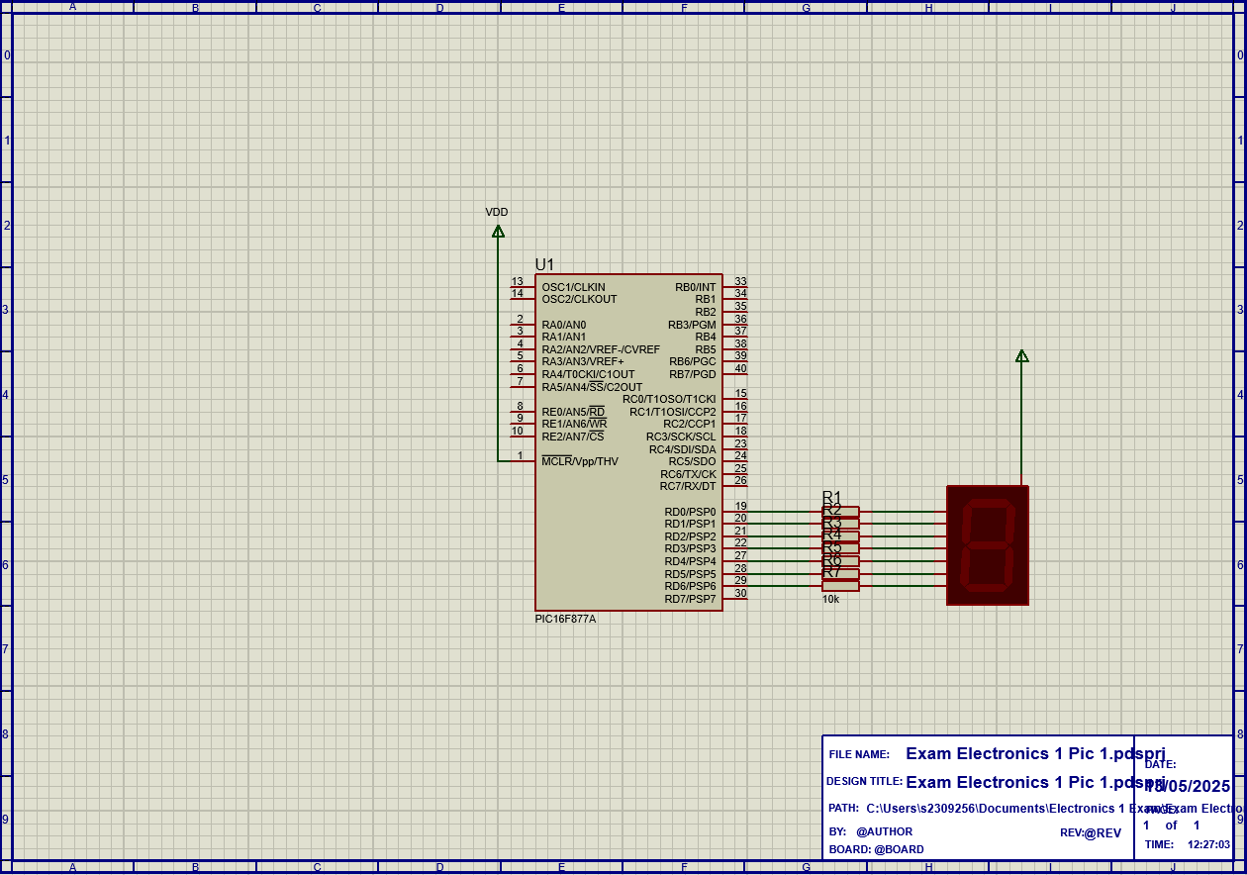

Question 2 Screen Dump
Circuit Design and Layout
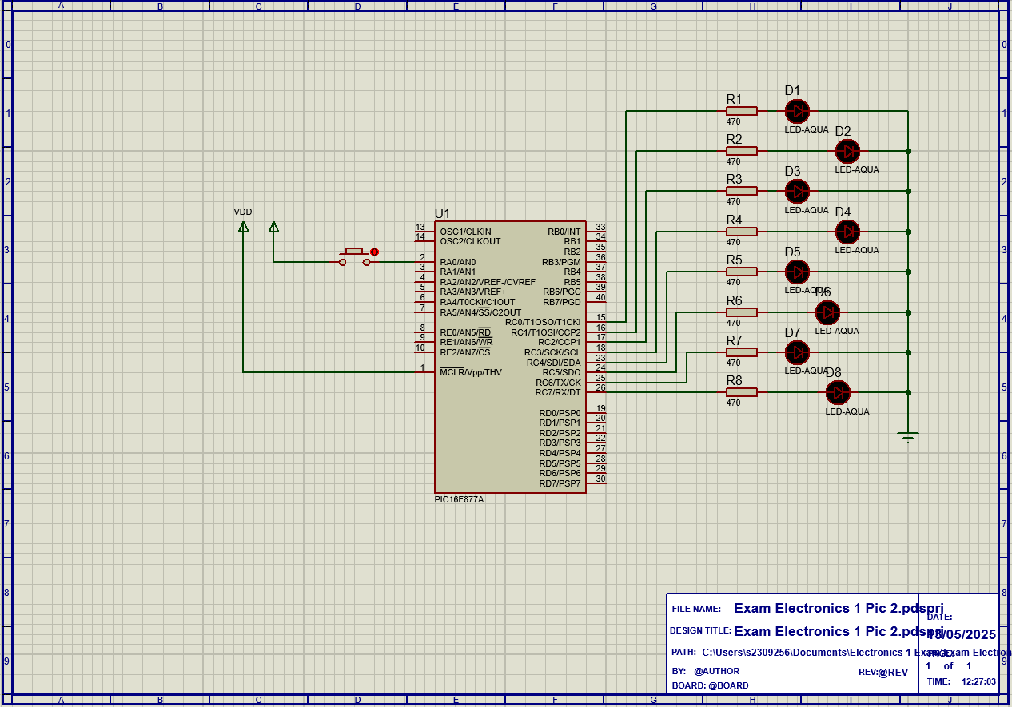

Simulation
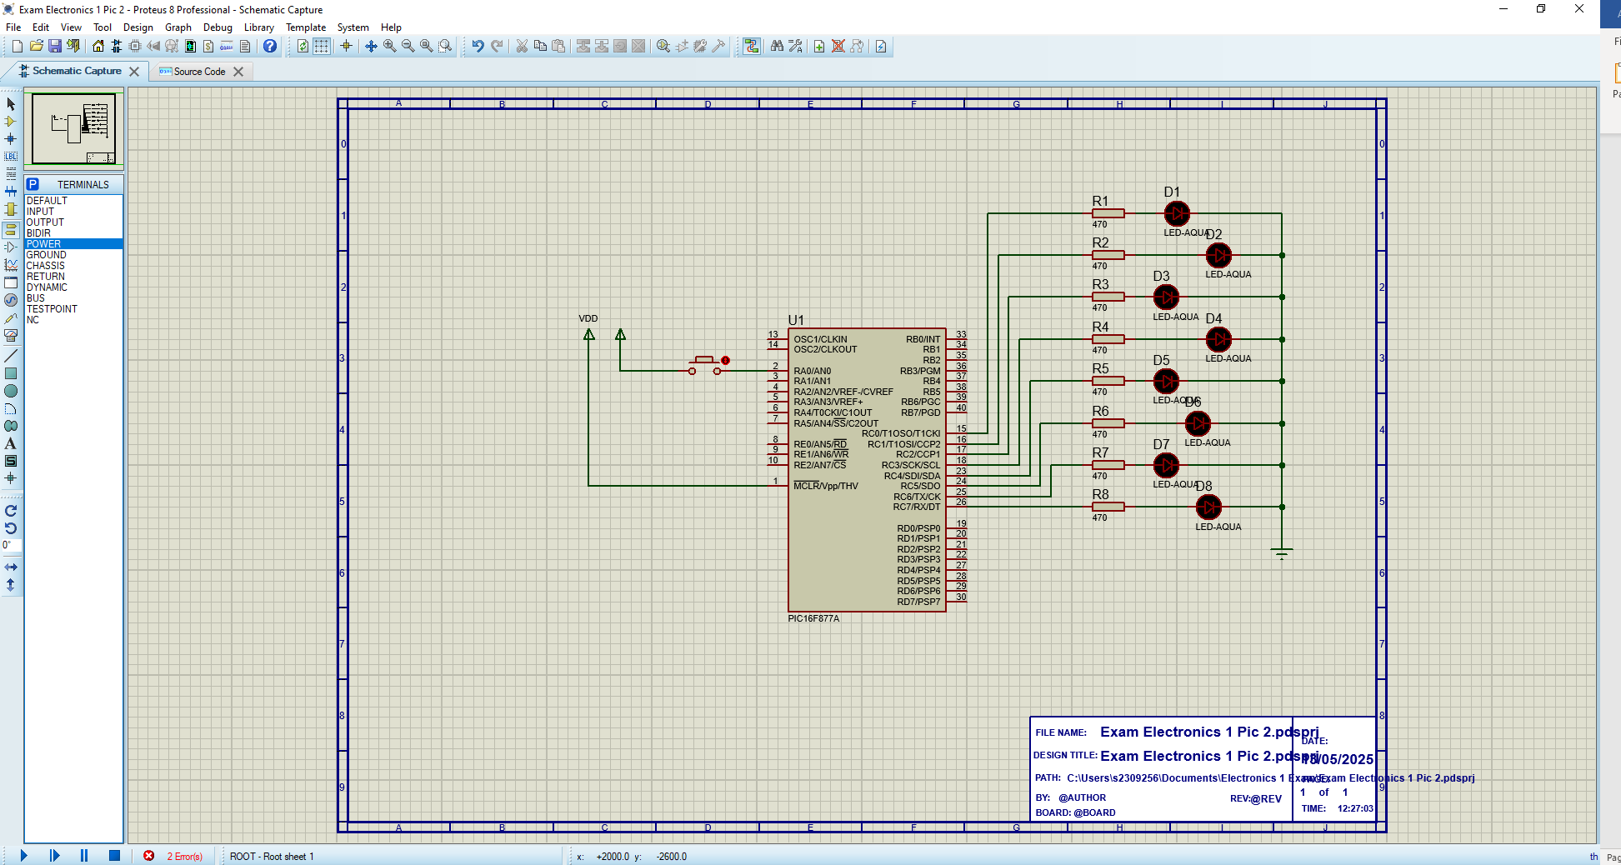
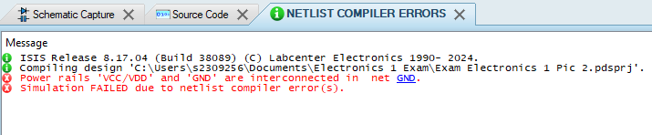
Error with netlist, stating there is overlap between a live and ground wire, rebuilt circuit yet issue still persisted

Question 3 Screen Dump
Circuit design and Layout
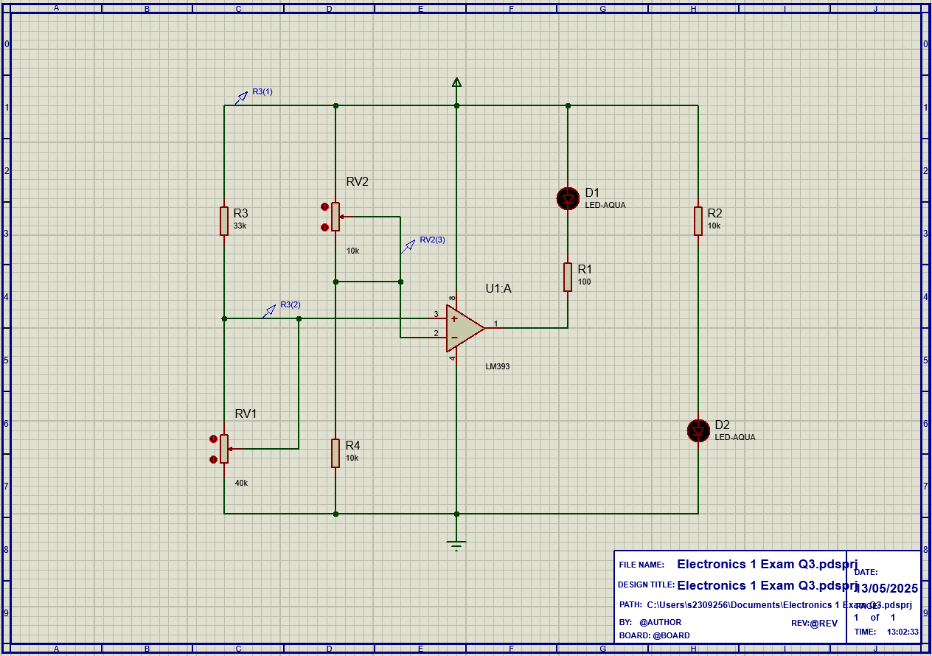
Simulation
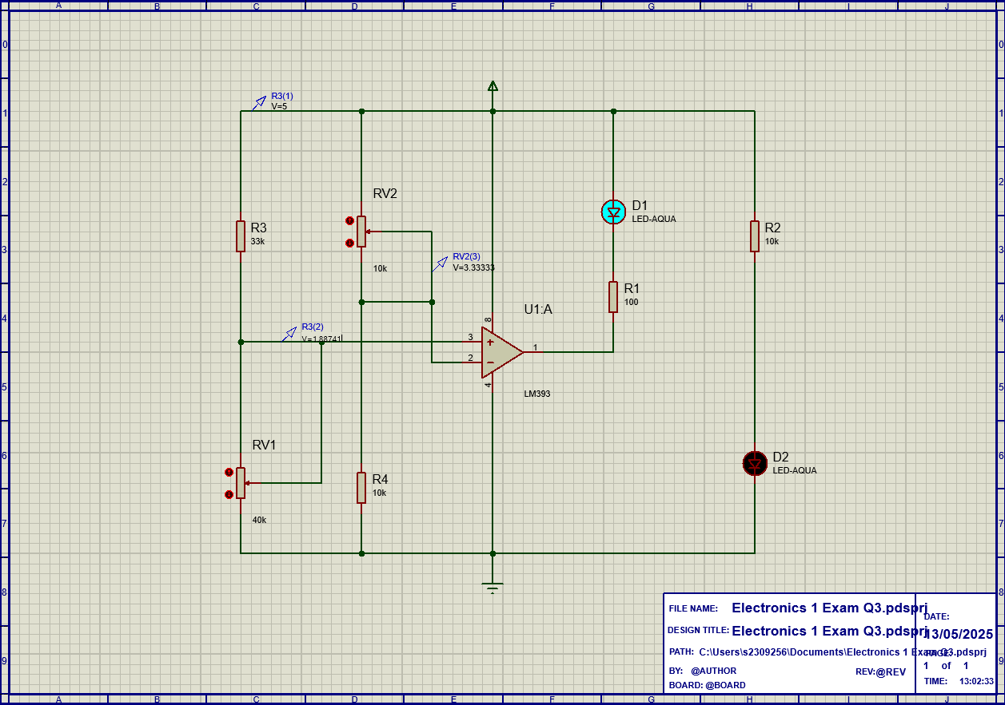

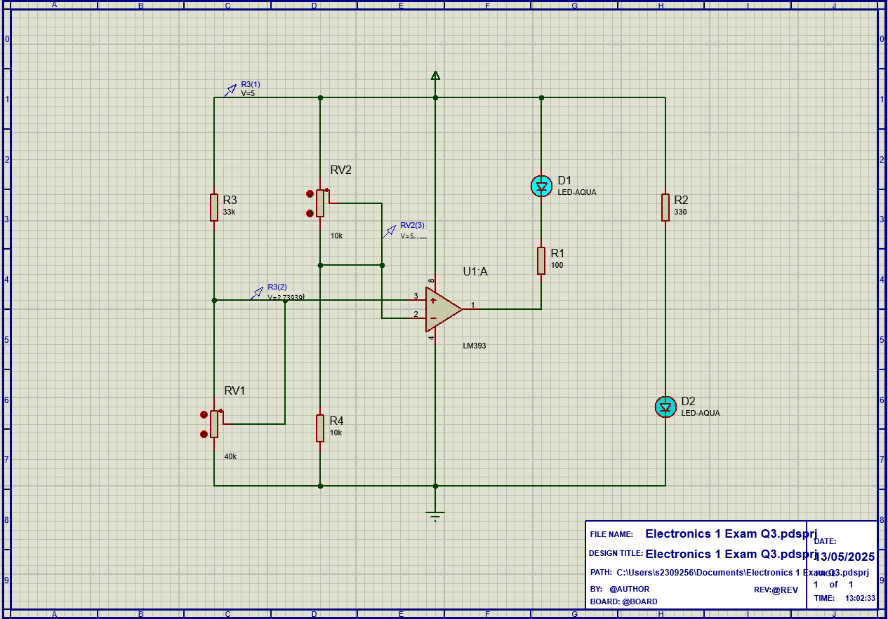
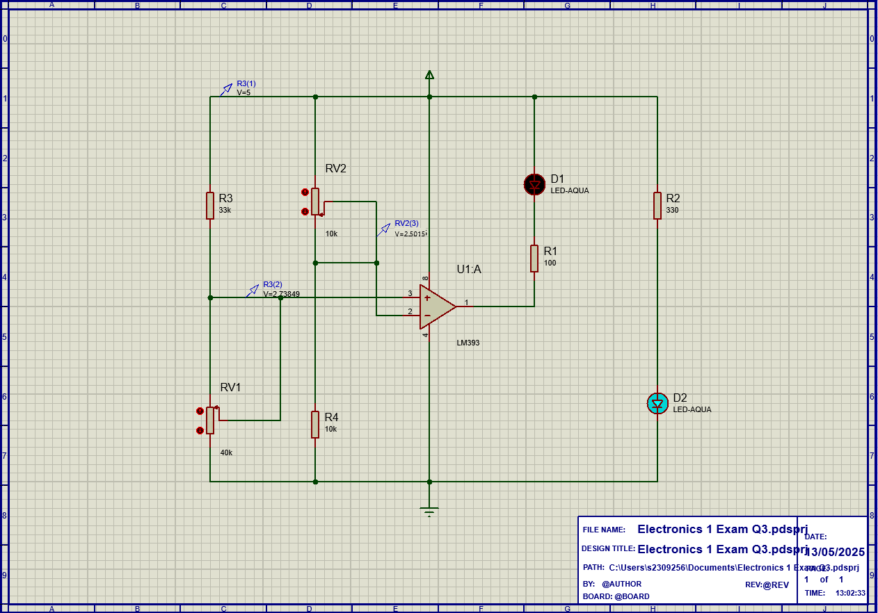

Question 4 Screen dump
Circuit Design and Layout
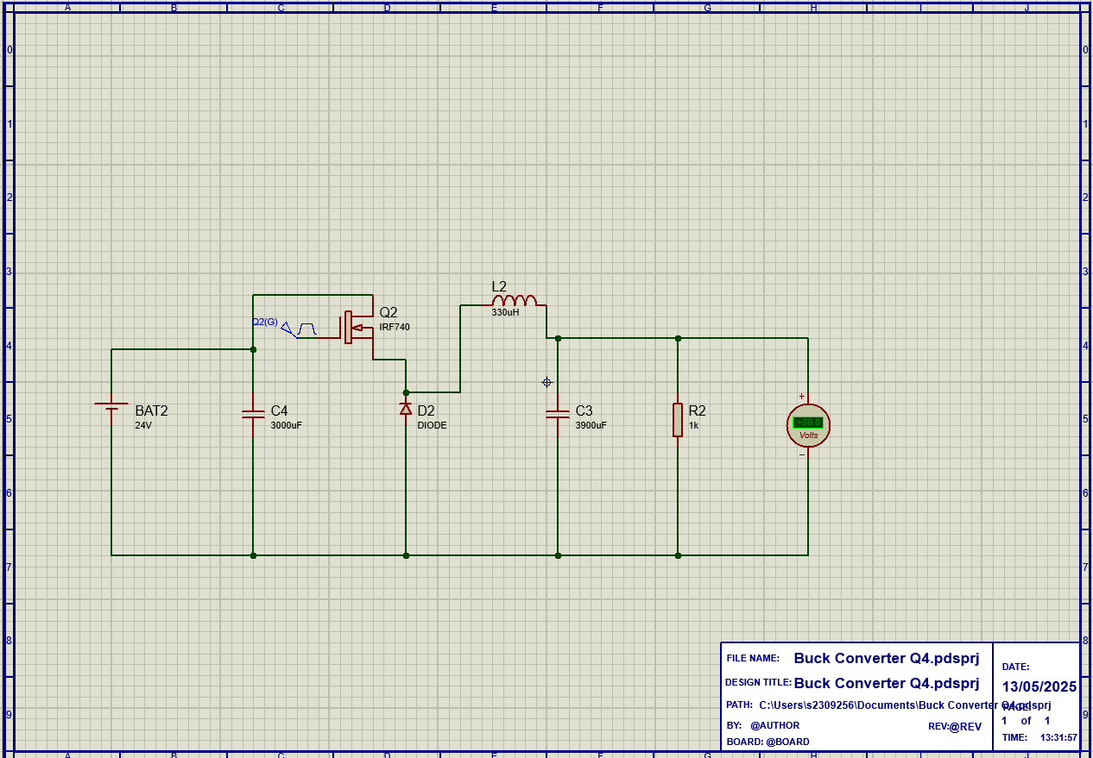
Simulation
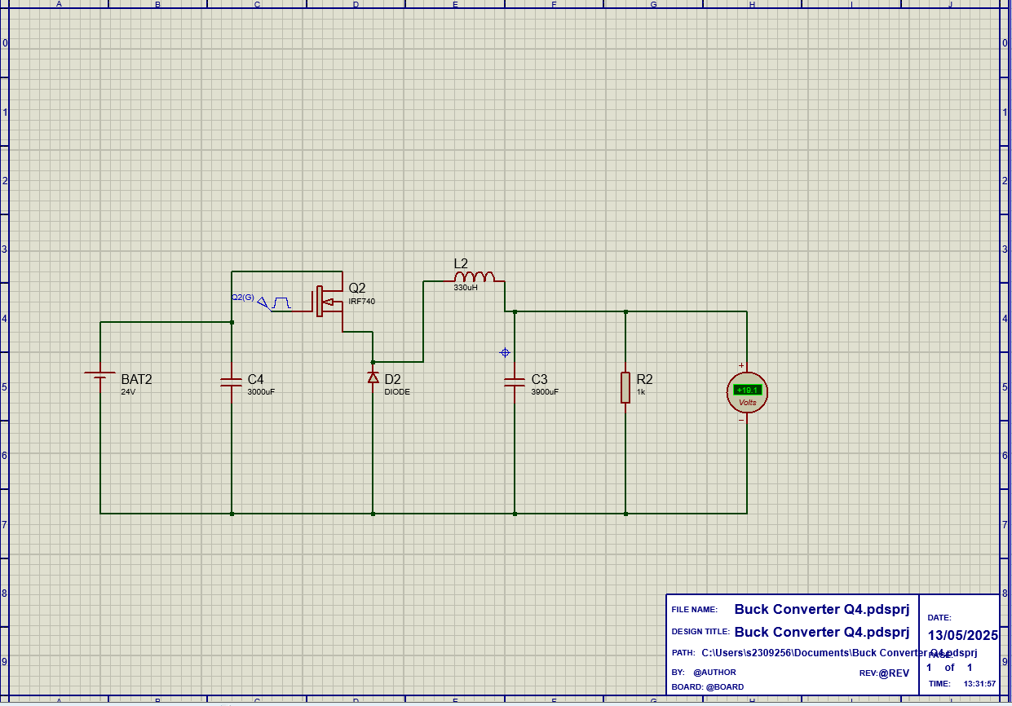

Simulation Lag Due to CPU Load
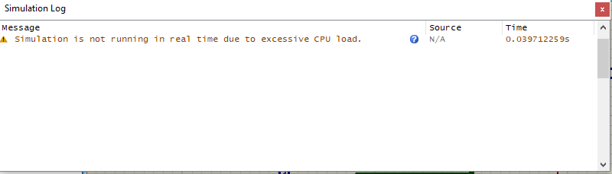
Impacted the speed at which the simulation ran, but still provided a result

