
Student Name: Uttam Devshibhai Vaghamashi

Student ID: 2520138

Module Name: Marketing Management

Module Code: LCMB7024

Lecturer’s Name: Laila Maazouz and Dian Mayasari

Work Count: 2840

Term 1

Contents
1. Introduction 3
1.1 Macro Factor 1: Government Regulation and Environmental Policies 4
1.1.1 Explanation 4
1.1.2 Impact on Pioneer (Tesla) 4
1.1.3 Impact on Follower (Ford) 5
1.1.4 Comparison 5
1.2 Macro Factor 2: Technological Advancement and Innovation 6
1.2.1 Explanation 6
1.2.2 Impact on Pioneer (Tesla) 7
1.2.3 Impact on Follower (Ford) 7
1.2.4 Comparison 8
2. Task 2 – Strategic Response 9
2.1 Porter’s Generic Strategies 9
2.1.1 Pioneer Strategy (Tesla: Differentiation Strategy) 9
2.1.2 Follower Strategy (Ford: Cost Leadership + Differentiation Hybrid) 11
2.1.3 Comparison 11
2.2 Ansoff Matrix 12
2.2.1 Pioneer Growth Strategy (Tesla: Product Development and Market Development) 12
2.2.2 Followers Growth Strategy (Ford: Market Penetration and Product Development) 12
2.2.3 Comparison 12
3. Critical Evaluation 13
3.1 Tesla vs Ford Comparative Performance. 13
3.2 Strategic Advantages and Strengths. 13
3.3 Strategic Limitations and Weaknesses. 14
4. Conclusion 14
References 15

1. Introduction
Marketing environment is a set of external factors that determine the ability of an organisation to exist and compete successfully and they include technological, economic, political, and socio-cultural forces (Kotler and Keller, 2022). The forces of the macro-environment are growing more dynamic, and global technological change is the sole factor that adds above 50% to the disruptor of competitive elements across the industries (McKinsey, 2023). This change is more specifically observed in the automobile industry, with the electric vehicle (EV) market in the world expanding by a margin of over 35% in 2023 and selling over 14 million vehicles annually worldwide (IEA, 2023). These fast evolutions leave opportunities and threats behind them and firms need to keep on changing their strategies. These opposing standpoints offer a solid foundation of considering the influence of the external environment factors on the competitive advantage (Ford Annual Report, 2023).
The report looks at how the selected macro factors present opportunities and threats to both the firms and measures their strategic response to them in terms of Porters Generic Strategies and Ansoff Growth Matrix. This facilitates a critical juxtaposition of the manner in which the pioneering and follower firms can maintain growth in a fast changing, and highly technological market.
1. Task 1 Macro Environment Analysis
The macro marketing environment is crucial in determining strategic marketing decisions by influencing the ability of firms, competitive positioning and sustainability in the long-run. Two forces that dominate the current industry in the electric vehicle (EV) industry are environmental regulation and technological disruption, to which pioneer and follower firms are both exposed. This part is a critical evaluation of these factors to Tesla (pioneer) and Ford (follower).

1.1 Macro Factor 1: Government Regulation and Environmental Policies

1.1.1 Explanation
Electric mobility transition has been expedited by government policies that are meant to reduce carbon emissions. At a global level, transport generates about 24% of CO 2 emissions, and more than 130 countries have set net-zero targets (IEA, 2023). Besides the regulatory prohibitions, like the proposal to cancel petrol and diesel cars in the UK by 2035, the governments introduce more strict emission standards and develop EV infrastructure. As an example, the European Union has already set fleet-wide emission levels of 55 percent cut by 2030, and worldwide government expenditures on EV subsidies reached more than30 billion dollars in 2022 (IEA, 2023).

1.1.2 Impact on Pioneer (Tesla)
Tesla has positioned itself to be in line with environmental regulation, where it has been enjoying the benefits of policy-based incentives and regulatory systems. In 2023, the company earned more than 1.8 billion regulatory credit in revenue which directly added to profitability (Tesla Annual Report, 2023). The global emission standards can be met with its fully electric portfolio of goods immediately, which means that Tesla can scale efficiently in regulated markets like in Europe and China. Moreover, Tesla has been investing in EV infrastructure, including charging networks, early, which helps the company gain its leading position in the market in favorable policy settings. Nevertheless, this benefit does not come without a price. Tesla might experience margin compression and differentiation in the future as the governments slowly remove subsidies and enhance competition by supporting new entrants to the market with policies. Hence, regulation helps Tesla to build leadership, but at the same time, it causes strategic uncertainty in the long-term.

1.1.3 Impact on Follower (Ford)
Ford also experiences a significant level of regulatory pressure because it has traditionally relied on internal combustion engine (ICE) vehicles. In order to adhere to environment policies, the company has invested more than 50billion in electrification by 2026 (Ford Annual Report, 2023). This shift comes with a heavy capital cost, reorganization costs, and its operation risks especially because Ford should at the same time deal with the falling ICE revenues. Moreover, emission regulations enhance complexity in production and supply chain adaptation particularly in the battery supply. Nonetheless, the regulation also gives the strategic opportunities that would gain access to the market of EVs with Ford and allow the company to access the government incentives. Irrespective of this, Tesla has a privilege over Ford due to the late-mover factor, which restricts its capacity to reap the full benefits of its policies.

1.1.4 Comparison
Environmental regulation, as Table 1 demonstrates, strengthens the first-mover advantage of Tesla and presents structure- and money-related pressure on Ford. The identical macro factor generates asymmetric effects with Tesla gaining the advantages of alignment and efficiency, and Ford being forced to bear transition costs and strategic constraints. This shows that regulatory environments have tendencies to support pioneering firms who already have established capabilities hence increasing competitive distances in the industry.
Table 1: Tesla and Ford Compared in terms of the Effect of Environmental Regulation.
Aspect | Tesla (Pioneer) | Ford (Follower)
Business Alignment | Fully aligned with EV policies | Transitioning from ICE vehicles
Financial Impact | $1.8 billion regulatory credit revenue | $50+ billion investment cost
Competitive Advantage | Strengthened due to early adoption | Weakened due to legacy constraints
Risk Exposure | Dependency on subsidies and policy changes | High transition and compliance costs

1.2 Macro Factor 2: Technological Advancement and Innovation

1.2.1 Explanation
The EV industry is highly competitive with technological innovation being the core source of competitive advantage, which has essentially changed the way products are developed, cost structure, and customer value propositions. The cost of batteries has decreased by about 89 percent since 2010 and gone down to less than 150/kWh, a factor that has made batteries affordable and has enhanced their mass adoption (BloombergNEF, 2023). Simultaneously, investments in EV-related technologies are expected to grow to more than 1.2 trillion around the globe in 2030, which illustrates the magnitude of the transformations in the industry (IEA, 2023). In addition to batteries, artificial intelligence, autonomous driving and software-defined vehicles are transforming cars into digital platforms instead of mechanical products. As an illustration, connected and software-enabled functions are anticipated to be present on over 70 percent of new automobiles by the year 2030 (McKinsey, 2023).

1.2.2 Impact on Pioneer (Tesla)
One of the strategic capabilities that Tesla has had an opportunity to exploit is technological innovation, which has allowed it to differentiate effectively and lead the market. Its cars have a range of over 500km per charge, which is impressive in comparison to many rivals, and its Full Self-Driving (FSD) software and over-the-air updates further improve customer experience and lifecycle product value (Tesla Annual Report, 2023). The vertical design with battery, software development, and charging stations ensures that Tesla is able to innovate more quickly and have a greater control over performance improvements. Besides, the AI capabilities and autonomous driving development are enhanced by the use of data-driven approach of Tesla that provides billions of miles of driving data. Nevertheless, the threat of the technologizing world is increasing. Rivalry in the form of BYD and Volkswagen are boosting their R&D budgets, and the number of patent filings in EVs worldwide is growing over 20 percent each year, which means the competition in innovation is growing (IEA, 2023). Subsequently, Tesla is slowly losing its technological edge, which needs ongoing investment to maintain it.

1.2.3 Impact on Follower (Ford)
Ford also experiences a major threat in the technological ability as it has concentrated on conventional car manufacturing in the past. The company is relying much on strategic alliances, which includes battery technology and software systems, which restricts their ability to control the pace of innovation and the differentiation. Despite launching such competitive EV models as Mustang Mach-E and F-150 Lightning, Ford vehicles can often be compared to Tesla with respect to the software integration and self-driving capabilities. Also, the spending by the Ford R&D, although growing, is still relatively low in comparison to major EV innovators. Nevertheless, the large-scale manufacturing experience of Ford is a prospective cost-efficient and mass production possibility. This would enable Ford to do price competition instead of innovation, especially with the maturation of EV markets. However, its delayed technological adjustment limits its capability to completely exploit the opportunities posed by fast innovation. Figure 1 demonstrates that Tesla has a better investment in the area of R&D that contributes to its competitive advantage in terms of innovation in relation to followed companies like Ford.
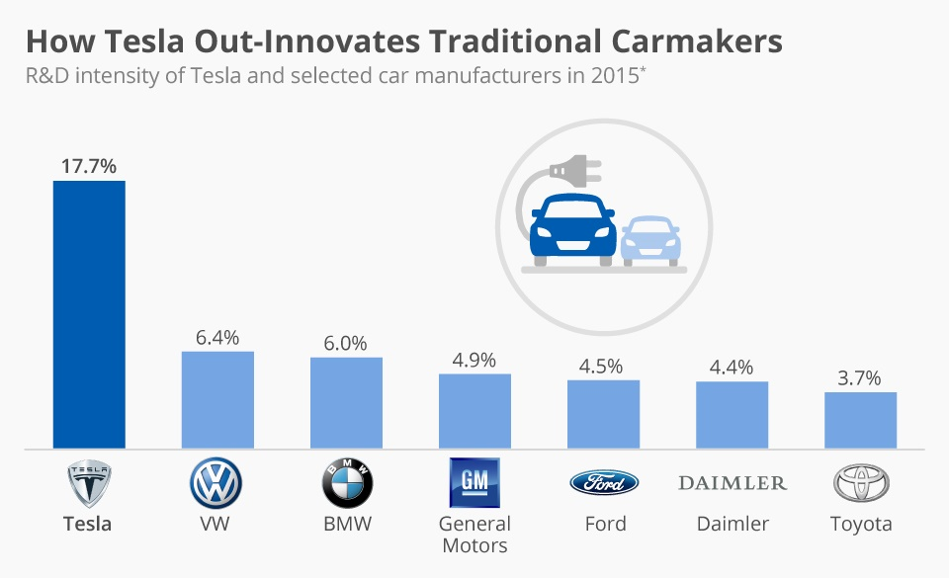
Figure 1: Tesla enjoys technological leadership that is largely due to its immensely greater intensity of R&D as compared to traditional automakers (Studeny et al., 2017).

1.2.4 Comparison
As Table 2 demonstrates, the competitive position of Tesla as being differentiated is greatly founded on the technological advantage, whereas the dependence of Ford on external alliances and slower innovations restricts its ability to be strategically flexible.
Table 2: Comparison between The Impact of Technological Innovation on Tesla and Ford.
Aspect | Tesla (Pioneer) | Ford (Follower)
Innovation Capability | High (battery + software integration, vertical integration) | Moderate (dependent on partnerships and suppliers)
Product Performance | 500+ km range, advanced autonomous and software features | Competitive EV models but lower technological sophistication
Competitive Position | Strong differentiation through innovation and ecosystem control | Competes on cost efficiency and brand legacy
Strategic Limitation | Increasing competition and narrowing technological gap | Slower innovation and limited control over technology development

2. Task 2 – Strategic Response
Continuing the analysis of macro-environment, Tesla (pioneer) and Ford (follower) have taken different strategic reactions to endure the growth under the regulatorial pressure and technology disruption. The answers to them can be critically assessed in terms of Porters Generic Strategies and Ansoff Growth Matrix, in which each company is trying to sustain or improve its competitive edges.

2.1 Porter’s Generic Strategies

2.1.1 Pioneer Strategy (Tesla: Differentiation Strategy)
The use of differentiation is the dominant approach of Tesla, as it is working on technological superiority, innovation, and brand positioning. Its competitive advantage is fuelled by state of the art battery technology, autonomous driving and a robust digital ecosystem (Porter and Advantage, 1985). Tesla spends a lot of money on the research and development, spending over 3 billion dollars per year, which allows the company to introduce new products on a regular basis and offer high-quality products (Tesla Annual Report, 2023).
Moreover, its direct to consumer sales channel and its over-the-air software updates make Tesla customers have more customer experience and brand loyalty, which enables Tesla to set premium prices. As an example, Tesla has higher profit margins than the conventional car manufacturers, and the automotive gross margins in 2022 exceeded 25 percent, which is much higher than the industry average of 10-15 percent (McKinsey, 2023). Nevertheless, Tesla faces such risks as the great expectations of innovation and the growth of rival imitations with the help of this strategy. As Figure 2 shows, Tesla dominates the EV market much more, which supports its differentiation strategy and growth based on innovation. Conversely, the proportion of follower firms including Ford is lower reflecting their less vigorous and transitional strategic position.
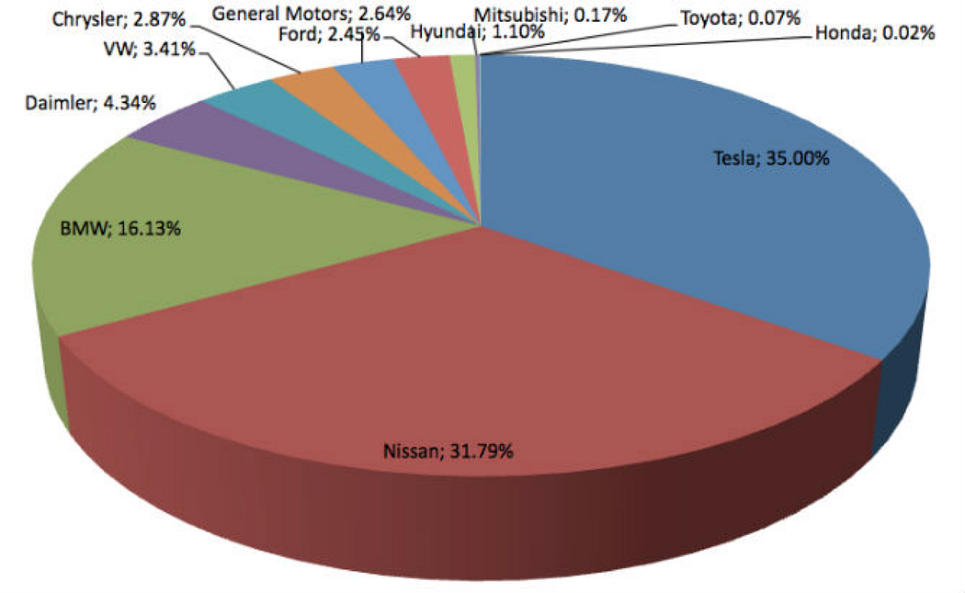
Figure 2: The distribution of market share within the global EV market that shows that Tesla is the dominant competitor in the market, with other traditional manufacturers being less powerful (Hopkins and Lazonick, 2024).

2.1.2 Follower Strategy (Ford: Cost Leadership + Differentiation Hybrid)
Ford uses a hybrid approach, which is a cost leadership strategy mixed with components of cost differentiation. During the process of EV adoption, Ford can use its mass-manufacturing potential to obtain cost-efficiencies and competitive prices. As an example, Ford focuses on cutting down the cost of EVs by 40 percent in 2026, aiming at affordability in the mass market (Ford Annual Report, 2023).
At the same time, Ford is differentiated by brand heritage and product differentiation including the F-150 Lightning, which is based on the popularity of its conventional pickup segment. However, the differentiation of Ford, in contrast to Tesla, is not as technology-based and more based on brand equity. This restricts its capacity to contend in the high end innovation markets especially in the software and autonomous driving technologies.

2.1.3 Comparison
As shown in Table 3, the pure differentiation strategy of Tesla allows Tesla to position its brands well and be ahead in innovation, whereas the hybrid strategy of Ford gives it the opportunity to reach a wider market but with less technological uniqueness. Importantly, Table 3: Strategy Analysis of Tesla and Ford Porter.
Aspect | Tesla (Pioneer) | Ford (Follower)
Strategy Type | Differentiation | Cost Leadership + Differentiation
Key Strength | Innovation and technology leadership | Cost efficiency and scale
Profitability | High margins (~25%) | Moderate margins
Competitive Focus | Premium and innovation-driven market | Mass market affordability

2.2 Ansoff Matrix

2.2.1 Pioneer Growth Strategy (Tesla: Product Development and Market Development)
The Tesla growth strategy is closely related to the product development and market development. The company is constantly releasing new models (e.g. Model Y, Cybertruck) and updating existing models with new software. This is an indication of a high emphasis on innovation-based growth (Ansoff, 1957).
Also, Tesla enters other geographical markets, including China and Europe, where the demand of EV is growing fast. In 2023, more than 60 percent of the increase in EV sales worldwide was in China (IEA, 2023), and hence the necessity to expand into the market. Gigafactories at Tesla also enhance scalability at a global level, which allows reducing costs and controlling supply chains. Nevertheless, the rapid growth also adds to the risks of operation and exposure to geopolitical risks.

2.2.2 Followers Growth Strategy (Ford: Market Penetration and Product Development)
Ford mainly employs strategic approaches of penetrating the market and product development. It will use its available customer base and brand recognition to launch EV variants of its well-known models, including the F-150 Lightning and Mustang Mach-E. This will enable Ford to enter the EV market with lower risks than new entrants.
Meanwhile, Ford is also spending much on product development to increase its EV line. Nonetheless, its expansion is limited by the legacy business and reduced innovation velocity. Nonetheless, the strategy developed by Ford allows switching to it progressively and stabilizing revenues, which is especially important in the face of falling demand of ICE vehicles.

2.2.3 Comparison
Tesla has more aggressive and innovative expansion plans compared to Ford as indicated in Table 4 and has more risk-averse expansion strategies.
Table 4: Ansoff Matrix analysis between Tesla and Ford.
Aspect | Tesla (Pioneer) | Ford (Follower)
Growth Strategy | Product & Market Development | Market Penetration & Product Development
Market Approach | Expansion into new global markets | Leveraging existing customer base
Innovation Level | High | Moderate
Risk Level | High (rapid expansion) | Moderate (gradual transition)

3. Critical Evaluation

3.1 Tesla vs Ford Comparative Performance.
In general, Tesla shows better performance than Ford in its reaction to the pressure of macro-environment, especially regarding technological innovativeness and regulatory conformity. The first-mover advantage enables Tesla to gain a bigger portion of the EV market, with the company taking about 19 percent of all EVs sold in the world as of 2023, and Ford being a smaller but increasing competitor (IEA, 2023). Such a performance difference indicates that Tesla has the capability of taking the initiative to influence the direction of the industry in a proactive manner, in contrast to Ford to a large extent reacting to the influence. Strategically, innovators can usually be ahead of the pack in a dynamic market because of their capacity to shape the technological standards and expectations to the consumer (Lieberman and Montgomery, 1988).

3.2 Strategic Advantages and Strengths.
The major strength of Tesla is the innovation-based differentiation strategy which is facilitated by heavy investment in research and development and vertical integration. This enables a quick product development, high software capability and good brand positioning (Porter and Advantage, 1985). Also, Tesla can enjoy the advantage of compatibility with environmental standards, which lowers compliance expenses and increases scalability.
Conversely, Ford has been able to leverage on its capacity to manufacture in large scale and its brand heritage to achieve cost efficiencies and access to mass markets. Its hybrid approach offers a slow change with a reduced risk in the short term. But Ford is hindered by legacy systems to drive agility, which lowers its competitive capabilities in high-tech segments.

3.3 Strategic Limitations and Weaknesses.
Although it has these benefits, Tesla is vulnerable to the threats of growing competition and excessive dependence on technological superiority as its competitors are investing fast in EV development. Also, high prices can reduce availability in the markets that are price-elastic (McKinsey, 2023).
Ford, in its turn, is plagued by structural inertia and high transition costs as it has invested over 50 billion in electrification, which affects the profitability in the short term (Ford Annual Report, 2023). It is limiting its capabilities to compete in a technology-based market because its innovation cycle is slow.

4. Conclusion
To sum up, the discussion reveals that the macro-environmental forces especially regulation and technological innovation have transformed the competitive reality in the EV industry. As an innovative company, Tesla is ahead of Ford because the company has utilized innovation, regulatory fit, and effective differentiation strategy to maintain competitive advantage. Conversely, the follower role prevents Ford to be responsive because of legacy structures and slower adoption of technology. Although Ford has a prospective of long-term growth based on its scale, its present strategy is more of a transitioning strategy as opposed to a transformative one.

References
Ansoff, H.I., 1957. Strategies for diversification. Harvard business review, 35(5), pp.113-124.
BloombergNEF (2023) Battery Price Survey 2023. Available at: https://about.bnef.com/insights/clean-energy/lithium-ion-battery-pack-prices-hit-record-low-of-139-kwh/ (Accessed: 22 March 2026)
Ford Motor Company (2023) Annual Report 2023. Available at: https://s205.q4cdn.com/882619693/files/doc_financials/2023/ar/2023-Ford-Annual-Report.pdf (Accessed: 22 March 2026)
Hopkins, M. and Lazonick, W., 2024. Tesla as a Global Competitor: Strategic Control in the EV Transition. Institute for New Economic Thinking Working Paper Series, (225).
International Energy Agency (IEA) (2023) Global EV Outlook 2023. Paris: IEA. Available at: https://www.iea.org/reports/global-ev-outlook-2023 (Accessed: 22 March 2026)
Kotler, P. and Keller, K.L. (2022) Marketing Management. 16th edn. Harlow: Pearson. Available at: https://studylib.net/doc/27749324/kotler--keller---chernev---16th-ed-edits?p=3 (Accessed: 22 March 2026)
Lieberman, M.B. and Montgomery, D.B., 1988. First‐mover advantages. Strategic management journal, 9(S1), pp.41-58.
McKinsey & Company (2023) The Future of Mobility Report. Available at: https://www.mckinsey.com/~/media/mckinsey/industries/automotive%20and%20assembly/our%20insights/the%20future%20of%20mobility/the-future-of-mobility.pdf (Accessed: 22 March 2026)
Porter, M.E. and Advantage, C., 1985. Creating and sustaining superior performance. Competitive advantage, 167, pp.167-206.
Studeny, M., Bartels, A., Rauch, M., Scheiblich, M., Just, V. and Buchmüller, M., 2017. Innovation management, Environmental sustainability, and market competitiveness.
Tesla Inc. (2023) Annual Report 2023. Available at: https://ir.tesla.com/_flysystem/s3/sec/000162828024002390/tsla-20231231-gen.pdf (Accessed: 22 March 2026)

