Certificate of Higher Education Skills for the Workplace (Health &Social Care)

Name: Muhammad Taimoor
Student Number: 2334543
Module Code: LCHS4003
Module Title: Introduction to Health and Social Care
Lecturer Name: Azida Zainol
Assignment Title: Portfolio- Two Tasks

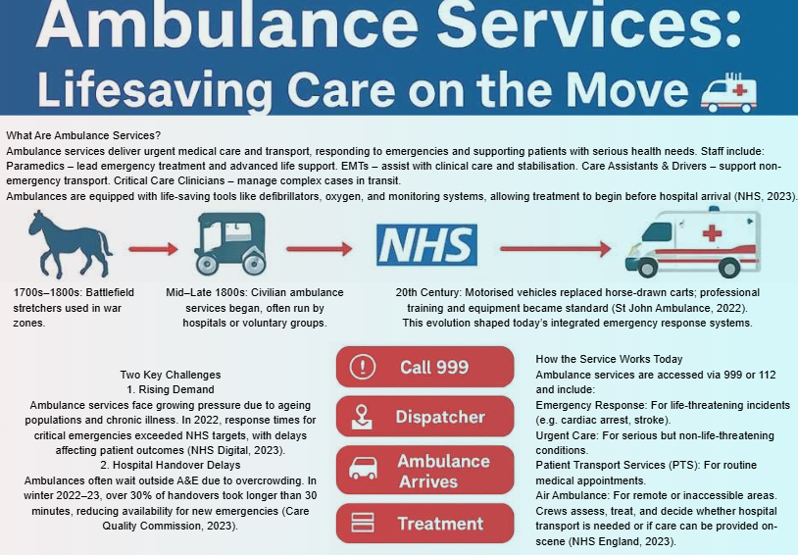

References:

Care Quality Commission, 2023. State of Care 2022/23. [online] Available at: https://www.cqc.org.uk/publications/state-care [Accessed: 16/10/2025].

NHS, 2023. Ambulance services overview. [online] Available at: https://www.nhs.uk/nhs-services/ambulance-services/ [Accessed: 18/10/2025].

NHS Digital, 2023. Ambulance Quality Indicators. [online] Available at: https://digital.nhs.uk/data-and-information/publications/statistical/ambulance-quality-indicators [Accessed: 13/10/2025].

NHS England, 2023. Urgent and Emergency Care. [online] Available at: https://www.england.nhs.uk/urgent-emergency-care/ [Accessed: 10/10/2025].

St John Ambulance, 2022. Our History. [online] Available at: https://www.sja.org.uk/about-us/our-history/ [Accessed: 19/10/2025].

Task 2 Essay:

The Origins and Structure of the National Health Service (NHS)
The National Health Service (NHS) was introduced in 1948 as a radical attempt to make healthcare fair and equal for everyone in the United Kingdom. Prior to NHS creation, most medical care in Britain depended on an individual’s ability to pay, private insurance schemes, charities, or limited local authority services, which meant that many working-class families could not afford proper treatment (Ham, 2021). Hospitals were often overcrowded, and access to healthcare varied widely depending on region and income. World War II changed how both the government and the public thought about public services. The establishment of the wartime Emergency Medical Service demonstrated that centrally organised healthcare could work efficiently and effectively during a national crisis. This experience convinced many politicians and medical professionals that Britain needed a permanent, national health system (Timmins, 2023).
Aneurin Bevan, who served as the Labour government’s Minister of Health, played a crucial role in shaping the NHS. His vision was shaped by the Beveridge Report of 1942, which had identified five “Giant Evils” in society including Want, Disease, Ignorance, Squalor, and Idleness, and called for reforms to eliminate them (Beveridge, 1942). Bevan’s plan aimed to tackle “Disease” by creating a system that was comprehensive, universal, and free to use. The idea of being free at the point of delivery was revolutionary at the time. It meant that people would no longer need to worry about medical bills when sick or injured; instead, services would be funded collectively through taxation. This shift transformed healthcare from a privilege of the wealthy into a basic human right, becoming the emotional and political foundation of the NHS.
The NHS's founding principles were clear: it includes meeting the common essentials of everyone, free to use, and allows care based on clinical needs instead of financial means (Department of Health and Social Care, 2022). These rules reflected a moral commitment to equality and social justice, which defined post-war Britain. Over time, however, reforms have sought to balance these ideals with the need for efficiency and sustainability. From the 1980s onwards, successive governments introduced market-style reforms and new management structures to improve performance and accountability. Supporters argued that competition between providers encouraged innovation and better service delivery; meanwhile, critics like Pollock (2020) warned that such changes risked weakening the NHS’s founding values by prioritising profit-like models over public service.
In today’s structure, the NHS is no longer a single, unified organisation across the UK. Health services are devolved, meaning England, Scotland, Wales, and Northern Ireland each manage their systems independently, with their own policies, budgets, and priorities. In England, NHS England now oversees operations and allocates funding to Integrated Care Boards (ICBs), which plan health services for local populations. The NHS functions across several levels of care: primary care, mainly provided by general practitioners (GPs); secondary care, which covers hospital and specialist treatment; and community services, such as mental health, rehabilitation, and public health programmes (NHS England, 2023).
Despite its achievements, the NHS faces growing challenges in the 21st century. The population is ageing, and long-term conditions such as diabetes and heart disease are becoming more common, increasing the demand for healthcare. There are also significant workforce shortages, with many doctors and nurses reporting stress and burnout. Long waiting lists for elective procedures and emergency care reflect these pressures. Financial strain has been another major issue, with debates over whether funding has kept pace with demand. The COVID-19 pandemic placed additional stress on resources, exposing gaps in capacity and highlighting the urgent need for investment and reform (King’s Fund, 2023).
In conclusion, the NHS emerged as a bold and compassionate response to the inequalities of pre-war Britain. Rooted in the principles of universality, fairness, and free care at the point of need, it has become a cornerstone of British identity. Although the NHS now faces financial pressures, staff shortages, and rising patient demand, its core values remain as important as ever. To protect these ideals for future generations, policymakers must prioritise long-term investment, workforce wellbeing, and modernisation while upholding the belief that healthcare is a shared public good.

References:
Beveridge, W. (1942) Social Insurance and Allied Services. London: HMSO.
Department of Health and Social Care (2022) NHS Constitution for England. Available at: https://www.gov.uk/government/publications/the-nhs-constitution-for-england (Accessed: 15/10/ 2025).
Ham, C. (2021). Health Policy in Britain. 8th edn. London: Palgrave Macmillan.
King’s Fund (2023). The NHS at 75: Priorities for the Future. Available at: https://www.kingsfund.org.uk (Accessed: 18/10/ 2025).
Pollock, A. (2020). NHS plc: The Privatisation of Our Health Care. London: Verso.
Timmins, N. (2023). The Five Giants: A Biography of the Welfare State. London: HarperCollins.

