Community Engagement
Name – Najmeh Dadash
Institution – University of Wales Trinity Saint David
Professor – Mr. Gareth Hughes
Course -- Accounting
Date – 4 May 2018

Executive summary
This paper discus about general problem that may face many organisations and hinder their progress towards being successful in accomplishing the projects planned. The document begins by identifying the organisation, which is a business group called Bright Art at YCG. It includes a group of five business students from the Wales Trinity Saint David University who are working along with Ysgol Crug Glas. The main problem that will be addressed by the organisation, as it is discussed later in the paper is assisting the art development of YCG by taking part in their art sessions and raising the adequate funds that are able to support it and carry on with its projects.
Introduction
The purpose of the report is to bring in to light, through findings, some of the sensitive issues that are facing business groups in carrying on with their projects. After the identification of the problem that is facing organisations like Bright Art at YCG, it is explained how this can affect and hinder carrying on of projects. If it happens the problem has already invaded the organisation, the paper in pursuit of seeking the solution discusses the problem-solving techniques. This begins by identifying what the problem is and taking the necessary steps towards solving such an identified problem. The process was marked by the implementation of problem solving in the organisation. Ideas, which are rich in remits, are implemented in the organisation operations, a factor that contributes towards escaping the risks that may come along with a certain problem (Demetrious, 2014 p.255).
The report findings as per the research is conducted can be drawn according to the analysis of the data concerning problems in the organisation. This is very important to the business group hence it assists in carrying on their projects without the fear of risks interfering with their missions. It is advisable for organisations to identify the problems that are faced during their operations to ensure that projects are done smoothly without hindrance.
Brief Background Information on the Organisation
The Bright Art at YCG is made up of a group of five university students, a specialized group that is working for Ysgol Crug Glas School. The group is significance to the organisation through participating in art sessions and raising the required funds in order to support it abundantly. This majorly helps the art department of the organisation. The business group is made known to all possible projects that they can be part of and that they can assist in solving the relevant problems (Karanges et al, 2015 p.130). A factor that encourages one choose to work with the Art department is because the business group members are introduced to all the possible projects, which they can be part of in the school. From such point, the organisation is so far aware of the problem it is proposed to handling. They are aware that they have to run an art session that involves raising adequate funds that will assist in lighting the art room and most probably to have a mini art expedition in the business school (Naidoo & Meyer, 2017 p.800). As an organisation, the school looks forward to the group by helping them in the creation and selling of smart cards, which is part of their artwork.
The activities of the organisation are not limited, and they are even involved in social media platforms. Afterward, there is a phenomenon of social media campaign conducted by the organisation, where the employment of social media aspect like Facebook litetakes place (Demetrious, 2014 p.259). The organisation members are in a position to post and share posts on a Facebook page, which is a way of notifying their followers and viewers about the events coming on the way. Most of these events include fundraising as a way of addressing the problem affecting the organisation as well as updating on the progress of the organisation’s project. In the perspective of using social media, it is a hard task to determine how the posts shared on social media are effective since the data is limited and it is always not easy to determine the followers who see the post and what they do after seeing it. Connected to the page is a link to Blog and the page for fundraising that is referred as Just Giving. However, with a fairly constituent amount engagement, the organisation has proven that there are some people reviewing the posts and responding in a positive way (Karanges et al, 2015 p.132).
The activities of the organisation with most engagements are regarded to as the events organized by the blog. This can partially contribute to success in the activities that are involved in the organisation at large. Nevertheless, this does not guarantee to be the magnificent baking talent that is possessed by every individual who is a group member and dedication that is experienced in other groups to reach the goals of the organisation (Naidoo & Meyer, 2017 p.812). The incorporation of the social media shows some nice progress and such kind of engagement is believed to be kept at that pace even in the future times (Karanges et al, 2015 p.132). The main goals of the organisation to the school are hoped to accomplish with the completion of projects like raising enough money to purchase UV light and fitting in the school. This is one of the main goals of the organisation to achieve on behalf of the school as per the objectives of the organisation. The benefits of the UV lights are directed towards children and are a fundamental item in the institution to the lovely pupils of Ysgol Crug Glas.
The Problem
In the field of being an artist, there are many challenges that one should be prepared to face. It is very much clear that one should be prepared to deal with personal disappointments just in the same manner with the issues affecting artists as a whole (Fisher, 1998 p.550). Some of the common challenges faced by artists during the start of their careers as well as those big issues that strike the whole industry have been discussed below. Since working as an artist is under creative field, it is obvious that one requires a very tough skin that happens with no exception (Brizzell, 1998 p.122). Whether it is an individual, a group of many (band), label not forgetting manager, agent, or even a promoter are all placed in the same line where they face several barriers along the journey (Tobin et al., 2012 p.101). Such journey is none other than just working towards the success of the whole organisation.
A very important strategy that everyone in this industry should know is just learning how to deal with disappointment as one keeps pressing on how to achieve the goals without considering taking a move back whenever things seem not to work as expected (Brizzell, 1998 p.123). It is very important that the artist should be aware of how to manage or other deal with the common business problems related with the industry to avoid the issue of being blind hence loosing focus (Tobin et al., 2012 p.102). Loosing focus may come as a form of one not being in a position to see any future and without much thinking he/she just gives up due to tough challenges. By the time one is overcome with challenges, it simply implies that all what seemed like his or her goal or target will not be achieved by any means (Brandfonbrener, 2010 p.25).
The most important thing to note when dealing with demo disappointment should be that every single person or band that made it through has ever faced such a challenge (Brandfonbrener, 2010 p.29). Many are the times when there is no response to one’s demo and this does not have to mean there is something wrong one is doing (Tobin et al.,2012 p.103). As a way of comforting oneself as well as being hopeful, one should know that it really takes some time for the right demo to be in the hands of the right person. In other words, it does not mean that one is doing anything wrong.
For a focused artist, the only thing running over the mind should be that there is still a chance of improving possibilities of getting a response (Brizzell, 1998 p.138). In order to meet the above level, it is a mandatory that one should stick to some basic ground rules. At times it is obvious that even with the right approach, there is no success achieved (Tobin et al., 2012 p.105). It is at such a point; when many will lose focus then eventually give up while they should just keep aiming far by observing the basics. Some of the things an artist should do at such a hard time are ensuring that he or she stays on top of one’s social media presence (Brandfonbrener, 2010 p.33).
One of the most disappointing factors is receiving different results from the expectations one had which on top are not pleasing (Fisher, 1998 p.552). This is a very common behavior when it comes to things like reviews of one’s album or band supposed to appear in a newspaper then the opposite happens (Brandfonbrener, 2010 p.44). When such happens the most important thing is to note that it is something that happens often and again, it is not personal (that is one should not treat it as something affecting him or her but instead view it in a whole industry’s perspective). By looking at the case of writers, it is very clear that at times they say a review appears for appeasing a person but it catches them by surprise when an editor drops it (Tobin et al., 2012 p.108). The best advice given at this time is that one should just contact the publishers to explain what happened. After they give the whole story, it is very important to make a request and know whether they can run it in the next issue.
On top, it is also good to inform people of what happened and again providing dates on when the review will resurface. Artist’s success comes when fans value as well as accept his or her work. This implies that if one has no support from the fans he or she will just be doing nothing. Another very important factor is that just as it is with everyone, artists too want to be paid for their work but it ends up being kind of friction with fans caused by the royalty collection companies (Tobin et al., 2012 p.110). As obvious, this reflects too badly on the artist. Above everything, it is very crucial that communication should be highly valued since it is the most important factor behind the success of an organisation (Brandfonbrener, 2010 p.49). Though it sounds easy to everyone, communication must be viewed with a lot of seriousness since there are difficult and frustrating barriers on its way.
Problem Solving Techniques
Effective engagement of a community builds trust, goodwill and respect among the organisation and community. Therefore, various incidences have been aligned down and intensified in order to resolve people’s issues all over the areas where the organisation has located its branches. Emerging groups of community leaders have come up together to motivate people and demonstrate the usual significance of the organisation towards the services being offered (Ple & Angot, 2015 p.9).
Development of an effective community corporations is an art that represents departure from an aware means of functioning between the organisation and occupants of a particular community (Zhou, 2016 p.466). The sector mostly requires the perspective policing that goes beyond the law enforcement standards with a focus and willingness for engagement. Moreover, effective partnership involves the willingness of members of a community to engage in a dialogue that is constructive. All the same, efforts intentional builds collaborate with the organisation, trust and community members acting as strength catalysts of facilitating welfare (Wang & Yang, 2016 p.86).
However, when the organisations are exposed to respect of various reasons for a specific interface, members of community are likely to be less fear as their voice are perceive heard and processed if the perspective ideas is fairly. Therefore, in a community that is a cooperative centered, has the authority to be imitative not merely from the rule but also from the validity of the community eyes (Zhou, 2016 p.466). The members of a community can view the cooperative as legitimate when they see the administration carrying out its duties very fairly, lawfully and in accordance to the best interests of the community. Building of a validity sense for an integrity procedural in the organisation have emerged as a promising plan in the department thus, increasing trust and reduced confrontation.
Solving of the Problem
Various incidences have been reported that the organisation departments are rude to people while serving them. Besides, their occupation is based on offering services for an organisation development where they are taught on how to interact more effectively with people by helping them out (Tarhini, Ammar & Tarhini, 2015 p.25). Various strategies are based on an advocacy that is non-profit and helps all the corporate staffs all over the institutions to improve their interaction behaviors with people. Moreover, lack of cultural basic knowledge has reduced in order to facilitate effective communication for fast and good progression of the organisation. The new recruits should first be given a period of time to adapt the nature of the organisation department for them to gain a bit of experience before admitted to the enforcement area of work (Wang & Yang, 2016 p.86). Transparency is also promoted when the organisation staffs are open and respectful on a certain reason for a particular interaction.
Once the workers are very certified and have adapted to the organisation atmosphere, they are given chance to work due to the contemporary knowledge of implementing and working experience (Zhou, 2016 p.466). In addition, their neurological changes taught have been well educated on how to assess the authority by use of their alternative techniques. The implemented strategy gain has increased compliance and deescalated the unstable situations that might appear within the organisation. However, decision-making within the organisation should highly be applied in order to give effective services to everyone through an analyzed protocol.
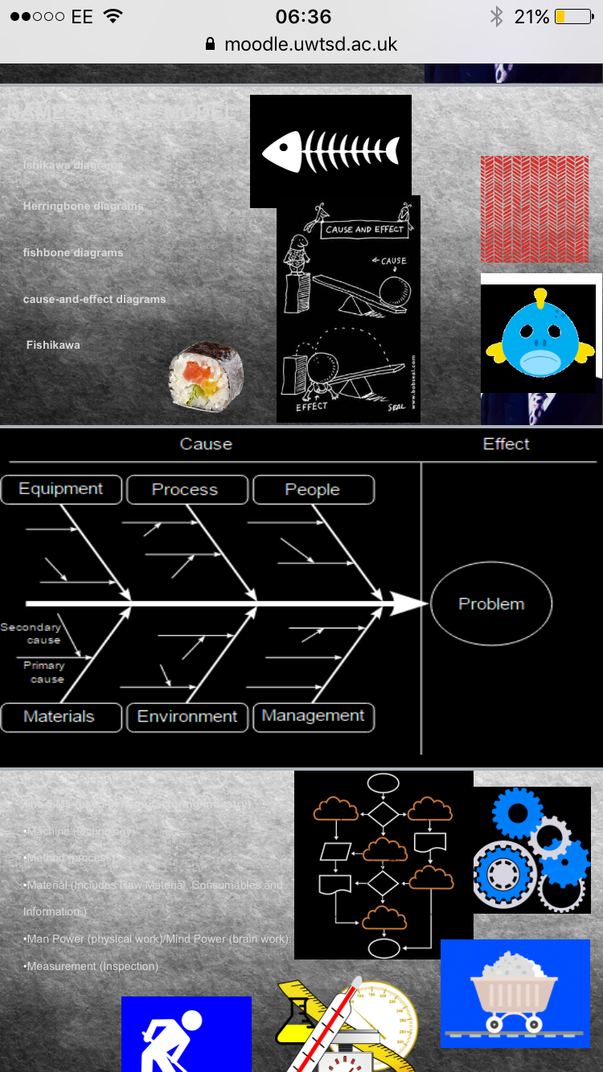
From the diagram, it is clear that a problem is made up of many components brought together. All the factors constituting to a problem share some characters that make them appear under one category that is no matter how they play different roles towards a problem, all end up being the primary cause to such a problem (Men & Tsai, 2014 p.426). At a given stage the cause appear to have more strength than the effects but under a matter of time the effects outweigh them. All the factors create a state of equilibrium hence playing a role towards the buildup of the problem (effect).
Problem Solving Implementation
Implementation is an investigation systematic study of the procedures used in the application of enterprises as well as the related issues that affect these practices’ (Zhou, 2016 p.466). Furthermore, the observations of the implementation research (IR) should be cooperative that involves both the decision makers and implementers in the identification and designing of a study as well as extra levels of research method. However, progression is recognized to the plan methods for scaling-up and implementing of which they are not adequate to the knowledge required in managing the difficulty intervened.
Contrary, the adaptive learning of achieving the methods that influences businesses with an assortment of the investors whom are essential in identifying the required changes have helped in safeguarding the variations that are interpreted into plans and exercise (Zhou, 2016 p.466). This has resulted to placing the shareholders in a commitment manner of the organisational ideologies. Moreover, while there is many assets, exact key principles or overall stages for the investor’s engagement are highly related to nature of the effort, meaning that these are frequently stimulating challenges to be implemented in practice and mainly at the community level.
However, the (IR) crews are regularly interdisciplinary and can comprise members with varying considerate in the community as an engagement. Several forms of teaching session may be beneficial in making sure everybody has a clear and a common knowledge of the purpose methods (Tarhini, Ammar & Tarhini, 2015 p.25). The IR toolkit stimulates the team power in order to recognize all the applicable investors and continuously highlight the significance of a suitable shareholder. However, this provides an appropriate basis for consumers to adapt the training assemblies in order to incorporate supplementary material or a help associated to the community engaged.
Conclusion
In conclusion, it is very important for one to identify the problem in any given organisation. When the problem is identified, the next step is looking at the techniques on how to handle such problems. With the techniques in position, another very important part should be on how to implement the idea of problem solving so that it help to provide possible solutions. Under the techniques for solving the problem, such issues like decision making, recruiting new trainees as well as implementing new services should be incorporated just to mention a few. When such factors are considered, the organisation is seen to run just as smooth as one would have expected. Failure to consider these factors, the organisation would just but end up disappointing people, a factor that leads to its failure. From the introduction part, it is very clear that for a smooth run identifying the problem is very important hence providing solutions as well as techniques.

Bibliography
Brandfonbrener, A.G., 2010. Etiologies of medical problems in performing artists. Performing arts medicine, 3, pp.25-49.
Brizzell, C., 1998. ARTNOW: A (stumbling) movement towards arts advocacy. TDR/The Drama Review, 42(1), pp.122-158.
Demetrious, K., 2014. Community engagement and the third sector. Public relations: theory and practice: 4th Edition, pp.259-285.
Esquivel, M.I.V., Parks, C., Reyes, A., Tirhi, S. and Tamariz, M.I., 2017. Problem Solving and Leadership Individual and Organisational Motivation Affected by Stress: The Use of Mindfulness into Action Practices to Encourage Protective Health Behaviors among Individuals and Organisations. In Encyclopedia of Strategic Leadership and Management (pp. 526-537). IGI Global.
Fisher, J., 1998. Approaching the Millennium: Essays on Angels in America. Theatre Journal, 50(4), pp.550-552.
Goetsch, D.L. and Davis, S.B., 2014. Quality management for organisational excellence. Upper Saddle River, NJ: pearson.
Karanges, E., Johnston, K., Beatson, A. and Lings, I., 2015. The influence of internal communication on employee engagement: A pilot study. Public Relations Review, 41(1), pp.129-131.
Kushner, R.J., 2003. Understanding the links between performing artists and audiences. The Journal of Arts Management, Law, and Society, 33(2), pp.114-126.
Marsland, J. and Krump, G., 2014. The changing theatre landscape: New models in use by theatre artists, groups and organisations.
Marston, D., Lau, M., Muyskens, P. and Wilson, J., 2016. Data-Based Decision-Making, the Problem-Solving Model, and Response to Intervention in the Minneapolis Public Schools. In Handbook of Response to Intervention (pp. 677-692). Springer, Boston, MA.
McLachlan, K. and Hutchison, J., 2014. What are the critical success factors for effective university-community engagment?.
Men, L.R. and Tsai, W.H.S., 2014. Perceptual, attitudinal, and behavioral outcomes of organisation–public engagement on corporate social networking sites. Journal of Public Relations Research, 26(5), pp.417-435.
Naidoo, R. and Meyer, J., 2017, September. Impact assessment to measure the success of implementation of rural community engagement projects. A case study. In AFRICON, 2017 IEEE (pp. 800-805). IEEE.
Ple, L. and Angot, J., 2015. Serving poor people in rich countries: the bottom-of-the-pyramid business model solution. Journal of Business Strategy, 36(2), pp.3-15.
Silverman, T., 2017. UK Foreign Fighters to Syria and Iraq: The Need for a Real Community Engagment Approach. Studies in Conflict & Terrorism, 40(12), pp.1091-1107.
Tarhini, A., Ammar, H. and Tarhini, T., 2015. Analysis of the critical success factors for enterprise resource planning implementation from stakeholders’ perspective: A systematic review. International Business Research, 8(4), p.25.
Thompson, M., Peters, B., Small, N. and Rodgers, K., 2015. A problem shared. International Journal of Integrated Care, 15(5).
Tobin, C.L., Porcel, J.M., Wrightson, J.M., Waterer, G.W., Light, R.W. and Lee, Y.G., 2012. Diagnosis of pleural infection: state-of-the-art. Current Respiratory Care Reports, 1(2), pp.101-110.
Wang, M.H. and Yang, T.Y., 2016. Investigating the success of knowledge management: An empirical study of small-and medium-sized enterprises. Asia Pacific Management Review, 21(2), pp.79-91
Wang, X. and Tang, X., 2009. Face photo-sketch synthesis and recognition. IEEE Transactions on Pattern Analysis and Machine Intelligence, 31(11), pp.1955-1967.
Zhou, B., 2016. Lean principles, practices, and impacts: a study on small and medium-sized enterprises (SMEs). Annals of Operations Research, 241(1-2), pp.457-474.

