Introduction to Web and Databases (ACCA4023)

  - Molly Thomas 2502132

Contents

Introduction 2
Requirements 2
Implementation 2
Webpage Screenshots 2
Validation 4
HTML – Hypertext Markup Language 4
CSS – Cascading Style Sheets 5
Web Development terms 5
Evaluation of Website 6
Website Comparison 9
References 13
Appendices 14
Homepage 14
Itinerary and Checklist page 15
Contact information page 17
Styling Sheet 18

Introduction
This report will showcase many stages of the creation of the website and how I have demonstrated HTML and CSS techniques to produce a functional site. I have delved into website development terms and tools to broaden my understanding of these skills and their importance in creating effective, user-friendly, and accessible websites. This research has assisted me in evaluating the website I have created, highlighting the skills I have used and to reflect on future improvements that could be made.

Requirements
The website, “Run for Change!”, promotes a charity half marathon in Cardiff aimed at raising funds for environmental causes. The event features eco-friendly activities including family sports day, eco-fair, raffle, and the main half marathon. It targets not only Cardiff residents but also environmentally conscious runners from across the UK, bringing people together to raise awareness and funds for this important cause.

Implementation

Webpage Screenshots
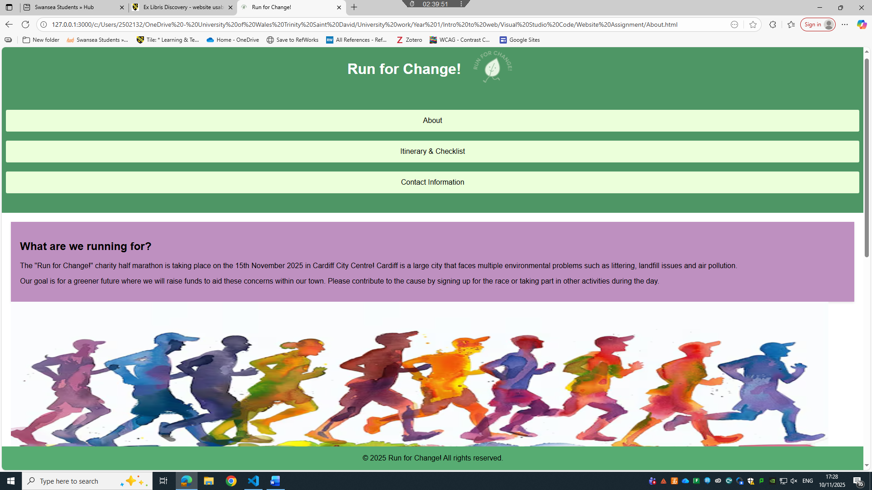
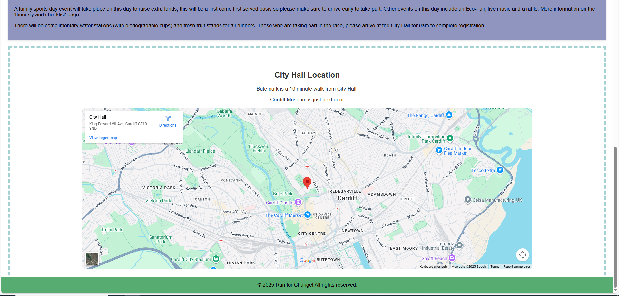Figure 1 - Shows the home page

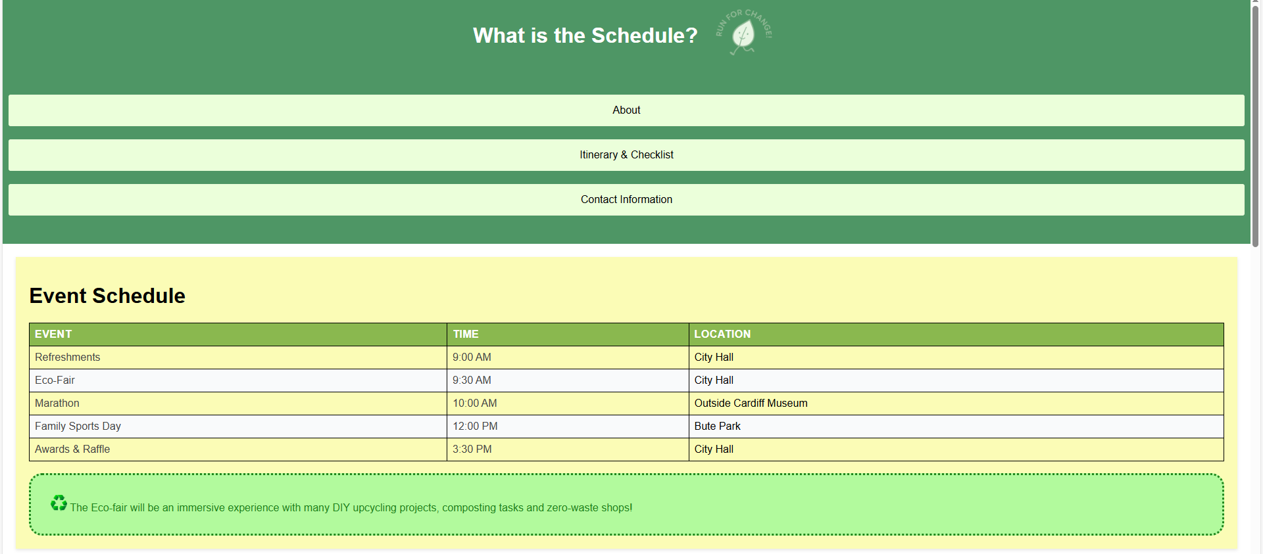
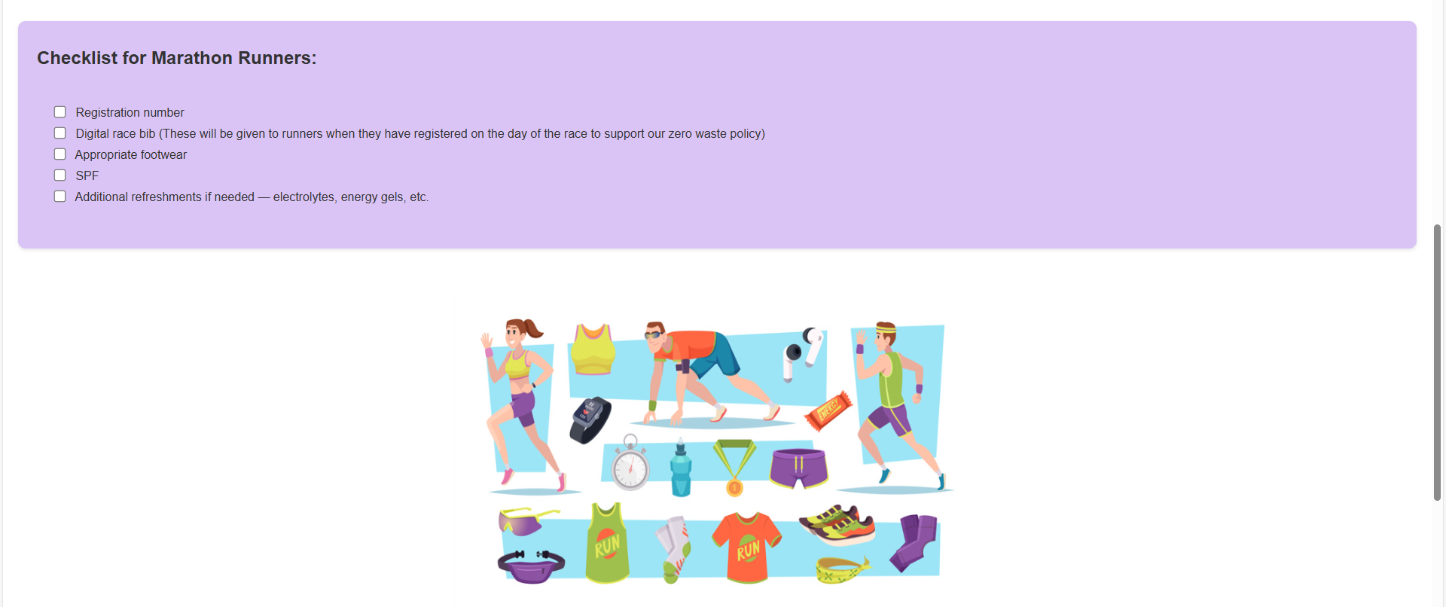

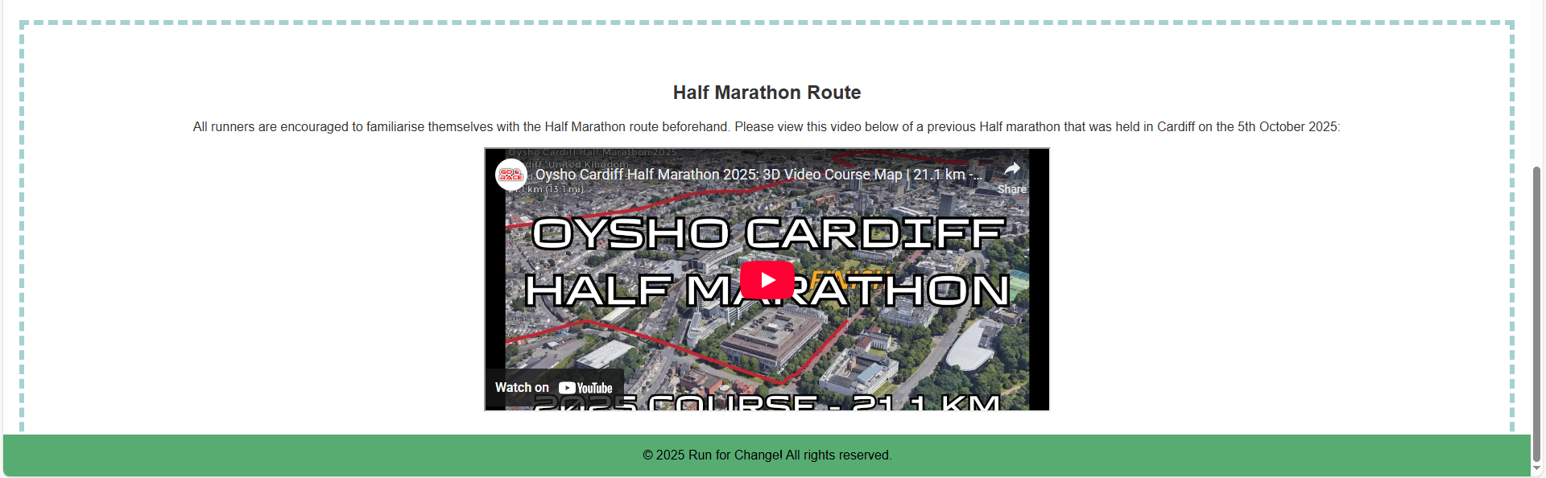Figure 2 – Shows the Itinerary and Checklist page

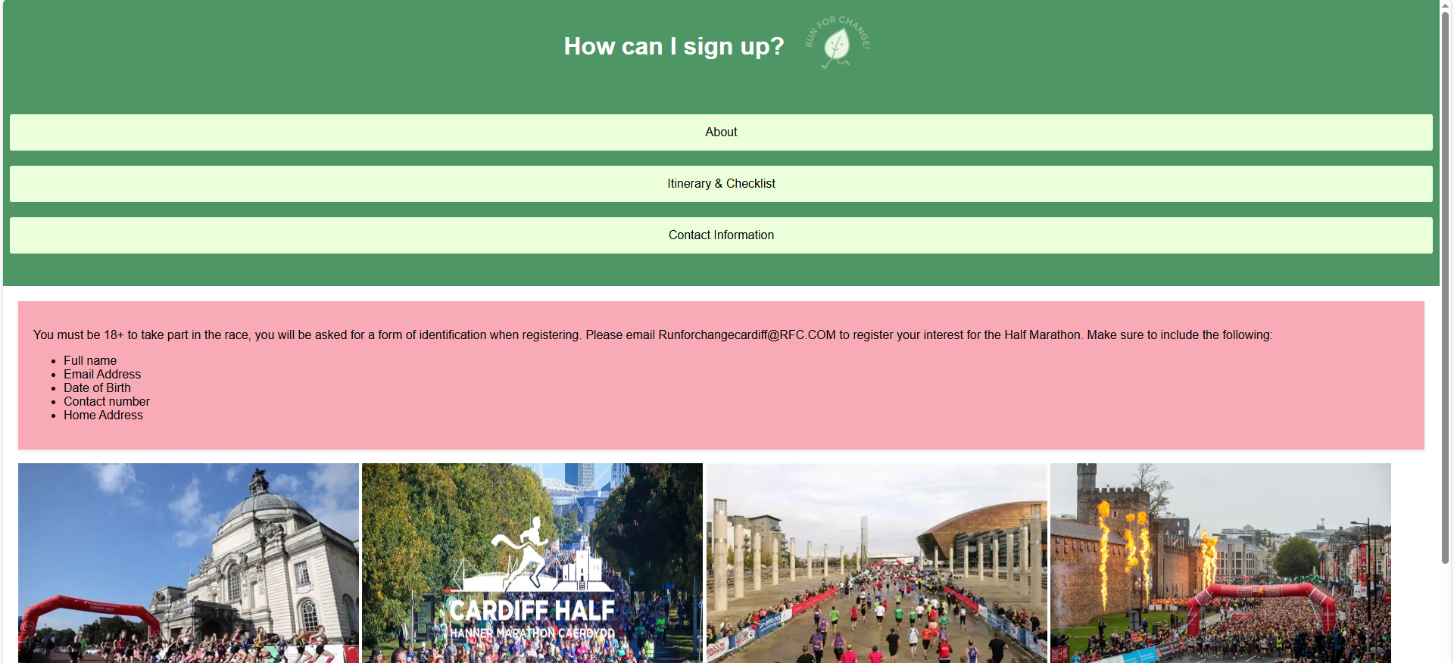
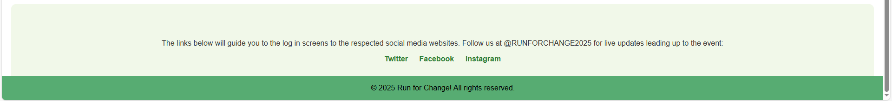Figure 3 – Shows contact information page

Validation

HTML – Hypertext Markup Language
I validated all three webpages using the W3C HTML Validator. A recurring error appeared on each page related to my navigation: a <div> cannot be placed inside an unordered list. To fix this, I removed the <div> from the <ul> and placed it inside the individual <li> elements instead.
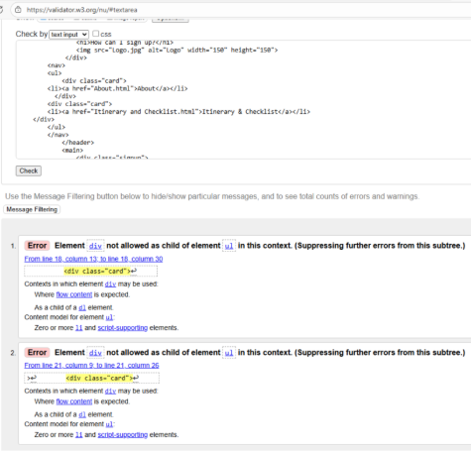
  - Figure 4 – Shows HTML errors

CSS – Cascading Style Sheets
I validated my CSS using the W3C CSS Validator and found two errors. One was a rule in my bordered-text class with an invalid value, so it wasn’t affecting the design. I removed the unnecessary display property since it wasn’t needed for my layout.
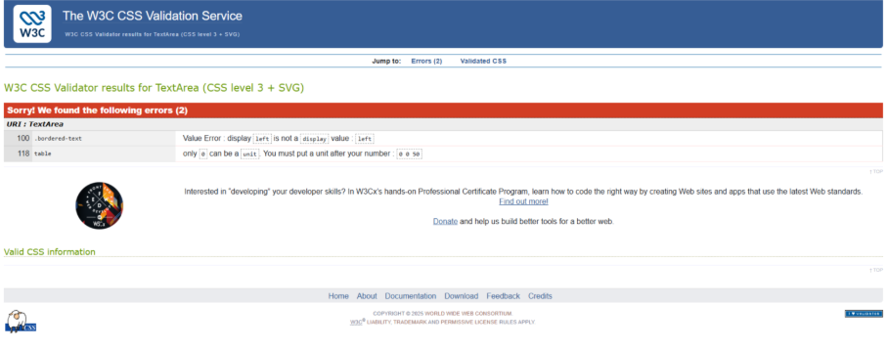Figure 5 – Shows CSS errors
After fixing the issues and adjusting my code, I rechecked my HTML and CSS to confirm there were no remaining errors or warnings.
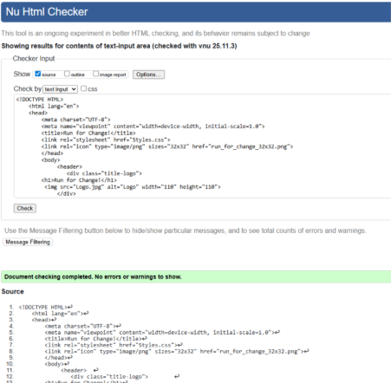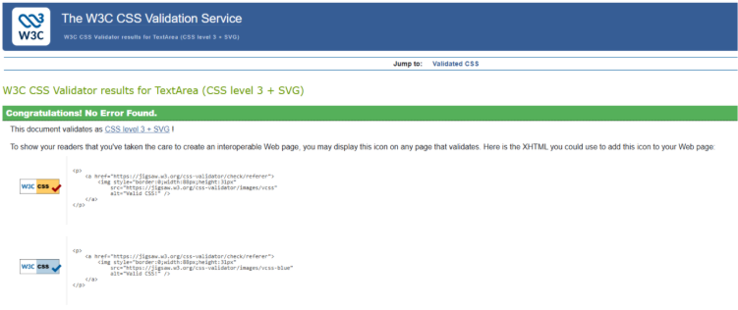Figure 6 – Shows HTML and CSS errors corrected, and no additional errors found

Web Development terms
Usability
Website usability is the term that demonstrates how a user can navigate through a website efficiently and easily. It prioritises the user experience, monitoring clarity and responsiveness on a webpage. [1]
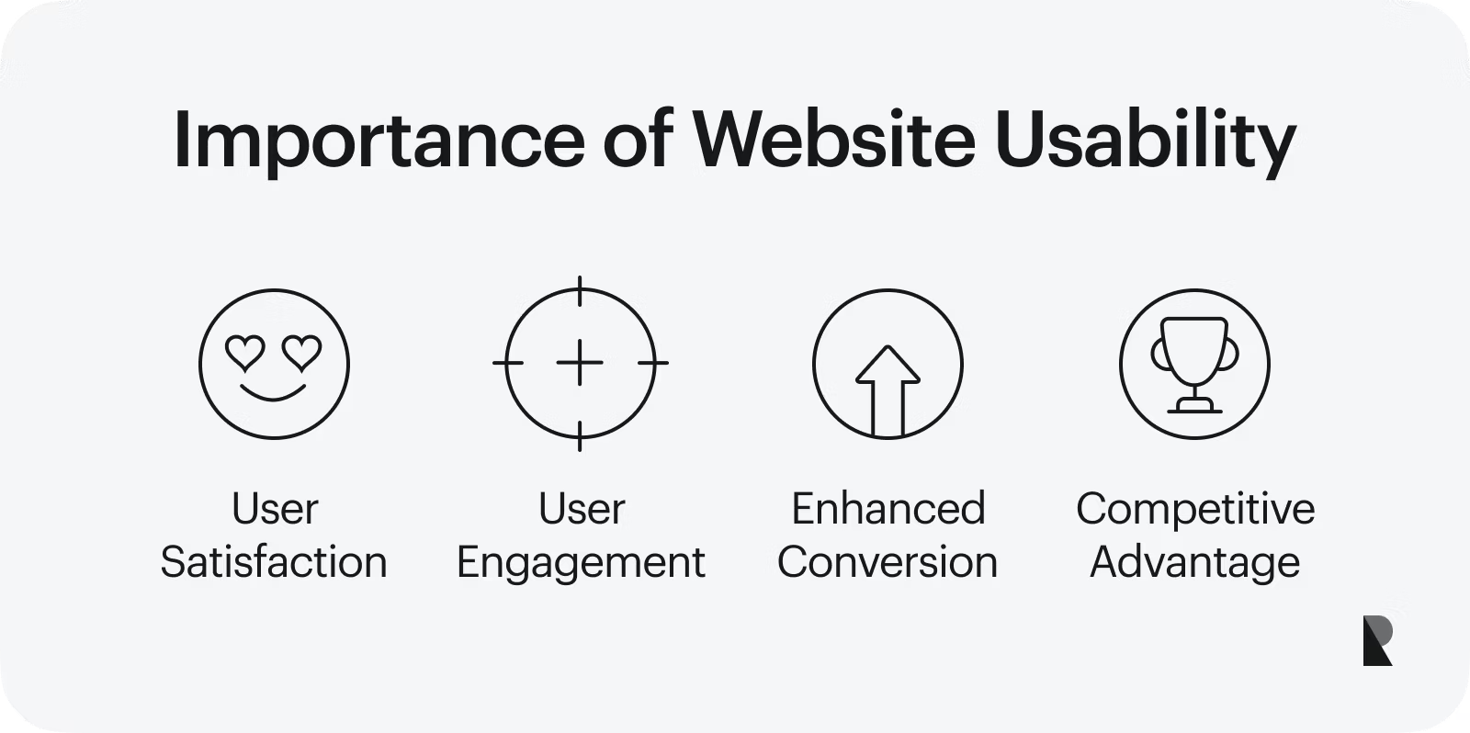 [1]
Usability measures how easy an object is to use. For many websites and software applications, the user needs to be able to achieve their goals to be successful and satisfied with the service. [2] Even though a website could be designed very well and visually appealing if the usability elements are not working then this will affect the overall look and feel of the website, therefore users will browse elsewhere. [1] A team will conduct usability tests for a website to ensure that a wide group of users can digest what is being presented to them and detect any faults that may affect usability. [2]

Accessibility
Website accessibility collectively assists users with or without disabilities to perceive and interact with a website. Technology and tools are created to accommodate and benefit the viewer.[3] The disabilities that can affect access to the internet are:
- Visual
- Speech
- Physical
- Neurological
WCAG has accessibility standards that they should abide by. Having a robust website is important for the site to function on multiple search engines such as Edge, Safari, Firefox, etc. [4] To improve inclusion, they can then add assistive tools such as voice recognition, screen magnifiers/readers, colour contract checkers etc.
It is vital that good design and website accessibility co-exist; a team can still make a site aesthetic while keeping it inclusive to all. If the webpages are consistent with clarity, there shouldn’t be any issues for the end-user. [4]

Search Engine Optimisation
Search engine optimisation (SEO) is the method of improving the visibility, volume, relevance, and quality of a website to increase the quality and quantity of users that visit the page. [5]

SEO Elements:
- Title tags and meta descriptions - Summarizing content for search results
- Internal content
- Headings - Designing structure of pages with H1–H6 tags
- Page speed
- Keyword optimization - Using relevant keywords that relate to content
- Internal linking - Linking webpages together
- Concise URLS

Using these search engine optimisation tactics is important for developers to master, so the website thrives. When a website reaches a high popularity status and is one of the top search positions, websites will be able to attract more organic traffic. [6] SEO practices encourage the creation of user-focused websites that are easy to navigate, load efficiently, and provide meaningful content. [6]

Evaluation of Website
Usability
I chose a colour scheme that offers contrast while staying cohesive. Since the charity event supports environmental awareness, green is used as the primary colour to reflect nature. Using multiple shades of green keeps the theme consistent while adding variety to make the pages engaging and lively.
Functionality
All three webpage hyperlinks are correctly placed and fully functional. The final page includes working social media links (Facebook, Twitter, Instagram) that take the user to the respected social platform. The embedded map allows easy access to directions, and the YouTube video opens and plays correctly. The page is responsive when navigating through.
Content
The first page gives a brief description of Run for Change and the event date, includes a watercolour image matching the colour theme, and shows the event location with an interactive map at the bottom.
The second page presents the day’s itinerary with times and locations, a marathon checklist for runners, and a YouTube video of the half marathon route.
The last page is the contact information, advising users how they can sign up to take part in the marathon. There is a row of images of previous Cardiff half marathons. At the bottom of this page is then the social media information and relevant links to each one, advising users to stay updated.
I created a logo for this event using an online logo designer to encompass what the event is advertising. This has then been added as a favicon in my html to create a brand for my website and overall increase SEO. I have also included this logo in the header of every page on my website.
Future Improvements
I could include more in-depth content within my website to make the event more trustworthy and inviting. Also, integrating a real contact form rather than relying on email would provide users with a more convenient and professional way to ask questions or register their interest

Search Engine Optimisation (SEO)
Using SEO features improves accessibility and overall user experience. Each webpage has a unique title to indicate its content—for example, the second page is titled “What is the Schedule?”, signaling the charity event itinerary. The main title “Run for Change!” is consistent across all pages to unify the event. Headings (<h1> for main, <h2> for subheadings) structure content and highlight key sections.
Meta-tags control how pages appear in search results and ensure correct display. Each page uses a UTF-8 charset for efficiency and universality. Viewport settings <meta name="viewpoint" content="width=device-width, initial-scale=1.0"> ensure proper display on laptops, phones, and tablets.
To improve navigation and SEO, all three pages are linked via <a href="..."> elements. Adding a favicon enhances SEO and gives the site a professional appearance: <link rel="icon" type="image/png" sizes="32x32" href="run_for_change_32x32.png">
Figure 7 – Shows the Run for Change! logo

Accessibility
Perceivable
The media within my HTML have Alt attributes that label what the images, iframes and videos entail. I have designed my webpage to create sections for clarity for the consumer. My webpage and social links are working correctly and directing the user to what is informed on the page.

Operable
My website operates well in terms of navigation through the pages using the mouse and keyboard. There is a functional interactive checklist that visitors to the site will be able to use to check off the equipment they need for the half marathon. These features create a smooth and fun website to navigate through.

Understandable
The information is descriptive of the charity event and what it entails, using simple but effective language for all users to comprehend. The Itinerary for the day event is included in a clear format (table) with times and locations.

Robust
My HTML and CSS coding has been validated with no additional errors found. The interactive checklist on the Itinerary page works in a browser setting, to achieve this I used: <input type="checkbox">.
Contrast checker
I used this colour tool to ensure my website met WCAG standards, improving readability and professionalism for a better, more visually appealing user experience.
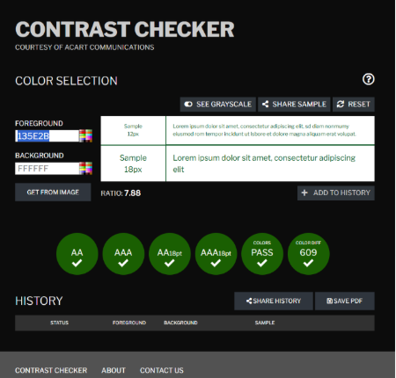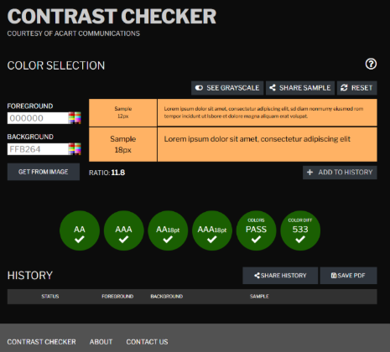Figure 8 – Shows the approval of my colours using colour contract checker

WAVE
I downloaded the WAVE (Web Accessibility Evaluation Tool) to test accessibility in my webpages and find any issues. The tool identified an error stating “Headings must be properly nested”, the heading tags within my html were not in chronological order. I corrected this so that it follows a logical hierarchy.
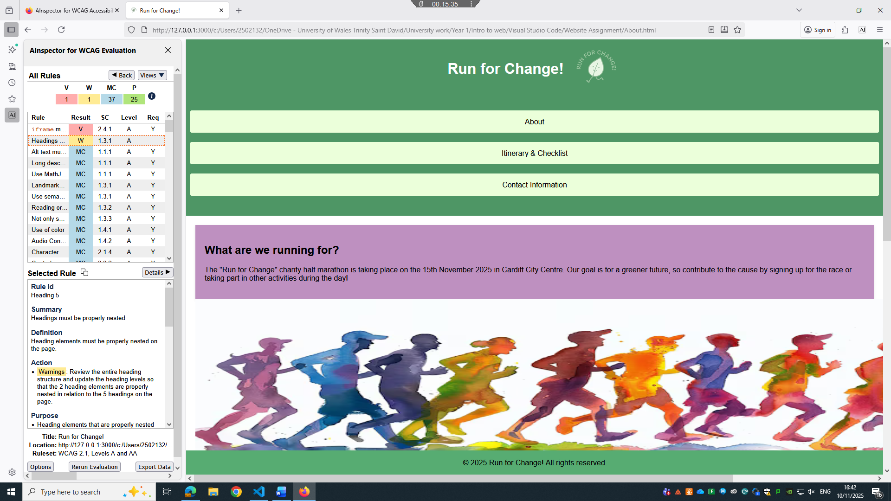Figure 9 – Shows the evaluation of my website in WAVE extension tool with heading errors.

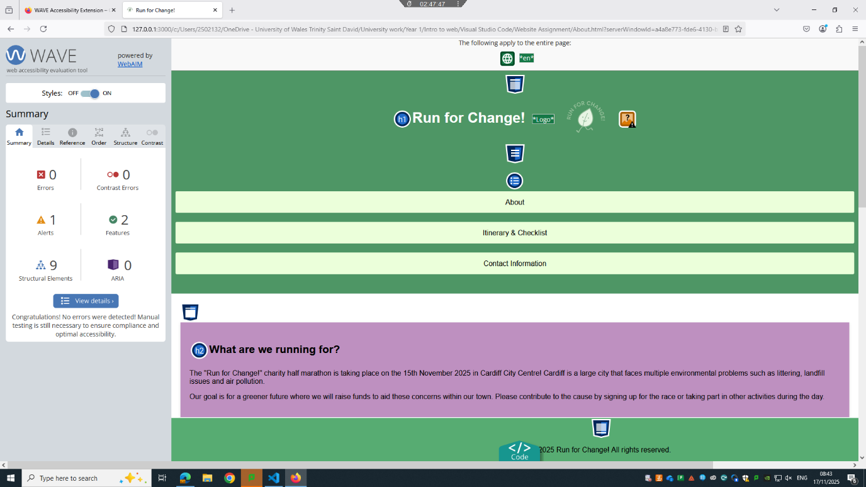Figure 10 – Shows the evaluation results after my errors were corrected

Website Comparison
I have chosen to compare the Pandora website and the Abbott Lyon website as they are both well-known women's jewellery brands that offer similar products.
Official Pandora™ UK | Charms & Bracelets | Women's Jewellery
VS
Abbott Lyon - Personalised, Meaningful Jewellery and Gifts
Usability
My first impression of the Pandora website is that it is visually appealing, using calming colours that give the page a warm feel. The background animation is festive and elegantly promotes new Christmas products. The navigation bar is responsive with large text, and hovering over each option reveals clear categories, making it easy for users to find what they need. The product descriptions, sizing, prices, and high-definition images are relevant and concise, creating a professional catalogue.
In comparison, the Abbott Lyon website feels bright and attention-grabbing. Large tiles showcase products that users can click for more details. The page features multiple pop-ups and banners advertising sales, countdowns, live chats, and discount codes, creating a sense of urgency to purchase within a limited timeframe. Its content is more detailed than Pandora’s but keeps product information clear and straightforward.
Accessibility
I have used the Browser Stack Accessibility testing system to evaluate different aspects of Pandora and Abbott Lyon’s websites, while relating to WCAG 2.1. The tool has picked up many problems with both sites and highlighted the severity of them in depth.
Abbott Lyon’s accessibility score is 67/100. Relating to the WCAG 2.1 guidelines, the keyboard (2.1.1) is fully approved and Timing Adjustable (2.2.1) has no issues found. The scan has suggested that regular manual checks must be put to test out character key shortcuts (2.1.4) to ensure accessibility for visitors to the site that are using assistive technology is still functioning efficiently. The assistive technology and keyboard shortcuts must work together so the user’s key presses don’t conflict with shortcuts set by the creators.
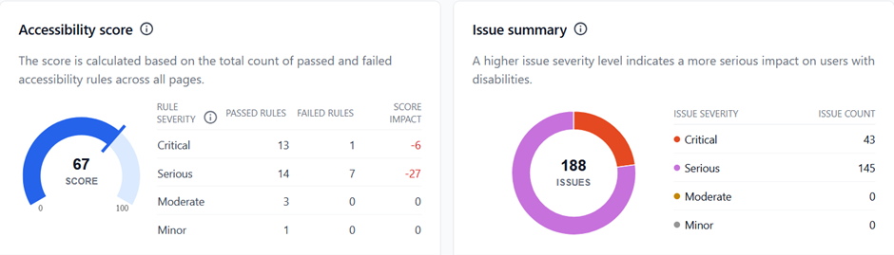Figure 11 - Shows accessibility score and summary of Abbott Lyon’s Website

Pandora’s accessibility score is 55/100. This scan has suggested that the creators of this website test that there are no keyboard traps (WCAG 2.1.2). Some users cannot use a mouse due to visual or physical impairments, so the site must fully support keyboard navigation. If a user can enter a section using the keyboard, they must also be able to exit it smoothly.
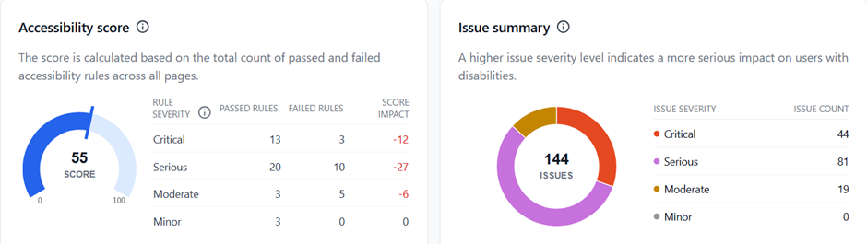Figure 12 – Shows accessibility score and summary of Pandora’s Website

Search Engine Optimisation
After reviewing the html for both Websites in DevTools I have been able to compare specific aspects of the meta-data such as:
Titles - Pandora’s title includes the trademark symbol and a brief description of what they sell, it gives a very professional feel. (<title data-react-helmet="true">Official Pandora™ UK | Charms &amp; Bracelets | Women's Jewellery</title>).
Abbott Lyon’s title is simple but effective; using keywords that will improve SEO.
(<title> Abbott Lyon - Personalised, Meaningful Jewellery and Gifts </title>).

Theme Colour - This meta-tag is a small detail that can make a difference to the overall aesthetic of a webpage. Abbot Lyon has the tag listed but it is empty, meaning there no colour has been selected for the site. Whereas Pandora’s theme colour is listed as #FFFFFFF (white).
Href and Lang - These tags specify the webpage’s language and version. Abbott Lyon includes multiple options (x-default, en-GB, en-US, en-IE), while Pandora UK leaves it empty, as only one audience is targeted.
Meta Description - This meta tag provides a summary of the webpage’s content. Pandora’s reads: “Find your style in Pandora’s jewellery collection….” which encourages customers to click and explore further.
Abbott Lyon doesn’t appear to have a meta description, which may reduce site traffic since no key information is highlighted in search results.
Viewport - The viewport tag controls how a page scales on different devices. Pandora uses width=device-width, initial-scale=1.0, minimum-scale=1.0, maximum-scale=5 for tight layout control, while Abbott Lyon uses width=device-width, initial-scale=1, giving users more flexibility, which is better for accessibility.
Mobile Friendliness
Using Microsoft Edge DevTools, I tested both websites on multiple devices, including iPhones, iPads, Samsung phones, Asus Zenbooks, and Nest Hubs.
Pandora is generally more responsive, loading pages and images faster. Abbott Lyon has slight delays when loading images, and product pages transition less smoothly. Pandora’s minimalistic layout allows clean, smooth navigation, while Abbott Lyon’s product pages can feel choppy as the screen jumps from product details back to the top. Both sites maintain consistent readability, with appropriate font sizes and spacing across different screen sizes.
Pandora remains visually minimal with plenty of white space and large product tiles that clearly separate items. Abbott Lyon, however, uses many pop-ups, which can feel crowded on mobile devices, though products are still presented clearly with large images and concise descriptions.
Conclusion
Pandora outperforms Abbott Lyon with smoother navigation, faster page transitions, and a consistent user experience. Its minimalistic layout and white space enhance usability and highlight products. In contrast, Abbott Lyon experiences slight lags when loading images or switching pages, which can affect flow. Large images and concise descriptions showcase products, but frequent pop-ups clutter the mobile experience.
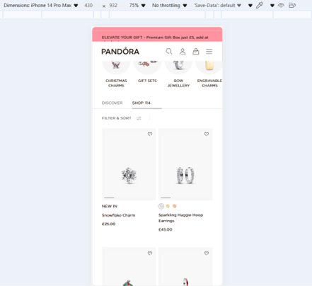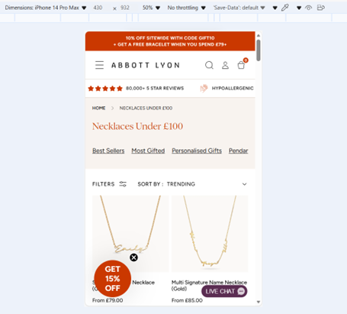
  - Figures 13 and 14 – Show Pandora website and Abbott Lyon Website in an iPhone 14 Prox Max display

References

[1] A.Mika, Ramotion, “What is Website Usability?”, Oct 6, 2025, Website Usability: Definition, Principles and Methods | Ramotion Agency [online]
[2] M. Dishman, "Website Usability Testing Software-Improving User Experience and Satisfaction with Community College Websites," The Community College Enterprise, vol. 21, (1), pp. 84-87, 2015. [Scholarly Journal] Available: Website Usability Testing Software-Improving User Experience and Satisfaction with Community College Websites - ProQuest
[3] S.L.Henry, W3C, “Introduction to Web Accessibility”, March 7, 2024, Introduction to Web Accessibility | Web Accessibility Initiative (WAI) | W3C
[4] J. Thatcher, Web accessibility: web standards and regulatory compliance, 1st ed. 2006. Berkeley: FriendsofED, 2006. doi: 10.1007/978-1-4302-0188-5.
[5] C. Álvarez-García, “Relevance of Meta Tags and Search Engine Optimisation (SEO) Strategies in Web Localisation,” Íkala : revista de lenguaje y cultura, vol. 30, no. 2, 2025, doi: 10.17533/udea.ikala.356108.
[6] R. Tatikonda, J. Ponnala, R. Thatikonda, D. K. Yendluri, M. Kempanna, and B. Ananthan, “Optimizing Digital Marketing Strategies Through Search Engine Optimization,” in 2024 IEEE International Conference on Contemporary Computing and Communications (InC4), IEEE, 2024, pp. 1–6. doi: 10.1109/InC460750.2024.10649088.

Appendices

Homepage
<!DOCTYPE HTML>
<html lang="en">
<head>
<meta charset="UTF-8">
<meta name="viewport" content="width=device-width, initial-scale=1.0">
<title>Run for Change!</title>
<link rel="stylesheet" href="Styles.css">
<link rel="icon" type="image/png" sizes="32x32" href="images/run_for_change_32x32.png"> <!--Favicon-->
</head>
<body>
<header>
<div class="title-logo">
<h1>Run for Change!</h1>
<img src="Images/Logo.jpg" alt="Logo" width="110" height="110"> <!--logo next to header-->
</div>
<nav>
<ul>
<li> <!--Navigation bar with a div class for styling-->
<div class="card"><a href="About.html">About</a></div>
</li>
<li>
<div class="card"><a href="Itinerary-and-Checklist.html">Itinerary & Checklist</a></div>
</li>
<li>
<div class="card"><a href="Contact-information.html">Contact Information</a></div>
</li>
</ul>
</nav>
</header>
<main>
<div class="top-para">
<h2>What are we running for?</h2>
<p>The "Run for Change!" charity half marathon is taking place on the 15th November 2025 in Cardiff City Centre! Cardiff is a large city that faces multiple environmental problems such as littering, landfill issues and air pollution.<p>
<p>Our goal is for a greener future where we will raise funds to aid these concerns within our town. Please contribute to the cause by signing up for the race or taking part in other activities during the day. </p>
</div>
<img src="Images/Runners.jpg" alt="Marathon runners" width="1800" height="400">
<div class="bot-para">
<p>A family sports day event will take place on this day to raise extra funds, this will be a first come first served basis so please make sure to arrive early to take part. Other events on this day include an Eco-Fair, live music and a raffle. More information on the 'Itinerary and checklist' page.</P>
<p>There will be complimentary water stations (with biodegradable cups) and fresh fruit stands for all runners. Those who are taking part in the race, please arrive at the City Hall for 9am to complete registration.</p>
</div>
<br>
<div class="bordered-text"> <!--Border surrounds Iframe map-->
<h2>City Hall Location</h2>
<p>Bute park is a 10 minute walk from City Hall.</p>
<p>Cardiff Museum is just next door</p>
<iframe class="map-for-hall" src="https://www.google.com/maps/embed?pb=!1m18!1m12!1m3!1d9938.086387584353!2d-3.1787318596173053!3d51.48529510631089!2m3!1f0!2f0!3f0!3m2!1i1024!2i768!4f13.1!3m3!1m2!1s0x486e1cba54acae3f%3A0xbabb7c5b0df64d57!2sCity%20Hall%2C%20King%20Edward%20VII%20Ave%2C%20Cardiff%20CF10%203ND!5e0!3m2!1sen!2suk!4v1759768637522!5m2!1sen!2suk" width="600" height="450" style="border:0;" allowfullscreen="" loading="lazy" referrerpolicy="no-referrer-when-downgrade">
</iframe></div>
</main>
<footer>
<p>&copy; 2025 Run for Change! All rights reserved.</p>
</footer>
</body>
</html>

Itinerary and Checklist page
<!DOCTYPE HTML>
<html lang="en">
<head>
<meta charset="UTF-8">
<meta name="viewport" content="width=device-width, initial-scale=1.0">
<title>Run for Change!</title>
<link rel="stylesheet" href="Styles.css">
<link rel="icon" type="image/png" sizes="32x32" href="Images/run_for_change_32x32.png"> <!--Favicon-->
</head>
<body>
<header>
<div class="title-logo">
<h1>What is the Schedule?</h1>
<img src="Images/Logo.jpg" alt="Logo" width="110" height="110">
</div>
<nav>
<ul>
<li> <!--Navigation bar with a div class for styling-->
<div class="card"><a href="About.html">About</a></div>
</li>
<li>
<div class="card"><a href="Itinerary-and-Checklist.html">Itinerary & Checklist</a></div>
</li>
<li>
<div class="card"><a href="Contact-information.html">Contact Information</a></div>
</li>
</ul>
</nav>
</header>
<main>
<div class="Schedule"> <!--Timetable for event-->
<h1>Event Schedule</h1>
<div class="table-container">
<table>
<thead>
<tr>
<th>Event</th>
<th>Time</th>
<th>Location</th>
</tr>
</thead>
<tbody>
<tr>
<td>Refreshments</td>
<td>9:00 AM</td>
<td>City Hall</td>
</tr>
<tr>
<td>Eco-Fair</td>
<td>9:30 AM</td>
<td>City Hall</td>
</tr>
<tr>
<td>Marathon</td>
<td>10:00 AM</td>
<td>Outside Cardiff Museum</td>
</tr>
<tr>
<td>Family Sports Day</td>
<td>12:00 PM</td>
<td>Bute Park</td>
</tr>
<tr>
<td>Awards & Raffle</td>
<td>3:30 PM</td>
<td>City Hall</td>
</tr>
</tbody>
</table>
<br>
<aside id="Eco"> <!--Includes Recycling icon within my paragraph-->
<img src="Images/recycle.png" alt="recycle" width="25" height="25">
The Eco-fair will be an immersive experience with many DIY upcycling projects, composting tasks and zero-waste shops!
</aside>
</div>
</div>
<br>
<div class="checklist"> <!--Interactive checklist-->
<h2>Checklist for Marathon Runners:</h2>
<ul>
<li><label><input type="checkbox"> Registration number</label></li>
<li><label><input type="checkbox"> Digital race bib (These will be given to runners when they have registered on the day of the race to support our zero waste policy)</label></li>
<li><label><input type="checkbox"> Appropriate footwear</label></li>
<li><label><input type="checkbox"> SPF</label></li>
<li><label><input type="checkbox"> Additional refreshments if needed — electrolytes, energy gels, etc.</label></li>
</ul>
</div>
<div class="logo">
<img src="Images/marathon-essentials.jpg" alt="Marathon essentials" width="700" height="500"></div>
<div class="bordered-text"> <!--Border surrounds Youtube video-->
<h2>Half Marathon Route</h2>
<p>All runners are encouraged to familiarise themselves with the Half Marathon route beforehand. Please view this video below of a previous Half marathon that was held in Cardiff on the 5th October 2025: </p>
<iframe width="700" height="325" src="https://www.youtube.com/embed/FU4hDvtcWDk?si=OCHRcBBjD6zqpv4-" title="YouTube video player" allow="accelerometer; autoplay; clipboard-write; encrypted-media; gyroscope; picture-in-picture; web-share" referrerpolicy="strict-origin-when-cross-origin" allowfullscreen></iframe>
</div>
</main>
<footer>
<p>&copy; 2025 Run for Change! All rights reserved.</p>
</footer>
</body>
</html>

Contact information page
<!DOCTYPE HTML>
<html lang="en">
<head>
<meta charset="UTF-8">
<meta name="viewport" content="width=device-width, initial-scale=1.0">
<title>Run for Change!</title>
<link rel="stylesheet" href="Styles.css">
<link rel="icon" type="image/png" sizes="32x32" href="Images/run_for_change_32x32.png"> <!--Favicon-->
</head>
<body>
<header>
<div class="title-logo">
<h1>How can I sign up?</h1>
<img src="Images/Logo.jpg" alt="Logo" width="110" height="110">
</div>
<nav>
<ul>
<li> <!--Navigation bar with a div class for styling-->
<div class="card"><a href="About.html">About</a></div>
</li>
<li>
<div class="card"><a href="Itinerary-and-Checklist.html">Itinerary & Checklist</a></div>
</li>
<li>
<div class="card"><a href="Contact-information.html">Contact Information</a></div>
</li>
</ul>
</nav>
</header>
<main>
<div class="signup">
<p> You must be 18+ to take part in the race, you will be asked for a form of identification when registering. Please email Runforchangecardiff@RFC.COM to register your interest for the Half Marathon. Make sure to include the following:</p>
<ul>
<li>Full name</li>
<li>Email Address</li>
<li>Date of Birth</li>
<li>Contact number</li>
<li>Home Address</li>
</ul>
</div>
<br>
<div class="image-row"> <!--All images are in a row-->
<img src="Images/cityhall.webp" alt="City Hall" width="450" height="300">
<img src="Images/cardiff-half-marathon.jpg" alt="cardiffhalf" width="450" height="300">
<img src="Images/bay.webp" alt="cardiffhalf" width="450" height="300">
<img src="Images/castle.png" alt="castle" width="450" height="300">
</div>
<div class="social-media">
<p>The links below will guide you to the log in screens to the respected social media websites. Follow us at @RUNFORCHANGE2025 for live updates leading up to the event:</p>
<div class="social-links">
<a href="https://twitter.com" target="_blank">Twitter</a>
<a href="https://facebook.com" target="_blank">Facebook</a>
<a href="https://instagram.com" target="_blank">Instagram</a>
</div></div>
</main>
<footer>
<p>&copy; 2025 Run for Change! All rights reserved.</p>
</footer>
</body>
</html>

Styling Sheet
/*General body styling*/
body {
font-family: Arial, sans-serif;
background-color:#ffffff;
color:#333;
margin: 0;
padding: 0;}

/* Header styling*/
header {
background-color:#4e9665;
color:rgb(255, 255, 255);
padding: 8px;
text-align:center;
margin:0px;
display:block;
}

/* Navigation menu*/
nav ul {
list-style-type:none;
padding:0;}

nav ul li {
display:inline;
margin: 0 1px}

nav ul li a {
color: rgb(0, 0, 0);
text-decoration: none;}

/* Main content styling*/
main{
padding:20px;
}

/*Footer styling */
footer{
background-color:#57ac72;
color:rgb(0, 0, 0);
text-align:center;
padding:1px;
position:fixed;
bottom: 0;
width: 100%;
}

.top-para{
background-color:rgb(190, 144, 192);
color:black;
text-align: left;
padding: 20px;
border-radius: 0px;
box-shadow: 0 2px 5px rgba(0, 0, 0, 0.1);
}

.bot-para{
background-color:rgb(144, 149, 192);
color:black;
text-align: left;
padding: 20px;
border-radius: 0px;
box-shadow: 0 2px 5px rgba(0,0,0,0.1);
}

.card{
background:rgb(235, 255, 218);
padding:15px;
margin: 1px;
border-radius:3px;}

.card:hover {
background-color:rgb(115, 219, 153);
transform:scale(1.03);
box-shadow:0 4px 8px rgba(0,0,0,0.2)}

.Schedule{
background-color:rgb(251, 252, 182);
color:black;
text-align: left;
padding: 20px;
border-radius: 0px;
box-shadow: 0 2px 5px rgba(0,0,0,0.1);}

.signup {
background-color:rgb(248, 171, 182);
color:black;
text-align: left;
padding: 20px;
border-radius: 0px;
box-shadow: 0 2px 5px rgba(0,0,0,0.1);}

a{color:black;}
a:hover{color:rgb(255, 255, 255);}
.logo {text-align: center;}

.bordered-text {
border: 6px solid rgb(164, 209, 209);
padding: 50px;
border-style: dashed;
margin: 0px;
flex:2;
text-align: center;}

#Eco {
background-color:rgb(178, 250, 157);
color:#000000;
padding: 30px;
box-sizing:border-box;
border-radius: 20px;
border-style: dotted;color: rgb(31, 134, 27);}

/* Base Table Styling */
table {
width: 100%;
border-collapse: collapse;
min-width: 500px;}

thead tr {
background-color: #8ab84f;
color: #fff;
text-align: left;}

th, td {
padding: 14px 18px;}

tbody tr {
border-bottom: 1px solid #e0e0e0;}

tbody tr:nth-of-type(even) {
background-color: #f9fafb;}

tbody tr:hover {
background-color: #eaf2ff;
transition: background-color 0.2s ease;}

th {
font-weight: 600;
text-transform: uppercase;
letter-spacing: 0.03em;}

td {color: #444;}

/* Add a slight color tag for locations */
td:last-child {
font-weight: 500;
color: #000000;}

th, td {
border: 1px solid rgb(0, 0, 0);
padding: 8px;}

.title-logo {
display: flex;
align-items: center;
justify-content: center;
gap: 15px;
}

.title-logo h1 {
margin: 0;
}

.title-logo img {
order: 2;}

.checklist {
background-color: #d9c4f5;
border-radius: 10px;
padding: 15px 25px;
margin: 20px 0;
box-shadow: 0 2px 5px rgba(0,0,0,0.1);}

.checklist ul {
list-style: none;
padding: 20px;}

.checklist li {
margin: 8px 0;
font-size: 1rem;}

.checklist input[type="checkbox"] {
margin-right: 10px;
transform: scale(1.2);
cursor: pointer;}

.map-for-hall {
width: 80%;
height: 500px;
border-radius: 10px;
display: block;
margin: 0 auto;}

/* Social links */
.social-media {
background-color: #f1f8e9;
text-align: center;
padding: 60px;
border-radius: 10px;
margin-top: 20px;}

.social-links a {
color: #2e7d32;
margin: 0 10px;
font-weight: 600;
text-decoration: none;
transition: color 0.3s;}

.social-links a:hover {
color: #1b5e20;
text-decoration: underline;}

