Feasibility Plan
for an International Meeting

Name: Elena Luca
Student number: 2206171
Module title and code: International Meetings Management for the Hotel Industry, BMIH6007
Lecturer`s name: Kathryn Flynn

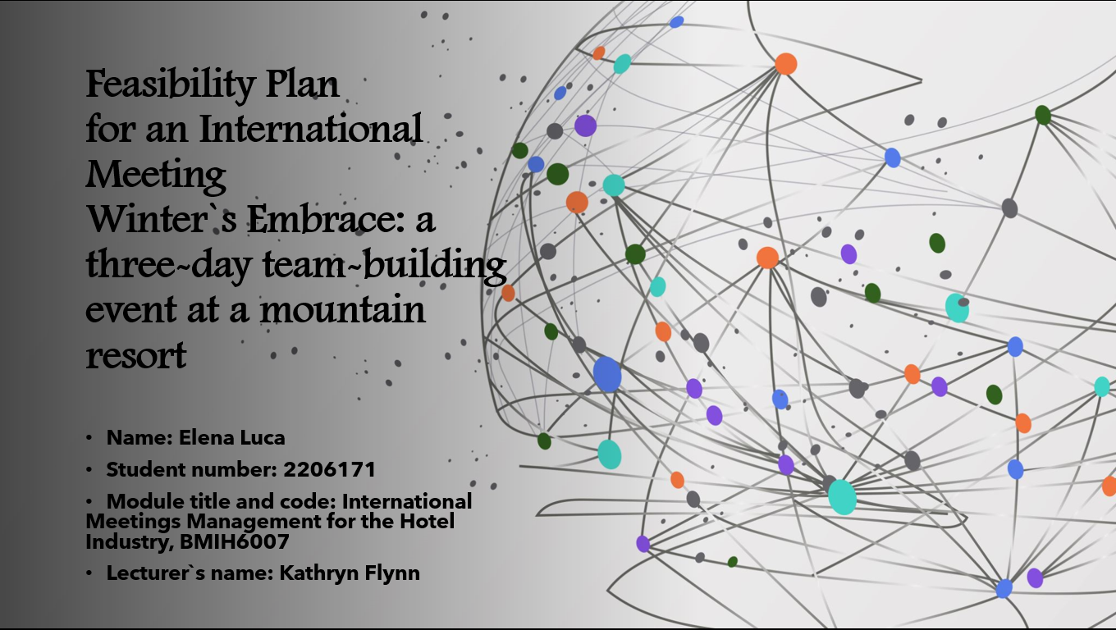
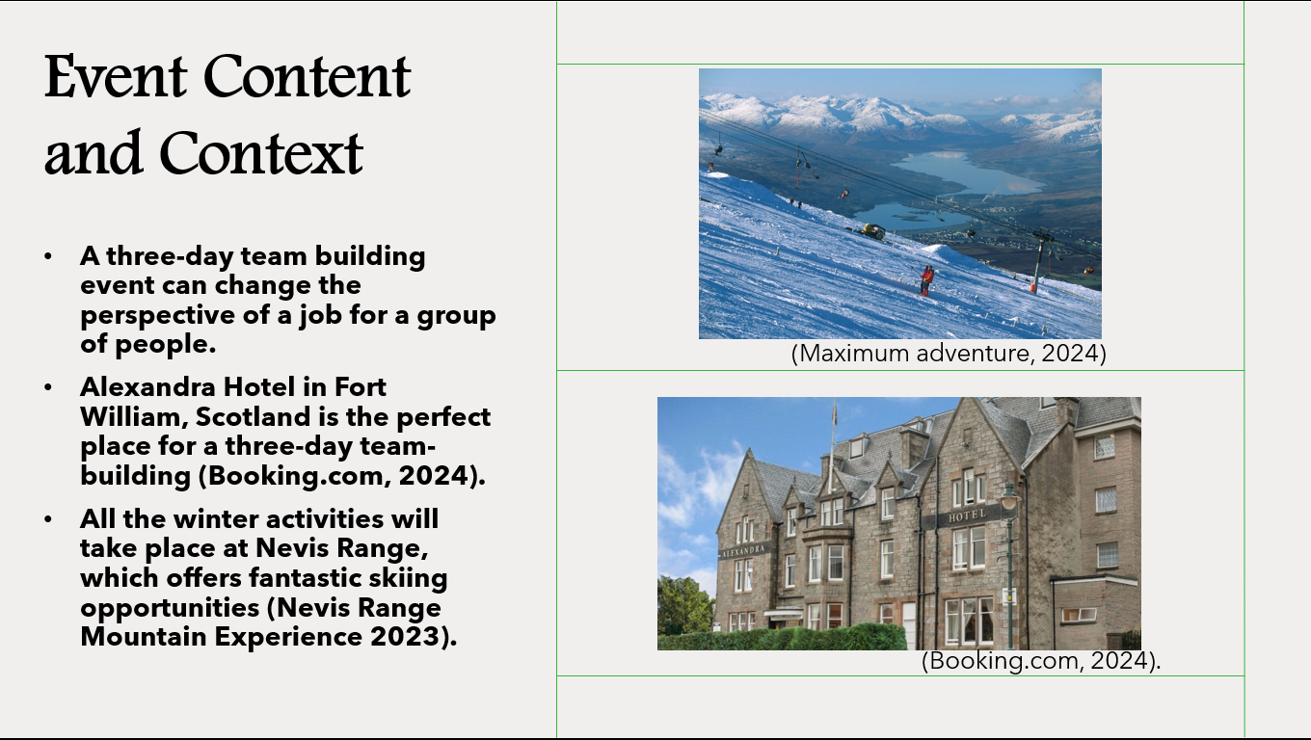
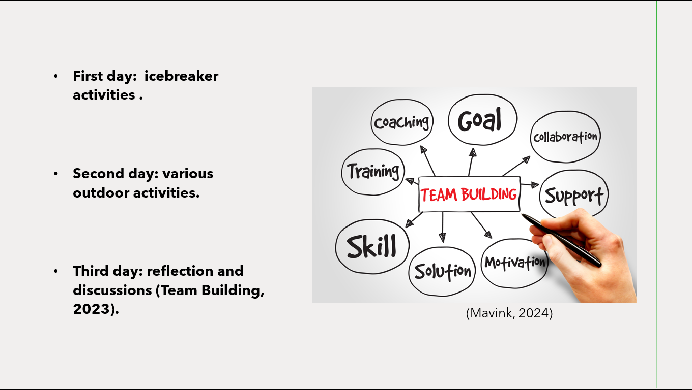
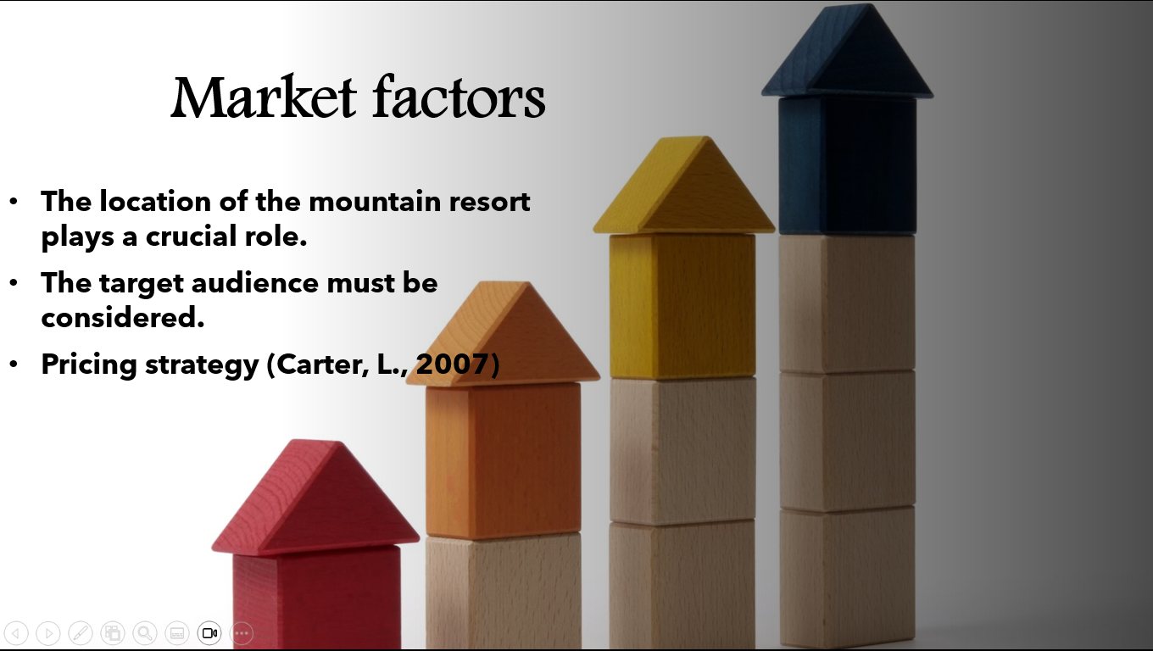
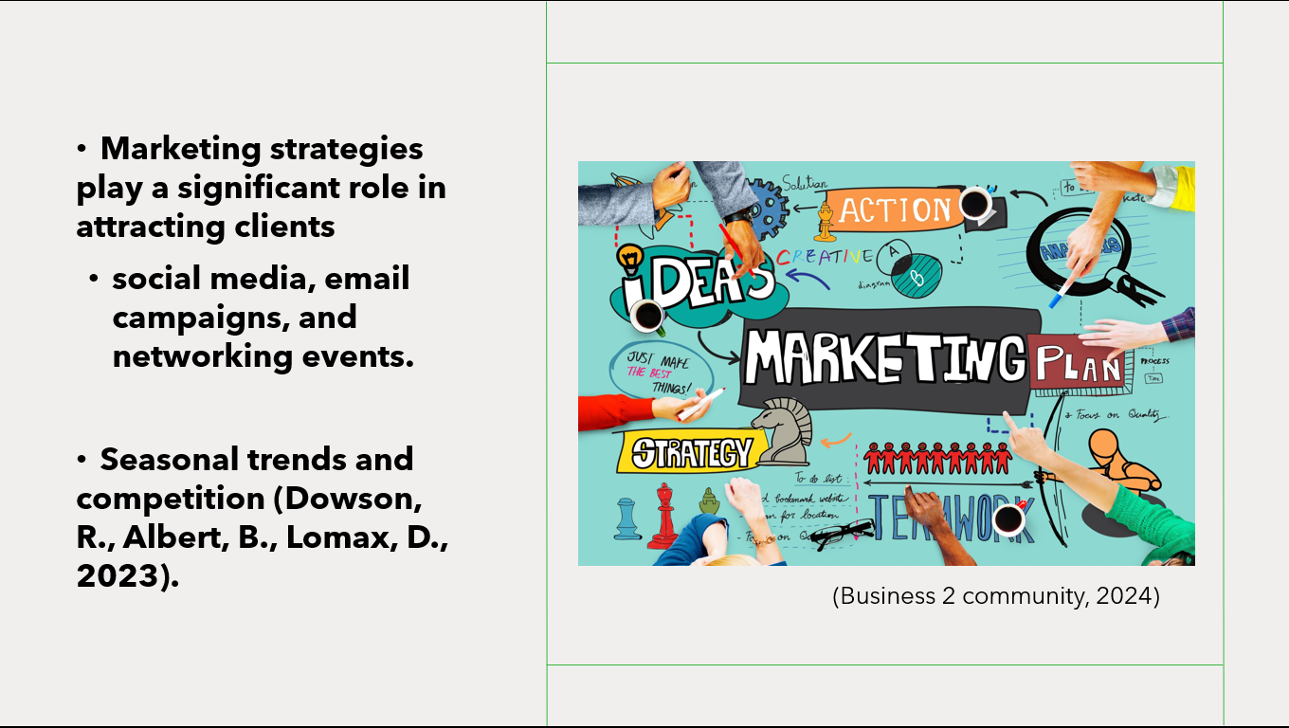
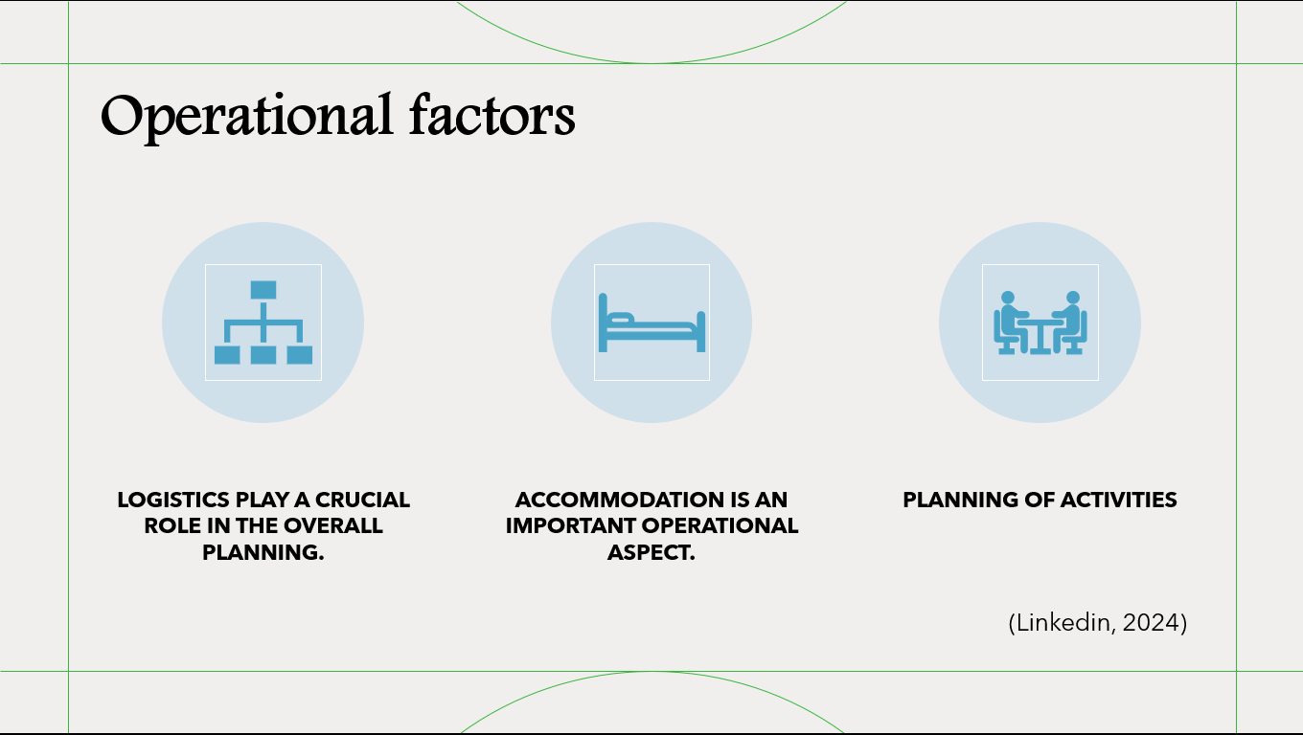
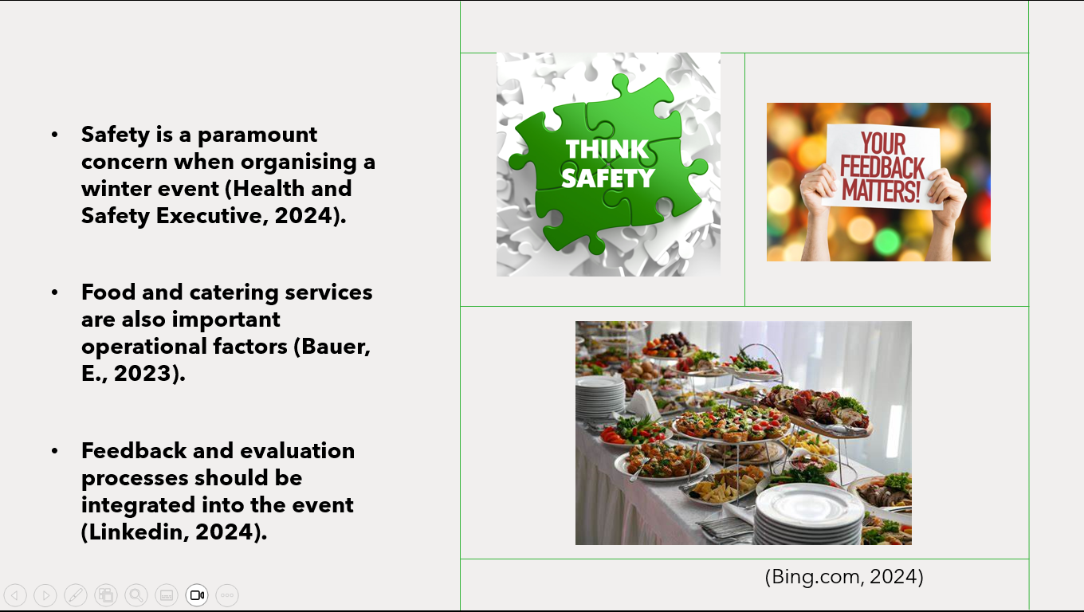
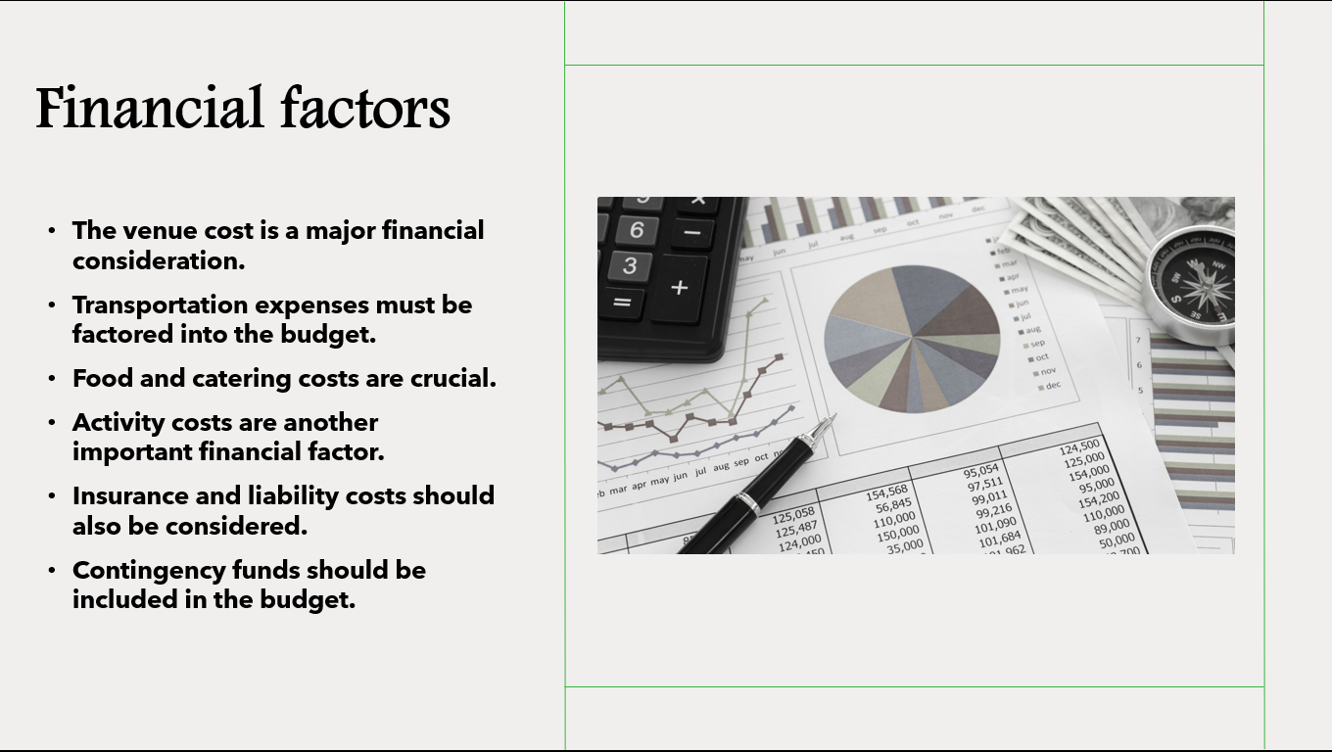
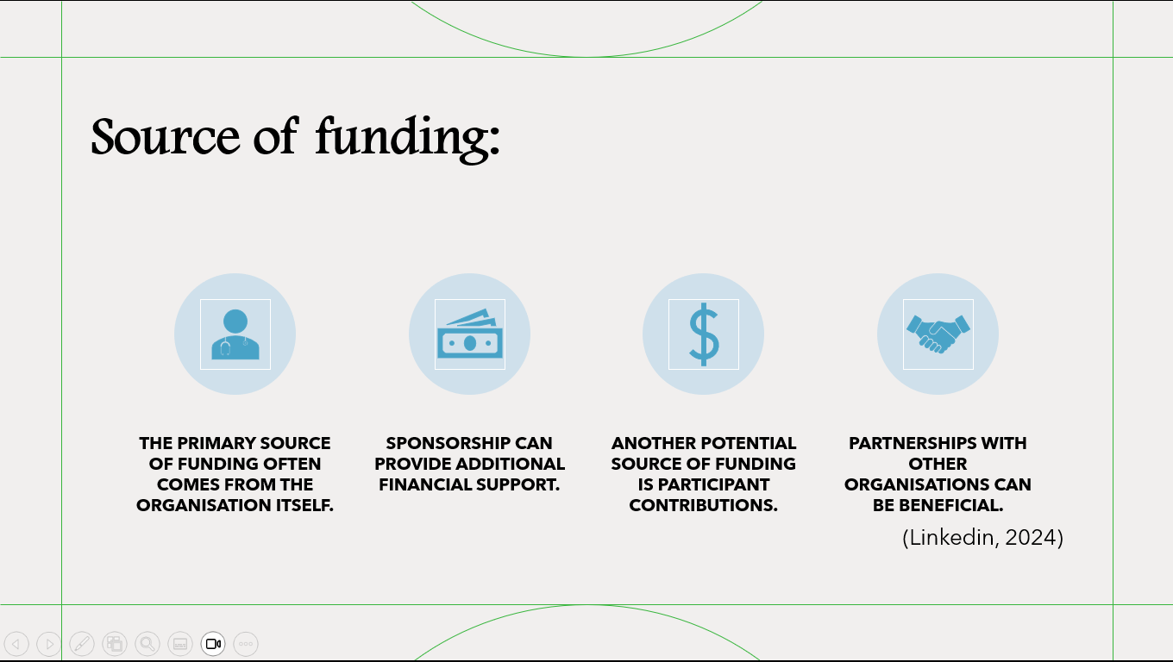
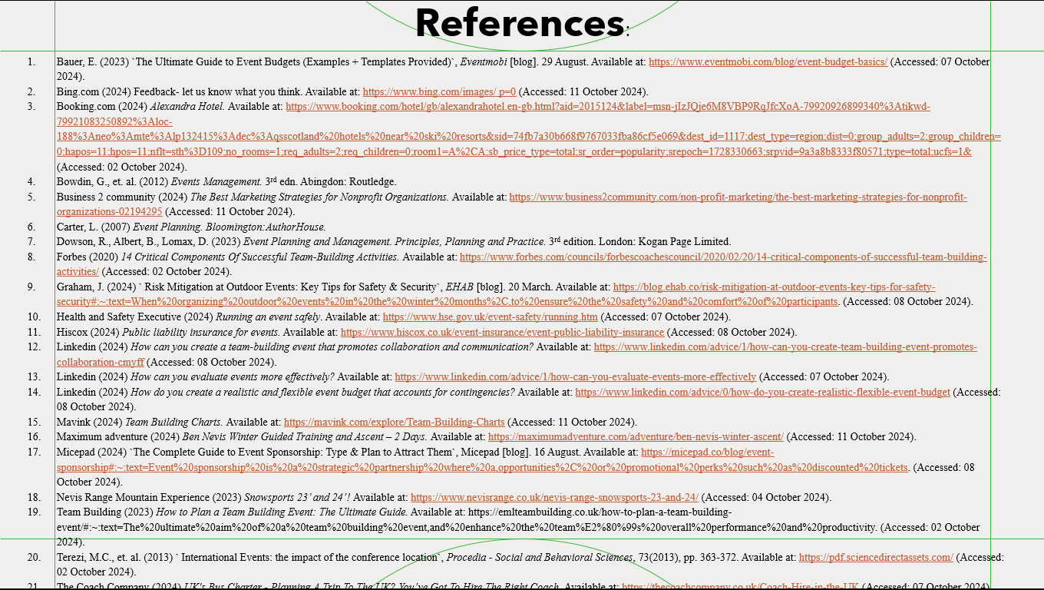

References:
- Bauer, E. (2023) `The Ultimate Guide to Event Budgets (Examples + Templates Provided)`, Eventmobi [blog]. 29 August. Available at: https://www.eventmobi.com/blog/event-budget-basics/ (Accessed: 07 October 2024).
- Booking.com (2024) Alexandra Hotel. Available at: https://www.booking.com/hotel/gb/alexandrahotel.en-gb.html?aid=2015124&label=msn-jIzJQje6M8VBP9RqJfcXoA-79920926899340%3Atikwd-79921083250892%3Aloc-188%3Aneo%3Amte%3Alp132415%3Adec%3Aqsscotland%20hotels%20near%20ski%20resorts&sid=74fb7a30b668f9767033fba86cf5e069&dest_id=1117;dest_type=region;dist=0;group_adults=2;group_children=0;hapos=11;hpos=11;nflt=sth%3D109;no_rooms=1;req_adults=2;req_children=0;room1=A%2CA;sb_price_type=total;sr_order=popularity;srepoch=1728330663;srpvid=9a3a8b8333f80571;type=total;ucfs=1& (Accessed: 02 October 2024).
- Bowdin, G., et. al. (2012) Events Management. 3rd edn. Abingdon: Routledge.
- Business 2 community (2024) The Best Marketing Strategies for Nonprofit Organizations. Available at: https://www.business2community.com/non-profit-marketing/the-best-marketing-strategies-for-nonprofit-organizations-02194295 (Accessed: 11 October 2024).
- Carter, L. (2007) Event Planning. Bloomington:AuthorHouse.
- Dowson, R., Albert, B., Lomax, D. (2023) Event Planning and Management. Principles, Planning and Practice. 3rd edition. London: Kogan Page Limited.
- Forbes (2020) 14 Critical Components Of Successful Team-Building Activities. Available at: https://www.forbes.com/councils/forbescoachescouncil/2020/02/20/14-critical-components-of-successful-team-building-activities/ (Accessed: 02 October 2024).
- Graham, J. (2024) ` Risk Mitigation at Outdoor Events: Key Tips for Safety & Security`, EHAB [blog]. 20 March. Available at: https://blog.ehab.co/risk-mitigation-at-outdoor-events-key-tips-for-safety-security#:~:text=When%20organizing%20outdoor%20events%20in%20the%20winter%20months%2C,to%20ensure%20the%20safety%20and%20comfort%20of%20participants. (Accessed: 08 October 2024).
- Health and Safety Executive (2024) Running an event safely. Available at: https://www.hse.gov.uk/event-safety/running.htm (Accessed: 07 October 2024).
- Hiscox (2024) Public liability insurance for events. Available at: https://www.hiscox.co.uk/event-insurance/event-public-liability-insurance (Accessed: 08 October 2024).
- Linkedin (2024) How can you create a team-building event that promotes collaboration and communication? Available at: https://www.linkedin.com/advice/1/how-can-you-create-team-building-event-promotes-collaboration-cmyff (Accessed: 08 October 2024).
- Linkedin (2024) How can you evaluate events more effectively? Available at: https://www.linkedin.com/advice/1/how-can-you-evaluate-events-more-effectively (Accessed: 07 October 2024).
- Linkedin (2024) How do you create a realistic and flexible event budget that accounts for contingencies? Available at: https://www.linkedin.com/advice/0/how-do-you-create-realistic-flexible-event-budget (Accessed: 08 October 2024).
- Mavink (2024) Team Building Charts. Available at: https://mavink.com/explore/Team-Building-Charts (Accessed: 11 October 2024).
- Maximum adventure (2024) Ben Nevis Winter Guided Training and Ascent – 2 Days. Available at: https://maximumadventure.com/adventure/ben-nevis-winter-ascent/ (Accessed: 11 October 2024).
- Micepad (2024) `The Complete Guide to Event Sponsorship: Type & Plan to Attract Them`, Micepad [blog]. 16 August. Available at: https://micepad.co/blog/event-sponsorship#:~:text=Event%20sponsorship%20is%20a%20strategic%20partnership%20where%20a,opportunities%2C%20or%20promotional%20perks%20such%20as%20discounted%20tickets. (Accessed: 08 October 2024).
- Nevis Range Mountain Experience (2023) Snowsports 23’ and 24’! Available at: https://www.nevisrange.co.uk/nevis-range-snowsports-23-and-24/ (Accessed: 04 October 2024).
- Team Building (2023) How to Plan a Team Building Event: The Ultimate Guide. Available at: https://emlteambuilding.co.uk/how-to-plan-a-team-building-event/#:~:text=The%20ultimate%20aim%20of%20a%20team%20building%20event,and%20enhance%20the%20team%E2%80%99s%20overall%20performance%20and%20productivity. (Accessed: 02 October 2024).
- Terezi, M.C., et. al. (2013) ` International Events: the impact of the conference location`, Procedia - Social and Behavioral Sciences, 73(2013), pp. 363-372. Available at: https://pdf.sciencedirectassets.com/ (Accessed: 02 October 2024).
- The Coach Company (2024) UK's Bus Charter - Planning A Trip To The UK? You’ve Got To Hire The Right Coach. Available at: https://thecoachcompany.co.uk/Coach-Hire-in-the-UK (Accessed: 07 October 2024).

