Matthew James Hilyer
Using Kolb’s theory to reflect on my past experience
This essay explores a learning experience I had whilst surfing using Kolb’s learning theory, I will take into consideration how the tide affected my situation and evaluate its safety. Firstly, Kolb’s learning theory will be defined, linked to my personal experience. Secondly, an explanation of how my personal experience is a concrete experience and will go through the effects, causes, and precautions I will be able to take into the future. Lastly, a reflection will be given looking back while applying a more experienced surfer’s opinion as well as academic sources. Whilst reflecting, I will consider how different factors influenced the situation and impacted my enjoyment. Continuing to follow Kolb’s theory I will draw up an abstract concept that will be a plan that I will employ when I next surf.

Kolb’s learning cycle is a theory of learning that is centred around learning through active learning (Kolb, 1984). The way it is displayed is in a cycle suggesting it is an ongoing process. The main parts of Kolb learning theory are broken down into 4 different sections:
Concrete experiences
This section relies on immediate hands-on experience. Predominantly a tangible activity that evokes a strong emotional response and can be analysed and learnt from. In this example, my concrete experience was my first session surfing in unsafe conditions as a beginner.

Observation and reflection
This section is usually the participant trying to grasp their concrete experience through reflection, in efforts to recognize patterns by drawing on previous experiences and other knowledge and insights. This section occurred for me once we had finished our session and spoken about it with my surfing partners.
Abstract conceptualization
According to Kleinheksel et al. (2023) the Abstract conceptualization phase is where the theories for what has just been observed are processed and expanded. These phases will usually have some form of discussion about what has happened either internally, on their own or verbality with others. I had formed theories on my own when I concluded my research after the facts.
Active experimentation
This is putting theory into practice and getting real-world feedback instantly through experiential learning (Kolb and Kolb, 2005). This stage allowed participants to develop their understanding of their situation and have results. For me, this active experiment will run out when I next go surfing (Tomkins and Ulus, 2016).

I will now go through the experience and apply Kolb’s learning theory
Concreate experience
I had left for Fresh Water West with a borrowed wetsuit, with little experience of the ocean long term, and had neglected to check the surf forecast as I was unaware of this practice. When we arrived at the beach the conditions seemed to be favourable and perfect for a beginner. After 10 minutes of acclimatizing myself to the temperature, the waves became very choppy (National Geographic, no date) there was a set of dumping waves that threw me off my board. The board I was using was a 6-foot fin tale board I had made it near impossible to stay buoyant. I also did not fully grasp where to position myself on the board as I frequently found myself slipping off back into the water. The group that I had surfed with were able to tolerate these waves which motivated me to push on as they had a good degree of experience. Another issue was, I had on one occasion been dragged out into the ocean at a hazardous pace which I struggled to pull myself back from due to the fatigue from the waves. I had noticed a flatter section (RNLI, no date) where there were minimal waves. I had paddled there for a rest and quickly noticed my distancing from the beach according to (Short and Hogan,1994). I had found myself in rip currents these are particularly dangerous currents that run out to sea according to RNLI (no date). Throughout this ordeal, I felt very vulnerable to the elements as a I did not understand the situation. At times it was quite stressful due to the aggression of the swell which continually battered me throughout and kept me pinned under water a long while.
Reflective observation
Looking back, it was quite unwise for me to attempt to surf. As we can see according to Surf Hub (2023) referred conditions would be 1-2 ft weak and gentle waves with light offshore winds. Due to my lack of knowledge of rip currents I had found myself in a dangerous position where I did not have the ability to rescue myself and was left to the fate of the ocean. I had followed the instruction of a fellow surfer which led me to safety however, if I had been on my own there was a very real chance I would have been continually dragged further out to sea with little stamina left which could have resulted in drowning.
The reflection I am undergoing is in considering my knowledge of safety. I can now see that I would have benefitted from checking the surf forecast (Surfline, 2024) before I went, as if I had I would have chosen a different day to surf. This negativity impacted my daily objectives and well-being as I could not grasp the basics due to the aggression of the swell. According to Longden (2024), beaches with large tidal ranges can be more unpredictable and dangerous. This could be a reason as to why there was so much chop and unpredictability. I would potentially have picked another beach.

Abstract conceptualization
According to the learning style inventory grid, converges are best able to apply their learning with abstract conceptualization paired with active experimentation. As seen by Akella (2010) the main ability of this learning is hypothetical deductive reasoning which involves disproving hypotheses drawn from an observation made in the previous stage through testing. This best applies to me and my situation as I could always reason due to my decisive nature. It also mentions practical applications being more effective for convergent learners. Therefore, from this knowledge, I can understand that my theory should include some form of practical application as well as an experimentation phase in which I practically test these theories.
In the future, I will take the time to understand surf reports from researching (Surfline, 2024) the beach I attend. This will prevent me from ending up in conditions unsuitable for beginners. As well as this I could read around rip cur and understand how they work and how best to avoid them (Sheppard, 2018). To apply Kolb's learning style inventory, it would benefit me to go out to the beach in unfavorable conditions so that I could identify rips from the beach and increase my understanding of how they are formed and work. This would be quite challenging for me to test due to the safety of it however, I would have to test this with experienced surfers/lifeguards. I do this by entering into what I thought was a rip and attempting to get out by swimming along the shore as seen in Surf Hub (2023).

Active experimentation
With the active experiment phase what I have learnt is to compare and read a surf forecast (Surf Hub, 2023). I did this by going through the forecast and selection days which I believed would be suitable and unsuitable and after this initial assessment, I headed to the beach to see if I was correct. This appears to the hypothetical education as I had observed the results of the weather forecast and made my own informed decision. This decision was informed (The Wave Shack, 2024) upon completion of the experiment. I had successfully judged fore out of the five correct. The factors that assisted me was due to familiarising myself with the surf report specifically the windspeeds and how higher speeds can contribute to the unpredictability.
My assessment of rips was also very successful due to practise of the identification of formation from the beach (National Geographic, no date) paired with my research and guidance by experienced surfers I understood that where the water is darker with fewer breaks is most likely a rip. As well as this the water appears rippled at the surface and tends to be enclosed by calm water (National Geographic, no date).
Conclusion
To summarise, utilizing Kolb’s experiential learning cycle to my surfing experience has enabled me with valuable insights into the importance of preparation, safety, and reflective learning. The concrete experience of surfing in unsafe conditions mentioned the need for a well-rounded grasp of surf forecasts, rip currents, and wave dynamics. Reflecting on this experience allowed me to acknowledge the risks of inadequate preparation and the probable consequences of not understanding the environment. Through abstract conceptualization, I was able to form methods for improving my future surfing sessions, implementing the significance of checking surf conditions and learning about rip currents. The active experimentation phase allowed me to test these new strategies, increasing my confidence and safety when engaging with the surf. By repeating Kolb’s learning cycle, I can further refine my skills, enhancing both my safety and enjoyment in future surf experiences. This process underscores the value of experiential learning in improving practical decision-making

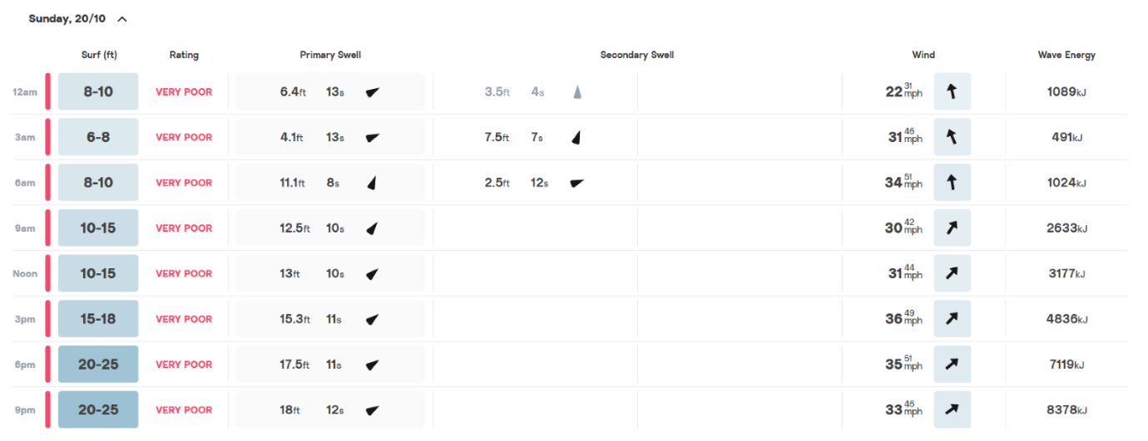

Objective of the day:
Grasp the basics of surfing, learn the timing of how to catch a wave and learn to pop up and enjoy myself.

Reference List

Akella, D. (2010) 'Learning together: Kolb's experimental theory and its application', Journal of Management & Organization, 16(1), pp. 100-112. DOI:10.5172/jmo.16.1.100
Catlin (2024) Interview by Matthew Hilyar. 18 November, Carmarthen.
Kleinheksel, A.J., Chen, W., Rudd, M.J., Drowos, J., Gupta, S., Minor, S. and Bailey, J.M. (2023) ‘Putting reflection back into practice: Kolb's theory of experiential learning as a theoretical framework for just-in-time faculty development’, SN Social Sciences, 3(59).

Kolb, A.Y. and Kolb, D.A. (2005) 'Experiential Learning Theory', Academy of Management Learning & Education, 4(2), pp. 193-212.
Kolb, D.A. (1984) Experiential Learning: Experience as the Source of Learning and Development. New Jersey: Prentice Hall.
Longden, C. (2024) Interview by Matthew Hilyar. 18 November, Carmarthen.
National Geographic (no date). Surfing. Available at: https://media.nationalgeographic.org/assets/reference/assets/surfing-4.pdf (Accessed: 21 November 2024).
RNLI (no date) Rip currents. Available at: Rip Currents - Water Safety Advice and Drowning Prevention. (Accessed: 20 November 2024).
The Wave Shack (2024) How To Read a Surf Report - Surfing Theory, The Wave Shack. Available at: https://thewaveshack.com/surfing-theory/how-to-read-a-surf-report/ (Accessed: 23 November 2024).
Sheppard, B. (2018). How to spot a rip (and what to do if you’re in one). Available at: https://www.surfnation.com.au/blogs/news/how-to-spot-a-rip (Accessed: 25 November 2024).
Short, A.D. and Hogan, C.L. (1994) ‘Rip Currents and Beach Hazards: Their Impact on Public Safety and Implications for Coastal Management’, Journal of Coastal Research, pp. 197-209.
(Shack, 2019) Surf Hub ( 2023) How to surf: The Ultimate Guide (2023 Update). Available at: How To Surf: The Ultimate Guide [2023 Update] – Surf Hub (Accessed: 16 November 2024).
Surf Hub (2023) How to surf: The Ultimate Guide (2023 Update). Available at: How to Surf: The Ultimate Guide [2023 Update] – Surf Hub (Accessed: 25 November 2024).
Surfline (2024) All things surf, all in one place. Available at: https://www.surfline.com/ (Accessed: 25 November 2024).
The Wave Shack (2024) How To Read a Surf Report - Surfing Theory, The Wave Shack. Available at: https://thewaveshack.com/surfing-theory/how-to-read-a-surf-report/ (Accessed: 23 November 2024).
Tomkins, L., Ulus, E., 2016. ‘Oh, was that “experiential learning”?!’ Spaces, synergies and surprises with Kolb’s learning cycle. Management Learning 47, 158–178. https://doi.org/10.1177/1350507615587451

