

BA BUSINESS MANAGEMENT
Assignment 1

Module: The Global business environment
Code: LCBB4005
Lecturer: Olusoyi Ashaye
Name: Tanya Garabinska
Student ID:2129044

SUBMITTED ON THE 7th September 2022

Table of Contents
Introduction 3
A brief discussion about the developing country Ethiopia 3
Business environment analysis of the country Ethiopia by applying appropriate theories 4
PESTLE analysis of Ethiopia 4
Porter’s five forces analysis 5
Opportunities and challenges when doing business in Ethiopia 6
Opportunities 6
Challenges 7
Barriers experienced by foreign business in Ethiopia 9
Recommendations 10
Conclusion 10
References 11

Introduction
International business is a broader concept in the business world as it is related to the transfer of goods and services across the whole world by making a strong organizational strategy as well as handline other things effectively. When a business organisation expands its territory outside the home country where it operates then it is considered to be in the form of international business. However, doing international business outside the own territory is not so easy because there requires operational excellency, human resource management, tactical planning, organizing the resources as well as analysis of the business environment (Adekola et al., 2016). A business environment of a country can be analyzed by focusing on their PESTLE analysis as well as Porter’s five forces analysis for any kind of business, corporate governance of the country, as well as the economic condition of that country. To complete this task. HSBC Holdings which is a public limited company and a British multinational universal bank allocated in London has been chosen and the developing country Ethiopia has been selected to analyze their business environment and other related issues with international business in this country. This assignment will cover the country’s details about their business environment as well as recommendations will also be provided for the following company while moving their business to that specific country.

A brief discussion about the developing country Ethiopia
Ethiopia is strategically situated in the Horn of Africa as a launching point for travel to the countries of the Middle East and the business market of those. Ethiopia, which has over 115 million people (as of 2020), is one of the most populous countries after Nigeria in the African country. The economic growth of the country is good enough which is 6.3% and it is the result of fiscal year 20/21. With a gross national income of $890 per person, it is also among the poorest countries (World Bank, 2022). By 2025, Ethiopia wants to be in the lower middle-income bracket. Capital accumulation, particularly through investments in public infrastructure, was one of the main drivers of growth. As covid 19 attacked the whole country so this country was also affected, and their GDP rate become lower in the year 2019/20. The COVID-19 pandemic did not seriously disrupt agriculture, where more than 70% of the population works, nevertheless, it contributed somewhat more to growth in FY2020/21 than it did in FY2019/2020 (USAID, 2022). Ethiopia ranks 150th in terms of economic freedom in the 2022 Index with a score of 49.6. Maintaining its strong economic growth and quickening the pace of poverty reduction are Ethiopia's two main challenges. The nation needs to make significant progress in job creation and improve governance to ensure that growth is equitable throughout society in order to address these concerns. Most government funds are used for projects and initiatives that help the poor (World Bank, 2022).

Business environment analysis of the country Ethiopia by applying appropriate theories
If HSBC holdings want to operate its business globally and especially in the country of Ethiopia it should analyze the business environment properly and for that, the PESTLE analysis, and Porter’s five forces model analysis have been included.

PESTLE analysis of Ethiopia
Political Factors: Political variables are very important in determining investment decisions made by both global corporations and companies like Ethiopian Ethiopia. Long-term sustainability is affected by a variety of factors, including the political context. The political governance structure, international trade agreements and other treaties, regulatory procedures, terrorist attack risks, and other elements are the key political factors in Ethiopia that might have an impact on foreign business (Bruji et al., 2018). The Ethiopian Government is also struggling to maintain peace in the Northern region of Tigre which could make inactive HSBC.
Economic factors: The economic conditions of a country or area have a direct bearing on the allure that a market may potentially have. Ethiopia should consider a few economic parameters in both the existing market and the market it seeks to join, including the disposable income level the rate of inflation, and the growth rate of the country's gross domestic product (GDP) (Knight et al., 2014). The administration of the nation is operating deficit budgets, as was noted in the political factors.
Social factors: Both the amount of labour talent that is available and the degree of consumer demand are heavily influenced by a variety of social variables. These the participation of women in the workforce, social power structures, demographic trends, and others are just a few examples. Frequently, the end product's quality and the cost of the production process reflect the attitude toward health and safety. Due to its stringent adherence to health and safety regulations, Ethiopia may encounter competition in emerging economies from companies with lower cost structures.
Technological factors: Technology is quickly dismantling organizational structures across several industries. Changes in the macro environment are being brought about by a number of technical developments to forecast customer behaviour, and the increased importance of venues over providers (Chand et al., 2014). The country is trying its best to use the latest technology to accept mobile payments and use the Fintech service and at the same time before introducing new products, Ethiopia must assess the degree of social acceptability of technology.
Environmental factors: Environmental issues are rapidly gaining appeal, not just with consumers but also with regulators and legislators. Due to climate change and ecosystem changes, more than 20% of all species on Earth will have vanished by the turn of the century. The country is focused on recycling policies, environmental standards, waste management, and the influence of climate change and working strategically for that (Ferraro et al., 2015).
Legal factors: The terms for entering the market, the rules defining how to function there, and the procedures for resolving conflicts with other players are all typically influenced by legal elements. Ethiopia could run into a lot of problems, like consumer complaints and government takeovers, if the judicial system is unsteady (Dobbs 2014). Ethiopia is concerned about its legal business issues, especially about business law, intellectual property rights, employment laws, transparency in the judiciary system, and so on.

Porter’s five forces analysis
The threat of new entrants: There is nothing to worry about in the way of new banking and financial industry rivals. Opening a new bank is a challenging endeavour. People are more willing to put their faith in established names in the industry, since they know them to be trustworthy (Friedman et al., 2002). While it's difficult for upstart financial institutions to match the stability and breadth of offerings of established players, new banks are showing promise.
Power of suppliers: Any bank's main resource is capital, and there are four key sources of capital in the market Client deposits, mortgage loans, and Securities made using mortgages, Credit provided by other lenders. The bank may yet have the capital necessary to cover expected withdrawals by relying on these four essential suppliers. The power of the providers, which is commonly described as ranging from modest to high, is significantly influenced by the market (Chand et al., 2014).
Power of buyers: Despite the fact, that buyers do not pose a danger to the banking industry, the comparatively high switching costs are a crucial factor that influences the power of buyers. If a person utilizes only one bank for all their financial requirements, such as their loan, balance check, savings account, and so on, it may be fairly difficult for them to move banking firms and find a better one to meet their needs elsewhere.
The threat of substitutes: Some of the largest threats to substitution in the banking industry come from non-financial rivals rather than rival banks. But among the many banking services that are also offered by non-banking firms are insurances, mutual funds, and fixed income securities (Dobbs, 2014). Replacements in terms of deposits or withdrawals pose no threat to the sector.
Competitive rivalry: There is a widespread consensus that the financial services sector is highly competitive. Because the business that provides financial services has been operating for such a long time, almost everyone who may benefit from financial products already has access to them. Because of this, banks need to try to pry customers away from other companies.

Opportunities and challenges when doing business in Ethiopia

Opportunities
A booming population: The population of Ethiopia is increasing day by day and it has already 110 million inhabitants, it is estimated that within the year 2050 the population will be 200 million (World Bank, 2022). As the number of people increases the business opportunity for the business also increases because there will be more people to hire from and people will also get the opportunity to become involved in a business and run their family effectively.
Strong economy and GDP growth: The growth rate of Ethiopia is quite good compared to the other countries in Africa. So, the new businesses have a huge opportunity to do or expand their business in this country and earn a good amount of profit both for the country as well as for the business and doing so will also help the business to create an impact on the economy of Ethiopia.
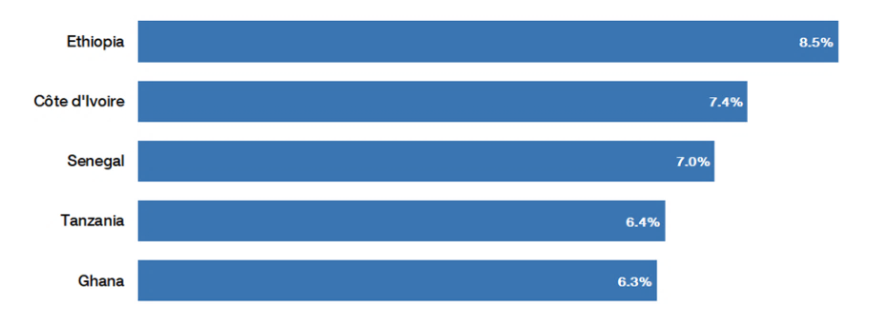
Figure 1: Growth of economy in Ethiopia (World Bank, 2022).
Investment opportunity: Ethiopia's government is working for economic diversification and modernization to move away from an almost entirely agrarian economy. They are promoting the development of the secondary sector. There is a widespread belief that certain businesses may relocate their production from Asia to Africa in the future because Asian wages won't be attractive enough to support the manufacturing of some low-cost goods (Grundy, 2006). In its region, Ethiopia is encouraging delocalization and might gain from it.

Challenges
Poor-country: Though the GDP of the country has developed a lot in recent years per capita income is still low and, in their homes, most rural residents lack direct access to power. Ethiopia has one of the lowest percentages of internet users worldwide. Even though Ethiopia is still mostly an agricultural nation today, this is largely due to a lack of modern technology (Hamilton et al., 2018). Consider the fact that agriculture only accounts for 30% of the GDP while employing around 70% of the population.
Lower literacy rate: The illiteracy rate is a huge challenge for a new business to cover up, especially when they are trying to move their business activity to Ethiopia. Almost 50% of the population of Ethiopia aged up to 15 does not know reading and writing and this can be a huge challenge to deal with the labor force of that country (World Bank, 2022).
Lower use of technological advancement: It is also a challenge for the new business to continue their business in this country because the country still doesn’t have any proper facilities to use modern technology at their production facility and still it is dependent on agriculture.

Management of corporate governance, business strategy, and cultural sensitivity while doing business in Ethiopia
Corporate governance: Corporate governance is the term used to describe how and why businesses are governed. It reveals who is in charge, responsible for what, and who makes choices. It is essentially a toolkit that enables management and the board to handle the difficulties of running a business more skillfully (Hill et al., 2006). There are many corporate governance theories and the company that wants to do their business in Ethiopia can follow any of them. Here stakeholder theory of corporate governance has been chosen.
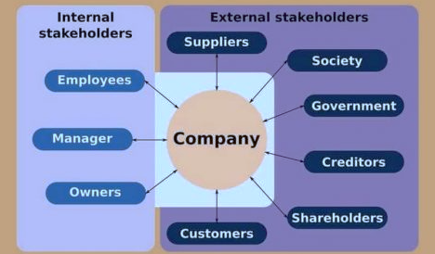
Figure 2: Stakeholder’s theory (Thomas, 2008).
The focus of the stakeholder theory of corporate governance is on how corporate conduct affects all recognizable stakeholders of the firm. According to this view, corporate management (officers and directors) should consider each stakeholder's interests when determining how the company is to be governed. Making measures to lessen or manage stakeholder interest conflicts falls under this category (Perara, 2017). The two main categories of stakeholders are internal and external stakeholders. Internal stakeholders are mainly corporate directors as well as employees and external employees are investors, govt agencies, customers, and so on.
Cultural sensitivity: Understanding cultural aspects that may have an impact on research is known as cultural sensitivity. To engage their target audience, marketing teams for brands must create effective messaging that considers regional cultural variations. The following company can use Hofstede’s cultural dimension while doing business in Ethiopia.
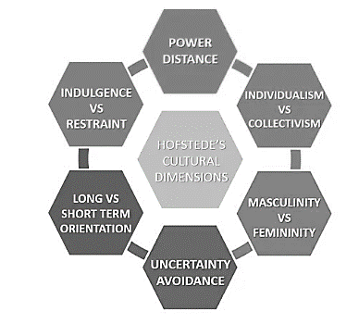
Figure 3: Hofstede’s cultural dimension (Hofstede, 2011).
Beliefs about the proper allocation of power in society: The amount to which a community's less powerful members have come to tolerate and even anticipate an uneven distribution of power is reflected along this dimension. On the individualism/collectivism spectrum, one might evaluate the weight one should give to one's own interests vs those of the collective. The masculinity/femininity dimension's focus is on what values a culture prioritizes (Hofstede, 2009). The most important factor in this predicament is how society reacts to the reality that the future is uncertain. Every culture must maintain some ties to its history while tackling concerns from the present and the future. The model has recently included a dimension called Indulgence (Morrison, 2011).

Barriers experienced by foreign business in Ethiopia
Trade barriers: Especially for individuals who import products for domestic consumption, importers struggle to obtain foreign currency. A stringent regulatory framework governing foreign money is implemented by the National Bank of Ethiopia (NBE). The remaining companies experience onerous delays when organizing trade-related payments, but larger corporations, state-owned enterprises, and manufacturing industries have not had significant difficulty in getting foreign exchange (Wild et al., 2003). Before an order may be placed, an importer must apply for an import permit and receive a letter of credit for the whole import amount.
Managing global teams: Another barrier faced by many foreign businesses in Ethiopia is the management of global teams. As many people of Ethiopia still don’t have any basic education as well as no learning of reading and writing so in this case, getting a skilled workforce becomes tough for the foreign countries and when people are not skilled and knowledgeable it becomes difficult for the foreign businesses to give concentration on their business and managing the global team.

Recommendations
- The HSBC holdings need to give focus on the population of Ethiopia because the population is quite large in the country and maximum are not educated so this can give benefit HSBC to hire workers with low wages (Shenkar et al., 2014).
- The HSBC holdings need to give attention to the investment opportunities in Ethiopia because investment opportunity is fair enough in the country and the company can easily find out the sectors of investment and in the agricultural sector the country is doing good so investing in that sector would be a great advantage for the company.
- The company needs to take strong operational strategies such as quality control management, cost reduction of the banking process, and managing more savings so that it becomes highly effective to do banking and financial task in Ethiopia (Thomas, 2008).
- The company needs to follow a proper cultural dimension along with corporate governance theory because this will assist the company to take the right actions if they do business in Ethiopia (Permer et al., 2010). Cultural diversity or lack of knowledge about corporate governance can be a pitfall for the company so proper theory adoption will reduce this problem.

Conclusion
Analysis of the business environment as well as doing international business in a developing country both are challenging because it requires proper analysis of every small thing starting from the business opportunities to challenges. Ethiopia is a developing country whose GDP is growing gradually, and overall economic condition is rising but, in some cases, it has some lacking such as education of their people, trade barriers as well as corruption level of the country (Worthington et al., 2009). On the other hand, HSBC holding is a universal bank and financial service provider company and has the experience to run the business so there will be not so big an issue if they want to do business in the country but in some cases, the company needs to take proper action. A country’s overall economic condition, skilled labor force, and political and economic conditions create a huge impact on international business and these things need to be considered carefully while expanding business in developing countries.

References
- Adekola, A. and Sergi, B.S., 2016. Global business management: A cross-cultural perspective. Routledge.
- Bruijl, D. and Gerard, H.T., 2018. The relevance of Porter's five forces in today's innovative and changing business environment. Available at SSRN 3192207.
- Cavusgil, S.T., Knight, G., Riesenberger, J.R., Rammal, H.G. and Rose, E.L., 2014. International business. Pearson Australia.
- Chand, M. and Tung, R.L., 2014. The aging of the world's population and its effects on global business. Academy of Management Perspectives, 28(4), pp.409-429.
- Cuervo‐Cazurra, A., 2011. Global strategy and global business environment: The direct and indirect influences of the home country on a firm's global strategy. Global Strategy Journal, 1(3‐4), pp.382-386.
- Dobbs, M.E., 2014. Guidelines for applying Porter's five forces framework: a set of industry analysis templates. Competitiveness review.
- Ferraro, G. and Brody, E.K., 2015. The Cultural Dimension of Global Business (1-download). Routledge.
- Friedman, A.L. and Miles, S., 2002. Developing stakeholder theory. Journal of management studies, 39(1), pp.1-21.
- Grundy, T., 2006. Rethinking and reinventing Michael Porter's five forces model. Strategic change, 15(5), pp.213-229.
- Hamilton, L. and Webster, P., 2018. The international business environment. Oxford University Press.
- Hill, C.W. and Hernández-Requejo, W., 2006. Global business today.
- Hofstede, G., 2009. Geert Hofstede cultural dimensions.
- Hofstede, G., 2011. Dimensionalizing cultures: The Hofstede model in context. Online readings in psychology and culture, 2(1), pp.2307-0919.
- Mohamed, E.K. and Lashine, S.H., 2003. Accounting knowledge and skills and the challenges of a global business environment. Managerial finance.
- Morrison, J., 2011. Global Business Environment. Palgrave Macmillan.
- Parmar, B.L., Freeman, R.E., Harrison, J.S., Wicks, A.C., Purnell, L. and De Colle, S., 2010. Stakeholder theory: The state of the art. Academy of Management Annals, 4(1), pp.403-445.
- Perera, R., 2017. The PESTLE analysis. Nerdynaut.
- Shenkar, O., Luo, Y. and Chi, T., 2014. International business. Routledge.
- Thomas, D.C., 2008. Cultural intelligence: People skills for global business. ReadHowYouWant. com.
- Usaid, 2022. Economic Growth and Trade | Ethiopia | U.S. Agency for International Development. [online] Usaid.gov. Available at: <https://www.usaid.gov/ethiopia/economic-growth-and-trade> [Accessed 10 August 2022].
- Wetherly, P. and Otter, D., 2014. The business environment: themes and issues in a globalizing world. Oxford University Press.
- Wild, J.J., Wild, K.L. and Han, J.C., 2003. International business (p. 342). Upper Saddle River, NJ: Prentice Hall.
- Worldbank, 2022. [online] Available at: <https://www.worldbank.org/en/country/ethiopia/overview> [Accessed 10 August 2022].
- Worthington, I. and Britton, C., 2009. The business environment. Pearson education.

