

Name:-Dev Kishorkumar Manseta
Student Id:-2212021
Subject: - International Marketing
Subject Code: - LCMB7006
Lecturer’s Name:- Dr. Tushara Balendran
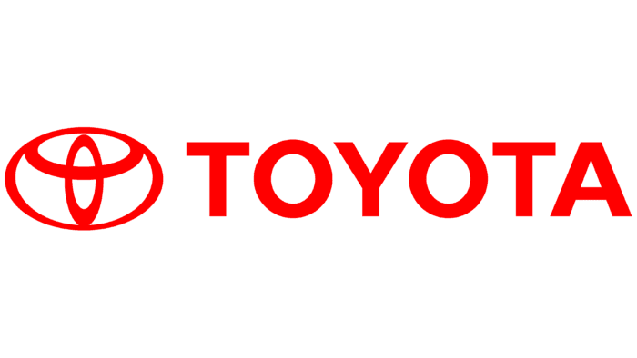

Table of Contents
Introduction 3
Company background 3
Macro environment 4
Micro environment 9
SWOT analysis 11
Segmentation, targeting and positioning 12
Marketing mix 16
Directional development strategy 22
Conclusion 23
Recommendations 23
Reference list 27

Introduction
The assignment is based on the title International Marketing. The selected company is Toyota. A critical analysis is done of the business of the enterprise in two different markets. The chosen countries are India and the United Kingdom. The macro and micro environment analysis of the two markets is done by PESTLE Analysis and Porter's five forces analysis respectively. The STP framework is used to judge Toyota in India and the UK. Moreover, the marketing mix elements are compared in both nations. The directional development strategy of the company is described with the application of the Ansoff matrix.

Company background
Toyota is a popular multinational company in the Japanese automotive industry. The organisation started its journey in 1937 and its current headquarters is in Aichi. Koji Sato is the present CEO of the firm and it has around 366,283 employees (Toyota-industries, 2023). The enterprise has global recognition and it has an excellent customer base all over the world. Some of the main subsidiaries of the Japanese organisation are Daihatsu, Hino Motors, FAW Toyota, and others. After gaining a stronghold in Japan, it opted to expand to other markets. Toyota entered India in 1997 while expanding to the British market in 1965.
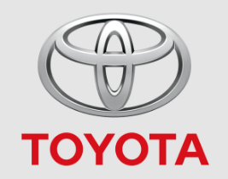
Figure 1: Toyota logo
(Source: Toyota-industries, 2023)

Macro environment
PESTLE Analysis
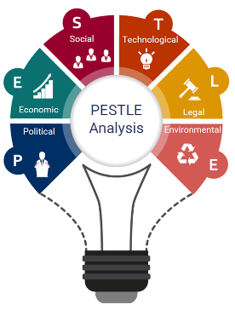
Figure 2: PESTLE Analysis
(Source: Christodoulou and Cullinane, 2019)
Political factors: India is the world's largest democracy and is one of the most powerful nations (Store.marketline, 2023a). The country has always tried to maintain political stability over the years. However, Toyota never faced any political disturbances in the country and that makes the factor favourable. However, political stability in the UK is better. Due to this, the Japanese firm has always maintained a good relationship with the government. The multinational company has not faced many trade barriers in the UK. However, it witnessed certain difficulties in India in terms of setting up manufacturing plants but the disputes were solved within short spans. Toyota has suffered from the exit of the United Kingdom from the European Union. Due to this, there was a permanent stoppage of acquiring potential employees from the EU markets (Cairney et al., 2019). Therefore, it was unfavourable and challenging for the automotive company to create a skilled workforce. However, obtaining government support has remained common in both markets.
Economic factors: India is the fifth largest economy in the world and it has maintained a good GDP growth over the years (Armstrong and Richter, 2022). Due to this, it has been easy for Toyota to achieve higher sales growth as consumption volume has increased with time. However, the country has shown excellent growth in the last two decades. The UK is the sixth largest economy in terms of nominal GDP and it lost the fifth spot to India in 2022 (Armstrong and Richter, 2022). However, the British economy has not fluctuated much in the last few decades. It was favourable because it has helped Toyota in maintaining a stable sales volume over the years. A key similarity between India and the UK is that both countries have good exports and imports. As a result, Toyota has been helpful in many ways. The corporate tax rate of India is 40% for foreign companies (Paisabazaar, 2023). It has been a challenge for the Japanese automotive company as its net profit has remained low, which makes the factor unfavourable. Moreover, different profit issues have resulted after the incorporation of GST. On the contrary, the corporate tax rate of the United Kingdom is 25%. The main problem is that it has remained to fluctuate over the years (Bbc, 2023). Therefore, Toyota has found it challenging to gain profitability in the same range over the years.
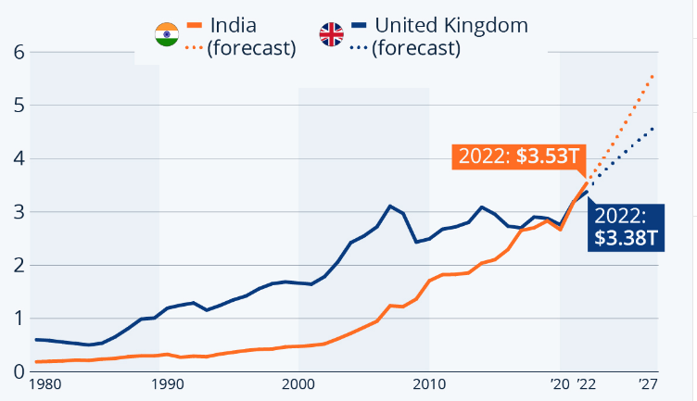
Figure 3: GDP growth comparison of India and the UK
(Source: Armstrong and Richter, 2022)
Sociocultural factors: India is the second most populated country in the world with a population of around 1.4 billion (Worldometers.info, 2023a). Henceforth, it can be considered a gigantic consumer market, which makes the factor favourable. It has remained beneficial for Toyota as high sales volume has been obtained. On the other hand, the population of 68 million makes the UK a decent consumer market (Worldometers.info, 2023b). Therefore, Toyota has limited its production in this country so that an equilibrium is maintained between supply and demand. The Japanese company has benefitted from both markets in the context of labour. India is the home of cheap labourers (Store.marketline, 2023a). Based on this, Toyota can create a huge workforce so that its productivity can remain high. However, the British market provides skilled workers due to its 99% literacy rate (Store.marketline, 2023b). Therefore, a qualified workforce has been made easy. Customer buying behaviour is different in both countries. Indians prefer both quality and price before purchasing luxurious items while British people give a higher preference to quality. It has remained a challenge for Toyota in setting the price of its products. The Japanese culture is somewhat different from both the Indian and British cultures. Hence, dealing with it has remained a key challenge for Toyota.
The cultural aspects of the two countries can be understood by applying Hofstede's cultural insights framework. The main advantage of Hofstede model is that key differences between cultures can be known (Minkov and Kaasa, 2021). Additionally, better understanding of cross-cultural individuals is acquired. However, a key limitation is that it is based on inconclusive research (Pirlog, 2020). Furthermore, the framework lacks accuracy.
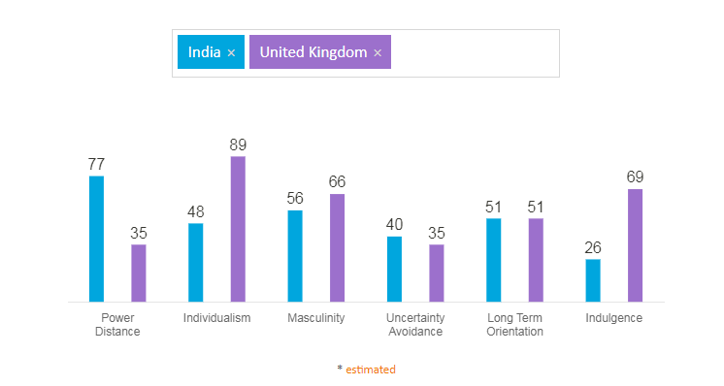
Figure 4: Hofstede cultural comparison between India and the UK
(Source: Hofstede-insights, 2023)
The main cultural difference between India and the UK is that the former possesses unequal power distribution whereas power is shared and widely dispersed in the latter one. Therefore, Toyota has to give centralised power to the country head in India. However, the company has multiple individuals on the Board in the UK. Their presence of a collectivist nature in India where individuals are closely tied (Shukla, 2021). It has helped Toyota in forming compatible teams in the market (Toyotabharat, 2023a). However, individual rights are paramount in the UK. Due to this, a deep focus has been given by Toyota on employee rights in the British market. Relating to the score of indulgence versus restraints in India, it can be said that employees are very much focused on their responsibilities (Shukla, 2021). It has been advantageous for the Japanese firm to accomplish its corporate objectives. On the other hand, British employees tend to give equal priority to professional life and personal time (Storry and Childs, 2022). Therefore, the automotive company is focused on giving deeper focus on staff benefits (Toyota.co.uk, 2023a). The culture of India is somewhat similar to the United Kingdom in areas such as masculinity versus femininity, uncertainty avoidance, and long-term versus short-term orientation. Therefore, the Japanese multinational did not bring any massive changes while operating in these markets.
Technological factors: India has shown a good improvement in the area of technology in the last few years. An excellent prevalence of social media has been seen in this market (Hole, Pawar and Khedkar, 2019). It has helped Toyota in attracting customers via different promotional approaches on social networking sites. On the other hand, the UK has remained a technologically advanced country over the years. It has shown good performance in adopting Industry 4.0 technologies (Store.marketline, 2023b). Hence, it is a favourable factor. Therefore, Toyota has succeeded in bringing top-quality products with technology integration. However, both countries are behind Japan in terms of technological growth.
Legal factors: India has a good legal infrastructure, which has been beneficial for the operating firms. All companies have to follow the Companies Act 2013 (Store.marketline, 2023a). The Japanese firm obeys the legislation along with some other regulations. Hence, smooth conduction of business has been ensured. In the UK, there is a need of following the Employee Relations Act 1999, Equality Act 2010, and others (Khan et al., 2019). Therefore, Toyota has treated its employees well due to this. The organisation pays its workers while following the National Minimum wage rate Act 1998. The available legislation indicates it as a favourable factor.
Environmental factors: India is suffering from different types of environmental pollution in the last few years and the contribution of the automobile sector is high (Store.marketline, 2023a). The government is very much worried and it is prioritising electric cars. Toyota has acknowledged it while bringing certain EVs into the Indian market, which makes the factor favourable. On the contrary, climate change has remained a key concern for the British government (Loureiro and Alló, 2020). Hence, car brands have focused on lowering emissions. The Japanese company has prioritised it while reducing its environmental impacts.
Conclusion
It has been found that political stability in both the UK and India has remained a benefit for Toyota. However, it has suffered from Brexit in the United Kingdom. The markets have high GDP growths, which has been beneficial for the automotive company. A key difference is the population as India is a humongous consumer market for the automotive firm as compared to the UK. The enterprise has to accommodate the Indian culture and the British culture while making specific changes. The company has tried to deal with the climate change problem in the UK while lowering its emission.
Similarities and differences
The key similarities between India and the UK are political stability, high GDP growth, technological advancement, and others. On the contrary, the major differences are seen within population, environmental challenges, cultural differences, and others.

Micro environment
Porter's five forces framework
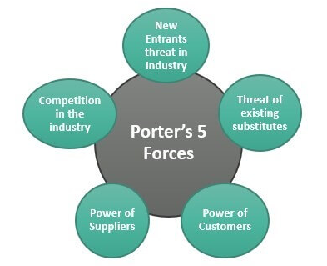
Figure 5: Porter’s five forces
(Source: Chesula and Kiriinya, 2018)
The threat of new entrants: The threat is low in the Indian automotive sector as well as in the United Kingdom. The company entered India in 1997 and it currently has a 2.89% market share in the hugely competitive industry (Godigit, 2023). Hence, it does not think about new entrants. Moreover, it has a loyal customer base. On the contrary, the company has a 6.61% share in the organised British automotive market (Media.toyota.co.uk, 2023). As a result, it can be said that the Japanese automotive firm has driven out the competition magnificently in this country. Therefore, new companies are not so challenging for Toyota.
Bargaining power of suppliers: The threat is low in both the Indian and British automotive sectors. In India, multiple suppliers provide quality raw materials to car brands (Sahoo, 2020). It has helped Toyota in ensuring supply chain effectiveness up to a certain extent. Moreover, the United Kingdom also has an exceptional infrastructure for automotive organisations (Giampieri et al., 2019). It has helped Toyota to set up its manufacturing plant in this market. The company has not worried about the suppliers in both countries and effective control has been obtained.
Bargaining power of buyers: The threat is high in India but low in the UK. The people of India often give better emphasis on price rather than quality while buying cars (Store.marketline, 2023a). It has remained a challenge for the Japanese company in terms of making the products affordable for the target customers. Along with that, it has remained tough to understand the needs of the buyers. However, British customers give more focus on quality over price when purchasing luxurious items (Store.marketline, 2023b). In this case, they do not bargain much for quality products. Toyota mainly thinks about providing top-notch cars to customers without thinking about the price.
The threat of substitutes: The threat is high in the automotive sectors of both countries. The Japanese firm mainly sells fuel cars to meet the needs of the customers. The main alternative to such products is an electric vehicle (Secinaro et al., 2020). Toyota has introduced some new variants in this new product line such as Innova Hycross ZX, Cruiser Hyryder E, and others (Toyota-industries, 2023). However, it is not possible for the company to replace all fuel cars and focus only on electric cars. In this case, different challenges are to be faced as both countries have excelled in their EV markets.
Competitive rivalry: The threat is high in the Indian automotive industry and moderate in the British automotive industry. The automotive sector of India is very much competitive because of the presence of many top names. It is dominated by car companies such as Maruti Suzuki, Hyundai Motors, Tata Motors, KIA, and others (Sahoo, 2020). Hence, the Japanese firm has witnessed enormous challenges to make its mark. The competition is not so vigorous in the UK, which helped Toyota to achieve a 6.61% market share (Media.toyota.co.uk, 2023). The main competitors are Ford, General Motors, Volkswagen, and others. Nevertheless, the firm must focus on expanding its share in the coming days.
Similarities and differences
India and the UK are similar in certain grounds such as threat of new entrants, bargaining power of suppliers, and threat of substitutes. However, they differ in bargaining power of buyers and competitive rivalry.

SWOT analysis
Strengths | Weaknesses
- Toyota has a strong brand image all over the world for its high quality cars the organisation is successfully operating in 67 countries for manufacturing purposes and it already entered and conducting successful business operations in over 170 countries’ markets across the globe (Toyotauk, 2023c).  - Toyota generated $276.57 billion in revenue in 2021, which demonstrates immense revenue growth as the organisation generated $251.62 billion in annual revenue in 2020 (Companiesmarketcap, 2023).  - Toyota has a strong global employee strength of 366,283 individuals, which makes the human resource of the organisation highly strong (Toyota-industries, 2023). | - A significant chip shortage in its supply chain made Toyota cut its production volume (Trivedi, 2022). It shows a weak supply chain of the organisation.  - Toyota had to recall millions of cars due to experiencing significant manufacturing defects in 2018 (Wsj.com, 2018). It even happened in the past on a number of occasions.  - Additionally, there are also inefficiencies within the internal operations of the organisation, which hindered it from achieving exponential growth in the global automotive sector.
Opportunities | Threats
- A high level of government support in the markets it operates.  - Access to cheap and skilled labour.  - Growth of social media in India.  - Growth of Industry 4.0 technologies in the UK.  - Favourable legal infrastructure in the countries it operates. | - Different cultural preferences in different markets.  - Closure of employee sources from the EU countries in the UK.  - High threat of substitute products in the markets in which it operates.  - High competition in the Indian automotive sector.  - Environmental degradation concerns around the world.
Table 1: SWOT analysis for Toyota
(Source: Created by author)
Similarities and differences
In terms of similarities, Toyota gets support from both the Indian and UK governments, in terms of a key opportunity to grow. In this context, both countries have high labour availability along with ideal legal infrastructure, favourable to Toyota. On the other hand, in both countries, the organisation has substitute threats and unfavourable conditions regarding environmental degradation. In terms of differences, the growth of Industry 4.0 in the UK is an opportunity for Toyota, which it cannot avail of from India. On the contrary, the social media growth in India is a favourable situation, which is not observed to the same extent in the UK. The closure of employee sources from EU countries is a UK-specific issue for Toyota, which is not observed in India. On the other hand, the competition level in the Indian automotive sector is a threat, which is not observed in the case of the UK market. Additionally, a dissimilarity is also observed in terms of customer preference, creating a threat to the organisation.

Segmentation, targeting and positioning
Segmentation
Market segmentation is the strategy a company adopts for developing an accurate marketing mix and allocating resources more effectively to a specific group in the entire market to ensure a high level of business success (Arsova and Temjanovski, 2019). This strategy helps companies in tailoring their marketing activities and practices according to the condition of the selected market segment so that high effectiveness of those activities and practices can be ensured, contributing to the growth and development of that company. Market segmentations can be of different types such as demographic, geographic, psychographic, socio economic status and geo demographic in a broader sense (Salome, 2020). In India, the organisation focused on demographic segmentation. In this context, mainly family demography is emphasised by the organisation, as mainly family cars are the main category in terms of the product range in this country (Toyotabharat, 2016). On the other hand, in the case of Toyota in the UK, the organisation focuses on demographic segmentation. In this context, age demography is emphasised by the organisation. It is found that the average age of the buyers of Toyota cars in the UK is 63(Hosking, 2018). Thus, it can be said that in the UK, the middle-aged market segment is emphasised by the company. Hence, there is a slight dissimilarity in terms of the choice of demography to differentiate its marketing strategies in the UK and India.
Targeting
The targeting strategy used by a company in a market can mainly be of three types such as undifferentiated marketing, differentiated marketing and concentrated marketing (Dong, 2022). Depending on the nature of the customer base, companies develop the marketing mix strategy(s), where these above-mentioned targeting strategies play a key role. Here, in the case of India Toyota emphasises undifferentiated marketing as the targeting strategy. This is because, in undifferentiated marketing, organisations focus on developing a single marketing mix strategy, addressing the entire market (Breesam, Atta and Mahdi, 2019). In India, Toyota mainly focuses on quality cars in an affordable range for the entire market (Toyotabharat, 2016). However, in the UK, Toyota emphasises a differentiated marketing strategy as two categories are emphasised here, such as original cars and customised cars with different pricing strategies while maintaining high quality (Toyota.co.uk, 2023b). Hence, dissimilarity in these two different markets can be identified from this discussion.

Positioning
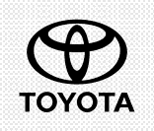
Low Price
High Price
Low Quality
High Quality
Figure 6: Perceptual mapping for India
(Source: Created by author)
In India, Toyota mainly uses benefit positioning. It is to compete with other companies such as Tata Motors, Hyundai, Maruti Suzuki, KIA Motors and a few others (91wheels.com, 2023). Benefit positioning is the strategy where an organisation stresses product benefits to its customer base for enhancing the sales volume in a market (Amadi, 2022). It is observed that while promoting cars in India, Toyota significantly focuses on benefits provided by the cars, price and various other information, as it has a dedicated webpage for every model (Toyotabharat, 2023b). It shows the organisation's high dedication to maintaining an optimum level of benefit positioning to secure a competitive advantage in the Indian market.

Low Price
High Price
Low Quality
High Quality
Figure 7: Perceptual mapping for the UK
(Source: Created by author)
In the UK the organisation emphasises user positioning as it categorises them as the users of original car models and the users of customised car models (Toyota.co.uk, 2023b). This is used by the organisation in order to effectively compete with the organisations in the UK market such as Ford Motors, General Motors, Volkswagen and a few others. The user positioning strategy emphasises developing products or services following the expectations of specific user bases to increase the appeal of those products or services more(Hu, 2020). In the UK, the user needs for both original car models and customised car models are addressed by the organisation.

Similarities and differences
The similarity in the case of the UK and Indian markets is in both cases, demographic segmentation is emphasised. However, in terms of specific demography, a dissimilarity can be observed in targeting Indian customers and UK customers. A high dissimilarity is also observed between India and the UK, in the case of targeting, As Toyota emphasises undifferentiated marketing in India, whereas following differentiated marketing in the UK. Additionally, positioning strategies in both countries are dissimilar, as in India, Toyota uses benefit positioning, whereas, in the UK, it follows user positioning.

Marketing mix
Product
Toyota Motors is a Japanese company; this organisation includes Toyota, Lexus, Hino and Daihatsu. However, in the case of India, it has been found that the Toyota brand has used individual product branding as here Toyota has used the brand name Toyota Bharat (Toyotabharat, 2023a). Here this is termed as individual branding as this branding is not closely connected to Toyota Motors and its offerings. However, the brand is a namesake of Toyota Motors which is similar. On the other hand, a similar approach of individual branding has been found in the case of the UK so here it has been branded using the name Toyota UK. This indicates in the two countries standardisation of products is maintained (Venaik and Midgley, 2019). However, while branding in the case of India for the target audience the one segment of product that is an affordable range of family cars is offered. However, in the UK the line stretching is evident here Toyota incorporated upward stretching by enhancing product quality (Toyota.co.uk, 2023b). Therefore, here for the middle-aged customers segment the company has offered two ranges of cars one is the affordable ones and another is high-quality cars with the higher price which are customisable too. This way the product aspect of the company has similarities in overall branding but differences in the approach of product line management.
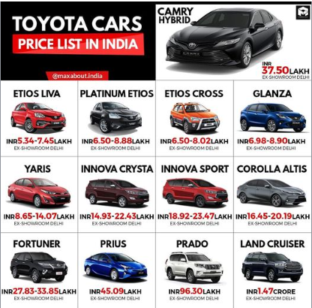
Figure 8: Toyota product range in India
(Source: Autos.maxabout, 2023)
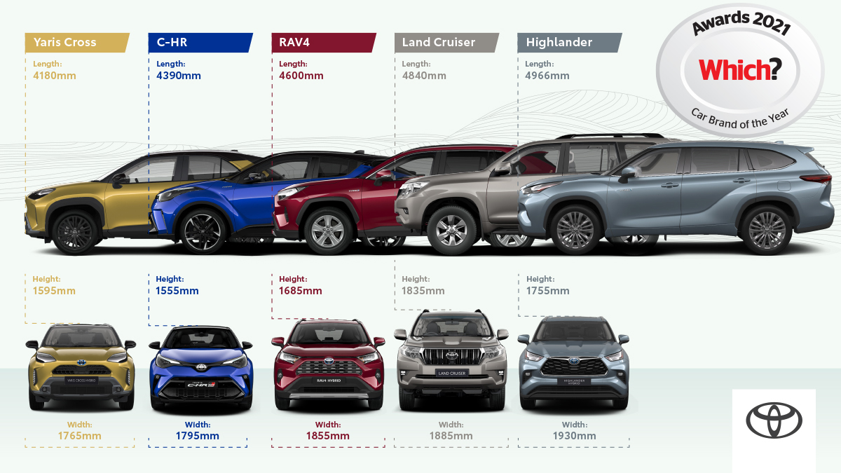
Figure 9: Toyota product range in the UK
(Source: Toyota.co.uk, 2023b)
Price
In the case of India as the target market is the customers who prefer quality products at a reasonable rate so that here Toyota has used a competitive pricing strategy (Toyotabharat, 2016). This is because there are several players in India that positively create a threat to the organisation by offering cars in the affordable range (91wheels, 2023). However, in the case of the UK, it has been found that here the quality is preferred highly. Hence, here Toyota has used line stretching. Therefore, Toyota has taken the strategy of value-based pricing. Therefore, they offer different models within different price ranges based on the value of the product. The more the product quality gets increased and customisation takes place the more the price of the products increases (Toyota.co.uk, 2023b). Hence, this shows that in India and the UK, the pricing strategy has a major difference. However, this difference is developed to address the different target customers of the organisation. Hence, this is a key strategic move to market the products to ensure success. Therefore, this indicates here the adaptation strategy is kept based on the local market demand for strategic pricing.
Place
Place refers to the distribution channels that are used by a brand to promote its product to increase sales. In the case of Toyota, it has been found that the company has a high dependence on dealerships for selling its products (Toyotauk, 2023; Toyotabharat, 2023c). This is a form of indirect selling. Hence, this indicates that Toyota uses an indirect selling strategy. However, this is highly evident in India as well as in the UK. Moreover, in the case of the UK, the brand has considered intensive indirect selling so in the UK they have nearly 177 dealerships (Carlier, 2023). On the other hand, in India similarly, the company is working on increasing the number of dealerships (Toyotabharat, 2023c). This indicates the similarity in the distribution channel setting. This shows the standardisation strategy for the organisation.
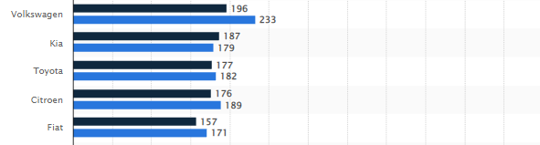
Figure 10: Toyota dealership numbers in the UK
(Source: Carlier, 2023)
Market entry methods
However, in the case of the UK, Toyota has entered the joint venture market entry strategy with PSA (Toyotauk, 2023a). On the other hand, in India Toyota entered using a joint venture entry mode with Vikram Kirloskar in 1997 (Thakkar, 2019). This again indicates that even in the case of a market entry strategy to select a location and place the business strategically Toyota has used the standardisation strategy for marketing and used a similar entry mode that is a joint venture in India and in the UK market. The key advantages of joint venture are shared risk and liabilities while entering into a new market. However, here the disadvantage is lack of central control over the product and services management in the new market.
Promotion
Promotional strategies are the most important part of marketing so sales growth gets increased with the strategic development of brand awareness (Venaik and Midgley, 2019). Hence, in the case of India, it has been found that Toyota has marketed its products using the advertising strategy on TV and other social media platforms (Toyotabharat, 2023e). Here for promotional activities and advertisements Toyota has preferred to use the local language and local popular faces to attract customers positively. This shows that here localisation has been used. On the other hand, in the case of the UK, its innovative social media online campaigns are developed for marketing. However, it has been found that localisation has been used in the case of advertisement and online content creative emotional angles are promoted while promoting equality and strength (Campaignlive, 2023). This indicates that to address the national culture of higher equality and individuality the content has been prepared accordingly. This shows that again local responsiveness is prioritised here. Apart from that, in both the country direct marketing is done using the trade shows by Toyota (Toyotabharat, 2023e). This again indicates the similarity in the marketing tactics. This shows that the promotional activities are similar in both markets.
People
In the case of India, it has been found that Toyota possesses, nearly 4000-5000 employees. Here the local employees are employed to manage the local market (Toyotabharat, 2023d). The organisation is working on investing more in creating employment scope. Here the employees are given the training to maintain the standardised operation with being locally responsive. On the other hand, in the case of the UK, it has been found that Toyota possesses 3000 employees in the UK (Toyotauk, 2023b). The organisation has here also used the localisation strategy and employed local employees who have better knowledge about the UK market. This shows in the people selecting for marketing activities in both countries Toyota has used a similar strategy.

Process
In terms of processes in India, the offline selling of cars from the dealership is the only process to purchase cars (Toyotabharat, 2023c). However, in the UK a similar process has been found to be used by Toyota (Toyota, 2023a). In both cases Toyota has separate official websites where the customers can visit the available models and price ranges afterward, they can contact the customers' service professionals to have support for identifying nearby Toyota showrooms while booking test drives (Toyota, 2023a; Toyotabharat, 2023c). However, the purchase stage takes place in the offline mode. This shows that in both the country the used process. However, the key norms are maintained effectively to promote central control. This indicates the standardisation of the process.
Physical evidence
In the case of the physical evidence, the artefacts are highlighted. In the case of India, it has been found that the dealerships are presented with similar norms with similar interiors as the UK and other countries (Toyotabharat, 2023a; Toyota, 2023a). This is because the dealership’s artefacts are the factors that hold brand uniqueness. Hence, to stand out and showcase one brand image the physical evidence is similar in nature in both countries. Hence, this has made the physical evidence effective. On the other hand, a similar uniform is used in both countries which also indicate the standardisation of the physical evidence of the organisation in the Indian and the UK market.

Directional development strategy
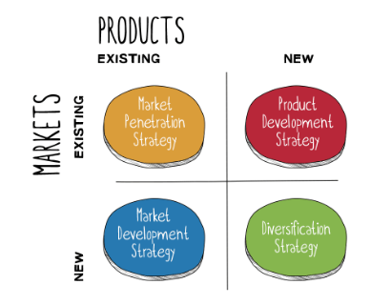
Figure 11: Ansoff’s matrix
(Source: Chintalapati, 2020)
Directional development is a critical factor to consider which can be explained significantly using Ansoff’s matrix. Ansoff’s matrix is a business growth theory that consists of four key strategies which include market penetration where the existing product is promoted in the existing market (Chintalapati, 2020). On the other hand, product development is another one where the new product is developed in the existing market. However, in differentiation is a unique strategy where a new product is introduced in a new market (Chintalapati, 2020). In the case of India, it has been found that in terms of directional growth Toyota has opted for this strategy and introduced its new product that is Toyota Qualis model in the Indian market (Thakkar, 2019). Here the market was new and the product as well. The product was an innovation from the joint venture between Toyota and Vikram Kirloskar. On the other hand, in the case of the UK, it has been found that Toyota has entered into introduced their existing model named Corona (Mag.toyota, 2023). This model was first introduced in New Zealand. However, after entering the UK Toyota first sold this car. This indicates that Toyota has used the market development strategy here. This is because the market development strategy is the one that is used while ensuring growth with a new market expansion strategy with the existing product (Chintalapati, 2020). Hence, this shows that there is a strong difference between the development strategy in the Indian and the UK market.

Conclusion
From the analysis, it has been found that the Indian and the UK markets’ external business environment have created several opportunities and threats for Toyota. Therefore, they have developed their target market and the marketing plan so that success can be achieved. However, Toyota’s internal fundamentals are strong enough that is creating competencies. India Toyota has targeted customers who prefer high-quality cars at an affordable range and in the UK the middle age customer segment is the target market. Therefore, they have standardised some of the marketing elements like product branding, distribution channels and market entry, people, processes and physical pieces of evidence. However, there is a difference between product line management, pricing, and promotional strategies. Moreover, the development process is different as diversification is used for India and the market development strategy is used for the UK.

Recommendations
Factors | Opportunities (O)  1. Favourable government support.  2. Cheap and skilled labours.  3. Indian social media growth.  4. Industry 4.0’s growth in the UK.  5. Favourable legal infrastructure. | Threats (T)  1. Different customer preferences.  2. Employee shortage in the UK.  4. High substitute threats.  5. High competition in India.  6. Environmental concerns.
Strengths (S)  1. Strong global brand image and presence.  2. Strong financial resources.  3. Robust human resources | SO – Maxi-Maxi strategies  1. The organisation can utilise its strong global image and presence to capitalise to effectively exploit social media growth in India, industry 4.0 technologies' growth in the UK, favourable government support and favourable legal structure to push its sales more in the market by emphasising the market penetration strategy as per Ansoff matrix. This is because this strategy focuses on increasing the sales volume of an organisation in the market it already operates in (Alkasim et al., 2018).  2. With the strength of strong financial resources the organisation can effectively integrate industry 4.0 technologies more in terms of a cost-reduction strategy through innovations (Bag et al., 2021).  3. The organisation is also suggested the strategy of acquiring most employees from India and the UK to further strengthen its human resources while exploiting the opportunity of access to cheap and skilled labour in these countries. This is important as cheap and skilled labour can significantly increase the productivity and efficiency of a workforce (Sima et al., 2020). | ST - Maxi-Mini strategies  1. The organisation can exploit its strong brand image and presence to effectively combat the threats of high competition in India and high substitution threats in the Indian and UK markets. Here, the organisation can take the strategy of emotional branding to further exploit its brand image and presence, as it is highly suitable for enhancing customer loyalty (Permata and Hussein, 2022).  2. It can use its strong financial resources to take the strategy of high investments to use data analytics and with that insight, comply with customer preferences. As well as it can also use this strength to take effective environmental measures to fight off the threat of increased environmental concerns in the markets it operates.  3. As the organisation has strong human resources, it can widely utilise international assignments to cope up with employee storage in the UK. This is because international assignments significantly help in strengthening human resource management in an organisation (Panda, Pradhan and Singh, 2022).
Weaknesses (W)  1. Weak supply chain.  2. Weak R&D.  3. Poor operational efficiency. | WO - Mini-Maxi strategies  1. With the help of Industry 4.0 technologies, the supply chain weakness of the organisation can be mitigated. This is because Industry 4.0 in the supply chain significantly helps in increasing the efficiency of the supply chain to make it stronger (Fatorachian and Kazemi, 2021).  2. The opportunities of favourable government support, favourable legal structure, and access to cheap and skilled labour can be utilised by the organisation to Emphasise collaborations and overcome its weaknesses in R&D, through that.  3. The organisation can exploit social media growth in India to overcome its operational inefficiencies by recruiting talented candidates. This is because social media is significantly helpful in gaining access to a large potential candidate base for effective recruitment (Ruparel et al., 2020). | WT - Mini-Mini strategies  1. The organisation needs to focus more on supply chain automation to strengthen its supply chain and effectively deal with threats such as different customer preferences, high substitute threats and high competition in India. This is because supply chain performance significantly impacts organisational performance of a company, which can be improved by supply chain automation (Xu, Mak and Brintrup, 2021).  2. The organisation needs to invest more in R&D to overcome its weakness and effectively address different customer preferences through innovations and also address environmental concerns subsequently.  3. The organisation is also suggested to employ workforce automation to remove its weakness of operational efficiency and effectively mitigate the threat of employee shortage in the UK. This is because workforce automation significantly enhances both efficiency and productivity (McClure, 2018).
Table 2: Recommendations for Toyota in TOWS format
(Source: Created by author)
Product life cycle
The product life cycle model helped in determining the stages Toyota is at in the Indian market and the UK market.
In 2021 in India, the organisation encountered a significant loss of sales after preferable year-on-year sales growth in the past few years (Thakkar and Shyam, 2021). It shows that the organisation has completed its journey in the growth stage and entered into the maturity stage in terms of the life cycle of its business in India. Hence, here, a defense strategy can be recommended to apply. In this context, the position defense or fortress strategy is recommended to Toyota for application in India, as the strategy emphasises protecting the advantageous factors available to an organisation that helps in securing the competitive edge in the market by strengthening the business as a fortress (Kanagal, 2018). It will prevent the organisation from going into the decline stage in terms of PLC in the Indian market.
On the other hand, in the UK, it is observed that the organisation is keeping a high level of year-on-year sales growth as it is continuously enhancing its market share in the country’s automotive sector (Media.toyota.co.uk, 2021). This factor shows that the organisation is in the growth stage in terms of its life cycle in the UK market. Therefore, an attack strategy will be feasible for the organisation, aiming to further enhance its growth of market share in the UK. Here, the organisation is suggested to adopt the leapfrogging strategy. This strategy stresses incremental and consistent innovation by an organisation in order to stay ahead of the competition (Moeketsi and Letaba, 2022). As the substitute threat is a key challenge to the organisation, the strategy of leapfrogging will help it effectively encounter it and increase the market share in the UK as a result.

Reference list
91wheels.com. (2023). Toyota Innova hycross competitors-frequently asked questions, 91Wheels. Available at: https://www.91wheels.com/faqs/what-are-the-top-competitors-of-toyota-innova-hycross/167742 [Accessed 13 April 2023].
Alkasim, S.B., Hilman, H., Bohari, A.M.B., Abdullah, S.S. and Sallehddin, M.R., (2018). The mediating effect of cost leadership on the relationship between market penetration, market development, and firm performance. Journal of Business and Retail Management Research, 12(3), pp. 190-200.
Amadi, L., (2022). Brand Benefit Positioning Strategy And Repurchase Intention Of Consumers Of Food And Beverages Brands In Rivers State, Nigeria. World Bulletin of Management and Law, 7, pp.21-28.
Armstrong, M. and Richter, F. (2022) Infographic: India overtakes UK to become fifth biggest economy, Statista Infographics. Available at: https://www.statista.com/chart/28258/gdp-of-india-and-united-kingdom/ [Accessed 13 April 2023].
Arsova, M. and Temjanovski, R., (2019). Strategy for market segmentation and differentiation: contemporary marketing practice. Journal of Economics, 4(1), pp.27-35.
Autos.maxabout.com, (2023). Toyota Cars Available at: https://autos.maxabout.com/cars/toyota [Accessed 13 April 2023].
Bag, S., Gupta, S. and Kumar, S., (2021). Industry 4.0 adoption and 10R advance manufacturing capabilities for sustainable development. International journal of production economics, 231, p.107844.
Bbc.com. (2023). What is corporation tax and who pays it?BBC News. BBC. Available at: https://www.bbc.com/news/business-63255747#:~:text=The%20tax%20is%20currently%20charged,will%20continue%20to%20pay%2019%25. [Accessed 13 April 2023].
Breesam, M.A., Atta, K.M. and Mahdi, M.S., (2019). The Influence of Entrepreneurial Supply Chain on Marketing: An Exploratory Case Study of General Company for Batteries Manufacturing. Int. J Sup. Chain. Mgt Vol, 8(6), p.741.
Cairney, P., McHarg, A., McEwen, N. and Turner, K., (2019). How to conceptualise energy law and policy for an interdisciplinary audience: The case of post-Brexit UK. Energy Policy, 129, pp.459-466.
Campaignlive.co.uk, (2023). Toyota advertising, marketing campaigns and videosAvailable at: https://www.campaignlive.co.uk/the-work/advertiser/toyota/7997 [Accessed 13 April 2023].
Carlier, M. (2023). Number of car dealerships in franchise networks* in the United Kingdom (UK) in January 2014 and January 2017Available at: https://www.statista.com/statistics/312034/size-of-car-dealership-networks-in-the-united-kingdom-uk/ [Accessed 13 April 2023].
Chesula, O.W. and Kiriinya, S.N., (2018). Competitiveness in the telecommunication sector in Kenya using Porters five forces model. International Journal of Research in Finance and Marketing (IJRFM), 8(7), pp.1-10.
Chintalapati, S., (2020). BankBuddy. ai—Business Expansion and Marketing Dilemma: A Case Study to Discuss the Ansoff Growth Matrix Concepts Combined with Business Expansion Strategies for Expanding into Emerging Markets. Emerging Economies Cases Journal, 2(1), pp.44-53.
Christodoulou, A. and Cullinane, K., (2019). Identifying the main opportunities and challenges from the implementation of a port energy management system: A SWOT/PESTLE analysis. Sustainability, 11(21), p.6046.
Companiesmarketcap.com. (2023). Toyota (TM) - revenue, CompaniesMarketCap.com - companies ranked by market capitalization. Available at: https://companiesmarketcap.com/toyota/revenue/#:~:text=Revenue%20in%202022%20(TTM)%3A,that%20were%20of%20%24251.62%20B. [Accessed 13 April 2023].
Dong, H., (2022). Marketing View of Core Competence Cultivating on Business Majors in Private Universities. International Business Research, 15(1), pp.110-120.
Fatorachian, H. and Kazemi, H., (2021). Impact of Industry 4.0 on supply chain performance. Production Planning & Control, 32(1), pp.63-81.
Giampieri, A., Ling-Chin, J., Taylor, W., Smallbone, A. and Roskilly, A.P., (2019). Moving towards low-carbon manufacturing in the UK automotive industry. Energy Procedia, 158, pp.3381-3386.
Godigit.com. (2023). Top car manufacturers in India: Brands, Market Share & SalesDigit Insurance. Available at: https://www.godigit.com/motor-insurance/car-insurance/find/top-car-manufacturers-in-india [Accessed 13 April 2023]
Hofstede-insights.com. (2023). Compare countriesHofstede Insights. Available at: https://www.hofstede-insights.com/fi/product/compare-countries/ [Accessed 13 April 2023].
Hole, Y., Pawar, M.S. and Khedkar, E.B., (2019), November. Omni channel retailing: An opportunity and challenges in the Indian market. In Journal of Physics: Conference Series (Vol. 1362, No. 1, p. 012121). IOP Publishing.
Hosking, P., (2018). Car adverts appeal to the young but older people are in the driving seat, The Times & The Sunday Times: breaking news & today's latest headlines. The Times. Available at: https://www.thetimes.co.uk/article/car-adverts-appeal-to-the-young-but-older-people-are-in-the-driving-seat-qmbpgqzhl#:~:text=The%20majority%20of%20new%20cars,For%20Toyota%20it%20is%2063. [Accessed 13 April 2023].
Hu, Y., (2020). Research on the commercial value of Tiktok in China. Academic Journal of Business & Management, 2(7), pp.57-64.
Kanagal, N.B., (2018). Building Competitive Edge. International Journal of Marketing Studies, 10(3), pp.1-91.
Khan, N., Korac‐Kakabadse, N., Skouloudis, A. and Dimopoulos, A., (2019). Diversity in the workplace: An overview of disability employment disclosures among UK firms. Corporate Social Responsibility and Environmental Management, 26(1), pp.170-185.
Loureiro, M.L. and Alló, M., (2020). Sensing climate change and energy issues: Sentiment and emotion analysis with social media in the UK and Spain. Energy Policy, 143, p.111490.
Mag.toyota.co.uk, (2023). Toyota celebrates 50 years in the UK Available at: https://mag.toyota.co.uk/toyota-celebrates-50-years-in-the-uk/#:~:text=In%201965%20the%20Corona%20wasn,sold%20officially%20in%20the%20UK. [Accessed 13 April 2023].
McClure, P.K., (2018). “You’re fired,” says the robot: The rise of automation in the workplace, technophobes, and fears of unemployment. Social Science Computer Review, 36(2), pp.139-156.
Media.toyota.co.uk. (2021). Toyota achieves record UK New Car Market Share, Toyota Media Site. Available at: https://media.toyota.co.uk/toyota-achieves-record-uk-new-car-market-share/ cms [Accessed 14 April 2023].
Media.toyota.co.uk. (2023). Toyota sets new records with 2022 sales performanceToyota Media Site. Available at: https://media.toyota.co.uk/toyota-sets-new-records-with-2022-sales-performance/ [Accessed 13 April 2023]
Minkov, M. and Kaasa, A., (2021). A test of Hofstede's model of culture following his own approach. Cross Cultural & Strategic Management, 28(2), pp.384-406.
Moeketsi, T.C. and Letaba, T.P., (2022). Leapfrogging pathway for fourth industrial revolution: a case of process innovation within an automotive subsidiary firm. South African Journal of Industrial Engineering, 33(4), pp.81-93.
Paisabazaar.com. (2023). Corporation tax india: Overview, rates & tax liabilityCompare & Apply Loans & Credit Cards in India- Paisabazaar.com. Available at: https://www.paisabazaar.com/tax/corporation-tax/ [Accessed 13 April 2023].
Panda, M., Pradhan, R.K. and Singh, S.K., (2022). What makes organization-assigned expatriates perform in the host country? A moderated mediation analysis in the India-China context. Journal of Business Research, 142, pp.663-673.
Permata, D.D. and Hussein, A.S., (2022). Emotional branding, corporate image and its effect on the loyalty of JKN-KIS participants: A mediating role of satisfaction. International Journal of Research in Business and Social Science (2147-4478), 11(4), pp.16-22.
Pirlog, A., (2020). Intercultural “Diagnosis” of Management in the Republic of Moldova According to Geert Hofstede Model: Comparative Analysis. Centre for Studies in European Integration Working Papers Series, 1(16), pp.119-128.
Ruparel, N., Dhir, A., Tandon, A., Kaur, P. and Islam, J.U., (2020). The influence of online professional social media in human resource management: A systematic literature review. Technology in Society, 63, p.101335.
Sahoo, S., (2020). Assessing lean implementation and benefits within Indian automotive component manufacturing SMEs. Benchmarking: An International Journal, 27(3), pp.1042-1084.
Salome, I.O., (2020). Moderating factors and customer loyalty of selected hotels in Lagos state, Nigeria. Journal of Asian Business Strategy, 10(1), pp.1-12.
Secinaro, S., Brescia, V., Calandra, D. and Biancone, P., (2020). Employing bibliometric analysis to identify suitable business models for electric cars. Journal of cleaner production, 264, p.121503.
Shukla, S., (2021). India abroad: Diasporic cultures of postwar America and England. Princeton University Press.
Sima, V., Gheorghe, I.G., Subić, J. and Nancu, D., (2020). Influences of the industry 4.0 revolution on the human capital development and consumer behavior: A systematic review. Sustainability, 12(10), p.4035.
Store.marketline.com. (2023a). India pestle insights - a macroeconomic outlook report. Marketline. Available at: https://store.marketline.com/report/india-pestle-and-macroeconomic-analysis/ [Accessed 13 April 2023]
Store.marketline.com. (2023b). United Kingdom (UK) Pestle Insights - a macroeconomic outlook report Marketline. Available at: https://store.marketline.com/report/uk-pestle-and-macroeconomic-analysis/#:~:text=London%2C%20Manchester%2C%20Norfolk%20and%20East,6%2C772.1%20on%20March%2030%2C%202021. [Accessed 13 April 2023].
Storry, M. and Childs, P. eds., (2022). British cultural identities. Taylor & Francis.
Thakkar, K. (2019). Toyota steps on the gas, makes India one of its top 10 markets Available at: https://economictimes.indiatimes.com/industry/auto/auto-news/toyota-steps-on-the-gas-makes-india-one-of-its-top-10-markets/articleshow/67596257.cms [Accessed 13 April 2023].
Thakkar, K. and Shyam, A.R., (2021). Toyota posts first loss in 5 years on slow sales, The Economic Times. Available at: https://m.economictimes.com/industry/auto/auto-news/toyota-posts-first-loss-in-5-years-on-slow-sales/articleshow/87169008.cms [Accessed 14 April 2023].
Toyota.co.uk. (2023a). Official toyota website: New and used cars: Toyota UK. Toyota GB. Available at: https://www.toyota.co.uk/ [Accessed 13 April 2023].
Toyota.co.uk. (2023b). New Cars & Vans: View the range: Toyota UK, Toyota GB. Available at: https://www.toyota.co.uk/new-cars [Accessed 13 April 2023].
Toyotabharat.com. (2016). Marketing and Branding Promotion, Toyota Bharat. Available at: https://www.toyotabharat.com/documents/environment/sustain-report/2016/Marketing_and_Branding_Promotion.pdf [Accessed 13 April 2023].
Toyotabharat.com. (2023a). Toyota India: Official WebsiteToyotabharat. Available at: https://www.toyotabharat.com/ [Accessed 13 April 2023].
Toyotabharat.com. (2023b). Toyota Glanza, Toyotabharat. Available at: https://www.toyotabharat.com/showroom/glanza/ [Accessed 13 April 2023].
Toyotabharat.com. (2023d). Toyota in India. Available at: https://www.toyotabharat.com/toyota-in-india/about/ [Accessed 13 April 2023].
Toyotabharat.com. (2023c). Become a Dealer Available at: https://www.toyotabharat.com/become-dealer/ [Accessed 13 April 2023].
Toyotabharat.com. (2023e).Marketing And Brand Promotion Available at: https://www.toyotabharat.com/documents/environment/sustain-report/2016/Marketing_and_Branding_Promotion.pdf [Accessed 13 April 2023].
Toyota-industries.com. (2023). Annual financial report 2022 - Toyota-industries.com Available at: https://www.toyota-industries.com/investors/item/2022_annual_financial_report_E.pdf [Accessed 13 April 2023].
Toyotauk.com, (2023a). Toyota in Europe Available at: https://www.toyotauk.com/about-toyota/toyota-in-europe [Accessed 13 April 2023].
Toyotauk.com, (2023b). Toyota Motor Manufacturing UK Available at: https://www.toyotauk.com/#:~:text=There%20are%20two%20manufacturing%20plants,3%2C000%20members%20(including%20Agency). [Accessed 13 April 2023].
Toyotauk.com. (2023c). Toyota, Toyota in the World. Available at: https://www.toyotauk.com/about-toyota/toyota-in-the-world [Accessed 13 April 2023].
Trivedi, A. (2022). Toyota shows it's (still) going to be hard to get a car, Bloomberg.com. Bloomberg. Available at: https://www.bloomberg.com/opinion/articles/2022-08-04/toyota-shows-it-s-still-going-to-be-hard-to-get-a-car [Accessed 13 April 2023].
Venaik, S. and Midgley, D.F., (2019). Archetypes of marketing mix standardization-adaptation in MNC subsidiaries: Fit and equifinality as complementary explanations of performance. European Journal of Marketing, 53(2), pp.366-399.
Worldometers.info. (2023a). India population (live)Worldometer. Available at: https://www.worldometers.info/world-population/india-population/ [Accessed 13 April 2023].
Worldometers.info. (2023b). U.K. population (live) Worldometer. Available at: https://www.worldometers.info/world-population/uk-population// [Accessed 13 April 2023].
Wsj.com. (2018). Toyota recalls more than 1 million vehicles over fire risk, The Wall Street Journal. Dow Jones & Company. Available at: https://www.wsj.com/articles/toyota-recalls-more-than-1-million-vehicles-over-fire-risk-1536132145 [Accessed 13 April 2023].
Xu, L., Mak, S. and Brintrup, A., (2021). Will bots take over the supply chain? Revisiting agent-based supply chain automation. International Journal of Production Economics, 241, p.108279.

