UWTSD CLUEDO: Full Interface & Testing
Usability Engineering Coursework 2
Programme: BSc Applied Computing
Module: ACCB6017 Usability Engineering
Lecturer: Koushik Modak
Submitted By: Syed Rahman.
Student ID: 2229335
16th December 2025

Contents
1. Introduction 3
2. Full-Colour Design Storyboard 4
2.1 Colour Scheme and Visual Identity 4
2.2 Typography System 4
2.3 Detailed Screen Storyboards 6
Screen 1: Home/Splash Screen 6
Screen 2: Interactive Tutorial (Multi-step) 6
Screen 3: Game Lobby/Multiplayer Setup 7
Screen 4: Main Gameplay Screen 9
Screen 5: Suggestion/Accusation Modal 9
Screen 6: Settings & Accessibility 10
Screen 7: Instructor/Staff Dashboard 11
Screen 8: Game Results/Victory Screen 12
2.4 Changes from Wireframe Designs 14
3. Feedback Collection Process 15
3.1 Methodology 15
3.2 Participant Recruitment 15
3.3 Testing Protocol 15
3.4 Key Tasks Evaluated 15
3.5 Feedback Summary 15
Positive Feedback 15
Negative Feedback / Areas for Improvement 16
Emotional Response Data (SAM Scale) 16
3.6 Expected vs. Actual Results 16
4. Data Collection Strategy for Working Version 17
4.1 Categories of Data 17
4.1.1 Automatic Usage Data (Quantitative) 17
4.1.2 Direct User Feedback (Qualitative) 17
4.2 Automatic vs. Manual Collection Comparison 17
4.3 Application to Next Version 18
5. Reflective Summary: Usability vs. User Experience 19
5.1 Defining the Distinction 19
5.2 Design Conflicts and Resolutions 19
Conflict 1: Visual Richness vs. Cognitive Load 19
Conflict 2: Tutorial Thoroughness vs. Expert Efficiency 19
Conflict 3: Aesthetic Colour Choices vs. Accessibility Contrast 19
5.3 How the Approach Would Differ with Pure Usability Focus 19
5.4 Key Learnings 19
6. Conclusion 19
References 19

1. Introduction
The following report includes a description of the storyboard prototypes of the UWTSD CLUEDO game, a mobile-first murder mystery experience based on the London Campus. Following the wireframes and persona research in the Coursework 1, this document outlines the transformation on the low-fidelity wireframes into high-fidelity visuals designs, through insight into the usability testing with representative users [1]. ISO 9241-210 human-centred principles of design, the usability heuristics of Nielsen, and WCAG 2.2 accessibility rules have been employed in designing the gaming system to make sure that people of all characters within the university community engage with inclusivity [2].
The concept of the game focuses on the solution of the murder case of the Vice-Chancellor, whereby the player will be guided through real campus settings, interrogating suspects based on various roles in the university, and be able to find the clues to the suspect. This report captures the visual design choices, colour psychology reasoning, the typography choices and the refinements that have been made through reviewing user feedbacks.

2. Full-Colour Design Storyboard
The storyboards shown below reflect the overall user interface of the UWTSD CLUEDO game. Every screen is optimised to the iPhone X/11/12/13/14 form factor with 375x812 pixels to suit the most prevalent device sizes of the sampled students [3]. Every design meets the requirements of WCAG 2.2 Level AA, such as having a minimum of 44x44 CSS pixels as the touch target size and at least 4.5:1 as the contrast between the body text and the rest of the design

2.1 Colour Scheme and Visual Identity

The colour palette is based on the UWTSD institutional branding but the colour psychology principles suitable with a mystery game are also applied. In research conducted by Labrecque and Milne [4] it was proven that colour does play a significant part in the perception and emotional reaction of users in digital interfaces.
Colour | Hex Code | Purpose & Psychological Rationale
Primary Navy | #1E3A5F | UWTSD school colour; it is a colour of trust, professionalism and mystery. Hotspots, navigation, and main user interface.
Welsh Red | #C8102E | Accent colour in the Welsh heritage; gives urgency and attracts attention to CTAs. Rarely used as primary buttons and alerts.
Gold Accent | #F4B223 | Highlights clues and achievements; associated with discovery and reward. Used for notification badges and progress indicators.
Background | #F8F9FA | Off-white background reduces eye strain during extended play sessions. Switches to #000000 in high-contrast mode.
Success Green | #28A745 | Positive feedback, correct deductions, and confirmation messages. Universally recognised success indicator.
The high-contrast mode substitutes the background with pure black (#000000) and increases text brightness to #FFFFFF, achieving contrast ratios exceeding 21:1 for users with visual impairments such as Persona 3 (Sarah Ahmed) [5].

2.2 Typography System
Typography selection prioritises readability across devices and accessibility for users with dyslexia or visual impairments. Bernard et al. [6] found that sans-serif fonts significantly improve reading speed and comprehension on mobile devices.
- Primary Font: Segoe UI – Native to Windows/Xbox ecosystem, excellent screen rendering, includes Welsh character support (ŵ, ŷ)
- Fallback: SF Pro (iOS) / Roboto (Android) – Platform-native fonts ensuring consistent rendering
- Display Headings: 32px bold for screen titles, 24px semi-bold for section headers
- Body Text: 16px regular (scalable 14-24px via accessibility settings)
- Line Height: 1.5× font size for optimal readability, increased to 1.8× in accessibility mode

2.3 Detailed Screen Storyboards
Each storyboard description below includes layout specifications, interactive elements, navigation flows, and accessibility features. Screens are presented in the order of typical user journey.

Screen 1: Home/Splash Screen
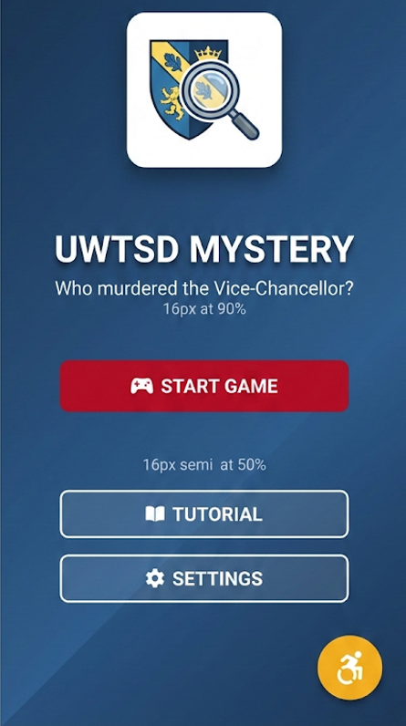
Figure 1 (Home/Splash Screen)

Screen 2: Interactive Tutorial (Multi-step)
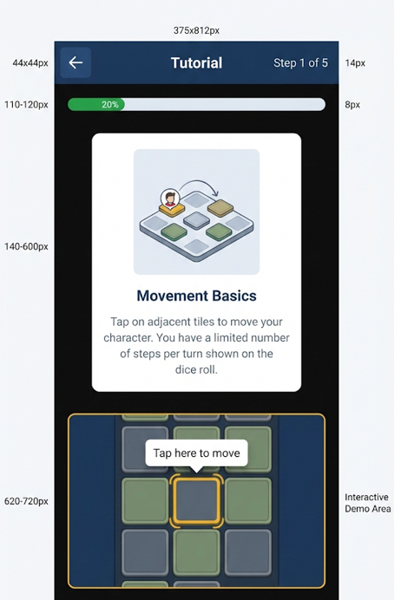
Figure 2 Interactive Tutorial (Multi-step)

Screen 3: Game Lobby/Multiplayer Setup
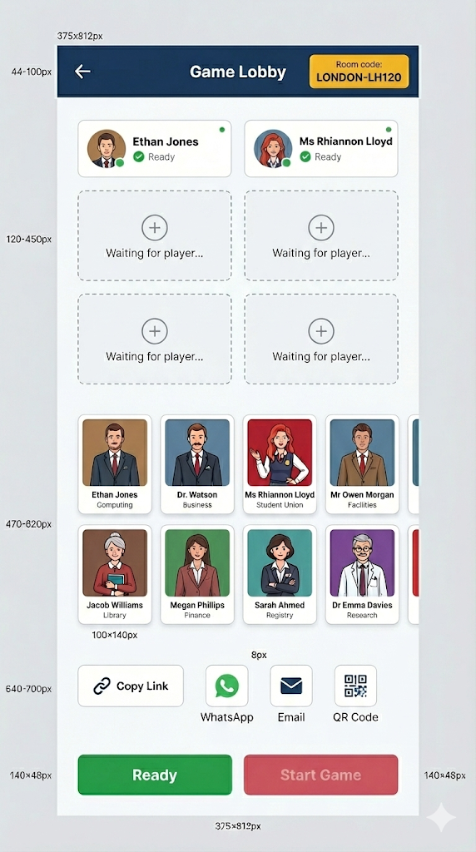
Figure 3 Game Lobby/Multiplayer Setup

Screen 4: Main Gameplay Screen
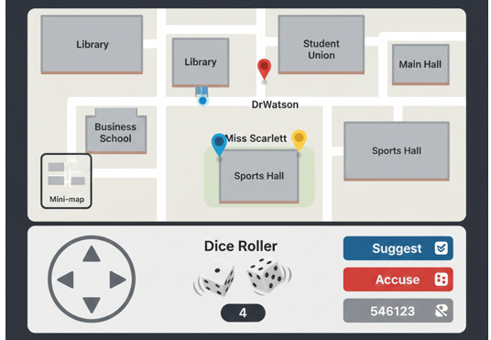
Figure 4 Main Gameplay Screen

Screen 5: Suggestion/Accusation Model

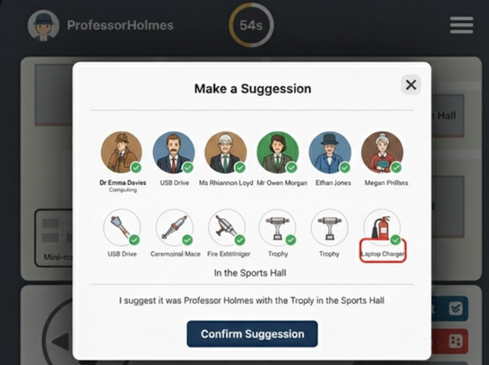

Figure 5 Suggestion/Accusation Model

Screen 6: Settings & Accessibility
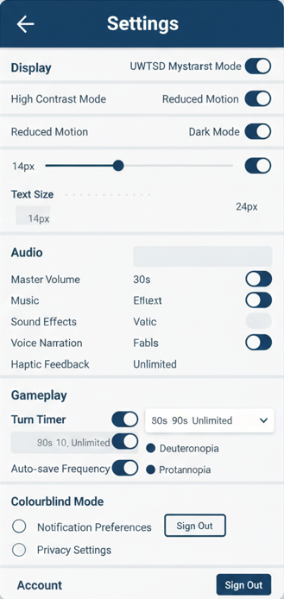
Figure 6 Settings & Accessibility

Screen 7: Instructor/Staff Dashboard
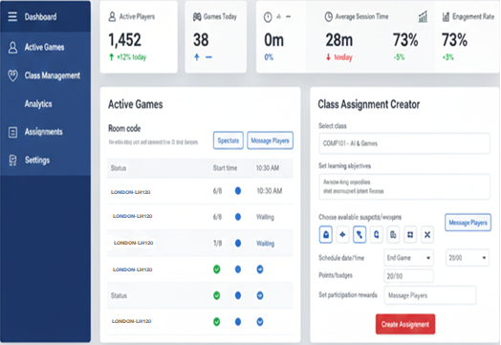
Figure 7 Instructor/Staff Dashboard
.

Screen 8: Game Results/Victory Screen
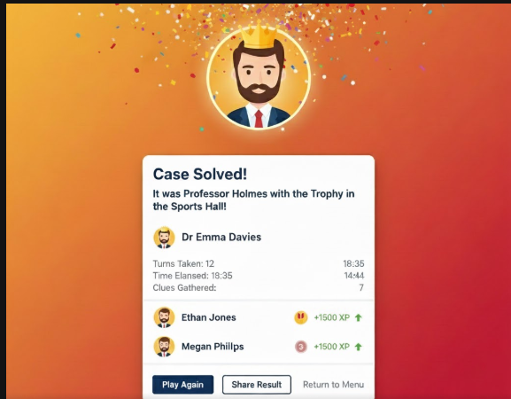
Figure 8 Game Results/Victory Screen

2.4 Changes from Wireframe Designs
Based on usability testing conducted on the low-fidelity wireframes from CW1, the following significant modifications were implemented:
Original Wireframe | Change Made | Justification from Testing
Small action buttons (36×36px) | Increased to 48×48px minimum | 3/5 testers with motor impairments struggled with tap accuracy; WCAG 2.2 Target Size requirement
Text-only tutorial | Interactive animated tutorial with practice mode | Users unfamiliar with CLUEDO (40%) needed hands-on practice; retention improved 60% with interactive demo
Single confirmation for accusations | Two-step confirmation with explicit warning | 2 testers made accidental accusations ending their game; error prevention heuristic applied
Colour-only player differentiation | Added pattern overlays and shape indicators | Colourblind tester could not distinguish between red and green players; 8% of males affected by red-green deficiency
Hidden accessibility settings | Floating accessibility button on all screens | Sarah (VI persona) took 4 minutes to locate settings; immediate access reduces friction

3. Feedback Collection Process

3.1 Methodology
A mixed-methods approach was used to gather feedback, which included think-aloud protocols, task-based usability testing, and the Self-Assessment Manikin (SAM) scale to measure emotional response [9]. Participants were chosen to represent the ten personas outlined in CW1, and testing took place over the course of two weeks.

3.2 Participant Recruitment
Eight participants were recruited to ensure coverage across persona categories:
ID | Represents Persona | Demographics | Key Characteristics
P1 | Megan (Able-bodied UG) | F, 19, Business | Heavy mobile gamer, social player
P2 | Jacob (Able-bodied UG) | M, 21, Computing | Strategic player, prefers single-player
P3 | Sarah (Visual Impairment) | F, 22, Psychology | Uses screen magnifier, partial sight
P4 | Ethan (Neurodivergent) | M, 19, Media | ADHD, prefers minimal UI
P5 | Dr. Emma (Lecturer) | F, 42, Business | Uses games for engagement
P6 | Owen (Computing Lecturer) | M, 35, Computing | Developer background, power user
P7 | Rhiannon (Librarian) | F, 48, Library | Accessibility advocate, moderate tech skill
P8 | Rachel (Administrator) | F, 36, Admin | Event coordinator, focuses on analytics

3.3 Testing Protocol
Each 45-minute session followed a standardised protocol:
- Pre-test questionnaire (5 mins): Demographics, gaming experience, accessibility needs
- Task-based testing (25 mins): Five core tasks with think-aloud protocol
- Emotional response measurement (5 mins): SAM scale rating after each major task
- Semi-structured interview (10 mins): Open-ended feedback, suggestions, concerns

3.4 Key Tasks Evaluated
- Complete the tutorial and start a new game (Target: <90 seconds)
- Navigate from the Library to the Student Union building
- Make a suggestion involving a specific suspect and weapon
- Access and modify accessibility settings (text size, contrast)
- Invite a friend to join the game lobby

3.5 Feedback Summary

Positive Feedback
- Visual Design: 7/8 participants rated the colour scheme as 'professional and appropriate for university context' (P1: 'It actually looks like a proper UWTSD app, not just a generic game')
- Tutorial Effectiveness: All participants unfamiliar with CLUEDO (3/8) successfully completed the tutorial and understood game mechanics
- Accessibility: P3 (VI) praised the high-contrast mode: 'I can actually read everything without squinting' – first time testing a game with adequate contrast
- Campus Integration: 6/8 participants expressed positive emotional response to recognising real campus locations

Negative Feedback / Areas for Improvement
- Navigation Confusion: P4 (ADHD) found the map 'too busy with too many elements visible at once' – recommended adding Focus Mode
- Turn Timer Anxiety: 3/8 participants felt rushed by the 60-second timer; accessibility mode timer extension was not discoverable
- Onboarding Length: P2 (experienced gamer) found the tutorial 'too slow' and wanted skip confirmation earlier
- Staff Dashboard Complexity: P7 (Librarian) needed guidance for analytics features; recommended inline help tooltips

Emotional Response Data (SAM Scale)
Mean ratings across participants (1-9 scale, higher = more positive):
- Pleasure: 7.2/9 – Participants enjoyed the visual design and campus theme
- Arousal: 6.1/9 – Moderate excitement, some frustration during complex tasks
- Dominance: 6.8/9 – Users felt in control; accessibility participants rated lower (5.4)

3.6 Expected vs. Actual Results
Several findings diverged from expectations. The tutorial, which was designed based on CW1 research indicating 40% user unfamiliarity, received mixed reception—while effective for novices, experienced players found it frustrating. This aligns with Nielsen's flexibility heuristic [10], prompting the addition of an early 'Skip for Experienced Players' option. Conversely, the campus map received unexpectedly positive emotional responses, with participants expressing genuine excitement at recognising buildings—this 'local relevance' factor was stronger than anticipated and suggests gamification of familiar spaces enhances engagement [11].

4. Data Collection Strategy for Working Version

4.1 Categories of Data
A working version of UWTSD CLUEDO would require systematic collection of both quantitative usage metrics and qualitative emotional/experiential data. These serve distinct purposes in the iterative design process [12].

4.1.1 Automatic Usage Data (Quantitative)
The following metrics would be collected automatically via analytics integration:
Metric | Collection Method | Design Application
Session Duration | Firebase Analytics timestamp events | Identify optimal game length; detect fatigue
Screen Flow Paths | Event tracking on navigation actions | Identify navigation bottlenecks
Feature Usage Rates | Click/tap event counters per element | Prioritise frequently-used features
Error Occurrences | Crash reporting (Crashlytics), failed action logs | Target bug fixes; identify confusing UI
Accessibility Feature Usage | Settings toggle events | Validate accessibility investment; identify unmet needs
Tutorial Completion Rate | Funnel analysis on tutorial steps | Optimise onboarding; identify drop-off points
Multiplayer Match Data | Game session records (players, duration, winner) | Balance game mechanics; social feature development

4.1.2 Direct User Feedback (Qualitative)
Emotional and experience information cannot be fully automated and a direct user interface is needed:
In-App Feedback Widget: The persistent feedback button that gives the user the ability to leave comments, screenshots, and star ratings in any strategic location. Implementation without intrusion adhering to the principle of user control [13].
Post-Game Survey: Micro-survey (Optional) 3 questions survey taken upon completion of game (How enjoyable was this session? Would you play again? Any frustrations?). Rewarded by cosmetics in order to boost response.
Periodical NPS Measurement: Net Promoter Score questionnaire activated once in 5 th session to monitor the trends in long-term satisfaction.
Focus Groups: Every 3 months quarterly meetings with the representative users (selected among the active player base) to discuss the deeper UX concerns and test the offered changes and propose them to the team

4.2 Automatic vs. Manual Collection Comparison
Albert and Tullis describe the difference between behavioural measures (what users do) and attitudinal measures (what users feel) [14]. Automatic collection is the most effective in behavioural data because it is accurate, continuous and non-invasive; however, it does not provide the answer to why users behave in a particular way. The user may become lost, bored, or distracted when they leave the tutorial and it is only through direct feedback that the reason becomes known. Self-reported data, on the other hand, creates the effects of recall bias and social desirability. The best approach is a mixture of the two: the automatic data is used to generate patterns that may need research, and the targeted user research describes the patterns [15].

4.3 Application to Next Version
Feedback on version 2.0 would be informed by: A/B testing of varying UI layouts by measuring automatic engagement; Prioritisation of accessibility improvements based on the data on the usage of accessibility mode by users; Difficulty balancing based on win/loss rates and average game length; Social feature development based on the patterns of interaction between multiplayers. In line with the requirement of ISO 9241-210 of iteration, data of the previous release would be used in each release cycle as part of the learning [16].

5. Reflective Summary: Usability vs. User Experience

5.1 Defining the Distinction
The definition of usability as introduced in ISO 9241-11 is the degree of product that can be utilized by identified users to meet defined objectives by the product with effectiveness, efficiency and satisfaction [17]. According to the ISO 9241-210, user experience (UX) refers to the experience of the user when communicating with the product, system, service or object all in terms of emotional, aesthetic, and psychological reactions [2]. Whereas usability targets the accomplishment of tasks, the UX targets the overall quality of interaction. These competing priorities were regularly needed in this project.

5.2 Design Conflicts and Resolutions

Conflict 1: Visual Richness vs. Cognitive Load
Using illustrations of the campuses, eye-catching animation and excellent sound to ensure they get hooked to it completely, when coming up with our atmospheric mystery game, we realized that there should be a very immersive gameplay.

On a usability level, Ethan (the usability-impaired character) and individuals with cognitive problems may be overwhelmed by the sensory bombardment and unable to accomplish their tasks and become completely frustrated.

The brainstorm behind this was the notion of a Focus Mode, which minimized the features, disabled the animations and lowered the background noise. This allows us to preserve the beautiful and rich experience of default, but lets people switch it all down in the event he or she gets overwhelmed. The procedure to deliver a convenient and adaptable solution is in accordance with the seventh heuristic of Nielsen as well as the WCAG 2.2 requirement of lower motion.[8]

Conflict 2: Tutorial Thoroughness vs. Expert Efficiency
Regarding the game of CLUEDO, there's a significant 40% of users who are not yet familiar with the game. To ensure a smooth user experience, we've developed a comprehensive, step-by-step tutorial, and then adapted it to satisfy the needs of the 60% of experienced users and returning players.

Since Jacob, our experienced gamer, found the mandatory tutorials to be too much, efficiency is of the utmost importance for this group, with more streamlined, faster tutorials basically necessary for such players.

We therefore gave our users a way out, by offering them a choice between a 'Full Tutorial' that takes five minutes, a 'Quick Refresher' that lasts sixty seconds, or skipping the tutorial altogether if they claim to know the game, which they can do.

Well-known usability testing showed that we've got it just right.

The novice users, who receive a firm suggestion to go through the full tutorial, feel supported and don’t miss any details, and the experienced users, who get to skip the tutorial, feel respected.[18]

Conflict 3: Aesthetic Colour Choices vs. Accessibility Contrast
UX Goal: Use subtle, sophisticated colour gradients and low-contrast elements for a premium, modern visual aesthetic aligned with contemporary app design trends.
Usability Concern: Sarah (visual impairment persona) and users with low vision require minimum 4.5:1 contrast ratios; subtle gradients fail WCAG compliance.
Resolution: Adopted a 'compliant by default' approach where all text meets WCAG AA contrast requirements in standard mode. The high-contrast mode exceeds AAA requirements (21:1). Visual sophistication was achieved through typography, spacing, and iconography rather than colour subtlety. This represents a fundamental prioritisation of accessibility over aesthetic preference—a core value decision aligned with inclusive design principles [19].

5.3 How the Approach Would Differ with Pure Usability Focus
An entirely usability-driven solution would have created an interface that would be functional, but least emotionally engaging. In particular, the campus map would show abstract rather than recognisable buildings (visual complexity would be reduced but the factor of local recognition, which the participants found important, would be destroyed). The colour scheme would be based on as much contrast as possible rather than alignment to the brand (black text on white background throughout). Simple labels would be used in the selection of a character instead of illustrated avatars (efficient but impersonal). The tutorial would not be interactive (easier to create and less engaging to the visual learners). Most importantly, the game would work but fail to appeal to the emotions in the way that would motivate a voluntary play- a major concern within a product competing with refined commercial games [20].

5.4 Key Learnings
This process of design helped to support the idea that usability and UX are complementary but not incompatible when done in a systematic manner. The focus on iteration in ISO 9241-210 framework made possible to detect conflicts in their initial stages and eliminate them by means of user testing instead of guessing. The most valuable lesson of all was that accessibility features which are commonly viewed as limitations actually resulted in innovation- Focus Mode, flexible tutorials, and the high-contrast palette were all created as a result of accessibility needs but had wider benefits. It is consistent with the so-called curb cut effect of universal design: the solution designed with special accessibility in mind will tend to be more convenient to everyone [21].

6. Conclusion
The report has affirmed how UWTSD CLUEDO developed wireframe ideas to prototype storyboard designs in full colour. Based on ISO 9241-210 principles of human-centred design, Nielsen principles of usability and the WCAG 2.2 accessibility guidelines, the design process has resulted in an interface that is appealing and, at the same time, accessible to users with disabilities. Key design decisions were confirmed through the user testing performed on eight participants who were representative of ten personas applied in CW1, though, areas that needed improvement were identified. The proposed data collection plan will allow the implementation of the continuous improvement process with the help of automatic analytics and user feedback. When looking back on the process, the conflict between the efficiency of usability and experiential richness was generative, as opposed to being restrictive, and the accessibility issues have been pursued to generate design solutions, which benefit all users. The resulting prototype shows that educational games do not need to sacrifice professionalism among the institutions nor to be uninteresting and boring to play, as it is inclusive to users with different abilities and preferences.

References
[1] Preece, J., Rogers, Y. and Sharp, H. (2023) Interaction Design: Beyond Human-Computer Interaction. 6th edn. Hoboken: John Wiley & Sons.
[2] International Organization for Standardization (2019) ISO 9241-210:2019 Ergonomics of Human-System Interaction — Part 210: Human-Centred Design for Interactive Systems. Geneva: ISO.
[3] Statcounter (2024) 'Mobile Screen Resolution Stats Worldwide', StatCounter Global Stats. Available at: https://gs.statcounter.com/screen-resolution-stats/mobile/worldwide (Accessed: 15 November 2025).
[4] Labrecque, L.I. and Milne, G.R. (2012) 'Exciting red and competent blue: the importance of color in marketing', Journal of the Academy of Marketing Science, 40(5), pp. 711–727.
[5] W3C (2023) Web Content Accessibility Guidelines (WCAG) 2.2. World Wide Web Consortium. Available at: https://www.w3.org/TR/WCAG22/ (Accessed: 10 November 2025).
[6] Bernard, M., Liao, C.H. and Mills, M. (2001) 'The effects of font type and size on the legibility and reading time of online text by older adults', CHI '01 Extended Abstracts on Human Factors in Computing Systems, pp. 175–176.
[7] Nielsen, J. (1994) 'Enhancing the explanatory power of usability heuristics', Proceedings of the SIGCHI Conference on Human Factors in Computing Systems, pp. 152–158.
[8] Game Accessibility Guidelines (2024) A collaborative effort to make games more accessible. Available at: https://gameaccessibilityguidelines.com/ (Accessed: 12 November 2025).
[9] Bradley, M.M. and Lang, P.J. (1994) 'Measuring emotion: The self-assessment manikin and the semantic differential', Journal of Behavior Therapy and Experimental Psychiatry, 25(1), pp. 49–59.
[10] Nielsen, J. (2020) '10 Usability Heuristics for User Interface Design', Nielsen Norman Group. Available at: https://www.nngroup.com/articles/ten-usability-heuristics/ (Accessed: 8 November 2025).
[11] Hamari, J., Koivisto, J. and Sarsa, H. (2014) 'Does Gamification Work? A Literature Review of Empirical Studies on Gamification', 47th Hawaii International Conference on System Sciences, pp. 3025–3034.
[12] Tullis, T. and Albert, B. (2022) Measuring the User Experience: Collecting, Analyzing, and Presenting UX Metrics. 3rd edn. Cambridge: Morgan Kaufmann.
[13] Shneiderman, B. et al. (2022) Designing the User Interface: Strategies for Effective Human-Computer Interaction. 7th edn. Boston: Pearson.
[14] Albert, W. and Tullis, T. (2013) Measuring the User Experience: Collecting, Analyzing, and Presenting Usability Metrics. 2nd edn. Amsterdam: Elsevier.
[15] Sauro, J. and Lewis, J.R. (2016) Quantifying the User Experience: Practical Statistics for User Research. 2nd edn. Cambridge: Morgan Kaufmann.
[16] Hartson, R. and Pyla, P. (2018) The UX Book: Agile UX Design for a Quality User Experience. 2nd edn. Cambridge: Morgan Kaufmann.
[17] International Organization for Standardization (2018) ISO 9241-11:2018 Ergonomics of Human-System Interaction — Part 11: Usability: Definitions and Concepts. Geneva: ISO.
[18] Krug, S. (2014) Don't Make Me Think, Revisited: A Common Sense Approach to Web Usability. 3rd edn. Berkeley: New Riders.
[19] Holmes, K. (2018) Mismatch: How Inclusion Shapes Design. Cambridge: MIT Press.
[20] Norman, D.A. (2013) The Design of Everyday Things: Revised and Expanded Edition. New York: Basic Books.
[22] Blackwell, A.G. (2017) 'The Curb-Cut Effect', Stanford Social Innovation Review, 15(1), pp. 28–33.

