

Assignment

The Global Business Environment

Name: Sorina Elvira Mariana Soflau-Moscaliuc
Student ID: 2247224
Module code: LCBB4005
Module name: The Global Business Environment
Lecturer: Piyumika Kithulgoda Gamage
Table of contents

Contents
Introduction 3
Briefly introduction to the selected country 4
Political Factors 5
Economic factors 6
Socio-Cultural factors 8
Technological factors 9
Environmental factors 10
Legal factors 11
Porter’s five forces 12
Fig. 1 12
Rivalry 13
The threat of new entrants 13
The bargaining power of buyers/customers 14
The threat of substitutes 14
The amount of bargaining power of suppliers 14
SWOT Analysis Tesla 15
Strengths 15
Weaknesses 15
Opportunities 15
Threats 16
Recommendations 16
Fig. 2 17
Conclusion 17
Reference list 20

Introduction

All the transactions made between different countries beyond their borders, with a desire to satisfy the demands of individuals and companies are called international businesses (Rugman, Collison, Hodgetts, 2016). According to Hung Anh (2002), all countries should become members of the global market, failing to do so their economy will decline. Therefore, to have a successful business each organization must increase their awareness in the context of international business environment, and contribute towards saving the Planet (Hung Ahn, 2022). During capitalism, corporations were restrained by political and welfare institutions, but with globalization employers and their companies regain the power to shape the economy and the society through material resources such as capital, taxes, and jobs (Beck,2018).
According to Wang (2019,p.2), “Globalization is a process of interaction and integration among, people, businesses, institutions, and governments of different countries in many aspects surrounding human lives”. Globalization is growing fast even though it cannot be measured, this fact is mentioned by John, et al.(2018) who state that nowadays 25% of products produced in the world are exported in comparison with the year 1950 when it was only 7%. The process of globalization had taken place thanks to the closer economic relationships between countries relating to labour, transportation and electronics (Worthington, 2006). Along with the fast-growing globalization, international organizations are extending their field of activities. Each country is putting all its forces to grow its internal economy by expanding its production on foreign markets. Although globalization can have a positive impact on businesses at the same time can endanger organizations as a result of increasing dependency on foreign suppliers and markets, due to a lack of control of the external economies (Hamilton, Webster, 2018). When an organization starts its internationalization, it should consider all factors that may affect its company, such as location, different economic and political conditions, and different cultures (Barber & Darder, 2004)(Markard et al.,2012). The process of internalization of businesses had created a need for companies to use accounting rules so they can reach across national frontiers (Atrill, et al., 2018).
This essay highlights the macroenvironment and the microenvironment for Tesla electric car production considering that this organization moves its production facilities from a developed country in this case, Germany, to a developing country Romania. Analyzing the automobile industry in Romania this essay offers an answer if the decision of moving to Romania will have the best outcome in the sense of profitability.
The structure of this report will be as following, first will be presented an introduction to the company that considers moving its production facilities to a foreign country. Then a brief introduction of the developing country chosen, in this case Romania will be described. In the next section will be analyzed the external environment factors and the automobile industry that could affect the organization, using the most known tools Pestle analysis and Portes Five Forces. In the fifth section will be outlined the SWOT analysis of Tesla, followed by some recommendations for the future success of this company. In the end all the findings will be gathered in a concluding section.
Tesla is an American company that was founded in 2003 by Elon Musk. This organization produces electric cars, batteries, solar panels, energy storage systems, and solar roofs. Tesla’s mission is to reduce the dependence on fossil fuels and to transfer the world to sustainable energy, therefore reducing the effects of climate change (Zhang, 2023).

Briefly introduction to the selected country
Romania is part of the European Union since 2007, located in the S-E part of Europe. Bucharest is the capital with the highest interest in investment, but it is not the only one with a particular interest in attracting foreign capital. This country has an increased potential for the global market thanks to its strategic location, although investors can face different challenges because of the business climate. Romania has a mixed economy being in the ten position in the European Union GDP classification. According to International Trade Administration, this country is the most important producer of electronics from Central and Eastern Europe. Romania has developed its information security, hardware research, and mobile technology in the last two decades becoming the leader in IT and motor vehicle production (International Trade Administration, 2022).
Through the whole history of Romania, political decisions, socio-economic measures, and cultural factors had a huge impact on the implementation of environmentally friendly techniques (Cotoara-Zamfir, R.H., Keesstra, S.D., and Kalantari, Z., 2018).
According to Whittington et al.(2020) the macro-environment of an organization is composed from all environmental factors that can have a great or less impact on the organization operations. The best tool for analyzing the external factors that can affect an organization is PESTLE analysis. This tool scans the most relevant external factors such as Political, Economic, Socio-Cultural, Technological, Legal, and Environmental that may have a positive or negative impact on an organization.

Political Factors

Political factors refer to those forces which may affect the company including the involvement of the government in the particular country that the organization activates. Since recently the Romanian government faced political instability the main two political rivals were fighting own survival and not for the proper ruling of the government. But starting with November 2021 the two political parties ruled in a grand coalition which brought the most needed political stability (Wondershare EdrawMax, 2023). This stability could have a positive impact on the electric automobile industry in Romania. In addition, the government is working on the reduction of gas emissions through new regulations. For example, they are planning to dispose of petrol and diesel cars by 2035 (Wondershare EdrawMax, 2023). This will also create a favourable situation to Tesla, towards their movement of the production facilities.
Corruption is another force that is a global challenge, each nation fights against corruption but it evolved so much that is almost impossible to eradicate it. Corruption is present in this country through bribery, embezzlement, fraud, and extortion. In Romania, the level of corruption is quite high and even though the government is fighting this cannot be reduced because of the lack of implementation in the law, the lack of qualified staff, and because the judicial system has great difficulties. Therefore, the business environment diminishes the interest of foreign investors. Tesla’s moving its production plant to Romania can be challenged the high level of corruption existing at the moment in Romania (Nitu, Paraschiv, Gheorghe, 2020) .
Apart from the relation of Romania with the European Union, this country has strong relationship with North Atlantic Treaty Organizations(NATO), World Trade Organizations(WTO), World Health Organization(WHO), United Nations(UN) this connections makes the country market grow significantly relating to exports and imports. This could be a great benefit for a car company to start developing their business in Romanian business market (Anton, 2017). Furthermore, this country has implemented good tax rates beneficial for foreign companies that want to activate in Romanian’s business market. For example, the corporate income tax rate was established at 10% according to Worldwide Tax Summaries 2023. But for micro enterprises that exceed revenues of 500,000 euros they will have to pay 16% this could be unfavourable for Tesla which has expensive products and could face more expenses (Wise, 2023).

Economic factors

Economic factors can be defined as the forces which may affect a business growth as well as profitability. This could refer to actual current interest’s rates, inflation, exchange rates, and economic growth. Many other factors could interfere as well with the business development and success such as the unemployment rate and gross domestic product per capital (Wondershare EdrawMax, 2023).
Romania has developed a strong and stable economic growth since signing the agreement with EU in 2007 (European Commission, 2023).The government currently is constantly updating the laws and financial conditions to promote a proper environment for businesses, for example the country offers no limits of foreign participation in commercial businesses and equal treatment for residents and non-residents investors. This factors could be a benefit for Tesla moving its facilities to Bucharest which is the capital of Romania because this law of foreign incentives offers the possibility for organization to own it 100% (A⁺Grades, 2023).
According to MarketLine Tesla already did a step on Romanian automobile market by opening an office called Tesla Motors Romania in Bucharest District 4, also has plans to install Supercharger stations in other 3 large cities apart from capital such as Timisoara, Pitesti and Sibiu (Romania-insider.com, 2021). Starting with 2008 Romanian’s gross domestic product increased gradually reaching to 309.70 USD Billion, this increase could be possible thanks to effective tax collection, rising of private consumption and to development through foreign investors (A⁺Grades, 2023). The evolution of GDP could be a benefit for Tesla because it shows that the power of buyers has increased and there will be consumers who will buy Tesla’s products.
Another factor that may affect the success of the organization could be Inflation, regarding that in Romania the level of inflation is quite high for example increased from 5,05% in 2021 to 9,7% 2023 this arise can be attributed to various factors such as energy and gas prices rise because of the current war from Ukraine which is just at Romanian borders (European Commission, 2023).
These factors have a negative impact on businesses considering that electric cars need electricity to work, but all this price increase affected the living costs, the costs of doing business, borrowing money and mortgages and moving a Tesla plant to Romania may not be a good idea at the moment (European Commission, 2023).
Being a global business Tesla may be affected by exchange rates but in Romania the banks offer companies accounts in any form of currency so it could be a positive factor for Tesla. Due to the high interests’ rates which Romania’s banking system performs can have a negative impact on the company because high interests’ rates mean increase cost of borrowing so costumers will be discouraged to buy new vehicles. On the other hand, Romania has a high level of foreign direct investment which has a positive impact on businesses. Sometimes fluctuations of fuel prices may be a benefit for electric cars industry, but some people may not be very keen on electric cars if they have long distances to travel so even though the fuel is expensive people may still choose combustion engine vehicles (Economist Intelligence, 2023).

Socio-Cultural factors

Socio-cultural factors refer to cultural and social forces that may influence the business activity such as local lifestyle trends, demographics, level of distribution of income and education, religion, level of consumerism and of course the pending legislation which may affect the corporate social policies. In Romania the population is composed from different ethnic groups, ages and other orientations, Romanians(71,9%),Hungarians(7,9%),Germans(4,1%),Jews(4,0%),Ukrainians(.3,2%) (Romania Demographics Profile 2019, n.d).
The present trend of demographics in Romania is the high rate of migration, with four millions of Romanians living abroad, this happens because of the high cost of living, the level of corruption, the small minimum wedge, and many others, therefore it does have a negative impact on a new business on Romania business market because it could lead to lack of workforce in the near future (IOM UN Migration Romania, 2023). Nowadays young population is more aware of the environment and the effects of carbon dioxide emissions, and they will be more attracted of the new technology and features an electric car from Tesla can offer. On the other hand, the reduction of population in this country at the moment may negatively impact businesses because the number of customers will go down so will the profit margins (The Strategy Story, 2023).
A company should consider the level of income and education of population of the particular area they want to move the production plant, therefore moving to Bucharest which has a population of 1,776,000 mainly high educated and young people could bring an important benefit to Tesla because this can offer the organization the necessary workforce to develop and grow their business. Furthermore, the young population is also more attracted of technology and new trends so will be very beneficial for and electric vehicles company (The Strategy Story, 2023). In Romania the Human Development Report has increased in the last few years, improving the citizens life, education and living standards, therefore can have a positive impact on Tesla because people became more aware about the climate change, and they want to reduce the impact it has on the environment for the future of the planet (The Strategy Story, 2023).
Another factor that can impact negatively the organization is the social status and the brand name and this happens because buying an electric car is more expensive and considered a lux in this country and could decrease the sales for the company(The Strategy Story, 2023).
According to a study conducted by Marketing Research which aimed to evaluate the attitudes of Romanians about their cars. This study come to the conclusion that 73% of Romanians intend to make the transition to hybrid or electric cars in the near future, although there are some barriers that can be difficult to cross for Romanians such as undeveloped infrastructure and not enough charging stations across the country. Another impediment is that some Romanians do not feel safe driving an electric car because it may burst in fire at any time (reveal Marketing Research, 2023).

Technological factors

Technological factors refer to technology forces that can affect an organization such as digital skills, the use of internet, AI, Robotics. During the last century the automobile industry had an incredible advantage in technology. In this era of evolution, the modern features of cars have evolved so much they cannot be recognised from the original vehicles that first appeared on the market (Gislam, 2020). Thanks to the growth of digital technology the features that can be assembled on today’s vehicles makes them more safe and offers much more than just commuting, for example they now have autonomous driving, accident prevention and also, they have the capacity of voice commands, and they can connect with smart devices with the help of internet (Gislam, 2020).
Another technologic factor is the use of augmented reality dashboard, this system helps drivers to check whether, speed, gas mileage without taking their eyes from the road (Gislam, 2020). Moreover, the use of artificial intelligence had increased rapidly and is considered that will own the future because helps the automotive industry the opportunity to improve public safety and helps with the supply chain decisions (AIIOT Future of Tech, 2023). AI gives the operators the power to become data driven in the future. For example, some companies such as Tesla , Mercedes, and BMW have already prototypes, and car models operating on AI technology. Also, some cities in Europe have already testing driverless public transport, thanks to AI which can revolutionize the public transport using GPS, sensors, IoT for a higher level of safety (AIIOT Future of Tech, 2023). At the moment Romania has a technology gap compared with the rest of European countries and that due to lack of capital. Nevertheless, Romania is ahead on innovation but behind on adaption, considering that Tesla is moving to Romania may be an opportunity for Tesla to invest their money in technology (McKinsey & Company, 2023).

Environmental factors

Environmental factors refer to environmental forces that may impact a company positively or negatively such as climate change, emission standards regulations, resource scarcity, waste and recycling, energy production and consumption and also environmental policies.
Each country become more aware about the effects of climate change and try to implement policies and laws for protecting the resources and the environment. Therefore, they start to use more and more eco-friendly products for day-to-day activities such as using solar panel for energy, using public green transportation systems, and of course trying to combat air pollution using electric cars. This has a huge impact on Tesla as a company producing eco-friendly products, increasing their sales and contributing to reducing global warming and destroying the planet. Romania as part of EU had signed as well for the agreement to dispose the fuel cars and use electric vehicles but at the moment this country does not have enough evolved infrastructure, the majority of individuals who own a car is not new but second hand (econ media, 2023). Romania owns a very important deposit of gas in the Black Sea, but this resource is not unlimited so in the future each country has to come up with alternatives to traditional transport (econ media, 2023).
Using electric cars, it is the new trend, but each nation should think on how the dispose the batteries because they pollute the environment even more than the traditional cars. Also, the process of extracting the components used for batteries cause a lot of harm to the planet. In Romania that will not be a problem because a Belgian company Avesta Battery and Energy Engineering is building a battery cell factory in this country which will supply batteries for automotive industry be 2026.this company also plans to open a recycling plant with capacity of 50,000 tonnes a year (electrive, 2023).

Legal factors

Legal factors refer to all forces that may affect a company sustained by implemented laws and regulations released by government. Although Romania does not have restrictions related to foreign investments at the moment it had in the past in the Accession Treaty of 2005 but was lifted in 2014 by EU.
One law that can have a direct impact on Tesla’s operations is the Labour Law Code 2003, this law deals with all aspects regarding employment, working hours, wages, overtime and covers the relationship between employers in Romania and abroad but also with the foreign citizens working in this country (Legislation, 2023). Another government law is Decision no. 1132/2008 on the regime of batteries and accumulators and waste batteries and accumulators has the authority to forbid the use of batteries that contain dangerous substances (Legislation, 2023). Regarding the protection of the environment exists the Law 265/2005 regarding the environmental protection which may affect the operation of Tesla (Legislation, 2023).

According to Anton (2007) in 2014 Romania implemented Holding legislation which requires that medium and small sized enterprises to be offered tax incentives. This country has adopted various policies and regulations that allow foreign investors to access all the resources they need. The legal system in Romania requires consultations with stakeholders 30 days in advance of any regulation to be implemented, although foreign investors have to wait a long time for some decisions to be taken such as environmental approvals, property titles and licenses. Romania is trying to adopt this new trend and regulations by supporting buyers to purchase an electric car through offering a bonus of 10,000 euros(Gogoi, 2022).

Porter’s five forces
Johnson, et al. (2017) states that an industry is composed from a group of organizations that produce products and services and they are quite similar. For analysing the forces that can affect an organization the model used by companies is called Porter’s five forces. This model scans the particular industry on which the company activates, for example the automobile industry in this case. For every company that want to thrive on the market is very important to analyze and fully understand the competitive environment before taking any decisions. This framework was invented in 1979 by Michel Porter and has a straight direction for identifying the powers of a business using the microenvironment(Bruijl, 2018).
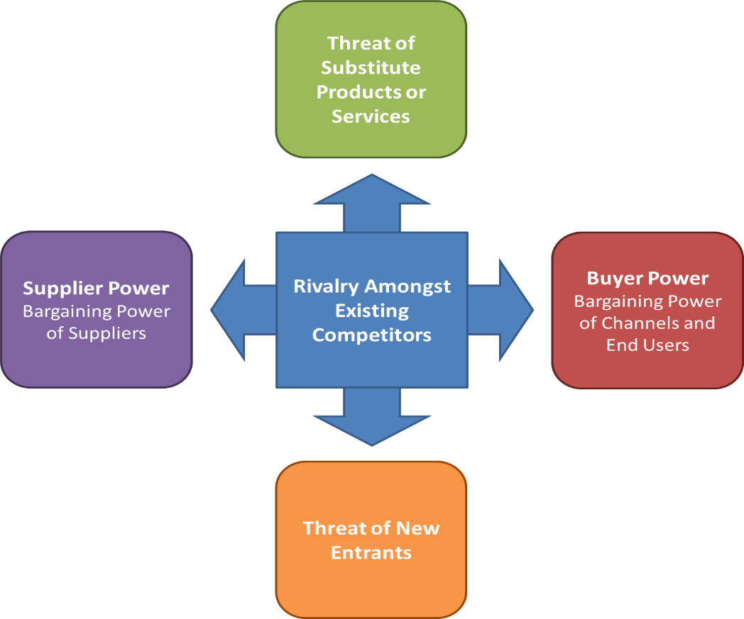

Fig. 1

According to Porter (1979) apart from competition this framework analyses other four factors that may affect a business such as threat of potential new entrants, bargaining power of buyers, bargaining power of suppliers, and the threat of substitute products or services.
The actual automobile industry is increasing especially the electric vehicle due to multi government policies under the Clean Energy Ministerial which heads towards adopting the electric vehicles globally with increasing sales with 30% by 2030. Romania is part of the countries that had agreed with this policy. According with Gogoi (2022) the European Commission plans to reduce the emissions with 100% by 2035 and this mean great news for electric manufacturers, their production and sales will grow.

Rivalry
Although electric vehicle industry has grown significantly in the last few years including hybrid vehicles. In the future Tesla will continue to have direct competition from other BEV entrants and indirect competition from the existing companies in the market. At the moment Tesla have 3 main competitors Nissan, Toyota and Chevrolet Volt. In contrast with the direct competitors of Tesla such as BMW, Mercedes Benz, Jaguar having their own loyal customers, Tesla’s competitive advantage and aggressive market make Tesla gain the market share(Mangram, 2012). The level of threat regarding competition it is low to medium at the moment because Tesla had created a niche market which is increasing gradually.

The threat of new entrants
In general, the threat off new entry is low in the automobile industry because of all the barriers exiting for example the upfront capital is enormous, also the brand name it is very hard to gain popularity on the market, so this takes time and money (Gogoi, 2022). In some cases, the legislation and the government policies could be an impediment for entering into the car industry for example the new agreement which implements the use of electric cars only by 2035 to reduce the global worming by 1,5 degrees Celsius, although this could be an advantage for Tesla being an innovative electric car producer(Gogoi,2022). In Romania the threat of new entrance is low to medium and that is because Romania owns a car manufacturer that produces electric cars Dacia, but this electric cars does not have the same level of luxury and technology as Tesla’s electric vehicles.

The bargaining power of buyers/customers

The bargaining power of buyers is medium to high in the automotive industry. In general buyers buy just one vehicle for personal use but sometimes there are government agencies or organizations that buy in bulk for their employees. In the las few years the bargaining power of buyers have increased thanks to the customers trends and the rise of competition in the industry (Caridade et al., 2017). In Romania this power of buying new product is low-medium ,because of the level of income of the buyers, therefore could have a negative impact on Tesla sells department.

The threat of substitutes
In the auto manufacture industry, the threat of substitutes can be medium to high, depending on the infrastructure of the country and the public transport development. There is no switching cost either for example if someone wants to buy a new electric car but is not sure from which company, he can choose any there is no price of switching from one company to another unless they choose the leasing method of buying. In Romania the threat of substitutes could be medium because the public transport lacks in terms of infrastructure and development, for example the trains and trains tracks are old, although the public transport tends to improve by using green energy (Gogoi, 2022). Romanian government had invested in the last year one billion euros for projects in the public transport ( Guvernul Romaniei, 2017).

The amount of bargaining power of suppliers
In the automobile industry the power of suppliers which refers to all parts a vehicle needs from engine, tyres, electronics to windows and airbags exist a wide variety of suppliers on the market so the level of bargaining power of suppliers is low (Chinta, 2018). This bargaining power of suppliers is low because there are a large number of suppliers in the market. Companies have no difficulties from one supplier to another if the current one do not follow the company’s rules (Study Corgi, 2023). In Romania the number of parts manufactures are over 500 so this can be beneficial for Tesla having a variety of suppliers to choose from. And in the near future there will be a factory producing batteries in Romania so will reduce the cost of import for Tesla.

SWOT Analysis Tesla

Strengths
Tesla has a unique position on the auto market, although is not the only company that offers electric cars. This organization is well known for its long-range electric vehicles, for luxury cars as well. Tesla has been growing gradually in the last few years. The sales had jumped from 27% in 2015 to 59% in next year. This organization had spent a significant sum for research and development and comes with new technology and new features for their vehicles every year. So, they keep their position on the market as a leader in the electric cars industry(Chinta,2018).

Weaknesses
Regarding the fact that Tesla has invested its money in research and development and because this company opened gigafactories in America and even Europe made the cash flow to have a negative sign. Moreover, due to increase in demand for electric vehicles in the future Tesla will lead the market and will own at least 30% of the market share. In Romania Tesla may face some problems due to lack of infrastructure and low power of buyer as well as no supplier for batteries but will have other benefits(Chinta,2018).

Opportunities
Tesla has already started reducing costs of production by creating partnerships with different companies. The organization is working towards new innovative products with high performance and low cost, but with new features and improved technology. New opportunities show from the horizon for Tesla thanks to new regulation and the level of awareness of the population towards saving the planet as well as protecting the environment. Therefore, the demand for electric cars is rising every year(Chinta,2018).

Threats
According to Chinta (2018), Tesla may be affected by the number of debts this company has. With the increase of technology and the level of knowledge towards software and innovation arises a threat towards electric cars is more present than ever. Buyers want to feel safe and secure when buying a new electric car, even though Tesla’s vehicles have a high level of security and internet connection control for their vehicles, hackers had already disabled some of the sensors and stolen some cars. Therefore, this is a real threat for electric cars industry. Although Tesla promotes sustainability and green energy to help save the environment and its resources, the waste resulted from the batteries could make more harm to the environment than the emissions from traditional cars(Chinta.2018).

Recommendations

Acknowledging the fact that the sales of EVs are growing quickly, therefore Tesla being one of the supplier for this market should try to become the major productor of EV. At the moment many states from US and Europe have a small number of Supercharger stations, therefore they should focus on funding more of this charging stations to be more accessible for the future customers.
With the current position Tesla has at the moment on the market should expand their line of products and produce a wider range of products affordable also by low-income consumers. Another proposition for Tesla becoming the leader of electric vehicles is that they need to involve more the consumers opinions on the future products they plan to produce. Because if you consider the costumers opinion when creating new products will make costumers more confident of buying the products(Uk Essays, 2023).

Annual report of Tesla is demonstrating how well this company is doing on the market.
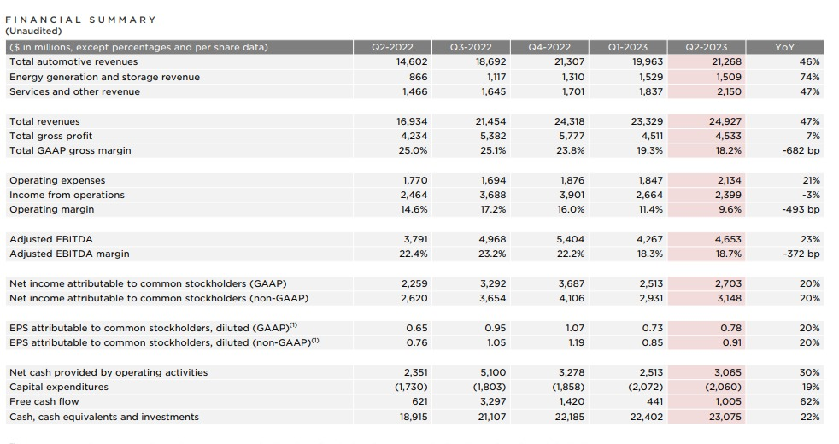

Fig. 2

Conclusion

The main points presented in this essay emphasize the importance of scanning the external environment and the industry in which a firm activates. Considering that Tesla is moving its production plant to Bucharest, after analysing the environment may be a good idea, leaving aside some factors that and impact negatively the company. Romania industry market has a great potential for foreign businesses because they do not have no limitation of foreign investment, the government treat foreign investor equal with local investors. Also, the bank system allows new foreign companies to open accounts in any currency they need. Another positive factor could be that the government offers 10,000 euros for people that want to purchase new electric car. The cost of labour is cheaper in Romania and the supplier market consists of over 500 producers so will reduce the costs of production. Therefore, Tesla will have more benefits if decides to move a plant of production to Romania-Bucharest.

Reference list

- AIIOT Future of Tech(2023) AI-Powered Transport: Real Life Benefits & Future Implications. Available at: Aiiot Talk : Artificial Intelligence | Robotics | Technology (Accessed: 16 August 2023).
- Anton, S.G. (2017) ‘Competitiveness and Investment Promotion in Bulgaria and Romania’ In Foreign Direct Investment in Central and Eastern Europe (pp. 219-240). Palgrave Macmillan, Cham.
- Atrill, P., et al.(2018) Accounting and Finance for Non-Specialists.11th. Harlow. Pearson. p.15. Available at: Accounting and finance for non-specialists [electronic resource] (exlibrisgroup.com) (Accessed: 16 August 2023).
- Barber, J. P., & Darder, F. L. (2004). Dirección de Empresas Internacionales. Pearson Prentice Hall.
- Beck, U.( 2018) What is globalization?. John Wiley & Sons.
- Bruijl, G.(2018) ‘The Relevance of Porter's Five Forces in Today's Innovative and Changing Business Environment’, Electronic Journal. Available at: (PDF) The Relevance of Porter's Five Forces in Today's Innovative and Changing Business Environment (researchgate.net)(Accessed: 10 August 2023).
- Business Studies Homework, ‘Sample on PESTEL Analysis of Romania’s Current Business Environment’,(2021). Available at: Sample on PESTEL Analysis of Romania’s Current Business Environment (essayhomeworkhelp.org)(Accessed: 8 August 2023).
- Chinta, R.N.N.,(2018)’Tesla-Porter Five Forces Analysis(Harvard)’, Available at: (PDF) Tesla - Porter Five Forces Analysis (Harvard) (researchgate.net)(Accessed: 11 August 2023).
- Combot, G.(2022) ‘Romania: An Emerging Automotive Hub In Europe’, Blue Europe, Available at: Romania : an emerging automotive hub in Europe (blue-europe.eu)( Accessed: 8 August 2023).
- Cotoara-Zamfir, R.H., Keesstra, S.D., and Kalantari, Z., (2018).’ The impact of political, socio-economic, and cultural factors on implementing environment-friendly techniques for sustainable land management and climate change mitigation in Romania’, Science of the Total Environment, 654.pp.418-429.
- Daniels, John, D. et.al. (2019) International business: environments &operations.16th. Harlow, England: Pearson.
- Econ media(2023),’Analysis :The Romanian automotive industry and the impact of electric cars. Romania needs a strategy for electromobility, autonomous driving and digital transformation’, Available at: ANALYSIS The Romanian automotive industry and the impact of electric cars. Romania needs a strategy for electromobility, autonomous driving and digital transformation (economedia.ro) (Accessed: 12 August 2023).
- Economist Intelligence (2023),’Romania’. Available at: Romania Economy, Politics and GDP Growth Summary - The Economist Intelligence Unit (eiu.com). (Accessed: 10 August 2023)
- Electrive(2023), ABEE to build battery factory for EV’s in Romania’. Available at: electrive.com (Accessed: 14 August 2023).
- European Commission(2023), ‘Economic Forecast for Romania’. Available at: Economic forecast for Romania (europa.eu) (Accessed: 12 August 2023).
- Fig. 1(2023) Available at: https://yourfreetemplates.com/porters-five-forces-template/
- Frue, K.,(2021) 'PESTLE Analysis of Tesla Inc.: The growth of the eco-friendly electric car', PESTLE Analysis. Available at: https://pestleanalysis.com/pestle-analysis-of-tesla/ (Accessed: 10 August 2023).
- Gislam, S.(2020) 5 Ways Technology Is Changing the Automotive Industry. Available at: Covering the latest trends in Industry - Industry Europe (Accessed: 16 August 2023).
- Graceffa, E. (2021) 'Tesla in Berlin', Research Gate, pp.2-8. Available at:(PDF) Tesla in Berlin (researchgate.net).( Accessed: 23 July 2023).
- Hamilton, L., Webster, P.( 2018). The international business environment. Oxford University Press.
- Hung Ahn, B.A. (2022) 'The importance of analyzing the international business environment in international business strategic planning, International Journal for Advanced Multidisciplinary Research and Studies, 2(6), pp. 923-931.
- International Trade Administration (2022). Available at: Romania - Market Overview (trade.gov) (Accessed: 17/07/2023).
- IOM UN Migration Romania (2023). Available at: Romania among the top 20 countries in the world with the highest... | IOM Romania(Accessed: 14 August 2023).
- Johnson, G., at al.(2017) Exploring Strategy Text Cases PDF EBook: Text and Cases. Harlow, England. 11th.Perason. Available at: Exploring strategy : text and cases (exlibrisgroup.com) (Accessed: 16 August 20230.
- Markard, J., Raven, R., & Truffer, B., (2012). Sustainability transitions: an emerging field of research and its prospects. Res. Pol.41.pp. 955-967.
- MarketLine Advantage(2023). Available at: MarketLine Advantage (exlibrisgroup.com) (Accessed: 16 August 2023).
- McKinsey & Company(2022) Bridging the gap: Transversal technologies to boost Romania’s resilience. Available at: Romania’s economic growth and tech challenges | McKinsey (Accessed: 16 August 2023).
- Muhammad, Z., et al.(2023)’Emerging Cybersecurity and Privacy Threats to Electric Vehicles and Their Impact on Human and Environmental Sustainability’, Energies, 16(13). Available at: Energies | Free Full-Text | Emerging Cybersecurity and Privacy Threats to Electric Vehicles and Their Impact on Human and Environmental Sustainability (mdpi.com)(Accessed: 11 August 2023).
- Nitu, M., Paraschiv, D.M., and Gheorghe, M.A.(2020) ‘Corruption and Its Implications in Romania’, Proceedings of the International Conference on Economics and Social Sciences, pp. 266-274. Available at: (PDF) Corruption and Its Implications in Romania (researchgate.net)(Accessed: 8 August 2023).
- Pérez Uribe, R.I. et al. (2021) Handbook of research on international business and models for global purpose-driven companies. Edited by R.I. Pérez Uribe, C. Largacha-Martinez, and D. Ocampo-Guzman. Hershey, Pennsylvania: IGI Global. Available at: https://doi.org/10.4018/978-1-7998-4909-4.(Accessed: 8 August 2023).
- Reveal Marketing Research(2023),’Reveal Marketing Research study about Romanians’ mentality and behaviour regarding their cars. The hybrid or electric car represents an alternative that Romanians tend to take into account on their next purchase’. Available at: Reveal Marketing Research study about Romanians' mentality and behavior regarding their cars. The hybrid or electric car represents an alternative that Romanians tend to take into account on their next purchase - Reveal(Accessed: 14 August 2023).
- Rugman, A.M., Collinson,S., Hodgetts, R.M. (2006) International business.4th.Pearson Education.
- Study Corgi(2023), ‘Porter’s Five Forces Analysis of the Automotive Industry’. Available at: https://studycorgi.com/porte’s-five-forces-analysis-of-the-automotive-industry/.(Accessed: (15 August 2023).
- The Strategy of Story(2023) Tesla Pestel Analysis. Available at: Tesla PESTEL Analysis - The Strategy Story. (Accessed: 8 August 2023).
- U.S. Department of State:2021 Investment Climate Statements, (2021) Available at: Romania - United States Department of State.(Accessed: 10 August 2023).
- Uk Essays(2023),’Recommendations for Future Success of Tesla’. Available at: Recommendations for The Future Success of Tesla (ukessays.com)(Accessed:12 August 2023).
- Wang, G.Y. (2019) Globalization. Edited by G.Y. Wang. London, England: IntechOpen.
- Whittington, R., et al.(2020) Exploring strategy: text and cases, Harlow. 12th. Pearson. Available at: Exploring strategy : text and cases (exlibrisgroup.com) (Accessed: 10 August 2023).
- Wise(2023) ‘New Fiscal Code: How to calculate the profit tax in 2023’. Available at: New Tax Code. Corporate Tax 2023 - Wise(Accessed:15 August 2023).
- Wondershare EdrawMax(2023), ‘Tesla Pestel Analysis’. Available at: Detailed PESTEL Analysis of Tesla | EdrawMax Online(Accessed: 12 August 2023).
- Worldwide Tax Summaries: Corporate-Taxes on corporate income,(2023). Available at: taxsummaries.pwc.com (Accessed: 10 August 2023).
- Worthington, B., Worthington, I., Worthington, C. (2006) The Business environment. Harlow. 5 th: Pearson Prentice Hall. Available at: The business environment (exlibrisgroup.com) (Accessed: 10 August 2023).
- Zhang, J.(2023) ‘Financial and Market Analysis of Post-Pandemic Tesla’, BCP Business & Management, 46, pp.58-65. Available at: (PDF) Financial and Market Analysis of Post-Pandemic Tesla (researchgate.net). (Accessed: 8 August 2023).

