

LOCATION: Swansea | LLEOLIAD: abertawe
LEVEL 5 | LEFEL 5
EXAMINATION PERIOD | CYFNOD ARHOLIADAU
may 2017 | mai 2017

MODULE CODE: M5X00372
Electrical Principles Theory
TIME: 2 HOURS

answer Three quESTIONs out of Four

Equipment or materials required – Calculator, Ruler, Protractor
Adnoddau neu ddefnyddiau sydd eu hangen - Cyfrifiannell, Ruler, Onglydd

answer Three quESTIONs out of Four

  - For the RLC circuit shown in fig Q1a, given R = 240 Ω, L=150 mH, C=0.1 µF, V=12 V and f=1250 Hz; calculate:
    - The circuit current and phase angle
[2 Marks]
    - The voltage drop across each component
[3 Marks]
    - The power dissipated by the resistor
[1 Mark]
    - The total power supplied to the circuit
[1 Mark]
    - The reactive power consumed by the circuit
[1 Mark]

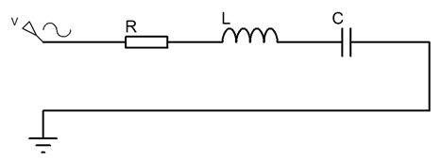
Fig. Q1a
  - Draw a phasor diagram for the circuit showing voltages and currents across each component
[4 Marks]
  - Calculate the resonant frequency of the circuit using the component values from Q1a
[1 Mark]
  - At resonance, calculate:
    - The circuit current and phase angle
[2 Marks]
    - The voltage drop across each component
[3 Marks]
    - The power dissipated by the resistor
[1 Mark]
    - The total power supplied to the circuit
[1 Mark]
    - The reactive power consumed by the circuit
[1 Mark]

  - Draw a phasor diagram for the circuit at resonance showing the voltages across and currents through each component
[4 Marks]

- For the circuit shown in Fig Q2, given: $V_{SRC}=10V$, $f_{SRC}=100Hz$,
$$Z_{SRC}=1+j0.1Ω$$

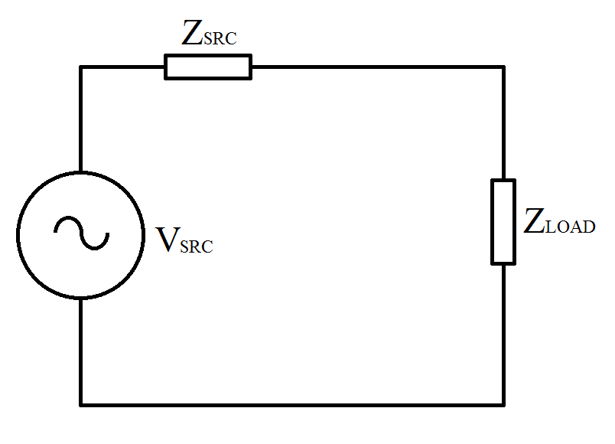
Fig Q2
Calculate:

  - The power dissipated by the load if $Z_{LOAD}=10-j0.5Ω$
[5 Marks]
  - Draw a phasor diagram showing the voltage drops across the source and load impedances
[4 Marks]
  - Show that maximum power is transferred from the supply to the load when the load impedance is the conjugate of the source impedance
[10 Marks]
  - Calculate the values of the resistors, inductors and capacitors in the circuit when maximum power is transferred and show them on a circuit diagram
[6 Marks]

  - List four losses associated with transformers
[2 Marks]

  - Describe a method that can be used to reduce eddy current losses within the transformer core indicating how and why it works?
[2 Marks]

  - For a simple transformer, as shown in FigQ3c, calculate the resistive and reactive elements of the core losses, given the primary winding resistance is 10Ω, the primary winding reactance is j30Ω, the secondary winding resistance is 2.5Ω, the secondary winding reactance is j4Ω, the primary and secondary voltages are 15V and 59.5V respectively, and the turns ratio is 0.25:1.

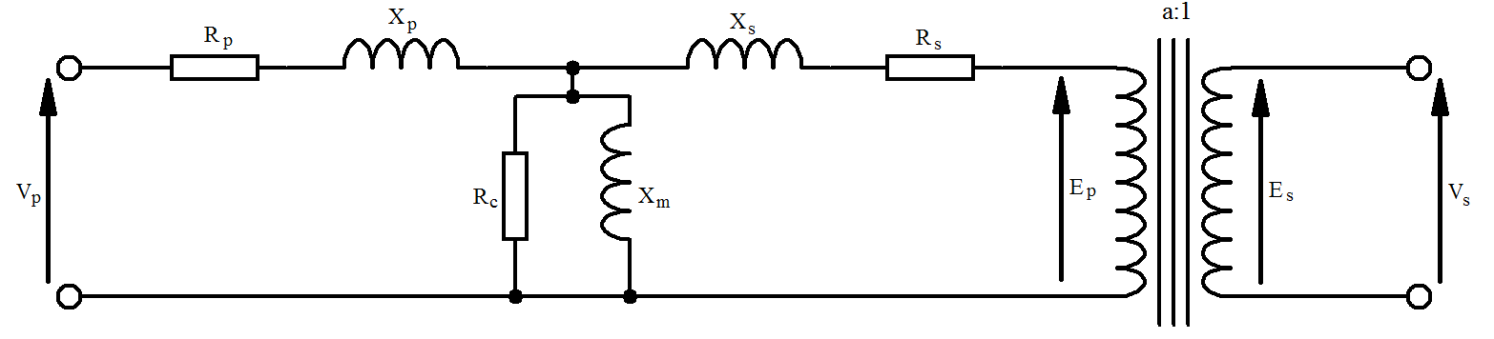
Fig. Q3c
[8 Marks]

  - Calculate the magnetic flux present within the core if the primary winding current is 10A peak.
[5 Marks]

  - For the transformer as shown in FigQ4c, calculate the output voltage and efficiency when the transformer is connected to a 100 Ω purely resistive load given the primary winding impedance is 12+j28 Ω, the secondary winding impedance is 2.5+j14 Ω, the core loss is 1000 Ω, and the magnetic loss is j2010 Ω, the primary voltage is 230 V, and the turns’ ratio is 2:1.
[8 Marks]

- For the three phase circuit shown in fig Q4, given: $V_{L1}=230∠0°V_{RMS}$,
${ V}_{L2}=230∠-120°V_{RMS}$, ${ V}_{L3}=230∠-240°V_{RMS}$,$Z_{1}=100+j200Ω$,
$Z_{2}=105+j20Ω$, $Z_{3}=95+j50Ω$

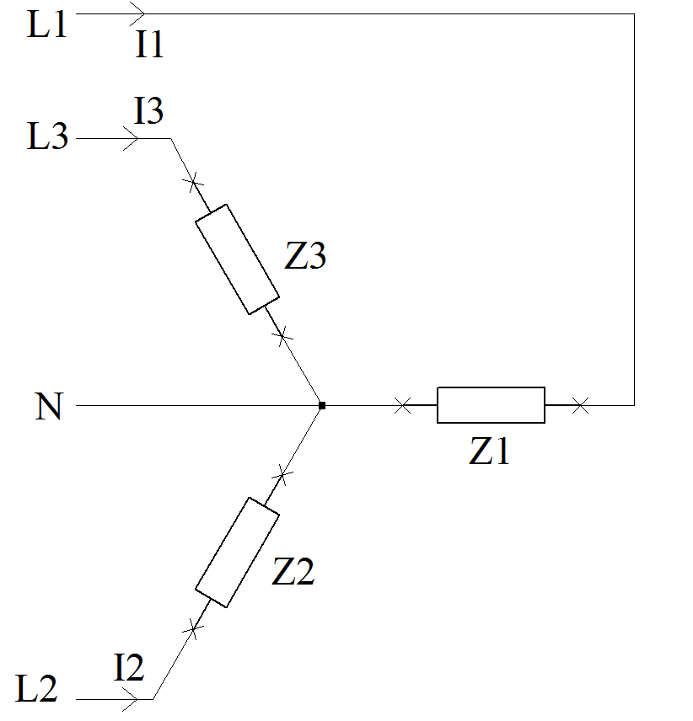
Fig. Q4

Calculate:

  - The individual phase currents and their phase angles
[6 Marks]
  - The active, reactive and apparent power for each phase
[6 Marks]
  - The power factor for each phase
[3 Marks]
  - Calculate the required shunt capacitors required for each phase to bring the power factor to 0.9 lagging
[6 Marks]
  - Draw a phasor diagrams showing the phase and line voltages and phase currents before and after power factor correction
[4 Marks]

Diwedd/End

