Report that critically reflects upon the actions made in the video entitled ‘An intense day on Crib Coch’ after the casualty fell.
Introduction:
‘An intense day on Crib Coch’ video showed two friends who went out with the goal of walking across Crib Coch, Snowdonia. This traverse is described as ‘sharp, serrated and spiky’ and ‘the definition of a knife-edge ridge’ (UKH, 2017). Furthermore, the ridge is often said not to be attempted in winter conditions unless fully equipped with crampons, ice axes and experience in alpine style mountaineering (UKH, 2017; MountainWalk.co.uk, 2024).
There was a southwesterly wind of 45 to 55mph around the tops of the Snowdon range, with drizzle all day, plus fog developing through the day, with a temperature of 3C with a real feel of minus 11 in the wind (Mountain Weather Information Service , 2020) (see appendices 2 for full weather report). Person 1 (see appendices 1 for index of anonymised names) was a qualified mountain leader; however, was just on a personal walk with a friend, but they met two others wanting to use an emergency escape route off Bwlch Coch, so they went as a group, and naturally person 1 stepped into the ‘leader role’. Unfortunately, as they were making their way down the steep slope one of the people who they had just met slipped out of control and fell for around 200m (see appendices 3). This report will be looking at what happened after the casualty fell, until mountain rescue services carried him out. Paying specific attention to how the leadership role was handled in relation to the group and taking care of the casualty. Furthermore, looking into the possible reasons for the actions and decisions undertaken during this incident, relating to the bigger picture of National Governing Body Awards (NGBs) and industry standards.
The broader picture: looking into experience, weather and terrain.
Person 1 had the summer mountain leader qualification which allows them to lead groups in the mountains and moorlands of the UK in summer conditions. For the purpose of this report, mountainous terrain and summer conditions are defined in accordance of the Mountain Leader Candidate Handbook, produced by Mountain Training (2022).
- Mountainous terrain is ‘wild county which may contain unavoidable steep and rocky ground where walkers are dependent upon themselves for immediate help’ (Mountain Training, 2024, p. 3)
- Summer conditions are anything that isn’t covered in the winter conditions definition, however there is no limit of the calendar. (Mountain Training, 2024)
Crib Coch is classed as a grade 1 scramble, that can be classed as a walk that may require both hands and feet to be used to complete sections of the walk. Typically, grade 1 scrambles are exposed walking routes where ropes and protection are usually not necessary (Lindon, 2015; Snowdonia Adventures, 2023). Whereas grade 1 scrambles are within the remit of a mountain leader, they should be undertaken with caution with the advice that they should only guide participants in optimal conditions and possibly as an end goal. For example, the North face of Tryfan can be used as an introduction to some steep ground, with a follow-up day going onto Crib Coch, but only if the leader feels participants are ready (Brown, 2023).
As person 1 was a certified mountain leader, it may be prudent to say that he should have known how to deal with the situation in a more holistic and thought-out process. However, Hickman and Stokes (2016) suggest that NGBs train and assess procedural and practical knowledge and are less orientated in soft skills, for example self-awareness and positivity. They furthermore state that outdoor leadership degrees provide this more reflective and softer approach. So, for person 1 as the ‘leader’ their cognitive load at the time of the incident may be overwhelmed. In a study looking at cognitive skills within leaders in emergency services, Sedlar & Kassaiova (2022) explore that there are two cognitive skill categories: situational awareness and decision-making and within these are processes such as communication. This means that the leader can process the information gathered to create an ever-evolving plan and this can be communicated to the rest of the team.
How the incident was approached in relation to finding the casualty.
As the casualty slipped due to the steep and icy terrain, the casualty proceeded to fall around 200m+. In this instance, it would be important to create a critical and informed plan to both find the casualty and to keep the leader safe, ensuring that they do not become a casualty too. This is in-line with governing body advisories within the hierarchy of rescue: “self, team, victim then equipment” (British Canoeing, 2019). To formulate a plan by assessing and identifying options, Sedlar & Kassaiova, (2022) state the leader could have followed the acronym SAFER: Stop - Assess – Formulate – Execute – Review (Anglesey Adventures , 2023). This could have created a calmer environment. However, as the video shows between minutes 3:37 to 7:20, as the group started to search for the casualty, person 1 gives a quick reminder to the team to take care when going down the hill, therefore showing some awareness to the hierarchy of rescue. But they, the leader, announces this whilst running down the hill themself. This lack of planning also shows that person 1 was subjected to the ‘flight of fight theory’ through the stress they were experiencing, due to what had just happened (Porcelli & Delgado, 2017). Person 1 also assumed that the two people they met had previous experience on steep ground and did not provide support or advice in moving in this terrain. This is the ‘complacency’ heuristic trap (Johnson, et al., 2020). When things are going wrong, they should have thought of this situation within a mountain leader capacity. However, the viewer can see that person 1’s cognitive load was on the edge, as they shout ‘fuck’ and ‘can’t believe he’s conscious’. The video also exhibits person 1, and the other group members slipping and falling while they descend. They do not travel as far as the casualty; however, it would have been easy for them to have lost control and become a potential casualty themselves.
Galloway (2007) explains that an outdoor leader’s decision-making capability is different to a clinical setting, as there are many environmental factors that are at hand. As a result, outdoor leaders may find a solution then scan for others, whilst always re-evaluating (Sedlar & Kassaiova, 2022) to see if they may work better. This capability comes over time with experiences and reflections. Where person 1 has a mountain leader qualification, it is apparent they could not evaluate different options and ideas as there were high stakes and stressors (Galloway, 2007; Calvey, 2023), leading to the fight of flight reaction.
How the incident was approached in relation to first aid.
Their approach to first aid was not coherent, seemingly due to the panic that arose from the incident. This is the part of the video where leadership broke down, as the group went straight into the situation with minimal planning.
Regarding first aid, hypothermia if not treated can lead to rapid deterioration and possible fatality. For the casualty in the video, they experienced a big fall that led to their trousers coming off and multiple cuts developing through their fall. When found, the casualty was laid on the frozen ground, the priority being to get them off the ground and cocoon them in insulating/wind breaking layers (Rund, 2023; Thomas, 2021). When doing this there is a need to be mindful of other injures, as will be detailed later in the report. To be able to move the casualty without affecting the spine requires excellent group communication and for the leader to be in the position of most usefulness (Anglesey Adventures , 2023). Everyone helping ensures appropriate lifting when turning the body to put insulating matts/bags under the casualty. The video shows person 1 moving the casualty, this meaning there is potential danger of further complicating the casulaty's injuries. For person 1, even though they had the right idea to insulate the casaluty, they did not impliment their decision though communicating to the others (Sedlar & Kassaiova, 2022)
As stated in the Mountain Leader Syllabus (2024, p, 23) the leader should be able to ‘demonstrate emergency bivouac skills’ and ‘explain the causes, symptoms, prevention and treatment of…hypothermia, cold injuries and heat disorders’. To be able to demonstrate these skills a leader needs appropriate equipment for themself and the group, such as spare clothing and a group shelter (Mountain Training, 2024). Long (2003) states in the Hill Walking Handbook, that each group member should carry a group shelter in case of an unforeseen incident. Furthermore, it states that temperature in a group shelter rises rapidly and almost eradicates the effect of wind chill. In the case of the video, person 1 was the only one with an emergency shelter, it was a two-man version which barely covered the casualty. This resulted in them having to wrap the casulty in it, rather than having him and his carer fully inside. Even though person 1 and his friend set out with a shelter, its size and appropriateness was not fit-for-purpose for two users.
Conducting a primary survey of the casualty is important to help counteract the ‘red mist’ that may be experienced in a high-paced situation, and individuals may only see the obvious injury, but may forget or overlook the more silent and possibly life-threatening circumstances (Buxton Mountain Rescue Team, 2012). Primary surveys such as ‘DR ABC’ can be helpful to remember a clear order of a head-to-toe check (Thomas, 2021). Relating back to the video, person 1 was very conscious about getting the casualty warm. Whilst this is important, they did not assess other possible injuries that may have resulted from the fall, such as a C spine injury. This would be a large concern, and if moved or jolted suddenly could result in major complications, including motor and sensory deficits (Hagen, 2015). However, on analysing the video, there was no structure or instructions from person 1 for others in the group. Person 1 could have immediately had one of them supporting the head to prevent any further injures to the casualty’s spine (Buxton Mountain Rescue Team, 2012), whilst others were conducting a primary survey and getting the casualty warm. However, later in the video when they managed to find help from another group it seemed that one of them was helping to support the head.
Because of how the casualty fell, it would also be a priority to make sure the casualty did not have any critical bleeds. At the end of the video when person 1 reflects, they describe the casualty’s injuries, one of the things mentioned is that the casualty needed multiple blood transfusions after the incident. This indicates that they had a substantial bleed. Reviewing the video, it is not clear where this bleed was as a full head to toe check was not performed. The casualty did have a head injury and multiple broken bones, which would suggest internal bleeding. Having a critical bleed in a cold environment will cause hypothermia to set in quicker (Lapostolle, et al., 2012). But this can be ruled out, as if the casualty did have a critical bleed the outcome of survival would most likely have been different.
The casualty did have a head injury that was bleeding a lot, person 1 did not address this even though they pulled out the first aid kit multiple times but failed to utilise it. Furthering this, the casualty initially mentions their head when asked what areas of the body felt in most pain. This reinforces the above points about securing the head and dealing with the wound at hand.
How the incident was approached in relation to calling for help.
Person 1 took on the leader role instinctively, as they were giving instruction and appeared to be the primary carer for the casualty. When they arrived at the scene however, their actions were erratic and unpredictable with little planning. The viewer sees this when person 1 empties their bag onto the floor with the wind almost taking his equipment away. Furthermore, they travel back on forth to their bag, yet not being proactive or productive; pacing and talking to themself in a worried manner, using language, such as ‘it looked the most fucking scary thing I’ve ever seen mate ever’. This way of talking can make other team members question the leader’s authority and decision-making abilities (Hannah, et al., 2009). Person 1 did not compose the group and talk to them from the onset to formulate a plan, whilst adjusting their leadership style to suit the situation. This practice could provide confidence of the leader within the other group members (Hershkovich, et al., 2016).
Person 1 decided that they did not have enough equipment, so decided to go down the Pyg Track that was around 100m away from where the casualty was lying, to try and find people who may have more spare equipment, or more experience in first aid - or possibly guide mountain rescue to the location of the casualty. The decision to leave the casualty with the other two group members (whose mountaineering and first aid experience is unclear) presents both positive and negative scenarios. Jones (2020) indicates that one may leave the group, but they need the right equipment and information written down of the precise location, number of casualties and the nature of the injury. However, through the mechanism of the fall being a slip, and that person 1 only had trainers, it can be considered that venturing up and down the slopes could lead to further casualties.
How the incident unfolded and changed after the mountain rescue arrived.
When mountain rescue arrived, it was just a singular person acting as a scout to find the casualty and provide initial support before the rest of the crew came up with more kit. Instantly, it is apparent how calm and collected they are, as they pause and make sure the group is alright. They pull out a big emergency shelter from the top of their bag to provide cover for the casualty, making sure the rest of the group are warm by providing them with extra layers. From this the viewer can see the strong situational awareness of the scout, as they gather information to help feed into their decision-making process. They do this by asking small concise questions not to overwhelm the participants, as it is clear their cognitive load is at the limit (time). At this point in the video the viewer can see how relieved person 1 is to see the scout, they visibly take a step back from the situation and start to process what has happened.

Conclusion:
Through critically analysing ‘An Intense Day on Crib Coch’ many aspects of person 1’s behaviour has been examined, and how they dealt with the situation. Fortunately, the casualty survived on the mountain, and did not die later from their injuries, or hypothermia. Whereas if person 1 had done nothing the casualty’s outcome is likely to have been different. It can be argued that person 1 should have dealt with the situation differently, as they were a mountain leader; however as Groves and Varley (2020 p.1) state that outdoor adventure has had such advances in ‘knowledge, training and technology [that] have been adopted to make us safer, or make us feel safer’. This implies that these qualifications may show a level of technical knowledge, but not help in the facilitation of soft skills that are vital in a high-paced situation, or, when gathering information and formulating a coherent plan to communicate to a group. This is clearly visible when the mountain rescue arrived, demonstrating the flaws in person 1’s approach to the whole situation.
Through analying this video it has made myself think about my own practice in the outdoors, notably the importance of carrying the correct kit for an expedition and preparing for a wide range of potential eventualities, such as the size needed for a group shelter, carrying insulating pads and hot drinks, and a suitable/versatile first aid kit.

Word count: 2678

References
Anglesey Adventures , 2023. Sea Kayak safety and Rescue. [Online]
Available at: https://www.angleseyadventures.com/sea-kayak-safety-and-rescue
[Accessed 10 January 2023].
British canoeing , 2019. Foundation safty and rescue training course notes , Nottingham : British Canoeing .
Brown, J., 2023. mountain leader training [Interview] (9 August 2023).
Calvey, A., 2023. How dose psychology correlate with and have an impact on decision-making process in outdoor leadership, s.l.: Humak.
DR ABCDEF - Buxton mountain rescue team primary survey training video. 2012. [Film] Directed by Buxton Mountain Rescue Team. England : s.n.
Galloway, S., 2007. Experience and medical decision making in outdoor leaders. Journal of experiential education, 30(2), pp. 99-116.
Groves, M. & Varley, P., 2020. Critical mountaineering decisions: technology, expertise and subjective risk in adventurous leisure. Leisure Studies, pp. 1466-4496.
Hagen, E., 2015. Acute complications of spinal cord injuries. world J Orthop, 6(1), pp. 17-23.
Hannah, S., Uhl-Bien, M., Avolio, B. & Cararretta, F., 2009. A framework for examining leadership in extreme contexts. The Leadership Quarterly, 20(6), pp. 897-919.
Hershkovich, O., Gilad, D., Zimlichman, E. & Kreiss, Y., 2016. Effective medical leadership in times of emergency: a perspective. Disaster and Military Medicine, 2(4).
Hickman, M. & Stokes , P., 2016. Beyond learning by doing: an exploration of critical incidents in outdoor leadership education. Journal of adventure education and outdoor learning , 16(1), pp. 63-77.
Johnson, J. et al., 2020. Rethinking the heuristic traps paradigm in avalanche education: Past, present and future. Leisure & tourism, 6(1).
Jones, C., 2020. MWIS, Emergency planning for mountain first aid. [Online]
Available at: https://www.mwis.org.uk/blog/post/emergency-planning-first-aid
[Accessed 18 January 2024].
Lapostolle, F. et al., 2012. Risk Factors for onset of hypothermia in trauma victims: The HypoTraum study. Crit Care, 16(4).
Lindon, H., 2015. BMC, Scrambling skills: the grades Explained. [Online]
Available at: https://www.thebmc.co.uk/understanding-scrambling-grades
[Accessed 30 December 2023].
Long, S., 2003. Hill walking, the official handbook of the mountain leader and walking group leader schemes. Nottingham: Mountain leader training UK.
Mountain Training, 2024. Mountain Leader Candidate Handbook, 2022: Mountain Training.
Mountain Weather Information Service , 2020. Snowdonia National Park , s.l.: Mountain Weather Information Service .
MountainWalk.co.uk, 2024. An introduction to Crib Goch. [Online]
Available at: https://www.mountainwalk.co.uk/crib-goch.html
[Accessed 18 January 2024].
Porcelli, A. & Delgado, M., 2017. Stress and decision making: effects on valuation, learning, and risk-taking. current opinion in behavioral sciences, Volume 14, pp. 33-37.
Rund, T., 2023. Casualty evacuation inartic and extreme cold environments: A paradigm shift for traumatic hypothermia management in tactical combat casualty care. Int J Circumpolar Health, 82(1).
Sedlar, M. & Kassaiova, Z., 2022. Markers of cognitive skills important for team leaders in emergency medical services: a qualitative interview study. BMC Emergency Medicine, 22(1).
Snowdonia Adventures, 2023. Scrambling Grades Explained. [Online]
Available at: https://www.snowdonia-adventures.co.uk/summer/information/scrambling-grades/
[Accessed 30 December 2023].
Thomas, D. L., 2021. St John Ambulance, How to do the primary survey (DR ABC). [Online]
Available at: https://www.sja.org.uk/get-advice/first-aid-advice/how-to/how-to-do-the-primary-survey/
[Accessed 15 January 2024].
Thomas, L., 2021. St John Ambulance, Hypothermia. [Online]
Available at: https://www.sja.org.uk/get-advice/first-aid-advice/effects-of-heat-and-cold/hypothermia/
[Accessed 18 January 2024].
UKH, 2017. One minute mountain: Crib Goch. [Online]
Available at: https://www.ukhillwalking.com/articles/destinations/one_minute_mountain_crib_goch-9344
[Accessed 18 January 2024].

Appendices:
Appendices 1: key outlining the ammonized names of the video:
Person 1: the mountain leader in the group and appeared to be the leader, also the one who had the camera.
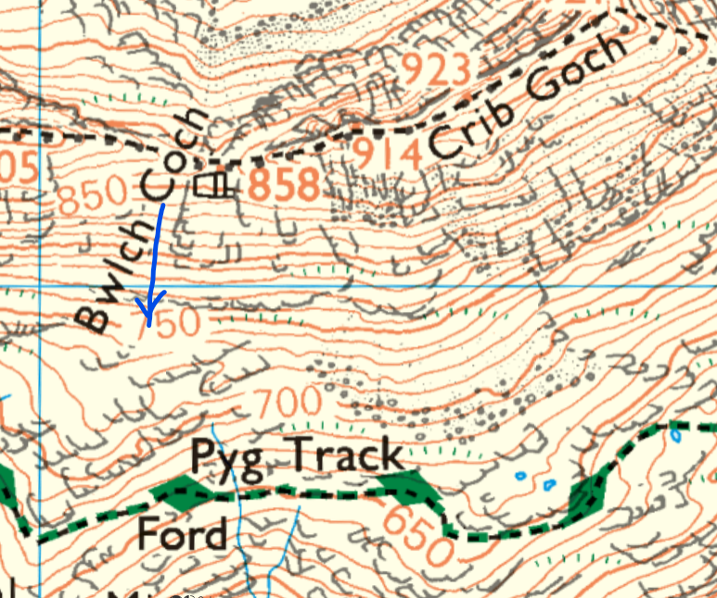
The casualty will be referred to the ‘casualty’
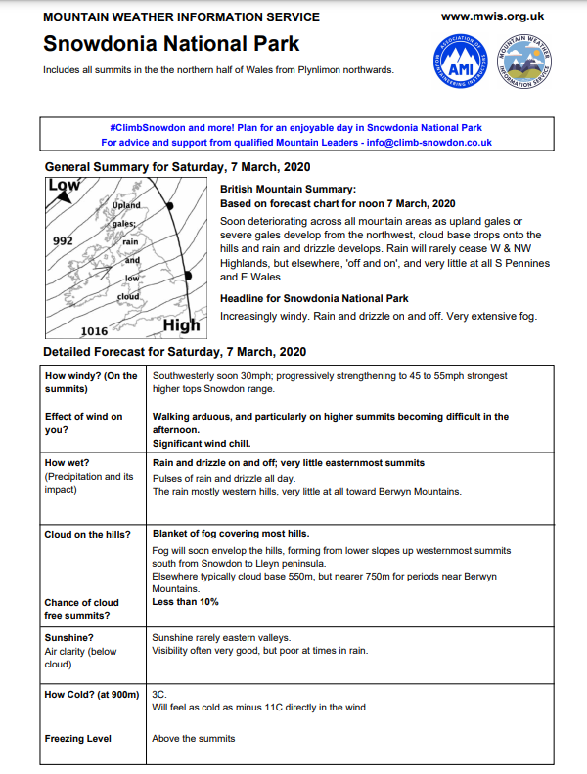
Appendix 2: shows the weather report from MWIS on the day of the incident .

Appendices 3 shows a map of crib coch and an arrow pointing where they chose take an emergency escape route
The arrow ending in the rough location where the casualty stopped on the slope

