UK low productivity growth – even worse than thought
Productivity is what drives long-term economic growth as it determines potential GDP. If long-term growth is seen as desirable, then a fall in productivity represents a serious economic problem.
Recent data suggest that the problem, if anything, is worse than previously thought and does not seem to be getting better. Productivity is now some 21% below what it would have been had productivity growth continued at the rate experienced in the years before the financial crisis (see second chart below).
In its latest productivity statistics, the ONS reports that labour productivity (in terms of output per hour worked) fell by 0.1% in the second quarter of 2017. This follows a fall of 0.5% in quarter 1. Over the whole year to 2017 Q2, productivity fell by 0.3%.
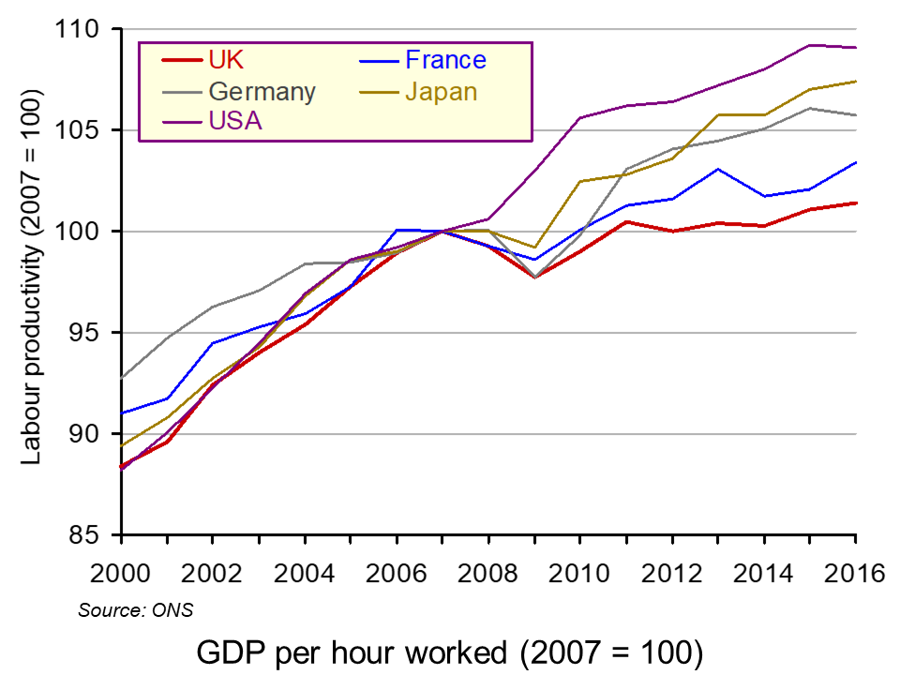
Most other major developed countries have much higher productivity than the UK. In 2016, Italy’s productivity was 9.9% higher than the UK’s; the USA’s was 27.9%, France’s was 28.7% and Germany’s was 34.5% higher. What is more, their productivity has grown faster (see chart).
But what of the future? The Office for Budget responsibility publishes forecasts for productivity growth, but has consistently overestimated it. After predicting several times in the past that UK productivity growth would rise towards its pre-financial crisis trend of around 2% per year, in its October 2017 Forecast evaluation Report it recognises that this was too optimisitic and revises downwards its forecasts for productivity growth for 2017 and beyond.
As the period of historically weak productivity growth lengthens, it seems less plausible to assume that potential and actual productivity growth will recover over the medium term to the extent assumed in our most recent forecasts. Over the past five years, growth in output per hour has averaged 0.2 per cent. This looks set to be a better guide to productivity growth in 2017 than our March forecast of 1.6 per cent.
Looking further ahead, it no longer seems central to assume that productivity growth will recover to the 1.8 per cent we assumed in March 2017 within five years.
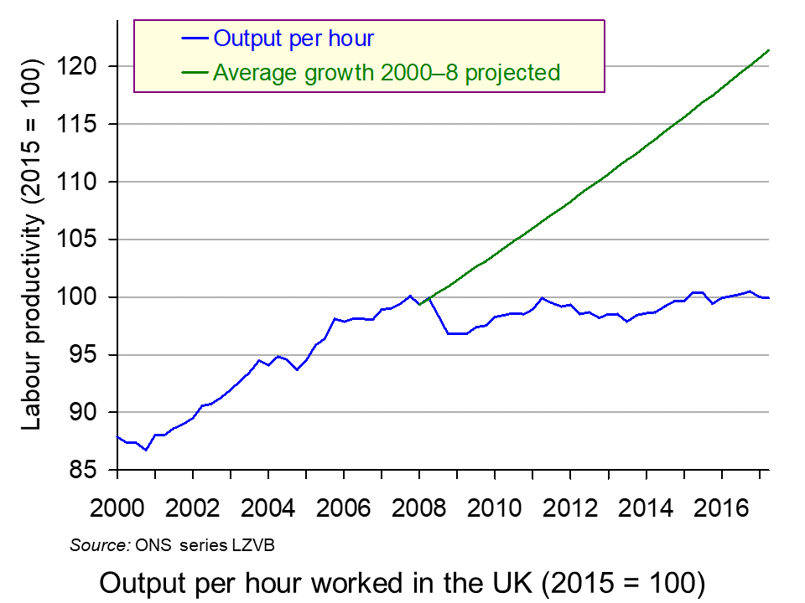
But why has productivity growth not returned to pre-crisis levels? There are five possible explanations.
The first is that there has been labour hoarding. But with companies hiring more workers, this is unlikely still to be true for most employers.
The second is that very low interest rates have allowed some low-productivity companies to survive, which might otherwise have been driven out of business.
The third is a reluctance of banks to lend for investment. After the financial crisis this was driven by the need for them to repair their balance sheets. Today, it may simply be greater risk aversion than before the financial crisis, especially with the uncertainties surrounding Brexit.
The fourth is a fall in firms’ desire to invest. Although investment has recovered somewhat from the years directly following the financial crisis, it is still lower than might be expected in an economy that is no longer is recession. Indeed, there has been a much slower investment recovery than occurred after previous recessions.
The fifth is greater flexibility in the labour market, which has subdued wages and has allowed firms to respond to higher demand by taking on more relatively low-productivity workers rather than having to invest in human capital or technology.
Whatever the explanation, the solution is for more investment in both technology and in physical and human capital, whether by the private or the public sector. The question is how to stimulate such investment.

Articles
UK productivity lagging well behind G7 peers – ONS Financial Times, Katie Martin (6/10/17)
UK productivity sees further fall BBC News (6/10/17)
UK resigned to endless productivity gloom The Telegraph, Tim Wallace (10/10/17)
UK productivity estimates must be ‘significantly’ lowered, admits OBR The Guardian, Richard Partington and Phillip Inman (10/10/17)
UK productivity growth to remain sluggish, says OBR BBC News (10/10/17)
Official Treasury forecaster slashes UK productivity growth forecast, signalling hole in public finances for November Budget Independent, Ben Chu (10/10/17)
The Guardian view on Britain’s productive forces: they are not working The Guardian, Editorial (10/10/17)
Data and statistical analysis
Labour productivity: April to June 2017 ONS Statistical Bulletin (6/10/17)
International comparisons of productivity ONS Dataset (6/10/17)
Forecast evaluation report OBR (October 2017)
Questions
- Explain the relationship between labour productivity and potential GDP.
- What is the relationship between actual growth in GDP and labour productivity?
- Why does the UK lag France and Germany more in output per hour than in output per worker, but the USA more in output per worker than in output per hour?
- Is there anything about the UK system of financing investment that results in lower investment than in other developed countries?
- Why are firms reluctant to invest?
- In what ways could public investment increase productivity?
- What measures would you recommend to encourage greater investment and why?
- How do expectations affect the growth in labour productivity?

The Guardian view on Britain’s productive forces: they are not working
The big economic question now is whether capitalism in the UK is capable of generating enough gains from growth
Productivity isn’t everything, observed the Nobel laureate Paul Krugman, but in the long run it is almost everything. For Britons, the worrying news is that the growth in productivity – the amount of stuff we produce every hour – has slowed to a snail’s pace. The Office for Budget Responsibility, after maintaining a sunny disposition in the face of ever darkening clouds of data, now accepts that we are unlikely to return to pre-crash levels of productivity growth. Below the OBR’s seemingly innocuous statement is the “everything” that Mr Krugman alludes to. Before the crash, we would have expected living standards to double every 40 years. If we were to carry on in the current manner, it would take more than two centuries to do so. Unless something drastic happens we face not just losing a decade, but a future.
While it is true that all western economies have failed to recover the kind of growth they experienced before the crash, rich world economies are picking up speed, while the UK splutters along. Our rivals are also more prosperous than we are: France and the US had an average productivity in 2015 of €55 per hour worked - 25% higher than the UK. Britain is becoming the sick man of the rich world. Some of reasons for the malaise is historical: our educational system has woefully disregarded vocational training; after the last war we had less need for an industrial recovery and spent less on new equipment.
However, that meant the others played catch up – and now it is a case of Britain lagging behind our rivals. It takes a German worker four days to produce what an employee here makes in five. Too many British workers work longer hours for lower pay than their rich-world counterparts. The reason is that our economy seems to be particularly bad at allocating labour: in the last year the less productive service sector has gone on a hiring spree, while higher value manufacturing has shrunk. The market, which so many rightwingers think needs unchaining, is operating a sort of reverse creative destruction where the strong are weakened so that the weak can be strengthened. The result is that productivity, expected to be the main driver of economic growth and wellbeing, is as flat as a pancake. The brute facts of a troublesome reality are beginning to bite. Workers are supposed to see their wages march in lockstep with productivity gains. Today household income per person is just 5% higher than a decade ago. The decade before the crisis saw six times that earnings growth. While low interest rates have helped in the past, the spectre of inflation is growing. If the stagnation is more permanent than previously thought, the Treasury will lose out on tax receipts. Last year Philip Hammond thought he would have £26bn over the next five years to weather the storms of Brexit. It now looks as if the chancellor will get less than half that. Britain is an ageing society. Its economy suffers with high levels of debt and it faces a Brexit likely to exacerbate longstanding economic weaknesses. Given the political emphasis placed on controlling immigration, UK exports will face higher costs in the coming decade. The danger is that we will resort to depreciating the pound to retain competitiveness – and deliver an inflation shock to the UK’s poorest. We need to avoid such low-wage, drudgery-filled dystopias. The Conservative party bears responsibility for a failed economic experiment which deflated demand through austerity and built an unequal economy on regulation-lite cheap labour. The question in economic terms now is whether capitalism is capable of generating enough gains from growth. Politically the issue is how such windfalls can be fairly distributed. Technological progress can raise productivity and boost wages. But as Britain is currently wired, this would see a rising concentration of wealth. A fairer, more productive economy needs designing. We must be architects of the future, not victims of it.
Fall in productivity puts pressure on Hammond before budget
OBR also expected to cut productivity forecasts, wiping out about two-thirds of chancellor’s £26bn budget ‘war chest’
The productivity of UK workers fell in the three months to June, piling pressure on the chancellor, Philip Hammond, before his budget next month.
Despite increasing numbers of hours put in by workers, labour productivity as measured by output per hour fell by 0.1% in the three months to June, according to the Office for National Statistics. That continues a fall started earlier this year, albeit at a slower pace, from the 0.5% drop recorded in the three months to March.
The figures will prove troubling for the chancellor, as weak productivity stands to erode the public finances by signalling weaker economic growth. The figures also rank Britain among the weakest of the G7 economies for labour productivity, although the gap with rival nations narrowed to 15.4% last year from 16.1% in 2015.
Philip Wales of the ONS said: “UK labour productivity continued to lag behind our international partners in 2016 ... analysis suggests that this lower level of productivity was evident across all industries, although the size of the gap varies considerably.”
Some industries are more productive than others. Manufacturing firms are among the most efficient – such as mining, quarrying and pharmaceuticals – because workers put in a relatively small share of total hours worked across the wider economy. The UK’s largest sector, services, accounts for a larger share of hours worked, at below average productivity.
Firms that attract investment from overseas are also about 74% more productive than domestic firms. The UK ranks fifth out of the top seven advanced global economies, with Canada and Japan having weaker levels of productivity. Germany is the most productive nation per hour, while the US is top for output per worker.
The UK has been in a prolonged period of weak productivity since the financial crisis. Brexit could be exacerbating the problem, as businesses turn back from investing in more efficient equipment owing to fears over the strength of the economy. Meanwhile, unemployment is at its lowest level since the mid-1970s - indicating that companies are preferring to invest in people rather than technology.
Howard Archer, the chief economic adviser to the EY Item Club, a forecasting group, said: “Given the uncertain economic and political outlook, it may be that several companies are trying to meet extra work by taking on labour rather than commit to investment.”
The weakness could be attributed to the creation of low-skilled, low-paid jobs in the economy, in which productivity - is limited. Despite the low jobless rate, wage growth is failing to keep pace with the rising cost of living.
Some economists also suggest there could be a link between weak productivity and low interest rates, as unproductive companies are able to continue operating by borrowing cheaply from banks and the financial markets. That could change as the Bank of England prepares to raise interest rates for the first time in a decade from as early as November.
Next week the Office for Budget Responsibility is expected to admit that its forecasts for improving productivity growth have proved to be consistently optimistic. The government’s independent forecaster will say that the trend for lower productivity growth since the 2008 crash is likely to persist for several more years, warranting a downgrade from its March forecast.
Without an improvement in productivity, the UK economy is expected to miss out on expected increases in wages and living standards, putting further pressure on the welfare system and depressing tax receipts.
Treasury officials are known to believe that the downgrade will wipe out about two-thirds of the government’s £26bn war chest, which the chancellor set aside in the last budget to spend in the event of a slowdown following a disorderly and damaging exit from the EU.
Hammond was expected to use some of the money in the autumn budget on 22 November to increase public sector pay and alleviate a spending squeeze that is hitting schools, hospitals and the police service at a time when all three services are under strain.
But the loss of about £18bn over the next four years after a reduction in productivity growth will severely limit his room for manoeuvre.

UK productivity sees further fall

The productivity of UK workers has fallen for the second quarter in a row, official figures indicate.
Hourly output fell 0.1% in the April-to-June period, the Office for National Statistics (ONS) said.
This follows a 0.5% decline in the first three months of the year.
Economists have warned that the UK's productivity continues to lag behind its major trading partners such as the US, France and Germany.
The ONS said the fall represented a continuation of the UK's "productivity puzzle", referring to the relative stagnation of labour productivity since the financial crisis.
We used to take it for granted that we would each get better off as the economy grew. As companies and the government invested in better technology and skills, each worker could produce more goods or services per hour, bringing in more revenue to their employers - and as a result, each worker could be paid more per hour. Those improvements in productivity were for most of the last 200 years the motor of economic growth, so regular they could be taken for granted.
In the past decade, that engine of improved prosperity has all but broken down. The latest productivity numbers show that the amount (output per hour) each worker produces shrank by 0.1%. Modest perhaps, but add that to all the other falls in productivity over recent years and we each produce no more than we did at the end of 2007.
But hang on, don't we keep reporting that the economy has grown? Indeed we do - with record levels of employment and the lowest unemployment rate in 45 years. How do you reconcile that?
Here's the answer. An economy is merely people and their economic activity (buying, selling, working, saving etc). So you can grow it without any improvements in productivity, by simply adding people to the workforce, be they EU migrant workers or pensioners choosing not to retire yet.
And that is what our economy has been doing - without improving the amount each worker produces. If you want to know why average wages haven't improved much in the same period, flat productivity is a big part of the answer.
The ONS pointed to differences between the manufacturing and services sectors.
Services output per hour grew by 0.2%, with output growth outpacing growth in hours worked.
In contrast, the ONS said, manufacturing output fell while hours grew, so labour productivity in manufacturing declined by 1.3% during the quarter.
On an annual basis, covering the 12 months after the UK voted to leave the EU, hourly output fell 0.3% from June 2016 to June 2017.
The last time the ONS recorded a fall in annual productivity of that magnitude was in the year to September 2013.
The UK has seen a steady economic recovery since the financial crisis, but it has been helped by longer hours and more people working.
Productivity has failed to grow consistently, raising concerns for businesses and policymakers.
"Productivity has been a long-term challenge, which is why we must invest now to step up our performance," said a Treasury spokesperson.
"We have announced £23bn for infrastructure, research and housing, while also reforming technical education so that our economy works for everyone."
Shadow business secretary Rebecca Long-Bailey said: "Our capacity to raise long run living standards seems to be going backwards.
"This country needs a radical and transformative industrial strategy. The only party that can deliver this is Labour."

