

Reed Hastings: Analysis of Leadership Style

Lim Pei Xian 2226079
BMBM6012 Leading and Developing People

Table of Contents
1.0 Introduction 1
2.0 Reed Hasting as Successful Leaders 2
2.1 Transformational Leadership of Reed Hastings 3
2.2 Innovative Leadership of Reed Hastings 6
2.3 Adaptive Leadership of Reed Hastings 7
2.4 Journey of Reed Hastings Achieving High Performance 10
3.0 Conclusion 13
4.0 References 14

1.0 Introduction
Into the loving arms of his parents Joan and Wilmot Hastings, Reed Hastings entered the world on October 8, 1960, in Boston, Massachusetts (Loudenback, 2015). He will be 63 years old this year, and his entire net worth will have reached $3.1 billion by the year 2023. Along with his life, before he became the Chief Executive Officer (CEO) of Netflix in 1997, Reed Hastings and Mark Box established Pure Software in October 1991. Reed Hastings served as Pure Software's first CEO. Purify was the name of the original product, which was a debugging tool designed for Unix/C engineers. In August of 1995, Pure Software decided to go public with the assistance of Morgan Stanley. Following that, Hastings came up with the idea for Netflix in 1997 after he was charged a hefty late fee for a videocassette he forgot to return to the shop on time, although DVDs were relatively new to the market, Hastings was certain that they could be sent through the mail without any problems (Hibler, 2023). Soon, Netflix was established in 1997 in the state of California by him and his business partner Marc Randolph, who parted ways with the company in 2004. In 1998, they launched their DVD mail-order business. Schmidt, (2020) mentioned that Netflix completed the shipment of their one billionth DVD in February of 2007. During this time, the firm released applications that gave clients access to movies and television series that could be downloaded instantly via streaming. Hasting’s major quote in his life is “Don't be afraid to change the model.”
Employees have fewer opportunities for social connection, face the challenge of drawing clear lines between work and personal life and frequently lack the physical space they need to get their work done at home (Stoker et al., 2021). The actions that make up these styles of leadership are crucial for the success of workers who work from home; thus, managers are required to reduce their amount of directive leadership and increase their level of empowering leadership (Ramarajan & Reid, 2013). If content creators want to avoid going via middlemen, they'll need to make some significant changes to their business operations, such as reorganising their IT systems, customer support departments, and compliance frameworks (Wroan, 2020). Content providers must also integrate production, distribution, and other B2B business units that were previously compartmentalised or outsourced. After laying the groundwork for understanding the environment in which Reed Hastings operates, this essay will try a critical analysis of the firm's leadership style to see if it is effective at fostering creativity, flexibility, and peak performance.

2.0 Reed Hasting as Successful Leaders
Leadership is about having sway, whether that be over subordinates, peers, or superiors in a professional or organisational setting. Naturally, having influence brings with it a heightened obligation for those in positions of authority to conduct themselves in an honest and moral manner when using their power (Asrar-ul-Haq & Anwar, 2018). It appears that one's cultural background plays a role in shaping their perspective of the characteristics and behaviours that identify a leader. It is possible to make the case that culture and leadership are inextricably linked and that both factors have significant bearings on the other (Jackson et al., 2015). Leadership entails swaying a group of individuals in a specific direction to achieve a predetermined objective, leadership also requires a lot of deliberate thought (McDermott et al., 2011). To accomplish this, one must have exceptional insight into oneself, emotional intelligence, and the internal and external environments in which the business operates.

2.1 Transformational Leadership of Reed Hastings
Transformational leaders motivate their teams to work together towards a common vision of achieving the organization's stated objectives and performance benchmarks. When leading a team, a transformational manager employs a technique that allows him to delegate duties and responsibilities based on each team member's specific skill set while also monitoring and assessing their progress (Khan et al., 2020). This issue arises soon after the official declaration that there would be a prohibition towards password-sharing in every household, there has been a significant number of customers who have terminated their membership with Netflix.
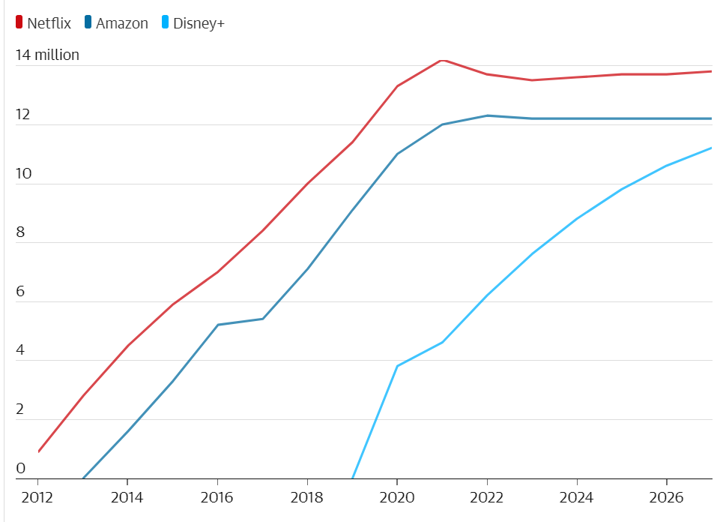
Figure 1: Subscription Base of Netflix and Its Competitors (Sweney, 2023)
On the other hand, the video streaming service has no intention of simply freezing accounts that are used by multiple people. Instead, the organisation is most likely going to support the imposition of an additional price for those accounts that are being used by many people outside of the home. A notice would be provided to account holders whose passwords are being used by other households as the first step in Netflix's plan to recoup those lost revenues (Sherman, 2022). As can be seen in Figure 1, the number of subscribers to Netflix experienced a significant decline as a direct result of the problem. In the UK in the year 2023, it is anticipated that Netflix would suffer a loss of approximately 200,000 subscribers (Sweney, 2023). Reed Hastings is a firm believer that people should be empowered to make decisions that are in the best interests of the organisation for which they work. Every worker can cultivate a sense of responsibility, which in turn encourages them to perform their jobs to the best of their abilities for the benefit of the firm when they are given the authority to make decisions (McAndrew, 2021). Hastings is a transformative leader who is responsible for motivating and inspiring his staff to strive towards the success of Netflix, in order to provide room for development, innovation, and transition, conventional corporate demanding procedures are being abandoned (O’Reilly & Chatman, 2020).
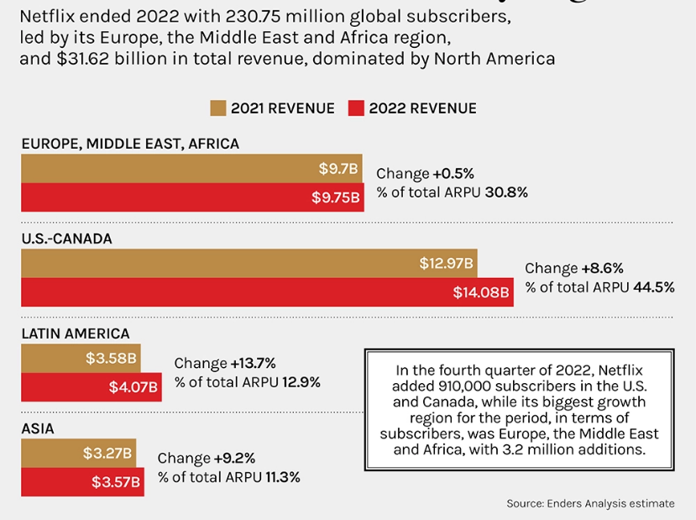
Figure 2: Subscribers and Revenue of Netflix (Szalai, 2023)
In response to this problem, Hastings swiftly devised a solution that would benefit both the company and its consumers, allowing it to acquire both new clients and keep the ones it already had. This is due to the vast majority of buyers being on the lookout for an affordable product that doesn't skimp on quality. Internet streaming subscriptions have become increasingly common in the United States due to their inexpensive cost and extensive supplementary features (Lee et al., 2018). The fact that Netflix is making money isn't hurting its case, though; the company earned $4.49 billion in net income in 2022, up from $5.12 billion the year before. The decision will help cushion the effect of the implementation of the firm's crackdown on password-sharing, as well as the rising inflation that has slammed customers globally and the strong currency, which has impacted users in countries where the streamer's pricing is dollar-based (Szalai, 2023). A look at Figure 2 reveals that despite a decline in earnings compared to 2021, Netflix is still on the rise. In a nutshell, Hastings's leadership in dealing with this complexity is deemed to be effective, which contributes to Netflix's ability to retain its annual income.

2.2 Innovative Leadership of Reed Hastings
When leaders think beyond the box, they are better able to meet the demands of their followers and prevent issues from escalating (Sen & Eren, 2012). According to the research of Horth & Buchner, (2014), "innovation leadership" is a strategy and philosophy that integrates many types of leadership in order to inspire and encourage workers to come up with new ideas and innovations. Leaders in this position must be receptive to new ideas from their followers, which requires an attitude of openness (Abdullrazak & Alyamani, 2019).
Shortly after, Netflix was sending out a million DVDs daily, generating over $500 million in income, and knocking both Blockbuster and mom-and-pop video stores out of business. Hastings, encouraged by the success of YouTube, urged Netflix to expand into the streaming video before the online retail giant Amazon could cut into Netflix's market share. Within a short period of time, the company's collection expanded from 1,000 titles to nearly 6,000 titles in the United States alone. Since Hastings took over as CEO, Netflix has shifted its focus from striking distribution arrangements with established television and film studios to developing its own original programming (Lawrence, 2023).
Hastings was a big part of making Netflix a one-stop shop for its customers. It streamed popular movies within a few weeks of their initial theatrical releases, along with popular original television programmes such as Orange Is the New Black and cherished network mainstays such as The Office (Allegretti et al., 2021). As an innovative leader, Hastings was the one who enlightened us to the fact that watching television need not be overly complicated, it might even be on a mobile device like a smartphone or a tablet (Lawrence, 2023). Hastings is a more quiet and fundamentally pragmatic individual. Prior to the invention of Hastings, the act of viewing television was a purely passive one, whether they like it or not, he's responsible for viewers having more power over their televisions than ever before (Carroll, 2023).

2.3 Adaptive Leadership of Reed Hastings
Empathy is a crucial quality for adaptive leaders to possess, as it allows them to better guide their workforce. Leaders have the most influence on their teams, therefore it's important for them to get to know their employees on a personal level in order to meet their demands (Vaheed, 2021). This method highlights adapting to a complex and fast-changing environment and develops organisational circumstances to accomplish aims (McKimm et al., 2022).
In countless examples of business scandals and failures, the inability to create an environment that is psychologically safe is cited as a contributing factor. As the popularity of streaming grew, Netflix CEO Reed Hastings, for example, suggested that the company be split into two distinct entities, each of which would be responsible for charging customers for DVD and streaming services in a separate manner (Ibarra, 2021). However, the decision, overturned after less than a month, was a colossal fiasco, one in which the corporation lost millions of members and its stock plunged 75 percent. Since the summer, Netflix has outraged its users by separating its DVD-by-mail service and its unlimited streaming subscription into two distinct offerings, and by imposing what amounts to a 60% price jump for customers who wish to keep the same services (Tuttle, 2011). As soon as the new prices went into effect, it was clear that Netflix members were leaving, which resulted in a precipitous drop in the stock price.
Netflix's CEO, Reed Hastings, decided to spin off the DVD subscription service, Qwikster, in September 2011 so that the company could focus on the streaming video side of things. The overwhelming disdain showed by customers resulted in the loss of 80,000 customers, which further contributed to the decrease in stock prices (Wingfield & Stelter, 2011). Hastings, famed for his flexible and transformational leadership style, tried to make up for the decision by announcing Qwikster's dissolution and Netflix's reacquisition of the DVD business a few weeks later (Ryan, 2013). Netflix was able to recover thanks to the adaptation, and by the third quarter of 2014, the stock price of the company had increased to $480 per share (Bowers et al., 2017). It might have been the worst decision he had made but he was trying his best on making up for the decisions he made. By focusing on the environment rather than the rules, he is able to lead in an adaptive manner. In a world full of uncertainty, having strict standards is unproductive. The optimal answer will present itself as a result of learning and adjusting to new circumstances over time. Hastings, Netflix's CEO, writes in the company's "Reference Handbook on our Freedom & Responsibility Culture," it would be preferable when minimizing disruption as staff would expand with ever highest productive people, not with regulations (Torres et al., 2022).

2.4 Journey of Reed Hastings Achieving High Performance
Hastings envisioned a highly democratic work atmosphere in his book titled "No Rule Rules: Netflix and the Culture of Reinvention." This environment would place a strong emphasis on creative autonomy and would have a low amount of bossism (Reed & Erin, 2022). The personnel were given authority under the stipulation that they must be able to produce the desired outcomes.
Netflix, a video streaming service, reported last month that it earned $4.5 billion on the backs of 148 million paying subscribers in the first three months of 2019 and the quantity is quite staggering. In addition to the swift growth of the streaming market, the film business as well as the technology giants Disney and Apple both hate to score a shot, and so both hastily created their own streaming services, Disney+ and Apple+, in an effort to catch up with the market trend. Reed Hastings, Netflix's founder and president, exuded an air of unruffled composure even in the midst of widespread investor anxiety regarding the firm. He was unconcerned that Netflix's dominant market position would be jeopardised (Hidayati, 2022). Netflix avoids this pitfall thanks to its dedication to excellent performance and transparency, as well as Hastings's skill at creating compelling future visions. In addition, providing employees with a solid platform on which to base well-reasoned decisions that are in the best interest of the organisation results from being upfront with sensitive information (McAndrew, 2021).
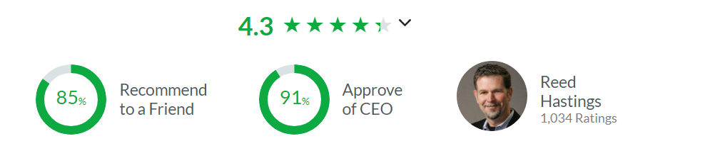
Figure 3: Approval Rating on Glassdoor (Glassdoor, 2023)
Everyone in the company, regardless of their position, is expected to share information honestly, broadly, and purposefully so that everyone can make better decisions. Having every worker fully informed is valuable, thus the risk of leaks is acceptable. Since the organisation values strengthening its professional connections, employees are encouraged to give and accept constructive criticism. It's inappropriate and counterproductive for employees to disagree quietly, which slows down the company's progress. Figure 3 displayed that this leadership style has had such a beneficial impact on the organisation that he has a 91% approval rating on the employment review of the CEO of Netflix on the website Glassdoor.
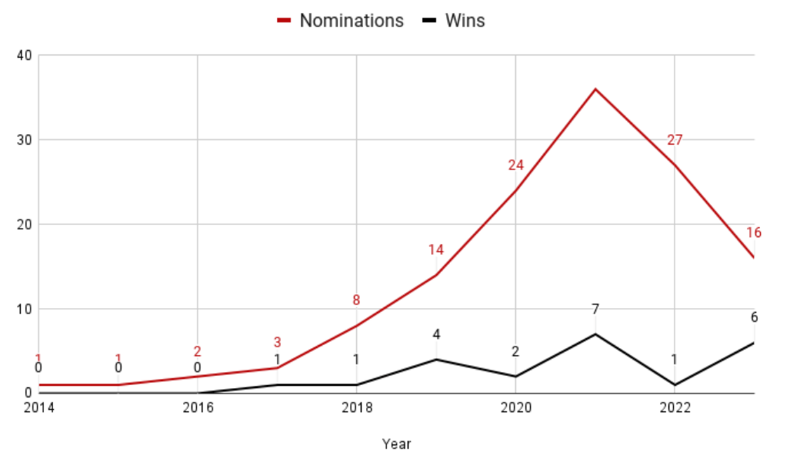
Figure 4: Netflix Oscar Wins and Nominations Over the Years (Moore, 2023)
Figure 4 reported in 2022 that Netflix had a 40-person awards operation and 15 advisors who split their time between Emmy and Oscar campaigns, demonstrating the company's dedication to the former (Moore, 2023). Given that Netflix hasn't completely embraced theatrical releases, its nomination for numerous awards has been considered problematic by some. This is the most convincing proof that Hastings plays a key role in Netflix's impressive productivity and ability to uphold its high-quality standards.

3.0 Conclusion
When it comes to tackling the complexities that have been presented by the video streaming sector, I believe that the combination of all three types of leadership that Reed Has is currently employing is the most effective method. Whatever the case may be, Reed Hastings's innovative method of leadership stands out as the one most likely to encourage creativity, flexibility, and peak performance among his employees. The decision by Reed Hastings in 2007 to broaden Netflix's business model from DVD rental to online video streaming provides the foundation for this argument. Because of this forward-thinking attitude, online video streaming has become popular while traditional DVD rental businesses like Blockbuster have been driven out of business. Soon when the pioneering provider of these services, Netflix, enters the market, it is quickly followed by a slew of imitators. As a result of Netflix's increased proficiency in offering these services, the company has seen an increase in subscriptions and market share. Netflix is well-known now for its streaming service, which offers users access to TV series and movies from any internet-connected device, for a monthly subscription fee. Netflix would not exist if its founder, Reed Hastings, had not come up with the idea and put it into action. Hence, the inventive style of leadership that Reed Hastings possessed is the most crucial factor that contributed to Netflix's ability to innovate, adapt, and perform well.

4.0 References
Abdullrazak, S.H. and Alyamani, A.A. (2019) “The Characteristics of Innovative Leadership and Its Role in Crisis Management Survey Study in the (UNDP) in Iraq Construction Sector.,” Tikrit Journal of Administration and Economics Sciences, 15(47), pp. 290–309. Available at: https://www.iasj.net/iasj/article/173036.
Allegretti, S. et al. (2021) “Executing a business model change: Identifying key characteristics to succeed in volatile markets,” Leadership, Education, Personality: An Interdisciplinary Journal, 3(1), pp. 21–33. Available at: https://doi.org/10.1365/s42681-021-00020-x.
Asrar-ul-Haq, M. and Anwar, S. (2018) “The Many Faces of Leadership: Proposing Research Agenda through a review of literature,” Future Business Journal, 4(2), pp. 179–188. Available at: https://doi.org/10.1016/j.fbj.2018.06.002.
Bowers, M.R., Hall, J.R. and Srinivasan, M.M. (2017) “Organizational culture and leadership style: The missing combination for selecting the right leader for Effective Crisis Management,” Business Horizons, 60(4), pp. 551–563. Available at: https://doi.org/10.1016/j.bushor.2017.04.001.
Carroll, N. (2023) Netflix on encouraging 'honourable' failure to Drive Innovation, Marketing Week. Available at: https://www.marketingweek.com/netflix-honourable-failure-innovation-market-research/ (Accessed: March 17, 2023).
Glassdoor (2023) Netflix reviews: What is it like to work at Netflix?, Glassdoor. Available at: https://www.glassdoor.co.uk/Reviews/Netflix-Reviews-E11891.htm (Accessed: March 16, 2023).
Hibler, J. (2023) Reed Hastings, Encyclopaedia Britannica. Encyclopaedia Britannica, inc. Available at: https://www.britannica.com/biography/Reed-Hastings (Accessed: March 14, 2023).
Hidayati, N. (2022) “Human Resources Management Review on netflix,” Proceedings of the International Conference on Economics, Management and Accounting (ICEMAC 2021) [Preprint]. Available at: https://doi.org/10.2991/aebmr.k.220204.043.
Horth, D. and Buchner, D. (2014) “Innovation Leadership How to use innovation to lead effectively, work collaboratively, and drive results,” Center for Creative Leadership, p. 18.
Ibarra, H. (2021) “Five leadership skills for the future,” Leader to Leader, pp. 14–17. Available at: https://doi.org/10.1002/ltl.20557.
Jackson, S., Sakuma, S. and DeVol, P. (2015) “The Complexity in Defining Leadership: How Gifted Students’ Backgrounds Influence Their Understanding of Effective Leadership,” NCSSS Journal [Preprint].
Khan, H. et al. (2020) “Impact of transformational leadership on work performance, Burnout and Social Loafing: A mediation model,” Future Business Journal, 6(1). Available at: https://doi.org/10.1186/s43093-020-00043-8.
Lawrence, A. (2023) Netflix's Reed Hastings changed the way we watch TV – for better or for worse, The Guardian. Guardian News and Media. Available at: https://www.theguardian.com/media/2023/jan/20/netflix-reed-hastings-ceo-quits# (Accessed: March 17, 2023).
Lee, C.C. et al. (2018) “Factors affecting online streaming subscriptions,” Communications of the IIMA, 16(1). Available at: https://doi.org/10.58729/1941-6687.1394.
Loudenback, T. (2015) Meet reed hastings, the man who built Netflix, Business Insider. Business Insider. Available at: https://www.businessinsider.com/reed-hastings-netflix-bio-2015-8?r=US&IR=T# (Accessed: March 14, 2023).
McAndrew, N. (2021) “‘Assessing Leadership in Business – Marketing: A Critical Investigation of Reed Hastings Investigation of Reed Hastings,” Honors Scholar Theses, pp. 1–21.
McDermott, A., Kidney, R. and Flood, P. (2011) “Understanding leader development: Learning from leaders,” Leadership & Organization Development Journal, 32(4), pp. 358–378. Available at: https://doi.org/10.1108/01437731111134643.
McKimm, J. et al. (2022) “Adaptive leadership during challenging times: Effective Strategies for Health Professions Educators: Amee Guide no. 148,” Medical Teacher, 45(2), pp. 128–138. Available at: https://doi.org/10.1080/0142159x.2022.2057288.
Moore, K. (2023) How many Oscars has Netflix won in its history?, What's on Netflix. Available at: https://www.whats-on-netflix.com/news/how-many-oscars-has-netflix-won-in-its-history-2023/ (Accessed: March 17, 2023).
O’Reilly, C.A. and Chatman, J.A. (2020) “Transformational leader or narcissist? how grandiose narcissists can create and destroy organizations and Institutions,” California Management Review, 62(3), pp. 5–27. Available at: https://doi.org/10.1177/0008125620914989.
Ramarajan, L. and Reid, E. (2013) “Shattering the myth of separate worlds: Negotiating nonwork identities at work,” Academy of Management Review, 38(4), pp. 621–644. Available at: https://doi.org/10.5465/amr.2011.0314.
Reed, H. and Erin, M. (2022) No rules rules: Netflix and the culture of reinvention. S.l.: VIRGIN BOOKS.
Ryan, L. (2013) “Leading change through creative destruction: How netflix's self-destruction strategy created its own market,” International Journal of Business Innovation and Research, 7(4), p. 429. Available at: https://doi.org/10.1504/ijbir.2013.054868.
Schmidt, A. (2020) How netflix's Reed Hastings overcame failure while leading his first company, Fox Business. Fox Business. Available at: https://www.foxbusiness.com/money/netflix-ceo-reed-hastings-winning-formula (Accessed: March 14, 2023).
Sen, A. and Eren, E. (2012) “Innovative leadership for the twenty-First Century,” Procedia - Social and Behavioral Sciences, 41, pp. 1–14. Available at: https://doi.org/10.1016/j.sbspro.2012.04.001.
Sherman, A. (2022) Netflix is finally going after password sharing. here's how it's likely to work, CNBC. CNBC. Available at: https://www.cnbc.com/2022/04/23/how-netflixs-password-sharing-crackdown-is-likely-to-work.html (Accessed: March 15, 2023).
Stoker, J.I., Garretsen, H. and Lammers, J. (2021) “Leading and working from home in times of covid-19: On the perceived changes in leadership behaviors,” Journal of Leadership & Organizational Studies, 29(2), pp. 208–218. Available at: https://doi.org/10.1177/15480518211007452.
Sweney, M. (2023) Netflix to lose 700,000 UK customers in two years, analysts predict, The Guardian. Guardian News and Media. Available at: https://www.theguardian.com/media/2023/jan/01/netflix-to-lose-700000-uk-customers-in-two-years-analysts-predict (Accessed: March 15, 2023).

Szalai, G. (2023) Streaming services are raising prices, so why is Netflix dropping them in 100-plus markets?, The Hollywood Reporter. The Hollywood Reporter. Available at: https://www.hollywoodreporter.com/business/business-news/netflix-price-drop-international-password-sharing-1235332333/ (Accessed: March 16, 2023).
Torres, R., Reeves, M. and Love, C. (2022) Adaptive leadership, BCG Global. BCG Global. Available at: https://www.bcg.com/publications/2010/leadership-engagement-culture-adaptive-leadership (Accessed: March 17, 2023).
Tuttle, B. (2011) Netflix admits it 'messed up,' will split DVD and streaming into two businesses, Time. Time. Available at: https://business.time.com/2011/09/19/netflix-admits-it-messed-up-will-split-dvd-and-streaming-into-two-businesses/ (Accessed: March 16, 2023).
Vaheed, B. (2021) “Managing Change Through Adaptive Leadership,” Progressio Alas Journal, 1(2), pp. 1–13.
Wingfield, N. and Stelter, B. (2011) How netflix lost 800,000 members, and good will, The New York Times. The New York Times. Available at: https://www.nytimes.com/2011/10/25/technology/netflix-lost-800000-members-with-price-rise-and-split-plan.html (Accessed: March 16, 2023).
Wroan, M. (2020) Covid-19 accelerates streaming challenges as well as demand, KPMG US. KPMG. Available at: https://info.kpmg.us/news-perspectives/technology-innovation/covid-19-accelerates-streaming-challenges-and-demand.html (Accessed: March 17, 2023).

