REFLECTIVE REVIEW OF LEARNING JOURNEY
by Georgiana Hodor

08.3.2019

Table of Contents:

- Introduction…………………………………………………………...page 3-4
1.1SWOT ANALYSIS…………………………………………….….page 4-6
1.2 Learning Styles……………………………………………………page 6-8
1.3 GO MAD Framework…………………………………………. …page 8-9
2. Development of Personal Skills………………………………...………page 9
3.APENDICE……………………………………………………………...page10-19
4.REFERENCES…………………………………………………………..page 20

Reflective Review of Learning Journey

This report is a reflective account of my learning journey through personal development when looking to establish a career as a manager. This reflective review can also be considered as my personal statement as it highlights my learning experiences. The reflective report covers information about my achievements, failures, flaws and also strengths that would help me to establish a career in management. The report also discusses the challenges I have faced as a management student, time management skills I have achieved, group discussions and effective communication. The report further discusses the feature of refining my areas of expertise. The review highlights my learning experiences and knowledge I have gathered during my learning journey.
As a child, I never really considered a career in business and entrepreneurship until I started a course in business management. Through my learning experiences, I have come to understand the concept of business, marketing strategies and numerous other concepts implemented to ensure the success of a business. The course has also enabled me to appreciate the importance of communication and teamwork given that most of the modules required assignments to be done in groups. Working in groups created a sense of team spirit with the same goal of succeeding (Costa and Kallick, 2018). At the beginning of the course, I was often faced with the issue of effective communication among my group mates as well as the faculty members. I was often confused as I tried to understand theories and their application. I could not even enquire or address my issues since I was too shy to face my tutors. However, constant learning and teamwork gave me enough confidence even to challenge my tutors.
Communication can be said to be the most important part of teamwork. Without efficient communication, it becomes hard to achieve the desired results. Effective communication allows information to be shared effectively hence ensuring that the tasks are divided between the team members making it easier for everyone to complete any assigned tasks (Sadler and Craig, 2003). During projects in class, the team members used different forms of communication such as written, verbal, interpersonal and visual communication. Through these forms of communication, the team members are able to easily share their ideas, thoughts, and opinions hence giving room for innovation and creativity. Through effective communication, chances of misunderstandings are minimized thus ensuring that all the attention remains on the project at hand (Forde, 2006). The course has enabled me to recognize the significance of communication such as body language, eye contacts, and facial expressions. I never realized that nonverbal communication is as important as verbal communication.
During this course, I have managed to develop effective time management skills especially when it comes to meeting deadlines.

SWOT ANALYSIS

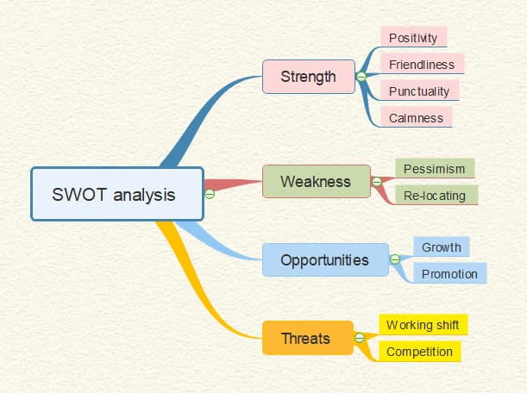

SWOT Analysis

Performing a SWOT analysis on me will be an effective way of identifying my development needs and areas that I need to improve on. While SWOT analysis is fundamentally used by the management, it can also be efficiently used in evaluating an individual as in my case. The analysis tends to focus on recognizing both the external and internal influences that may affect the impending performance of a business. The four primary factors that are focused in SWOT analysis tend to assess the balance the internal possessions and abilities and external potentials and threats (Pahl, Richter, and University of Applied Science Berlin, 2007).
Strengths: these are the qualities that will determine my success in management career. They will enable me to accomplish my goals. They are the qualities, traits, and aptitude that will give consistency to my business. In the business world, the strengths of a company may either be tangible or intangible. Strengths in business can comprise financial resources and a strong workforce. During my course of learning, I have realized that I possess some particular strengths that I believe can help me in my future career. They comprise positivity, friendliness, punctuality, and calmness.
The positivity I possess can be viewed as a strength because I believe it will allow me to take risks with a positive attitude that they will succeed. I will also be able to face setbacks with a positive attitude and not giving up easily.
Friendliness will allow me to adapt easily into the business world. Through friendliness, I will be able to get information and tactics from people who have been in the industry for longer. I will also be able to get the best people in my team, listen to their opinions and warnings to ensure success in my business dealings.
Punctuality will be essential to ensure the building of trust not just for my colleagues but also in business meetings. Being punctual will allow me to have enough time to prepare myself for such things as presentations and meetings.
Calmness is among my best traits. I am able to remain calm even if things may be going wrong on my side. I believe that this trait will help me to achieve my goals because, in the business world, things do not always go as expected. Calmness is a requirement for success. By remaining calm, I will be able to look over issues, see where I went wrong and try to solve them.
Weaknesses: these are usually the qualities that prevent an organization from achieving its full perspective. Weaknesses are however manageable and the impact of the impairment done by them can be reduced. This can only happen when an organization is able to identify its weaknesses. Just like a business organization, I also possess some weaknesses and by identifying them I will be able to have control over them. These comprise of pessimism and fear of relocation. I believe that I can control the two weaknesses for my success.
Since I know that I am not always an optimist I will ensure that I involve teamwork in areas that involve optimism. By listening to others it will be easier for me to believe in something despite my doubts. Effective communication with my colleagues will also play a role in reducing my pessimism.
Since I fear to relocate to different places, I will make sure my business premise is close to my home environment hence ensuring my comfort. If there ever comes a need to relocate, I will have mentally prepared for it so as not to affect my business dealings.
Opportunities: Every business possesses a myriad of opportunities in any given environment. Opportunities may arise from outside sources such as the presence of market and absence of competition, or inside sources such as unexploited establishment’s resources. Just like a business, I also have numerous opportunities for self-development and success. I believe that I have the opportunity of growing and getting promotions if I work effectively enough. If I am able to increase business and sales in my organization, I will have an opportunity of moving to the next level.
Threats: These are usually the elements of vulnerability that threaten the productivity of a business. Threats are often unavoidable and irrepressible but need to be known in order to find any feasible solution. Some threats may comprise of increase in competition or an increase in taxation. One of the threats I believe that I will encounter will be working shifts in the business. Since I cannot control the customers, I will have face working on stressful days and the days that will have a low number of customers. Another threat is the fact that I am not the only one getting into the business world. Most of us will venture into the same opportunities meaning that I will be faced with competition in achieving my dream career. I have to ensure that I am better than the rest of us so that I can be able to achieve such goals.

Learning Styles Questionnaires
Cognitive/learning style can be said to be the preferred way that any particular person processes information. Contrasting with the "individual differences in abilities" such as Stenberg, garner, and Guilford that tend to focus on peak performance, learning styles focus of an individual's typical mode of thinking, their problem-solving skills, and skills in remembering things (Allen, Scheve, & Nieter, 2010). For this reflective review, I undertook two learning styles questionnaires. These comprised Kolb and Lewin learning style and VARK questionnaire.
VARK Questionnaire
Visual, aural, reading and writing and kinesthetic (VARK) model can be said to be among the many instruments used to determine the learning style of any particular individual. The VARK questionnaire was first developed in 198 by Lincoln University of New Zealand (Dunn and Griggs, 2000). The questionnaire is based on three principles which are:
- Everyone is capable of learning academic issues; if not, everyone has their own styles;
- The learners’ motivation tends to increase when their learning styles are taken into account;
- All the educational theories can be learned through the application of senses and different perceptions.
In simple terms they meant to assert that individuals tend to acquire environmental knowledge through four main sensory modalities, the VARK (Visual, aural, reading and writing and kinesthetic) (Matthews, Deary, and Whiteman, 1998).
After undertaking the VARK questionnaire, I found that I had scored 18 on higher personal power, 16 on focused energy, 17 on “stickability”, 18 on learning orientation, 19 on high empathy, and 15 on realistic visioning, 19 on social competence, 20 on situational responsiveness, 19 on analytical skills and 17 on competitive motivation.
According to this analysis, my strengths were found to be situational responsiveness which I got the highest possible score (20) followed by analytical skills and high empathy (19). The areas that are blockages to my personal effectiveness are realistic visioning which I scored lowest at 15.
From these results, I can be categorized as among the group of students who are kinesthetic, meaning that I learn best through practical guidance. I am able to gain experience through the handling of objects through physical processes.
Myers Briggs Personality Profiling Test
The Myers-Briggs theory is essentially a reworking of the theory for testing psychological types that were designed by Carl Gustav Jung. This theory is based on testing on 16 different types of personalities which Carl Gustav Jung viewed as being stereotypes that act as beneficial reference points of understanding unique personalities (Emre, 2018).
Myers Briggs comprises four main preferences:
- Extraversion or introversion,
- Sensing and intuition,
- Thinking and feeling,
- Judgment and perception.
For this questionnaire, I found that I am more into extraversion than introversion, I’m into intuition rather than sensing, more into feeling rather than thinking and finally I am judgment than perception.

GO MAD Mind Map

SELF-BELIEF
THIS COURSE WILL HELPING ME TO IMPROVE MY MANAGERIAL SKILLS

Self-Evaluation by Applying Go mad Framework

Go mad framework deals with focused thinking. It enables individuals to fast-track their results and advance in efficiency. According to Go mad, the thinking of any person tends to determine their actions, well-being as well as their results. This is why it is necessary to have focused thinking.
Through Go mad evaluation, I found that I needed to work more on my imagination which will enable me to plan my priorities and define my goals. Increasing my imagination would come as an improvement in my career as it would enable me to believe in self, have personal responsibility for my goals and involve others in achieving the said goals.
I found that the major barriers to my learning and development comprised a lack of imagination as viewed from the VARK questionnaire and Myers Briggs personality test. The only way to overcome this would be to involve others in mentoring me and start being open-minded. Go mad framework option is one of the major interventions that would be helpful in my learning and development. I also plan to involve my tutors and my parents for them to be my support mechanisms.
A personal development plan is essential in this case as it will allow me to achieve one main learning objective. This involves self-analysis through the use of SWOT analysis, setting goals and thus finding my learning objectives. To ensure that I progress effectively, I will be monitoring my progress through weekly timed progress reviews.

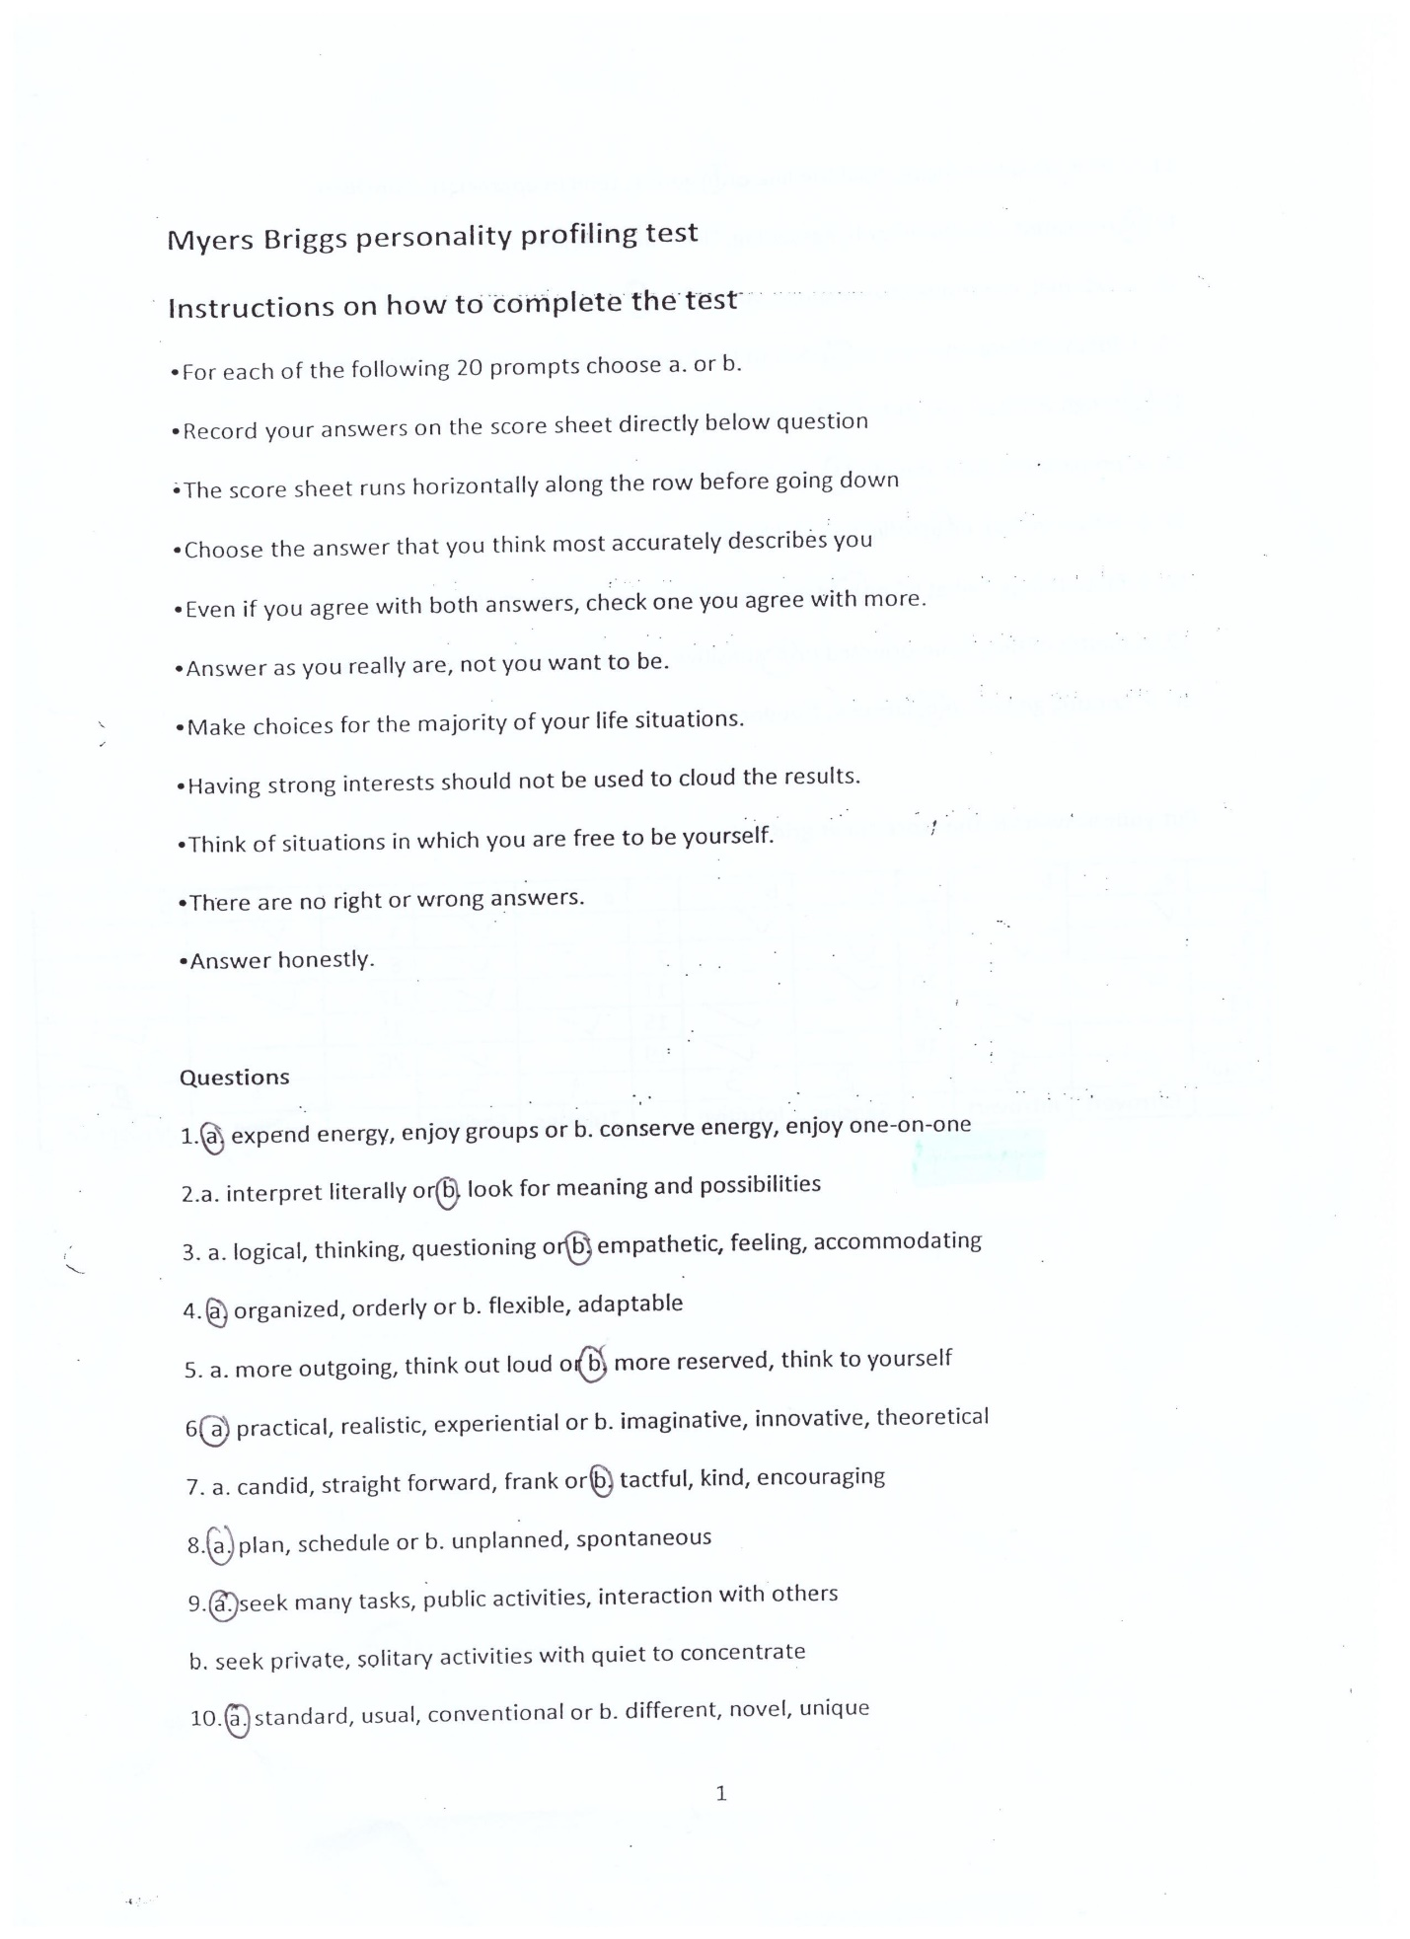
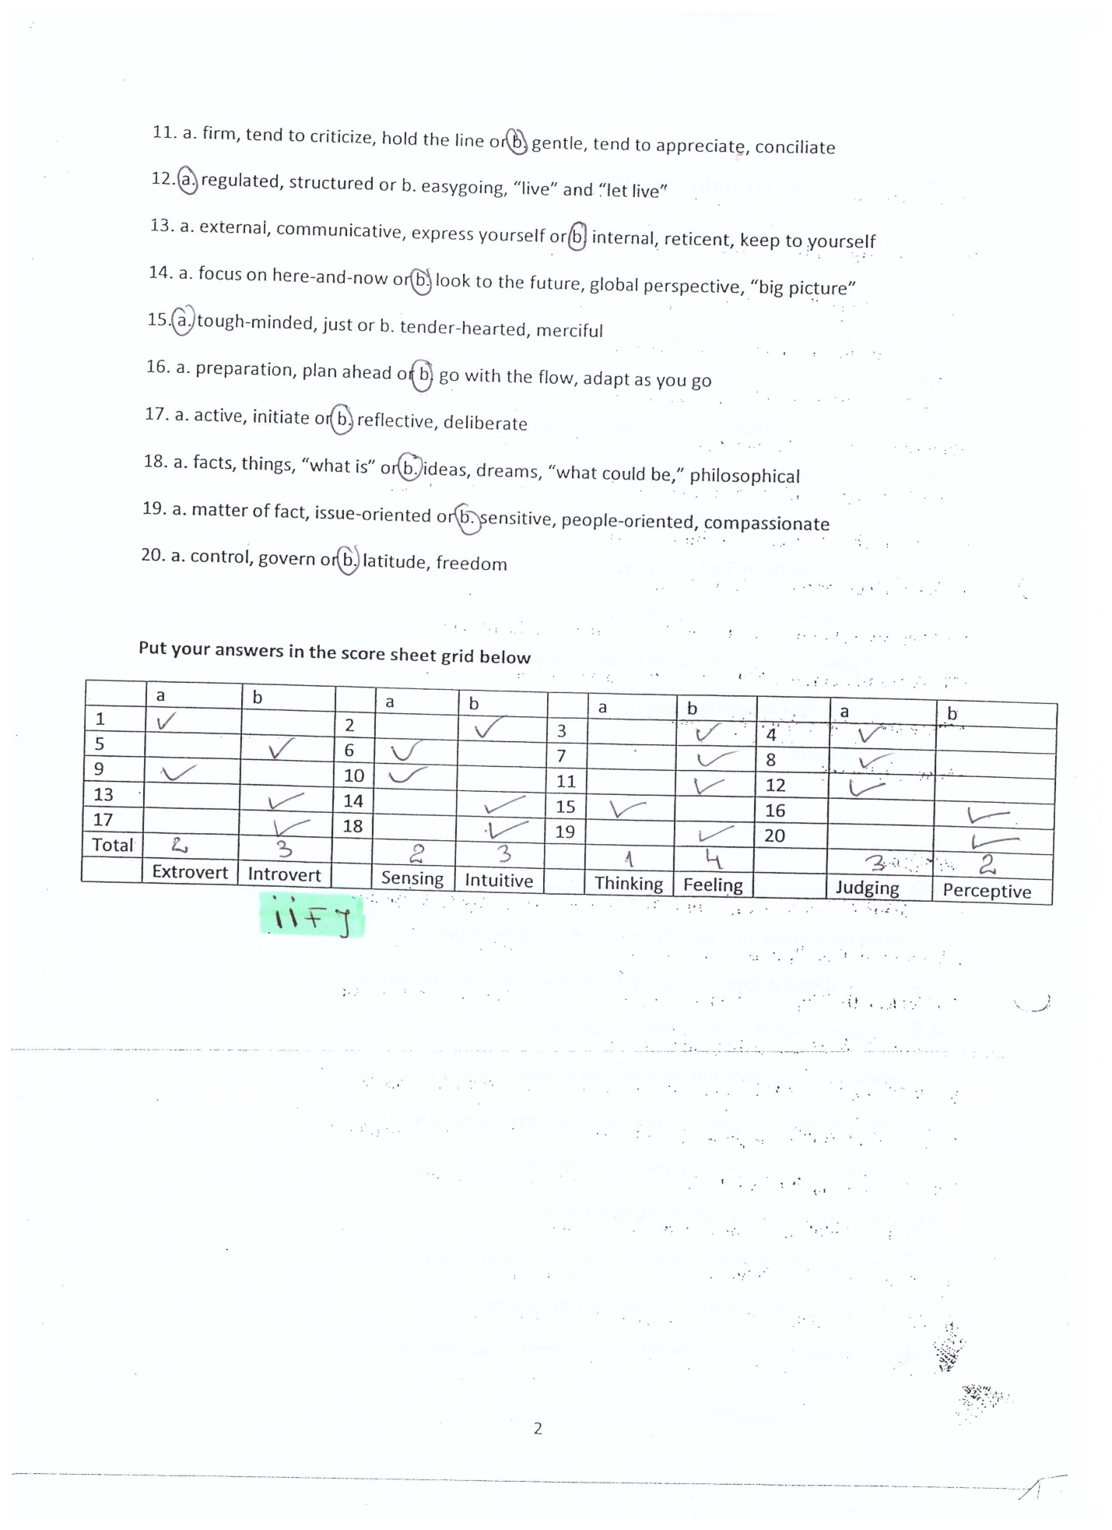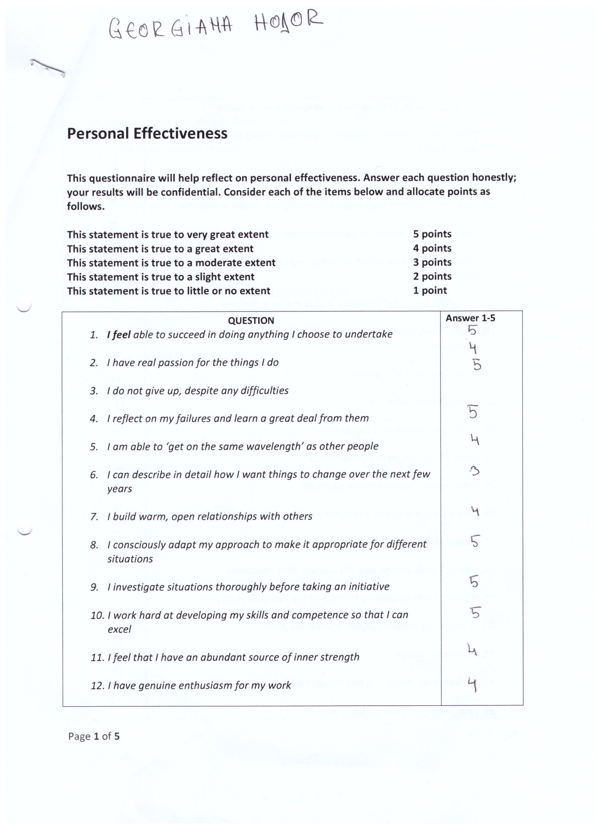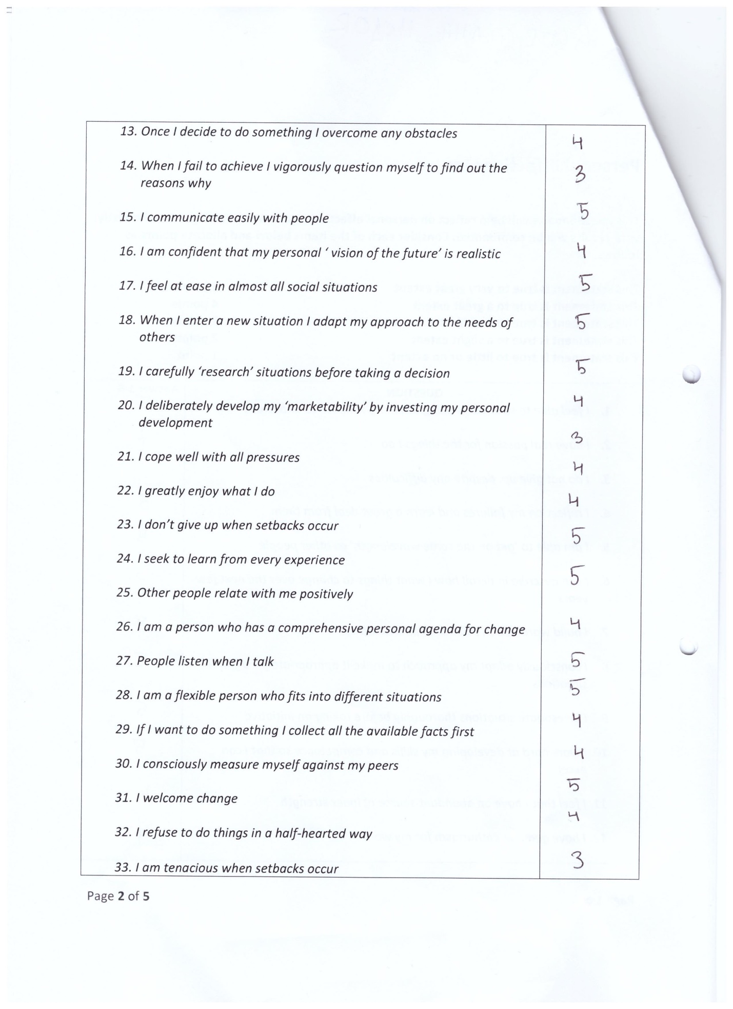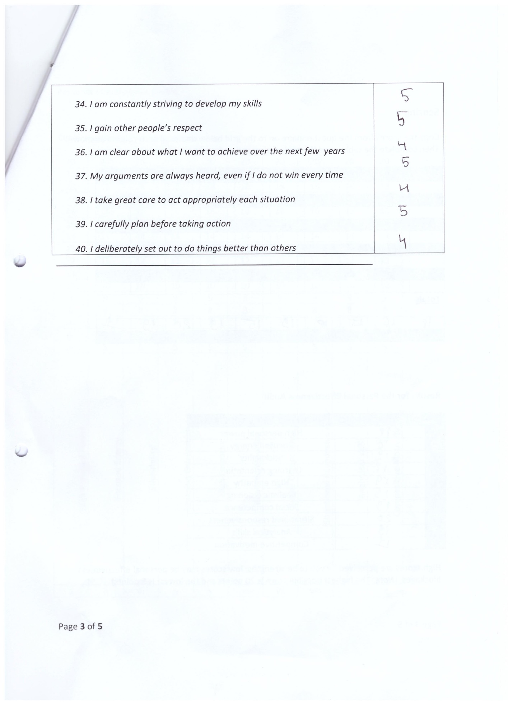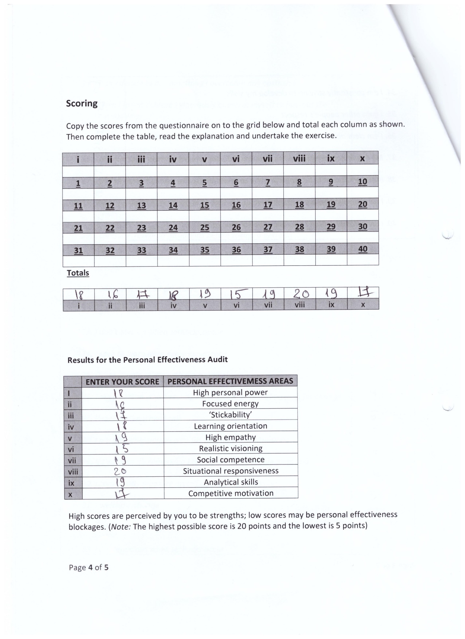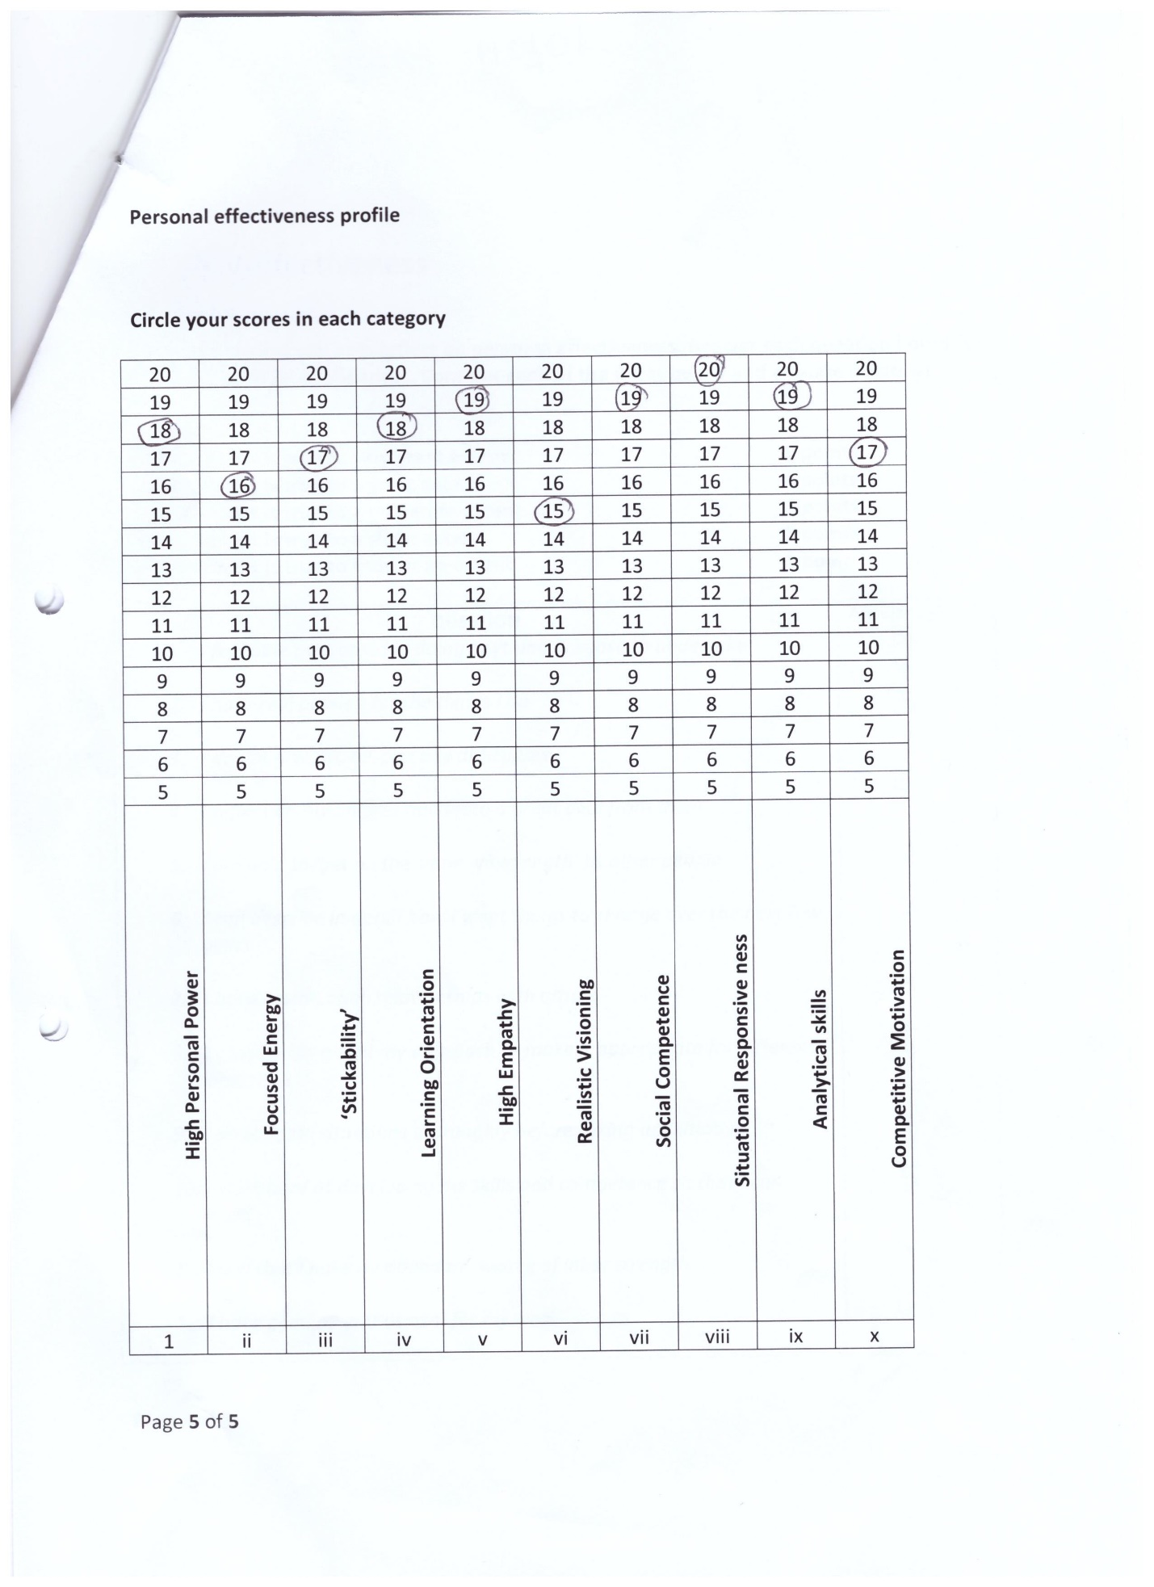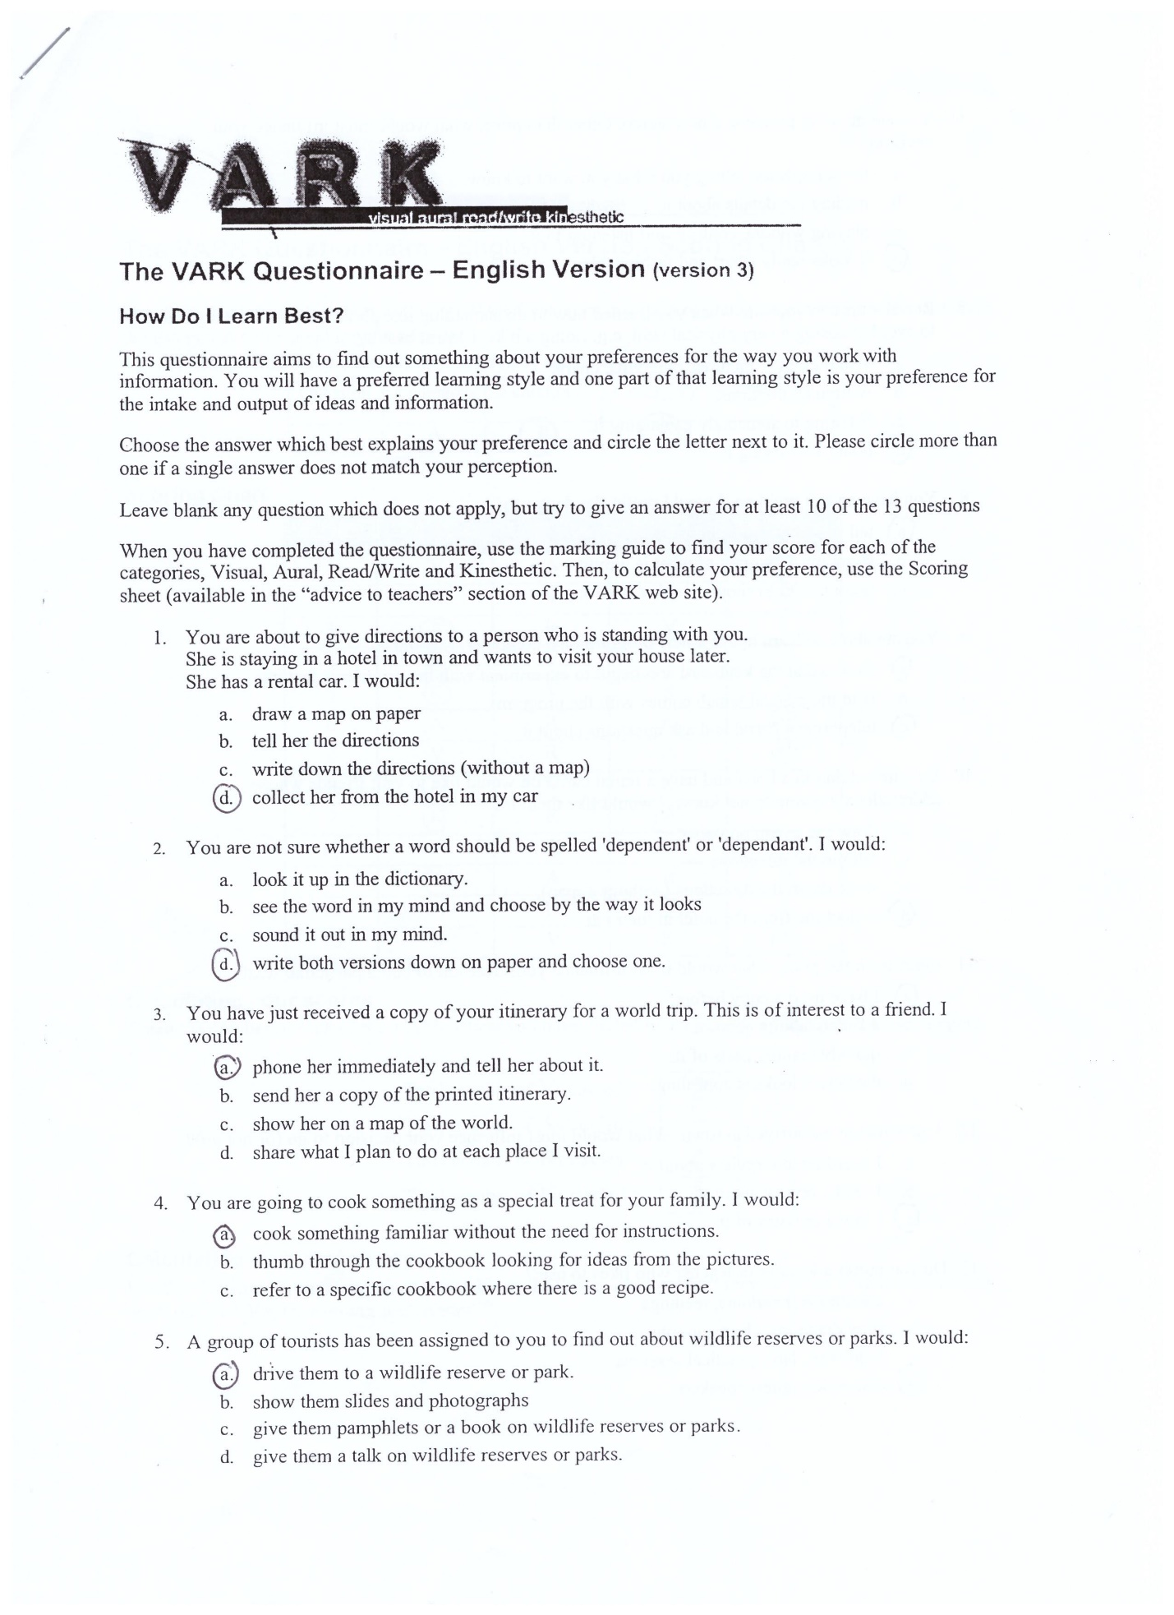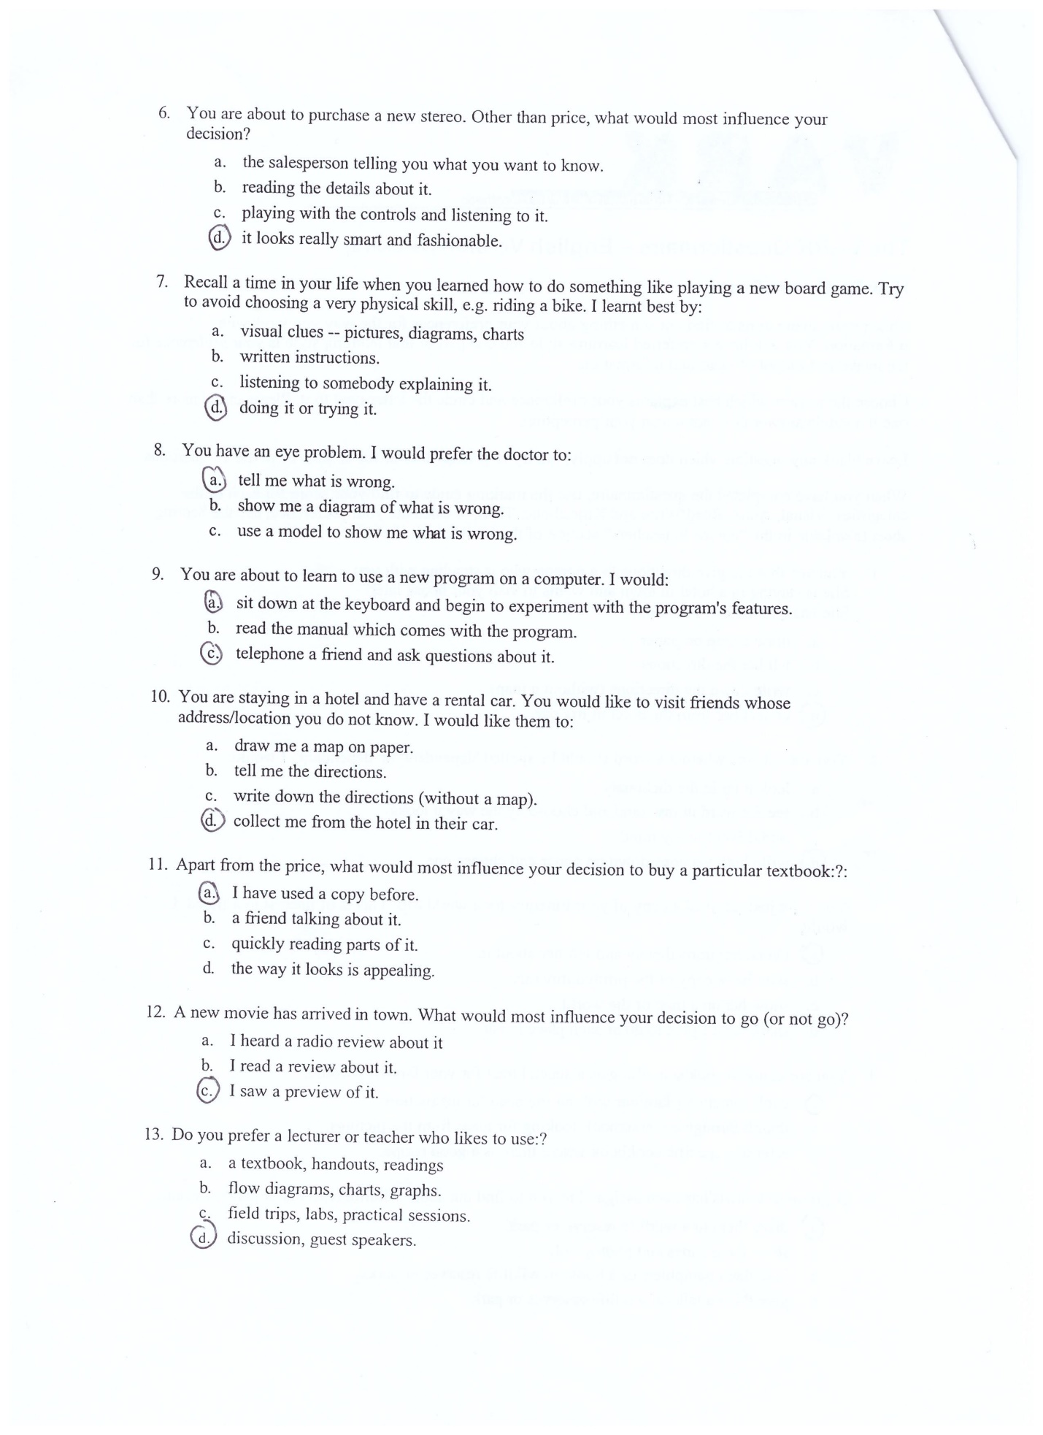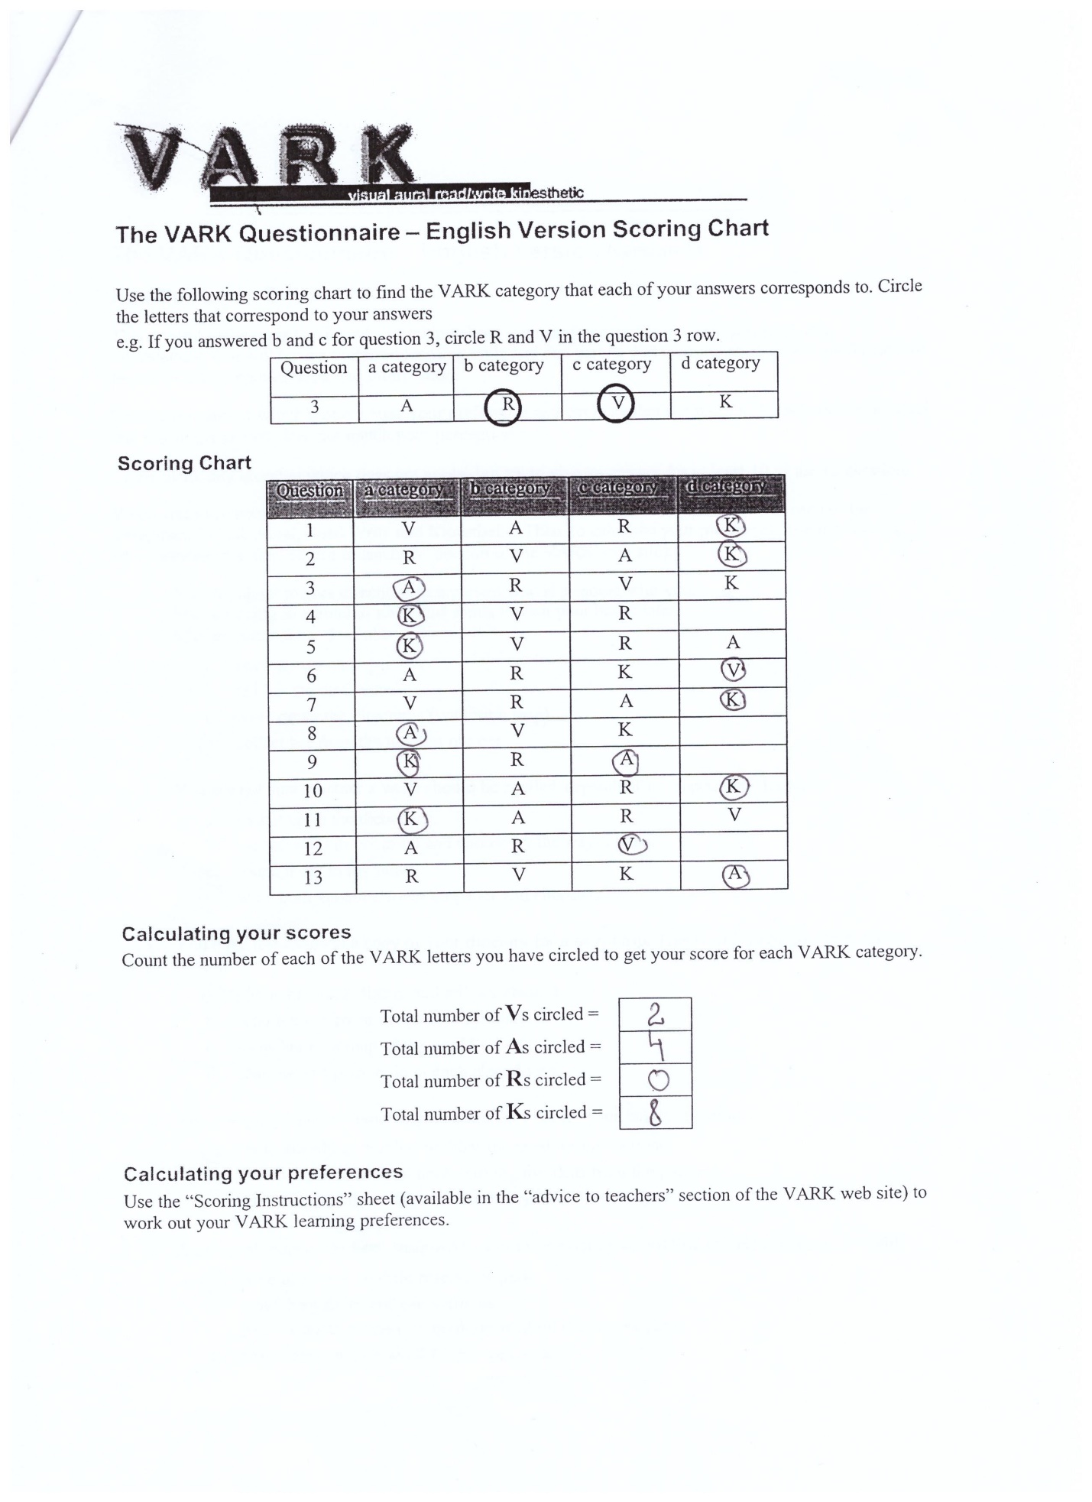

References
Allen, K., Scheve, J., and Nieter, V., 2010. Understanding learning styles: making a difference for diverse learners. Shell Education.
Costa, A. L., and Kallick, B., 2018. Learning and leading with habits of mind: 16 essential characteristics for success. Association for Supervision and Curriculum Development.
Dunn, R. S., and Griggs, S. A., 2000. Practical approaches to using learning styles in higher education. Bergin & Garvey.
Emre, M., 2018. The personality brokers: the strange history of Myers-Briggs and the birth of personality testing. Doubleday.
Forde, C., 2006. Professional development, reflection, and enquiry. SAGE Publications Ltd.
Matthews, G., Deary, I. J., and Whiteman, M. C., 1998. Personality traits. Cambridge University Press.
Pahl, N., Richter, A., and University of Applied Science Berlin, 2007. SWOT analysis: idea, methodology and a practical approach. GRIN Verlag.
Sadler, P., and Craig, J. C., 2003. Strategic management. Kogan Page.
Spaulding, D. T., Lodico, M. G., and Voegtle, K. H., 2013. Methods in educational research: from theory to practice. Jossey-Bass.
Werner, J. M., and Desimone, R. L., 2009. Human resource development. Cengage Learning.

