Lara Alicia Hanford

Research Practices

ADAD5001

Historical and Contextual Studies

My dissertation proposal draws on the core themes of my body of work. My work is heavily influenced by 21st perceptions of feminism, popular culture and the effects of modern society on the psychological and social health of women today. I will be using the following keywords to outline and support my thesis. The key words I have chosen are :- outspoken, expressive and relatable. I feel these keywords will help me to explore and develop all pertinent areas enabling me to offer fresh and challenging insight into my chosen topic.

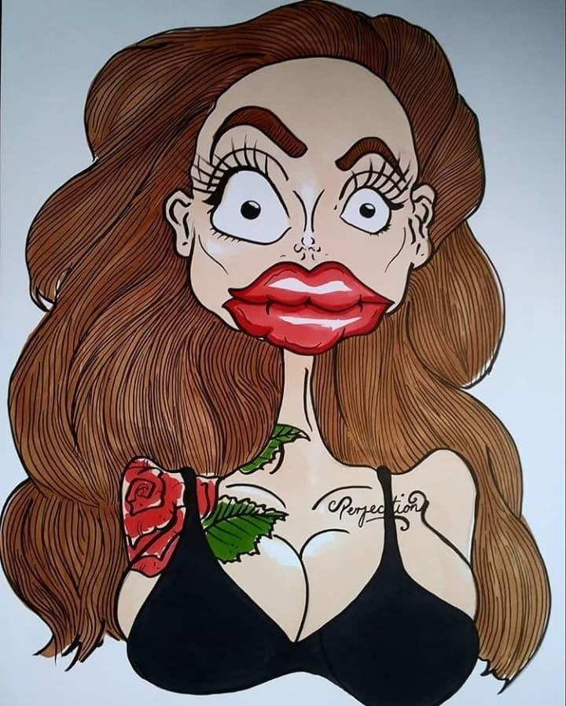
Plastic Perfection
(2018)

The first key word I have chosen is outspoken, my work often questions the role of ‘femininity’ in today’s society. What makes a strong woman in today’s standard? while I am given hope through recent issues raised in gender pay gaps, body positivity, the ‘ME TOO’ movement and more strong female influences in the public eye, I am disheartened by the contrasting toxic obsession with ‘Plastic Perfection. Young women are still being told we should conform to society’s expectations whether it be injecting fillers, covering the outline of our nipples with a thick padded bra, bleaching the hair on our lip or shaving unsightly underarm hair. Only to walk out the front door and see men with their tops off, covered in a thick coat of masculine body hair shoving their hands down their pants. These are the double standards still being faced today, this ideal of femininity is ingrained into little girls and boys from a very young age. As a child I suffered endless bullying in school for the dark hair on my arms and legs. I would dread putting the shorts in my PE kit on because I knew I would be ridiculed by the boys in my class for having “man arms”.

My work in influenced by many strong opinionated female trailblazers such as Barbara Kruger and Pauline Boty. Pop Artist Barbara Kruger’s use of black and white photographs with bold white over red lettering over layed not only catches the audiences eye, but also invokes opinion and ignites conversation. Her work deals with a range of issues like socio-economy, power, identity, sexuality and cultural constructions of power. I first discovered Kruger’s work a few years ago while reading an article discussing the appropriation of her red over white font style by the brand Obey, founded by James Jebbia. Although she had bitten her tongue for many years, when Obey filed a copyright infringement lawsuit against female fashion brand Married to the Mob in 2017 Kruger could stay silent no longer. Speaking in an interview with Complex Kruger stated

“What a ridiculous clusterfuck of totally uncool jokers. I make my work about this kind of sadly foolish farce. I’m waiting for all of them to sue me for copyright infringement “
- Barbara Kruger

This story perfectly illustrated to me how quick men are to take credit for a woman’s idea but how slow they are to credit the women that inspired them and gain the original artist more notirity.

"A revolution is on the way, and it's partly because we no longer take our standards from the tweedy top. All over the country young girls are starting, shouting and shaking, and if they terrify you, they mean to and they are beginning to impress the world."
- Pauline Boty

The reality of men oppressing women in art is not new, when thinking of the pop art movement of the 1960’s what famous names come to mind? Roy Lichtenstein, Jasper John, Andy Warhol, James Rosenquist, it was a pretentious boys playground. Pauline Boty was a founder in the British pop art movement and also the only female painter/pioneer in the british movement, though her time was short her rebellious free spirit still lingers on in her work, she was innovative and self assured creating funny and bold artworks like “Bum” in 1966. Her work often criticized the “Man’s World” in which she worked. While Warhol was touring Europe and America designing album covers for the rolling stones and becoming a regular at Studio 54 enjoying his fame, Boty found out she was pregnant and was diagnosed with cancer, she was told if she would abort the foetus she could be treated for the disease, but she put the life of her child before her own. In 1966 Boty gave birth to a healthy daughter and sadly passed away, her work was then forgotten about in a barn for 30 years.

I believe art is the perfect way to make bold statements and broadcast your opinions. Historically strong female artists are often overlooked and underappreciated, never gaining the notirity of their male counterparts. They tackled hard hitting, gritty subjects including sexuality, gender, identity and power. These women were the pioneers who paved the way for the modern female artists of today like myself, but has that road become any easier to walk?

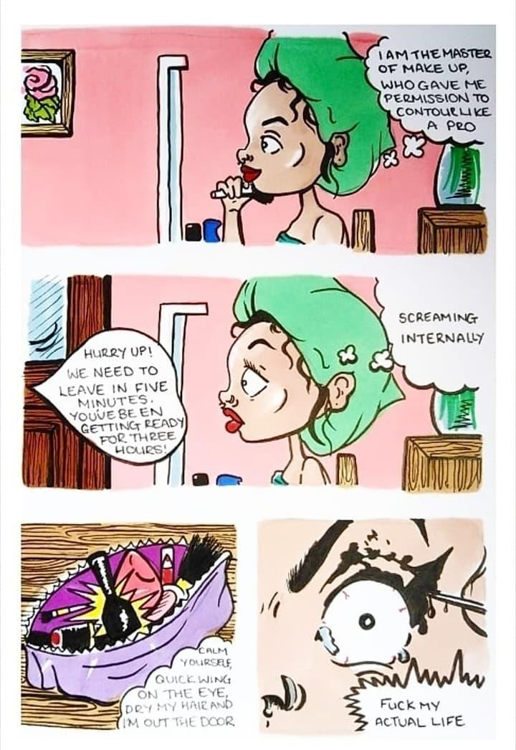
I’m Fine
(2019)
My second keyword is Expressive, I have always struggled to speak my mind or give my opinion due to my social anxiety, I doubt myself and overthink until there is nothing left to say. However art and illustration has opened up a brand new form of communication for me, as I have confidence in my work it allows me to speak openly about issues that affect me. The more my confidence grows and flourishes the more bold my opinions become. I have always had a dark sense of humour influenced in my youth by films like The Rocky Horror Picture Show, Young Frankenstein and The Little Shop of Horrors. Like these films I learnt not to take myself too seriously, and that divisive opinions are received better when delivered with humour aspose to delivering your message in a preachy self righteous way. In 2019 I developed a zine titled “I’m Fine” which looked at the day in the life of someone dealing with mental health problems. As someone who suffers with anxiety and depression I found it deeply cathartic to express and share the struggles I deal with on a daily basis. I knew given the material I was discussing that it would be easy to go down the ‘woe is me’ route, but that was a stigmatism I wanted to break. I wanted the audience to be able to laugh at their mental health and not let it consume their lives. The response I received after sharing the work was phenomenal, with people responding with their own stories and being able to make light of a shit day.

“I can only make art that reflects who I am, and humour is important to me so it’s going to be in my work.”
- Julien Ceccaldi

Julien Ceccaldi uses stylized large jawed caricatures to poke fun at post 2008 car crash millennials. His work is a parody of modern life and takes influence from the superficial and 70’s japaneese cartoons . His work covers subjects like gender, sexuality and socio-economy. Ceccaldi also uses cooling colour palettes in his illustrations, I also use this in my own zines to invoke a sense of calm and safety in expression to the viewer, when there is a strong message I don’t like to overwhelm with harsh vivid colours. I especially liked Ceccaldi’s 2017 painting deals with exclusion based on looks and not looking perfect and how superficial we have become.

“I have been taking every step toward the future every day through making many paintings and sculptures with my deep emotion hidden in my life.”
- Yayoi Kusama

Another artist whos work displays fantastic expression is Yayoi Kusama . Her stylistic bold dots are instantly recognisable today. She created pop art that had many themes including feminism. Early in her career her style was copied by many male artists and gained them instant fame, alas this was not to be the case with Kusama. This left her poor, desperate and she attempted suicide, one can only imagine the sense of frustration she was put through.

"If it were not for art, I would have killed myself a long time ago."
- Yayoi Kusama

Kusama’s trauma was a large inspiration in her work, she felt like she had no control of her life.She used art as a coping method, she had complete control of her work and how she made her audience feel. I also find art is a wonderful form of therapy, you can let out all of the feelings onto your canvas. It allows you to convey a message that is too hard to put into words.

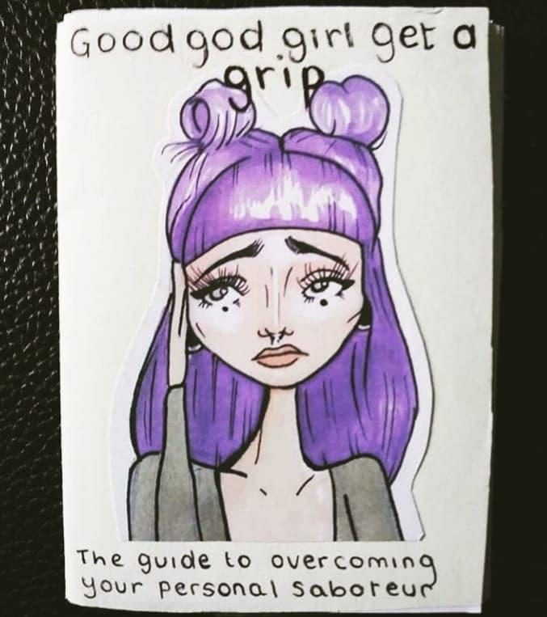
Lara’s Little Book of Calm (2017)

My final keyword is relatable, I like to make punchy statements and create work that women can identify with. I enjoy creating zines as it is a low cost way to communicate with you audience and it feel inclusive. I feel as artists we have a responsibility to educate and inform a wide audience. My work deals with a range of subjects such as gender equality, feminism and mental health, this resonates with others dealing with the same issues. It’s scary to think that only you are dealing with such issues, my work tries to combat that. You can build a community of like minded souls through art and help the audience feel like they are not alone. I feel that this is displayed in the rise of the meme, people share memes that they find most relatable on social media regularly to express their feelings.

“I never sat down and decided to make work about life and death. It just all comes out of my head like water pouring out of a jug.”
- David Shrigley

An artist who has uses this notion of community is David Shrigley a contemporary British Artist. He illustrates flat compositions take on strange elements of everyday life. Shrigley makes dark and funny illustrations that comment about the world. His witty commentary on awkward interactions is relatable to a vast audience. Some of my favourite works include I’m currently on fire (2018), Untitled (absolutely no problem at all) (2019) and Express my Love (2014). With crude lines and a wicked sense of humour Shrigley is able to reach many people with his work and allow them to take the superficial things in life a little less seriously, you don’t need a deep knowledge of art to appreciate his work which makes it relatable to everyone. I especially enjoyed his Exhibition of Giant inflatable Swan-Thing he created to show at Spritmuseum in Sweden. I believe it was poking fun at the instagram generation who feel the intense need to impress others online with photos of travel and wealth. I believe the Swan-Thing was a mockery of the rise in sale of unicorn pool floats that women spend large amounts of money on to get the perfect holiday snap. It’s laughing at the superficial age we are currently in, the need to keep an idealistic and unrealistic social media presence.

"I can't deny anything the viewer reads into the work; that is the viewer's pleasure, hopefully. I am a permissive artist. I allow things to happen. I believe the viewer is half the work. Duchamp said it and I believe it."
- Lynda Benglis

Lynda Benglis work confronts femininity in the context of a male-dominated art world.
She predominantly works in wax and foam with poured sculptures, she wanted distinguish her work from male artists at the time who worked in masculine materials like stone and metal. I believe this is also a commentary on how men stay unchanging and firm but like water women are adapt and change fluidly. In 1974 Benglis shook the world with her eye catching advertisement campaign for Artforum, in one of the most famous images she is photographed wearing nothing but a double ended dildo, talk about making a statement. She showed young women that power was more desirable than beauty and fitting into society’s mold of what a woman should be. Benglis’ work criticized traditional depictions of women in the media and she has paved a way for young female artists to follow in her footsteps. Like many female artist she garnered very little recognition at first, being compared to male artists like Jackson Pollock. This seems to be a recurring theme of people trying to credit men and discredit women in the art world.

You must connect with your audience if you want a reaction, it’s easy to excite the eyes but much harder to stimulate the brain. Visual communication is an international language and can be used to spread your message and ignite change.

“One is not born, but rather becomes, a woman.”
― Simone de Beauvoir, The Second Sex

Through my research I have uncovered a common theme in the double standards women suffered and are still suffering in today’s society. Female artists are on the rise but still are overlooked by peers in the art scene and by the masses. Male artists are constantly gaining recognition but the struggle it real for female artists, as we are constantly compared to our male counterparts, which undermines everything these women have fought for. By taking inspiration from strong female role models like Simone De Beauvoir, Tracey Emin and many more I will research where the fight for equality began and a look at where it is in the present day.

After extensive research into the subject, my chosen research Question is :-

The second sex- second hand or second chance?
A study into the changing expectations of women in society in the twenty first century

Bibliography

https://www.thecut.com/2017/11/i-think-about-when-barbara-kruger-dragged-supreme-a-lot.html

https://www.theartstory.org/artist-boty-pauline-life-and-legacy.htm

https://www.brainyquote.com/authors/yayoi_kusama

https://www.plastikmagazine.com/interviews/yayoi-kusama

https://www.theartstory.org/artist-benglis-lynda-life-and-legacy.htm

Simone de Beauvoir, The Second Sex

