PROFESSIONAL CAREER

DEVELOPMENT

CERTFICATE FOR HIGHER EDUCATION FOR SKILLS IN THE WORK PLACE

(CERT HE)
Samsul Islam 1914178
Lecturer Mel Squires

Date: 21/02/2020
Modual Code: BMSW4005

University Wales Trinity Saint David

(UWTSD)

Executive Summery

Purpose of this report is to demonstrate employability skills to be required by the employer to for the candidate to be employable. In this report I will analyse the skills required by myself to make an appropriate candidate. The report will break down specific skills such as Communication skills, problem solving, adaptability, collaboration, organisation, Technology, personality traits, networking writing, and information use and will be research appropriately. Using the SWOT analyse as explained by “Künzli, Benjamin Mar/Apr 2012” I have found out my strengths and weaknesses and how to use my strength to make my threats into opportunities. Also, I will provide an in-depth PDP to demonstrate my learning needs. To produce the PDP and discover learning style that need to be improved by utilising two questionnaires. VARK, Honey and Mumford explain preference learning style and modality. This will be constructed looking at previous and new learning techniques and current skills and development areas for a chosen career.

Table of Contents
CERTFICATE FOR HIGHER EDUCATION FOR SKILLS IN THE WORK PLACE 1
(CERT HE) 1
University Wales Trinity Saint David 1
(UWTSD) 1
Executive Summery 2
1.0 Terms of Reference 4
2.0 Procedure to Evaluate Report 4
3.0 Introduction 4
4.0 Areas of Development Needs 5
4.1 History of my learning 5
4.2 Development 5
5.0 Learning styles 6
5.1 VARK 6
5.2 Honey and Mumford 7
6.0 Methods and tools to identify 8
6.1 SWOT ANALYSIS 8
6.2 GO MAD 8
7.0 Importance of Employability Skills 9
8.0 What I Learnt and Plans to Overcome Learning Barriers 9
9.0 PDP 10
10.0 Conclusion 11
11.0 Recommendations 11
12.0 Appendices 12
13.0 REFERENCING 18

1.0 Terms of Reference

My name is Samsul Islam. This project was to write a report as part of my assignment from, UWTSD (University Wales Trinity Saint David) and lecturer (Melanie Squire) for the access level course higher education for skills in the work place (CERT HE). Demonstrate my understanding of Professional Career Development (PDP). Can I understand and implement how important it is for myself and others independently, within a team or organisation to attain what we perceive as a goal. Becoming qualified, career moves for a higher position in a current job or wanting to set up a business or expand a business. Explore different learning styles and understand employer’s needs. My deadline for this report is the 21/2/2020 which is when it would be handed in with all the necessary information in structured format.

2.0 Procedure to Evaluate Report

This report will be created from researching journals, books, articles, questionnaires from in class and further from the World Wide Web. Learning styles were also investigated and a strengths, weaknesses, opportunity and threats (SWOT) completed. This was followed alongside further exploring Employability skills, VARK, Honey and Mumford, Go MAD and a Personal Development Plan (PDP). All relevant exercises that will be completed to are attached to appendices.

3.0 Introduction

In this report I explain how the development to both short term and long-term career goals and targets which can guide my decision-making skills throughout my studies and career choices. Becoming involved in complex projects or, gain a certain type of job in my desired career utilising personal development plan” Stella Cottrell 2003”. PDP which is a guide for all, who want to reach particular career goals, in a structural procedure. I will create a PDP, review which methods can be used for myself as an Individual or in an organisation to be able to reflect and make personal improvements towards my career development and provide examples, my goals and what I am doing to achieve. I will explain and complete a tool called SWOT; however, I need to first understand my learning style therefore I will be explaining and executing a questionnaire known as Honey and Mumford along with a VARK questionnaire. I will be also utilising another method to help me complete SWOT analysis” Sarsby, 2016”, which is an exercise known as GO MAD” Andy Gilbert, 2005”. I will explain about employability skills as this is also part of my progression to advance in what I will want to accomplish whether I wish to do it for sort or long-term goals.

4.0 Areas of Development Needs

4.1 History of my learning

Previously, at high school I was unmotivated during the majority of class lessons, tasks, activities, homework and exams. Therefore, I became reluctant and disengaged, even at Further Education. There’s lots of potential inside me, however, this would only be noticed whenever I would participate in actual and physical activities such as making items like a box with compartments out of different types of wood to become a pencil case, manipulating and moulding plastic to a desired yet realistic creation along with learning to create electrical circuits (I made a forward moving electric car). Group activities where I would communicate with peers and complete our task. I would learn well when I had one to ones with my tutors and was given structured instructions. I realise I perform excellent when I have a good understanding after extensive researching.

4.2 Development

Years working in different fields including retail, food industry, administrator, payroll, HR (human resources) I decided to have a career change to better myself and have self-satisfaction by doing something greater and attain a good reputation. I would like to enhance and expand my education so that I could study Law. I have seen and spoken to many legal advisors and understand what it is they do and have formed a liking for law. My goals are, improving my learning skills and employability skills which are essential to recognise, manage and cope with emotions, gain authentic work experiences and implement what I learn in the future effectively and efficiently” Ann Gravells 2010”. Further become a barrister or/and a Solicitor due to liking how I have helped people throughout years of experiences in customer care fields, solving problems and inevitable have my own successful firm/business. This is why I choose CERT HE. This curriculum is a level 4 qualification and I can earn my certificate through the course of one year. Developing my skills and accomplishing myself 4 merits or 3 distinctions I can study Law in Cardiff University and get my LLB (Latin: Legum Baccalaureus) also known as Bachelors of Law degree so I can Practice Law. Throughout improving my skills over the course of three years at university, this course could also shape my entrepreneurship skills and help me after I have studied law. I would be able to understand how to set up and establish my own firm/s.

5.0 Learning styles

5.1 VARK

Introduced by Neil D. Fleming in 2006 is a 16-point questionnaire model that aims to identify how an individual prefers how to acuminate and process intellectual information” Neil D Fleming 1955”. VARK is an acronym that stands for (V) visual, (A) aural, (R) read/write and (k) kinesthetic. Also known as sensory modalities. Descriptions of the 4 sensory modalities and my results are below: -
- (V) Visual = 9
This modality is about how a person preference includes the depiction of information in graphs, diagrams, charts, symbols, maps and designs. Different formats that are used to highlight and convey messages are more understandable than just reading words, hearing or touch.
- (A) aural = 12
This perceptual mode describes the preference of information taken in via being heard or spoken. Understand by taking information, given verbal instructions or data and speaking. Discussions within groups or one to ones. Listening to radio’s, over the telephones and podcast are just some variations.
- (R) read/write = 3
Essentially, people preferences are words displayed. This emphasising the use of word in-put and out-put. Reading and writing are in many forms mainly found in essays, reports, journals, text books, articles and instructions.
- (K) kinesthetic = 11
This perceptual preference is related to people who use experience and practices to attain an understanding. People who prefer to have practical applications using real life or simulated experiences. Movements, experiments simulations and interactions to their learning environments are preferred in this modality.
According to VARK I have a multimodality. I will not be satisfied until u have had enough input or output in all preference modal. Taking longer to gather information that would result in having, deeper and broader understanding. I can be seen as a procrastinator however I prefer to have a clearer understanding before acting. This allows me to make effective decisions. I also seldom read/write therefore, I will manage my time by allowing enough time for each task, so that I would not have to rush and am able to research vastly to complete tasks to high standards. I will write notes from lecturer’s advice, guidance and instructions. Throughout university term’s, writing reports, essays, articles, journals and books and case studies and then reflecting and getting feedbacks, so my reading and writing will improve. Legal advisors must be able understand legislations and be capable to give and take critical information exceptionally throughout their career.

5.2 Honey and Mumford

This is a questionnaire is a self-development tool to find out people’s preference in learning styles. It is a model of learning theories developed by researchers Peter Honey and Alan Mumford who identified 4 distinct learning styles names as activist, theorist, pragmatist and a reflector. My questionnaire results were: -
- Activist = 6
This is someone that has a liking for new experience by being involved without bias. They are open minded and would grow strongly and vigorously with each new experience. They get bored of repetitive routines and long-term commitments. They do not learn from theories, reading or analysing data. They like role plays, problem solving and competition.
- Reflector = 18
In this preference people appreciate someone who is well experienced in the area of similar interest, observe from many angles by collecting as much information possible to gain knowledge before implementing. They are considerate of others and will always listen. They do not like to be rushed without preparation. Observant of activities, compare thoughts and actions of others, coaching, discussions in pairs or groups and from feed backs.
- Theorist = 14
They like to analyse and synthesis testable hypotheses. They like to understand the theory behind an action. The people with these preferences get information via stories, statistics, theories models (applying theories) and facts. They are also perfectionists. They think logically and rationally until they can prefect their scheme rather than subjective judgements. They do not work so effectively without instructions.
- Pragmatist = 13
Putting theories and learnings to practical uses via simulation or hands on experience. Engage objectives with structured information or instructions. Problem solving case studies or other problems via simulations until a desired outcome is gained before practical engagement.
I can identify my specific style and therefore choose activities which are beneficial to my learning. I have developed an understanding of which preference would be useful and apply.” Peter Honey, Alan Mumford 2000”. Information from researches and experienced people advise and feedback would allow me to have a further broad and deep understanding. I will further continue to develop my self-awareness by using case studies and given tasks to solve problems with my own research and reflecting completed drafts throughout university.

6.0 Methods and tools to identify

6.1 SWOT ANALYSIS

This is a simple yet effective framework which can help me make decisions. Individually, in teams or organization to be able to improve in a new and different environment. By first exploring my strengths and weaknesses to see the capability to accomplish a goal. I would understand all factors that could stop me from achieving my goal and look for opportunities to overcome them. My learning styles could affect me from qualifying to study and practice law. By doing a SWOT I realised I have great communication skills and an understanding for right and wrong, however I lack read/writing which is essential for legislations and communication. Without this skill improved I cannot proceed towards studying law. I will take the opportunities at university where I can get help, feedback and given tasks to improve this factor. This enables me to continue at Cardiff university doing my LLB degree with confidence. (Sarsby, 2016, Dyson, 2000, Künzli, Benjamin Mar/Apr 2012)

6.2 GO MAD

This is a pyramid results framework. A solution focused thinking methodology that once embedded can have a result that would be drastic. Using this framework, we enable ourselves to solve problems, productivity. This is also known as the art of making a difference. This technique is in 7 structured steps. My steps are: -
- Attain LLB degree.
- Recognised career, help people, utilising my skills learnt and personal satisfaction.
- Attend CERT HE and earn distinctions and/merits and improve my learning styles.
- 10
- 7
- Lecturers, piers, friends and personal tutors.
- Reflect all assigned tasks, getting feedbacks and second opinions lecturers from friends and piers. Conduct one to one with Beth Downing’s every Tuesdays
I realised importance to strategies when trying to achieve a goal. Following these steps, keeping it structured and maintained, would always let me see my theories are accomplishable or realise it is not worth continuing (result). I can utilise this method in day to day activities and long-term goals” Andy Gilbert, 2005”.

Importance of Employability Skills

Employers look for specific skill within a potential employee whilst recruiting. My goal requires me to have experience in fields that I wish to work in therefore I need to understand what skills I have that would benefit their business and what skills I need improving “Ann Gravells 2010”. Skills I have: -
  - Communication skills
  - Problem solving
  - Adaptability
  - Collaboration
  - Organisation skills
  - Technology Skills
  - Personality traits
  - Networking
Employment in the law firms or courts throughout education would give me experience in sector of my choice allowing me to become more appealing when I apply for jobs, and possibly in future to run a successful firm. To give Giving legal advice, I need to improve taking information by doing my own research and reading legislations. I need to be able to write legal notices and information to clients and third parties therefore I need to be able to critically think and write. I need to better manage my time, written communication and organisation skills. These skills are essential along with current skills “JP Robinson 2000”.

8.0 What I Learnt and Plans to Overcome Learning Barriers

Allowing myself enough space before deadlines to execute my skills according to VARK and Honey and Mumford, I can use each learning preference to gain a deeper and broader understanding allowing me to engaged tasks confidently and effectively. I understand that if I want to do study LLB and become a legal advisor and practice Law, I need to improve my read/write and have a good time management alongside gaining experience working in Law firms/courts even if it be short term voluntary whilst earning my qualification. I will do a PDP utilising all above mechanics and SMART.

9.0 PDP
Goals and Priorities | Objectives Now | Support and Resources | Measure objectives | Target date for achieving my objectives

FIRST TERM Targets
Mid Term Targets
Long term goals and priotities

- Keeping up to date with university work and not falling behind any scheduled assignments  - Become more Motivated  - Learn New techniques  - Time management and organisation | - Allow enough time for myself to complete tasks without rushing  - Practicing leaning style and skills learnt  - Motivate myself to get on with the task/s  - Manage time for studying, work and myself  - Structure learning material/s | - To Do list  - Alarms  - Weekly scheduled lectures  - Lecturers 1 to 1s after lectures  - World Wide Web to research all work for thorough arguments  - Friends, Family | - Create a weekly to do list and reflect  - Attend all lectures  - Set alarms to ready myself before lectures  - Set alarms on to do list and daily tasks set  - See lectures on Tuesday and Thursday or Friday for one to ones and get feedbacks  - Speak to family for encouragement | Ongoing throughout studying 2020 – 2021
- Continue improving my learning skills and more about employability skills and about running a business  - Develop my Read/Writing so that I can take information better without needing advice | - Write reports  - Essays  - Articles  - Books  - Case studies  - About referencing  - Reflecting  - Leadership skills  - Entrepreneurship skills | - Lecturer’s  - Peers  - Internet (google books, scholar, student library)  - Moodle  - Gain contacts in desired field for advice and demo | - Attend all lectures  - Research plenty viable sources of information  - Twice a week attend one to ones with lectures for guideless and feedback  - Research different learning styles  - Write plenty notes for given tasks  - Reflect on feedback given on completed drafts before submitting | Ongoing from  January 2020 – January 2021
- Attain skills and qualifications to study law.  - Experience in field I desire  - Short term job  - Contacts in relevant field  - Become more punctual and assertive. | - Complete CERT HE with distinctions and/or merit to qualify to study LLB and practice LAW  - Throughout my LLB course try work for a Law firm or courts.  - Continue to improve learning skills.  - Always allow time to complete task | - Online research  - Peers  - Lecturers  - Known Legal advisors  - Career wales and job centres  - Practical task in LLB course and possibly within a law firm/court | - Feedback from lecturers twice a week  - Distinction or merit after each assignment  - A job or voluntary placement in a law firm or courts whilst studying  - Attend all lectures throughout studies  - Passing exams  - Reviewing tasks twice before turning it in  - Tick to do list daily set tasks  - Voluntary placement | Ongoing from 2020 till 2023
“Beausaert, Simon; Segers, Mien; Gijselaers, Wim; Wiley-Blackwell 2011 Janet Strivens, Rob Ward 2010

10.0 Conclusion

I need to develop read and writing skills, organisation and time management skills based on evidence from VARK, also Honey and Mumford questionnaires as my learning style is multimodality and these preferences can be improved. Further investigation of SWOT and Go MAD I can create strategies to accomplish a goal. I can implement strategies of improvements utilising a PDP. Developing these skills and earning the CERT HE certificate would allow me to be employable in desired career.

11.0 Recommendations
By doing reports, essays, articles, books, journals and case studies would improve my read/writing skills. Spreading out assignments and setting a to do list would improve my time management and organisation skills. This structure should be implemented to improve set skills thought the course of university. Completing CERT HE would will also develop my employability skills and shape my futue entrepreneurship skills.

12.0 Appendices

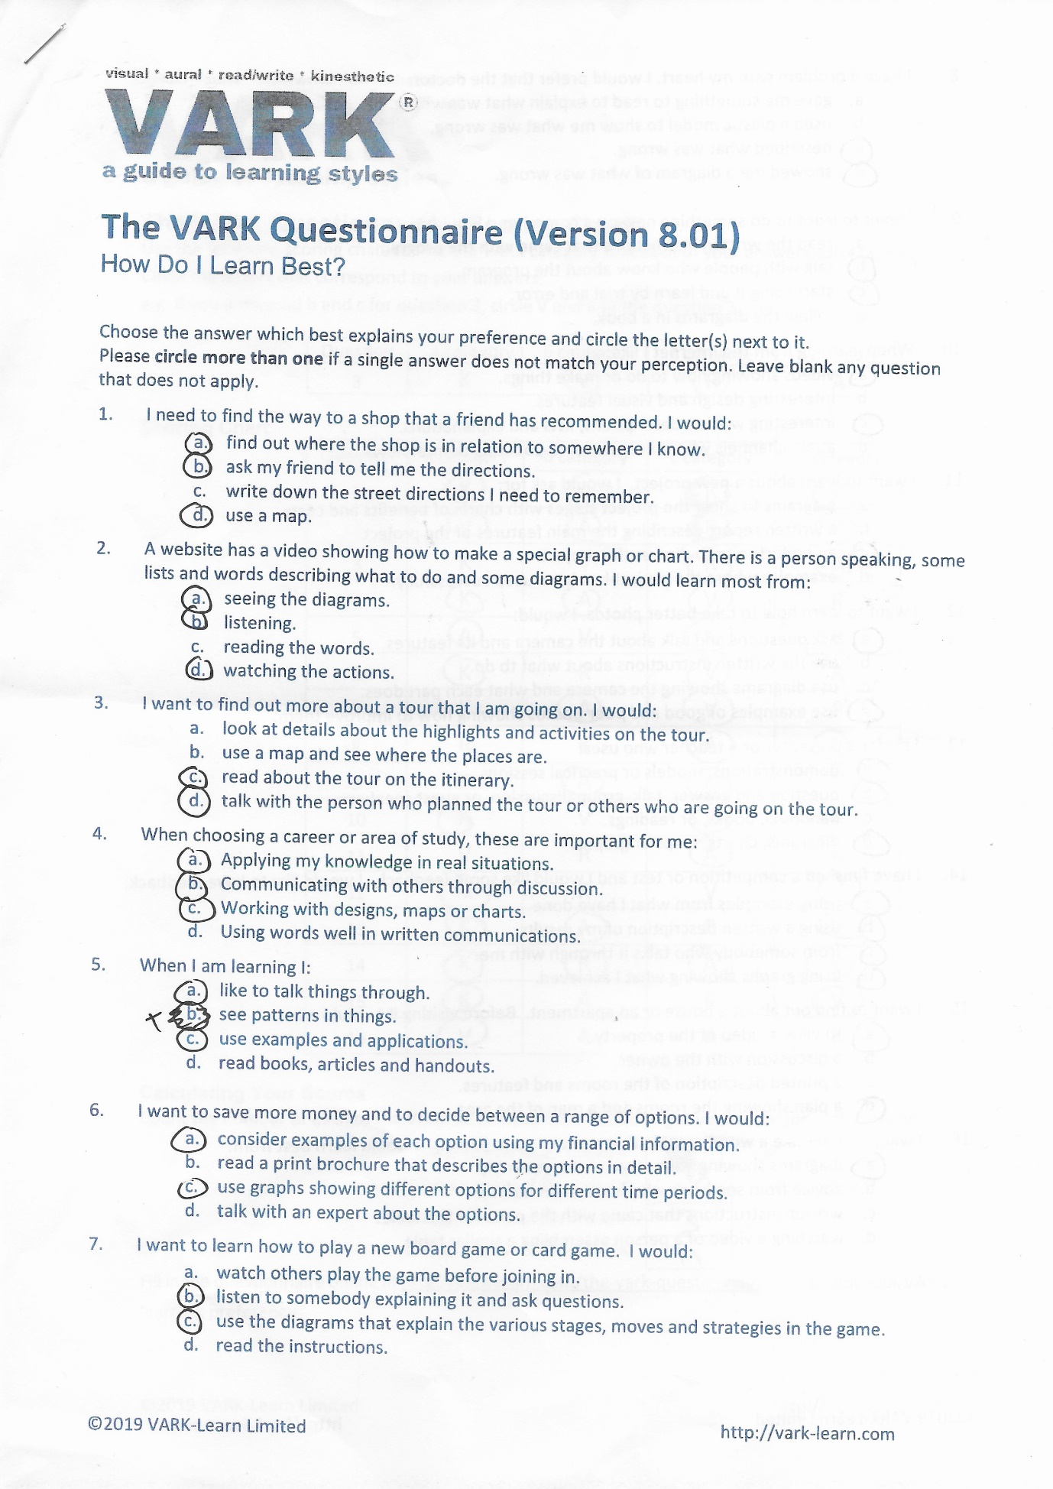



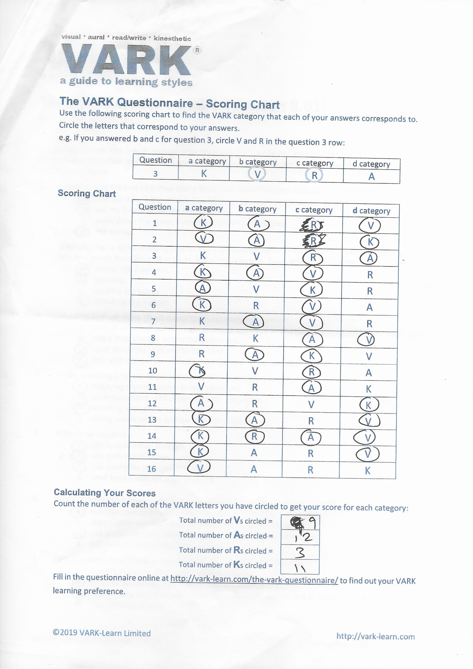
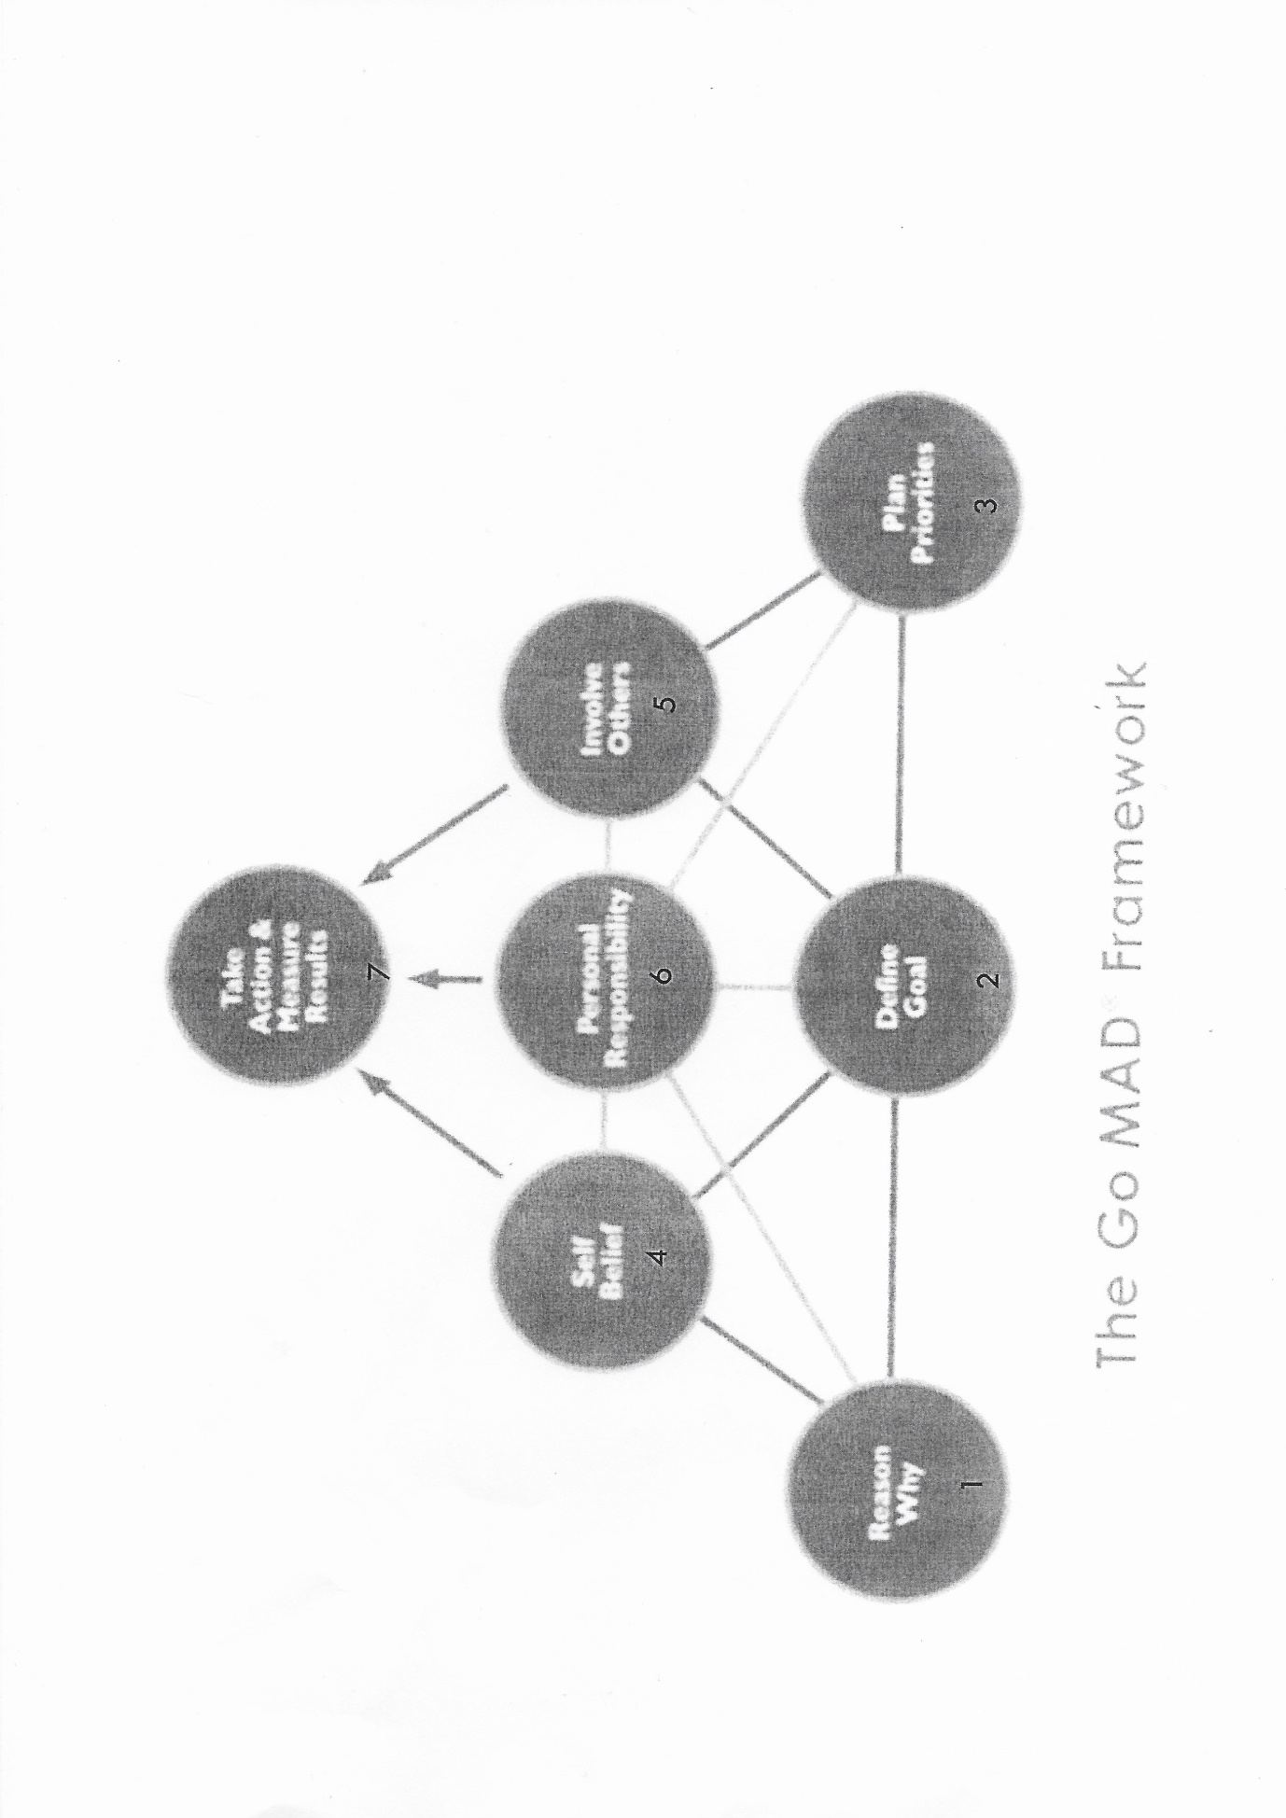

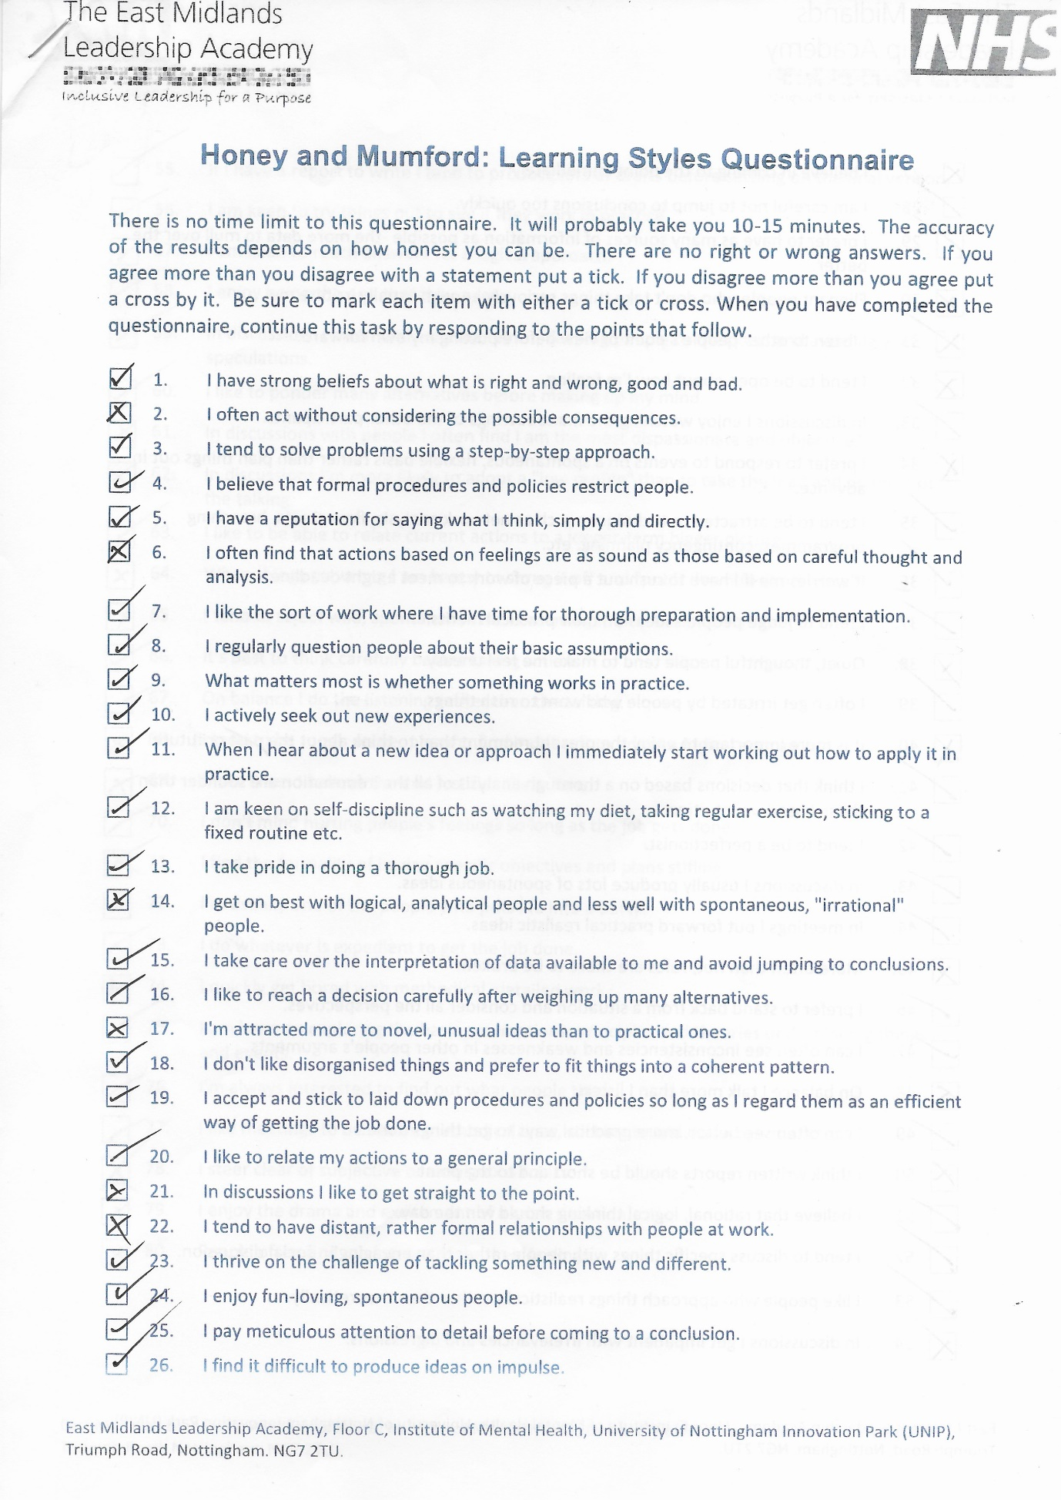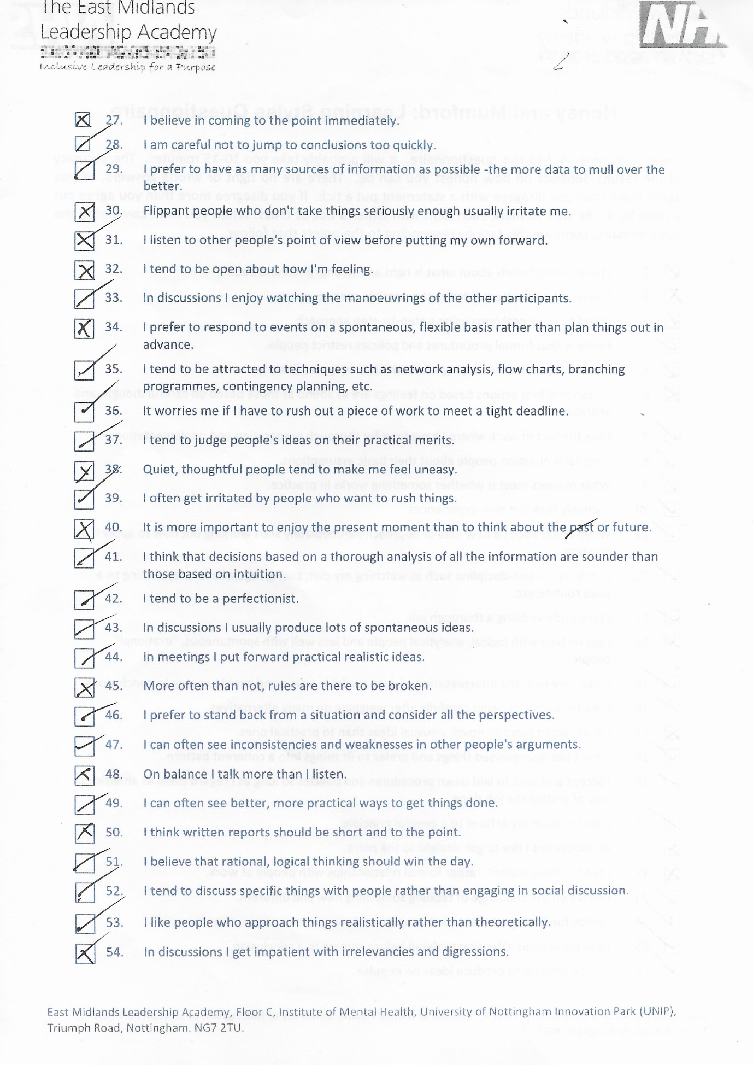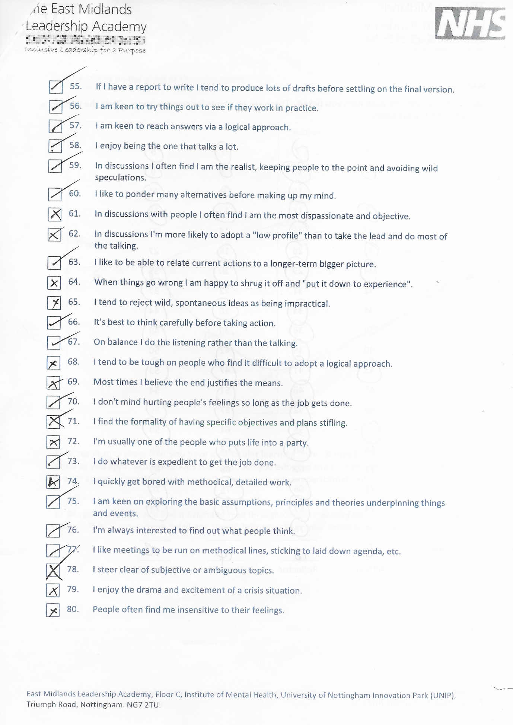

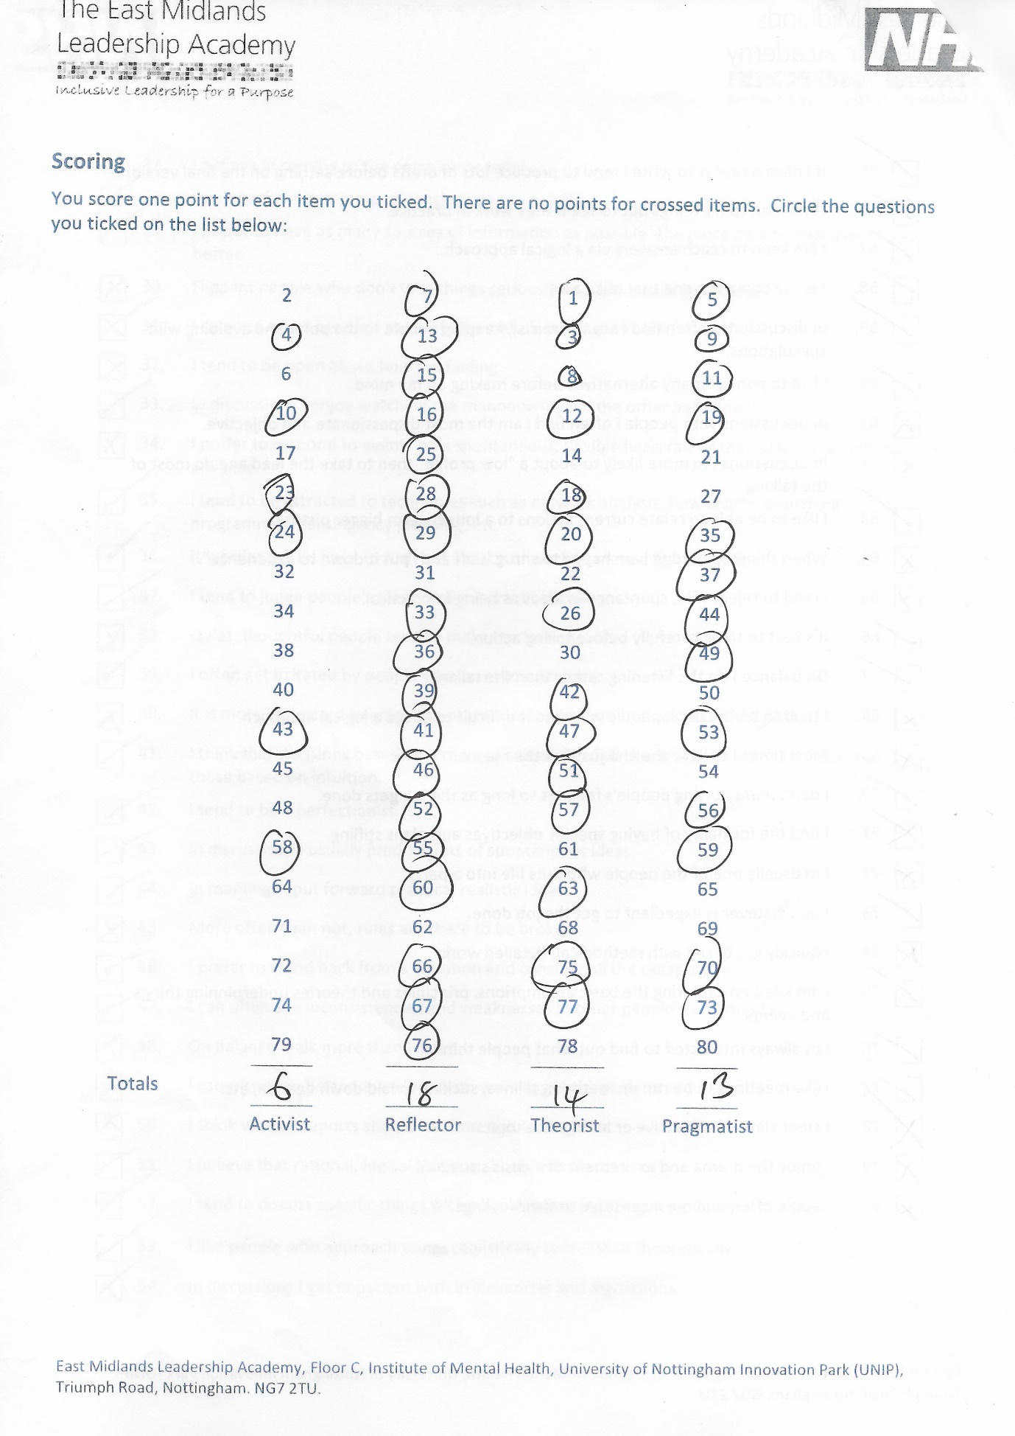

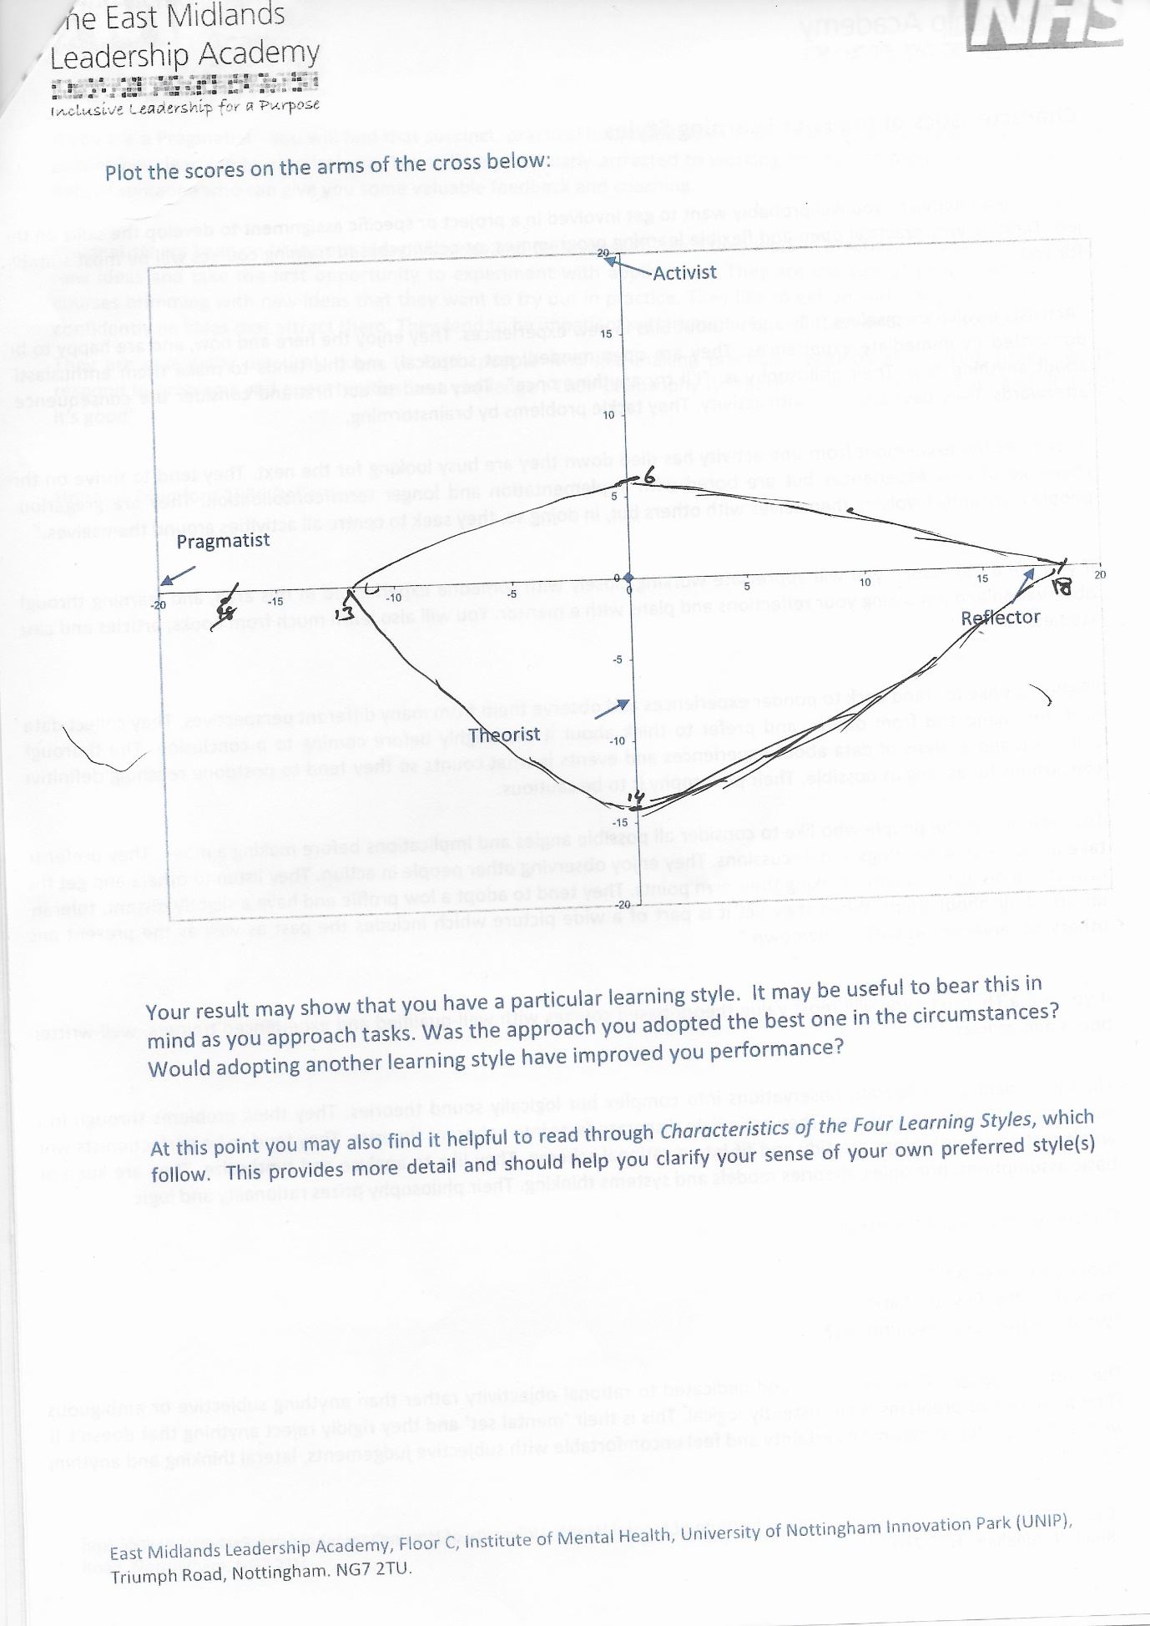

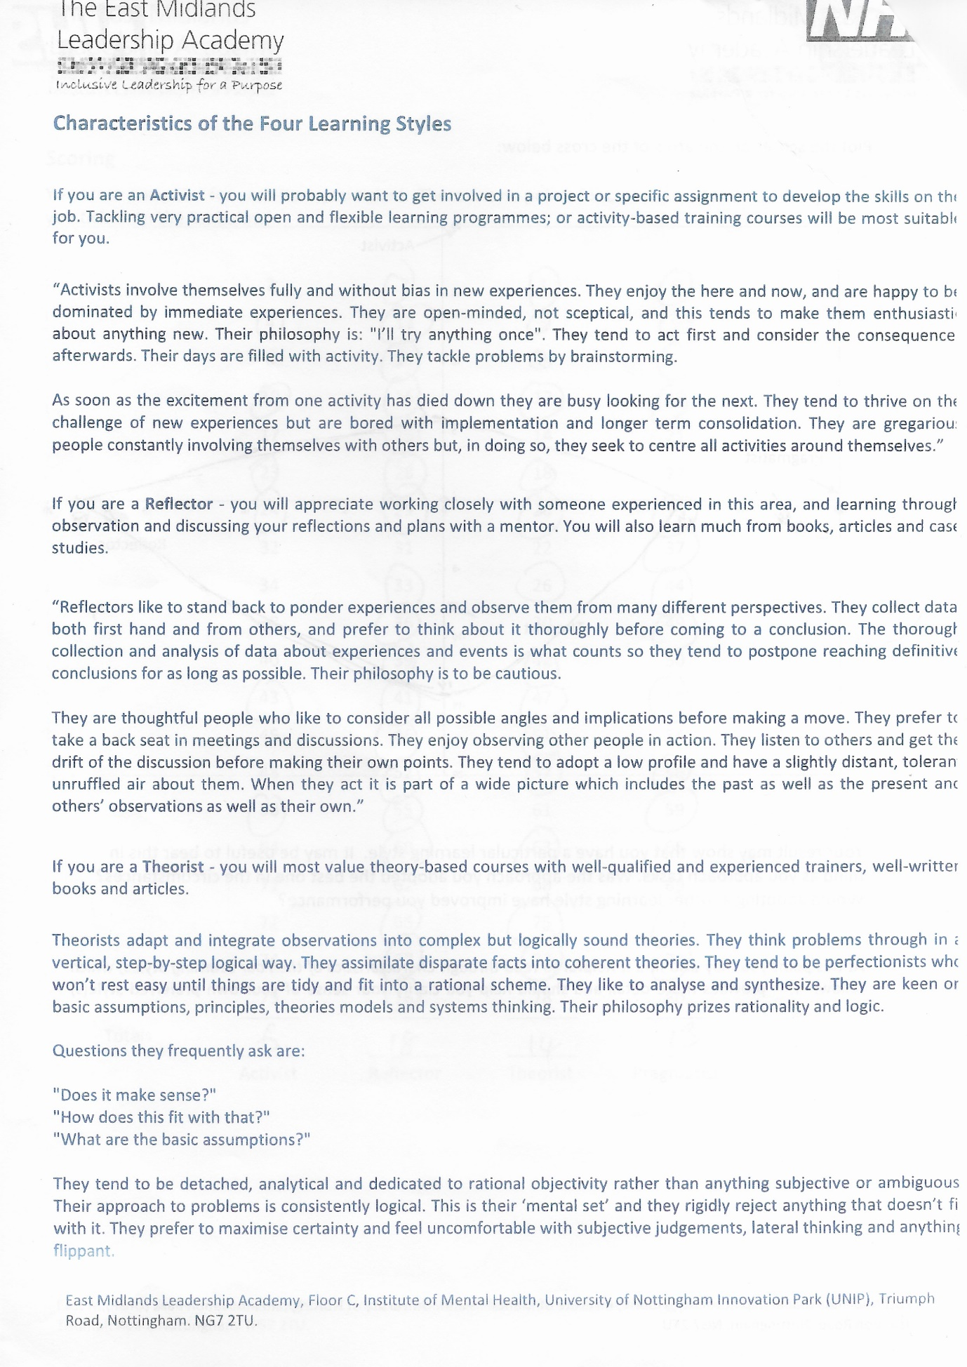

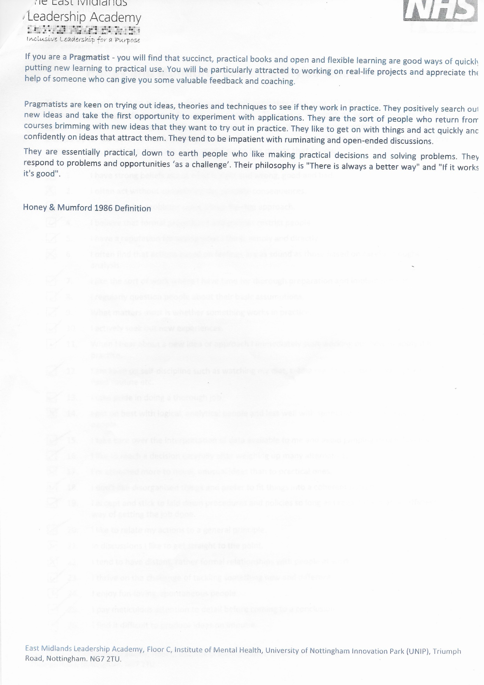

Strengths  - Good communication skill  - Adaptation skills  - Personality sense of right and wrong  - Researching skills  - Collaboration  - Networking | Weakness  - Reading to understand  - Writing to explain  - Can become unmotivated or disengaged  - Take to long to research  - Unorganised  - Time management  - qualification
Opportunities  - Attend university on time  - Spread work out to have ample time to work each one  - Gain qualification  - Improve read and writing skill  - Try stay engaged during lectures to gain understanding. | Threats  - Possibility of not passing tasks marks and being removed off the course  - Get help back due to peers  - Receive to much assignments together  - Become overwhelmed.  - Unforeseen reasons and miss lectures  - Lectures not enough to hel me advance

Internal Factors External Factors
Positive Negative
My SWOT analysis

13.0 REFERENCING

Andy Gilbert, 2005
Andy Gilbert. (June 1 2005). Art of making a difference. In: Andy Gilbert Go MAD. pocket gate farm, off breakback road, woodhouse eaves, Leicestershire LE12 9RS: Go MAD Books. 192.
Google Books

Ann Gravells 2010
Ann Gravells (01 May 2010). Delivering Employability Skills in the Lifelong Learning Sector. England: SAGE Publication.
ProQuest eBook Central

Beausaert, Simon; Segers, Mien; Gijselaers, Wim; Wiley-Blackwell 2011
Beausaert, Simon; Segers, Mien; Gijselaers, Wim; Wiley-Blackwell (2011). The Personal Development Plan Practice Questionnaire: the development and validation of an instrument to assess the employee's perception of personal development plan practice. oxford: Blackwell publishing ltd. vol 15. p.249-271.
Moodle library

Dyson, 2000
Robert G. Dyson , (February 1 2004), Strategic development and SWOT analysis at the University of Warwick Journal, of the Operational Research Society, Volume 152, Issue 3. 631-640.
Google Scholar

IJ Prithishkumar, SA Michael 13 may 2014
IJ Prithishkumar, SA Michael (13 may 2014). Understanding your student: Using the VARK model. India: Emerald Group Publishing Limited. Vol 60 183-186.
Google scholar

Janet Strivens, Rob Ward 2010
Janet Strivens, Rob Ward. (November 2010). An overview of the development of Personal Development Planning (PDP) and e-Portfolio practice in UK higher education. In: Journal of Learning Development in Higher Education. UK.
Google scholar

JP Robinson 2000
Jacquelyn P. Robinson (15 Sept 2000). the work places. what are employability skills. Development Specialist State Headquarters 216 Extension Hall Auburn University, AL. 3.
Google scholar

Künzli, Benjamin Mar/Apr 2012
Künzli, Benjamin. (Mar/Apr 2012). Führung: SWOT-Analyse. In: Künzli, Benjamin SWOT-Analyse. Germany Baden-Baden: Schaeffer Poeschel Verlag. Volume 81 Issue 2. 126-129.
ProQuest Central

Moayyeri, Hassam Jan 2015
Moayyeri, Hassam (Jan 2015). impact of undergraduate student learning preferences. London: academy publication co ltd. 8.
ProQuest Central

Neil D Fleming 1955
Neil D Fleming (1955). I'm different; not dumb Modes of presentation (V.A.R.K.) in the tertiary classroom. Lincoln University, Canterbury, New Zealand. P 7.
Google scholar

Peter Honey 2006
Peter Honey. (2006). 40-item version. In: Peter Honey and Alan Mumford learning style questionnaire. England and Wales: Peter Honey publication ltd.
Google scholar

Peter Honey, Alan Mumford 2000
Peter Honey, Alan Mumford (2000). The Learning Styles Questionnaire. The Learning Styles Questionnaire: 80-item Version. England and Wales: Peter Honey publication ltd. 54.
Google scholar

Sarsby, 2016
Alan sarsby, (2016), a guide to swot for business students. In: Alan Sarsby swot analysis. England: Spectaris ltd. 75.
Google Books

Stella Cottrell 2003
Stella Cottrell (2003). skills for success. personal development and employability. London: Stella Cottrell and Macmillan publishers ltd. 322
Google books

VARK. (2012). questionnaire 8.1. Available: https://vark-learn.com/. Last accessed 20th Feb 2020.

Honey and Mumford. (). learning style questionnaire. Available: https://www.leadershipeastmidlands.nhs.uk/sites/default/files/Honey%20%26%20Mumford%20-%20Learning%20Styles%20Quiz.pdf. Last accessed 20th Feb 2020.

