
MODULE : BUSINESS AND WEB MANAGEMENT

MODULE CODE: ACCA5019

LECTURE: DR. MOBOLANLE BELLO

NAME: SAMUEL KWABENA DUAH

STUDENT NUMBER: 2328690

DATE: 6TH MARCH, 2026



TABLE OF CONTENTS

Introduction---------------------------------------------------1
MealSwift Website Issues and How to Fix---------2
- Confusing Navigation
- Outdated Visual Design
- Non-Responsive Mobile Layout
- Limited Restaurant & Menu Information
- Low-Quality Images
- Minimal Customer Reviews or Ratings
- Minimal Customer Reviews or Ratings
- Weak Call-to-Actions
Responsive Design Implementation---------------------3
Implications of Responsive Implementation in E-Commerce Websites for Improving User Experience-------------------------------4
Implications of Responsive Implementation in E-Commerce Websites for Improving Sales----------------------------------------------4
Implementation Section------------------------------------5
Summary --------------------------------------------------------6
References-------------------------------------------------------7

Introduction:
MealSwift, a rapidly growing food delivery service, is seeking a complete redesign of its website and mobile app to address several issues that are negatively affecting user experience and overall business performance.
The current platform struggles with confusing navigation, an outdated visual design, and poor mobile responsiveness, all of which make it difficult for customers to browse restaurants, explore menus, and place orders efficiently. Additional challenges include limited restaurant and menu information, low‑quality images, and an inefficient ordering and checkout process that often leads to abandoned carts.
The absence of personalised recommendations and accessibility shortcomings further reduce user engagement and limit the platform’s usability for a wider audience.
This report focuses on issues and solutions of confusing navigation, outdated visual design, Non responsive Mobile Layout,. limited restaurant & menu information, . low-quality images, accessibility Issues,.minimal customer reviews or ratings and weak call-to-actions.

MEALSWIFT WEBSITE ISSUES AND HOW TO FIX THEM
Confusing Navigation
Issues:
Users struggle to find menus, cuisines, or account features when too many categories and unclear labels slow down their decision making. This confusion creates unnecessary friction, making it harder for them to navigate, choose what they want, and complete simple tasks. Clearer structure and labelling help restore confidence and ease of use.
Solutions:
Introduce a simplified, mobile‑first navigation bar with clear top‑level categories such as Home, Menu, Orders, and Profile, making it easier for users to move through key sections without confusion. Adding a powerful search bar with autocomplete for cuisines and dishes speeds up discovery and reduces the effort required to find specific items. Using consistent iconography and labels across both web and app creates a unified experience that feels familiar on any device, improving clarity and reducing cognitive load for returning users.

Outdated Visual Design

Issues:
The visual hierarchy is weak, and the generic branding fails to build trust or create a distinctive, credible identity overall.
Solutions:
Refresh the brand by introducing a modern colour palette, clean typography, and consistent spacing that creates a more polished and approachable visual identity. These updates help every element feel intentional and easier for users to scan, especially on smaller screens.
Using a grid‑based layout improves readability by organising content in a clear, structured way. Introducing a unified design system ensures that UI components look and behave consistently across all platforms, strengthening brand recognition and creating a smoother, more cohesive experience.
Non-Responsive Mobile Layout
Issues:
The layout breaks on smaller screens, causing elements to shift unpredictably and making key information harder to read. Buttons are also too small for comfortable touch interaction, which forces users to tap repeatedly or zoom in just to complete simple actions. These issues reduce overall usability and create a frustrating mobile experience that discourages users from continuing their journey.
Improving responsiveness and increasing the size of interactive elements would make navigation smoother and far more accessible.
Solutions:
Rebuild the interface using a mobile‑first responsive framework that adapts smoothly to different screen sizes and prevents layout issues on smaller devices. Increasing tap‑target sizes and adding more generous spacing improves touch accuracy, reduces user frustration, and supports more comfortable navigation. Incorporating sticky elements, such as a persistent “View Cart” button, keeps essential actions within reach at all times, minimising unnecessary scrolling and helping users complete tasks more efficiently. Together, these changes create a faster, clearer, and more intuitive experience across mobile and desktop.
Limited Restaurant & Menu Information
Issues:
Missing dish descriptions, dietary tags, delivery times, and popularity indicators makes it harder for users to feel confident when choosing what to order. Without clear details, they struggle to compare options, understand ingredients, or assess how long their meal will take to arrive.
This lack of information slows decision making and increases uncertainty, often leading users to abandon their selection or switch to alternatives that provide clearer guidance. it difficult for users to make confident decisions when choosing what to order.

Solutions

Add detailed menu descriptions, allergen information, and dietary filters to help users quickly understand what each dish contains and whether it meets their needs. Clearer information reduces hesitation and supports more confident decision‑making, especially for users with dietary restrictions or specific preferences.
Display estimated delivery times and restaurant popularity badges to set accurate expectations and include high‑quality images for every dish to make choices feel more intuitive and appealing. Together, these enhancements create a richer, more informative ordering experience.
Low-Quality Images
Issues:
Poor food imagery reduces appetite appeal and trust by making dishes look less fresh, less vibrant, and ultimately less desirable. When photos fail to capture accurate colours, textures, or portion sizes, users begin to question the quality of the food itself. This weakens their confidence in the restaurant’s standards and makes them hesitant to place an order.
Low‑quality visuals also lower perceived value, making even good dishes seem unappealing or poorly prepared. Without appetising, high‑resolution images, users struggle to imagine the taste or experience of the meal, which directly impacts their willingness to choose a dish or complete a purchase.
Solutions:
Standardize image guidelines for restaurants and implement responsive image loading to improve visual consistency, enhance performance across devices, and ensure faster, higher‑quality food imagery throughout the user experience

Accessibility Issues
Issues:
Low contrast, missing alt text, and poor keyboard navigation exclude users, reduce overall accessibility, and create significant compliance and usability risks.
Solutions:
Adopt WCAG 2.2 AA standards, add alt text, ARIA labels, and proper heading structure, and ensure full keyboard and screen‑reader compatibility to deliver an accessible and inclusive experience.
Minimal Customer Reviews or Ratings
Issues:

Users lack social proof when browsing new restaurants, which makes it harder for them to trust the quality of the food or the reliability of the service. Without reviews, ratings, or customer photos, they have little reassurance that others have had positive experiences. This uncertainty increases hesitation, slows decision‑making, and often leads users to abandon the ordering process in favour of better‑validated options.
Solutions:

Add restaurant‑level ratings and dish‑level reviews to give users clearer insight into overall quality and individual meal experiences. Highlighting items such as most ordered or top rated helps guide decision‑making by surfacing popular and well‑loved dishes, reducing uncertainty for first‑time customers.
These signals make it easier for users to trust new restaurants and feel confident in their choices.
Using verified customer badges further strengthens credibility by showing that feedback comes from real diners. Together, these elements build trust, reduce hesitation, and create a more reassuring and transparent ordering experience.
Weak Call-to-Actions
Issues:

CTAs lack clarity and urgency, leaving users without strong direction on how to complete their orders. This weak guidance creates hesitation, slows decision‑making, and reduces overall conversion effectiveness. When users are unsure of the next step or don’t feel motivated to act, they are more likely to abandon the process before finishing their purchase.
Solutions:
Use bold, high‑contrast CTAs such as “Order Now,” “Add to Cart,” and “Checkout” to give users clear direction and stronger motivation to act. Adding contextual nudges like “Free delivery if you add £3 more” helps guide decisions and increases basket value by making benefits immediately visible. Keeping CTAs sticky on mobile ensures essential actions always remain accessible, reducing friction and supporting faster task completion. Together, these improvements create a more persuasive and conversion‑focused experience.
RESPONSIVE DESIGN IMPLEMENTATION
Responsive design [3]
J. C. Hung and C.-C. Wang, “Exploring the website object layout of responsive web design: results of eye tracking evaluations,” The Journal of supercomputing, vol. 77, no. 1, pp. 343–365, 2021, doi: 10.1007/s11227-020-03283-1.
is an approach to web development that allows a website’s layout, images, and interface elements to automatically adjust to different screen sizes and devices. It creates a consistent, user friendly experience whether someone is browsing on a phone, tablet, or desktop. By adapting fluidly to each environment, it improves usability, reduces friction, and ensures content remains clear and accessible across all platforms.

Implications of Responsive Implementation in E-Commerce Websites for Improving User Experience
[4]
Riska Fitri Ulfiana and M. Muhammad Najib Dwi Satria S.Kom., “Design and Implementation of a Responsive E-Commerce Web Application for Teras Thrifting Store,” Sistemasi : jurnal sistem informasi (Online), vol. 14, no. 4, pp. 1640–1653, 2025, doi: 10.32520/stmsi.v14i4.5242.
It enhances user experience by ensuring that layouts, navigation, content, and interactive elements adapt smoothly to different screen sizes. This creates a consistent and comfortable environment for users whether they browse on a phone, tablet, or desktop.
By improving usability and strengthening visual clarity, it reduces friction during browsing and purchasing. Users can move through pages more easily, understand information faster, and interact with features without confusion.
This adaptability also increases accessibility, making digital spaces more inclusive for people with different needs. Altogether, it creates a more intuitive and satisfying journey for users across all devices.
Implications of Responsive Implementation in E-Commerce Websites for Improving Sales [5]
Riska Fitri Ulfiana and M. Muhammad Najib Dwi Satria S.Kom., “Design and Implementation of a Responsive E-Commerce Web Application for Teras Thrifting Store,” Sistemasi : jurnal sistem informasi (Online), vol. 14, no. 4, pp. 1640–1653, July 2025, doi: 10.32520/stmsi.v14i4.5242.

By creating faster, more accessible, and device‑adaptive shopping experiences, businesses reduce user frustration and make it easier for people to browse and buy across both mobile and desktop platforms. This smooth performance helps users feel more confident as they move through each step of the buying journey, from exploring products to completing checkout.
Clear layouts, responsive interactions, and consistent navigation strengthen trust by showing users that the experience is reliable and thoughtfully designed. When shoppers can find what they need quickly and interact without delays or confusion, they are more likely to complete purchases and return in the future.
Altogether, this approach supports higher conversion rates, encourages repeat buying, and builds long‑term loyalty across all devices.

IMPLEMENTATION SECTION
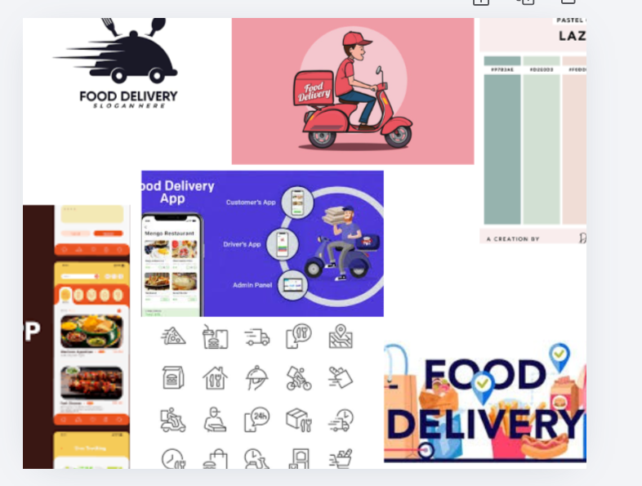
Figure 1 Mood Board

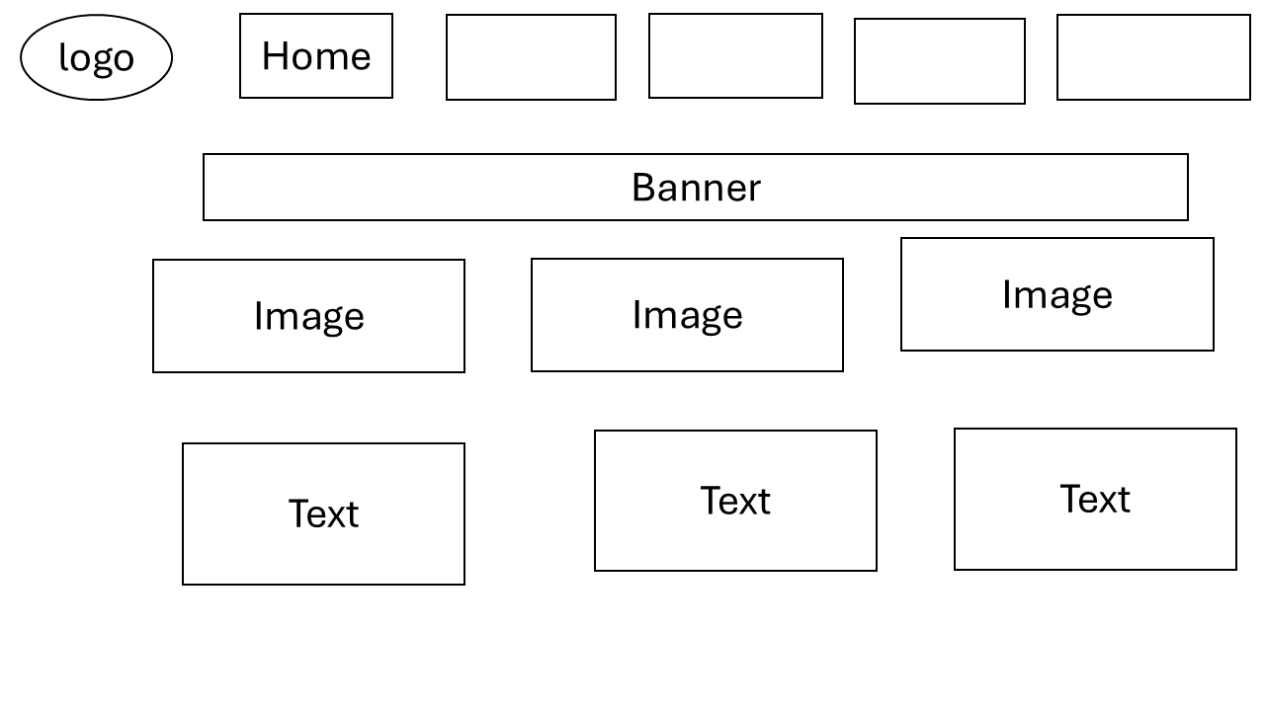
Figure 2 Wireframe Home
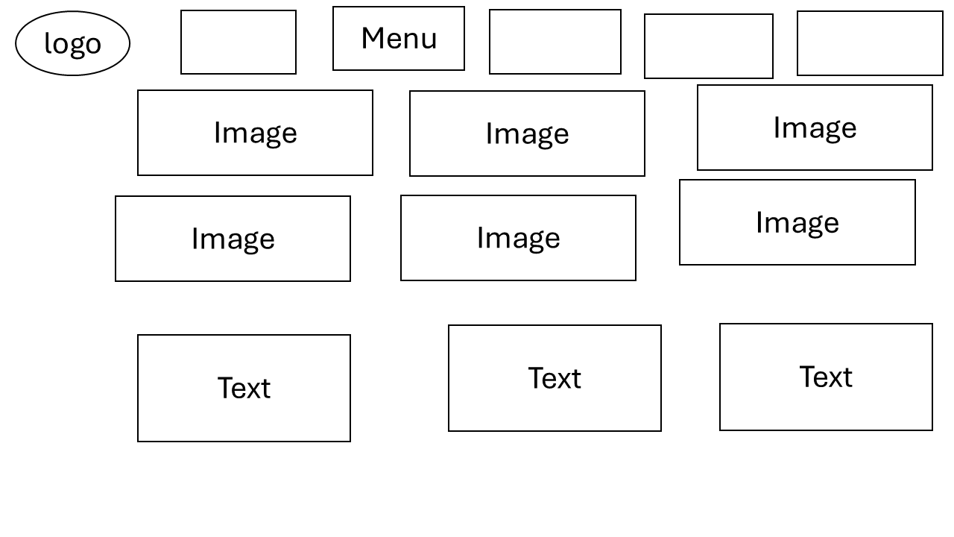
Figure 3 Wireframe Menu
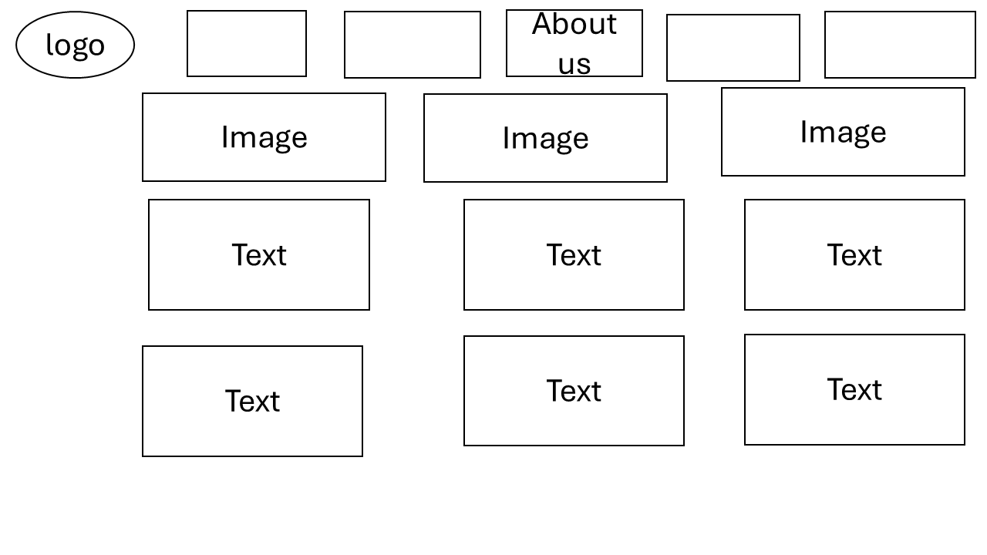
Figure 4 Wireframe About us

Figure 5 Wireframe Contacts

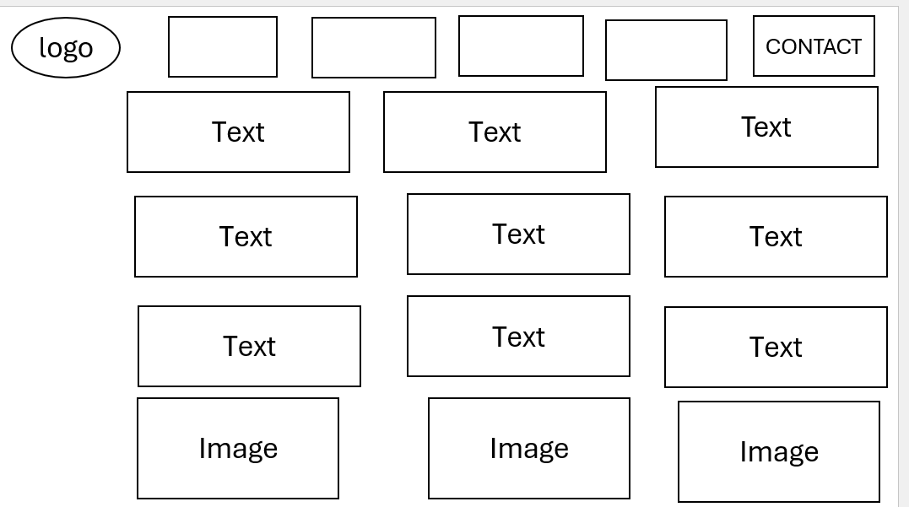

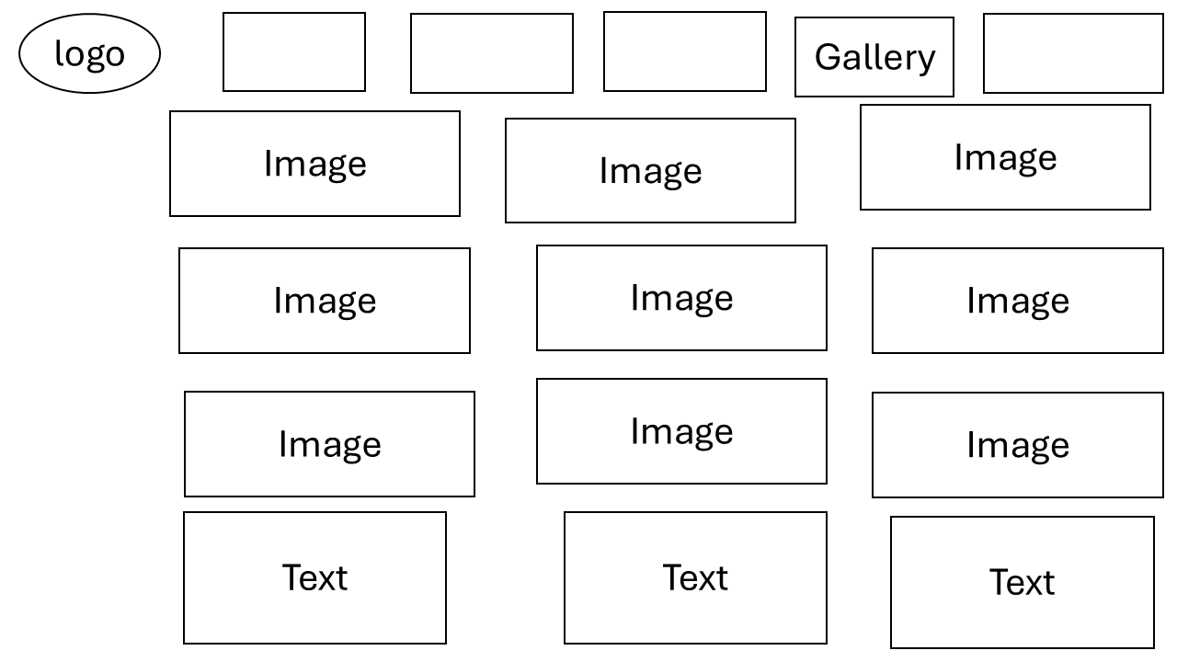
Figure 6 Wireframe Gallery

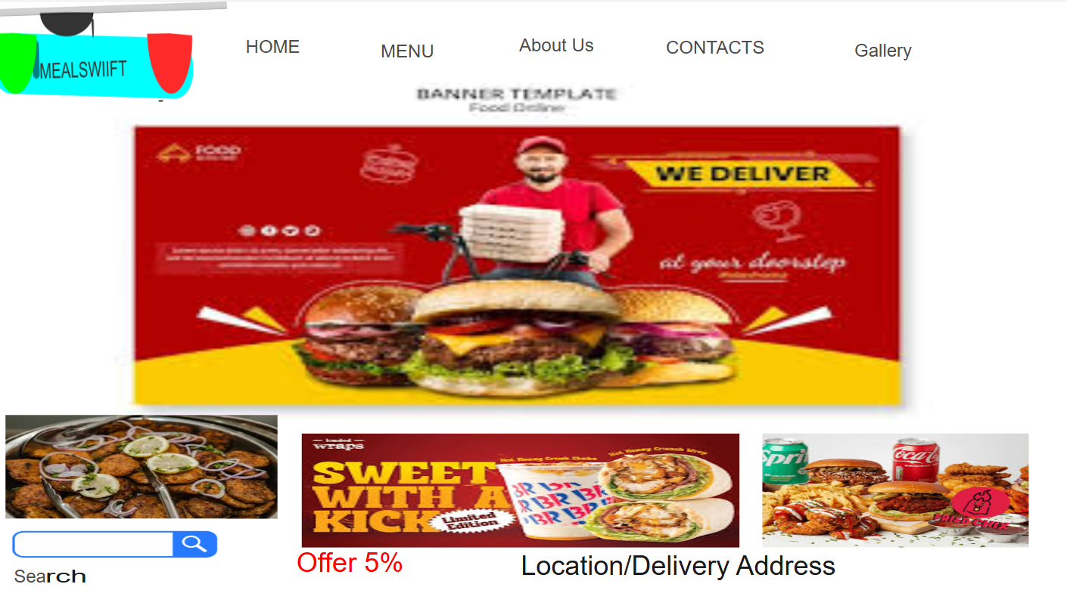
Figure 7 Home

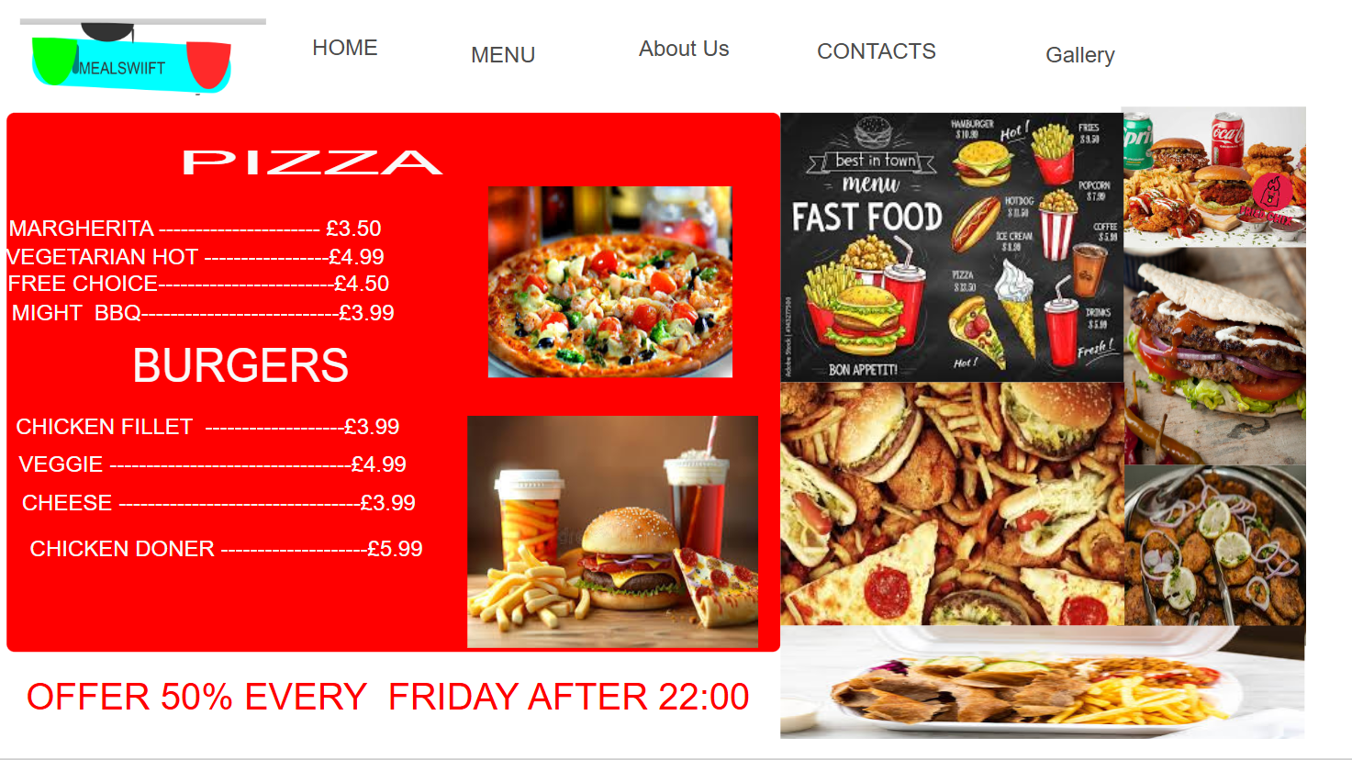
Figure 8 Menu

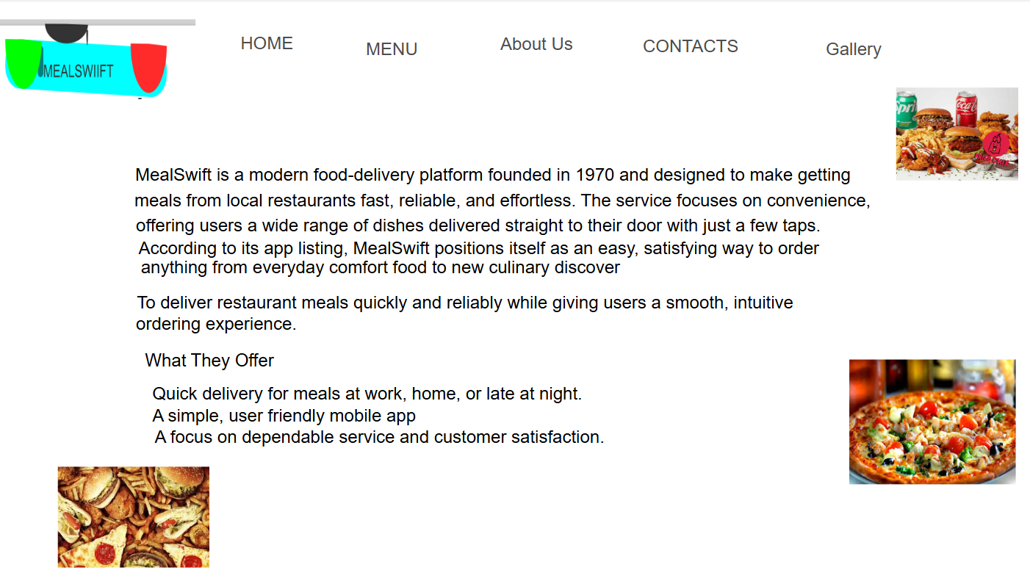
Figure 9 About Us

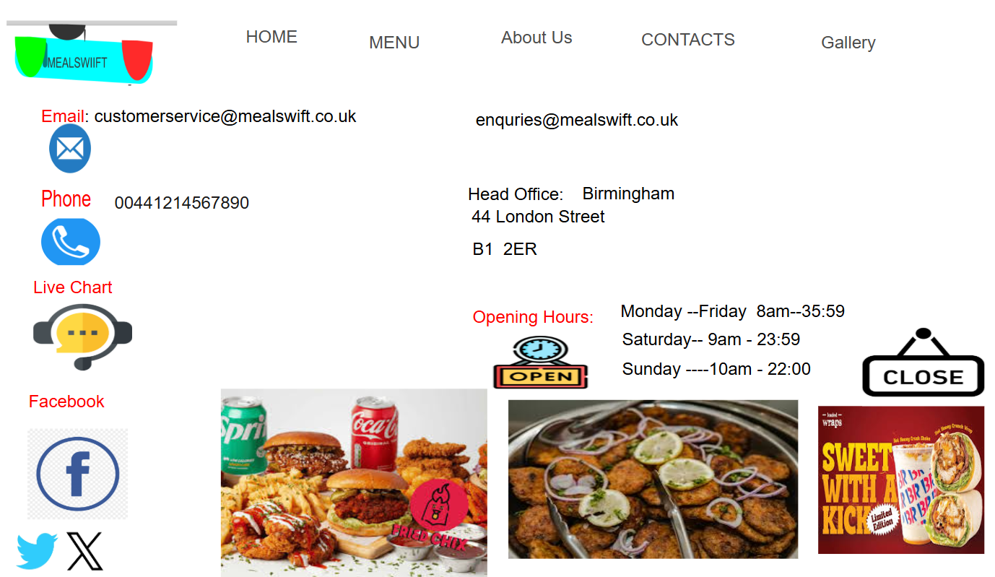
Figure 10 Contact

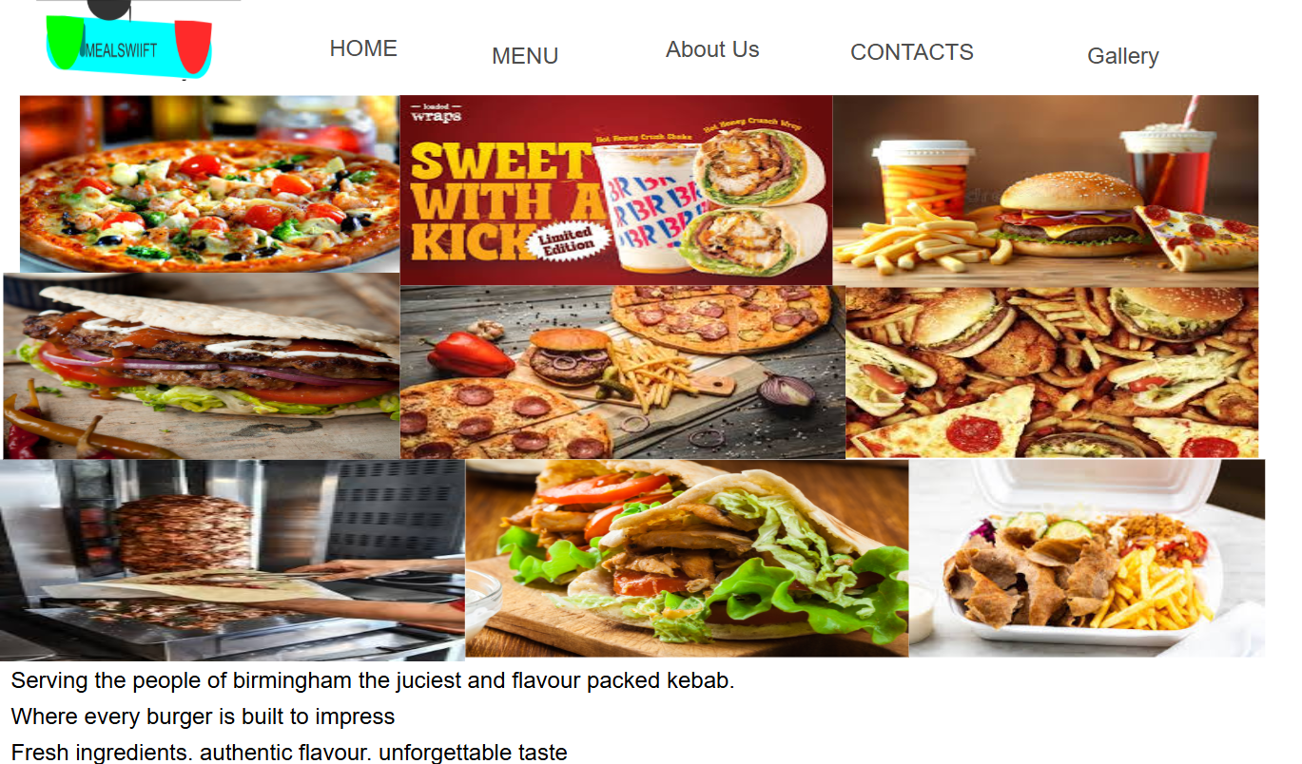
Figure 11 Gallery

MOODBOARD AND WIREFRAME DESIGN
Mood boards and wireframes shape a design in different but complementary ways, each influencing key decisions throughout the creative process.

Mood board
A mood board [1]
T. Huffman and linkedin.com, Carpenteria, CA. Creating a Mood Board., (2021). [Online Video]. Available at: https://www.linkedin.com/learning/creating-a-mood-board?u=77966930&auth=true
Is a visual, curated collection of images, textures, colours and text used to define the style, theme, or emotional direction of a project and also primarily used in design fields like fashion, interior, and graphic design, it acts as a, visual roadmap to align creative vision and communicate concepts.
Wireframe
A wireframe [2]
T. Green and linkedin.com, Carpenteria, CA. Applied Interaction Design: Accordion Folds., (2020). [Online Video]. Available at: https://www.linkedin.com/learning/applied-interaction-design-accordion-folds?u=77966930&auth=true
is a low-fidelity, black-and-white, or grayscale schematic that acts as the blueprint for a website or app, focusing on structure, layout, and functionality rather than final design details

Summary
The MealSwift project demonstrated how a structured, user‑centred design process can transform insights into meaningful, high‑impact improvements. By focusing on real user needs, we created a high‑quality, responsive website that enhances overall usability, strengthens brand trust, and streamlines the ordering experience. Each design decision aimed to reduce friction, support user confidence, and create a smoother digital journey.
These enhancements not only improve how customers interact with the platform but also directly support MealSwift’s wider business goals. The result is increased customer satisfaction, stronger engagement, and long‑term loyalty built through thoughtful, research‑driven design.
References
[1]
T. Huffman and linkedin.com, Carpenteria, CA. Creating a Mood Board., (2021). [Online Video]. Available at: https://www.linkedin.com/learning/creating-a-mood-board?u=77966930&auth=true

‌ [2]
T. Green and linkedin.com, Carpenteria, CA. Applied Interaction Design: Accordion Folds., (2020). [Online Video]. Available at: https://www.linkedin.com/learning/applied-interaction-design-accordion-folds?u=77966930&auth=true

[3]
J. C. Hung and C.-C. Wang, “Exploring the website object layout of responsive web design: results of eye tracking evaluations,” The Journal of supercomputing, vol. 77, no. 1, pp. 343–365, 2021, doi: 10.1007/s11227-020-03283-1.

[4]
Riska Fitri Ulfiana and M. Muhammad Najib Dwi Satria S.Kom., “Design and Implementation of a Responsive E-Commerce Web Application for Teras Thrifting Store,” Sistemasi : jurnal sistem informasi (Online), vol. 14, no. 4, pp. 1640–1653, 2025, doi: 10.32520/stmsi.v14i4.5242.

[5]
Riska Fitri Ulfiana and M. Muhammad Najib Dwi Satria S.Kom., “Design and Implementation of a Responsive E-Commerce Web Application for Teras Thrifting Store,” Sistemasi : jurnal sistem informasi (Online), vol. 14, no. 4, pp. 1640–1653, July 2025, doi: 10.32520/stmsi.v14i4.5242.

