Student name: Marek Czeslaw Florek
Student ID: 2025556
Programme: Certificate in Higher Education Skills for the Workplace
Module: Managing Enterprise in the 21st Century
Module code: BMSW4006
Lecture name: Daminabo Pokubo
Assignment Title: Written Business Plan

Table of Contents:
- Business overview…………………………….
- Product and Services………………………….
- Market Audit………………………………………
  - Competitors……………………………………..
  - SWOT Analysis…………………………………..
  - PESTLE Analysis…………………………………
- Target Market……………………………………..
- Marketing Plan…………………………………….
- Management Team………………………………..
- Financial Plan………………………………………
  - Cashflow Forecast…………………………………..
  - Profit and Loss......................................................
- References…………………………………………..

- Business Overview:
In this business plan, I will focus on some of the most important points for a company and for analysing the company. The points that will be analysed are the following: Business Overview, Product and Service, Market audit, Target Market, Marketing plan, Management Team and Financial Plan.
The business I will focus on is the sale of dried fruits or in particular the sale of dried plums. This type of product is very useful and healthy, and I think you will have great success in sales in the market. The company will offer its products on its stationary sites, but also online on its website and other sites for sale. The business will start on August 1, 2022, in the shopping centre of Birmingham, near the railway network where there is a large influx of people constantly. Affiliate business with 4 investors investing a total of £ 30,000, for a total of £ 120,000, all partners have equal shares, the profits will be shared equally for each and the losses.

- Product and Services:
This product is needed on the market due to the high content of vitamins and minerals that are useful and healthy for customers of all ages. One cup of plums has Calories:76, Protein:1gram, Fat: Less than 1 gram, Carbohydrates: 18gram, Fiber: 2gram, Sugar: 16gram, Calcium, Magnesium, Phosphorus, Potassium, Vitamin C, Vitamin A, Vitamin K, Folate (Danny Bonvissuto, 2020). Many specific companies offer the same product, but I think that with a good strategy and a lower market price on the market, our company will quickly win many customers.

- Market audit:
The market audit is a very valuable tool for tactical and strategic planning for new business (Lupnicka Denisa and Dado Jaroslav, 2013) this tool measures the risk, value, and effectiveness of marketing. One of the most important stages of the planning process is done with the help of assessing the current situation and the potential of the company (Violeta Radulescu, 2012).
  - Competitors:
Every company has competition in the market, so as a start-up business it is extremely important to study the market leaders who are close to us and with whom our business must compete. I will present three of these companies located in Birmingham.

AFG Dried Fruit & Nuts LTD, (Birmingham), Est: 17 May 2019
A private company based in Birmingham, two active directors. Wholesale and retail of fruits and vegetables. The good roar from customers and quality organic products (gov. UK, 2022).

Watan Dry Fruits Ltd, (Birmingham) Est: 1994
Organic Dry Fruits from Afghanistan. Products are processed and packed in Finest quality with verities of Mix Dry Fruit Salat as Afghani Tradition, 5* rating for customers (Watan Dry Fruits, 2022).

  - SWOT Analysis:
Slot analysis is a widely popular technology developed by Albert Humphrey, which analyses four factors that identify the project, product or organization to which they are applied (MindTools, 2022).

STRENGTHS: | WEAKNESS:
- Great location  - Quality products  - Secure suppliers  - Specialized services  - At a lower price than the competition | - new company  - starting a business  - strong competition
OPPORTUNITIES: | THREAT:
- product expansion  - opening new stores  - more frequent demand for these products  - merger with a larger company | - the war in Ukraine  - high inflation  - Covid-19  - a new competition with lower prices  - Changes in consumer trends

With the help of the strengths and capabilities of the SWOT table, we can surpass our competitors and build a very good company, weaknesses and threats are not minimal, so we must build a good strategy to overcome them and be useful for our business.
Strengths: Strengths of this business are first of all good localization, quality products, reliable suppliers, specialized services for all ages, and different types of product promotions compared to competing companies.
Weakness: As a new company, advertising will encourage the business to gain customers, good service, and customer feedback will benefit the status of the company and will encourage new customers to visit us. Strong competition will stimulate us to build a good business, new product promotions, product tasting, and advertising on the Internet. The potential for the profitability of a company is determined by the intensity of competition, therefore, in intense competition, the company will be able to transfer more value to its customers (CFI, 2020).
Opportunities: Like most new companies, the opportunities of our company are many, the business language to grow with the help of opening new sites not only in Birmingham but also at any point of the UK, expanding the range of products.
Threats:
Threats: the war between Russia and Ukraine is a major threat to both existing and start-ups and affects the world (EIU,2022). The biggest threat is the rapid rise in prices and high inflation. This will be a difficult period for any existing company, the prune business will cope with the temporary crisis thanks to the fact that without food we cannot function. Companies that offer other types of products than food will have greater losses and difficulties.
Covid-19 the pandemic that erupted in 2020 significantly reduced the revenue of any business and made it difficult to start a new business. In most areas, the creation of new businesses decreased by 58%, the registration of limited liability companies decreased, while the number of registrations of new companies increased by 42% in the economies compared to 2019 (Frederic Meunier, Cyraine Coste & Ricardo Maia,2022).
We need to analyse what changes our customers expect and seek. Thanks to the implementation of these changes and building strong relationships with our customers we can overcome threats. We have a control plan for threats to turn them into a positive plan for the company.

  - PESTEL Analysis:
Pestle analysis is a widely used tool for external and situational business systems. We have considered all the factors and developed a plan for any emergencies that may arise and developed a training schedule (Nerynaut, 2017).
This analysis consists of 6 factors that are: Political, Economic, Social, Technological, Environmental, and Legal.
Political: we must not forget about the Covid-19 pandemic, because of which we must keep our distance to protect ourselves and the people around us, which will make it difficult for us to have many visitors to the site because of the distance.
Economic: In addition to the already mentioned Covid-19 pandemic, there is now another economic factor influencing the organization, and that is the war between Russia and Ukraine, this will have a very negative impact on any company.
Social: The organization will offer vouchers for people in difficult financial situations and for people who have lost their jobs.
Technological: The organization will also offer an online delivery service which will be of great help to people who will not be able to visit our stores, for people who are immobile or have any disabilities, it will be easier to receive their products directly in your home.
Environment: from an environmental point of view, the site will be stocked with free face masks, hand sanitiser and constant cleaning of the store.
Legal: the staff of the store will be trained on how to deal with first aid and health and safety training.

- Target Market:
Your target market is the travelling staff to their workplace, students who increasingly care about healthy eating with natural and healthy products. Thanks to the good location of the store there is a large influx of people who pass and even out of curiosity will stop visiting our shop. Many people are retired and want to go out for a walk at the same time our store will attract their attention with free tasting and a special discount for the elderly, students, unemployed very large group of people will have the opportunity to take advantage of our offers they will be many and varied.

- Marketing Plan:
Your plan is, since we already have a site where the store will be located, to place an ad that we are looking for staff for the store, to furnish it with the necessary assortments to be a nice and pleasant place not only for our customers but also for staff working there. feels comfortable. Then we will deal with the website and our website, the other thing that will be one of the first to quarrel with a company that makes home deliveries while our company develops and begins to offer delivery with its transport.

- Management Team:
Our management team will consist of 5 people who will be:
Executive director: This person who will be in this position is an old family friend who will appoint, dismiss and make decisions for staff and will take care of all administrative duties. This position is the most important and nothing can happen without the knowledge of this person. Also, this person is responsible for the health and safety inspection, inspection of the fire extinguisher site and all protective equipment.
Financial Manager: this position is very important the role of this person is to focus on the financial goals of the business with his help we will earn more money at a lower cost.
Team leader: this is one of the main positions that an organization needs.
Advertising: this person will be polished everything on Facebook, Instagram and many other places. This person will also promote outdoors because they work and are to attract customers.
Operation Manager: this position is not one of the easy ones, it aims to manage services and activities, as well as planning, implementation and control.
Each business can be structured differently depending on what goals it has. For now, this is enough for our business, because we are just starting our business, maybe over time the number of employees will increase, and our business will grow.

- Financial Plan:
7.1 Cashflow Forecast:
For the opening of our shop for dried fruits and more precisely for prunes, we have a total of 4 investors who invest £ 30,000, a total of £ 120,000. The table below will present a brief business flow, how money enters and leaves the company for the first month for the opening of the store.

Expense: | Amount:
Rent | £1500
Website | £1500
Registration | £250
Stocks, products | £21,000
Furniture | £30,000
Internet | £50
Utilities | £900
Total: | £55,200

Unforeseen expenses can always appear in any financial plan, so this is an example and not specifically that this amount will be earmarked.

The monthly costs of the store after opening:
Expense: | Amount:
Rent | £1,500.00
Internet | £30.00
Council Tax | £150.00
Cleaning Service | £200.00
Bills | £900.00
Total: | £2,780.00

7.2 Profit and Loss:
Financial statement of income for one month
20 customers a day who will spend an average of around £ 7, a total of £ 140 a day in revenue.
7 days a week, which is £ 980 a week
30 days a Months, which is £4,200 a month
365 days a Year, which is £51,100 a year

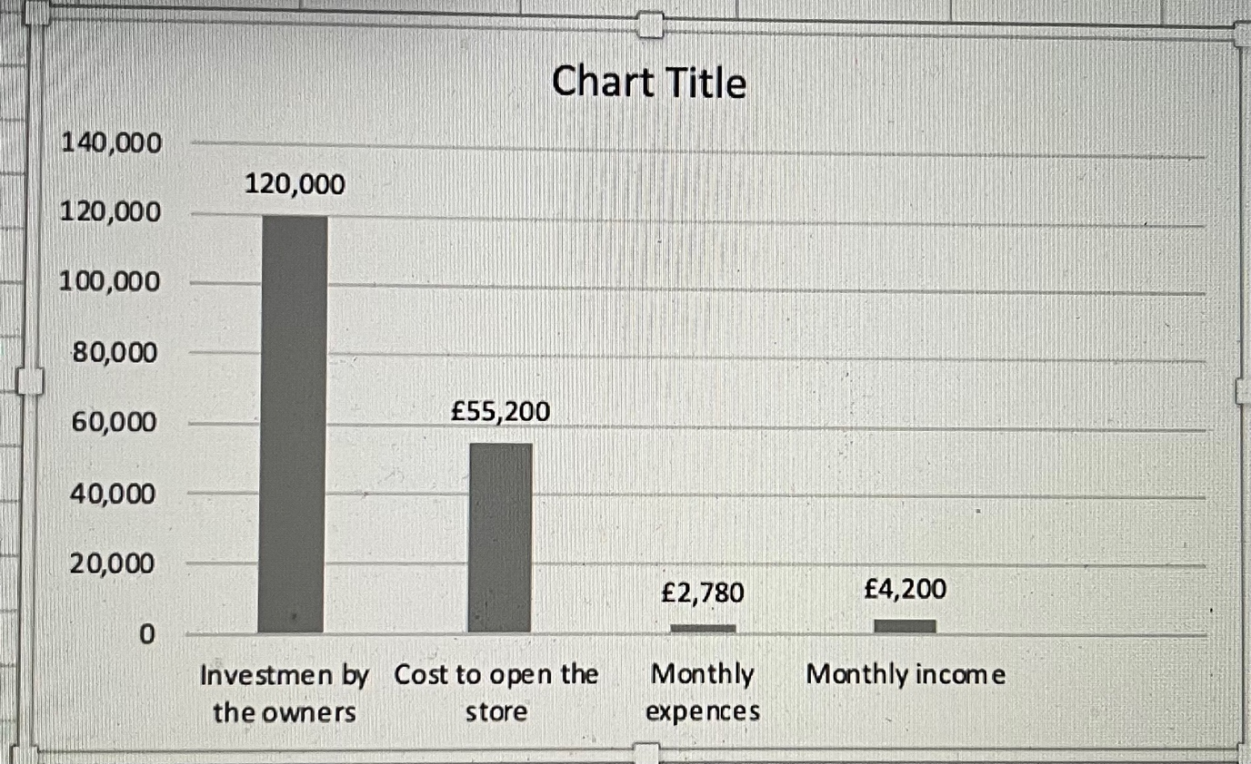

- Reference:
CFI (2020) Competitive Intensity. Available at: https://corporatefinanceinstute.com/resources/knowledge/strategy/competitive-intensity/.
(Accessed: 23 June 2022).

Danny Bonvissuto (2020) Plum, What, is a Plum? Available at: https://www.webmd.com/food-recipes/benefits-plums
(Accessed: 20 June 2022).

EIU (2022) Global economic impacts of the Russia-Ukraine war. Available at: https://www.eiu.com/n/global-economic-implications-of-the-russia-ukraine-war/.
(Accessed: 23 June 2022).

Frederic Meunier, Cyraine Coste and Ricardo Maia (2022). How did the COVID-19 pandemic influence the pace of new business formation? Available at: https://blogs.worldbank.org/developmenttalk/how-did-covid-19-pandemic-influence-pace-new-business-formation
(Accessed: 23 June 2022).

Gov.uk (2022) AFG DRIED FRUIT AND NUTS LTD. Available at: https://www.find-and-update.company-information.service.gov.uk/company/12001341/filing-history.
(Accessed: 20 June 2022).

Lupnicka Denisa and Dado Jaroslav (2013). Marketing Audit and Factors Influencing Its Use in Practice of Companies (From an Expert Point of View). Available at: https://www.semanticscholar.org/paper/Marketing-Audit-and-Factors-Influencing.Its-Use-in-Denisa-Jaroslav/e7cfc47981afe0f270065801627e289347647b84
(Accessed: 26 June).

MindTools (2022) SWOT Analysis. Understanding Your Business, Informing Your Strategy. Available at: https://www.mindtools.com/pages/artiche/newTMC_05.htm.
(Accessed: 20 June).

Nerdynant and Rashain, P. (2017). The Pestle Analysis; pp.2
Roya Zeitoune/October 2020
(Accessed: 26 June 2022).

Violeta Radulescu (2012). International journal of Academic research in Economics and Management sciences; 1 (5) pp.222.
(Accessed: 25 June 2022).

Watan Dry Fruits Ltd (2022). About us. Available at: https://watandryfruits.business.site/.
(Accessed: 23 June 2022).

