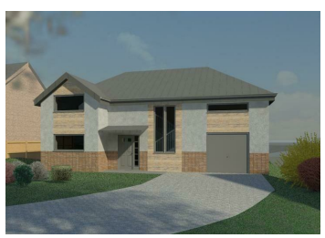  Case Study |   Patrick Furlong (0650804)  Fundamentals of Construction Technology

Contents
Introduction 1
Panelised OSC 1
Volumetric OSC 2
Hybrid OSC 2
Sub-assemblies and components OSC 3
Traditional construction 3
Twin timber frame construction 8
SIPs Construction 11
Recommendation 16
References 17
Appendix 18

Introduction
Offsite construction (OSC) has existed for centuries, with the earliest recorded example in 1624; houses were prepared in England and sent to the fishing village of Cape Ann Boafo et al (2016). OSC has been described and defined in many ways but it can be broadly defined as—“manufacturing buildings or functional elements of buildings in a factory to be transported and erected onsite” Ginigaddara et al. (2022)
OSC can be divided according to the degree of the off-site work undertaken Hwang et al (2018), and the four main categories are:
- Panelised
- Volumetric
- Hybrid
- Sub-assemblies and components

Panelised OSC
Panelised OSC consists of two-dimensional panels and frames assembled offsite in a factory which are sized for transportation and then delivered to construction sites for assembly to form a structure or building Lin, T. et al. (2022). In residential properties they usually consist of wall, floor and roofing panels which can be either open or closed. Closed panels incorporate elements such as lining materials, cladding or insulation, etc. whereas open panels have such elements fitted in situ on site Lin, T. et al. (2022). SIPs are a form of closed panel OSC and “are pre-manufactured sheathed panels which combine structure and insulation into one building component” Harris, J. et al. (2019). Harris, J. et al. (2019). This enables higher quality, increased thermal efficiency and a greater level of structural support Porteous and Kermani (2013).
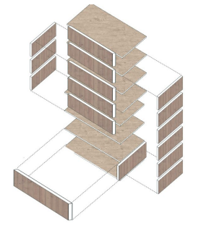
Figure 1panelised systems

Volumetric OSC
Volumetric OSC consists of completed fully enclosed modular units, complete with all finishes and fittings. They can be produced in a factory where the majority of project work can be done offsite, cutting the time necessary for on-site building to a bare minimum Lebza (2022).
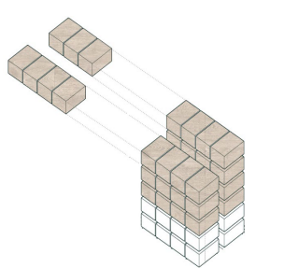
Figure 23D Volumetric Lebza (2022)

Hybrid OSC
Hybrid OSC uses a mixture of construction types. It can be a combination of both traditional and modular construction together i.e, a building can be partially built from traditional construction and partially from modular Gharehbaghi (2017) or they can combine panel and modular prefabrication systems to construct a whole building Boafo et al (2016).
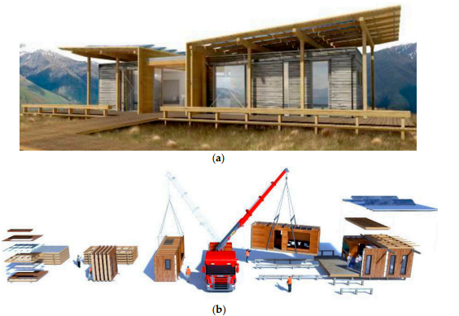
Figure 3 Hybrid structure–First Light House: completely installed building (a) and installation (b) Boafo et al (2016).

Sub-assemblies and components OSC
Sub-assemblies and components OSC are the most basic typology of OSC and involve the most amount of work on site. Components are common in many buildings regardless of whether they have been built traditionally or offsite. OSC components and sub-assemblies can be defined as: “Factory produced items which are not considered under full systems; yet become parts of the structure.” Ginigaddara et al (2019). They include things like stairs, doors, windows, I joists and steel elements.

Traditional construction
Swansea is in category 4 exposure zone the site will be subject to wind driven rain in excess of 100 litres/m2 per spell. The buildings outer leaf will be of brick or block and will require a minimum 50mm clear cavity. The worst acceptable fabric performance values for walls in Wales is 0.18 W/(m² K) according to Approved document L. This can be achieved with 100mm of KOOLTHERM K108 and an Inner Leaf BLOCKWORK (k-value = 0.42 W/mK) which will achieve a value of 0.16 W/(m² K). The total thickness of construction will be 352.5mm and if we include a 25mm service void and 12.5 mm plaster board the total overall wall section will be 390mm.

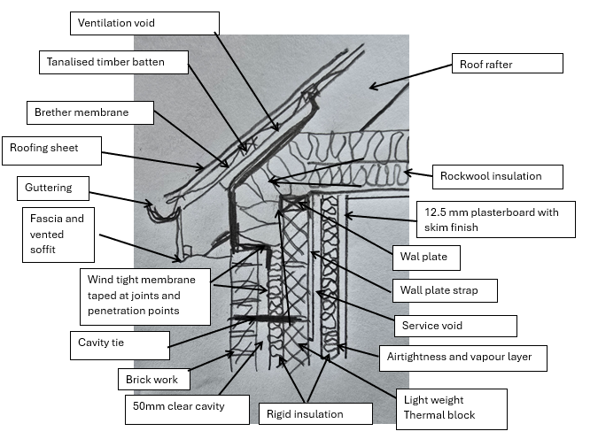
Figure 4Brick and block eaves detail
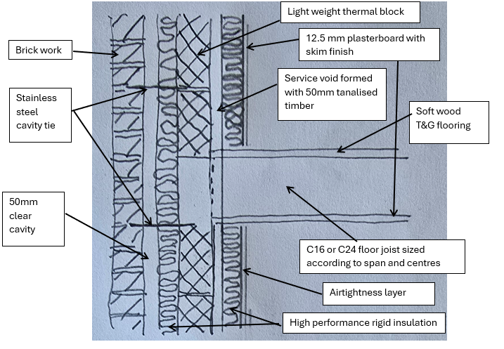
Figure 5 Brick and block floor joist detail
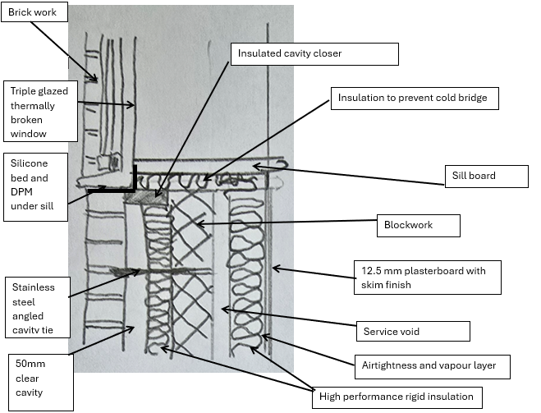
Figure 6 Brick and block window sill detail
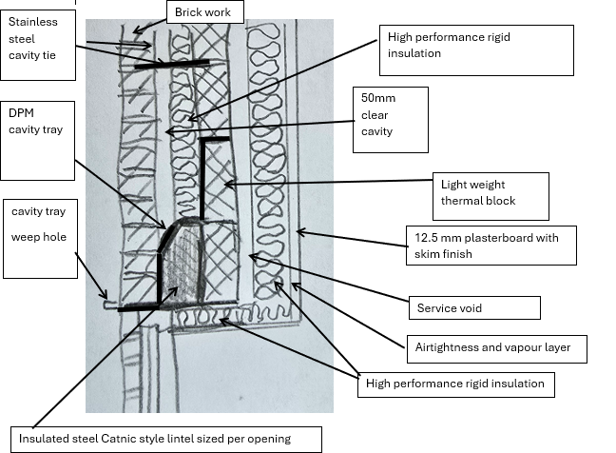
Figure 7 Brick and block lintel detail

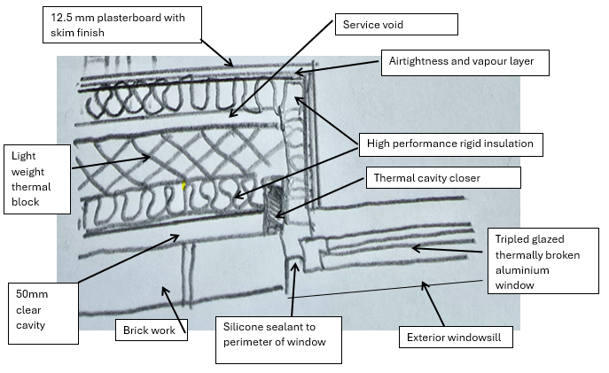
Figure 8 brick and block jab detail
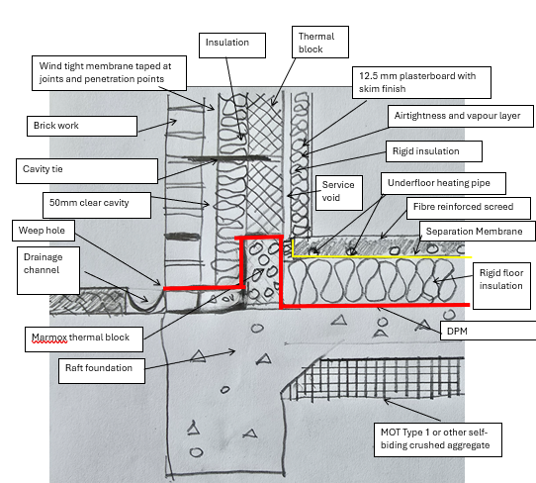
Figure 9 brick and block foundation detail

Twin timber frame construction
Timber Twin frame construction with an outer masonry leaf will still require a 50mm clear cavity. The timber stud will need to be need to 195mm and filled with Supafil® Frame 195mm to achieve a u value of 0.15 W/(m²K). The total section thickness will be 394mm (includes 102.5mm brick, 50mm cavity, 12.5mm plasterboard, 9mm OSB and 25mm service void).
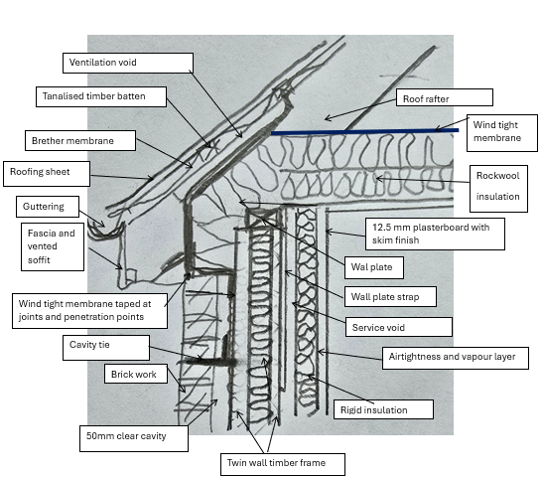
Figure 10 Timber frame eaves detail
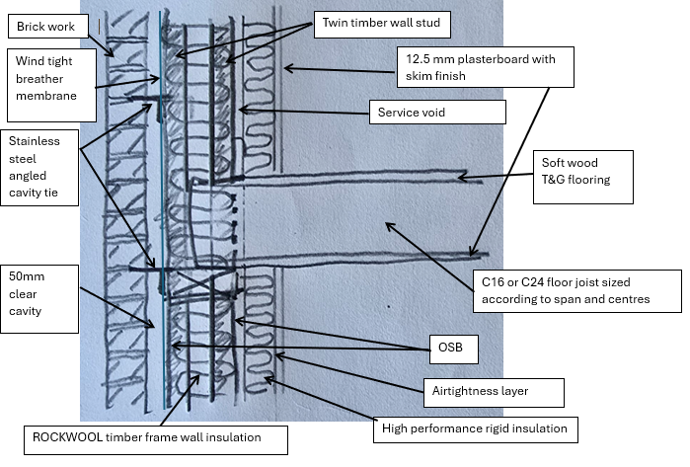
Figure 11 Timber frame timber floor detail
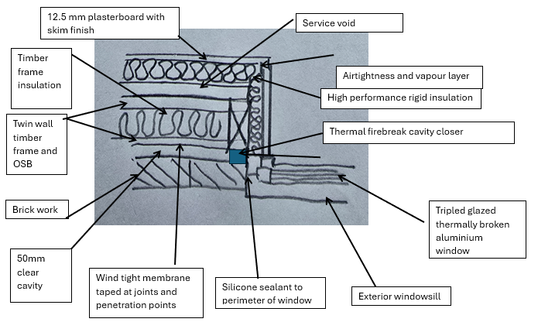
Figure 12 timber frame jab detail
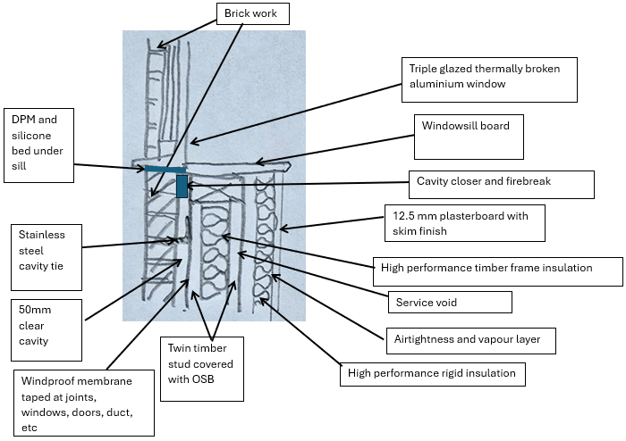
Figure 13 timber frame sill detail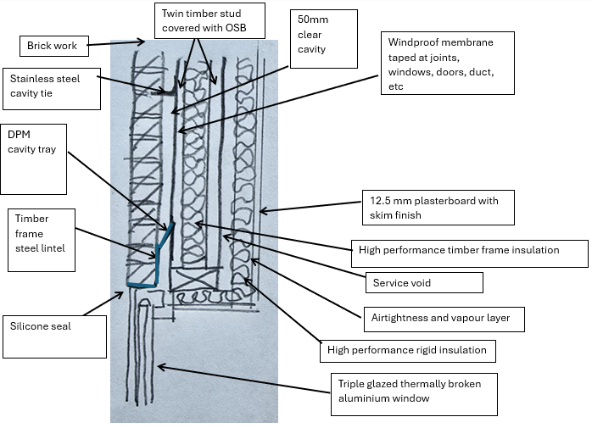
Figure 14 timber frame lintel detail
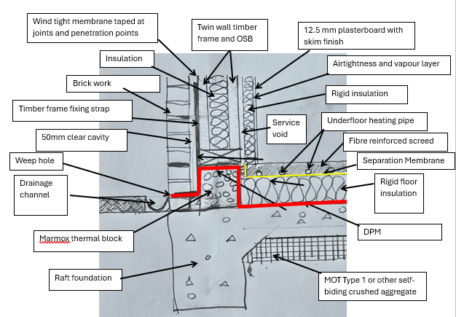
Figure 15 timber frame foundation detail

SIPs Construction
The SIP will still require the 50mm cavity and the use of Kingspan TEK® 172 (172mm width) to achieve a U value of 0.14 W/(m²K). The overall wall thickness will be with the service void and plasterboard 362mm.
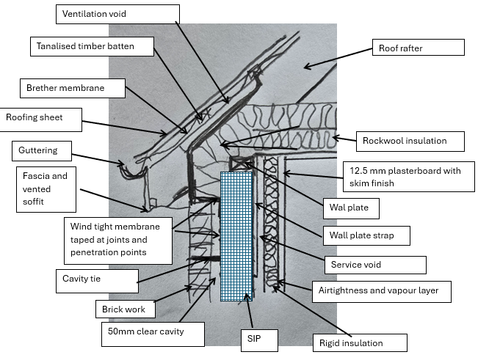
Figure 16 SIP eaves detail
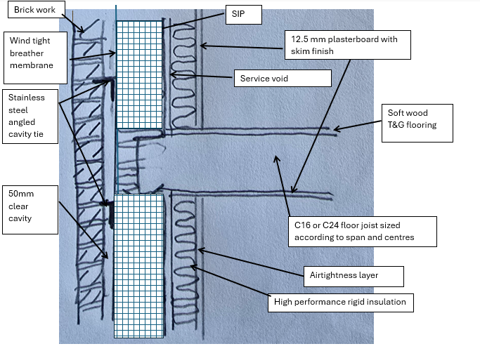
Figure 17 SIPs first floor detail
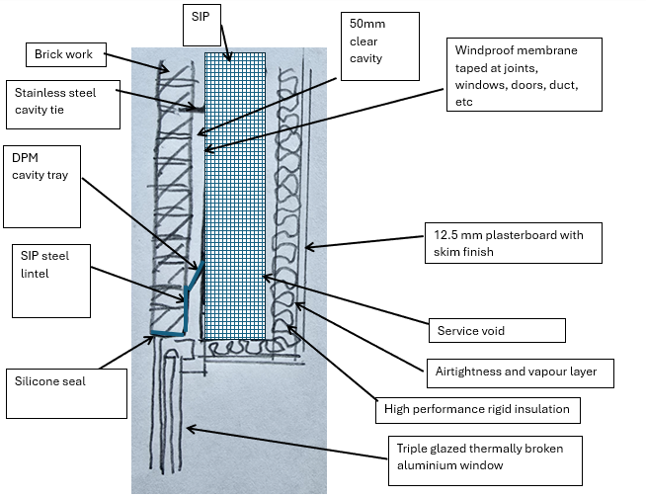
Figure 18 SIPS lintel detail
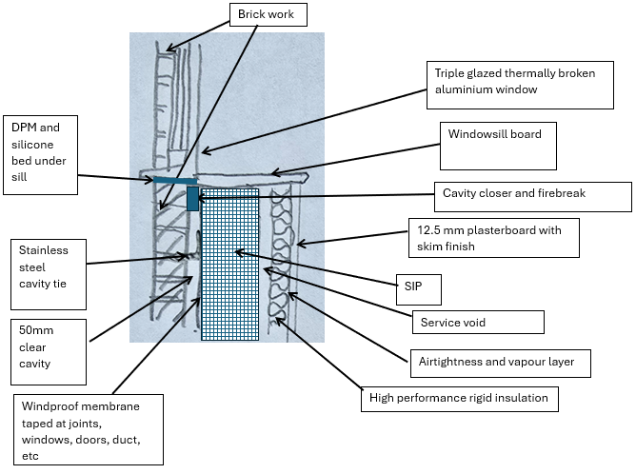
Figure 19 SIPs sill detail
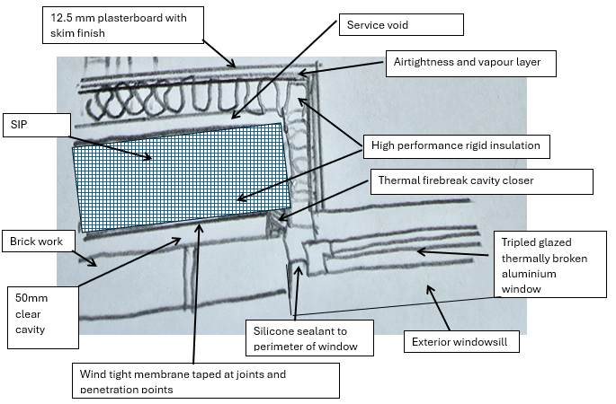
Figure 20 SIPs jab detail
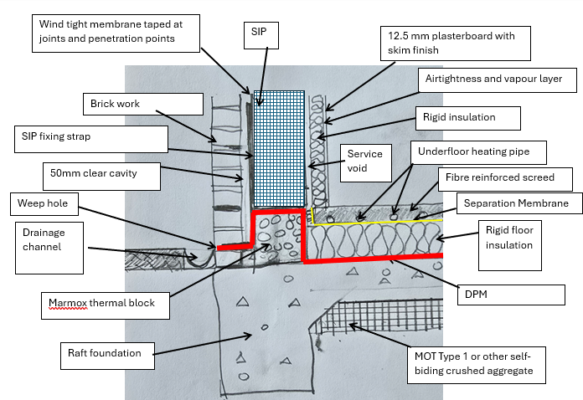
Figure 21 SIPs Foundation detail

Recommendation
In a modern building airtightness is integral to achieving real life U values along with a continuous layer of well installed insulation. The problem with traditional masonry construction is that the insulation layer and the wind tightness layer are within the cavity and are punctured at multiple points by the cavity ties. For every square metre there are 2.5 ties, each one of those ties has to be taped to achieve good airtightness. It is essential that rigid insulation is kept clean (free of dust, water or mortar) for the tape to adhere and accurately cut which is challenging on a live construction site. It is also essential that the insulation is close to the inner leaf and needs holding in place by clips on the cavity ties but that can only happen if a cavity tie is present and this is not always possible. Is difficult to minimize the gap between the insulation layer and other elements of the building such as the windows, doors, roof void, etc. This can then lead to bypass of the insulation rendering it useless. Traditional construction can also be adversely impacted by weather with can slow construction. I would therefore opt for one of the other methods over traditional construction. I would chose the SIPs or twin wall timber frame because it is capable of achieving a better U value of 0.14 W/(m²K) but with a reduced overall thickness of 362mm, which compares to 396mm and 0.15 W/(m²K) for the twin wall timber frame.

References
Boafo, F., Kim, J.-H. and Kim, J.-T. (2016) ‘Performance of Modular Prefabricated Architecture: Case Study-Based Review and Future Pathways’, Sustainability, 8(6), pp. 558-. Available at: https://doi.org/10.3390/su8060558.
Ginigaddara, B. et al. (2022) ‘Development of an Offsite Construction Typology: A Delphi Study’, Buildings (Basel), 12(1), pp. 20-. Available at: https://doi.org/10.3390/buildings12010020.
Ginigaddara, B. et al (2019). Typologies of offsite construction. In: Sandanayake, Y.G., Gunatilake, S. and Waidyasekara, A. (eds). Proceedings of the 8th World Construction Symposium, Colombo, Sri Lanka, 8-10 November 2019, pp. 567-577. DOI: doi.org/10.31705/WCS.2019.56. Available at: https://2019.ciobwcs.com/papers
Gharehbaghi, K. (2017) ‘Modular High-rise Construction: An Alternative Building System’, The international journal of the constructed environment, 8(3), pp. 15–25. Available at: https://doi.org/10.18848/2154-8587/CGP/v08i03/15-25.

Harris, J. et al. (2019) ‘Understanding Construction Stakeholders’ Experience and Attitudes toward Use of the Structurally Insulated Panels (SIPs) in New Zealand’, Sustainability, 11(19), pp. 5458-. Available at: https://doi.org/10.3390/su11195458.

Hwang, B.-G., Shan, M. and Looi, K.-Y. (2018) ‘Key constraints and mitigation strategies for prefabricated prefinished volumetric construction’, Journal of cleaner production, 183, pp. 183–193. Available at: https://doi.org/10.1016/j.jclepro.2018.02.136.
Lebza,R M. (2022) Comparative analysis of life cycle GHG emissions of off-site Prefabricated modular volumetric construction and Panelized construction system for High rise wooden residential buildings in Norway: The potential of prefabricated wood Constructions as an efficient and sustainable building practice and their life cycle Lin, T. et al. (2022) ‘Offsite construction in the Australian low-rise residential buildings application levels and procurement options’, Engineering, construction, and architectural management, 29(1), pp. 110–140. Available at: https://doi.org/10.1108/ECAM-07-2020-0583.
Ofori-Kuragu, J.K., Osei-Kyei, R. and Wanigarathna, N. (2022) ‘Offsite Construction Methods—What We Learned from the UK Housing Sector’, Infrastructures (Basel), 7(12), pp. 164-. Available at: https://doi.org/10.3390/infrastructures7120164.
Porteous, J. and Kermani, A. (2013) Structural timber design to Eurocode 5. 2nd ed. Chichester [England: John Wiley & Sons Inc.

Appendix
Figure 22 U value calculation Brick and block
Figure 23 SIPs U value data sheet
Figure 24 Twin wall timber frame U value calculation

