Effective Teaching, Learning and Assessment

Within the body of this essay the author shall critically assess and reflect upon a micro-teach lesson delivered on the 26th of October 2017 taking into consideration the prior planning of the lesson and the subsequent delivery. The essay will focus on the contemporary pedagogical methods that were used throughout the lesson and will critically analyse their effectiveness and impacts as teaching strategies.

The author shall will be using Kolb's Learning Cycle as a model for reflection and further continued professional development. As can be seen from (Learn.solent.ac.uk, 2017) Kolb's Learning Cycle consists of four segments which are in a cycle, these segments include Concrete Experience (doing/carrying out an experience), Observations and Reflections (reviewing the experience), Abstract Conceptualization (development if ideas/learning from the experience) and Active Experimentation/Testing (applying what you have learned from the experience). It is argued that this method of reflection is effective as it aids continual profession development through ongoing application and reflection, as stated by (Kolb, 1984). “Learning is the process whereby knowledge is created through the transformation of experience”. However, it could be argued that this method of learning and reflection is contentious. (Simplypsychology.org, 2017) argues that “effective learning only occurs when a learner is able to execute all four stages of the model. Therefore, no one stage of the cycle is an effective as a learning procedure on its own.” Therefore, all stages must be covered for the method to be effective.

I decided that I would teach the fundamental terminology of sustainability and its importance to the tourism sector. This topic was taught in association to the cross cutting theme of education for sustainable development and global citizenship (ESDGC).
I had to ensure that I effectively incorporated several forms of contemporary pedagogy and utilised contemporary learning methods to teach my subject. As stated by (Collinsdictionary.com, 2017) contemporary is defined as “existing or occurring at the present time” so my research had to focus on teaching methods that are currently being used to facilitate teaching and learning effectively. Therefore, I decided the contemporary methods I would use where Q and A (diagnostic/formative assessment), a video based activity (formative assessment) and an interactive questionnaire (summative assessment). It could be contested that my lesson plan (Appendix 1) therefore was appropriately structed as it included a range of teaching and assessment strategies to support learning. For example, the lesson amalgamated both traditional teaching and technology to teach the subject in a dynamic and interactive way. In contrast, whilst planning the lesson it could be stated that more consideration should have been take in relation to the structure of the PowerPoint, some of the slides where too detailed and there were some spelling mistakes. An article by (Tlss.uottawa.ca, 2010) discussing university teaching comments how too much text it can be detrimental to effective learning as “the audience is often placed in a position of cognitive overload because they must simultaneously read text and listen to the presenter”, as highlighted by (www.northumbria.ac.uk, 2009) grammar is equally important as “if you have any spelling or grammar mistakes it can undermine your presentation”. It is therefore recommended that slides should include less text as students may not fully engage in the lesson as they may try to copy information from the slides. Grammar needs to be thoroughly assessed also to ensure that the presentation makes sense and is credible.

The lesson began with an outline of aims and objectives and a brief Question and Answer session where students were asked to define what sustainability meant to them and state their beliefs on whether tourism could operate in a sustainable manner. These questions also related to the theme of ESDGC as students had to consider the impacts of tourism on the world and its communities. This teaching method was used as a form of diagnostic assessment as I assessed the learners prior understanding of sustainability and its impact upon tourism. Formative assessment also took place as immediate feedback was given to stimulate learning and development following the discussion. It can be argued that questioning can be used to support effective teaching and learning as it supports continual development through encouraging engagement and supporting analytical thinking. This is supported by an article by (Busch, 2017) who comments on the benefits of pre-questions (questions asked about material before someone has learned it). In the article the author discusses that results from a recent study showed learners who had been asked pre-questions were 50% more capable of recalling information in comparison to their fellow students. (Busch, 2017) comments that this is because this method captures the attention of learner and creates interest. The study also found that the students were not only able to recall answers of the pre-questions but were better at remembering key concepts from later in the lesson also. This demonstrates that questioning can not only be used to effective teaching through assessing prior knowledge but also it is an effective method of learning as those who had been had asked pre-questions were more capable at recalling information that learners who had not been. Conversely in could be argued that this method is only beneficial to those being questioned, therefore students who are not being questioned are placed in a detrimental position at no fault of their own. Also (Busch, 2017) further stated that the study highlighted students benefit more when the teacher controlled the pace and when it was self-directed by pupils the effect of questioning may be lessened.
In conclusion It is therefore recommended that the teacher considers the plausibility of this method be implementing it. This type of teaching method may be appropriate for teaching in a classroom as the lecturer could possibly control the pace of the questioning and ensure mass inclusion therefore supporting educational growth, however this method may not be as effective as a teaching and learning method in a large theatre as it is arguably unfeasible to control the pace and include all students in a theatre of around 100 or more students and could therefore be detrimental.

Following the Q and A I combined traditional teaching/lecturing and digital teaching to deliver the topics content and carryout a video based activity on YouTube. I used digital teaching methods by using Nearpod which is an interactive teaching platform that allows students to follow the presentation using their own devices such as tablets and laptops whilst simultaneously lecturing to the students.
It could be argued that both traditional methods of teaching such as lecturing and digital teaching through innovate methods such as Nearpod can be both beneficial and negative forms of teaching strategies. As can be seen from an article by (Bbcactive.com, n.d.) the way in which university lectures are being taught are changing, there has been a rise in the use of digital based teaching and innovative teaching, however it is stated that traditional lecturing may still be credible form of teaching and learning. Regarding more innovative and digital teaching (Bbcactive.com, n.d.) states that this form of teaching reduces the effect of traditional lecturing’s passive learning and supports effective leaning through more active learning where participate more in the lesson and it is cited “Traditional didactic lectures limit the opportunities for student interaction, but recent attempts to provide greater student interactions in lectures have resulted in much higher satisfaction, higher thinking skills and enhanced motivation.” In contrast it is also highlighted that digital teaching can also be negative. Students now have easy access to an extensive amount of information and in-depth information on a topic and this may reduce their higher thinking and analytical skills as they may not be used as frequently as before. There is also a danger of being distracted by media multitasking, (Bbcactive.com, n.d.) comments that “for some students who are overwhelmed by the age of media multitasking, it seems that the traditional lecturing model of keeping it simple could be a welcome relief from the fast-paced, distracted digital age.”
Traditional lecturing can be both positive and negative also. (Bbcactive.com, n.d.) highlights that traditional teaching has been criticised for several years for failing to engage students as it does not support varying learning styles and abilities and is often situated in theatre style which promotes passive learning as “as student’s peer down at one central figure on the stage without the potential for collaboration or interaction”. This often leads students to become disengaged and bored which can have catastrophic effects upon learning, an article by (Mann, 2009) states that a study found “60% of students find at least half their lectures boring - with about 30% claiming to find most or all of their lectures boring” and this lead students to create a variety of strategies to “cope” with boring lecturers all of which were damaging to effective learning. For example, research found that 75% of students admitted to daydreaming during lectures, doodling was second highest at 66%, this was followed by chatting with friends (50%), texting (45%) and passing notes to others finally at (38%). Research also found that over a quarter of students leave lectures during break and do not return after the break, this is most likely the most concerning effect of boring lectures as the has been evidence that supports a link between good attendance and good grades.
As seen in (Bbcactive.com, n.d.) traditional lecturing is not without merits and can be an effective teaching strategy also. Lecturers if delivered with enthusiasm can arguably facilitate learning as lecturers can cover their subject in more depth than a innovative or digital resources, lectures can help to educate students who learn through listening and lecturers could therefore be more appropriate depending on the type of learners being taught. Traditional lectures also allow students to gain immediate clarity on any complex issues and the lecturer can offer personal advice and guidance to students based on their own expert knowledge.
In conclusion it is recommended that the combination of both traditional methods of teaching and innovate teaching methods that support active learning be considered. It is argued that a combination of both methods could be used as a model to facilitate and support a wide range of learning abilities and strategies which will benefit a range of students, it is contended that this model will also encourage engagement and student participation also.

Following this the students had to carry out a video based task where they watched videos on YouTube. The videos demonstrated both effective sustainability and ineffective sustainability within tourism and the students had to identify each one in relation to the Economic, Environmental and Social-cultural factors shown. Students then participated in a group activity where they had to create mind map displaying the information they had used to identify the effective sustainability and ineffective sustainability videos and feedback to the class as found in (Appendix 2,3,4). This was used as a form of formative assessment as students had to display comprehension and analytical ability and provide each other feedback for further progression. It is arguable that both video based learning and mind maps support effective learning.
As seen from the University of Queensland (Uq.edu.au, n.d.) there are several pedagogical benefits to using video in the classroom, the article states that video usage in the classroom can impact on teaching and learning as it “encourages teachers to consider the flipped classroom model where learners can digest lecture content at their pace and explore content more deeply during class time.” The article comments that video based activities can facilitate the development of problem solving and thinking skills as research found that there was a connection between visual clues, the memory process, and the recall of new knowledge. This is supported by research conducted by (Willmot, Bramhall and Radley, 2012) which states there is evidence that students are inspired and engaged by video tasks if they are incorporated alongside student-centred learning activities. The research found that video based activities supported effective learning by supporting the development of team working and communication skills, increasing student motivation and “development of learner autonomy”.
As (Kaminski, 2016) highlights mind maps are also effective as a teaching and learning method as they arguably support retention and recall, higher-order processing and can also support the assemble of development of essay writing. (Kaminski, 2016) states that mind maps support retention and recall by linking new material to existing information to retain and later recall the new material. “Since mind maps are personalized and encourage multiple connections, they assist with this process.” Higher-order thinking skills are arguably very important (HOTS) (Watson, 2017) comments that (HOTS) are derived from various taxonomies such as that of Benjamin Bloom and they “distinguishes critical thinking skills from low-order learning outcomes, such as those attained by rote memorization.” Watson is stating that therefore HOTS are important as they can develop skills such as reason, comprehension, application, and evaluation, therefore mind maps are arguably an effective learning method as they facilitate the development of these skills.
In contrast both the video based activity and mind-map activity that I used were visual based activities. It could be argued that this may not support effective learning of all learners as this method of learning may not be suitable to all their learning styles. As can be seen from (Vark-learn.com, n.d.) there are four primary “sensory modalities” that are used for learning, these are Visual, Aural, Read/Write and Kinaesthetic also known as VARK. Fleming and Mills (1992) suggested these four modalities reflect the experiences of the students and teachers. Visual leaners prefer to learn through the medium of visual aids such as maps, graphs and diagrams, Aural learners prefer to learn through spoken or heard information, Read/write learners prefer information to be displayed as words and Kinaesthetic learners learn more effectively by relating to the use of experience or practising. Whilst the activities delivered had a strong visual element and incorporated some aural learning, it could be stated that due to lack of Read/Write and Kinaesthetic learning some students could become disengaged leading to ineffective learning.

In conclusion it could be stated that the activities used could both be beneficial and detrimental to effective teaching and learning. The activities supported flipped learning allowing students to become more involved with the teaching and learning and provided a platform for the development of higher order thinking skills and abilities such as critical thinking, analytical thinking and evaluative skills. The activities were however predominately visually based which could be to detrimental to learners if other learning styles, it is therefore recommended that whilst planning activities more consideration and depth is given in relation to the VARK modalities of learning to support the learning of all learners.

To conclude the lesson the students had to complete an interactive questionnaire/quiz as a form of both formative and summative assessment, this was then underpinned by allowing learners to ask any Questions and Answers to consolidate any queries. (Robinson, n.d.) states “Summative assessment demonstrates the extent of a learner's success in meeting the assessment criteria used to gauge the intended learning outcomes of a module or programme” therefore it is arguable that a quiz/questionnaire is an effective method of summative assessment as it allows lecturers to gather measurable evidence of learning and quantify achievement. But as mentioned by (Robinson, n.d.) summative assessment can also provide information of formative benefit also. This is supported by (www.uwc.ac.za, n.d.) who states that “quizzes are an effective way of providing students with formative and ongoing feedback on their learning progress.” It is further highlighted that quizzes can be used to identify if students are understanding the course content knowledge and recognise areas of course content where there may be lack of knowledge or confusion.
In conclusion, this debatably shows that quizzes can be both effective for assessment and teaching as through using them lecturers can gather measurable data for summative assessment but can also be used for formative assessment where feedback can be given on weaker areas, this will in turn support more effective teaching through the identification of course content that needs to be further covered and developed to support learning.

In conclusion I believe the micro teach I delivered expressed a range of contemporary pedagogies that arguably support effective teaching and assessment. Pre-Questioning learners can increase memory recall and have long term benefits regarding information retention, however consideration needs to be taken into how this method is applied to maximise its effectiveness as it may not be appropriate to use when teaching large groups. It was found that even though more innovative models of teaching such as digital teaching platforms can be effective they can also be negative too and that traditional lecturing is debatably beneficial in contemporary teaching still and through amalgamating both innovate digital teaching and traditional teaching we can create a learning environment that supports a wide range of learning abilities. The use video based learning can also be beneficial and research has found that the teaching strategies I used could support the development of higher order thinking skills (HOTS) such as analytical thinking and evaluative abilities, however whilst planning the lesson I didn’t realise that a lot of activities supported learners of a visual preference so for more effective teaching it is recommend I diversify my teaching strategies to support all learning styles. My research also highlighted the summative and formative benefits of quizzes, they can be used to collect to assess if learning and teaching has been effective through assessment and to identify where learning and teaching needs to improve to support continual educational development. In contrast it has been highlighted on several times that to ensure teaching is effective and professional I need to take more consideration in my grammar as they may negatively affect the students learning.

Appendix
(Appendix 1)

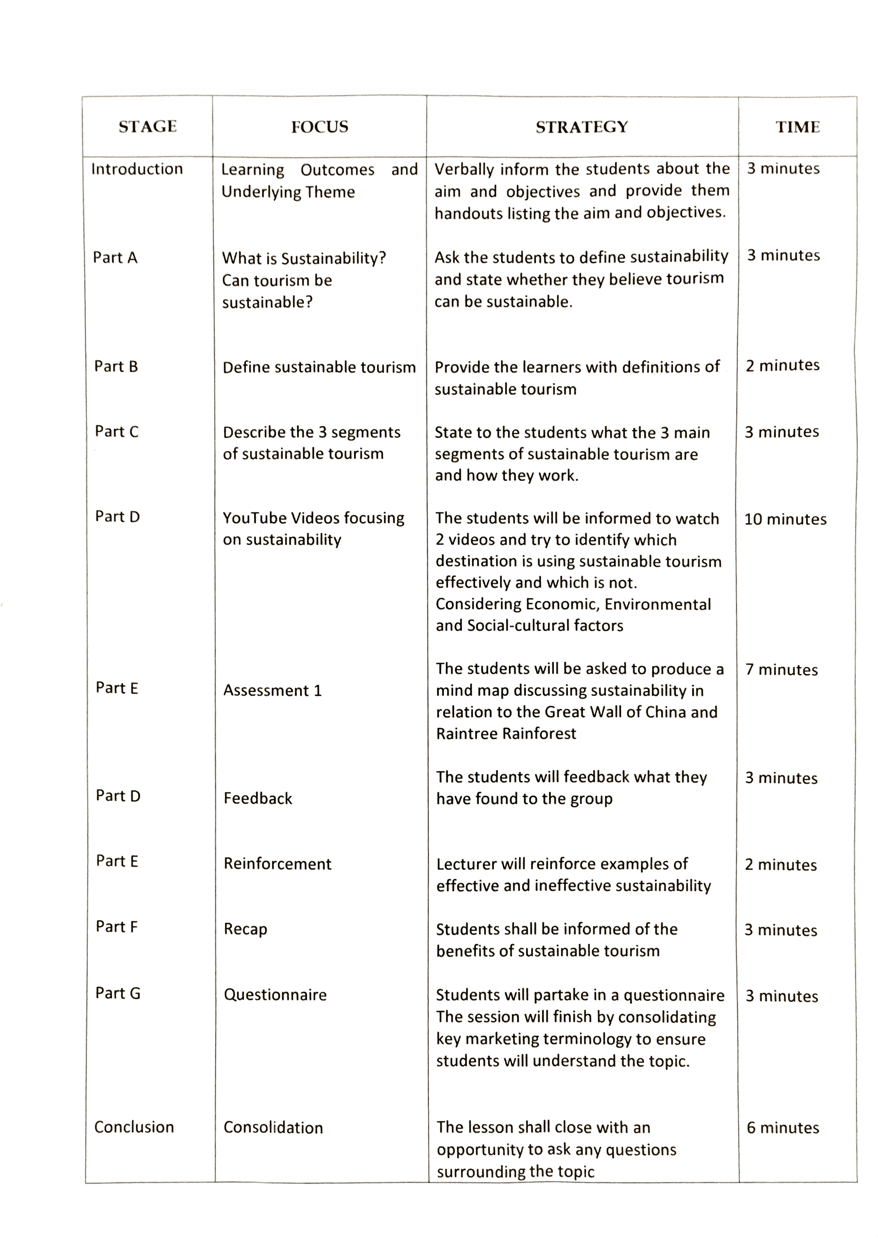

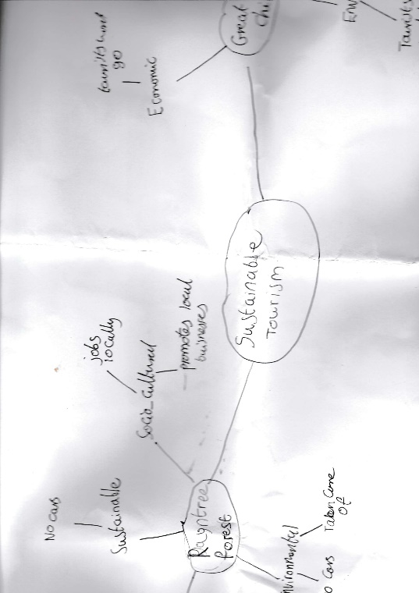
(Appendix 2)

(Appendix 3)

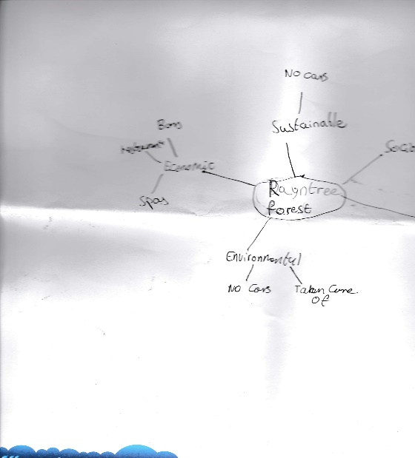

(Appendix 4)
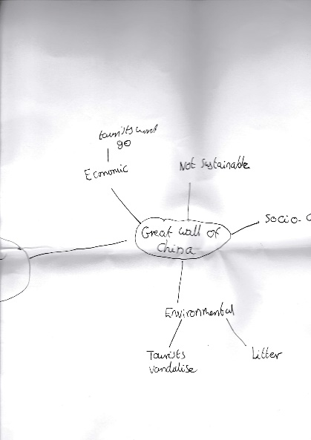

Bibliography

Bbcactive.com. (n.d.). Innovative teaching methods vs the traditional university lecture. [online] Available at: http://www.bbcactive.com/BBCActiveIdeasandResources/Innovativeteachingmethodsvsthetraditionaluni.aspx
Busch, B. (2017). Teachers: here's how to get your lessons off to a flying start. [online] the Guardian. Available at: https://www.theguardian.com/teacher-network/2017/jun/07/teachers-heres-how-to-get-your-lessons-off-to-a-flying-start
Kaminski, D. (2016). Using Mind Maps for Learning. [online] Inside Teaching MSU. Available at: http://insideteaching.grad.msu.edu/using-mind-maps-for-learning/
Kolb, D. (1984). Experimental learning. Englewood Cliffs: Prentice-Hall.
Learn.solent.ac.uk. (2017). Reflective thinking and writing: Kolb's Learning Cycle. [online] Available at: https://learn.solent.ac.uk/mod/book/view.php?id=2732&chapterid=1112
Mann, S. (2009). Why do 60% of students find their lectures boring?. [online] the Guardian. Available at: https://www.theguardian.com/education/2009/may/12/university-teaching
Robinson, D. (n.d.). Types of assessment - definitions - Learning and Development - University of Exeter. [online] Exeter.ac.uk. Available at: https://www.exeter.ac.uk/staff/development/academic/resources/assessment/principles/types/
Simplypsychology.org. (2017). Kolb's Learning Styles and Experiential Learning Cycle | Simply Psychology. [online] Available at: https://www.simplypsychology.org/learning-kolb.html
Tlss.uottawa.ca. (2010). Cite a Website - Cite This For Me. [online] Available at: https://tlss.uottawa.ca/site/images/1-SAEA/CPU/publications/04_PowerP_EN.pdf
Willmot, P., Bramhall, M. and Radley, K. (2012). Cite a Website - Cite This For Me. [online] Raeng.org.uk. Available at: https://www.raeng.org.uk/publications/other/using-digital-video-reporting
www.northumbria.ac.uk. (2009). Improving your PowerPoint presentation. [online] Available at: http://Your presentation will be on display for many people to see, if you have any spelling or grammar mistakes it can undermine your presentation. Spell-check your presentation or, better still, have a friend or colleague look through it.
www.uwc.ac.za. (n.d.). Using formative quizzes for continuous learning and assessment. [online] Available at: https://www.google.co.uk/url?sa=t&rct=j&q=&esrc=s&source=web&cd=1&cad=rja&uact=8&ved=0ahUKEwifqJ7L5ZnYAhVDPFAKHfv8DYYQFggtMAA&url=https%3A%2F%2Fwww.uwc.ac.za%2FTandL%2FDocuments%2FUsing%2520formative%2520quizzes%2520for%2520continuous%2520learning%2520and%2520assessment.pdf&usg=AOvVaw1wqiGq1Fa7fAsEFFS_zf20

