Questions
Do all 5 background points need to be referred to?
Yes. This is a case study and the information is there to give you material for your report. Ignoring any element of the case study means that the company will be missing part of your risk analysis. You need to make each word count; remember that this subject is called Application of Employment Law. Your focus should be on application of law, identification of risk, minimising risk and commercial recommendations.
I am particularly interested in reading your justification (or not!) for going beyond compliance.
What kind of expectations are there around metrics and targets? Do you have an example of metrics and targets for the recommendations?
This is about measuring the impact of your recommendations. For example, if your recommendation is about how to improve organisational productivity, then the measurement will be an increase in productivity. In a care home, the recommendations might be in place to improve occupancy, so that is the measure.
If your recommendation is about improving employee satisfaction, then you need to measure that.
Or, it could be about costs. If I made a recommendation about sending the entire HR team to the north of England to get the ACAS 5 day mediation training, there would be a considerable cost. How can this cost be justified? What is the likely return on this investment and how will it be measured?
At level 7, you should be thinking strategically about the commercial impact of your recomemndations and how it links with organisational strategy and targets.
Include timings in your recommendations?
Yes. Make your recommendations SMART as far as possible.
Include Case Law?
Yes, to highlight examples, Cite Them Right reference guidance can be found here: https://www-citethemrightonline-com.uwtsd.idm.oclc.org/sourcetype?docid=b-9781350927964&tocid=b-9781350927964-122&st=case+law
The legislation sets out the framework but case law is how it is applied by ETs, EAT and so on. These interpretations become the law through doctrine of precedent. Using case law in your assignment helps you apply your knowledge and also demonstrate that you are current.
Here is something that might help you when you are doing your reading around case law. Don’t worry about the Welsh context here, but you will need to think about it in your own practice if you work for the public sector. Just to add: employment law is not devolved but policies such as Fair Work Wales, Social Partnership and Public Procurement (Wales) Act 2023 do create an overlap.
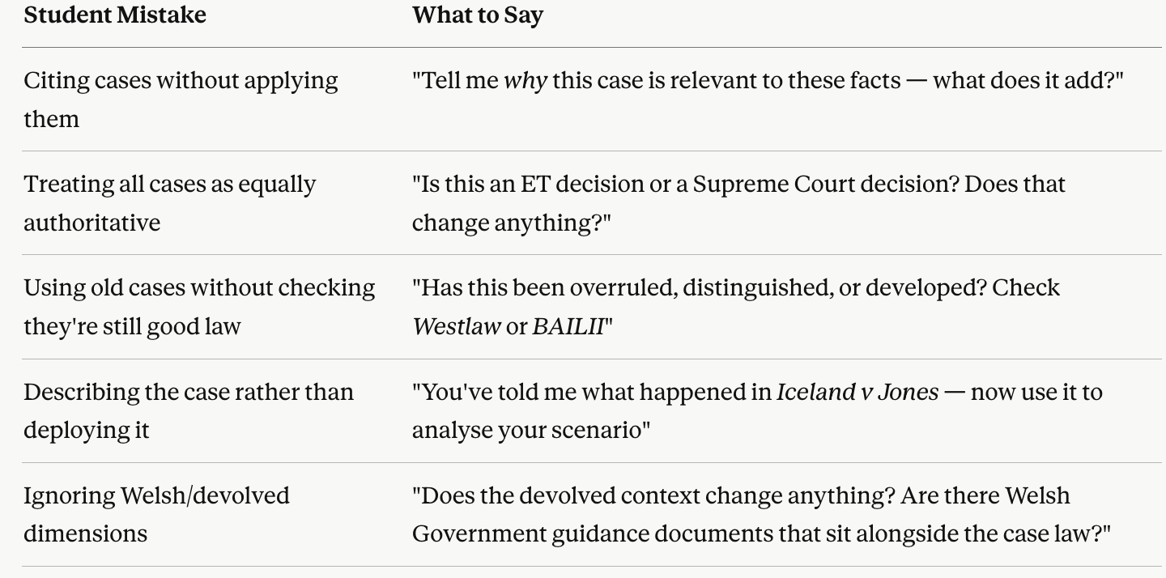

Bibliography?
Yes, separate for each task.
Do you definitely not need the leaflet on the word document?
I do not.
Can we quote Hannah Belton for example?
Yes, provide an example from those slides. You can cite anything or anyone you like so long as they are a credible, relevant academic source.
What should be included in the introduction?
Don’t just describe the law, set the scene and start analysis.
Clarification of leaflet layout?
Can be on one page or multiple, example on Canva, student’s own choice. I did show you some examples in an earlier session, perhaps week 1 or 2.
It says email/memo at bottom of task descriptions – should this be a report?
Yes, you can ignore email/memo
Draft deadline still this Friday?
Yes
Possibility of word count guidance for each part of the report?
Introduction — 150–200 words
Brief framing of the legal issues raised by the scenario. I want to see analysis, not scene-setting. Identify the key areas of law in play and signpost your structure. Please do not just repeat information from the case study.
Legal Issues , analysis, identification of risk. This should form the majority of the report. A well-structured report will include subject headings to help inform the reader.

Please remember to address the following points:

1. Immediate risks to the Company in terms of employment law, based on your analysis of the current situation.

2. Your advice and recommendations for improving compliance, taking into account the new Employment Rights Act 2025. She is aware that some of the details are unknown at this time, but she wants to get ahead of competitors in terms of implementation.

3. The business case from moving from what she describes as “near-compliance” to the prevention of disputes and conflict and your thoughts about the benefits of this, particularly in relation to strengthening the psychological contract, productivity and job quality.

Recommendations — 300–400 words
Don't introduce new legal points here, but connect findings to practical HR action, risk mitigation, and process improvement. Keep them SMART.
Conclusion — 150–200 words
What is the overall legal exposure? What is the priority advice? One crisp paragraph that a senior leader could act on.

