Cristina Creciun
2011283

Effective Team Working and Communication
BMSW4002

The Models of Communication and Communication skills

Lecturer: Charles Oham

Table of Content

- Introduction……………………………………. page 3
- Models of Communication…………………… page 3
- Shannon and Weaver………………………… page 4
- Wilber Schramm………………………………. page 5
- David Berlo ...……………………………….…. page 6
- Communication Skills…………………………. page 8
- Verbal communication ...……………………... page 8
- Nonverbal communication….………………... page 8
- Listening…………………………………….......page 9
- Conclusion…………………………………... page 10
- References………………………………….. page 11

Introduction
Objective of the report is to talk about the theory of communication, three communication models and find solution to solve communication problem at workplace. Also, discuss some examples of communication problem at my workplace and some case of study analyzed in class work. This report also will explain what verbal and nonverbal communication are and show importance of them.
Communication is a Latin term that means ‘to share’. It is about exchanging knowledge within different people. This involves communicating thoughts, beliefs, experiences, actions, and written words. Communication is generally characterized as the transmission of knowledge from one location to the other. Nonetheless, the different channels of conversation and the distances used to send messages sometimes lead to misunderstandings (Entrepreneur handbook, 2020).
Furthermore, this report will talk about active listening and empathetic listening.'Active listening' is consciously listening, as the name suggests. This is a complete focus instead of only passively "hearing" the speaker's message (Skills you need, 2011-2021). Active listening, also known as empathic listening, necessitates paying heed to the other party's contribution. Support and motivation instead of suggestion or critique is a central quality of empathic listening (Indeed, 2021).
Models of Communication
Models of interaction simplify the process by visually reflecting the several aspects of a communications session. Also, they serve an important role for communication students, as models help us to see concrete principles and stages in the process of communication, to describe communication and to apply communication concepts. Once you become conscious of how communication works, you will think more intentionally about your conversation discussions, which will make you to plan for future communication and advantage from past communication (Ashman, 2018).
The three models of communication will be discussed in this report are: Shannon and Weaver (1948), Schramm (1954), Berlo’s model (1960). Even though these three models are different, they also have common elements. Berlo's and Shannon -Weaver models have in common the following elements: sender, encoder, channel, decoder and receiver. However, the main difference is that Shannon-Weaver also contains the noise and feedback elements contrary to the Barlo's model. While Schramm's model is circular where both participants are active and transmit information to each other, but the obstacles are not described.
In 1948, Shannon and Weaver collaborated in writing an article called "Mathematical Communication Theory," which was also titled "Shannon Weaver Model of communication," in Bell System Technical Journal. This model is structured primarily to facilitate efficient cooperation between the sender and the receiver. They also identify causes that impact the "Noise" communication mechanism. The concept was originally planned to enhance technological interaction. Later, in the sphere of communication it is frequently used.


1948 model
This model includes sender, encoder, channel, noise, decoder, receiver, and feedback. Sender is the message's originator, encoder is the transmitter, message from encoder to decoder is transmitted via channel and during this process, signals can be disrupted by noise, which can cause the channel to be interrupted during the transmission process, which prevents the continuity of communications, or the listener may not receive the right signal. Decoder is the reception place where signals converted into message and receiver is destination of the information. As well if the recipient received the message he provides feedback (Communication theory, 2020).
Exist three levels of problems in this model:
1.Technical - where problem is in channel.
2.Semantic - meaning of the message send and received different.
3.Effectiveness – how successful the message is triggering the reaction.
Analysing this model, is evident that it is more effective in the case of direct communication, from person to person, than in the case of group communication. Also, that understanding the noise and removing it or confirming the information received will help solve various communication problems (Business topia, 2018).
At my former job as a sales assistant at a shoe store, I had some communication problems. For example, once a buyer wanted a model of slippers, but they were not in stock. I called the distribution company to add the given model to our order. I received an affirmative answer and I asked the buyer to picked them up tomorrow, as because the next day I was going to receive the order. The next day when I received the order, I noticed that the pair ordered by the customer was missing and obviously when the customer came, she was dissatisfied. When I called the distribution company, and the lady from the distribution centre misunderstood my order dew to noise. So, referring to the Shannon-Weaver model, I can conclude that there were two problems in our communication with the representative of the distribution company. First, I had to ask for feedback or ask for an email confirmation. Second, if the lady from the company did not understand my message, she should ask me to restate the order. Similar, to the "Maria and Pedro" case study that I studied in class, where Maria did not make sure Pedro heard what she said. As at Pedro's place of work was noisy, he was not able to understand what he has been told. This case study shows the importance of the feedback.
Wilber Schramm presented his model of communication in 1954. It represents a Circular Model, that describe communication as circular in nature. The sender and the receiver model are broken by this model and correspondence tends to be realistic.

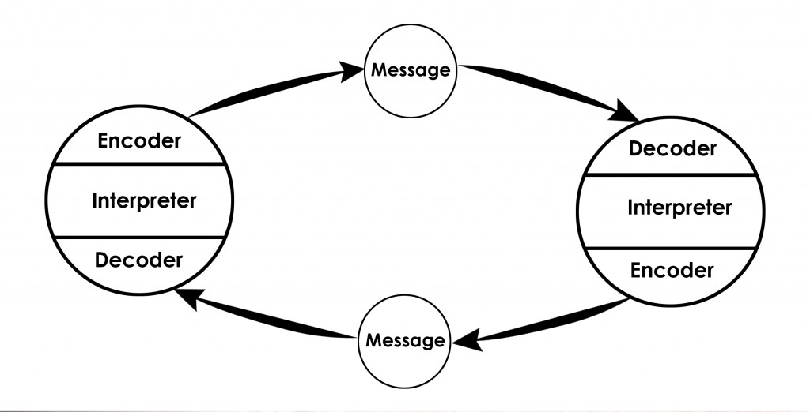
1960 model
This model includes interpreter, encoder, message, decoder and then they change the role. Schramm's model has several advantages. For instance, it shows that communication in nature is circular, not just in one direction and that it is not just sender and receiver but they always change with place. The most significant is that it shows the importance of feedback. However, the disadvantage of this model is that it does not describe the impediments that the message may encounter in the environment and the problems of decoding the information (Communication theory, 2020).
In 1960, David Berlo proposed Berlo’s Sender-Message-Channel-Receiver (SMCR) model of communication from Shannon Weaver’s Model of Communication (1949). He defined factors that influence individual communication components to make communication more effective. The model also focuses on encoding and decoding which happens before sender transmits the message and before receiver get the signal. The four elements of the Berlo Model representing the mechanism of contact are primarily. Sender, message, channel, and recipient. There are several factors influencing each variable (businesstopia,2018).


This is 1960 model.
Berlo's model explain that the source and the recipient must be at the same level in order to be successful in conversation. The receiver cannot be said to accept the whole message, so he might not be able to understand the sense even though he does receive the message. This model identifies diverse environmental, socioeconomic, language and other barriers.
This method does not describe the feedback process, which is a disadvantage. At the same time, this model does not describe noise sources and communication barriers. In addition, it does not describe communication in two directions and only in one direction, it is a linear communication model. However, it describes other things that have not been described by another model.
When I worked as a sales assistant, I also had communication problems because my colleague and I spoke different languages, I spoke Romanian and she spoken Russian. In my country there are many people who speak these two languages or at least speak only one and understand the other one. In one of the busy days trying to serve the customers quickly in order to clear the store as soon as possible, I ask him to bring a pair of a larger size of shoes and dew to of the language barrier he did not understand correctly and took the pair that a lady measured and left without bringing anything in return. As result the customer revolted, so that I went to ask my colleague why he did not bring the larger pair. He said that he did not understand correctly. Therefore, my colleague misunderstood the Romanian language and could not decode my message.
Communication skills
Communication is an amount of everything that people do as they communicate with others, and it is a connection of significance. Continuous communication means telling, listening, and understanding processes. Communication is simply described as information flow from one location to another. This knowledge transfer can be carried out in various forms. It may be a one-way or bidirectional operation. When the receiver receives the information sent by the sender, this states that a single way phase has completed. The sender must not be answered by the receiver, but the correspondence becomes a two-way operation when the recipient sends a request to respond to the sender's message. Media material is an example of one-way correspondence, in which the recipient is not obliged to answer, but only the information is received (Entrepreneur handbook, 2020).
Communication is divided into two essential types:
- Verbal
- Nonverbal
Verbal communication means to the use of words for communication purposes. It covers both oral and written communication. Written communication channel involves letters, company newsletters, e-mails, Web pages, reports and other. Verbal communication refers to phone calls, meetings, speeches, etc.
Non-verbal communication usually refers to motions of the hand and the body, actions, facial expressions, personal appearances, etc. Nonverbal contact extends both to the deliberate and unintended physical nature of communication. Nonverbal correspondence is also often considered to be a "wordless communication” (Suparna, 2020).
Both types of communication are important at the workplace. It is also important to understand and improve your communication skills to have a successful career, reduces conflicts, improve relationship, or to know how to manage your team. To have a successful business, there must be effective communication between management and staff to avoid misunderstandings that can affect productivity and job morale (Sampson, 2018).
An example of verbal communication at work are meetings, where management can verbally say goals, ideas and discuss various projects. Staff can also ask questions to management and discuss any issues at work. Another example would be communication between staff. For example, restaurant workers must be able to send an order correctly or specify some important things such as allergens.
By reading the non-verbal signals of your co-workers, you will develop a greater interpretation of their thoughts, feelings, and behaviours in such circumstances. For instance, the way you present yourself will sometimes convey more than just words. If you are planning to talk to a boss to apply for a raise, you can prefer to dress in a formal business suit to demonstrate your engagement to both a career and efficiency at the workplace. Moreover, if you choose to get a good job, you should present yourself dressed in a presentable way, be confident, look directly and speak freely. This language shows that you are prepared and have enough culture and knowledge to be employed (Indeed, 2020).
Effective communication also includes active listening. Active listening is the capacity to concentrate entirely on a speaker, hear their voice, and answer thoughtfully. Except for passive listening, which is the act of hearing a presenter without remembering their speech, this valuable interpersonal communication capability means that you are able to communicate and later remember precise specifics without the need for repetitive input. Active listeners using verbal and non-verbal approaches to demonstrate their commitment to the speaker. Not only does this support your desire to concentrate, but it also can ensure that the speaker can see that you are attentive and committed (Indeed, 2020).
Speaking about listening, it is also important to talk about emotional intelligence and empathic listening. Empathic listening is a method of being sensitivity and accuracy during conversation. Empathic listening includes creating an emotional link with the other participant and finding contacts between his background and yours, so that you can provide a more accurate reaction. Often called reflexive listening, empathic listening allows you to give interest to the contribution of the other person. Support and motivation, rather than suggestion or critique, are the main attribute of empathic listening. This are some qualities of emphatic listener: presence, non-judgement, patience, responsiveness, etc. (Indeed, 2021).

Conclusion
This report identified communication patterns of Shannon Weaver, Wilber Schramm, David Berlo and displayed their structure, components and issues. The communication process has things in common in all these models, obviously not all of them are ideal, but the most important problems to have a productive and efficient communication are the noise and feedback. It is important to understand where the problem occurs and to remove it. Whether is the noise or something else, we must ask for confirmation that the receiver has decode the information transmitted by the sender. The advantages and disadvantages of these models are also determined and analysed and discussed by providing examples of communication problems at my workplace. In addition, it was explained that understanding the communication process is beneficial in the workplace.
Listening and emphatic listening skills, offer benefits at workplace. An empathetic listener have a good emotional intelligence and can support and motivate. Such skills can be improved by practicing and observing mistakes or using advice read from books.

References
- Ashman, M. (2018). Introduction to Professional Communication [Online]. Available from: https://pressbooks.bccampus.ca/professionalcomms/chapter/3-2-the-communication-process-communication-in-the-real-world-an-introduction-to-communication-studies/(Accessed: 2 March 2021).
- Business topia (2018). Berlo’s SMCR Model of Communication [Online]. Available from: https://www.businesstopia.net/communication/berlo-model-communication(Accessed:3 March 2021).
- Communication theory (2020). Osgood- Schramm Model of Communication [Online]. Available from: https://www.communicationtheory.org/osgood-schramm-model-of-communication/(Accessed: 2 March 2021).
- Entrepreneur handbook (2020). What is Communication? [Online]. Available from: https://entrepreneurhandbook.co.uk/what-is-communication/ (Accessed: 1 March 2021).
- Entrepreneur handbook (2020). What is Communication? [Online]. Available from: https://entrepreneurhandbook.co.uk/what-is-communication/(Accessed:4 March 2021).
- Indeed (2020). Examples of Nonverbal Communication in the Workplace [Online]. Available from: https://www.indeed.com/career-advice/career-development/nonverbal-communication-examples(Accessed:6 March 2021).
- Indeed (2021). Active Listening Skills: Definition and Examples [Online]. Available from: https://www.indeed.com/career-advice/career-development/active-listening-skills(Accessed: 8 March 2021).
- Indeed (2021). Emphatic Listening: Definition, Examples and Tips [Online]. Available from: https://www.indeed.com/career-advice/career-development/empathic-listening(Accessed: 12 March 2021).
- Skills you need (2011-2021) Active listening [Online]. Available from: https://www.skillsyouneed.com/ips/active-listening.html(Accessed: 11 April 2021).
- Suparna, P. (2021). Verbal and Nonverbal Communication [Online]. Available from: https://www.economicsdiscussion.net/management/verbal-and-non-verbal-communication/verbal-and-non-verbal-communication/32376(Accessed: 5 March 2021).
- Quain, S. (2018). Examples of Verbal Communication in the Workplace [Online]. Available from: https://smallbusiness.chron.com/examples-verbal-communication-workplace-10936.html(Accessed: 6 March 2021).

