Professional Career Development
BMSW4005

Assignment title: Professional career development report and role play (interviewee and interviewer)

Student: Mariya Delieva (2007927)
Tutor: Husam Alharahsheh
2021/UWTSD

Contents
Introduction 3
Interviewer Role Play 4
Interviewee Role Play 4
Self-evaluation review 5
Personal develop planning 6
SWOT analysis 6
Review of understanding and expectation of the world of employment 7
Career ambitions 8
Personal development plan 9
Conclusion 10
References 11
Appendices : Appendix A: Application form 12
Appendix B: Job Advert 15
Appendix C : Answers to my partner 16
Appendix D: Job intervew questionnare 17

Introduction
Today, I have my own cleaning business in London that has been achieved by my hard work and dedication to achieving my goals. My journey has been started after the completion of secondary education. I have started my 1st job after completing my secondary education where I have gained skills and knowledge of accounting work. During this period, my parents parted. their ways that have encouraged me to do something in my life. My first job has also helped me to raise my other qualifications. I made changes in my career and become a police officer due to the bankruptcy of my first company. My family also moved from Bulgaria to London, and I have started my own cleaning business. The study focuses to examine my role-play as an interviewee and interviewer which outlines my skills and knowledge towards the readiness for employment. The study examines the challenges faced by an interviewer and interviewee and identifies various methods for the purpose to resolve the challenges. The report also consists of a self-evaluation review in pursuance to develop self-motivation as well it also helps me identify various learning styles. The report also focuses on personal career development planning including SWOT analysis. This report also helps to identify the personal career development plan aiming to find out and evaluate the individual aim and objective of an employee.
Where I am today:
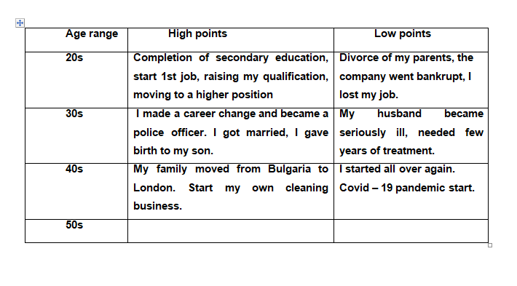

Interviewer Role Play
Based on Gibbs reflective cycle, I have played the role of the interviewer in which I have asked questions related to interviewee background, current role and responsibilities, strengths and weaknesses, and others. As an interviewer, I personally identify that the interviewee was quite worried, which prevented him from presenting himself in the best way. The interviewee is also lacking confidence during the interview. I also asked the interviewees about what she thought was the ideal work environment and whether she could work under pressure to find out how she would cope as a manager in critical situations. In order to play the role of the interviewer is quite tough for me because a good interviewer needs to have very good technical, creative, and better assessment skills which further helps to become a good interviewer. To become a better interviewer I need to be more approachable towards interviewees, I need to make them comfortable before asking anything and I need to give interviewees some feedback so it will eventually help them to become more rigid.

Interviewee Role Play
On the basis of Gibbs reflective cycle, I have played the role of the interviewee in which I have answered various questions asked by the interviewer. As an interviewee I need to wait for very long to give my interview which makes me feel more fatigue, I also faced challenges related to the strange and unexpected questions asked by the interviewer. To deliver a better interview, there are some skills to become a better interviewee need to have better skills, need to become more approachable do not have any type of fear in public speaking, and need to be more confident. To become a better interviewer, I will take some steps which help me to take interviewee such as firstly I will ask questions according to employee background roles and responsibility, try to remove the biasness during the interview etc.

Self-evaluation review
Self-motivation: My self-motivation to become an accountant is the future growth and success in any industry. During my internship period in the construction industry, I have realized my motivation to peruse my career as an accountant. I have worked as an accountant trainee in a construction company where I have gained skills that can apply to many industries. I have also gained knowledge on Microsoft excel, quick books, and tally which will help me to improve my existing skills. I have also observed that the growth of an accountant is very huge which will help me to explore various roles such as finance director, finance manager, chief financial officer account manager charted accountant, and financial controller, thus, my main self-motivation in the accounting field is the growth and success that I can experience in any industry (Philippakos, 2017).
Learning style: My learning style is based on interpersonal skills as I have a good interpersonal skill that helps me solve a complex problem. This learning style encourages me to peruse my career as an accountant. During my internship experience in a construction company, I have managed gained experience in preparing tax of company where I have managed complex calculation of the company. Therefore, my interpersonal skill is my main learning style of gaining accounting skills (Zell, et, al., 2020).
Professionalism: My professionalism skill is based on analytical skills, time management, and problem-solving. During my internship, I have to ensure the amount and details were correct and accurate because as I have to be responsible to perform this particular task for a company, during my internship I have to manage my time very effectively as well as efficiently in order to do my task according to the deadlines that provided me, I have also gained some problem-solving skill because as I’m new to the process, there are various problem arises during my work but as a responsible employee I try to solve each and every that made a challenge for me (Baker, 2017).

Personal develop planning

SWOT analysis
Strength: As an accountant, my personal strength is to maintain the company records properly and bookkeeping especially because they are the main source from where a company can identify its profitability as well as its expenses also. In accounting, I’m able to maintain these records quite accordingly this is the best way that I can justify my strength (Campbell et, al., 2015).
Weaknesses: On a significance of weakness when I have to manage the accounting for the company where a company needs to make their profit on the taxes which were regulated by the government of the country. This industry wants long hours of work and experience to save their taxes which makes it quite annoying for me because being an ethical accountant I gave all the data in a very precise and correct form which might not be entertained by any industry (Campbell et, al., 2015).
Opportunity: On a significance of opportunity, I have gained some better experience in my past work which further helps me to more identify the new opportunity in this sector, as I gained some experiences now the companies are offering me better packages and job roles which further helps me to peruse my career in this particular field. The new software and bookkeeping application further helps me to manage my time in order to perform my tasks effectively as well efficiently because this software generally has all the requirements which could help the accountant to maintain their book (Grit, et. al., 2019).
Threats: There are various numbers of web-based platforms that are available on the internet which helps the company to maintain their account effectively. This program creates a threat for accountants because it might affect our job fulfillment criteria. There is a various company in the market which gave their computer base accounting services which is more cost-effective in terms of our services that further create threat for accountant.

Review of understanding and expectation of the world of employment
In every province around the world, people are continuously looking for various opportunities and growth when they are looking for a job. as an employee, the most crucial thing in their life is job security because job security helps the employee to gain sustainability in their life if the job security were not there that might create some serious impact in employees life, in the very region around the world, employees were like to have perks which help them to provide ease their life such as children tuition, childcare facility and convince facility which further helps the employee to gain satisfaction in their life. It is necessary to prioritize employee growth because no matter where you are if an employee wants to see growth, then the company needs to invest in various opportunities which further helps the employee to grow in a significant manner (Vondracek, et. al., 2019).
The expectation from a modern accountant is not quite different from the traditional accountant. The main thing demanded by today's world is that modern accountants need to be tech-savvy which means modern accountants need to have proper knowledge about the technical skill which helps them record company’s transaction on the digital platform. Which allows the company to access their company record quite easily. There are various giant accountancy companies that help the companies to maintain their bookkeeping as well their balance sheet also such as Deloitte, Pricewaterhouse coppers, KPMG, and Ernst and young they are the leading accountancy firm that operates their client accounts globally and these companies are providing digitalization of services which further helps the company to attract their clients. Globalization has increased the regulations which significantly affects demand for accountancy in the future. It is also noticed that jobs for accountancy and auditor have continuously growing according to the time which further helps the company create a positive impact towards accounts aspirants.

Career ambitions
My career ambition is to develop my career in accounts because it is my ideal career where I can use my knowledge in order to build my career because I already have some certain skills that are particularly demanded in this sector. My long-term goal Is to become a financial auditor because this designation has certain value and respect that further motivated me to perform my task accordingly. Accounting also opens various doors and paths accounting also helps to open various opportunities in financial sectors such as accounting clerk, accounting information specialist, actuarial accounting, bookkeeping, budget analyst, capital accounting, cost accounting, and financial analyst as well. These are sectors that need some specific skills and knowledge which I have already gained in my experience. As an accountant, I want to see myself as a financial auditor because this field has more diversity that further helps me to build my career in the accounting sector.

Personal development plan
A personal development plan is critically helping me to achieve accountant goals, with a high level of satisfaction. Being a professional accountant, the main role is to enable classroom learning into the real world (Chlebikova, 2015).
Personal objectives | How I will accomplish this | How this will be measured | When I will accomplish this | People who can help me with this
To learn about organization skills  To learn how to manage multiple clients, follow proper reporting guidelines and meeting deadlines | I will ensure to take courses on organization skills.  I will also ensure to read books on accounting skills and practicing with colleagues | The increase in confidence of meeting deadlines will help me to measure my performance | 10th August 2021 | Tutors, colleagues, and friends.
To improve my critical thinking of managing any inaccuracies, errors, and discrepancies constantly  To learn about financial strategy | I will ensure to listen and consider unconventional opinions  I will ensure to participate in the decision making | The successful analysis of encountering any issue can help me measure my performance | 20th August 2021 | Colleagues and tutors
To enhance my interpersonal communication skills  To enhance my ability to simply the vast amount of data | I will ensure to take open feedback from employees  I will ensure to listen actively | To measure the understanding of clients and colleagues related to complex financial concepts explain by me | 25th August 2021 | Tutors, colleagues, and managers

Conclusion
Based on above analysis, it can be concluded that role play has become a more challenging task because in role-play activity I need to full fill all the desire skills that the interviewer and interviewee need to have. Self-evaluation also helps to identify my career direction and it also helps me to develop a path that helps me put my focus on the learning style as well as self-motivation in student life. Meanwhile, personal development planning helps me assess my own strength and weaknesses which further helps me to identify my areas for improvement as well. Considering the expectation of employees helps me realize the basic needs and benefits that could help an employee to provide ease in life.

References
Baker, W., 2017. Aspirations: the moral of the story. British Journal of Sociology of Education, 38(8), pp.1203-1216.
Campbell, D.E., Parks, C. and Wells, J.D., 2015. Understanding the role of theory on instrument development: An examination of strengths and weaknesses of discriminant validity analysis techniques. JITTA: Journal of Information Technology Theory and Application, 16(1), p.25.
Chlebikova, D., Misankova, M. and Kramarova, K., 2015. Planning of personal development and succession. Procedia Economics and Finance, 26, pp.249-253.
Grit, R., Guit, R. and Van der Sijde, N., 2019. Managing your competencies: personal development plan. Routledge.
Philippakos, Z.A., 2017. Giving feedback: Preparing students for peer review and self‐evaluation. The Reading Teacher, 71(1), pp.13-22.
Vondracek, Fred W., Richard M. Lerner, and John E. Schulenberg. Career development: A life-span developmental approach. Routledge, 2019.
Zell, E., Strickhouser, J.E., Sedikides, C. and Alicke, M.D., 2020. The better-than-average effect in comparative self-evaluation: A comprehensive review and meta-analysis. Psychological Bulletin, 146(2), p.118.

Appendix A: Application form
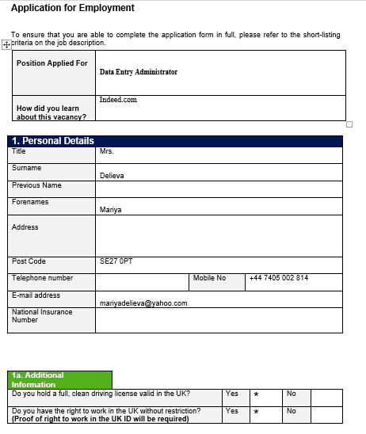
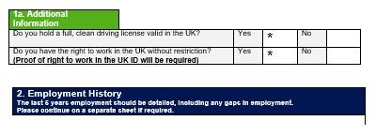
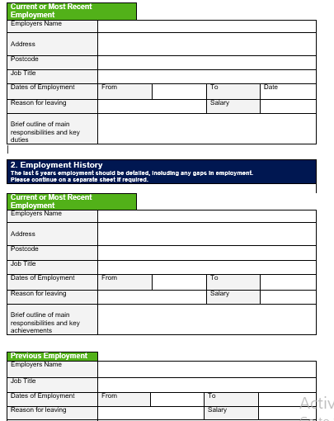
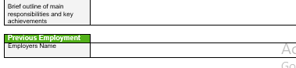
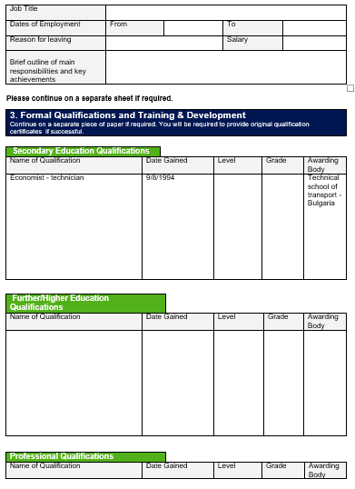
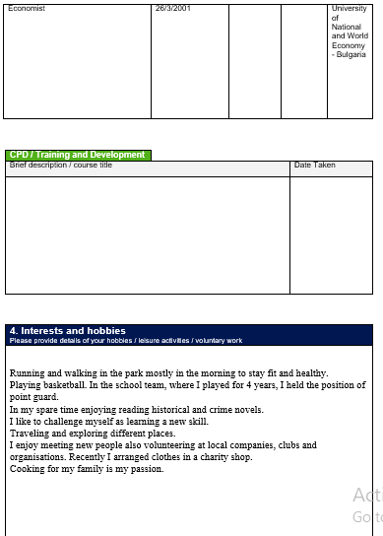
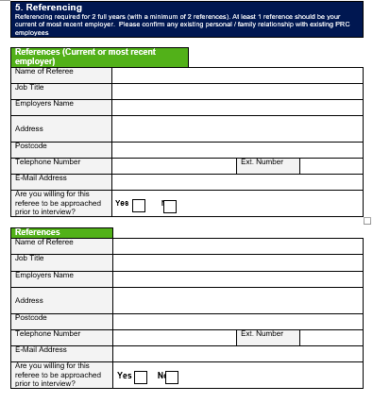
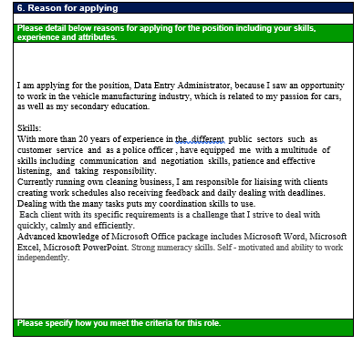
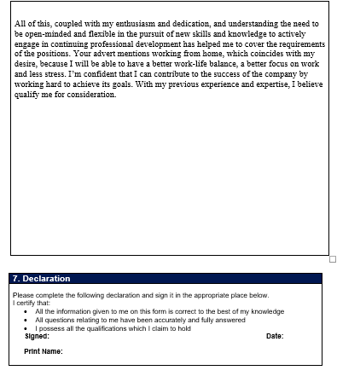

Appendix B: Job Advert
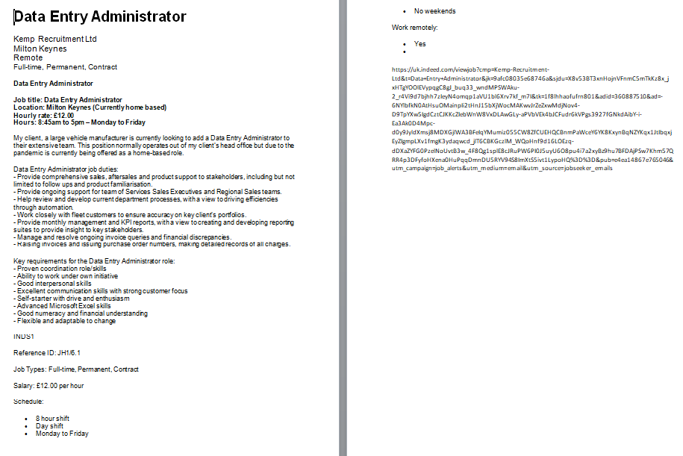

Appendix C: Answers to my partner
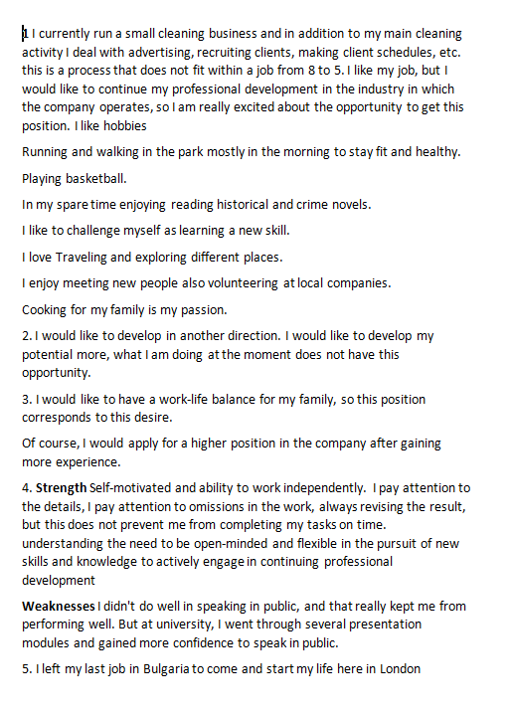

Appendix D: Job interview questionnaire



