Evaluation of Emotional Intelligence in Workplace Context.
Developing Emotional Intelligence Skills for the Workplace BMSW6106
nicoleta Baltaret- 2107487
2024
Table of Contents
Introduction 2
The role of EI in the workplace and FAYE Inc. 2
EI Models to enhance Clarke workplace abilities 4
Daniel Goleman’s Emotional Intelligence Model 4
Mayer, Salovey, and Caruso’s Ability Model of Emotional Intelligence 5
The Role of Culture in Understanding Emotional Intelligence (EI) and Mindfulness of Employees 6
Cultural Differences in Emotional Expression and Perception 6
FAYE Inc. and the harness benefits of EI and mindfulness among the employees 7
Conclusion 8
Appendix1- Poster 9
References 13

Introduction
Emotional Intelligence (EI) refers to the ability to recognize, understand, manage, and influence emotions in oneself and others. In a diverse and increasingly globalized workplace, like FAYE Inc., emotional intelligence plays a crucial role in fostering positive relationships, reducing conflicts, and promoting productivity. In Clarke's case, the challenges he faces reflect a need for higher emotional intelligence, particularly in managing interpersonal dynamics in a multicultural environment. To understand better the role of EI within FAYE Inc. and more specifically, how it applies to Clarke's situation it has been done research and within this case study has been found some key’s areas where EI plays a significant role in the workplace (Antonakis, 2009).

The role of EI in the workplace and FAYE Inc.
First, base on the case study it has been investigated and found multiples key’s areas where Emotional Intelligence plays a significant role in the workplace from self-awareness to self regulations, within a multicultural environment and so on.
1. Self-awareness
Self-awareness is the cornerstone of emotional intelligence and refers to the ability to understand one's own emotions, strengths, and limitations. Clarke may lack self-awareness when it comes to how his behaviour, such as addressing female colleagues as "my love," is perceived in the UK workplace. What might have been acceptable or normalized in Texas, where he previously worked, is not seen in the same light in the new context. This suggests that Clarke may not be fully attuned to how his actions affect others' emotions in different cultural environments. In the context of FAYE Inc., developing self-awareness is critical for all employees, especially those in leadership positions like Clarke. He must reflect on how his actions may unintentionally hurt others, particularly female employees who may find his language inappropriate or disrespectful. The key learning here is that emotional intelligence enables leaders to adapt their behaviours according to the cultural and emotional needs of the people they lead (Pinos, 2006).
2. Self-regulation
Self-regulation refers to the ability to manage and control one’s emotions and reactions, especially under pressure. Clarke’s desire to ask the Chinese team members if they have English names demonstrates a lack of self-regulation and cultural sensitivity. His intention might be rooted in practicality, but it risks alienating the Chinese delegation, whose cultural preference is to be called by their Chinese names, as they value friendship and respect in business relationships. In emotionally intelligent leadership, Clarke would regulate his impulse to prioritize efficiency (through English names) over fostering respectful cross-cultural relationships. At FAYE Inc., self-regulation is vital for managing workplace tensions. Clarke could manage his discomfort with cultural differences by adopting a more patient and culturally sensitive approach, particularly in understanding that communication styles vary across cultures. By learning to regulate his emotions and impulses, he would likely foster better relationships with both his colleagues and the visiting Chinese team (Pinos, 2006) (Nurul, 2017).

3. Social Awareness
Social awareness is the ability to empathize with others and understand their emotional and social cues. Clarke’s difficulty in recognizing that calling female colleagues "my love" could be seen as inappropriate in the UK workplace shows a lack of social awareness. His surprise that this was not raised in Texas also indicates a gap in his understanding of different social norms in different regions or workplaces. What works in one cultural context might not be acceptable in another. Clarke must develop greater sensitivity toward social norms and expectations in the new workplace culture of FAYE Inc. Social awareness is particularly important in diverse environments like FAYE Inc., where employees come from various cultural backgrounds. Clarke’s role as a supervisor demands that he be aware of these differences and practice inclusive leadership. For instance, when interacting with the Chinese delegation, instead of asking them for English names, he could demonstrate cultural awareness by learning and using their Chinese names, showing respect for their culture (Nurul, 2017).
4. Relationship Management
Relationship management refers to the ability to inspire, influence, and develop others while handling conflict effectively. Clarke’s management style favouring a strict schedule and disliking small talk might work for him personally, but it might not align with the Chinese team’s values of building personal relationships before diving into business. His lack of consideration for this aspect of relationship-building could create tensions or misunderstandings during the systems deployment process. In this case, an emotionally intelligent leader would take time to build rapport with the Chinese team, respecting their cultural practices of friendship and social interaction. Instead of avoiding small talk, Clarke could use it as a tool to strengthen trust and camaraderie, which would ultimately benefit the project’s success. In FAYE Inc., where cultural diversity is prevalent, developing effective relationships through emotional intelligence is essential for teamwork, collaboration, and productivity (Nurul, 2017).
5. Cultural Sensitivity and Emotional Intelligence in a Multicultural Environment
FAYE Inc.’s workforce, as well as its international collaborations (such as the Chinese delegation), highlight the importance of cultural sensitivity. Emotional intelligence becomes even more critical in multicultural environments because cultural norms and emotional expressions vary widely across different groups. In Clarke's case, his Texan background may have shaped his informal and direct approach to communication. However, this same approach may not translate well in the UK or when interacting with Chinese team members, whose cultural norms and expectations are different. Clarke could benefit from cross-cultural emotional intelligence, which involves being mindful of how culture influences emotional expression, communication styles, and workplace expectations. For example, in China, workplace relationships are built on respect and personal connections. For Clarke to succeed, he must understand that cultural differences extend beyond language and involve deeper values around respect, communication, and interpersonal dynamics (Varela, 2019).
6. Impact of Emotional Intelligence on Employee Morale and Productivity
The complaints from female employees at FAYE Inc. about Clarke’s greeting style suggest a decline in morale. This is where emotional intelligence plays a direct role in fostering a positive workplace climate. When leaders lack emotional intelligence, they can unintentionally create an uncomfortable or hostile work environment. Clarke’s surprise at the complaints shows that he may not fully understand the emotional impact his words have on his team, indicating a need for development in his emotional intelligence skills. Low morale can lead to disengaged employees, reduced productivity, and even increased turnover rates. By developing his emotional intelligence, Clarke can work to improve workplace morale by fostering respect, open communication, and trust. For instance, he could initiate conversations with employees to understand their concerns and preferences better, showing that he values their emotional well-being (Serhan, 2019).

EI Models to enhance Clarke workplace abilities
Further to understand the role of EI within the company and to help Clarke navigate the cultural and interpersonal challenges he's facing according with the case study, two prominent models of Emotional Intelligence (EI) has been found relatable within the case study and can be applied which are Daniel Goleman’s Emotional Intelligence Model and the Ability Model of EI by Mayer, Salovey, and Caruso. Each model offers distinct perspectives on how EI can be cultivated and applied in leadership, providing practical insights that could enhance Clarke’s ability to manage his team more effectively.

Daniel Goleman’s Emotional Intelligence Model
Emotional intelligence (EI) is a relatively new concept gaining attention due to its relevance in workplace emotions and leadership. The connection between EI and leadership is a growing area of research, with many associating high EI with leadership success. EI is measured in several ways, with two main models: the ability model (widely accepted in academia) and the mixed model (commonly used outside academia). Daniel Goleman’s mixed model, a prominent framework, details six emotional intelligence leadership styles according with the Leadership and Organizational Management Journal (Lowman & Thomas, 2015)These components can provide Clarke with actionable strategies to improve his leadership and interpersonal effectiveness.
a. Self-awareness
Applying this to Clarke shows that he can develop greater self-awareness by recognizing how his communication style, such as calling female colleagues “my love,” affects the workplace environment. His surprise at the complaints suggests a gap in understanding how his behaviour impacts others emotionally. Improving self-awareness will help him better align his behaviour with the cultural and social norms of FAYE Inc.
b. Self-regulation
as previously mention Self-regulation is the ability to control or redirect disruptive emotions and impulses, and the ability to think before acting. Clarke’s desire to ask the Chinese team members for English names reflects an impulse to prioritize ease of communication over cultural respect. By practicing self-regulation, Clarke can control these impulses and consider the feelings and preferences of the Chinese team, fostering a more respectful cross-cultural exchange.
c. Motivation
Motivation refer to a drive to achieve goals for the sake of achievement, rather than for external rewards. Clarke’s strict adherence to schedules and dislike for small talk may stem from a strong internal motivation to achieve results. However, a better understanding of how to balance task-driven leadership with relationship-building, especially in multicultural contexts, can improve both team morale and productivity. In Chinese business culture, forming relationships is often seen as equally important to task achievement.
d. Empathy
Empathy refers to the ability to understand the emotional makeup of others and treat them according to their emotional reactions. For Clarkes Empathy is crucial for his situation, especially as he navigates the cultural differences between his colleagues in the UK and the Chinese delegation. By practicing empathy, Clarke can understand the emotional needs of both the female employees who felt uncomfortable and the Chinese team members who value being called by their Chinese names. Empathy will help him bridge cultural gaps, making him a more effective leader.
e. Social Skills
Defined as the ability in proficiency in managing relationships and building networks, applied to Clarks result that his Clarke’s current discomfort with small talk and his preference for strict scheduling might limit his ability to build strong relationships with his team and the Chinese delegation. By developing his social skills, Clarke can enhance his ability to manage interpersonal dynamics, encourage collaboration, and create a more positive work environment.
So, in essence by following Goleman’s framework, Clarke can develop a balanced approach to leadership that combines emotional self-awareness and self-regulation with empathy and social skills. This will help him manage workplace relationships more effectively and address cultural differences in a respectful manner, leading to higher morale and better team performance. But that doesn’t mean that he can use only one model which is the reason why further research shows that an another compatible model for Clarke’s situation is Mayer, Salovey, and Caruso’s Ability Model of Emotional Intelligence.

Mayer, Salovey, and Caruso’s Ability Model of Emotional Intelligence
The Ability Model of EI, developed by John Mayer, Peter Salovey, and David Caruso, defines emotional intelligence as a set of four interrelated mental abilities. These are: Perceiving Emotions, Using Emotions to Facilitate Thought, Understanding Emotions, and Managing Emotions. This model focuses on EI as a cognitive ability, which emphasizes the understanding and strategic use of emotions (Mayer, 2008) (D. & David R. Caruso, 2016).
a. Perceiving Emotions
Clarke could enhance his ability to perceive emotions in the workplace, particularly in cross-cultural interactions. For instance, understanding subtle cues from the Chinese team, who may express discomfort indirectly, can help him adjust his approach. Similarly, perceiving the emotional discomfort of female employees when addressed in a certain way can help Clarke avoid unintentionally offending colleagues.
b. Using Emotions to Facilitate Thought
Clarke’s rigidity in sticking to schedules and aversion to small talk suggests that he may not fully appreciate how emotions can enhance decision-making. By understanding that emotions can play a productive role in fostering creative solutions and team cohesion, Clarke can learn to use moments of rapport (like small talk) as an opportunity to create stronger relationships that ultimately facilitate smoother teamwork and better problem-solving.
c. Understanding Emotions
Understanding the emotional dynamics of a diverse workplace will help Clarke navigate complex situations. For example, recognizing that the discomfort expressed by female colleagues or the Chinese team is tied to deeper cultural and emotional factors will enable him to respond in a more thoughtful and effective way. This understanding will help Clarke anticipate the emotional impact of his actions and make better-informed decisions.
d. Managing Emotions
Managing emotions effectively would help Clarke create a more emotionally intelligent workplace environment. He can manage his own emotions by adapting his leadership style to be more culturally sensitive and can also help his team manage their emotions by fostering a more inclusive and understanding work environment. This is particularly important as Clarke tries to raise team morale after the discomfort caused by his past behaviour.
The Ability Model of EI equips Clarke with cognitive tools to better understand and manage emotions in the workplace. By enhancing his ability to perceive, use, understand, and manage emotions, Clarke can become more adept at addressing both cultural and interpersonal challenges, creating a more harmonious and effective work environment. So Both Goleman’s Emotional Intelligence Model and the Ability Model by Mayer, Salovey, and Caruso offer valuable insights that can help Clarke improve his leadership abilities. Goleman’s model emphasizes the practical application of self-awareness, empathy, and relationship management, while the Ability Model focuses on cognitive skills in perceiving and managing emotions. By integrating these models, Clarke can develop the emotional intelligence necessary to navigate the cultural and interpersonal dynamics at FAYE Inc. This will not only help improve team morale but also ensure a more productive and harmonious workplace.

The Role of Culture in Understanding Emotional Intelligence (EI) and Mindfulness of Employees
Emotional Intelligence (EI) and mindfulness are crucial competencies for leaders and employees in today’s globalized and diverse workplaces. However, cultural differences can significantly influence how EI is expressed, perceived, and applied. Understanding the role of culture in EI and mindfulness is vital to creating inclusive work environments where employees from diverse backgrounds feel respected and supported. Below is a discussion of how culture influences the understanding and practice of EI and mindfulness in the workplace.

Cultural Differences in Emotional Expression and Perception
Emotions are expressed and perceived differently across cultures. What may be considered an appropriate emotional response in one culture might be viewed as inappropriate or misunderstood in another. These variations shape how EI is applied in multicultural environments, where leaders and employees must adapt to different emotional norms and communication styles (Masuda, 2008). Understanding cultural differences is crucial for effective leadership, especially regarding emotional intelligence (EI) and communication. In high-context cultures like China and Japan, communication relies heavily on non-verbal cues and indirect expressions of emotion. Leaders must be sensitive to subtle emotional signals, while in low-context cultures such as the U.S. or Germany, direct and explicit communication is the norm. For Clarke, a supervisor from Texas, this means adjusting his direct style when working with a Chinese team, becoming more attuned to non-verbal cues and prioritizing relationship-building over strict task completion. The distinction between individualism and collectivism also influences how emotions are expressed in the workplace. In individualistic cultures like the U.S., personal autonomy and direct feedback are valued, whereas in collectivist cultures like China, group harmony is prioritized, and open emotional displays are often discouraged. Clarke needs to be mindful of these dynamics, especially when his Chinese colleagues may avoid direct confrontation to maintain harmony. Mindfulness practices also vary between cultures. In Eastern cultures, mindfulness is often integrated into daily life through traditions like meditation, promoting reflection and calm decision-making. In contrast, Western cultures tend to focus on fast-paced, outcome-driven work environments, where mindfulness is often used to enhance productivity. Clarke, coming from a fast-paced, task-oriented background, may benefit from adopting a more reflective, mindful approach when working with a Chinese team. Leadership expectations are also shaped by culture. In Western individualistic cultures, transformational leadership focusing on emotional engagement and personal connections is valued. In collectivist cultures, leadership emphasizes harmony and consensus-building. Clarke’s direct leadership style may need adjustment when managing his Chinese team, where relational harmony is key to collaboration. In multicultural teams, mindfulness is essential. Leaders must actively listen and be open to different perspectives, adapting to various cultural expectations around emotions and communication. For Clarke, practicing mindful listening will help him better understand his team’s needs and adjust his approach to foster a more inclusive and harmonious work environment.

FAYE Inc. and the harness benefits of EI and mindfulness among the employees
FAYE Inc. can significantly benefit from Emotional Intelligence (EI) and mindfulness by cultivating a workplace culture that encourages self-awareness, empathy, emotional regulation, and mindfulness (Paul, 2023). These skills can improve collaboration, leadership, employee well-being, and overall organizational success. Here are key strategies FAYE Inc. can adopt:
Incorporate EI and Mindfulness into Leadership Development
Leaders set the emotional tone for the organization, so leadership development should include emotional intelligence training. FAYE Inc. should focus on core EI skills like self-awareness and empathy, using case studies and role-playing to prepare leaders for emotionally complex situations. Mindfulness practices such as stress reduction techniques and active listening will help leaders stay calm under pressure and improve decision-making, fostering a more emotionally intelligent workplace.
Embed EI and Mindfulness in Daily Practices
EI and mindfulness should be part of the daily workflow. FAYE Inc. can offer regular mindfulness breaks, providing employees with guided exercises to reduce stress. Encouraging active listening and mindful communication during meetings or in emails will enhance empathy and respect among colleagues. Embedding mindfulness in daily routines will foster collaboration and workplace harmony.
Foster a Culture of Psychological Safety and Open Communication
Creating an emotionally safe environment where employees feel comfortable expressing their emotions is key. FAYE Inc. can promote emotional check-ins at meetings and provide safe spaces for employees to share personal challenges. Leaders should model vulnerability by sharing their emotional journeys, helping to normalize emotional expression. A feedback culture that prioritizes emotional sensitivity will build trust and reduce defensiveness.
Cross-Cultural Emotional Intelligence Training
With a culturally diverse workforce, FAYE Inc. should offer cross-cultural EI training to help employees understand emotional expression across cultures. This training can prevent misunderstandings and improve international collaboration. Open dialogue about cultural differences, supported by mentorship programs, will promote empathy and cross-cultural understanding.
Promote Employee Well-Being with Emotional Support Programs
Providing emotional support is crucial to enhancing EI. FAYE Inc. can offer counselling services and workshops on stress management, burnout prevention, and mindfulness. Wellness initiatives, such as yoga and fitness programs, will improve both physical and emotional health, leading to better emotional regulation and stronger workplace relationships.
So according with the research by embedding EI and mindfulness into leadership development, daily practices, and overall culture, FAYE Inc. can improve collaboration, employee satisfaction, and innovation. A psychologically safe and inclusive environment will enhance both individual emotional competence and organizational performance in the global market.

Conclusion
Emotional Intelligence (EI) is a vital asset in fostering a harmonious and productive workplace, especially in diverse and multicultural environments like FAYE Inc. Clarke's case highlights the critical role of emotional intelligence in managing interpersonal relationships and navigating cultural differences. By developing key EI competencies such as self-awareness, self-regulation, empathy, and social awareness, Clarke can significantly improve his leadership abilities and workplace interactions. The application of both Daniel Goleman's Emotional Intelligence Model and the Ability Model by Mayer, Salovey, and Caruso provides Clarke with practical tools to enhance his emotional intelligence. Goleman’s model emphasizes the importance of empathy, self-regulation, and relationship management, while the Ability Model equips Clarke with cognitive strategies for perceiving, understanding, and managing emotions in a multicultural context. Integrating these frameworks can help Clarke address cultural sensitivities and create a more inclusive and respectful workplace. Additionally, fostering a culture of EI and mindfulness at FAYE Inc. can enhance collaboration, improve employee morale, and promote overall organizational success. By embedding EI practices into leadership development and daily interactions, FAYE Inc. can create an emotionally intelligent workplace that values psychological safety, open communication, and cultural awareness. In doing so, the company will not only boost individual well-being but also position itself as a strong competitor in the global market.

Appendix1- Poster
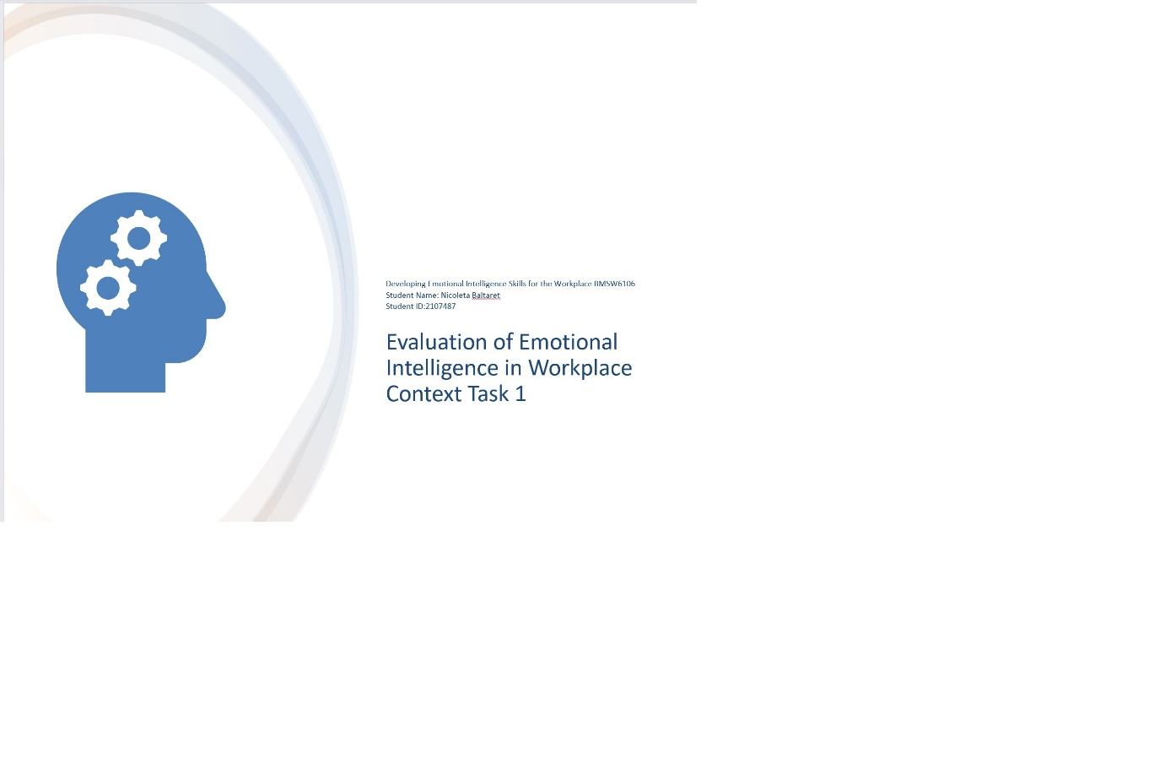
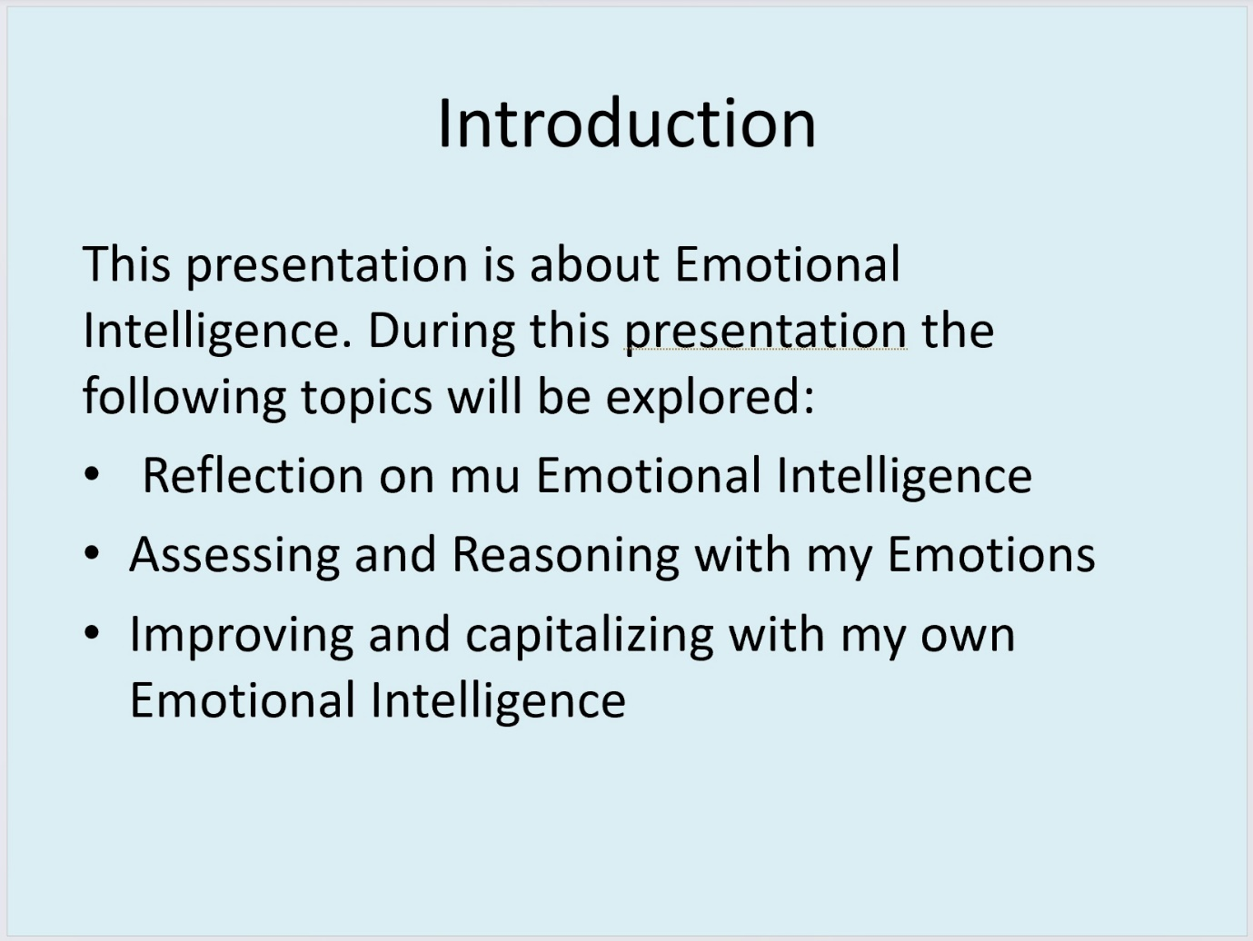
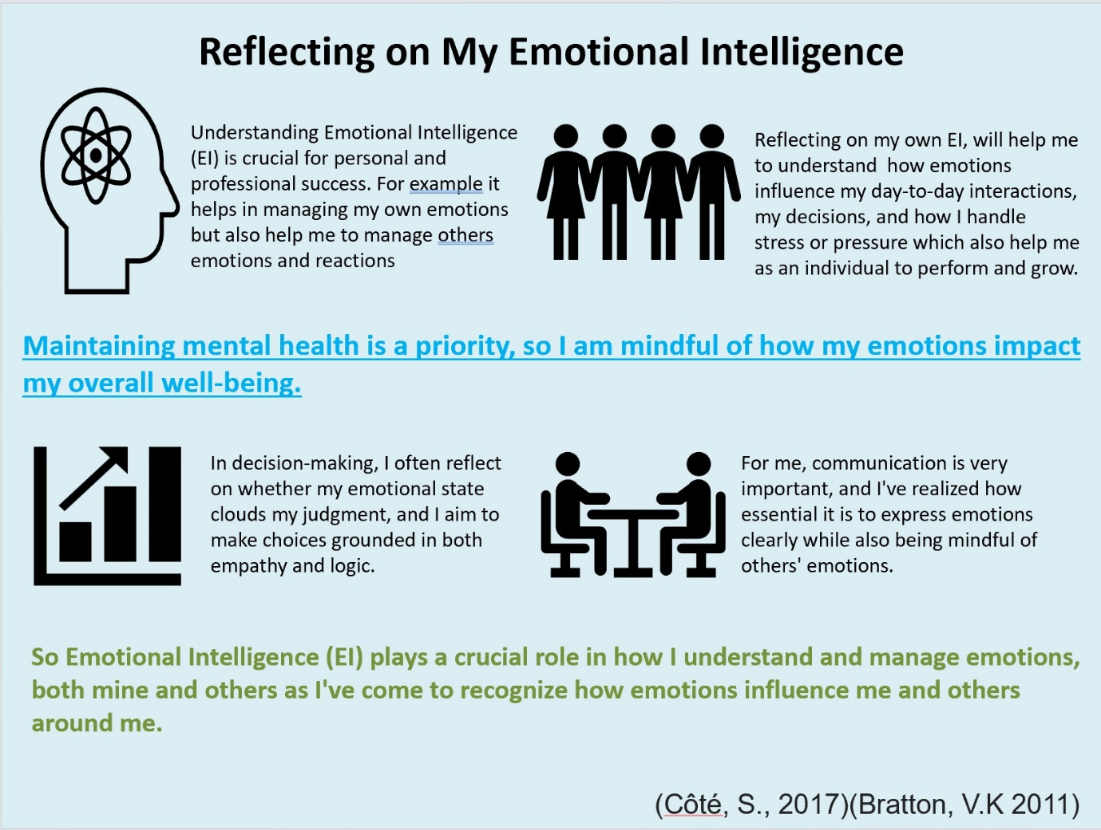
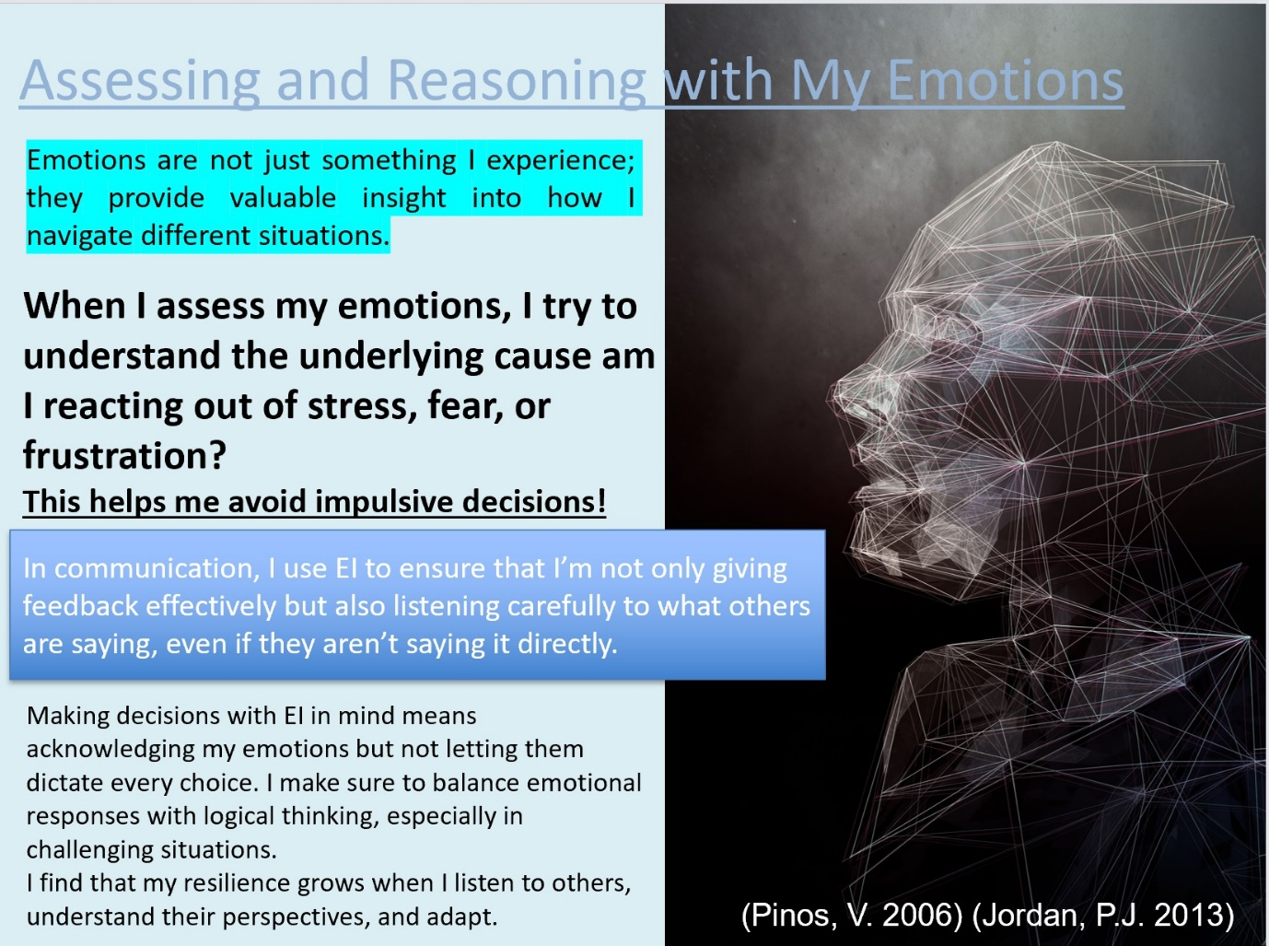
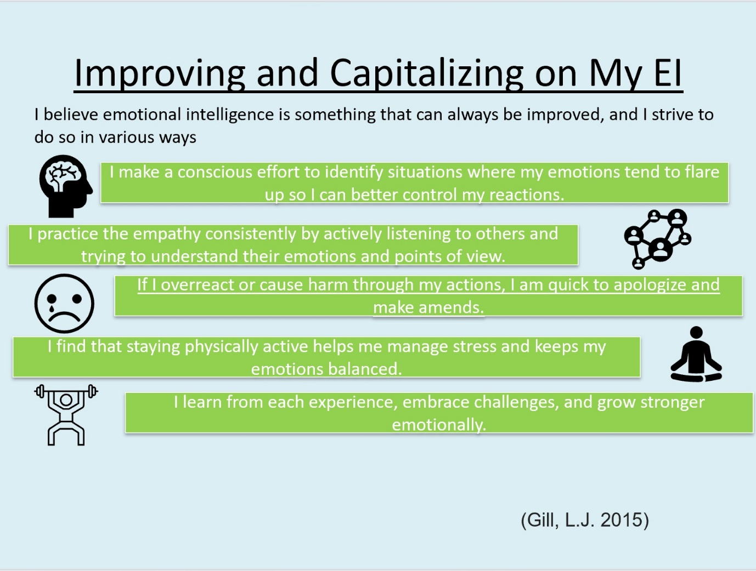
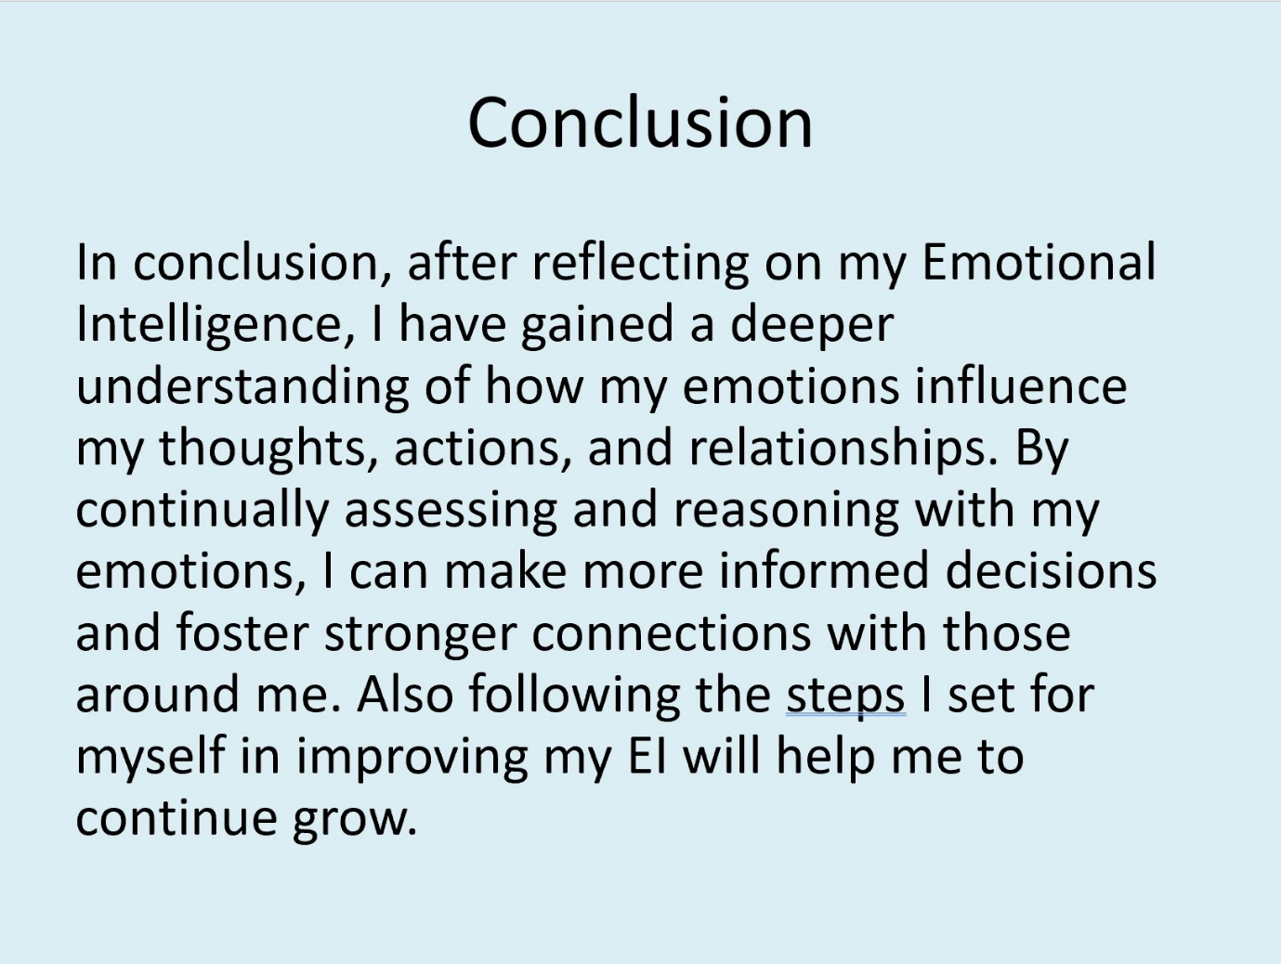
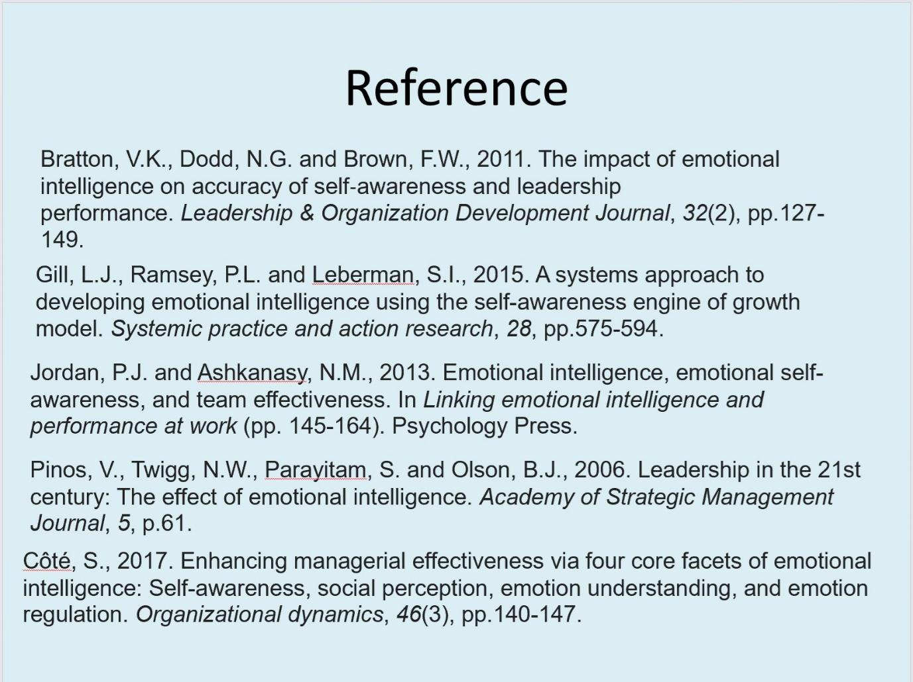

References
Antonakis, J. A. N. a. D. M., 2009. Does leadership need emotional intelligence?. The leadership quarterly, 20(2), pp. 247-261.
D., J. & David R. Caruso, a. P. S., 2016. The Ability Model of Emotional Intelligence: Principles and Updates. Sage Journal, 8(4), pp. 285-303.
Lowman, E. & Thomas, R. E., 2015. Emotional Intelligence in the Leadership Framework. Leadership & Organizational Management Journal, 2015(2), p. 3.
Masuda, T. E. P. C. M. B. L. J. T. S. &. V. d. V. E., 2008. Placing the face in context: Cultural differences in the perception of facial emotion. Journal of Personality and Social Psychology, 94(3), pp. 365-381.
Mayer, J. D. S. P. &. C. D. R., 2008. Emotional intelligence: New ability or eclectic traits. American Psychologist, 63(3), pp. 203-517.
Nurul, H. R. M. H. H. a. N. H., 2017. Emotional intelligence (self-awareness, self-management, social awareness and relationship management) and leadership behavior (transformational and transactional) among school educator leaders. International Journal of Educational Studies, 4(2), pp. 37-47.
Paul, D., 2023. Mindfulness–based positive transformative leadership development for health organisations. Leadership in Health Services, 36(1), pp. 77-96.
Pinos, V. T. N. P. S. a. O. B., 2006. Leadership in the 21st century: The effect of emotional intelligence.. Academy of Strategic Management Journal, 5(1), p. 61.
Serhan, A. a. G. H., 2019. The impact of emotional intelligence on employee performance in Saudi Arabia banking sector. Journal of Economics and Administrative Sciences, 25(16), pp. 127-146.
Varela, O., 2019. Multicultural competence: an empirical comparison of intercultural sensitivity and cultural intelligence. European Journal of International Management, 13(2), pp. 177-197.

