DRW Assignment 2
Assessment 2: Individual Employee’s Career Plan
How the company trains and develops employees so as to obtain the optimal performance levels of both the individual employees and the company objectives.

Student name and ID number: Liudmyla Truksans (1916135)
Tutor: Modak Koushik

2021

Table of Contents
1. Introduction 3
2. Company context 3
3. Purpose of career planning 4
4. Individual Employee’s Current 6
a. Knowledge 6
b. Skills 7
c. Competencies 8
5. Individual Employee’s Career Plan 8
6. Scheduled Annual Review and Performance Assessment Plan 10
7. Conclusion 12
References 13
Appendix 15

1. Introduction
A career development plan can be indeed beneficial for both employees and employers in any particular workplace. A career plan is quite helpful in order to focus on improvement and growth of the employee for the long run. In this case, the employee is focusing on making a career plan as an HR officer as in Tesco. The employee will follow up the criteria in order to make developments for the post of HR manager. On the other hand, the person will also describe the strengths and weaknesses and procedures in order to grow in the long run. This study will highlight the career development plan for the post of HR officer in Tesco.
I was working as a warehouse operative in Tesco PLC in Snodland, also one of my best friends working there already nearly 10 years and started like warehouse operative, after got step up for Former Supervisor, after that became Account Manager, later Contract Manager and now he is Experience Manager. He helped me to understand how system working in Tesco and helped me with career development plan.

2. Company context
Tesco is indeed quite a well known company in the United Kingdom. The company is significantly demanding among the consumers because of their quality of products and services to the consumers. Tesco provides different kinds of groceries and clothes to the consumers; therefore the company has a better reputation among the consumers. There are over 450000 employees in the company who work in Tesco and they work across 11 markets. Therefore, it can be said that the employees of the company are quite efficient and it helps the company to provide better services to the consumers (Kenny et al. 2018). The company seeks to listen to the requirements or demands of the consumers in order to make changes to their products and services and to ensure an increment in their sales and meet up with the needs of the consumers., It can be said that the company is much concerned about their employees and the company provides different kinds of facilities for their employees (Jackson and Tomlinson, 2020). Therefore, the employees seek to make themselves dedicated towards the company. This dedication and efficiency of the employees is helpful for the company in order to increase their productivity in the long run. The company is also concerned about the health of the employees; therefore, the company provides different kinds of medical facilities to their employees or workers and along with that, the company provides sick leaves. This can be much impactful for the company in order to keep the talented and efficient employees in the company.

3. Purpose of career planning
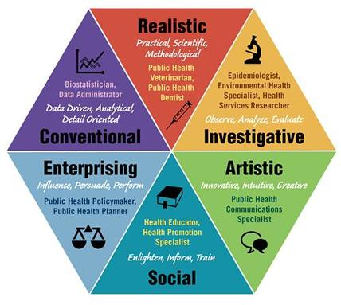
Figure 1: Holland's Six Personality Types
Careers are generally determined through an interaction between the environment and the personality of the individuals. According to the theory of career choice by John Holland, people choose their careers in a way so that they are able to work with others who think in the same way the former is doing (Swanson and Fouad, 2014). As a result people continue with their search of a specific working environment where they will get the opportunity of implementing their skills and abilities as well as expressing their values and perceptions. It can be stated that Holland's theory is focusing on the identification of personality type which in turn has been considered to be an important step towards selecting a career and a working environment. Holland on the basis of individual skills and abilities has identified six personality types - realistic, investigative, artistic, social, enterprising and conventional (Patton and McMahon, 2014). This particular theory is of the opinion that people who select their working environments as per their skills and competencies have been found to be more committed and successful. Thus, individuals are needed to focus on their skills and competencies identification while undertaking career planning.
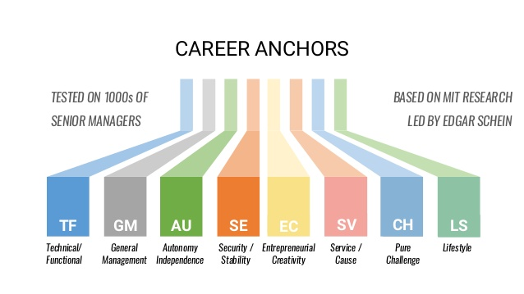
Figure 2: Career Anchors by Schein
Edgar Schein has introduced certain career anchors which are a step towards effective career planning process. Schein has been found to be in agreement with the explanation of Holland. Schein's theory highlighted that one's perception of personal motives, talents, values and abilities helps in forming the basis of personal development. In this case also the individuals are requested to indentify and understand their skills and capabilities for better identification of roles and responsibilities which they can carry out within a specific working environment (McGuire et al., 2017). Eight career anchors have been provided by this theory for helping career seekers. They are functional competence, general managerial competence, independence, stability, entrepreneurial capability, service, pure challenge and life style. Schein is of the opinion that aligning tasks and roles with individual abilities can result in better establishing of new goals and objectives. Individuals are required to relate with the career anchors in order to select a suitable career path for them.
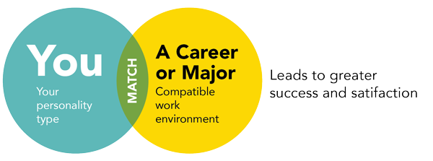
Figure 3: Frank Parsons' trait and factor theory
Another theory which also presents the same direction as Holland's and Schein's theories are Frank Parsons' trait and factor theory. This specific theory points out three actions which are required to be conducted in relation to career planning. The first step is to identify the personality traits of the individual (Arthur and McMahon, 2018). This can be done through skills, knowledge and competency assessment. The second step is to identify the character traits required for the job or the working environment. The third step is to tally the traits of the person with the traits of the working environment or the job.
From the above three theories of career choice it can be understood that it is initially important to understand one's traits and skills before concentrating on career selection. Tesco is also helping its employees in a similar way by developing and delivering programmes which will assist the employees to understand and enhance their capabilities and then plan their careers (Tesco Prorammes, 2021). Different HR programmes have been designed by the company to boost and further develop the personality traits of the HR professionals. In this manner Tesco helps its HR officers to undertake the programmes, consult with experts and continue with their further career planning.

4. Individual Employee’s Current

a. Knowledge
In order to carry out the roles and responsibilities of an HR Officer it is essential to retain effective knowledge of promoting equality and diversity across an organization. This kind of knowledge is required since it is a crucial part of organizational culture and helps in ensuring effective maintenance of employee wellbeing and interest (Mitchell and Gamlem2017). My current knowledge with respect to this area is adequate but there is need of further awareness of varied range of advanced practices which can enhance the ability to maintain equality and diversity across Tesco. One such area is enhancement of cultural competency. This will help in increased understanding of the viewpoints of different employees and effectively interacting with individual across varied cultures. The next area of knowledge playing an essential role with respect to the responsibilities of an HR Officer is knowledge about resourcing. An HR Officer must be aware of the resourcing needs of the company, requirements of the job positions and suitable ways of attracting adequate candidates to fulfil the needs (Schultz, 2015). Being a responsible HR Officer of Tesco my learning is at the development stage. Gradual learning and understanding of the processes, resourcing requirements, etc. is helping in further enhancement of the level of awareness. Another important knowledge area to be retained by the HR Officer is employment acts and legislations. Sufficient awareness is necessary in order to support development of policies, preparation of staff handbooks, providing advices on employment legislations, etc. As per my current knowledge there is need to further refine knowledge about employment acts and legislations.

b. Skills
The essential skills which are required to be taken into account for ensuring effective delivery of the responsibilities and roles of an HR Officer are IT (Information technology) skills, communication skills, problem skills and supervising skills (Lepeley et al., 2021). Referring to the personal skills audit (refer to the appendix) an idea can be gained about the current status of the skills retained by me. Depending on this skills audit the strength and weak points can be identified. The strengths in relation to IT skills are better ability to use MS Word, internet and e-mail. Further refinement is required in relation to PowerPoint presentation. Presentation skills are necessary for ensuring better interaction with the employees. The weak points are use of Excel spreadsheet, using and accessing databases and capability to use specialist HR software. By observing the skills audit it can be inferred that the current status of the communication capabilities are good and further refinement can lead to strengthening of other abilities like networking, public speaking, etc. However, there is room for improvement in the area of preparing and delivering training sessions. There is lack of training abilities and it needs to be addressed since training and development management is a crucial responsibility of an HR Officer.
Under problems solving skills the verbal reasoning skills is good but improvement is required for handling selective information and complex data. Therefore, this area is adequate but not better. The ability to consult with others and evaluating multiple solutions in order to identify an appropriate way of mitigating the problem is there and further refinement can help in strengthening of decision making capabilities. The current experience in relation to supervisory management is still at development stage and needs to be strengthened through gradual learning process.

c. Competencies
Tallying the expected roles of an HR Officer and the current status of skill and knowledge retained the competencies can be identified. Therefore, the identified competencies are interaction with others, effective handling of problems, preparation of crucial materials, delivering of advices, HR planning, maintenance of employee records, analysis of training needs and negotiations with staff and the representatives.

5. Individual Employee’s Career Plan
A career plan or action plan has been developed on the basis of the skills audit carried out and assessment of the current knowledge as well as competencies of the individual. The below provided career plan has focused on attaining the highlighted incompetency from the skills audit. The fulfilment of the objectives of the career plan will result in further strengthening of the capabilities and performance of HR Office.
Objective | Action | Measurement | Target
To attain awareness and develop knowledge about specialist HR Software | - Signing up at ‘Learning at Tesco’ (Tesco, 2021)  - Accessing virtual and face-to-face workshops  - Availing e-learning modules and videos uploaded by professionals  - Availing assistance from Digital Champions | - Discussing with seniors about the performance while undertaking the learning programme  - Taking help from the professionals and taking into consideration their suggestions and feedbacks | Within 6 months
To be able to handle complex data | - Accessing the help of seniors  - Availing appropriate learning programs provided by Tesco  - Attending workshops and video tutorials (Tesco, 2021) | - Considering the suggestions and feedbacks of seniors  - Maintaining reflective performance logs  - Asking for feedbacks with respect to performance and identifying the points for improvement | Within 4 months
To improve ability to prepare and deliver effective training session | - Accessing the ‘Learning at Tesco’ platform (Tesco, 2021)  - Going through the e-learning modules and videos uploaded by professionals  - Taking part in workshops  - Discussing essential points with seniors | - Considering feedbacks and suggestions from seniors  - Asking seniors for extra points for improvement and development  - Maintaining performance logs  - Reflecting on the performance  - Taking suggestions and feedbacks from co-workers as well | Within 3 months
To develop capability in relation to supervisory management | - Gradually learning from existing practices  - Discussing with immediate seniors  - Accessing a suitable program provided by Tesco  - Going through the e-learning modules and videos to improve learning | - Discussing with seniors about the performance while undertaking the learning programme  - Taking help from the professionals and taking into consideration their suggestions  - Maintaining performance logs  - Reflecting on the performance  - Taking suggestions and feedbacks from co-workers as well | Within 2 months

6. Scheduled Annual Review and Performance Assessment Plan
Tesco has provided several alternatives for the employees to avail and improve their competencies and level of knowledge. Besides maintaining effective employment processes Tesco has several programs and arrangements for supporting the training and development of the employees. While continuing as an HR Officer for Tesco the seniors and co-workers are constantly helping in gradual learning and development. The HR department at Tesco maintains different teams for monitoring and evaluating the performance of all employees (Tesco, 2021). In fact the system of monitoring and performance evaluation is categorized on the basis of the position held by the employees. There is a team entirely responsible for helping HR Officer to further improve performance and focus on career development. After carrying out the skills audit and discussing it with the monitoring and evaluation team they provided the advice of preparing a career action plan. The above career plan has been developed and presented before the team. In order to provide help for refinement and development of strengths and weaknesses the Tesco monitoring and evaluation team has fixed a date for annual reviewing of the career plan. The annual review includes going through the components of the career plan, advising on the improvement of the actions and measurement plan. In addition to this the team also takes up the responsibility for assessing the individual performance on the basis of the career plan developed (Tesco Prorammes, 2021). A particular template has been provided by the team for assessing the performance on weekly basis. Both the performance assessment plan and career action plan are reviewed by the Tesco HR management and monitoring team for providing the employees with useful suggestions and feedbacks. A sample of the performance assessment template has been provided below. Once the career plan is reviewed by the team then the actions will be undertaken. After a month the progress will be filled in the assessment plan and all the progress will be reviewed by the team at the end of the year.
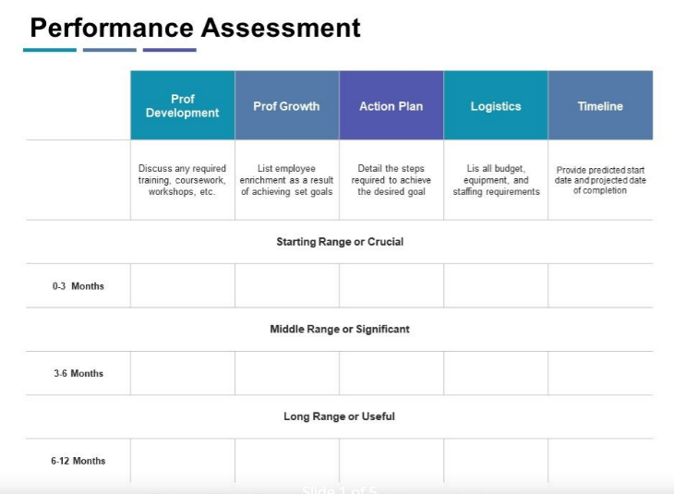

7. Conclusion
The discussions in this assignment have focused on analysing the ways through which Tesco helps an employee to develop further in order to extract better performance and positively influencing the attainment of the objectives. The perspective of HR Officer has been taken into account in this assignment. Some parts of the assignment have focused on reflecting on knowledge, skills and competencies retained by a person currently serving the role of HR Officer in Tesco. Based on this reflective analysis a career plan has been developed. It is seen from the evaluations that Tesco is greatly responsible towards guiding employee through the development stage and coming up with an effective career planning. In fact Tesco does not leave the responsibility over there and continuously assist the employee by reviewing their career plans and assessing performance on a periodic basis. On an overall basis it can be concluded that a company is needed to be with an employee from the start of their training and development till the end in order to ensure effective career development and fulfilment of organizational performance goals.

References
Armstrong, M. and Taylor, S., (2020). Armstrong's handbook of human resource management practice.
Arthur, N. and McMahon, M. eds., (2018). Contemporary theories of career development: International perspectives. Routledge.
Bravo, J., Seibert, S.E., Kraimer, M.L., Wayne, S.J. and Liden, R.C., (2017). Measuring career orientations in the era of the boundaryless career. Journal of Career Assessment, 25(3), pp.502-525.
Jackson, D. and Tomlinson, M., (2020). Investigating the relationship between career planning, proactivity and employability perceptions among higher education students in uncertain labour market conditions. Higher education, pp.1-21.
Lepeley, M.T., Beutell, N.J., Abarca, N. and Majluf, N. eds., (2021). Soft Skills for Human Centered Management and Global Sustainability. Routledge.
McGuire, D., Polla, G. and Heidl, B., (2017). Unlocking hospitality managers career transitions through applying Schein’s career anchors theory. European Journal of Training and Development.
Mitchell, B. and Gamlem, C., (2017). The big book of HR. Red Wheel/Weiser.
Patton, W. and McMahon, M., (2014). Career development and systems theory: Connecting theory and practice (Vol. 2). Springer.
Schultz, C., (2015). Reinventing HR. eBook Partnership.
Swanson, J.L. and Fouad, N.A., (2014). Career theory and practice: Learning through case studies. Sage publications.

Tesco Prorammes, (2021). Programmes | Tesco Apprenticeships & Graduates. Available at: https://www.tesco-programmes.com/programmes/ (Accessed: 26 March 2021).
Tesco, (2021). Skills and Training. [online] Tesco Plc. Available at: <https://www.tescoplc.com/sustainability/people/employment-skills/skills-and-training/> [Accessed 26 March 2021].

Appendix
Personal Skills Audit
Name: Liudmyla
Job role: Human Resource Officer

Please tick as appropriate to indicate how you would rate your skills in relation to the following work / functional areas.
 | Very good | Good | Adequate | Little or no experience
Information Technology
Use Microsoft Office Word
Use Excel spreadsheet
Use a Database
Use specialist HR software
Use the internet
Use e-mail
Use PowerPoint

 | Very good | Good | Adequate | Little or no experience
Communication Skills
Drafting contracts of employment
Taking notes of disciplinary
Write reports
Produce material to support presentations
Delivering a training session

Resolving disputes/complaints
Interviewing
Advising on HR issues
 | Very good | Good | Adequate | Little or no experience
Problem solving skills
Make good use of verbal reasoning skills, able to handle complex data and make selective use of information
Explore more than one solution in order to solve a problem
Consider the ideas of others to help solve problems

Supervisory Management
How much experience have you had in your role? |  |  | < 1 month | 1-3 months | > 3 months
How many people have you managed at any one time? |  |  | None | 1-5 | Above 5

I declare that the information given in this form is true
Signed | Liudmyla
Date | 26.03.2021



