Name: Catalina Rosu
Student Number: 1917494
Module Title: BMSW4001
Lecturer Name: Adesewa Ajayi

ACADEMIC AND EMPLOYABILITY SKILLS

Table of Contents
Introduction 2
Self-reflection 3
Conclusion 12
References 13

Introduction
Gibbs cycle of reflection is regarded as an effective model, which supports a learner in evaluating experiences gained from previous situations. Furthermore, the model helps in developing a framework or system through which a person could develop a critical action plan that might assist the individual to accomplish its ultimate goal. In the following reflective report, I am going to use the model for evaluating my response as well as for reviewing my knowledge. The model of reflection is concerned with 6 key dimensions such as Analysis, Description, Evaluation, Action plan and Conclusion as well. I shall analyse the elements of the reflective model to assess my experience and knowledge, which I collected from past circumstances. Ultimately, the upcoming sections shall involve my evaluation regarding certain areas of the topic that I precisely illustrated individually.

Self-reflection
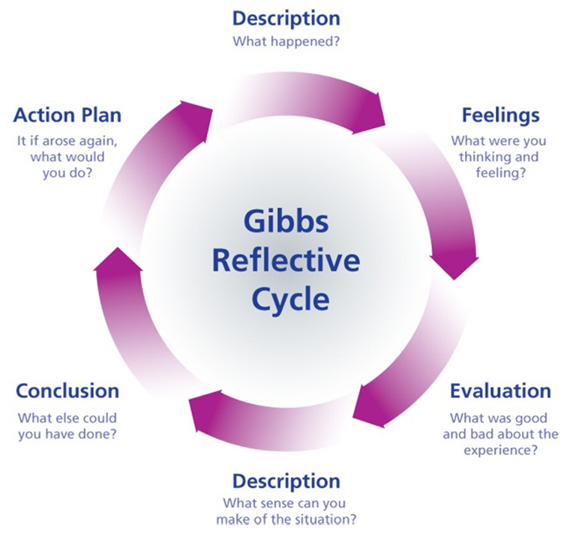
Figure 1: Gibbs cycle
Source: (Ardian et al. 2019)
Description
Initially, I have gone through the description dimension of Gibbs cycle and analysed certain specified topics that could help me in attaining my desirable job role. Juevesa et al. (2020) stated that a well-furnished cv could support a person in obtaining desirable jobs easily. Effective cv site skills might help me to describe the job I need initially. I am desirous of being a health care assistant as per my qualifications. I also like to serve patients and treat them effectively.
I have sound knowledge in the field of healthcare management because of which I am qualified as healthcare personnel. Earlier, I worked as a healthcare assistant in a care home where I was responsible to serve care users, provide those medicines and other care facilities and track their progress. Therefore, I identified the importance of sound cv because it supported me expressing my perspective associated with my job role. Furthermore, I succeeded in demonstrating my skills and experience within a specified job role that is helpful to attract prospective employers towards me. Apart from it, I also conducted a reflective writing that supports me to identify my abilities for the job. Earlier, as stated in the above unit of the report, reflective learning tends to be effective to identify personal weaknesses and strengths, which result in establishing a sound personal development plan. Thus, I developed a PDP that might help me to develop strategies for overcoming my weaknesses and maintaining my strengths. Furthermore, my tutor provided feedback to me by which I have been able to recognise my key strengths that are knowledge, accuracy and non-verbal skills.
Nevertheless, I also obtained certain negative responses from the tutor that sometimes I speak louder that becomes intolerable for listeners. It is one of my biggest weaknesses, which I need to overcome to improve my communication skills. Therefore, I need to resolve the issue for achieving strong career growth. I need to go through my analytical thinking capabilities for developing a strong basis related to my career in healthcare. Murali et al. (2017) opined that analytical thinking skills stay essential to seek sound employment opportunities. Nowadays, most employers attempt to recruit candidates that are specialised in such skills. Hence, I identified that I need to improve my soft skills to develop my career. Subsequent to the analysis, I selected 2 key themes that could help me to establish my professional career sustainability that is knowledge on summarising and paraphrasing along with public speaking abilities.
Feelings
With respect to my past experience, which I gained while practising the skills mentioned above along with other themes, I identified that few of key skills require further improvement for achieving sound career progress. In the feelings dimension of the cycle, I embrace my feelings, which I observed during practising on the topics.
I usually become nervous during cv site regarding my job role. The issue I face is how to convey my feelings to the viewers or employers. Therefore, I understood that I need to resolve the challenge effectively to attract desired employers towards my skills and obtain the desired job role. Apart from it, I also applied effective theoretical concepts for analysing my past and present feelings associated with circumstances where I assessed that according to my tutor, I have a strong level of confidence towards my non-verbal skills. Though, subsequent to the feedback provided, I ensured that I needed to develop my skills to greater extent. If I would speak in front of an audience in a louder voice, they might not listen to me effectively. Due to that, I might not be able to convey my perspectives or feelings to them regarding a specified topic. Furthermore, I conducted SWOT analysis, which represents that I need to develop my hard and soft skills like internet skills and communication skills. Henceforth, related to it, my analytical thinking abilities also require development as they are successful to drive proper solutions to certain issues. Moreover, as I mentioned before, I need to enhance my public speaking skills to interact with others efficiently. If I could improve the factors mentioned above, I could furnish myself with successful employability skills to attain my desired job role thereby ensuring strong growth of career in the long run.
Evaluation
As per my opinions, a person could maintain career development through evaluation of key employability skills, which helps in differentiating it from others and encourage establishing a remarkable persona. Ardian et al. (2019) opined that the cycle provides analytical ideas in topic areas, which are essential to ensure core skills and help to review the skills properly. After evaluating my cv and my past experiences, I observed that I require incorporating few strategies to site cv efficiently. Few important strategies of improving skills of cv site are, I could highlight key statements that I need to demonstrate as eye-catching statements. Subsequent to that, I could customize the information for representing key items, which employers search for.
I evaluated feedback, which I obtained from my lecturer about my skills. I observed that I need to use certain strategies for improving my communication abilities. As argued by Amutio-Kareaga et al. (2017) focus on proper meditation serves as an effective strategy to improve communication skill. The contradiction stated the methods by which I could develop my soft skills. From evaluating my capability of public speaking, I observed that the theory is effective to develop public speaking style. The principles of the Dialogic model are helpful in developing public relations by effective communication (Kent 2017). In the modern era, the importance of theory is increasing. Hence, I need to apply the theory into my action plan. Gibbs theory might support me to evaluate that is crucial to identify key aspects that I experienced earlier.
Analysis
Holder et al. (2019) contradicted that analysis could be conducted by individuals concerning all factors leading the person to evaluate career development chances. Hence, I could argue that I reviewed my entire experiences that are both negative and positive and negative thereby influence me in ensuring career progress.
First experience, which I analysed, is my proficiency relate to cv site. As per my tutor’s opinion, I sited sound cv; however few mistakes were presented in it. Mostly, I analysed certain grammatical issues that are not accepted in professional career. Henceforth, I need to resolve existing issues in cv site for improving my skills. Furthermore, I need to develop communications skills to greater level for preventing flaws I committed in the past. Sonnenschein and Ferguson (2020) the foremost strategy to enrich communication skills is to involve listeners effectively.
In addition to it, other key strategy that I need to use for the same is I need to increase my focus upon message that needs to express to others. Nonetheless, it stays important for me to establish sound body language. Since my tutor responded to me that I am effective in maintaining sound eye contact therefore, it is considered as one of my strengths in communicating with people. Furthermore, I analysed that I need to develop my public speaking skills and analytical thinking skills for developing solutions to upcoming issues in my career. I could adopt strategies to control my voice tone.
Conclusions
I analysed my experience, illustrated and evaluated them to establish few effective strategies, which could lead me to obtain my desired job role and improve my career. The conclusion dimension of the cycle includes some key questions regarding my learning derived from the scenario, ways to convert weaknesses into strengths and my performance in the past. It could help me to develop skills that I need for ensuring sound progress in my career. From aforementioned dimensions I observed that my performance is acceptable; however, I require developing it further.
I deduce that flaws presented in my key competencies require proper management. My inability to resolve the flaws could create an adverse effect on my career opportunities. The ultimate finding, which is observed by me, is development of communication traits initially, as it could pose favourable effect on listeners. Additionally, the paraphrasing and summarising skills are also required to be established. Additionally, development of cv site skills might help in portraying proper information regarding skills to the employer. I also need to develop analytical thinking skills to increase employer’s attraction towards me thereby obtain desired job role and perform it effectively to ensure career progress.
Action plan
The action plan is helpful in overcoming past flaws and developing core skills to improve individual personality. Development of action plan for my skills to be developed is as follows:
Skills required for improvement | Strategies for improving skills | Objective | Time frame
Analytical thinking skills | Playing mind games and solving puzzles could help me to improve my analytical thinking skills.  I could also attend professional classes, listen podcasts as well as ask questions from my tutor during my classes for improving my analytical competencies. | To develop effective solutions for risks faced in career | 2 months
Writing skills | I could focus on frequently writing on matters related to academic for improving my grammar and speed. I could have a cross-check by my lecturer to recognise flaws. I could develop my writing skills by reading books. Additionally, developing time-based targets could also help me to improve my speed in writing | To maintain cv effectively for obtaining desired job role. | 1 month
Public speaking skills | I require strong focus on specified matters to develop my public speaking skills. In order to exercise control on words, I need to speak slowly, avoid use of fillers and improve my pronunciation.  I could also attend different workshops where I would practice speaking in front of audience effectively. | To communicate effectively with society. To interact effectively with my team members in my job role for developing strong relations with them thereby ensure sound growth in professional career. | 1 month
Knowledge on summarising and paraphrasing | It could attend professional classes to develop my vocabulary and focus on practising on content paraphrase effectively. It could also judge the gaps between the actual content and paraphrased content | To develop my writing abilities | 1 month
Communication skills | It could focus on attending various workshops to learn that ways to communicate with people and develop strong listening skills.  Reading journals, blogs, articles and reports shall help me to increase communication abilities.  I need to sustain my voice tone to encourage listeners to listen to me. | To interact with people effectively thereby convey my feelings regarding the subject matter | 2 months
Table 1: Action plan
(Source: Created by the author)

Conclusion
Gibbs cycle of reflection stays essential to identify primary skills that a person requires to develop. In confirmation of the aforementioned analysis, I conclude that I have learnt different aspects, which shall support me to manage complex situations successfully. In addition, I could resolve my existing weaknesses or issues with the help of the action plan, which could encourage me to attain sustainable growth in my professional career. The action plan contains information regarding the strategies to be undertaken by me for improving skills within stipulated period. It might assist me to be a successful healthcare assistant and discharge my duties effectively through the skills targeted to improve.

References
Amutio-Kareaga, A., García-Campayo, J., Delgado, L.C., Hermosilla, D. and Martínez-Taboada, C., 2017. Improving communication between physicians and their patients through mindfulness and compassion-based strategies: a narrative review. Journal of clinical medicine, 6(3), p.33.
Ardian, P., Hariyati, R.T.S. and Afifah, E., 2019. Correlation between implementation case reflection discussion based on the Graham Gibbs Cycle and nurses’ critical thinking skills. Enfermeria clinica, 29, pp.588-593.
Holder, N.A.K.A., Sim, Z.L., Foong, C.C. and Pallath, V., 2019. Developing a Reflection Guiding Tool for underperforming medical students: An action research project. Tuning Journal for Higher Education, 7(1), pp.115-163.
Juevesa, R.D., Juevesa, C.V. and Castino, J.M.P., 2020. Employee Engagement, Commitment, Satisfaction and Organizational Performance Among Multigenerational Workforce. International Journal of Research in Engineering, Science and Management, 3(7), pp.36-40.
Kent, M.L., 2017. Principles of dialogue and the history of dialogic theory in public relations. Prospect of public relations science, pp.105-129.
Murali, S., Poddar, A. and Seema, A., 2017. Employee loyalty, organizational performance & performance evaluation–a critical survey. Journal of Business and Management, 19(8), pp.62-74.
Sonnenschein, K. and Ferguson, J., 2020. Developing professional communication skills: Perceptions and reflections of domestic and international graduates. Journal of University Teaching & Learning Practice, 17(3), p.5.

